Forking the Library Full Stack Repository
Student Step-by-Step Guide using GitHub Website
Public Classroom Repository
https://github.com/vvekselva/Library-Full-Stack-KHAE

Instructor Public Repository  vvekselva/  Library-Full-Stack-KHAE | FORK  → | Student Repository  <student-username>/  Library-Full-Stack-KHAE
The fork is created in the student's own GitHub account.

1. What You Will Do
Each student will create a personal GitHub account and create a fork of the common classroom repository. The fork will be created directly from the GitHub website.
Fork: A fork is a copy of the public repository created under your own GitHub account. You can later clone your fork to your computer, develop the assigned work, commit it, and push it to your own repository.
Important: Do not fork the private instructor repository named Library-Full-Stack-KHAE-Master. Students must fork only the public repository: Library-Full-Stack-KHAE.
Step 1 - Create a GitHub Account
If you do not already have a GitHub account, create one using the GitHub signup page:https://github.com/signup
- Enter your email address.
- Create a password.
- Choose a GitHub username.
- Complete the verification requested by GitHub.
- Verify your email address if GitHub asks you to do so.
Note: Remember your GitHub username. Your fork will be created under this username.
Step 2 - Sign In to GitHub
Open GitHub and sign in using your own student GitHub account:https://github.com/login
After signing in, confirm that your profile icon is visible in the GitHub page. Do not use another student's GitHub account.
Step 3 - Open the Public Classroom Repository
Open the following repository in the web browser:https://github.com/vvekselva/Library-Full-Stack-KHAE
Confirm the following before continuing:
- Repository owner: vvekselva
- Repository name: Library-Full-Stack-KHAE
- Visibility: Public
- Branch displayed: main
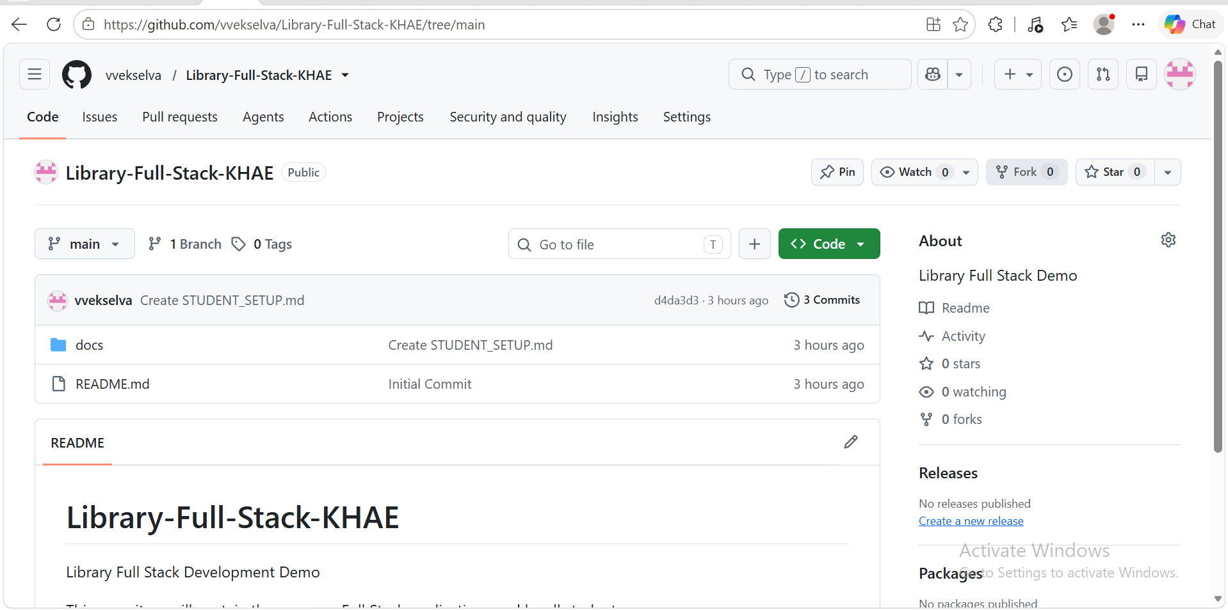
Figure 1 - Public classroom repository on GitHub. The Fork button is shown in the upper-right area of the repository page.
Step 4 - Click Fork
On the repository page, locate the Fork button near the upper-right side of the page and click it.

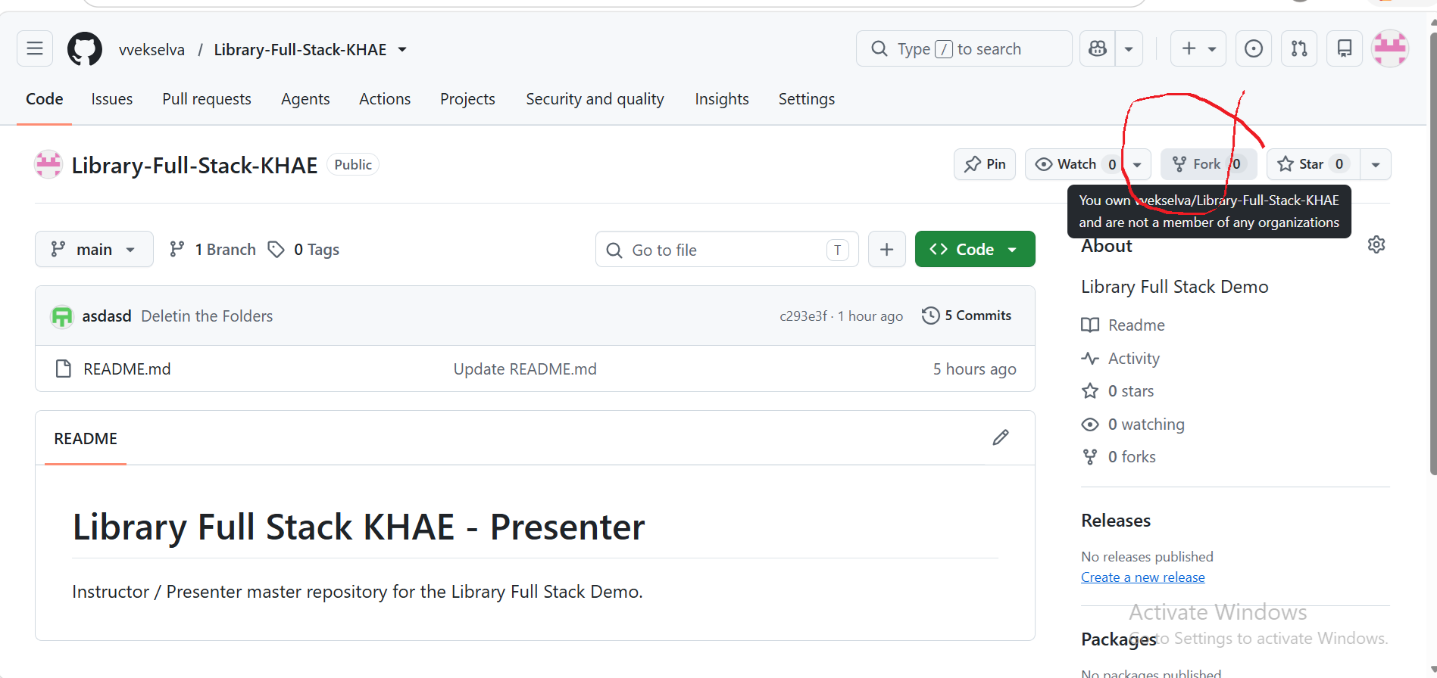
Fork
Note: The Fork operation is performed on GitHub itself. SourceTree is not required for this step.

Step 5 - Complete the Create a New Fork Page
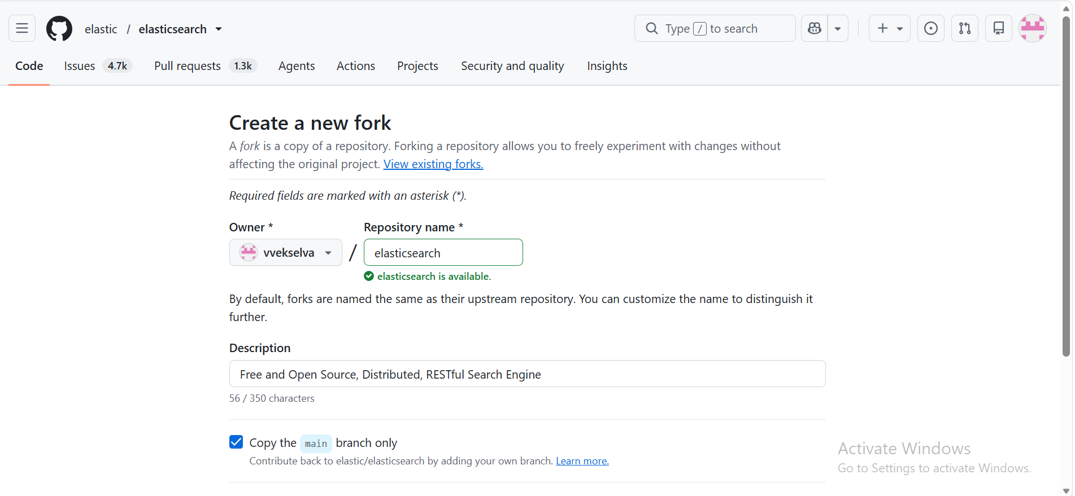

GitHub opens a page for creating the fork. Complete the fields as follows:
Field | Value to Use
Owner | Select your own GitHub username.
Repository name | Keep Library-Full-Stack-KHAE.
Description | Optional. You may leave the default/description unchanged.
Copy the DEFAULT branch only | Select this option. The classroom development uses the default main branch.
Then click:Create fork
Step 6 - Wait for GitHub to Create the Fork
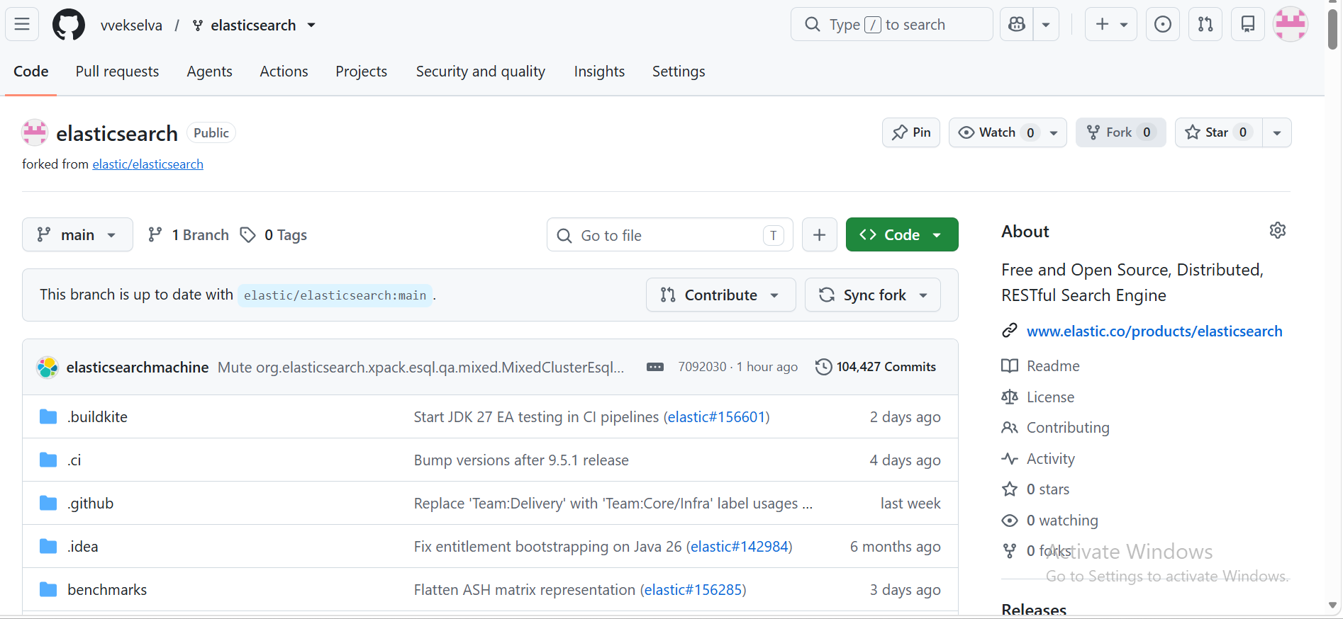
GitHub creates a new repository under your account and opens the new fork automatically.
For example, if the student GitHub username is student1422, the fork URL will be similar to:
https://github.com/student1422/Library-Full-Stack-KHAE
Step 7 - Verify That the Fork Is Correct
On the new repository page, verify these details:
- ✓ The owner displayed before the repository name is your own GitHub username.
- ✓ The repository name is Library-Full-Stack-KHAE.
- ✓ GitHub indicates that the repository is forked from vvekselva/Library-Full-Stack-KHAE.
- ✓ The files and folders initially match the public classroom repository.

Before Fork | After Fork
Instructor repository  vvekselva/Library-Full-Stack-KHAE | Student repository  <student-username>/Library-Full-Stack-KHAE
Step 8 - Use Your Fork for SourceTree Cloning
After the fork has been created, the student should clone the student fork, not the instructor repository.
Example:
Do Not Clone for Student Development | Clone This Repository
https://github.com/vvekselva/Library-Full-Stack-KHAE.git | https://github.com/<student-username>/Library-Full-Stack-KHAE.git
Note: The instructor repository remains the common source. The student performs development in the student's own fork and later submits the work back through a Pull Request.

2. Student Quick Checklist
☐ GitHub account created and email verified.
☐ Signed in using my own GitHub account.
☐ Opened https://github.com/vvekselva/Library-Full-Stack-KHAE.
☐ Clicked Fork.
☐ Selected my own GitHub account as Owner.
☐ Kept the repository name as Library-Full-Stack-KHAE.
☐ Selected Copy the DEFAULT branch only.
☐ Clicked Create fork.
☐ Verified that the new repository belongs to my GitHub username.
☐ I will clone my fork into SourceTree for development.

3. Common Problems
Problem | What to Do
Fork button is not visible | Make sure you are viewing the repository main page and are signed in to GitHub.
GitHub says a fork already exists | Open your existing fork instead of creating another fork.
Wrong Owner selected | Cancel and select your own personal GitHub account as the fork owner.
Fork created with a different name | For this classroom exercise, keep the repository name Library-Full-Stack-KHAE unless the instructor gives another instruction.
Student accidentally opens the Master repository | Do not use Library-Full-Stack-KHAE-Master. It is not the classroom repository to be forked.

4. Official Reference
GitHub documentation - Fork a repository: https://docs.github.com/en/pull-requests/how-tos/work-with-forks/fork-a-repo
Next activity: Clone your own fork using SourceTree.

