Adding the Presenter Public Repository as a Remote in SourceTree
Student Guide - Library Full Stack KHAE

Purpose
This guide explains how to connect the Presenter Public GitHub Repository to your existing student local repository in SourceTree. After this setup, you can receive documents, skeleton code, task files, and other updates published by the presenter.
Important
Adding a remote does not copy, download, merge, or change project files. It only creates a connection to another Git repository. Files are received later when Fetch or Pull is performed.

Repository Connections After Setup
From | Remote Name | Connects To
Student Local Repository | origin | Student GitHub Repository
Student Local Repository | Presenter_Public | Presenter Public GitHub Repository
Presenter Public Repository URL: https://github.com/vvekselva/Library-Full-Stack-KHAE.git

Step 1 - Open the Presenter Public Repository on GitHub
Open the Presenter Public Repository in a web browser. Click the green Code button and select HTTPS. Copy the repository URL.
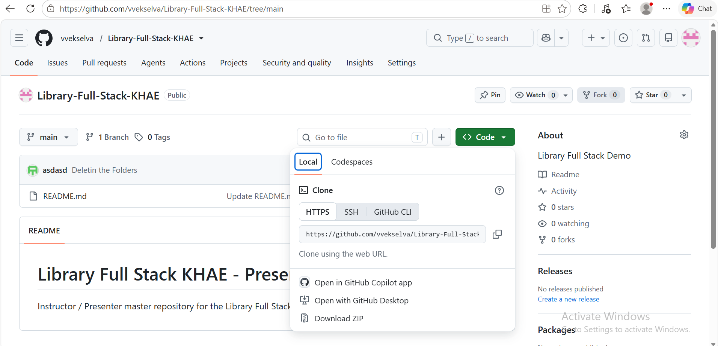
Figure 1 - Presenter Public Repository on GitHub. Copy the HTTPS repository URL.

Step 2 - Open Your Student Local Repository in SourceTree
Open SourceTree and open the local repository in which you are doing your course work. The repository should already have the remote named origin. The origin remote is your own GitHub repository.
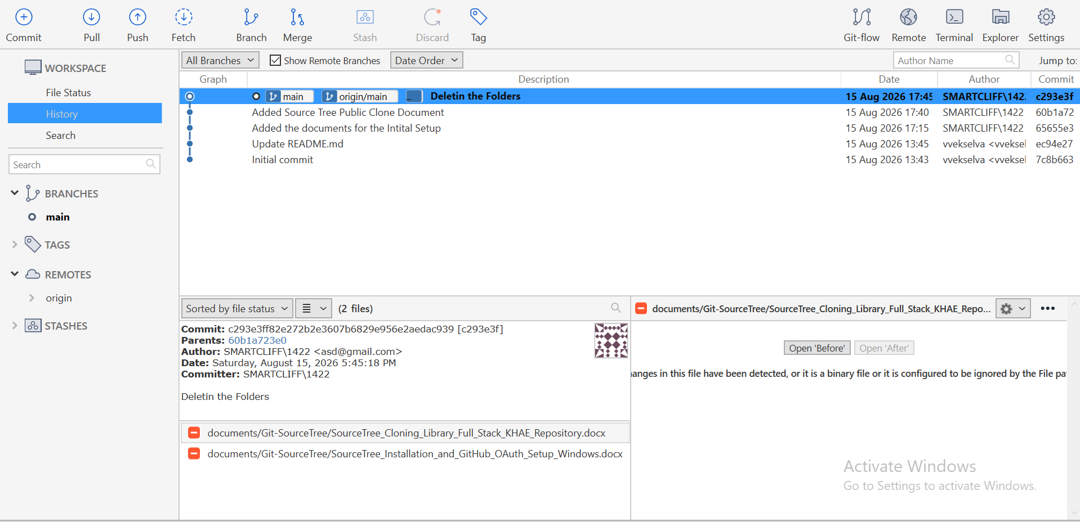
Figure 2 - Student local repository in SourceTree. The existing origin remote is visible.

Step 3 - Open Repository Settings
Click Settings on the SourceTree toolbar. The Repository Settings window will open. Open the Remotes section and click Add to add another remote repository.
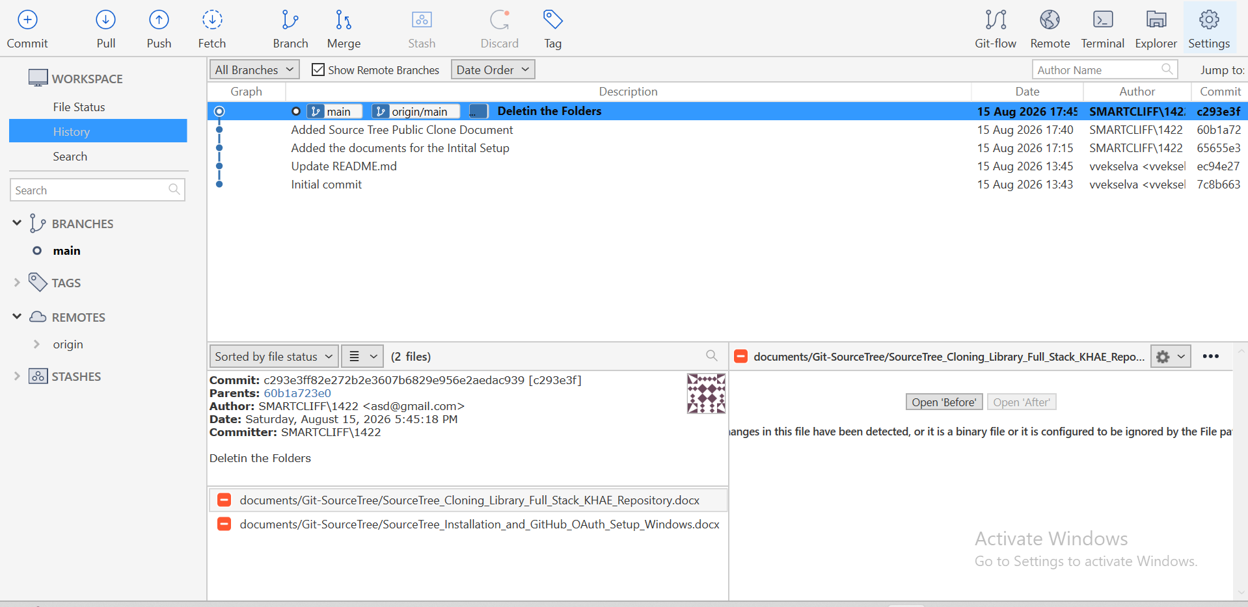
Figure 3 - Click Settings to open the repository configuration.

Step 4 - Enter the Presenter Public Remote Details
In the Remote details window, enter the following values:
Field | Value
Remote name | Presenter_Public
URL / Path | https://github.com/vvekselva/Library-Full-Stack-KHAE.git
- Keep the Default remote check box unselected. The student repository should continue to use origin as its normal/default remote.
- If SourceTree shows Remote Account or Username, use the GitHub account already configured in SourceTree.
- Click OK after checking the remote name and URL.
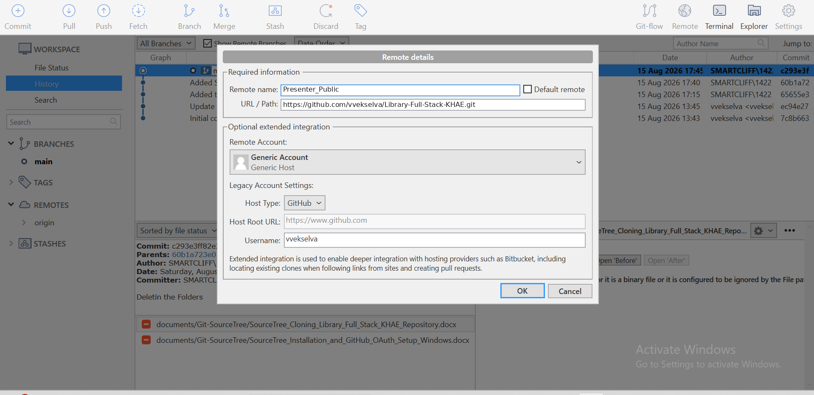
Figure 4 - Remote details for the Presenter Public Repository.

Step 5 - Verify the Two Remotes
After saving, return to the repository. Under REMOTES, the repository should have two connections. The exact display may vary slightly depending on the SourceTree version.
Remote | Purpose
origin | Student GitHub Repository - used to push your own work
Presenter_Public | Presenter Public Repository - used to receive presenter updates

How the Two Remotes Are Used
To receive course updates: use the Presenter_Public remote when the presenter asks you to Fetch or Pull new material.
To save your own work on GitHub: commit your changes and Push them to origin.
Do not push student work to Presenter_Public
Your normal student work should be pushed to origin, which points to your own GitHub repository. Presenter_Public is the shared repository from which course updates are received.

