DineSync AI
Intelligent Multi-Tenant SaaS Ecosystem for Predictive Restaurant Operations
Design Document
UI Design · Database Design · Module Design · Algorithms & Flowcharts

Prepared by: [Student Name(s) / Roll Number]
Reviewed by: [Guide / Supervisor Name]
Document Version: 1.0
Date: [DD / MM / YYYY]

Table of Contents
1. Introduction & Design Goals 3
2. System Architecture 3
3. Module Design 4
4. Database Design 6
4.1 Design Approach 6
4.2 Entity-Relationship Diagram 7
4.3 Collection Schemas 8
5. UI Design 11
6. Algorithm Design & Flowcharts 14
6.1 Order-to-Billing Algorithm 14
6.2 Kitchen Ticket Routing Algorithm 15
6.3 Inventory Auto-Deduction Algorithm 15
6.4 AI Predictive Forecast Algorithm 16
6.5 Graceful Degradation (AI Fallback) Algorithm 17
7. Security & Multi-Tenancy Design 17
8. Conclusion 18

1. Introduction & Design Goals
This document translates the requirements captured in the Software Requirements Specification into a concrete technical design for DineSync AI. It covers the system architecture, the design of each functional module, the database schema, the user-interface design, and the core algorithms/flowcharts that govern order processing, kitchen routing, inventory deduction, and AI-driven forecasting.

Design Goals
- Strict tenant isolation — no tenant can read or write another tenant's data under any code path.
- Real-time by default — state changes (orders, kitchen tickets) propagate to every relevant screen without manual refresh.
- Loose coupling between the transactional core and the AI microservice, so predictive features can fail without affecting billing or kitchen operations.
- A feature-based, modular codebase so each business capability (menu, order, inventory, …) can be developed, tested, and reasoned about independently.

2. System Architecture
DineSync AI follows a three-tier architecture. The presentation tier is a React single-page application; the application tier is a Node.js/Express REST API that also hosts the Socket.IO real-time engine; and a dedicated Python/FastAPI microservice provides AI inference, kept fully decoupled from the transactional path. MongoDB is the single system of record, accessed through Mongoose from the Node.js tier.
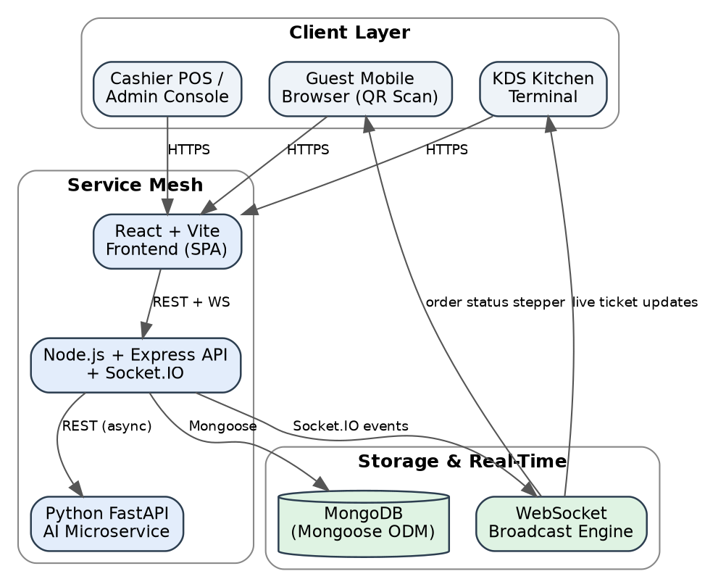
Figure 1: DineSync AI three-tier system architecture.
Requests from any client (guest browser, cashier POS, KDS terminal) pass through the React frontend, which calls the backend over REST for state-changing operations and subscribes to Socket.IO channels for live updates. The backend applies authentication, tenant-isolation, and RBAC middleware before touching the database, and asynchronously calls the AI microservice only for prediction-related endpoints.

3. Module Design
The backend follows a feature-based clean architecture: each module owns its Mongoose model(s), a service layer (business logic), a controller layer (HTTP handling via a consistent ApiResponse/ApiError contract), and a router registered under /api/v1. The frontend mirrors this structure with one feature folder per module (api / components / pages).
Module | Responsibility | Key Backend Artifacts
Auth & Tenant | Registration, login, OTP, JWT issuance, tenant profile | auth.model, tenant.model, auth.service
Branch | Multi-location branch profiles & schedules | branch.model, branch.service
Menu (Category/Item) | Catalog, pricing, modifiers, dietary tags | category.model, menuItem.model
Table | Floor layout, table status, QR generation | table.model, table.service
Reservation | Booking, overlap checks, status lifecycle | reservation.model
Order (POS) | Order capture, bill split/merge, status sync | order.model, order.service
Kitchen (KDS) | Station routing, Kanban ticket lifecycle | kitchenTicket.model
Inventory | Ingredients, recipes, purchases, stock ledger | ingredient.model, recipe.model, purchase.model, stockTransaction.model, supplier.model
Customer (CRM) | Profiles, loyalty tiers, feedback | customer.model, feedback.model, loyaltyTransaction.model
Billing | Invoicing, GST/service charge, payments | invoice.model, payment.model
Employee | Roster, attendance, leave, payroll | employee.model, shift.model, attendance.model, leave.model, payroll.model
Reports | Aggregation-pipeline analytics, export, scheduling | scheduledReport.model
AI Bridge | Node ↔ FastAPI bridge with retry + fallback | ai.service (Node), ai-service/app (FastAPI)
Customer Experience | Public QR ordering, live tracking, self-checkout | shares order/table/menu models via public routes
Notification | Multi-channel dispatch, templates, preferences | notification.model, notificationTemplate.model, notificationPreference.model
Super Admin | Tenant lifecycle, plans, feature flags, audit | subscriptionPlan.model, tenantSubscription.model, featureFlag.model, auditLog.model, securityLog.model

4. Database Design

4.1 Design Approach
DineSync AI uses MongoDB, a document-oriented database, accessed through Mongoose schemas that enforce structure, validation, and default values at the application layer. Every tenant-owned collection carries a restaurant (and, where applicable, branch) reference that is indexed and enforced by tenant-isolation middleware on every query — this is the primary mechanism that keeps one restaurant's data invisible to another. Compound indexes (e.g., {restaurant, createdAt} on Order, {restaurant, status} on KitchenTicket) are used to keep the most frequent dashboard and KDS queries fast as data volume grows.
The entity-relationship diagram overleaf (Figure 2, landscape) shows the primary collections and their relationships. Every branch-level and operational entity ultimately traces back to a single Restaurant (tenant) document, which is the root of the isolation boundary.

4.2 Entity-Relationship Diagram
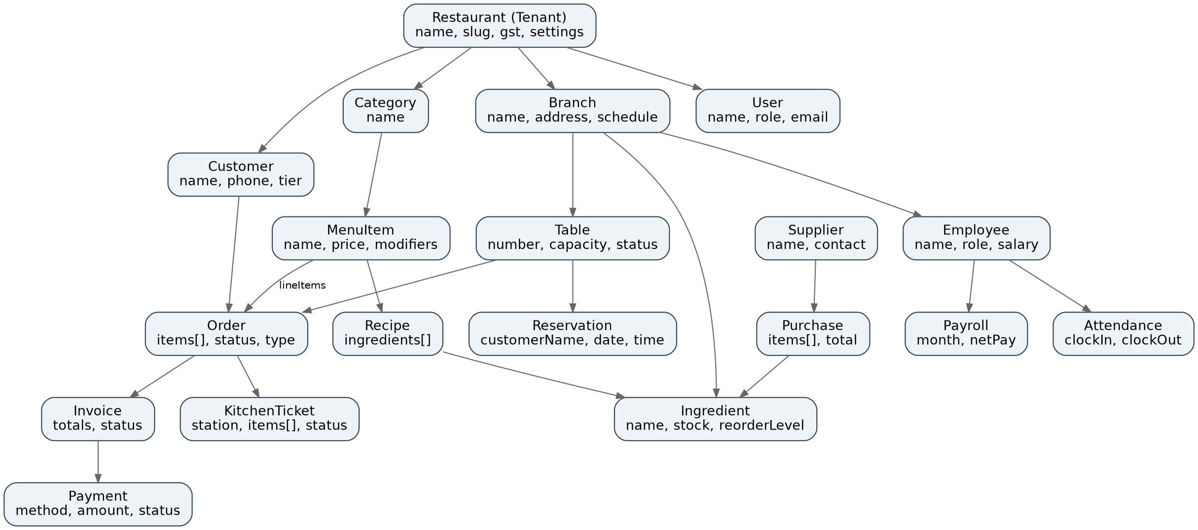
Figure 2: Entity-relationship diagram of the core DineSync AI collections.

4.3 Collection Schemas
The following tables summarize the key fields of the most central collections. Fields common to nearly all collections (createdAt, updatedAt timestamps, and the restaurant/tenant reference) are omitted from repeated tables for brevity but are present on every tenant-scoped collection.

Restaurant (Tenant)
Field | Type | Description
name, slug | String | Display name and unique URL-safe tenant identifier
gst.gstRegistered, gst.gstin | Boolean, String | GST registration flag and validated GSTIN
settings.currency, settings.timezone | String | Per-tenant locale configuration (default INR / Asia-Kolkata)
settings.orderPrefix | String | Prefix used when generating order numbers
settings.serviceChargePercent | Number | Default service charge applied to bills
socialLinks | Object | Facebook / Instagram / Twitter profile links

Order
Field | Type | Description
orderNumber | String (unique) | Auto-generated as ORD-YYYYMMDD-XXXX
orderType | Enum | Dine-In, Takeaway, Delivery, QR Order
orderStatus | Enum | Pending, Accepted, Preparing, Ready, Served, Completed, Cancelled
paymentStatus | Enum | Pending, Paid, Refunded
items[] | Array<OrderItem> | menuItem ref, quantity, unitPrice, modifiers[], kitchenStatus
table, branch, restaurant | ObjectId refs | Links to Table, Branch, and Restaurant documents
isDeleted, deletedAt | Boolean, Date | Soft-delete flag for audit retention

KitchenTicket
Field | Type | Description
order, table, branch, restaurant | ObjectId refs | Links back to the parent order and location
station | Enum | Main Kitchen, Tandoor, Bar, Dessert, Beverage
status | Enum | Pending, Preparing, Ready, Served, Delayed
items[] | Array<TicketItem> | orderItemId, menuItem ref, quantity, kitchenStatus, priority, preparationTime, timestamps

Ingredient
Field | Type | Description
ingredientName, category, unit | String | Identity and unit of measurement (kg, L, pcs, …)
currentStock, minimumStock, maximumStock | Number | Live stock level and operating bounds
reorderLevel | Number | Threshold that triggers a low-stock alert
purchasePrice, sellingPrice | Number | Costing fields used in margin/AI-waste calculations
supplier | ObjectId ref | Linked Supplier document
expiryDate, barcode | Date, String | Perishability tracking and scan support

Customer
Field | Type | Description
customerId (unique), fullName, phoneNumber, email | String | Identity and contact details
dietaryPreference | Enum | Veg, Non Veg, Vegan, Jain
favoriteItems[] | Array<ObjectId> | Referenced MenuItem documents
visitCount, totalSpent, averageOrderValue | Number | Behavioural metrics feeding CRM/AI models

Invoice
Field | Type | Description
invoiceNumber (unique) | String | Sequential/unique invoice identifier
order, customer, table, cashier | ObjectId refs | Links to the order, guest, table, and billing staff member
invoiceStatus | Enum | Draft, Generated, Paid, Refunded, Cancelled
subtotal, discount, couponDiscount, loyaltyDiscount, serviceCharge | Number | Line items feeding the final bill computation

Reservation
Field | Type | Description
reservationNumber (unique) | String | Unique booking reference
table, branch, restaurant | ObjectId refs | Booked table and location
customerName, customerPhone, customerEmail | String | Guest contact captured at booking time
numberOfGuests, reservationDate, reservationTime, duration | Number/String | Booking window used for overlap validation
status | Enum | Pending, Confirmed, Seated, Completed, Cancelled, No Show
bookingSource | Enum | Walk In, Phone, Website, QR

Employee
Field | Type | Description
employeeId (unique), employeeCode | String | Identity references used across attendance/payroll
department | Enum | Management, Kitchen, Service, Cashier, Reception, Inventory, Delivery
employmentType, salaryType | Enum | Full Time/Part Time/Contract/Temporary; Monthly/Hourly
status | Enum | Active, On Leave, Suspended, Resigned

5. UI Design
The frontend is a single React application with role-aware routing: staff-facing screens live under /restaurant/*, the public guest experience under /menu/* and /customer/*, and platform governance under /super-admin/*. The screens below are UI reference mockups from the platform design deck illustrating the key workflows.

5.1 Front-of-House — Table Management, Digital Catalog, Reservations, POS
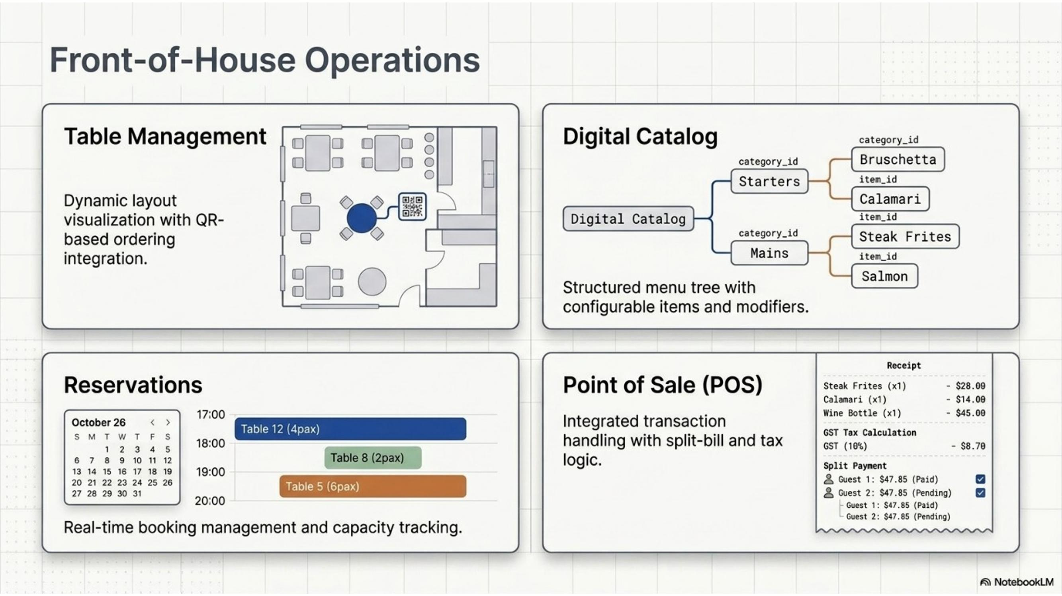
Figure 3: Front-of-house screens — dynamic table layout with QR ordering, structured menu catalog, reservation timeline, and split-bill POS receipt.

5.2 Back-of-House — Kitchen Display, Inventory, Staff Roster
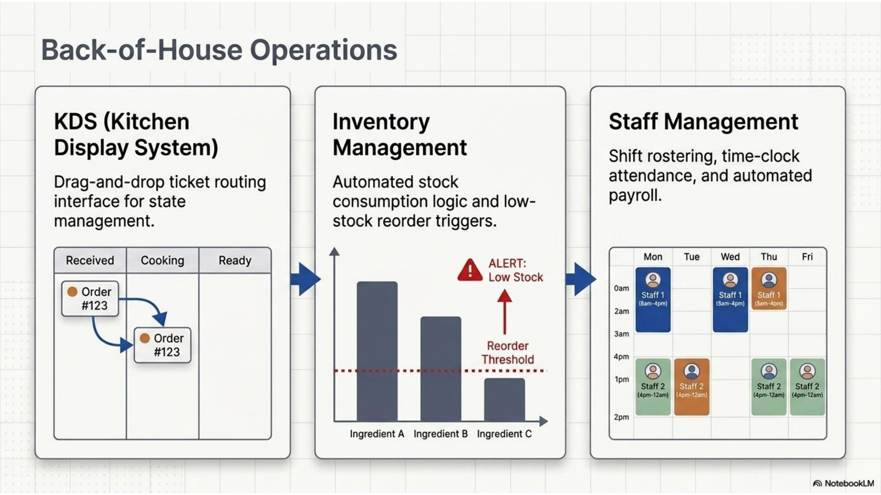
Figure 4: Back-of-house screens — KDS Kanban board, stock-level chart with reorder alert, and weekly staff roster.

5.3 Guest-Facing Digital Ordering
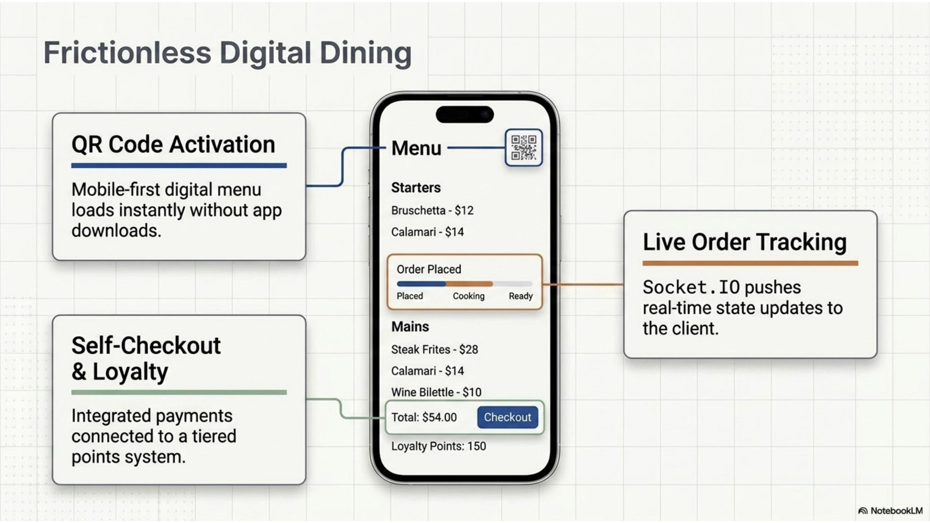
Figure 5: Mobile guest ordering screen — QR menu access, live order-status stepper, and self-checkout with loyalty points.

5.4 Executive Analytics Dashboard
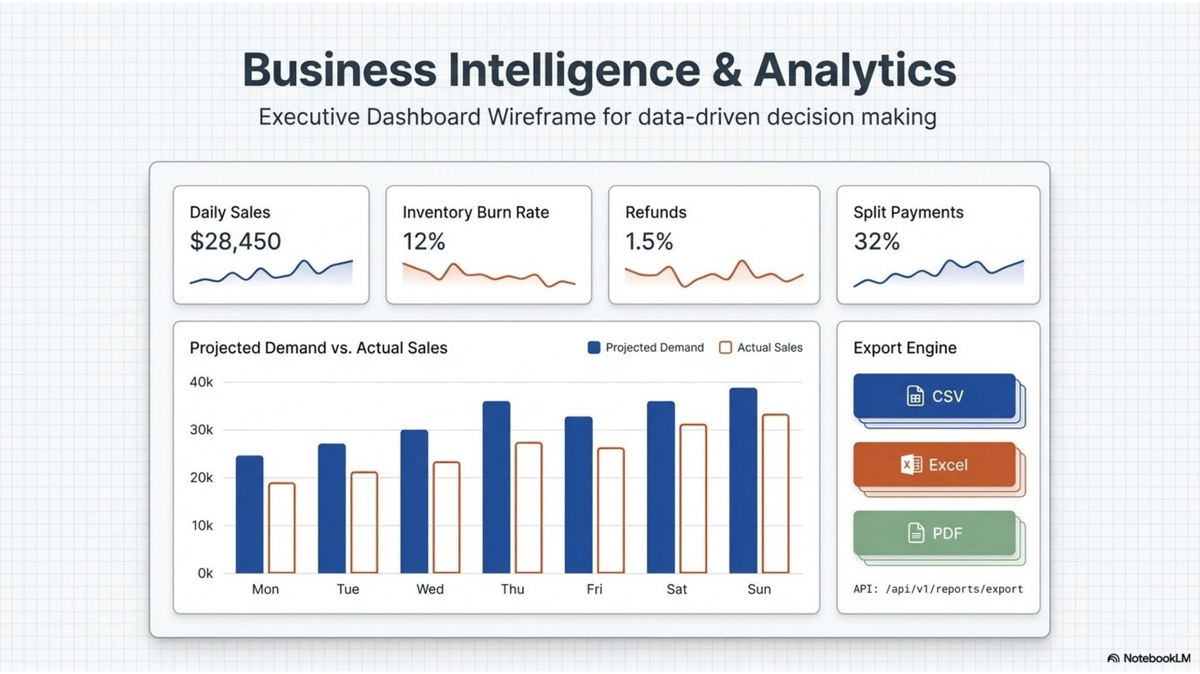
Figure 6: Executive dashboard wireframe — daily KPIs, projected-vs-actual demand chart, and multi-format export engine.

5.5 Multi-Tenant Isolation & Request Flow
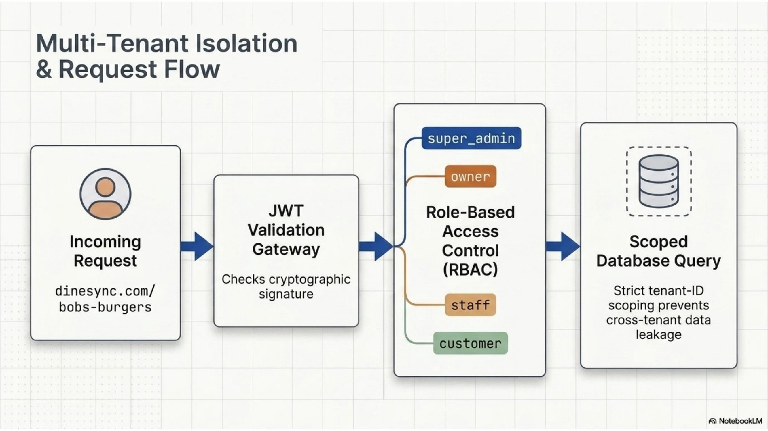
Figure 7: Every incoming request passes through JWT validation and RBAC before a tenant-scoped database query is executed.

5.6 Super Admin — Subscription Tiers
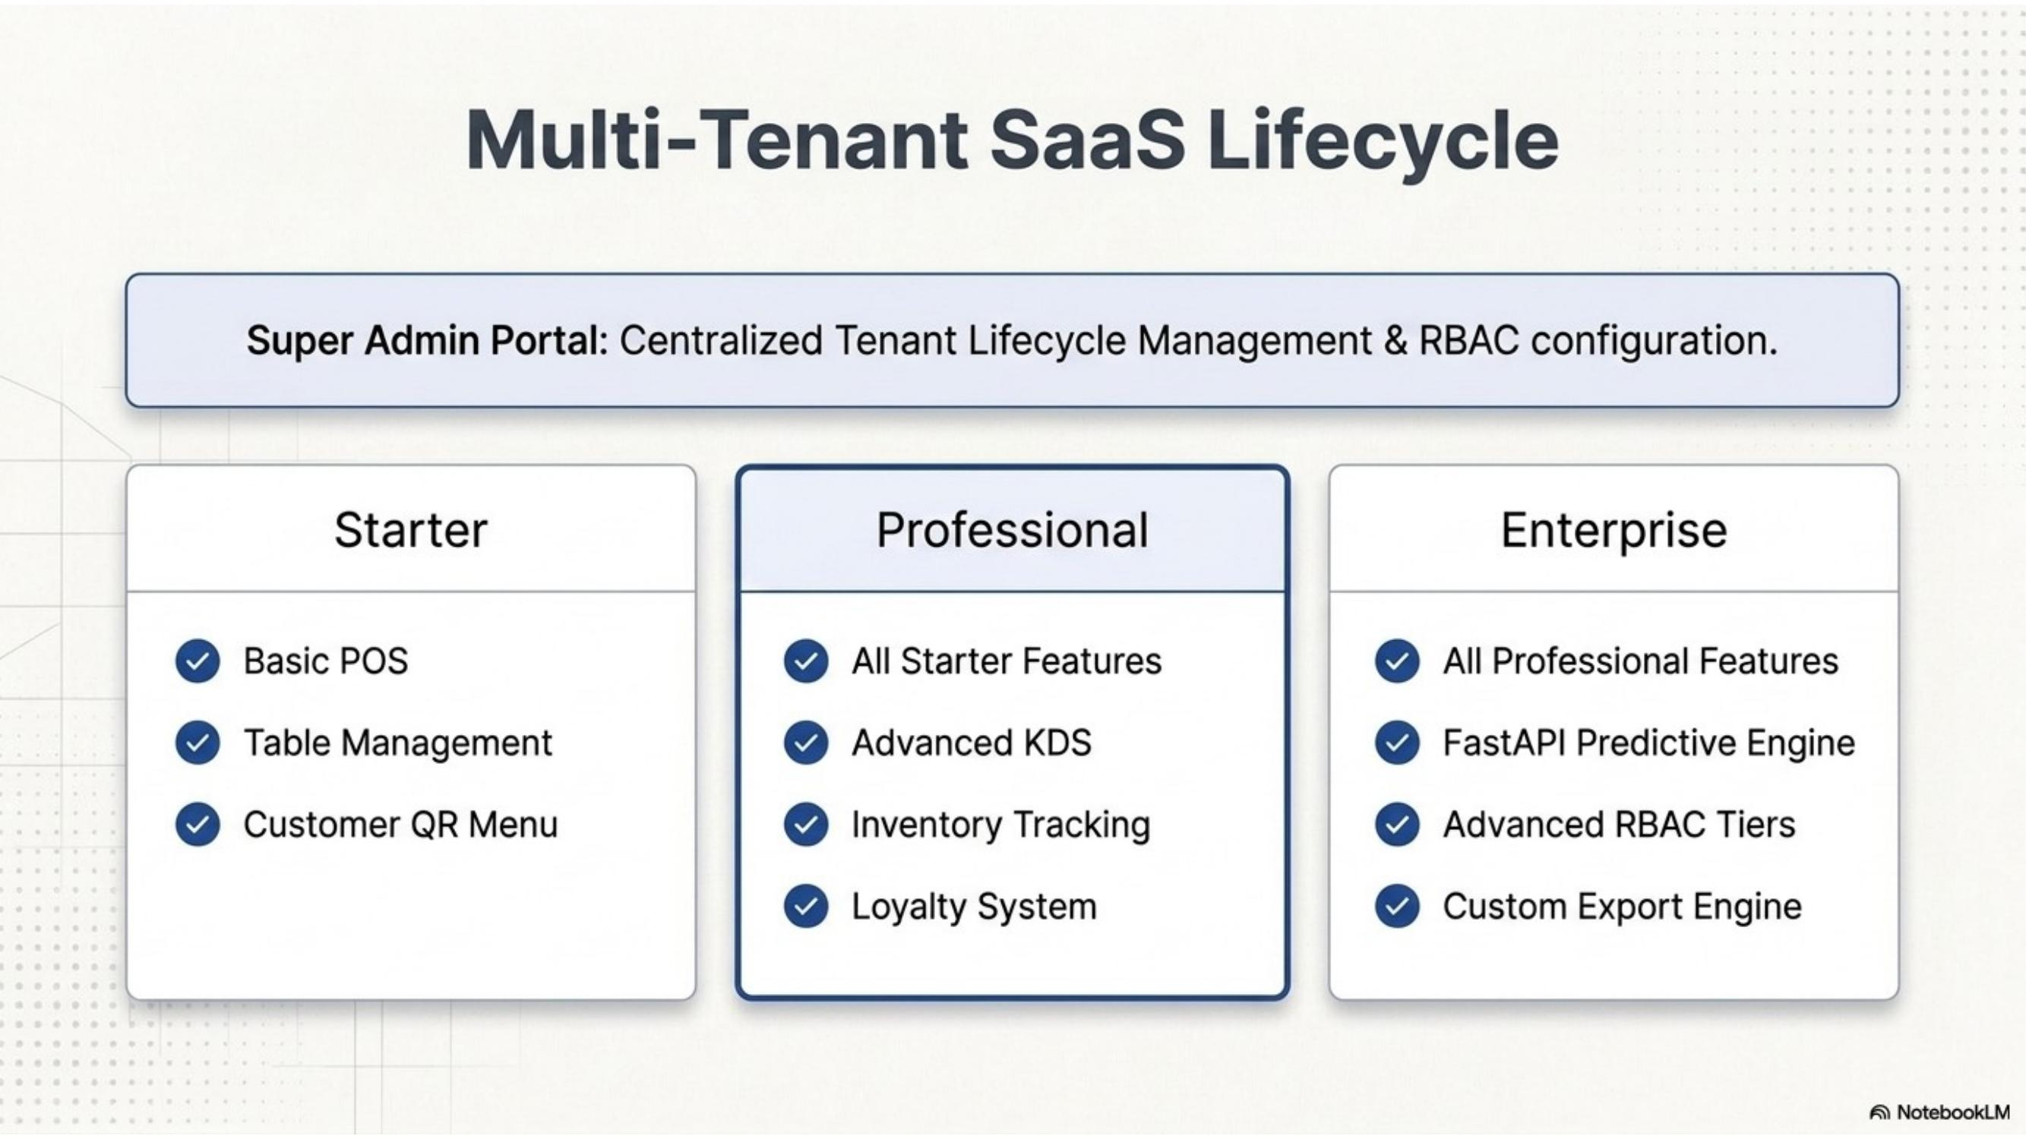
Figure 8: Super Admin portal — centralized tenant lifecycle management across Starter, Professional, and Enterprise plans.

6. Algorithm Design & Flowcharts

6.1 Order-to-Billing Algorithm
This is the core operational algorithm of the system, tracing an order from placement to payment.
Step | Action
1 | Guest scans table QR (or cashier opens POS) and browses the digital menu.
2 | Items and modifiers are selected and the order is placed.
3 | Order.pre("validate") generates a unique order number; the order is persisted with status = Pending.
4 | The order is automatically split into one KitchenTicket per station (Main Kitchen, Tandoor, Bar, Dessert, Beverage).
5 | Socket.IO broadcasts the new ticket(s) to the relevant KDS terminal(s) in real time.
6 | Kitchen staff transition each ticket item through Preparing → Ready (drag-and-drop on the KDS Kanban board).
7 | On item completion, the linked Recipe is used to auto-decrement ingredient stock (see 6.3); the guest's live order tracker updates over WebSocket in parallel.
8 | The order is marked Served, then Completed once billed.
9 | The cashier (or guest, via self-checkout) generates an Invoice: subtotal + service charge + GST − discounts, computed server-side.
10 | If a split bill is requested, an equal or itemized split is calculated across guests.
11 | Payment is captured (Cash/Card/UPI); the invoice status becomes Paid.
12 | Loyalty points are accrued to the customer profile, completing the cycle.
Pseudocode (order status transition guard):
function transitionOrder(order, nextStatus):
if not isValidTransition(order.orderStatus, nextStatus):
raise InvalidTransitionError
order.orderStatus = nextStatus
order.save()
socket.emit("order:status", { orderId, nextStatus }) // tenant-scoped room
if nextStatus == "Completed":
generateInvoice(order)

6.2 Kitchen Ticket Routing Algorithm
Each order item carries a category/station mapping. When an order is confirmed, items are grouped by station and one KitchenTicket document is created per station with only that station's items, so each kitchen counter sees only what is relevant to it. A compound index on {restaurant, status} keeps the KDS query (typically "all non-Served tickets for this branch") fast regardless of historical ticket volume.

6.3 Inventory Auto-Deduction Algorithm
on kitchenTicketItem.status -> "Ready":
recipe = Recipe.findOne({ menuItem: item.menuItem })
for each (ingredient, qtyPerUnit) in recipe.ingredients:
deduction = qtyPerUnit * item.quantity
ingredient.currentStock -= deduction
StockTransaction.create({ ingredient, type: "consumption", quantity: deduction })
if ingredient.currentStock <= ingredient.reorderLevel:
raise LowStockAlert(ingredient)
ingredient.save()
This keeps stock levels continuously accurate without manual counting, and is the data source for the AI inventory-depletion forecast.

6.4 AI Predictive Forecast Algorithm
Illustrated for the Sales Forecast model; the Demand Prediction and Inventory Depletion models follow the same request/fallback shape.
Step | Action
1 | Frontend/backend requests a forecast from FastAPI: GET /api/v1/sales-forecast?horizon=7|30.
2 | The AI service fetches historical order and revenue data for the tenant from MongoDB.
3 | Data is cleaned and aggregated into daily/weekly buckets.
4 | If sufficient history exists, a trend + seasonality model produces the forecast and a confidence interval.
5 | If history is insufficient, the service (or the Node.js bridge) falls back to a simple historical-average heuristic.
6 | The forecast JSON is returned to the Node.js API, which applies a timeout guard and up to 2 retries.
7 | The frontend AI Dashboard renders the result using Recharts, alongside a stated confidence/accuracy indicator.

6.5 Graceful Degradation (AI Fallback) Algorithm
DineSync AI is designed so a failure of the AI microservice never blocks a sale. The fallback loop is illustrated below.
Step | Action
1 | Node.js backend requests a forecast/recommendation from FastAPI.
2 | A network or service failure occurs (timeout, connection refused, 5xx response).
3 | Exponential-backoff retry logic engages (bounded number of attempts).
4 | If failures persist, the system routes to fallback heuristics — e.g., reverting to standard historical averages computed directly in Node.js.
5 | Graceful degradation: the POS, KDS, billing, and every core operational path continue running normally; only the AI insight panel shows a reduced-confidence or "heuristic" result.

7. Security & Multi-Tenancy Design
- Authentication: stateless JWT carrying { id, role, restaurantId }, verified on every protected route by a protect middleware.
- Authorization: an authorize(...roles) middleware restricts endpoints to the appropriate RBAC role(s): super_admin, owner, manager, staff, customer.
- Tenant isolation: an enforceTenantIsolation middleware compares the JWT's restaurantId against the requested resource and injects a mandatory restaurant filter into every database query, guaranteeing scoped database access as shown in Figure 7.
- Auditability: platform-level actions (tenant approval, plan changes, feature-flag toggles) are written to an append-only audit log, and authentication/security-relevant events to a separate security log.

8. Conclusion
This design realizes the requirements defined in the SRS through a modular, tenant-isolated, real-time architecture. The clean separation between the transactional core and the AI microservice, combined with recipe-driven inventory automation and a unified real-time event bus, gives DineSync AI both the operational reliability restaurants need day-to-day and the predictive intelligence layer that differentiates it from conventional POS systems.

