DineSync AI
Intelligent Multi-Tenant SaaS Ecosystem for Predictive Restaurant Operations
Project Synopsis
A Cloud-Based, AI-Augmented Restaurant Operations Platform

Submitted by: [Student Name(s) / Roll Number]
Under the guidance of: [Guide / Supervisor Name]
Department: [Department Name]
Institution: [College / University Name]
Academic Year: [20XX – 20XX]

Table of Contents
1. Introduction 3
2. Problem Statement 3
3. Existing System and its Limitations 4
4. Proposed System 4
5. Objectives 5
6. Scope of the Project 5
7. Key Modules Overview 6
8. Technology Stack 6
9. Expected Outcomes 7
10. Feasibility Study (Summary) 7
11. Future Enhancements 7
12. Conclusion 8
13. References 8

1. Introduction
The Indian and global restaurant industry runs on razor-thin margins and razor-tight timing. A dine-in guest waiting for a table, a kitchen chasing a ticket, a manager reconciling cash at midnight, and a supplier invoice sitting unpaid are all part of the same operational surface, yet in the vast majority of small and mid-sized restaurants, these functions are handled by disconnected tools, paper registers, or no system at all.
DineSync AI is proposed as a single, cloud-native, multi-tenant Software-as-a-Service (SaaS) platform that unifies Point-of-Sale (POS) billing, a real-time Kitchen Display System (KDS), QR-code based guest self-ordering, Customer Relationship Management (CRM) and loyalty, inventory and vendor management, staff attendance and payroll, business analytics, and a dedicated Artificial Intelligence microservice that turns historical operating data into forward-looking forecasts and recommendations.
The system is designed from the ground up as a multi-tenant application, a single deployment can securely host many independent restaurant businesses ("tenants"), each with its own isolated data, branches, staff, menu, and subscription plan, administered centrally through a Super Admin console.

2. Problem Statement
Restaurant operators today typically depend on a fragmented "spaghetti" technology stack: a standalone POS terminal, a separate spreadsheet or notebook for inventory, a third tool for staff shifts, and no shared source of truth between them. This produces several recurring problems:
- Manual, error-prone order transfers between the front counter and the kitchen, causing delays and missed items.
- Blind inventory management, stock-outs and over-ordering are discovered only after they cause a problem.
- Zero demand forecasting, purchasing and staffing decisions are based on gut feel rather than data.
- No unified view of customers, so loyalty and repeat-visit opportunities are lost.
- Time-consuming, error-prone manual billing, tax calculation, and bill-splitting.
- No predictive intelligence: owners react to problems (a busy Saturday, a spoiled ingredient) instead of anticipating them.

3. Existing System and its Limitations
Most existing restaurant software falls into one of two categories. Legacy, single-purpose POS systems (e.g., traditional billing terminals) handle transactions well but have no meaningful data intelligence, no guest-facing digital ordering, and no cross-module visibility. On the other end, large enterprise restaurant-management suites offer breadth but are expensive, hardware-dependent, and built for large chains, making them inaccessible for independent restaurants and small chains. Neither category offers a genuinely unified, real-time, AI-driven operating system built for multi-branch, multi-tenant use at an affordable price point.

4. Proposed System
DineSync AI proposes a three-pillar architecture that keeps each concern cleanly separated while unifying them through a shared data layer and real-time event bus:
- Interactive Floor (Frontend) — a React/Vite/Tailwind single-page application serving the POS, KDS, admin dashboards, and the customer-facing digital ordering experience.
- Operational Brain (Backend Core) — a Node.js/Express REST API backed by MongoDB, with Socket.IO powering real-time order, kitchen, and notification updates.
- Predictive Engine (AI Microservice) — a Python/FastAPI service that hosts eight purpose-built predictive and NLP models covering sales, demand, inventory, wait-time, recommendations, and sentiment.
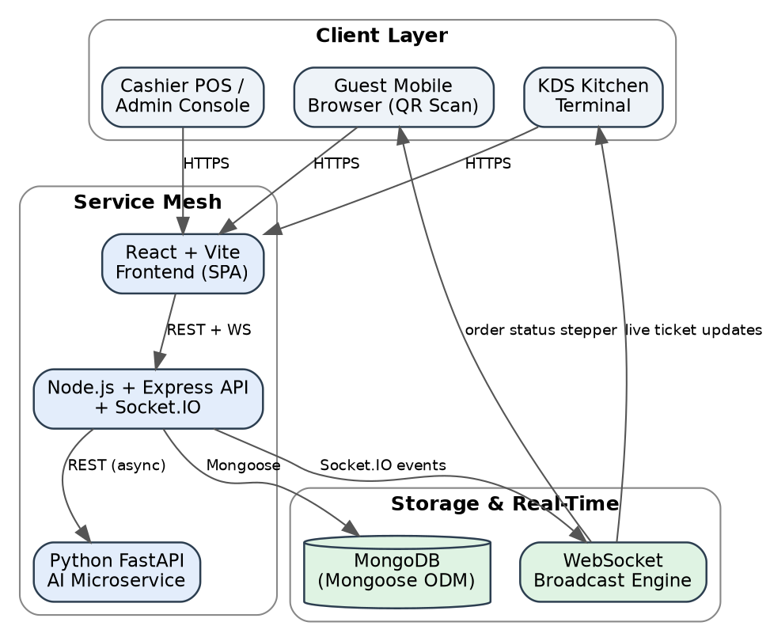
Figure 1: High-level three-tier system architecture of DineSync AI.

5. Objectives
- To design and build a single, real-time platform that unifies POS billing, kitchen operations, guest self-ordering, inventory, CRM, staff management, and analytics for restaurants.
- To implement secure multi-tenant data isolation with role-based access control (RBAC), enabling one platform deployment to serve many independent restaurant businesses.
- To provide a frictionless, zero-download QR-based digital ordering and live order-tracking experience for dine-in guests.
- To automate inventory consumption using recipe-linked stock deduction and low-stock alerting.
- To integrate a dedicated AI microservice that delivers sales forecasting, demand prediction, inventory depletion forecasting, wait-time prediction, smart menu optimization, food-waste risk detection, customer recommendations, and sentiment analysis.
- To provide restaurant owners and platform administrators with real-time, exportable business-intelligence dashboards.
- To ensure the system degrades gracefully — core operations (billing, kitchen tickets) continue uninterrupted even if the AI microservice is unavailable.

6. Scope of the Project
The scope of DineSync AI covers the complete restaurant operations lifecycle for dine-in, takeaway, and QR-ordered service across one or more branches of a tenant restaurant:
- Tenant onboarding, subscription tiers (Starter / Professional / Enterprise), and platform-level Super Admin governance.
- Branch, table, and reservation management with real-time floor status.
- Menu and category management with modifiers, dietary tags, and pricing.
- Order capture (POS and guest QR), kitchen ticket routing, and billing with GST and split-payment support.
- Recipe-linked inventory, purchase orders, and supplier ledgers.
- Customer CRM with tiered loyalty points and feedback capture.
- Employee shift rostering, attendance, leave, and payroll.
- Multi-channel notifications (Email, SMS, WhatsApp, Push, in-app) driven by scheduled and event-based triggers.
- AI-driven forecasting and recommendation features, and exportable analytics (CSV, Excel, PDF).
Out of scope for the current version: native mobile applications, direct integration with third-party delivery aggregators (UberEats, DoorDash), and payment gateway certification for production card processing — these are identified as future roadmap items (Section 11).

7. Key Modules Overview
# | Module | Core Capability
1 | Auth & Tenant | Multi-tenant registration, JWT authentication, OTP verification, password reset
2 | Branch Management | Multi-location branch profiles, operating schedules
3 | Menu Management | Categories, items, modifier groups, dietary/spice tags
4 | Table Management | Floor layout, table status, dynamic QR code generation
5 | Reservation Management | Booking, overlap checking, grid/calendar views
6 | Order Management (POS) | Order capture, modifiers, bill split/merge, real-time sync
7 | Kitchen Display System | Station-wise ticket routing, Kanban board, prep timers
8 | Inventory Management | Recipe-based auto consumption, reorder alerts, stock audit
9 | Customer CRM & Loyalty | Tiered loyalty, points accrual/redemption, feedback
10 | Billing & Payments | GST computation, service charge, split-payment, e-receipts
11 | Employee & Payroll | Shift rostering, clock-in/out, leave, monthly payroll
12 | Reports & Analytics | Aggregation-pipeline reports, PDF/Excel/CSV export
13 | AI & Predictive Intelligence | Eight predictive/NLP models via FastAPI microservice
14 | Customer Experience Platform | Public QR ordering, digital menu, live order tracking
15 | Notifications & Cron | Multi-channel alerts, scheduled jobs, alert center
16 | Super Admin & SaaS Console | Tenant lifecycle, subscription plans, feature flags, audit log

8. Technology Stack
Layer | Technology
Frontend | React 18, Vite, Tailwind CSS, shadcn/ui, Zustand (state), Recharts, Socket.IO Client, Axios
Backend API | Node.js, Express.js, MongoDB with Mongoose ODM, Socket.IO, Node-cron, Nodemailer
AI Microservice | Python 3.10+, FastAPI, Uvicorn, PyData stack (predictive models & NLP)
Database | MongoDB (document-oriented, tenant-scoped collections)
Authentication | JSON Web Tokens (JWT) with Role-Based Access Control (RBAC)
Real-time layer | Socket.IO event broadcasting for KDS, order tracking, and alerts

9. Expected Outcomes
- A fully functional, deployable multi-tenant restaurant management platform demonstrating end-to-end order-to-billing flow.
- Verified real-time synchronization between POS, KDS, and the guest-facing order tracker.
- Working predictive models for sales, demand, and inventory depletion forecasting with measurable accuracy.
- A secure RBAC and tenant-isolation model verified against cross-tenant data leakage.
- An executive analytics dashboard with exportable reports for data-driven decision-making.

10. Feasibility Study (Summary)

Technical Feasibility
All chosen technologies (React, Node.js, MongoDB, FastAPI) are open-source, well-documented, and have strong community/enterprise support, making the stack technically feasible for a small team to build and maintain.

Economic Feasibility
The stack relies entirely on open-source frameworks and can be hosted on commodity cloud infrastructure, keeping development and hosting costs low relative to licensing-based commercial POS suites.

Operational Feasibility
The QR-based guest ordering flow requires no app download, and the POS/KDS interfaces are designed for minimal staff training, supporting quick real-world adoption.

11. Future Enhancements
- Continuous AI model retraining, incorporating external datasets such as local weather patterns into demand forecasts.
- Native mobile applications for guests and staff (React Native).
- Third-party delivery aggregator integrations (UberEats, DoorDash) via a unifying order API layer.

12. Conclusion
DineSync AI addresses a clearly observable gap in the restaurant technology market: the absence of an affordable, unified, and genuinely intelligent operating system for independent and mid-sized restaurants. By combining real-time operational tooling with a purpose-built predictive AI layer inside a secure multi-tenant SaaS architecture, the project demonstrates both sound full-stack software engineering practice and practical business value.

13. References
- React documentation — https://react.dev
- Express.js documentation — https://expressjs.com
- MongoDB & Mongoose documentation — https://www.mongodb.com , https://mongoosejs.com
- FastAPI documentation — https://fastapi.tiangolo.com
- Socket.IO documentation — https://socket.io
- DineSync AI project repository (source code and technical documentation).

