DineSync AI
Intelligent Multi-Tenant SaaS Ecosystem for Predictive Restaurant Operations
Software Requirements Specification
Prepared in accordance with IEEE 830 conventions

Prepared by: [Student Name(s) / Roll Number]
Reviewed by: [Guide / Supervisor Name]
Document Version: 1.0
Date: [DD / MM / YYYY]

Table of Contents
1. Introduction 3
1.1 Purpose 3
1.2 Document Conventions 3
1.3 Intended Audience 3
1.4 Project Scope 4
1.5 References 4
2. Overall Description 4
2.1 Product Perspective 4
2.2 Product Functions 5
2.3 User Classes and Characteristics 5
2.4 Operating Environment 6
2.5 Design and Implementation Constraints 6
2.6 Assumptions and Dependencies 6
3. System Features (Functional Requirements) 7
4. External Interface Requirements 11
5. Non-Functional Requirements 12
6. Other Requirements 13
Appendix A: Glossary 14

1. Introduction

1.1 Purpose
This Software Requirements Specification (SRS) describes the functional and non-functional requirements of DineSync AI, a multi-tenant, AI-augmented restaurant management SaaS platform. It is intended to serve as the single reference for the design, implementation, and verification of the system, and to establish a shared understanding of scope between the development team and evaluators.

1.2 Document Conventions
Functional requirements are identified using the pattern FR-<Module>-<Number> (e.g., FR-ORD-03). Priority is expressed as High, Medium, or Low. The keywords "shall" and "must" denote mandatory requirements; "should" denotes a recommended but non-mandatory requirement.

1.3 Intended Audience
- Development team — for implementation guidance and acceptance criteria.
- Project guide / evaluators — for scope verification and academic assessment.
- Restaurant owners / operations staff (as prospective end users) — for functional review.

1.4 Project Scope
DineSync AI covers tenant and branch management, menu and table management, reservations, POS order capture, kitchen ticket routing, recipe-linked inventory, customer CRM and loyalty, billing and payments, employee attendance and payroll, multi-channel notifications, reporting and analytics, a public QR-based guest ordering experience, and an AI microservice delivering predictive forecasts and recommendations. Platform governance (tenant approval, subscription plans, feature flags, audit logging) is handled through a Super Admin console.

1.5 References
- IEEE Std 830-1998 — IEEE Recommended Practice for Software Requirements Specifications.
- DineSync AI system README and architecture index (project repository).
- React, Express, MongoDB/Mongoose, FastAPI official documentation.

2. Overall Description

2.1 Product Perspective
DineSync AI is a new, self-contained product composed of three cooperating services: a React single-page frontend, a Node.js/Express REST + WebSocket backend, and a Python/FastAPI AI microservice, all backed by a shared MongoDB data store. The backend is the system of record and applies tenant-scoping to every query; the AI service is stateless and is invoked by the backend over HTTP.
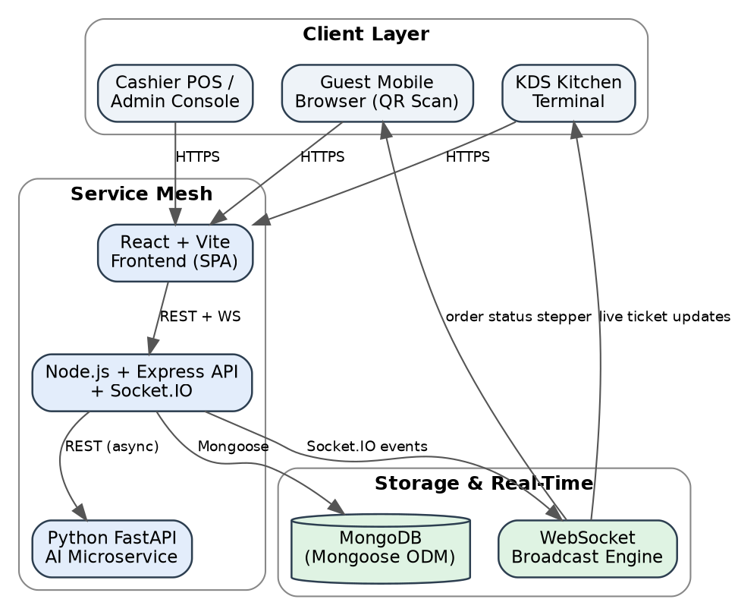
Figure 1: Product perspective — three-tier service architecture.

2.2 Product Functions
At a high level the product performs the following functions: tenant/user authentication and authorization; menu, table, and reservation administration; order capture and kitchen ticket orchestration; inventory consumption and procurement tracking; customer loyalty management; billing and payment processing; staff attendance/payroll; notification dispatch; analytics and reporting; and AI-based forecasting and recommendations. A detailed breakdown appears in Section 3.

2.3 User Classes and Characteristics
Role | Description | Typical Access
super_admin | Platform operator; not attached to a single tenant | Super Admin console — tenant approval, plans, feature flags, audit/security logs
owner | Restaurant / tenant owner | Full access within their tenant: all modules, branches, and settings
manager | Branch-level operations manager | Day-to-day operational modules (orders, kitchen, inventory, staff, reports) for assigned branch(es)
staff | Cashier, waiter, kitchen staff | Scoped access to POS, KDS, or table modules depending on assignment
customer | Dine-in guest / loyalty member | Public QR ordering, live order tracking, self-checkout, loyalty dashboard

2.4 Operating Environment
- Server-side: Node.js v18+ runtime, Python 3.10+ runtime, MongoDB (self-hosted or Atlas).
- Client-side: any evergreen desktop or mobile browser (Chrome, Edge, Safari, Firefox) for staff consoles, KDS terminals, and guest QR ordering — no native app installation required.
- Network: HTTPS for all client-server traffic; WebSocket (Socket.IO) for real-time channels.

2.5 Design and Implementation Constraints
- All persistent data must be scoped by restaurant (tenant) identifier to guarantee isolation.
- The AI microservice must be callable independently of the core transactional path; core POS/KDS operations must not block on AI service availability.
- Financial calculations (GST, service charge, split bills) must be performed server-side to prevent client-side tampering.

2.6 Assumptions and Dependencies
- Restaurants have reasonably reliable internet connectivity at the point of sale.
- Guests using QR ordering carry a smartphone with a modern mobile browser.
- GST/tax rules are configured per tenant and assumed accurate as entered by the tenant owner.

3. System Features (Functional Requirements)

3.1 Authentication & Tenant Management
ID | Requirement | Priority
FR-AUTH-01 | The system shall allow a new restaurant to register as a tenant with a unique slug/subdomain identifier. | High
FR-AUTH-02 | The system shall authenticate users via email/password and issue a signed JWT containing user id, role, and restaurant id. | High
FR-AUTH-03 | The system shall verify new accounts via a One-Time Password (OTP) sent to the registered contact. | High
FR-AUTH-04 | The system shall support a self-service password reset flow. | Medium
FR-AUTH-05 | The system shall reject any request whose JWT tenant id does not match the resource being accessed (tenant isolation). | High

3.2 Branch, Menu & Table Management
ID | Requirement | Priority
FR-BRN-01 | The system shall allow an owner to create and manage multiple branches per tenant, each with its own address and operating schedule. | High
FR-MNU-01 | The system shall allow management of menu categories and items, including price, description, dietary tags, and image. | High
FR-MNU-02 | The system shall support configurable modifier groups per menu item (required/optional, single/multi-select, min/max selection). | High
FR-TBL-01 | The system shall allow creation of tables with number, capacity, type (Indoor/Outdoor/VIP/Private) and status. | High
FR-TBL-02 | The system shall generate a unique QR code per table that deep-links to that table's digital ordering session. | High

3.3 Reservation Management
ID | Requirement | Priority
FR-RES-01 | The system shall allow staff to create a reservation with customer details, guest count, date, time, and duration. | High
FR-RES-02 | The system shall prevent double-booking by checking for time-overlaps on the same table. | High
FR-RES-03 | The system shall track reservation status through Pending, Confirmed, Seated, Completed, Cancelled, and No-Show. | Medium
FR-RES-04 | The system shall present reservations in both grid and calendar views. | Low

3.4 Order Management (POS)
ID | Requirement | Priority
FR-ORD-01 | The system shall allow creation of an order of type Dine-In, Takeaway, Delivery, or QR Order. | High
FR-ORD-02 | The system shall auto-generate a unique, date-stamped order number for every order. | High
FR-ORD-03 | The system shall allow line items with quantity, selected modifiers, and special instructions. | High
FR-ORD-04 | The system shall track order status through Pending, Accepted, Preparing, Ready, Served, Completed, and Cancelled. | High
FR-ORD-05 | The system shall broadcast order and item status changes in real time via Socket.IO to all subscribed clients (KDS, guest tracker, manager dashboard). | High
FR-ORD-06 | The system shall support merging multiple tickets into one bill and splitting one bill across multiple guests (equal or itemized). | Medium

3.5 Kitchen Display System (KDS)
ID | Requirement | Priority
FR-KDS-01 | The system shall automatically route confirmed order items to the correct kitchen station (Main Kitchen, Tandoor, Bar, Dessert, Beverage). | High
FR-KDS-02 | The system shall present kitchen tickets on a Kanban board with drag-and-drop status transitions (Pending → Preparing → Ready → Served). | High
FR-KDS-03 | The system shall record preparation start/ready/served timestamps and compute actual preparation duration per ticket. | Medium
FR-KDS-04 | The system shall support marking a ticket item as Delayed and flag it for manager attention. | Medium

3.6 Inventory & Vendor Management
ID | Requirement | Priority
FR-INV-01 | The system shall maintain ingredient records with current stock, unit, minimum/maximum stock, and reorder level. | High
FR-INV-02 | The system shall automatically decrement ingredient stock according to recipe mappings when a kitchen ticket item is completed. | High
FR-INV-03 | The system shall raise a low-stock alert when current stock falls at or below the configured reorder level. | High
FR-INV-04 | The system shall record supplier purchase orders and update stock on receipt. | Medium
FR-INV-05 | The system shall maintain an auditable stock-transaction ledger for every stock movement. | Medium

3.7 Customer CRM & Loyalty
ID | Requirement | Priority
FR-CRM-01 | The system shall maintain a customer profile with contact details, visit count, total spend, and dietary preference. | Medium
FR-CRM-02 | The system shall assign customers to a loyalty tier (Bronze, Silver, Gold, Platinum) based on configured spend/visit thresholds. | Medium
FR-CRM-03 | The system shall accrue and allow redemption of loyalty points against an order. | Medium
FR-CRM-04 | The system shall allow customers to submit feedback and ratings, which feed the AI sentiment-analysis model. | Low

3.8 Billing & Payments
ID | Requirement | Priority
FR-BIL-01 | The system shall generate an invoice from a completed order with subtotal, discount, service charge, and GST computed server-side. | High
FR-BIL-02 | The system shall support multiple payment methods (Cash, Card, UPI) and partial/split payments. | High
FR-BIL-03 | The system shall assign a unique invoice number and maintain invoice status (Draft, Generated, Paid, Refunded, Cancelled). | High
FR-BIL-04 | The system shall support refund processing against a paid invoice. | Medium

3.9 Employee & Payroll
ID | Requirement | Priority
FR-EMP-01 | The system shall maintain employee records with department, employment type, and salary structure. | Medium
FR-EMP-02 | The system shall support shift rostering and clock-in/clock-out attendance tracking. | Medium
FR-EMP-03 | The system shall support leave request submission and approval workflow. | Low
FR-EMP-04 | The system shall compute monthly payroll from attendance and salary records. | Medium

3.10 Reports & Analytics
ID | Requirement | Priority
FR-REP-01 | The system shall provide an executive dashboard summarizing daily sales, inventory burn rate, refunds, and split-payment ratio. | High
FR-REP-02 | The system shall provide sales, inventory, customer, employee, and financial reports using MongoDB aggregation pipelines. | Medium
FR-REP-03 | The system shall support exporting any report to CSV, Excel, or PDF. | Medium
FR-REP-04 | The system shall support scheduling recurring reports for automatic generation/delivery. | Low

3.11 AI & Predictive Intelligence
ID | Requirement | Priority
FR-AI-01 | The system shall provide 7-day and 30-day sales/revenue forecasts with a confidence indicator. | High
FR-AI-02 | The system shall provide ingredient-level inventory depletion forecasts and auto-reorder recommendations. | High
FR-AI-03 | The system shall classify menu items into Best Sellers, Seasonal Favorites, and Underperforming Items (Smart Menu Matrix). | Medium
FR-AI-04 | The system shall perform sentiment analysis on customer feedback text. | Medium
FR-AI-05 | The system shall predict guest wait time and generate personalized customer recommendations. | Medium
FR-AI-06 | The system shall detect food-waste risk based on slow-moving perishable stock. | Low
FR-AI-07 | If the AI microservice is unreachable, the backend shall fall back to a heuristic (historical-average) estimate rather than failing the request. | High

3.12 Customer Experience Platform (Public QR Ordering)
ID | Requirement | Priority
FR-CXP-01 | The system shall let a guest scan a table QR code and load the digital menu without app installation or login. | High
FR-CXP-02 | The system shall let a guest place an order directly from the digital menu. | High
FR-CXP-03 | The system shall show the guest a live order-status stepper (Accepted → Preparing → Ready → Served) updated over WebSocket. | High
FR-CXP-04 | The system shall support guest self-checkout with digital payment and an e-receipt. | Medium

3.13 Notifications & Super Admin
ID | Requirement | Priority
FR-NOT-01 | The system shall dispatch notifications via Email, SMS, WhatsApp, and Push/in-app channels based on user preference. | Medium
FR-NOT-02 | The system shall run scheduled cron jobs for recurring tasks such as daily reports and stock audits. | Medium
FR-SUP-01 | The system shall let a super_admin approve/suspend tenants and configure subscription plans (Starter/Professional/Enterprise). | High
FR-SUP-02 | The system shall maintain an immutable audit log and security log of platform-level actions. | Medium
FR-SUP-03 | The system shall support feature flags to progressively roll out functionality per tenant/plan. | Low

4. External Interface Requirements

4.1 User Interfaces
- A responsive web application (React SPA) providing role-appropriate dashboards for owner/manager/staff, a dedicated KDS Kanban screen, and a mobile-optimized guest ordering interface.

4.2 API Interfaces
The backend exposes a versioned REST API under /api/v1, summarized below.
Base Path | Purpose
/api/v1/auth | Tenant registration, authentication, JWT issuance
/api/v1/restaurants/:id/categories, /menu-items | Menu catalog management
/api/v1/restaurants/:id/tables | Table layout and QR generation
/api/v1/restaurants/:id/orders | Order creation, modifiers, bill split
/api/v1/restaurants/:id/kitchen | Kitchen ticket status and station logs
/api/v1/restaurants/:id/inventory | Ingredients, purchases, stock adjustments
/api/v1/restaurants/:id/customers | CRM profiles, loyalty accrual/redemption
/api/v1/restaurants/:id/employees | Attendance, shifts, payroll
/api/v1/restaurants/:id/ai | Bridge to the FastAPI predictive engine
/api/v1/public/restaurants/:id | Guest self-ordering, live tracking, self-checkout
/api/v1/super-admin | Platform-level tenant and subscription management

4.3 Communication Interfaces
- HTTPS for all REST calls; the client attaches a Bearer JWT and an x-tenant-slug header on every authenticated request.
- WebSocket (Socket.IO) channels for real-time order, kitchen, and notification events.
- Internal REST calls (with timeout and 2× retry) from the Node.js backend to the FastAPI AI microservice.

5. Non-Functional Requirements

5.1 Performance
- Order-status changes shall propagate to subscribed clients (KDS, guest tracker) within 1–2 seconds under normal load, via the WebSocket channel rather than polling.
- Standard list/detail API responses shall return within 500 ms under nominal load for a single tenant.

5.2 Security
- All authenticated endpoints shall validate a JWT and enforce Role-Based Access Control (RBAC) with the roles super_admin, owner, manager, staff, and customer.
- Every tenant-scoped query shall be filtered by restaurant id to prevent cross-tenant data access, enforced by a dedicated tenant-isolation middleware.
- Passwords shall be stored using a salted one-way hash; sensitive configuration (secrets, credentials) shall be kept out of version control.

5.3 Reliability & Availability
- Core POS and KDS operations shall remain fully functional if the AI microservice is unreachable (graceful degradation with fallback heuristics).
- The system shall use exponential-backoff retry when calling the AI microservice before falling back.

5.4 Usability
- The guest ordering flow shall require no account creation or app download.
- Staff-facing screens (POS, KDS) shall be operable with minimal training, using drag-and-drop and single-tap interactions where practical.

5.5 Scalability & Maintainability
- The system shall support horizontal scaling of the stateless Node.js and FastAPI services behind a load balancer.
- The backend shall follow a feature-based clean architecture (model / service / controller / routes per module) to keep modules independently maintainable.

5.6 Portability
- The system shall be deployable via containerization (Docker) across common cloud environments without code changes.

6. Other Requirements
- Legal/Compliance: GST computation shall follow applicable Indian tax slabs as configured per tenant; the system validates GSTIN format when GST registration is enabled.
- Data Retention: Soft-delete (isDeleted flag) shall be used for tables and orders to preserve historical/audit records instead of hard deletion.
- Internationalization: currency and timezone are configurable per tenant (default INR / Asia-Kolkata) to allow future multi-region deployment.

Appendix A: Glossary
Term | Definition
Tenant | An independent restaurant business hosted on the shared DineSync AI platform, with isolated data.
RBAC | Role-Based Access Control — restricting system actions based on assigned user role.
KDS | Kitchen Display System — the digital ticket board used by kitchen staff.
JWT | JSON Web Token — a signed token used to authenticate API requests.
Modifier | A configurable add-on/variant option attached to a menu item (e.g., size, spice level).
Graceful Degradation | The principle that core functionality continues to operate even when a dependent (non-critical) service fails.

