**CS661-Assignment3**

**Group No-56**

**Member1 - Kriti Majumdar (Roll-22111404)**

**Member2 – Monish Singam S (Roll-231250082)**

1.1) For loading the 3-D data, the “tornado3d_vector.vti” and the python file "rk4.py" should be in the same directory.

1.2) Run the python script in while being in the right directory as "python3 rk4.py” without the quotes.

1.3) Give the input for the seed value co-ordinates i.e x,y and z one by one and press Enter.

1.4) A vtp file named "streamline.vtp" will be generated.

1.5) Open ParaView and click on "File" in the menu.

1.6) Select "Open" and navigate to the location where streamline.vtp is saved.

1.7) In the ParaView interface, select the "Apply" button to display the streamline

The Screenshot of running the python file is given below:

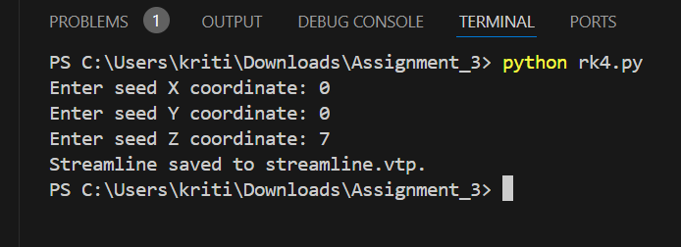

Other Requirements:

1) Python (version 3.9 preferably)

2) vtk (version 9.2.5 (latest))

3) paraview (version 5.12.0 preferably)