**CS661-Assignment1**

**Group No-56**

**Member1 - Kriti Majumdar (Roll-22111404)**

**Member2 – Monish Singam S (Roll-231250082)**

Part 1:

1.1) For loading the 2-D data, the dataset Isabel_2D.vti and the python file "Ass1_Part1.py" should be in the same directory.

1.2) Run the python script in while being in the right directory as "python3 Ass1_Part1.py” without the quotes.

1.3) Enter the isoValue that is desired to be extracted from the dataset. You should enter the values within the range.

1.4) A vtp file named "isoContour.vtp" will be generated.

1.5) Open ParaView and click on "File" in the menu.

1.6) Select "Open" and navigate to the location where isoContour.vtp is saved.

1.7) In the ParaView interface, select the "Apply" button to display the isocontour and change the background to some darker colour to see the iscontour.

The Screenshot of running the python file is given below:

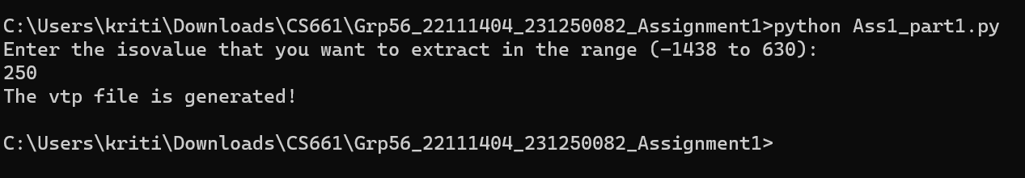

Part 2:

2.1) For loading the 3-D data, the dataset Isabel_3D.vti and the python file "Ass1_Part2.py" should be in the same directory.

2.2) Run the python script in while being in the right directory as "python3 Ass1_Part2.py” without the quotes.

2.3) Enter yes/no on the basis of whether you want the volume rendering process with or without Phong Shading.

2.4) View the data on the rendered window.

2.5) You will see the back view of the data. Rotate the data to see the front view.

The Screenshot of running the python file is given below:



Other Requirements:

1) Python (version 3.9 preferably)

2) vtk (version 9.2.5 (latest))

3) paraview (version 5.12.0 preferably)