**INDIAN INSTITUTE OF TECHNOLOGY, KANPUR**

**DEPARTMENT OF COMPUTER SCIENCE & TECHNOLOGY**

Project Report

On

“Water Pollution sensing using automatic Boat”

By

Kriti Majumdar(22111404)

Somesh Vas(22111056)

Shrutika Jadav(22111082)

Ashee Jain(22111073)

Divyaksh Shukla(231110603)

Harsh Meena(200416)

Praveen Singh(200721)

Contents

1. Introduction 3
2. Objective 4
3. Methodology 5
   1. Hardware Components & Configuration 5
   2. Lawnmower Algorithm 10
4. Discussion 12
5. Conclusion 12
6. Acknowledgement 13

Introduction

The sustenance of life on our planet hinges upon the fundamental essence of clean water. Our lakes, reservoirs, and canals constitute the lifeblood of our ecosystem, serving as indispensable sources of drinking water for communities worldwide. However, the purity of these essential water bodies faces an escalating threat due to the cumulative impact of human activities, culminating in widespread pollution.

The pressing concern of maintaining water purity stems from multifaceted anthropogenic activities, encompassing industrial discharge, agricultural runoff, and urban waste, among others. These factors collectively contribute to the degradation of water quality, posing severe challenges to the ecosystems that rely on these water sources and jeopardizing the health and well-being of countless communities.

Conventional approaches to monitoring water quality often prove inadequate in addressing these mounting concerns. The traditional methods, characterized by labour- intensive sampling processes and periodic assessments, exhibit limitations in providing comprehensive and real-time insights into the dynamic nature of water quality. Consequently, the inability to swiftly detect and respond to fluctuations in water conditions impedes effective conservation and management efforts.

Recognizing these challenges, there is an urgent need for innovative, efficient, and technology-driven solutions that revolutionize the monitoring and maintenance of water purity. By leveraging advancements in technology and data analytics, there exists an opportunity to develop sophisticated systems capable of real-time monitoring, predictive analysis, and informed decision-making, thereby safeguarding the integrity of our vital water resources.

This project endeavours to address the deficiencies inherent in traditional monitoring methods by proposing a comprehensive solution that amalgamates cutting-edge technologies with robust monitoring frameworks. Through a multidisciplinary approach, the aim is to create a system that not only accurately assesses water quality parameters but also facilitates proactive interventions, ensuring the conservation and sustainable utilization of our precious water resources.

In the subsequent sections of this report, we delve deeper into the methodology employed, the outcomes achieved, and the implications of our proposed solution, ultimately contributing to the collective efforts aimed at preserving the purity of our planet's essential water bodies.

Objective

The primary objective of this project is to introduce and implement an innovative and autonomous solution, the Fully Automated Water Pollution Monitor Boat. This cutting-edge technology integrates the computational capabilities of a Raspberry Pi board with state-of-the-art pollution detection sensors, revolutionizing the conventional approach to water quality monitoring.

Specifically, the objectives include:

**Development of Autonomous Monitoring:** Designing and implementing a self-navigating boat equipped with advanced sensors and automated functionalities, ensuring real-time data collection and analysis without human intervention.

**Real-Time Pollution Detection:** Integrating pollution detection sensors capable of accurately assessing and quantifying various water quality parameters, enabling instantaneous identification and analysis of pollutants present in water bodies.

**Data Processing and Analysis:** Leveraging the computational power of the Raspberry Pi board to process and analyze collected data swiftly, facilitating the generation of comprehensive reports and insights into water quality metrics.

**Enhanced Monitoring Efficiency:** Establishing a more efficient and cost-effective method for monitoring water bodies by reducing labour-intensive processes and offering continuous, automated monitoring capabilities.

**Facilitating Informed Decision-Making:** Providing actionable insights derived from real-time data to stakeholders, policymakers, and environmental agencies, enabling proactive interventions and effective management strategies for preserving water quality.

**Promoting Environmental Sustainability:** Contributing to the collective efforts aimed at safeguarding vital water resources, fostering ecosystem health, and promoting sustainable water management practices.

By achieving these objectives, this project aims to pioneer a transformative approach to water quality monitoring, fostering a paradigm shift towards proactive, technology-driven solutions in safeguarding the integrity of our planet's essential water bodies.

Methodology

**Hardware Components and Configuration:**

The foundational cornerstone of the proposed solution for efficient water quality monitoring resides in the meticulously designed and integrated structure of the monitoring boat. This innovative vessel amalgamates cutting-edge technology and precise engineering to achieve autonomous navigation, comprehensive sensor data acquisition, and real-time analysis for effective pollution monitoring in water bodies.

At its core lies a compact yet powerful unit housing a series of intricately interconnected components, ingeniously crafted to orchestrate the boat's autonomous functions and robust data collection capabilities. This central unit encompasses:

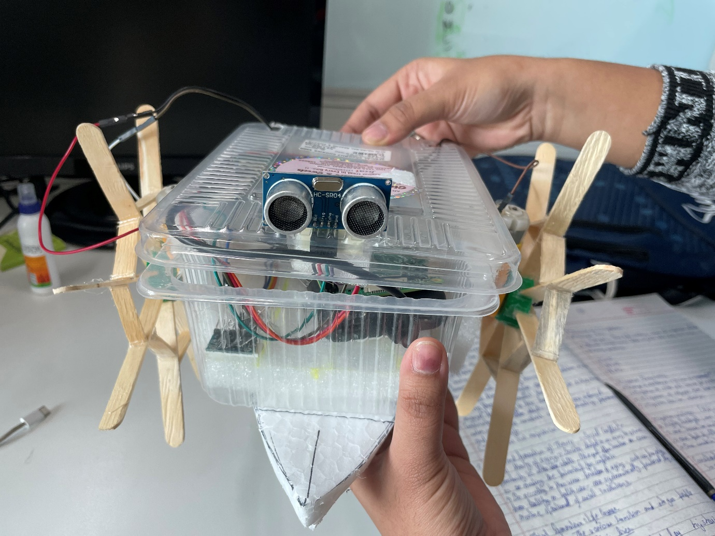

**Fig1: Overall Boat Structure**

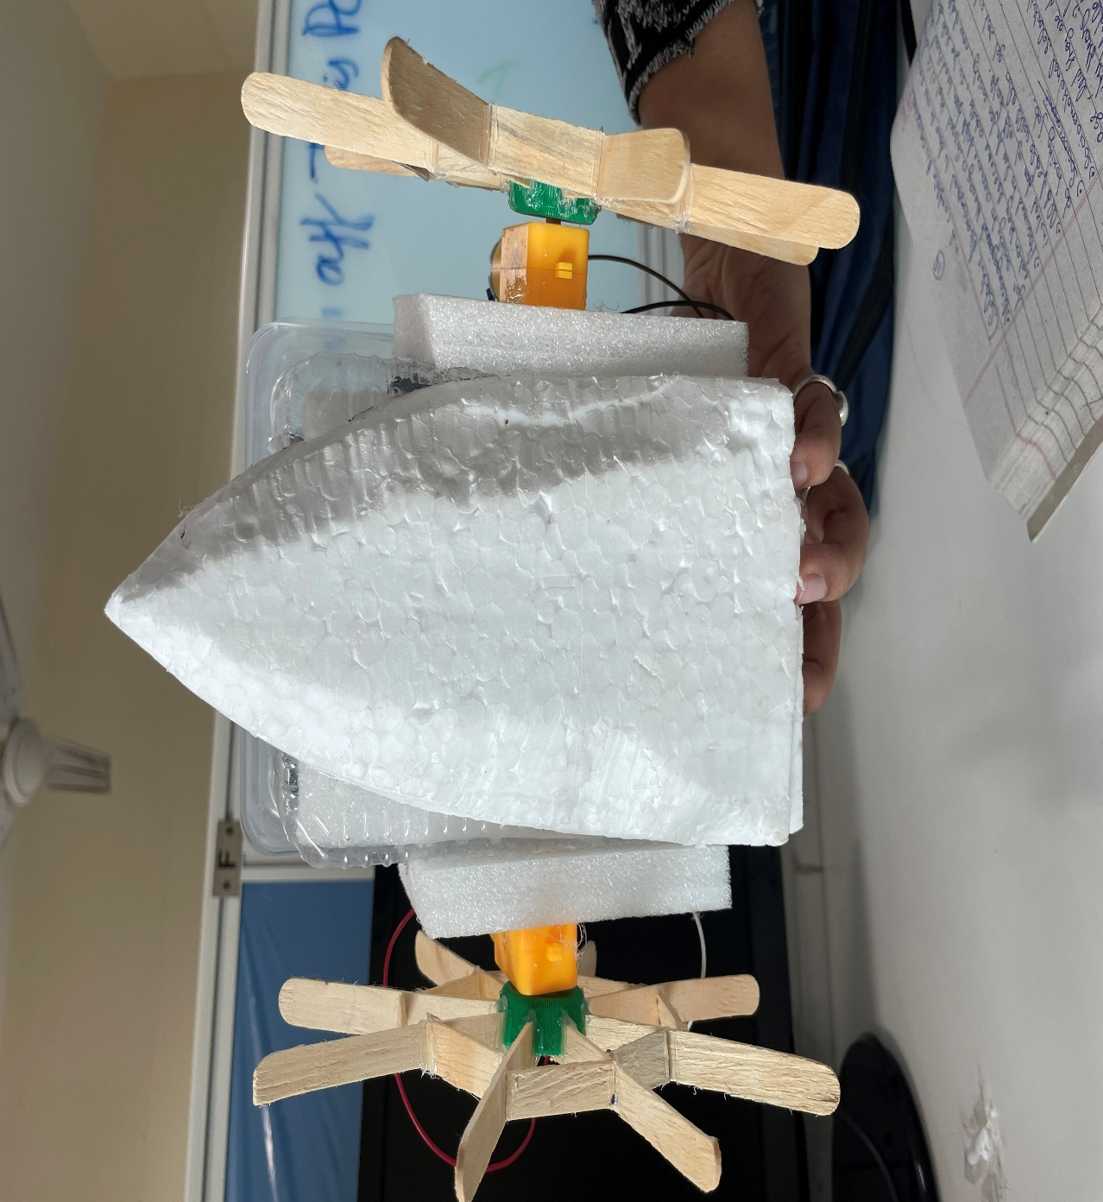

**Fig2:Upside down view of the boat**

**1. Raspberry Pi:**

The Raspberry Pi is a compact, affordable, and versatile single-board computer known for its robust processing capabilities and GPIO pins that facilitate connections to external devices. In projects like the water pollution monitor boat, it serves as the central computing unit, controlling motors, gathering data from sensors like the ultrasonic and IMU sensors, and executing algorithms for autonomous navigation and real-time analysis, making it an indispensable component for complex functionalities and data processing.

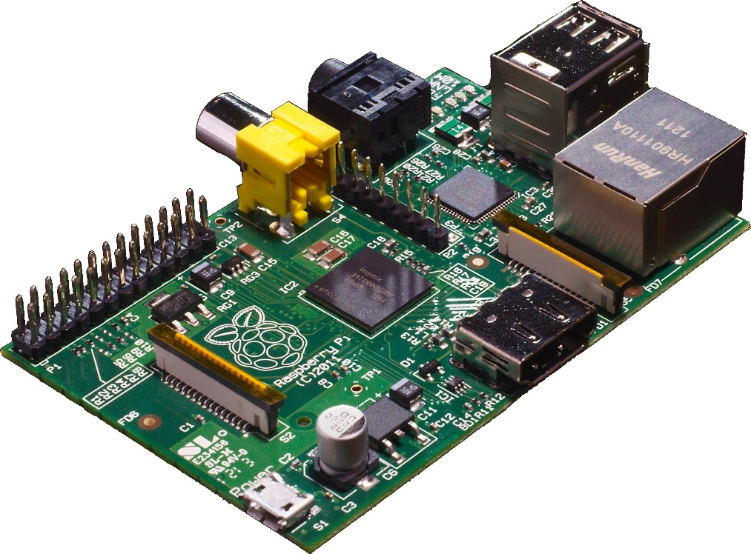

**2. L298N Motor Controller:**

|  |  |
| --- | --- |
| **Raspberry Pi Pins** | **L298n Pins** |
| GPIO 5 | IN1 |
| GPIO 6 | IN2 |
| GPIO 18 | IN3 |
| GPIO 27 | IN4 |
| GPIO 4 | ENA |
| GPIO 13 | ENB |

The L298N is a popular dual H-bridge motor driver IC used for controlling and driving DC motors or stepper motors. It allows bidirectional control of two motors and regulates their speed and direction. With its ability to handle high currents and voltage, the L298N is commonly employed in robotics and projects requiring precise motor control, like the propulsion system in the water pollution monitor boat. 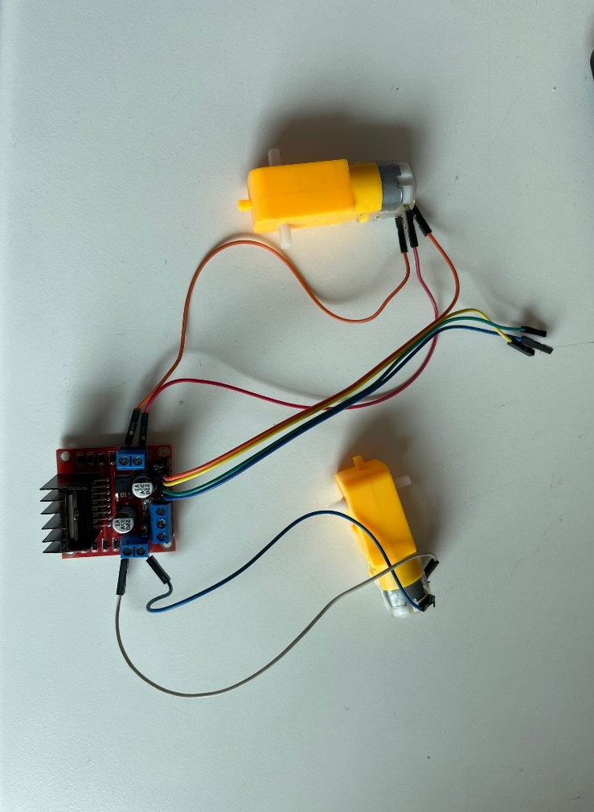

**3. Ultrasonic Sensor:**

Ultrasonic sensors emit high-frequency sound waves and measure the time they take to bounce off an object and return. This time calculation helps determine the distance between the sensor and the object, enabling precise distance measurements without physical contact. In the context of the water pollution monitor boat, ultrasonic sensors play a critical role in obstacle detection and avoidance, ensuring safe navigation by detecting and alerting the boat's system about nearby objects or obstacles in the water.

|  |  |
| --- | --- |
| **Raspberry Pi Pins** | **Device Pins** |
| GPIO 4 | Trigger |
| GPIO 17 | Echo |
| 4 | VCC |
| 8 | GND |

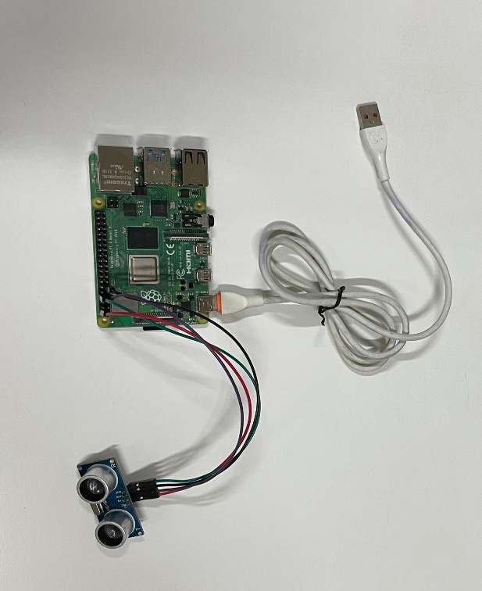

**4. IMU Sensors:**

IMU (Inertial Measurement Unit) sensors are devices that integrate multiple sensors—typically including accelerometers, gyroscopes, and magnetometers—to measure and report an object's orientation, velocity, and gravitational forces. Accelerometers detect linear acceleration, gyroscopes measure angular velocity or orientation changes, and magnetometers track the direction and strength of the magnetic field. By combining data from these sensors, IMUs provide comprehensive information about an object's movement, tilt, and direction in three-dimensional space. We use it to determine the local positioning of our boat. By double integrating the acceleration value it gives we get the displacement value of the boat. By comparing the value with initial position [ i.e (0,0,0) at the bottom right of the pool],we get the exact local position of the boat.

|  |  |
| --- | --- |
| **Raspberry Pi Pins** | **Device Pins** |
| GPIO 2 | SDA |
| GPIO 3 | SCL |

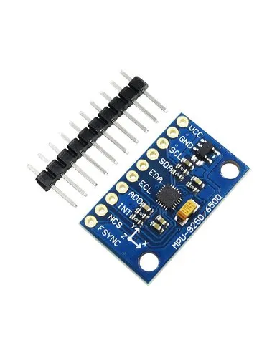

**5. Other Hardwares Used:**

**Plastic Box as Boat Structure**: The plastic box serves as the foundational structure, providing housing and protection for the integrated components while ensuring buoyancy and stability in water.

**Ice Cream Sticks as Wheels:** Ice cream sticks are used as supplementary wheels, enhancing the boat's movement on surfaces outside water, contributing to stability and smoother mobility during handling and testing phases.

**Power Bank as Power Supply:** The power bank acts as a reliable and portable power source, supplying energy to drive the Raspberry Pi, sensors, and motor controllers, ensuring uninterrupted operation during monitoring sessions.

**Male-to-Male/Female Connecting Wires:** These wires facilitate connections between various components on the circuit board, ensuring seamless communication and functioning of the integrated system.

**Thermocol for Balancing:** Thermocol is utilized for balancing, ensuring the boat's stability and proper distribution of weight, contributing to optimal performance during navigation in water bodies.

**Lawnmower Algorithm**

The Lawnmower Algorithm, also known as the Boustrophedon Cellular Decomposition, is a navigation algorithm often used in robotics for area coverage. It's named after the back-and-forth movement pattern of a lawnmower cutting grass.

**Basic Principle:**

1. **Grid-Based Approach:** The algorithm divides the area to be covered into a grid or cells.
2. **Boustrophedon Path Planning:** The robot starts from a designated point and moves in a back-and-forth or zigzag pattern along rows, much like a lawnmower mowing a lawn.
3. **Cell Decomposition:** Each row or cell is traversed entirely in one direction, reaching the end, and then the robot turns and moves in the opposite direction, covering the adjacent row.
4. **Complete Coverage:** This back-and-forth motion continues until the entire area is covered, ensuring systematic and comprehensive coverage without missing any sections.

**Steps Involved:**

1. **Initialization:** Start at a specific point within the area to be covered.
2. **Move in a Straight Line:** Travel in a straight line along a row or cell, covering the distance until reaching the boundary or obstacle.
3. **Turn and Move in the Opposite Direction:** Upon reaching the boundary, turn and move in the opposite direction, covering the adjacent row or cell.
4. **Repeat Until Completion:** Continue this pattern of alternating directions, covering rows or cells until the entire area is thoroughly covered.

**Final Lawnmower Algorithm:**

In our pursuit of refining the initial algorithm, significant updates were made to integrate data from the ultrasonic sensor for precise object detection. Emphasis was placed on optimizing the algorithm's functionality to better mimic the lawnmower motion pattern. Notably, the refined algorithm's detailed functionality is visually depicted in the attached images, providing a comprehensive visual representation of its exact working mechanism.

These enhancements reflect our commitment to improving the algorithm's efficiency, incorporating sensor data for object detection while aligning its movement pattern to emulate the characteristic motion of a lawnmower.

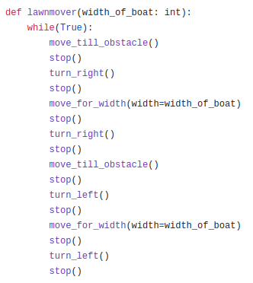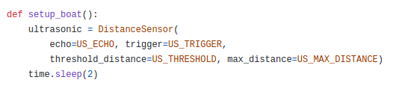

.

**Discussion:**

The successful realization of a Fully Automated Water Pollution Monitor Boat, employing Raspberry Pi technology, represents a significant stride in automated environmental monitoring systems. The achievement of implementing the lawnmower movement pattern demonstrates the boat's sophisticated navigation capabilities, enhancing its efficiency in covering water surfaces comprehensively. Leveraging IMU sensor data for local positioning further bolsters the boat's accuracy in tracking its spatial coordinates within diverse water bodies, crucial for effective monitoring.

However, an obstacle emerged during the project's execution: the inability to seamlessly integrate water pollution measurement sensors due to the absence of an ADC converter. This limitation posed a challenge in acquiring real-time data essential for accurate pollution detection in water bodies, representing a critical area for further development.

**Conclusion:**

The development and successful implementation of the Fully Automated Water Pollution Monitor Boat signify the potential advancements achievable through the integration of cutting-edge technologies like Raspberry Pi in environmental monitoring. While the project achieved milestones in achieving autonomous movement and precise positioning using IMU sensors, the absence of ADC converters created a roadblock in integrating pollution measurement sensors, hampering real-time data acquisition for accurate water quality assessment.

Looking ahead, the integration of ADC converters emerges as a crucial solution to empower the boat's capacity for real-time pollution detection. This project serves as a foundational framework for future enhancements, underscoring the necessity of seamless sensor integration to achieve comprehensive and precise water quality assessment in real-world environmental monitoring applications. The identified challenges pave the way for continued innovation and refinement in the pursuit of effective automated water pollution monitoring solutions.

**Acknowledgement**

The gracious support and guidance extended by Dr. Amitangshu Pal throughout the development of the Fully Automated Water Pollution Monitor Boat project is sincerely appreciated. The project's success owes much to Dr. Pal's expert guidance and insightful contributions, which significantly shaped the project's trajectory.

The assistance and facilitation provided by all CSE staff members in arranging the necessary equipment setup and resources for the project are deeply acknowledged. Their dedicated efforts in ensuring a conducive environment for the project's execution were invaluable.

Additionally, heartfelt thanks are extended to all Teaching Assistants (TAs) for their consistent guidance and support. Their continual availability and guidance greatly contributed to the project's progression and resolution of queries.

This project's accomplishments stand as a testament to the collective efforts and invaluable contributions of Dr. Amitangshu Pal, the CSE staff members, and the dedicated TAs. Their support and assistance were integral in shaping the project's success and fostering a conducive learning environment.