Heart Disease Risk Prediction - End-to-End MLOps Report
MLOps (AIMLCZG523) - Assignment 01
Student: <name, BITS ID> | Repository: <GitHub URL> | Video: <link> | API / access: <URL or "localhost, see section 2">

1. Introduction
Problem. Predict whether a patient has heart disease from 13 routine clinical attributes and serve the model as a containerised, monitored REST API on Kubernetes.
Data. UCI Heart Disease, Cleveland subset (303 patients, 13 features, original 0-4 severity label binarised to presence/absence).
Scope. Acquisition and EDA, feature engineering, two tuned models, MLflow tracking, packaging, unit tests, GitHub Actions CI/CD, Docker, Kubernetes deployment, Prometheus/Grafana monitoring.
Headline result. Logistic Regression was selected (nested-CV ROC-AUC 0.898; 20% hold-out ROC-AUC 0.965, recall 0.93).

2. Setup and installation
python -m venv .venv && source .venv/bin/activate # Windows: .venv\Scripts\activate
pip install -r requirements-dev.txt
python scripts/download_data.py # fetch UCI file, write data/processed/heart_clean.csv
python -m src.heart.eda # figures -> reports/figures
python -m src.heart.train # MLflow runs -> ./mlruns, model -> models/
mlflow ui # http://127.0.0.1:5000
flake8 src api tests scripts && pytest -v
docker build -t heart-api:latest . && docker run -p 8000:8000 heart-api:latest
curl -X POST localhost:8000/predict -H "Content-Type: application/json" -d @scripts/sample_request.json
If UCI is unreachable, the file processed.cleveland.data can be placed manually in data/raw/. Dependencies are split into requirements.txt (training), requirements-serve.txt (slim serving image) and requirements-dev.txt (adds pytest and flake8).

3. Data acquisition and EDA
Acquisition and cleaning (scripts/download_data.py, src/heart/data.py): ? is parsed as missing; duplicates are dropped; the 0-4 label num is binarised (>0 means disease). Missing values (ca: 4, thal: 2; six rows in total) are not filled during cleaning. They are imputed inside the model pipeline so that statistics come only from training folds (no leakage). A schema check (validate_schema) guards column presence.
Class balance. 164 healthy (54.1%) vs 139 diseased (45.9%): near-balanced, so accuracy is meaningful. Recall is still tracked because a false negative (missed disease) is the costly error.
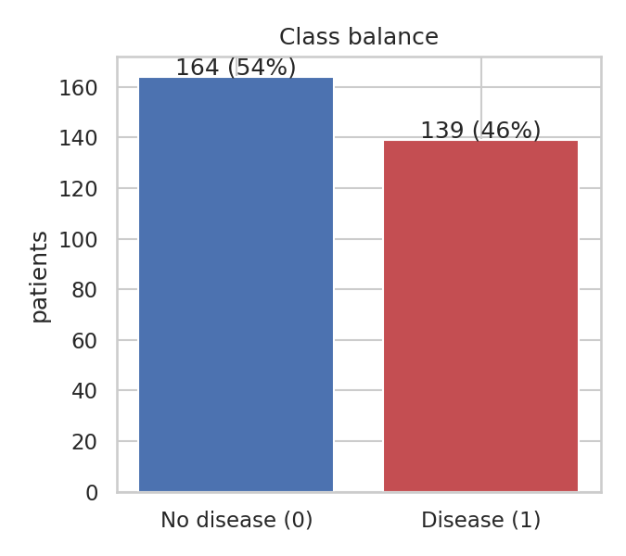
Class balance
Distributions. Diseased patients are older (mean 56.6 vs 52.6), reach a lower maximum heart rate (139 vs 158), and have much higher ST depression oldpeak (1.57 vs 0.59). Cholesterol differs little (251 vs 243).
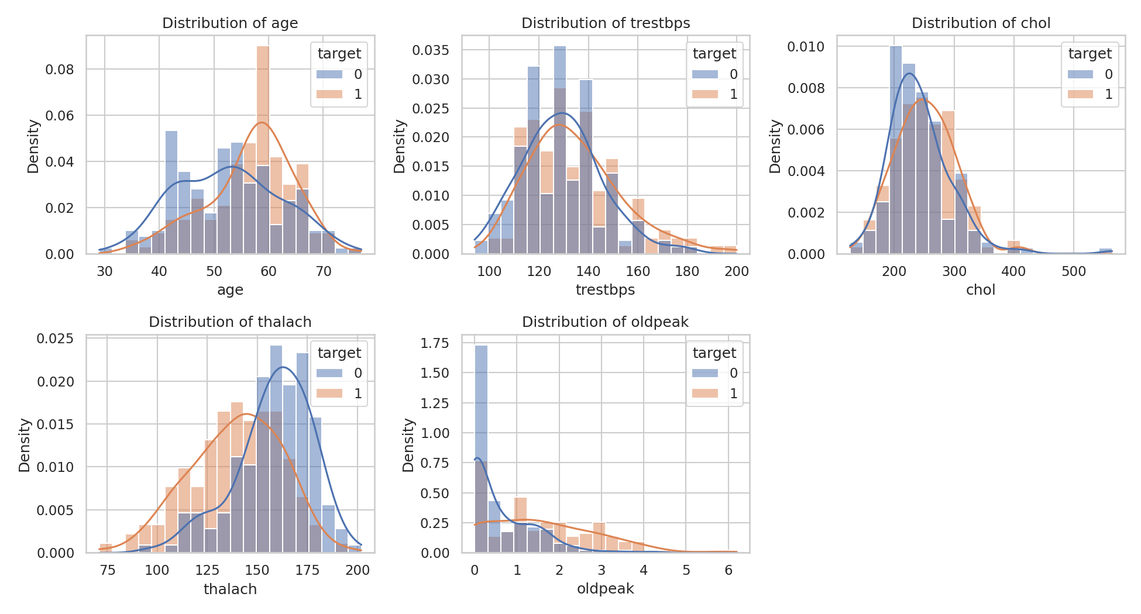
Histograms of numeric features by class
Outliers. IQR rule flags 5 values in chol, 5 in oldpeak and 9 in trestbps. They are clinically plausible (e.g. cholesterol 564 mg/dl), so they are kept; scaling and a regularised model limit their influence.
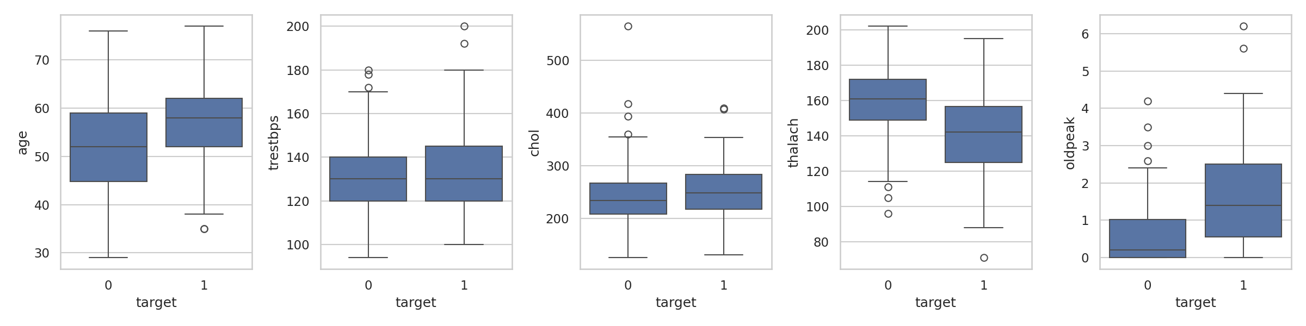
Box plots
Correlation with target. Strongest: thal (0.53), ca (0.46), exang (0.43), oldpeak (0.43), thalach (-0.42), cp (0.41), slope (0.34). Weak: chol (0.09) and fbs (0.03). No pair of predictors is so strongly collinear that it needs removal.
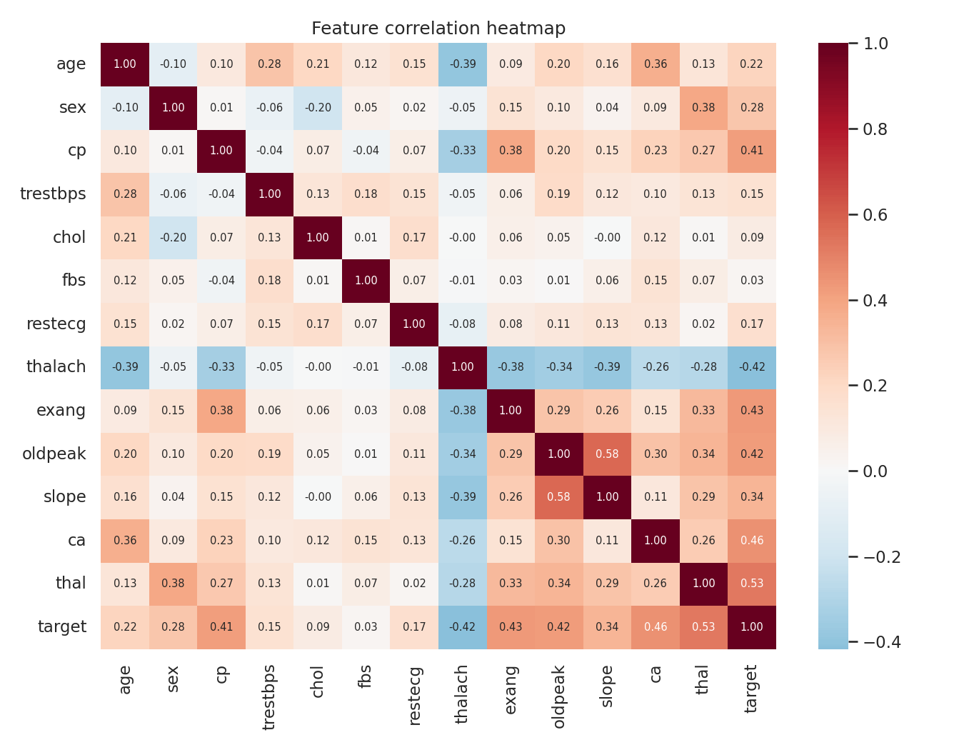
Correlation heatmap
Categorical effects. Disease rate is 77% with exercise-induced angina vs 31% without; 55% in males vs 26% in females; and 73% for asymptomatic chest pain (cp=4) vs 18-30% for other types.
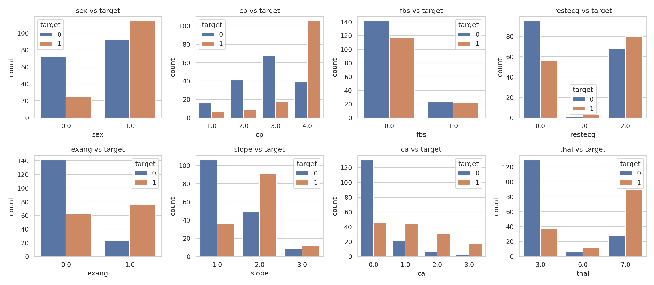
Disease rate by categorical feature

4. Feature engineering and modelling choices
Preprocessing (src/heart/features.py, one ColumnTransformer):
Group | Columns | Steps
Numeric | age, trestbps, chol, thalach, oldpeak | median imputation, standard scaling
Categorical | sex, cp, fbs, restecg, exang, slope, ca, thal | most-frequent imputation, one-hot (handle_unknown="ignore")
handle_unknown="ignore" means an unseen code at serving time cannot crash the API. Treating ca, thal, cp, slope as categorical avoids imposing a false ordering on codes.
Models. Logistic Regression (interpretable, strong baseline for small tabular data) and Random Forest (captures non-linearity and interactions).
Tuning and evaluation. An 80/20 stratified split (seed 42) holds out 61 patients for the final test. On the 80% training portion, GridSearchCV (3-fold, ROC-AUC) is nested inside 5-fold stratified cross-validation, so reported CV metrics are not inflated by tuning. Grids: LR C; RF n_estimators, max_depth, min_samples_leaf. Metrics: accuracy, precision, recall, F1, ROC-AUC.
Model (best params) | CV acc | CV prec | CV recall | CV ROC-AUC | Test acc | Test recall | Test ROC-AUC
Logistic Regression (C=0.1) | 0.831 | 0.859 | 0.765 | 0.898 | 0.885 | 0.929 | 0.965
Random Forest (depth 3, leaf 3, 100 trees) | 0.818 | 0.830 | 0.764 | 0.897 | 0.836 | 0.857 | 0.947
Selection. Rule: highest mean nested-CV ROC-AUC. Logistic Regression wins, only marginally on CV (0.898 vs 0.897) but with lower fold variance (ROC-AUC std 0.012 vs 0.028) and better hold-out results. Tuning chose strong regularisation (C=0.1) for LR and shallow trees for RF, both signs that with 303 rows the data supports only simple models. A simple linear model is also easier to explain clinically.
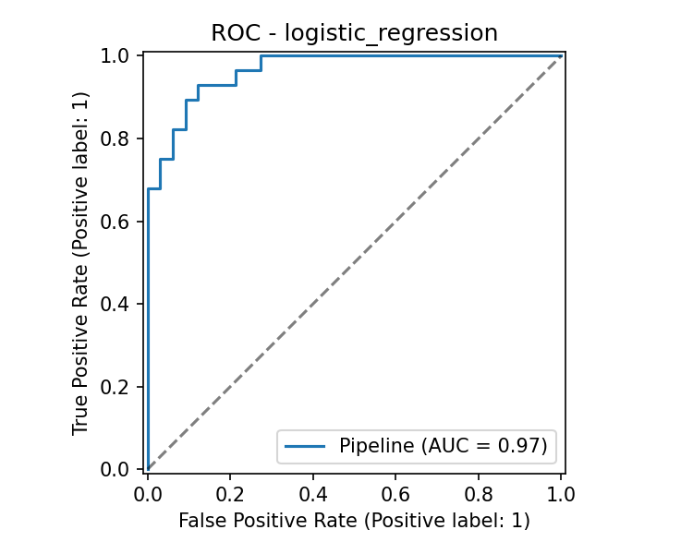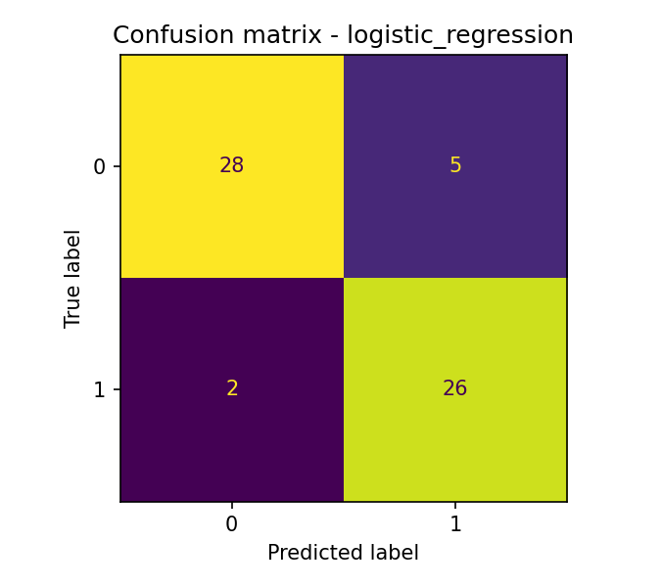
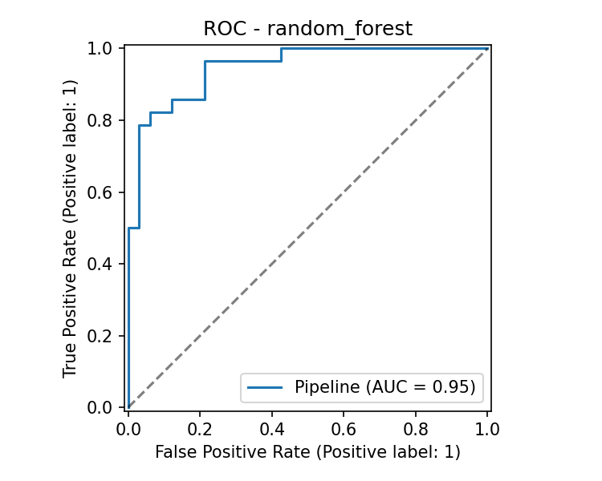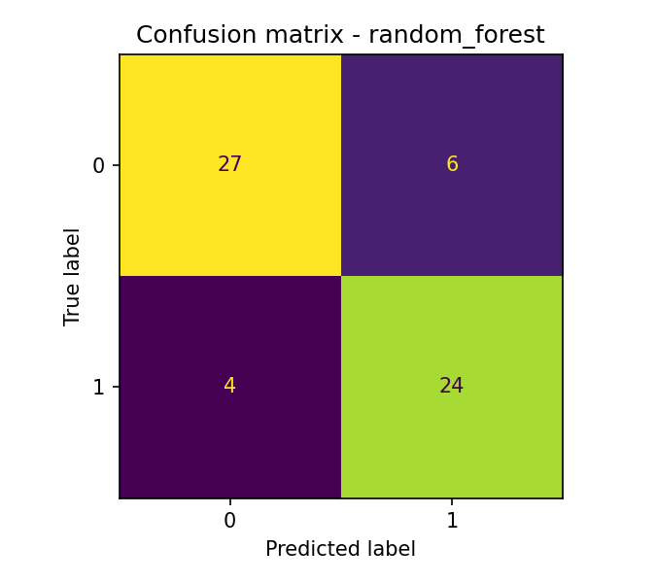
Caveat. With 61 test rows, one patient changes accuracy by 1.6 points; the test figures carry wide uncertainty, so the CV numbers are the more reliable comparison.

5. Experiment tracking summary
MLflow (local file store mlruns/, experiment heart-disease) records one parent run per training session and one nested run per model. Logged per run: hyper-parameters, seed, library versions, nested-CV metrics (mean and std), hold-out metrics, ROC and confusion-matrix plots, and the fitted pipeline with its input signature. Tracker (src/heart/tracking.py) wraps MLflow so training also works with --no-mlflow (used in unit tests).
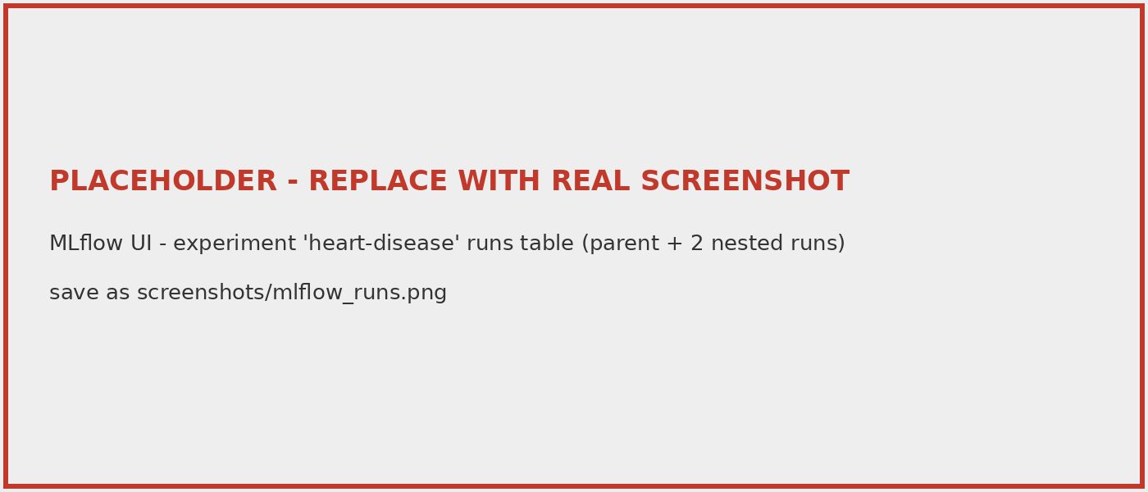
MLflow runs table
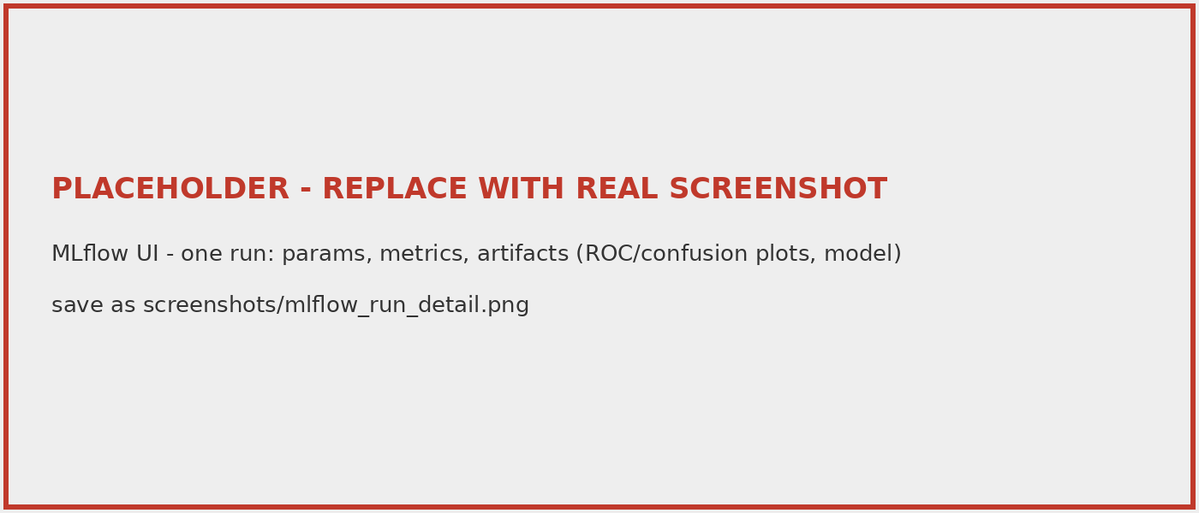
MLflow run detail
Observations. Both models reach almost identical CV ROC-AUC, but RF shows roughly twice the fold-to-fold variance. Larger RF depth was not selected by the grid, consistent with overfitting on 242 training rows. Tracking made this comparison reproducible: every number above can be traced to a run, parameters and seed.

6. Model packaging and reproducibility
The complete preprocessing and estimator is one sklearn.Pipeline saved with joblib (models/model.joblib) next to models/metadata.json (feature list, metrics, library versions, seed). The API loads the identical object, so training and serving transforms cannot diverge. A fixed seed (42) and version-pinned dependency files make runs repeatable from a clean environment; CI proves this on every push by installing from the requirements file on a fresh runner.

7. Architecture
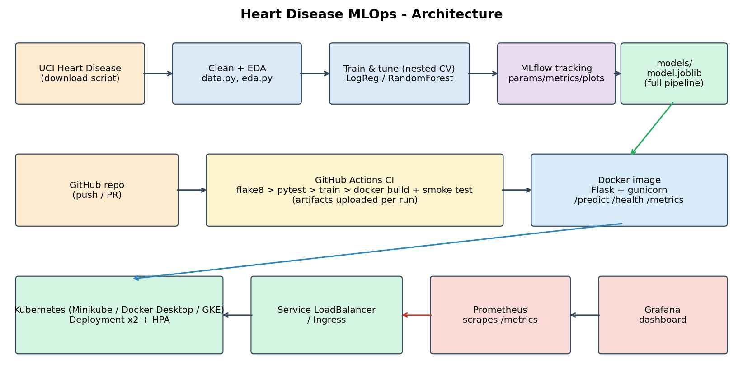
Architecture diagram
Flow: UCI data -> download/clean -> EDA and training (MLflow) -> versioned model artifact -> Docker image -> Kubernetes Deployment behind a LoadBalancer Service -> clients call /predict; Prometheus scrapes /metrics; Grafana visualises; GitHub Actions automates lint, test, train and image smoke test.

8. CI/CD pipeline
.github/workflows/ci.yml runs on every push to main and every pull request:
- lint-test: flake8, then pytest with coverage and JUnit XML (uploaded as artifacts, even on failure).
- train (needs lint-test): download data, generate EDA figures, train with MLflow, upload model, reports, mlruns/ and the cleaned dataset.
- docker (needs train): build the image, run it, poll /health, call /predict and /metrics, upload smoke.json and container logs.
Jobs are chained with needs, so any lint, test, or training error stops the pipeline with the failing command in the log (production-readiness requirement).
Tests (tests/, 18 tests): data cleaning (binarisation, duplicates, missing values kept, schema), preprocessing (no NaNs, scaling, unseen category, missing at inference), metrics, end-to-end training that writes artifacts, and API contract (valid prediction, missing field, out-of-range value, non-JSON body gives HTTP 400). Coverage is produced as coverage.xml in each run.
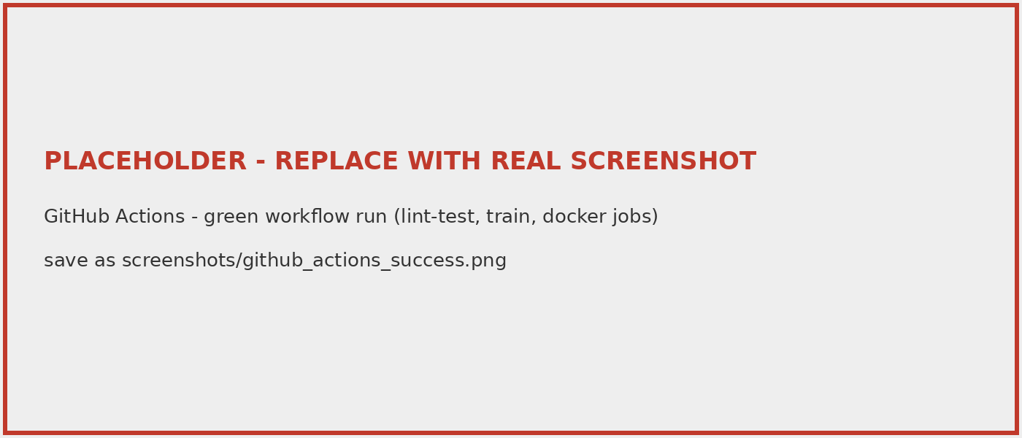
Successful workflow run
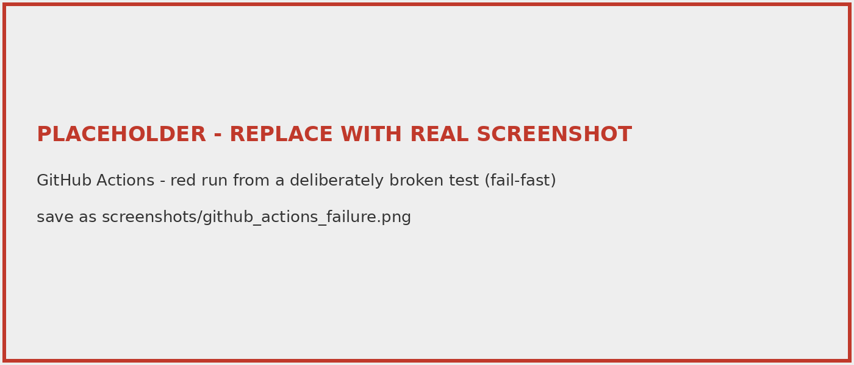
Failing run demonstrating fail-fast

9. Containerisation and deployment
API (api/app.py, Flask + gunicorn): POST /predict accepts the 13 features as JSON, validates presence and ranges, and returns prediction, label, confidence and probability_disease. GET /health serves probes; GET /metrics serves Prometheus.
{"confidence": 0.5762, "label": "no heart disease likely", "prediction": 0, "probability_disease": 0.4238}
Docker. python:3.11-slim, slim serving requirements only, non-root user, HEALTHCHECK, gunicorn with 2 workers and access log to stdout.
Kubernetes (k8s/): Deployment (2 replicas, readiness and liveness probes on /health, CPU/memory requests and limits), Service of type LoadBalancer, optional Ingress and HorizontalPodAutoscaler. Cluster used: <Minikube / Docker Desktop / GKE>. For a public cloud, push the image to a registry and change image: in deployment.yaml.

docker build and run

kubectl get pods,svc

curl /predict against the service

10. Monitoring and logging
Logging. Every request emits one JSON line (request id, method, path, status, latency ms); every prediction logs class and confidence; validation errors are logged with the reason. Logs are collected with kubectl logs -l app=heart-api.
Metrics (api/metrics.py, /metrics): request count by path and status, latency histogram, predictions by class, and 5xx count. Prometheus scrapes the pods (annotations in the Deployment; manifests in k8s/monitoring.yaml). The Grafana dashboard (monitoring/grafana-dashboard.json) shows request rate, p95 latency, predictions by class and error count. scripts/load_test.py generates traffic to populate it.

Grafana dashboard
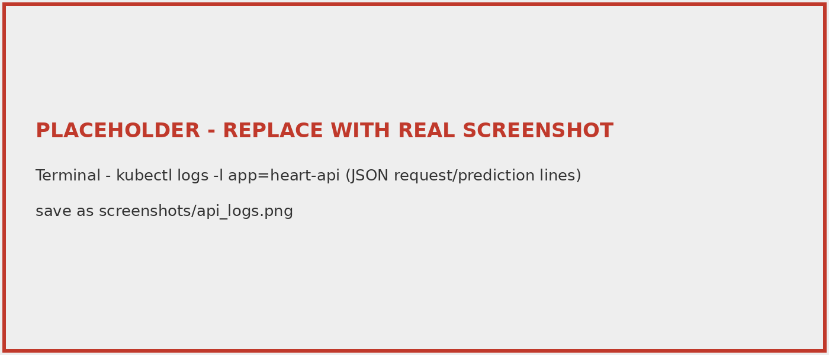
API logs

11. Limitations and future work
Only 303 patients from one hospital, so confidence intervals are wide and generalisation is unproven; the model is a teaching artifact, not a medical device. Future work: data and prediction drift monitoring, MLflow model registry with staged promotion, GitOps deployment (Argo CD), probability calibration, and threshold tuning to favour recall.

12. Links
Code: <GitHub URL> | Video: <link> | API: <URL / access instructions>

