VISVESVARAYA TECHNOLOGICAL UNIVERSITY
“JnanaSangama”, Belgaum -590014, Karnataka.


LAB REPORT

On

ANALYSIS AND DESIGN OF ALGORITHMS (23CS4PCADA)

Submitted by

KRITIKA PANWAR (1BF24CS151)

in partial fulfillment for the award of the degree of
BACHELOR OF ENGINEERING
in
COMPUTER SCIENCE AND ENGINEERING



B.M.S. COLLEGE OF ENGINEERING
(Autonomous Institution under VTU)
BENGALURU-560019
February to June 2026
CERTIFICATE

B. M. S. College of Engineering,
Bull Temple Road, Bangalore 560019
(Affiliated To Visvesvaraya Technological University, Belgaum)
Department of Computer Science and Engineering



This is to certify that the Lab work entitled “ANALYSIS AND DESIGN OF ALGORITHMS” carried out by KRITIKA PANWAR(1BF24CS151), who is bonafide student of B. M. S. College of Engineering. It is in partial fulfillment for the award of Bachelor of Engineering in Computer Science and Engineering of the Visvesvaraya Technological University, Belgaum during the year 2025-26. The Lab report has been approved as it satisfies the academic requirements in respect of Analysis and Design of Algorithms Lab - (23CS4PCADA) work prescribed for the said degree.

Dr.Priyanka Chandrashekhar Hiremath Dr. Kavitha Sooda
Assistant Professor Professor and Head
Department of CSE Department of CSE
BMSCE, Bengaluru BMSCE, Bengaluru

Index Sheet
Sl.  No. | Experiment Title | Page No.
1 | Write program to obtain the Topological ordering of vertices in a given digraph. | 4-6
2 | Implement Johnson Trotter algorithm to generate permutations. | 7-8
3 | Sort a given set of N integer elements using Merge Sort technique and compute its time taken. Run the program for different values of N and record the time taken to sort. | 9-11
4 | Sort a given set of N integer elements using Quick Sort technique and compute its time taken. | 12-14
5 | Sort a given set of N integer elements using Heap Sort technique and compute its time taken. | 15-16
6 | Implement 0/1 Knapsack problem using dynamic programming. (5 Marks) | 17-19
7 | Implement All Pair Shortest paths problem using Floyd’s algorithm. | 20-22
8 | - Find Minimum Cost Spanning Tree of a given undirected graph using Prim’s algorithm.  - Find Minimum Cost Spanning Tree of a given undirected graph using Kruskal’s algorithm. | 23-26
9 | Implement Fractional Knapsack using Greedy technique. | 27-29
10 | From a given vertex in a weighted connected graph, find shortest paths to other vertices using Dijkstra’s algorithm. | 30-31
11 | Implement “N-Queens Problem” using Backtracking. | 32-33

Course outcomes:
CO1 | Analyze time complexity of algorithms using asymptotic notations.
CO2 | Apply various algorithm design techniques for the given problem.
CO3 | Evaluate the appropriate algorithm/design technique for solving a given problem.
CO4 | Conduct practical experiments by applying appropriate algorithm design technique to solve problems.

Lab program 1:
CODE:

#include <stdio.h>
#define MAX 100
int graph[MAX][MAX];
int indegree[MAX];
int queue[MAX];
int front = 0, rear = 0;
void topologicalSort(int n){
int i, j, count = 0;
for(i = 0; i < n; i++){
indegree[i] = 0;
}
for(i = 0; i < n; i++){
for(j = 0; j < n; j++){
if(graph[i][j] == 1){
indegree[j]++;
}
}
}
for(i = 0; i < n; i++){
if(indegree[i] == 0){
queue[rear++] = i;
}
}
printf("Topological Ordering: ");
while(front < rear){
int vertex = queue[front++];
printf("%d ", vertex);
count++;
for(i = 0; i < n; i++){
if(graph[vertex][i] == 1) {
indegree[i]--;
if(indegree[i] == 0){
queue[rear++] = i;
}
}
}
}
if(count != n){
printf("\nGraph contains a cycle. Topological ordering not possible.");
}
}
int main(){
int n, i, j;
printf("Enter number of vertices: ");
scanf("%d", &n);
printf("Enter adjacency matrix:\n");
for(i = 0; i < n; i++){
for(j = 0; j < n; j++){
scanf("%d", &graph[i][j]);
}
}
topologicalSort(n);
return 0;
}

OUTPUT:

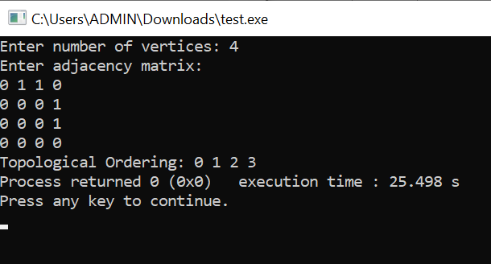

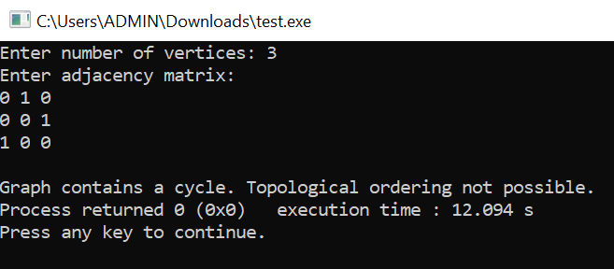

GRAPH:
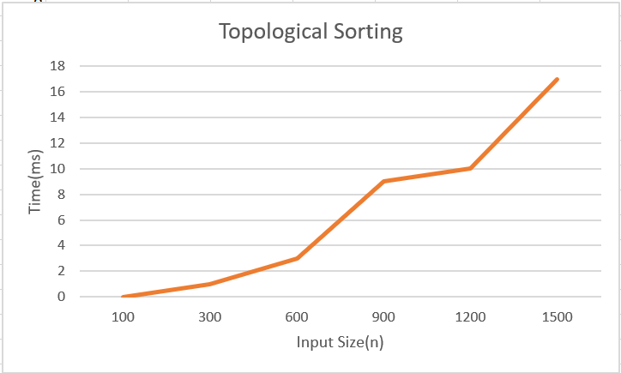

LEETCODE 207.Course Schedule

CODE:

#include <stdbool.h>
bool canFinish(int numCourses, int** prerequisites, int prerequisitesSize, int* prerequisitesColSize){
int graph[2000][2000] = {0};
int indegree[2000] = {0};
int queue[2000];
int front = 0, rear = 0;
int count = 0;
for(int i = 0; i < prerequisitesSize; i++){
int a = prerequisites[i][0];
int b = prerequisites[i][1];
graph[b][a] = 1;
indegree[a]++;
}
for(int i = 0; i < numCourses; i++){
if(indegree[i] == 0){
queue[rear++] = i;
}
}
while(front < rear){
int node = queue[front++];
count++;
for(int i = 0; i < numCourses; i++){
if(graph[node][i] == 1){
indegree[i]--;
if(indegree[i] == 0){
queue[rear++] = i;
}
}
}
}
return (count == numCourses);
}

OUTPUT:


Lab program 2:
CODE:

#include<stdio.h>
int memory(int p[],int d[],int n){
int m=-1;
for(int i=0;i<n;i++){
if(d[i]==-1 && i>0 && p[i]>p[i-1] && p[i]>m) m=p[i];
if(d[i]==1 && i<n-1 && p[i]>p[i+1] && p[i]>m) m=p[i];
}
return m;
}
void main(){
int n;
printf("Enter n:");
scanf("%d",&n);
int p[n],d[n];
for(int i=0;i<n;i++){
d[i]=-1;
p[i]=i+1;
}
printf("Permutations:\n");
while(1){
for(int i=0;i<n;i++){
printf("%d ",p[i]);
}
printf("\n");
int m=memory(p,d,n);
if(m==-1) break;
int pos;
for(int i=0;i<n;i++){
if(p[i]==m) pos=i;
}
int newPos=pos+d[pos];
int temp=p[pos];
p[pos]=p[newPos];
p[newPos]=temp;
temp=d[pos];
d[pos]=d[newPos];
d[newPos]=temp;

for(int i=0;i<n;i++){
if(p[i]>m) d[i]=-d[i];
}
}
}

OUTPUT:

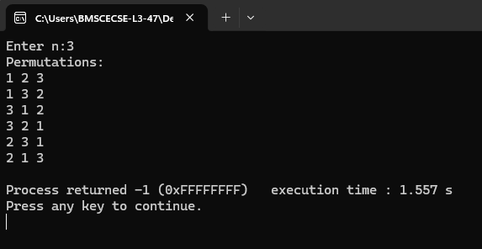

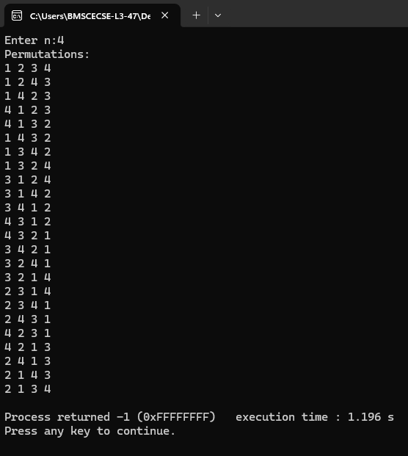

Lab program 3:
CODE:

#include<stdio.h>
void merge(int low,int mid,int high,int arr[]);
void merge_sort(int low,int high,int arr[]){
if(low<high) {
int mid=(low+high)/2;
merge_sort(low,mid,arr);
merge_sort(mid+1,high,arr);
merge(low,mid,high,arr);
}
}

void merge(int low,int mid,int high,int arr[]){
int i=low,j=mid+1,k=low;
int temp[100];

while(i<=mid && j<=high) {
if(arr[i]<arr[j])
temp[k++]=arr[i++];
else
temp[k++]=arr[j++];
}
while(i<=mid)
temp[k++]=arr[i++];

while(j<=high)
temp[k++]=arr[j++];

for(i=low;i<=high;i++)
arr[i]=temp[i];
}

int main(){
int n;
printf("Enter the size of array: ");
scanf("%d",&n);
int arr[n];
printf("Enter elements: ");
for(int i=0;i<n;i++)
scanf("%d",&arr[i]);
merge_sort(0,n-1,arr);
printf("Sorted array: ");
for(int i=0;i<n;i++)
printf("%d ",arr[i]);

return 0;
}

OUTPUT:

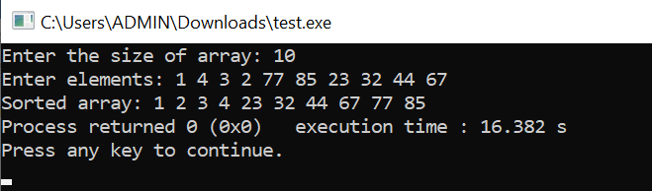

GRAPH:

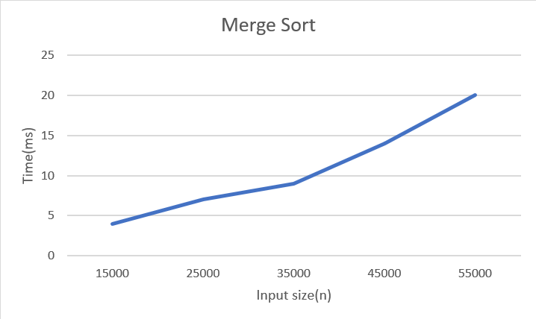

LEETCODE 912.Sort an Array

CODE:

void merge(int arr[], int low, int mid, int high) {
int i = low, j = mid + 1, k = low;
int temp[high + 1];
while (i <= mid && j <= high) {
if (arr[i] <= arr[j])
temp[k++] = arr[i++];
else
temp[k++] = arr[j++];
}
while (i <= mid)
temp[k++] = arr[i++];
while (j <= high)
temp[k++] = arr[j++];
for (int p = low; p <= high; p++)
arr[p] = temp[p];
}
void mergeSort(int arr[], int low, int high) {
if (low < high) {
int mid = (low + high) / 2;
mergeSort(arr, low, mid);
mergeSort(arr, mid + 1, high);
merge(arr, low, mid, high);
}
}
int* sortArray(int* nums, int numsSize, int* returnSize) {
mergeSort(nums, 0, numsSize - 1);
*returnSize = numsSize;
return nums;
}

OUTPUT:



Lab program 4:
CODE:

#include<stdio.h>
#include<time.h>
#include<stdlib.h>
void quicksort(int low,int high,int arr[]);
int partition(int low,int high,int arr[]);
void quicksort(int low,int high,int arr[]){
if(low<high){
int p=partition(low,high,arr);
quicksort(low,p-1,arr);
quicksort(p+1,high,arr);
}
}
int partition(int low,int high,int arr[]){
int i=low;
int j=high+1;
int pivot=arr[low];
int temp;
while(i<j){
do{
i++;
}while(i<=high && arr[i]<=pivot);
do{
j--;
}while(arr[j]>pivot);
if(i<j){
temp=arr[i];
arr[i]=arr[j];
arr[j]=temp;
}
}
temp=arr[j];
arr[j]=pivot;
arr[low]=temp;
return j;
}
void main()
{
clock_t start,end;
double cpu_time_used;
int n;
printf("Enter number of elements:");
scanf("%d",&n);
int arr[n];
printf("Enter elements:");
for(int i=0;i<n;i++){
scanf("%d",&arr[i]);
}
start=clock();
quicksort(0,n-1,arr);
end=clock();

cpu_time_used=(((double)(end-start))/CLOCKS_PER_SEC)*1000.0;
printf("Sorted array:");
for(int i=0;i<n;i++){
printf("%d ",arr[i]);
}
printf("\nExecution time:%.5f ms",cpu_time_used);
}

OUTPUT:

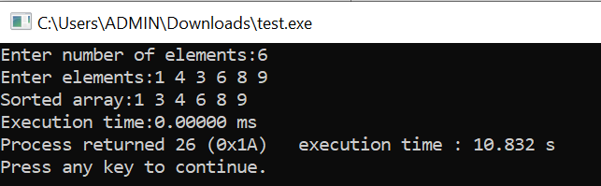

GRAPH:

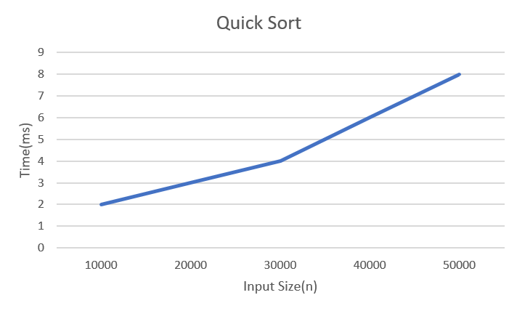

LEETCODE 207.Course Schedule

CODE:

#include <stdlib.h>
int* sortedSquares(int* nums, int numsSize, int* returnSize) {
int* res = (int*)malloc(sizeof(int) * numsSize);
int i = 0;
int j = numsSize - 1;
int k = numsSize - 1;
while (i <= j) {
int left = nums[i] * nums[i];
int right = nums[j] * nums[j];
if (left > right) {
res[k--] = left;
i++;
} else {
res[k--] = right;
j--;
}
}
*returnSize = numsSize;
return res;
}

OUTPUT:



Lab program 5:
CODE:

#include<stdio.h>
#include<time.h>
#include<stdlib.h>
void heapify(int H[],int n){
for(int i=n/2;i>=1;i--){
int k=i;
int v=H[i];
int heap=0;
while(heap==0 && 2*k<=n){
int j=2*k;
if(j<n && H[j]<H[j+1])
j=j+1;
if(v>=H[j])
heap=1;
else{
H[k]=H[j];
k=j;
}
}
H[k]=v;
}
}
void heapSort(int H[],int n){
heapify(H,n);
for(int i=n;i>=2;i--){
int temp=H[1];
H[1]=H[i];
H[i]=temp;
int k=1;
int v=H[1];
while(2*k<=i-1){
int j=2*k;
if(j<i-1 && H[j]<H[j+1])
j=j+1;
if(v>=H[j])
break;
H[k]=H[j];
k=j;
}
H[k]=v;
}
}
void main(){
int n;
printf("Enter number of elements:");
scanf("%d",&n);
int H[n+1];
printf("Enter the elements:\n");
for(int i=1;i<=n;i++){
scanf("%d",&H[i]);
}
clock_t start=clock();
heapSort(H,n);
clock_t end=clock();
double cpu_time_used=(((double)(end-start))/CLOCKS_PER_SEC)*1000.0;
printf("\nElements after heap sort:");
for(int i=1;i<=n;i++){
printf("%d ",H[i]);
}
printf("\nInput Size:%d Execution Time:%.5f",n,cpu_time_used);
}

OUTPUT:

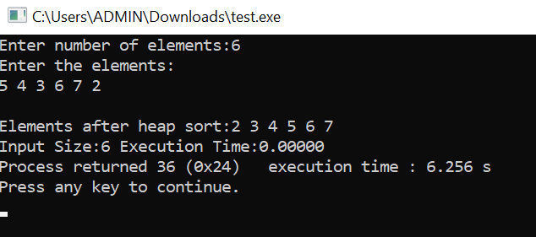

GRAPH:

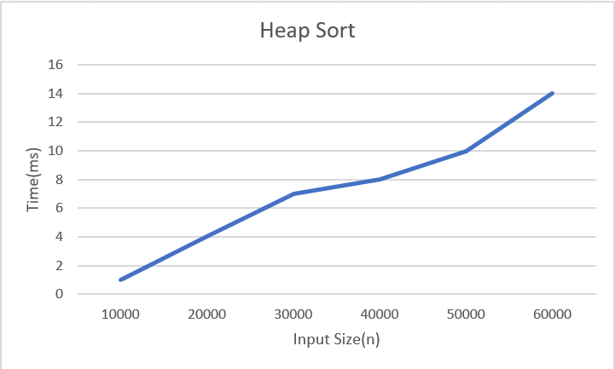

Lab program 6:
CODE:

#include<stdio.h>
int max(int a,int b){
return (a>b)?a:b;
}
void main(){
int n,m;
printf("Enter the number of objects and capacity:");
scanf("%d %d",&n,&m);
int v[n+1][m+1];
int p[n+1],w[n+1],x[n+1];
printf("Enter the weight and profit:\n");
for(int i=1;i<=n;i++){
scanf("%d %d",&w[i],&p[i]);
}
for(int i=0;i<=n;i++){
x[i]=0;
}
for(int i=0;i<=n;i++){
for(int j=0;j<=m;j++){
if(i==0 || j==0) v[i][j]=0;
else if(w[i]<=j) v[i][j]=max(v[i-1][j],p[i]+v[i-1][j-w[i]]);
else v[i][j]=v[i-1][j];
}
}
int i=n;
int j=m;
while(i>0 && j>0){
if(v[i][j]!=v[i-1][j]){
x[i]=1;
j=j-w[i];
}
i=i-1;
}
printf("Selected objects weight and profit:\n");
printf("%-5s %-5s","w","p");
for(int i=0;i<=n;i++){
if(x[i]==1) printf("\n%-5d %-5d",w[i],p[i]);
}
printf("\nTotal profit:%d",v[n][m]);
}

OUTPUT:

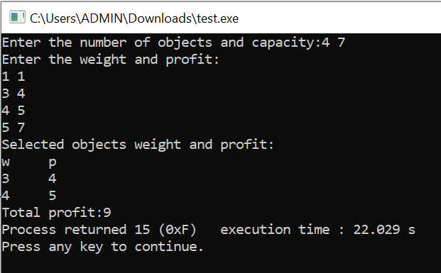

LEETCODE 518.Coin Change II

CODE:

int change(int amount, int* coins, int coinSize) {
unsigned long long dp[amount + 1];
for (int i = 0; i <= amount; i++)
dp[i] = 0;
dp[0] = 1;
for (int i = 0; i < coinSize; i++) {
for (int j = coins[i]; j <= amount; j++) {
dp[j] += dp[j - coins[i]];
}
}
return (int)dp[amount];
}

OUTPUT:



Lab program 7:
CODE:

#include<stdio.h>
#include<limits.h>
void main(){
int n;
printf("Enter the number of vertices:");
scanf("%d",&n);
int a[n][n];
printf("Enter the weights and 0 for no edges:\n");
for(int i=0;i<n;i++){
for(int j=0;j<n;j++)
{
scanf("%d",&a[i][j]);
}
}
for(int i=0;i<n;i++){
for(int j=0;j<n;j++){
if(i!=j && a[i][j]==0) a[i][j]=INT_MAX;
}
}
for(int i=0;i<n;i++){
for(int j=0;j<n;j++){
for(int k=0;k<n;k++){
if(a[i][k]!=INT_MAX && a[k][j]!=INT_MAX){
if(a[i][j]>a[i][k]+a[k][j]) a[i][j]=a[i][k]+a[k][j];
}
}
}
}
printf("Shortest pairs:\n");
for(int i=0;i<n;i++){
for(int j=0;j<n;j++){
if(a[i][j]==INT_MAX) printf("Infinity ");
else printf("%d ",a[i][j]);
}
printf("\n");
}
}

OUTPUT:

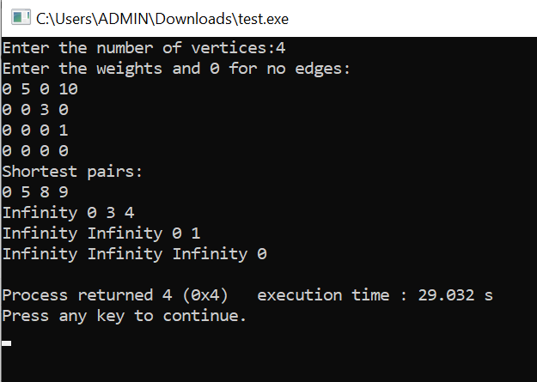

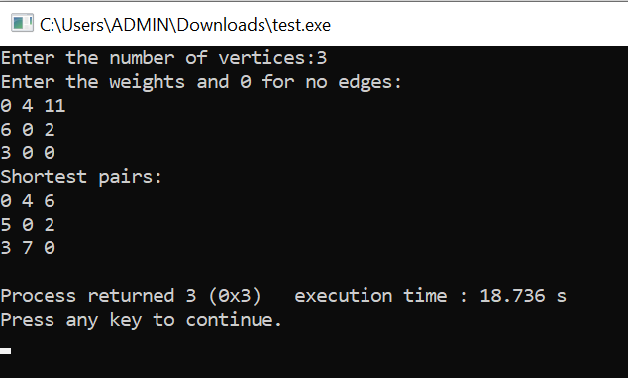

LEETCODE 783.Minimum Distance Between BST Nodes

CODE:

#include<limits.h>
#include<stdlib.h>
int minVal=INT_MAX;
struct TreeNode* prev=NULL;
void inorder(struct TreeNode* root){
if(root!=NULL){
inorder(root->left);
if(prev!=NULL){
int d=abs(root->val-prev->val);
if(d<minVal) minVal=d;
}
prev=root;
inorder(root->right);
}
}
int minDiffInBST(struct TreeNode* root) {
minVal=INT_MAX;
prev=NULL;
inorder(root);
return minVal;
}

OUTPUT:



Lab program 8:
8(a)
CODE:

#include <stdio.h>
#define MAX 10
#define INF 999
int main(){
int cost[MAX][MAX];
int visited[MAX] = {0};
int n, i, j;
int min, a, b;
int edges = 0, minCost = 0;
printf("Enter number of vertices: ");
scanf("%d", &n);
printf("Enter adjacency matrix:\n");
for(i = 0; i < n; i++){
for(j = 0; j < n; j++){
scanf("%d", &cost[i][j]);
if(cost[i][j] == 0)
cost[i][j] = INF;
}
}
visited[0] = 1;
printf("Edges in MST:\n");
while(edges < n - 1){
min = INF;
for(i = 0; i < n; i++){
if(visited[i]){
for(j = 0; j < n; j++){
if(!visited[j] && cost[i][j] < min){
min = cost[i][j];
a = i;
b = j;
}
}
}
}
printf("%d - %d = %d\n", a, b, min);
minCost += min;
visited[b] = 1;
edges++;
}
printf("Minimum Cost = %d\n", minCost);
return 0;
}

OUTPUT:

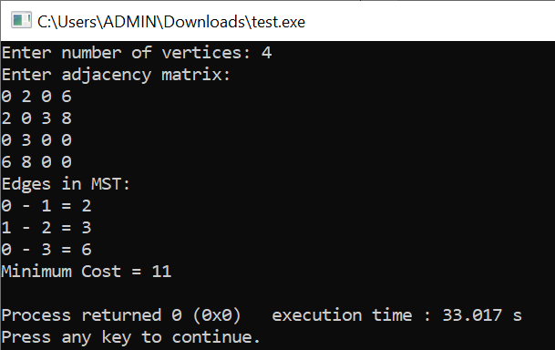

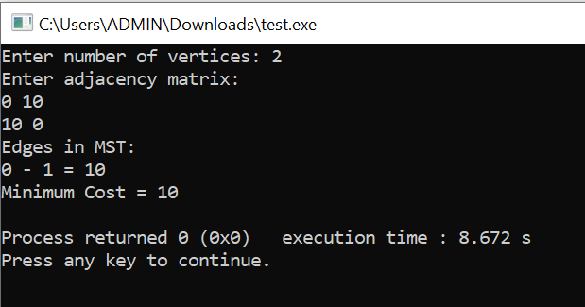

8(b)
CODE:

#include <stdio.h>
#define MAX 10
#define INF 999
int parent[MAX];
int find(int x){
while(parent[x] != x)
x = parent[x];
return x;
}
void unionSet(int a, int b){
parent[find(a)] = find(b);
}
int main(){
int cost[MAX][MAX];
int n, i, j;
int min, a, b;
int edges = 0, minCost = 0;
printf("Enter number of vertices: ");
scanf("%d", &n);
printf("Enter adjacency matrix:\n");
for(i = 0; i < n; i++){
for(j = 0; j < n; j++){
scanf("%d", &cost[i][j]);
if(cost[i][j] == 0)
cost[i][j] = INF;
}
}
for(i = 0; i < n; i++){
parent[i] = i;
}
printf("Edges in MST:\n");
while(edges < n - 1){
min = INF;
for(i = 0; i < n; i++){
for(j = i + 1; j < n; j++){
if(cost[i][j] < min){
min = cost[i][j];
a = i;
b = j;
}
}
}
if(find(a) != find(b)){
printf("%d - %d = %d\n", a, b, min);
minCost += min;
unionSet(a, b);
edges++;
}
cost[a][b] = cost[b][a] = INF;
}

printf("Minimum Cost = %d\n", minCost);
return 0;
}

OUTPUT:

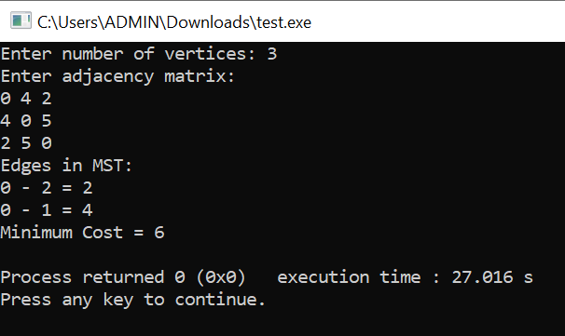

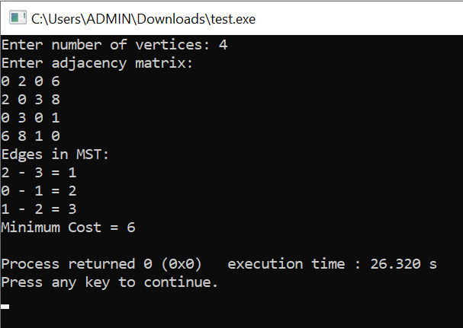

Lab program 9:
CODE:

#include<stdio.h>
struct object{
float profit;
float weight;
float pw;
};
void sort(struct object o[],int n){
struct object temp;
for(int i=0;i<n-1;i++) {
for(int j=0;j<n-i-1;j++){
if(o[j].pw<o[j+1].pw){
temp=o[j];
o[j]=o[j+1];
o[j+1]=temp;
}
}
}
}
int main(){
int n;
printf("Enter number of objects:");
scanf("%d",&n);
struct object o[n];
printf("Enter the profit and weight for:\n");
for(int i=0;i<n;i++){
printf("Object %d:",i);
scanf("%f %f",&o[i].profit,&o[i].weight);
o[i].pw=o[i].profit/o[i].weight;
}
sort(o,n);
int size;
printf("Enter the size of the knapsack:");
scanf("%d",&size);
float total_profit=0;
int rm=size;
int i=0;
while(rm!=0){
if(o[i].weight<rm){
total_profit+=o[i].profit;
rm-=o[i].weight;
}
else{
total_profit+=((o[i].profit*rm)/o[i].weight);
rm=0;
}
i++;
}
printf("%-12s %-12s %-12s %-12s\n", "Object", "Profit", "Weight", "Ratio");
for(int i = 0; i < n; i++){
printf("%-12d %-12.2f %-12.2f %-12.2f\n",
i, o[i].profit, o[i].weight, o[i].pw);
}
printf("\nMaximum profit: %.2f\n", total_profit);
return 0;
}

OUTPUT:

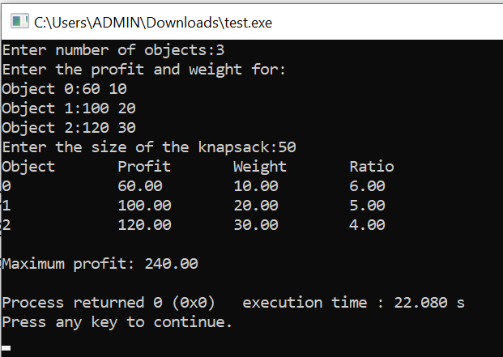

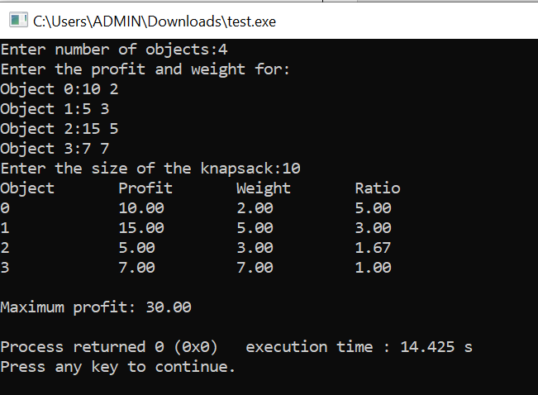

LEETCODE 455.Assign Cookies

CODE:

int cmp(const void* a,const void*b)
{
return (*(int*)a)-(*(int*)b);
}
int findContentChildren(int* g, int gSize, int* s, int sSize) {
int count=0;
qsort(g,gSize,sizeof(int),cmp);
qsort(s,sSize,sizeof(int),cmp);
int i=0,j=0;
while(i<gSize && j<sSize){
if(g[i]<=s[j]){
count++;
i++;
}
j++;
}
return count;
}

OUTPUT:

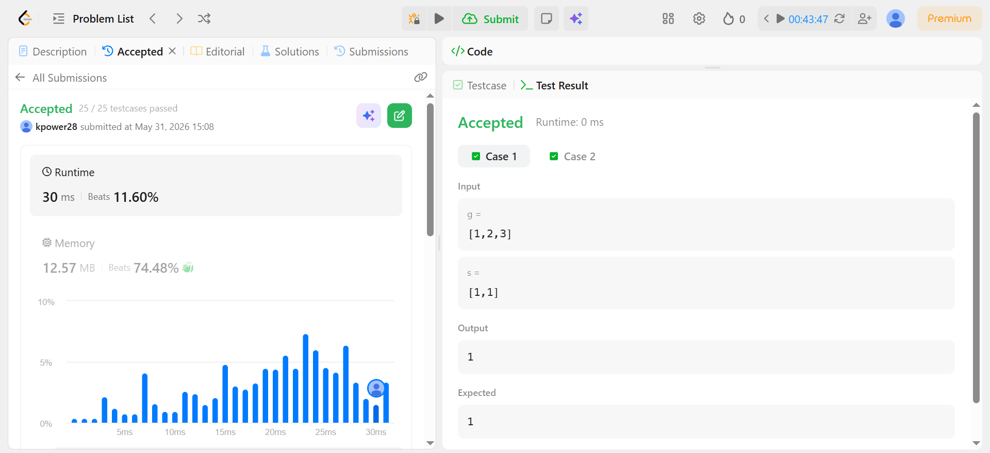

Lab program 10:
CODE:

#include<stdio.h>
#include<limits.h>
void p(int parent[],int j){
if(parent[j]==j){
printf(" Path:%d ",j);
return;
}
p(parent,parent[j]);
printf("%d ",j);
}
void main(){
int n;
printf("Enter the number of vertices:");
scanf("%d",&n);
int a[n][n];
printf("Enter the weights and enter 0 for no edges:\n");
for(int i=0;i<n;i++){
for(int j=0;j<n;j++){
scanf("%d",&a[i][j]);
}
}
int distance[n];
int visited[n];
int parent[n];
int source;
printf("Enter the source vertex:");
scanf("%d",&source);
for(int i=0;i<n;i++){
distance[i]=(i!=source && a[source][i]==0)?INT_MAX:a[source][i];
parent[i]=source;
visited[i]=0;
}
distance[source]=0;
visited[source]=1;
for(int i=1;i<n;i++){
int min=INT_MAX;
int u=-1;
for(int j=0;j<n;j++){
if(!visited[j] && distance[j]<min){
min=distance[j];
u=j;
}
}
if(u==-1) break;
visited[u]=1;
for(int v=0;v<n;v++){
if(a[u][v]!=0 && !visited[v]){
if(distance[u]+a[u][v]<distance[v]){
distance[v]=distance[u]+a[u][v];
parent[v]=u;
}
}

}
}
printf("The distances are:\n");
for(int i=0;i<n;i++){
printf("%d to %d",source,i);
if(distance[i]==INT_MAX) printf(":No path");
else{
p(parent,i);
printf(":%d",distance[i]);
}
printf("\n");
}
}

OUTPUT:

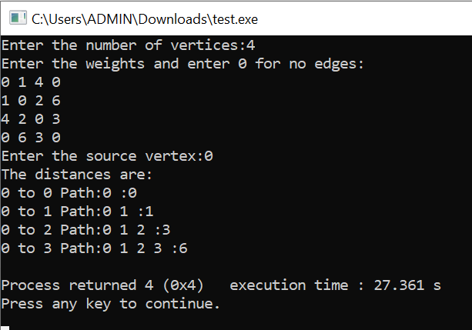

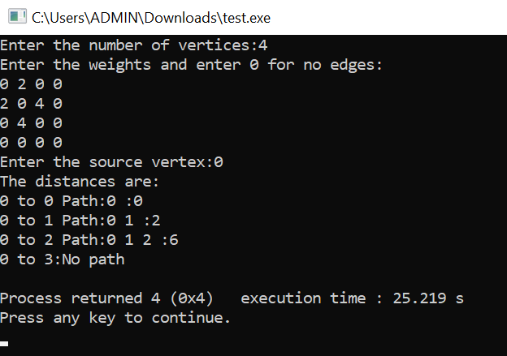
Lab program 11:
CODE:

#include<stdio.h>
#include<stdlib.h>
int x[20];
int counter=1;
int place(int k,int i);
void nqueens(int k,int n){
for(int i=1;i<=n;i++){
if(place(k,i)){
x[k]=i;
if(k==n){
printf("\nSolution:%d\n",counter++);
for(int j=1;j<=n;j++){
for(int k=1;k<=n;k++){
if(x[j]==k) printf("Q ");
else printf(". ");
}
printf("\n");
}
printf("\n");
}
else{
nqueens(k+1,n);
}
}
}
}
int place(int k,int i){
for(int j=1;j<k;j++){
if(x[j]==i || (abs(j-k)==abs(x[j]-i))) return 0;
}
return 1;
}
void main(){
int n;
printf("Enter number of queens:");
scanf("%d",&n);
nqueens(1,n);
if(counter==1) printf("No solution");
}

OUTPUT:

