VISVESVARAYA TECHNOLOGICAL UNIVERSITY
“JnanaSangama”, Belgaum -590014, Karnataka.



MOBILE APPLICATION DEVELOPMENT REPORT
on

ShareBite: A Surplus Food Donation Management System

Submitted by

JAYAM SHANMUKHA SHIVANVITHA(1BF24CS127)
KAPPALABANDA KEERTHI(1BF24CS133)
KRITIKA PANWAR(1BF24CS151)

Under the Guidance of
Sonika Sharma D
Assistant Professor, BMSCE

in partial fulfillment for the award of the degree of
BACHELOR OF ENGINEERING
in
COMPUTER SCIENCE AND ENGINEERING



B.M.S. COLLEGE OF ENGINEERING
(Autonomous Institution under VTU)
BENGALURU-560019
Feb-2026 to June-2026

B. M. S. College of Engineering,
Bull Temple Road, Bangalore 560019
(Affiliated To Visvesvaraya Technological University, Belgaum)
Department of Computer Science and Engineering

CERTIFICATE
This is to certify that the project work entitled “ShareBite” carried out by Kritika Panwar (1BF24CS151), Jayam Shanmukha Shivanvitha (1BF24CS127), Kappalabanda Keerthi (1BF24CS133) who are bonafide students of B. M. S. College of Engineering. It is in partial fulfillment for the award of Bachelor of Engineering in Computer Science and Engineering of the Visveswaraiah Technological University, Belgaum during the year 2024-2025. The project report has been approved as it satisfies the academic requirements in respect of Mobile Application Development (23CS4AEMAD) work prescribed for the said degree.

Signature of the Guide Signature of the HOD
Dr. Kavitha Sooda
Assistant Professor, Dept. of CSE Prof.& Head, Dept. of CSE
BMSCE, Bengaluru BMSCE, Bengaluru
External Viva
Name of the Examiner Signature with date

1._____________________________ ________________________

2. _____________________________ _________________________

B.M.S. COLLEGE OF ENGINEERING
DEPARTMENT OF COMPUTER SCIENCE AND ENGINEERING



DECALARATION

We, Kritika Panwar(1BF24CS151), Jayam Shanmukha Shivanvitha(1BF24CS127), Kappalabanda Keerthi(1BF24CS133)students of 4th Semester, B.E, Department of Computer Science and Engineering, B. M. S. College of Engineering, Bangalore, hereby declare that, this Mobile Application Development entitled "Project Title" has been carried out by us under the guidance of Name of the faculty, Assistant Professor, Department of CSE, B. M. S. College of Engineering, Bangalore during the academic semester Feb-2026 to June-2026

We also declare that to the best of our knowledge and belief, the development reported here is not from part of any other report by any other students.

Signature
Kritika Panwar(1BF24CS151)
Jayam Shanmukha Shivanvitha(1BF24CS127)
Kappalabanda Keerthi(1BF24CS133)

Table of Contents
Sl No | Topics | Page Nos
1 | Abstract | 5
2 | Introduction | 6-7
3 | Hardware and Software Requirements | 8-9
4 | Design Layouts: Screen Shots of Mobile App | 10-13
5 | Database Table screen shots | 14-21
6 | Testing  Unit Testcases  (module wise) | 22-25
7 | Conclusion and Future Work | 26-27
8 | Appendix  (All teammates Infosys springboard certificates) | 28-32

Abstract
Food wastage is a significant global issue that contributes to environmental degradation and resource loss, while many individuals and communities continue to face food insecurity. A major challenge is the lack of an efficient mechanism to connect food donors with organizations capable of redistributing surplus food. To address this problem, ShareBite, a mobile-based surplus food donation management system, was developed.
The system was designed and implemented using Flutter for cross-platform mobile application development, Firebase Authentication for secure user management, Cloud Firestore for cloud-based data storage, Cloudinary for image storage, and location-based services for live tracking. The application enables donors to create food donation requests, upload food images, and monitor donation status, while NGOs can view, accept, and collect donations through a structured workflow. Additional features such as OTP-based verification, donation history management, and review mechanisms were incorporated to ensure transparency and accountability.
The developed system successfully facilitates communication between donors and NGOs, streamlines the donation process, and provides secure and efficient food pickup management. Features such as real-time tracking, cloud-based storage, and verification mechanisms improve reliability and user experience.
The results demonstrate that ShareBite can effectively reduce food wastage by simplifying food donation activities and improving coordination between stakeholders. The system promotes sustainable food utilization and has the potential to contribute positively to social welfare by ensuring that surplus food reaches those in need in a timely and efficient manner.

Chapter 1
Introduction

1.1 Background
Food wastage is one of the major global challenges affecting food security, economic development, and environmental sustainability. According to the Food and Agriculture Organization (FAO), nearly one-third of all food produced for human consumption is lost or wasted globally, amounting to approximately 1.3 billion tonnes every year. The United Nations Environment Programme (UNEP) Food Waste Index Report 2024 estimates that 1.05 billion tonnes of food waste were generated globally in 2022, equivalent to 132 kilograms per person per year, with households accounting for about 60% of the total food waste. At the same time, millions of people continue to suffer from hunger and malnutrition worldwide. These statistics highlight the urgent need for effective food redistribution mechanisms that can reduce wastage and ensure that surplus food reaches those in need. The use of digital technologies provides an opportunity to improve coordination between food donors and charitable organizations, thereby promoting sustainable food management practices.
1.2 Problem Statement
Large quantities of edible food generated by households, restaurants, hostels, catering services, and events are often discarded due to the absence of an efficient redistribution system. Existing food donation processes are largely manual and rely on phone calls, personal contacts, or informal communication channels, which can result in delays, poor coordination, and missed donation opportunities. Additionally, the lack of real-time tracking and secure verification mechanisms reduces transparency and accountability during the donation process.
1.3 Proposed Solution
To address these challenges, ShareBite is developed as a mobile-based Surplus Food Donation Management System. The application serves as a centralized platform that connects food donors with registered NGOs. Donors can create donation requests, upload food details and images, and track donation progress. NGOs can view available donations, accept requests, navigate to pickup locations, and complete food collection through OTP-based verification. The system utilizes Flutter for application development, Firebase Authentication for user management, Cloud Firestore for data storage, Cloudinary for image storage, and Google Maps API for location tracking.
1.4 Objectives of the System
- To reduce food wastage through efficient food donation management.
- To connect food donors with NGOs through a centralized platform.
- To simplify the process of creating and managing donations.
- To provide real-time tracking during food pickup.
- To ensure secure food handover through OTP verification.
- To maintain donation history and review records for transparency.
1.5 Users of the System
a. Donor
The donor is responsible for providing surplus food through the ShareBite platform.
b. NGO
The NGO is responsible for accepting donations, collecting food, and distributing it to beneficiaries.
1.6 Functionalities under Donor Login
i. Register and login to the system.
ii. Create food donation requests.
iii. Upload food images.
iv. Track donation status.
v. View accepted NGO details.
vi. Verify donation handover using OTP.
vii. View donation history.
viii. Submit reviews and ratings.
1.7 Functionalities under NGO Login
i. Register and login to the system.
ii. View available donations.
iii. Accept or reject donation requests.
iv. View donor details and pickup location.
v. Start pickup process.
vi. Track donor location.
vii. Verify OTP during food collection.
viii. View donation history.
ix. Submit reviews and ratings.
Chapter 2
Hardware and Software Requirements

The successful implementation of ShareBite requires both hardware and software resources to support application development, deployment, and execution. The following requirements were considered during the development of the system.

2.1 Hardware Requirements

1.Processor
An Intel Core i3 processor or higher is required for application development, testing, and execution of development tools.
2.RAM
A minimum of 4 GB RAM is required to ensure smooth operation of the IDE, emulator, and supporting software.
3.Storage
At least 10 GB of free storage space is required for project files, SDKs, dependencies, and development tools.
4.Android Smartphone
An Android device is required for testing and deploying the ShareBite application.
5. GPS Module
GPS functionality is required to support location tracking and navigation features within the application.
6. Internet Connection
A stable internet connection is necessary for accessing Firebase services, Cloudinary, and Google Maps API.

2.2 Software Requirements

1. Flutter
Flutter is an open-source UI framework developed by Google. It is used to develop the ShareBite mobile application and provides a single codebase for Android application development.
2.Dart
Dart is the programming language used for developing the ShareBite application. It is used to implement application logic, user interface components, and backend integration.
3.Firebase Authentication
Firebase Authentication provides secure user registration, login, and session management for both donors and NGOs. It ensures that only authorized users can access the system.
4.Cloud Firestore
Cloud Firestore is a cloud-based NoSQL database used to store user profiles, donation details, donation status updates, OTP information, reviews, and historical records.
5.Cloudinary
Cloudinary is a cloud image management service used to store and retrieve food images uploaded by donors. It enables efficient image handling within the application.
6. Google Maps API
Google Maps API provides location-based services such as displaying donor locations, route navigation, distance calculation, and real-time pickup tracking.
7. Android Studio
Android Studio is the primary Integrated Development Environment (IDE) used for coding, debugging, testing, and deploying the ShareBite application.
8. Visual Studio Code
Visual Studio Code is a lightweight source code editor used during development for writing and managing project files.
9. Git and GitHub
Git and GitHub are used for version control and source code management. They help track changes, manage branches, and support collaborative development.
10. Android Operating System
The ShareBite application is designed to run on Android devices and requires Android OS for execution and testing.
Chapter 3
Design Layouts: Screen Shots of Mobile App

3.1 Login and signup
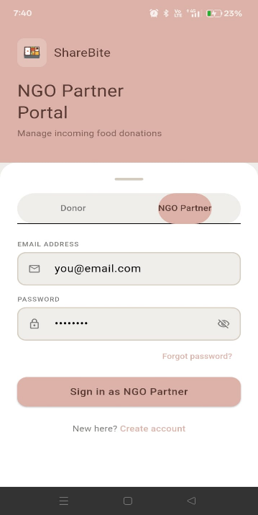
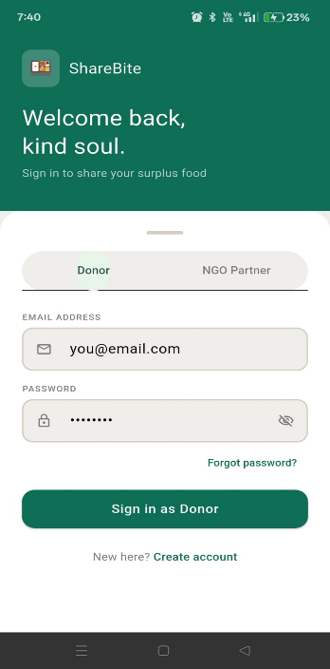
Fig 3.1.1 donor login page Fig 3.1.2 Ngo login page

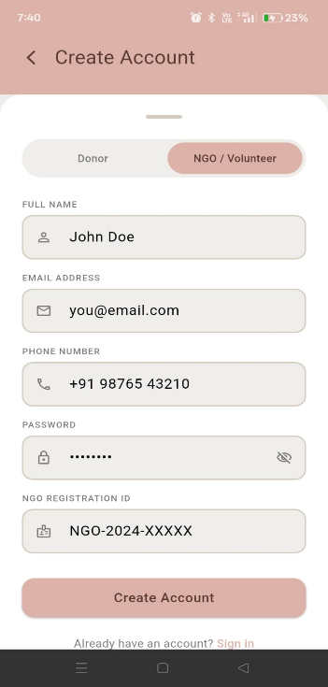

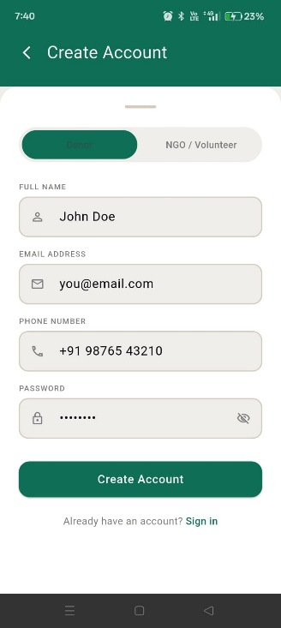

Fig 3.1.3 donor signup page Fig 3.1.4 Ngo signup page
3.2 Donor and Ngo homepages
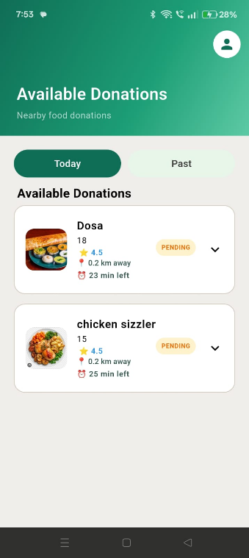
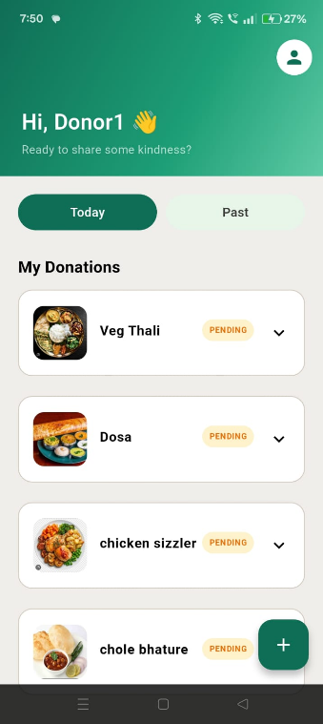

Fig 3.2.1 Donor home page Fig 3.2.2 Ngo home page
3.3 Add Donation 3.4 Edit profile
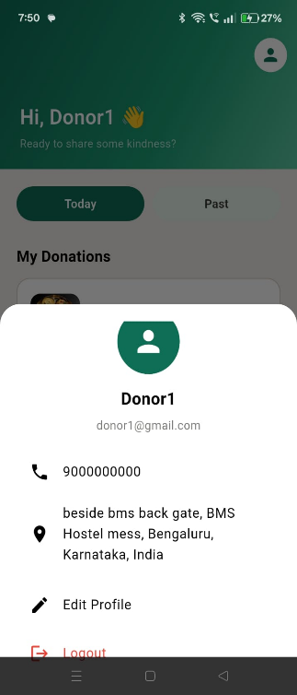
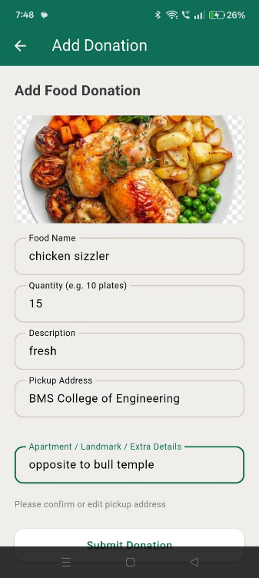

Fig 3.3Add a donation page Fig 3.4 Edit the profile
3.5 Real time donation flow

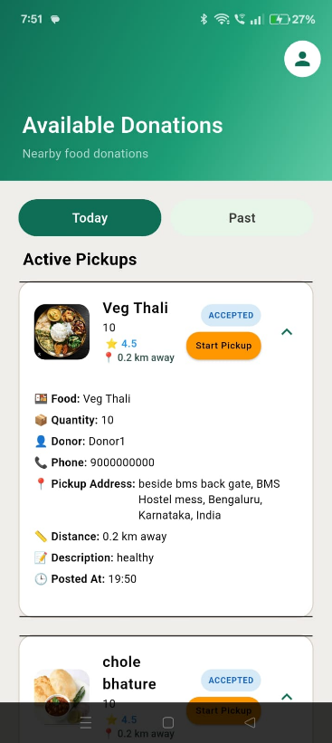
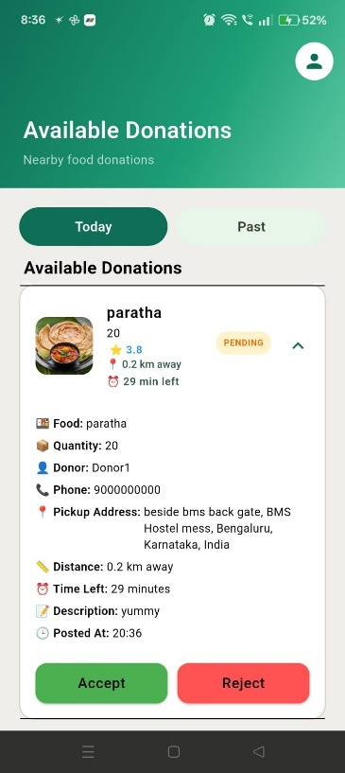

Fig 3.5.1 Accept/Reject donation Fig 3.5.2 Start Pickup
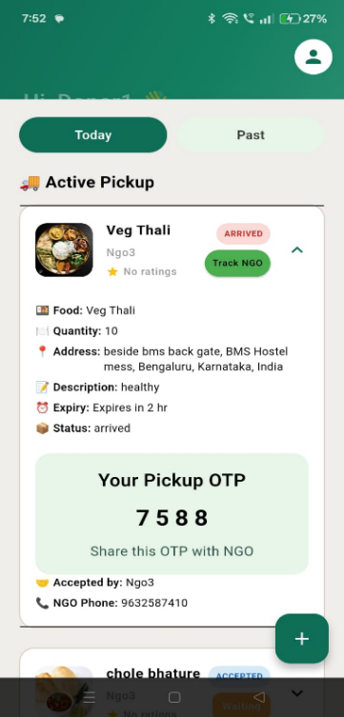
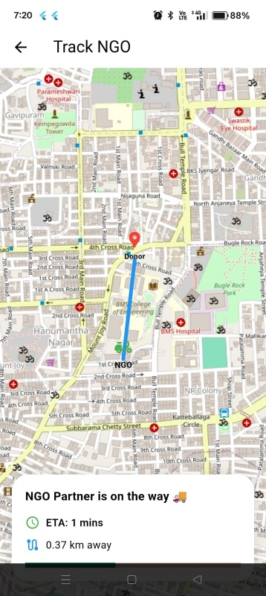

Fig 3.5.3 Navigate page Fig 3.5.4 Enter OTP for verification
3.6 Review page
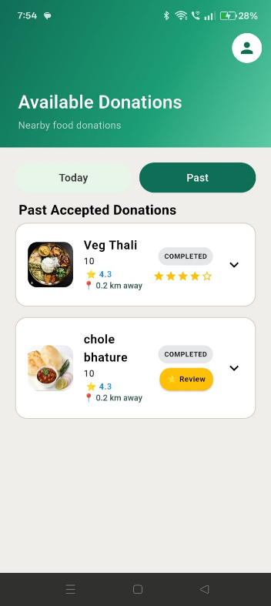
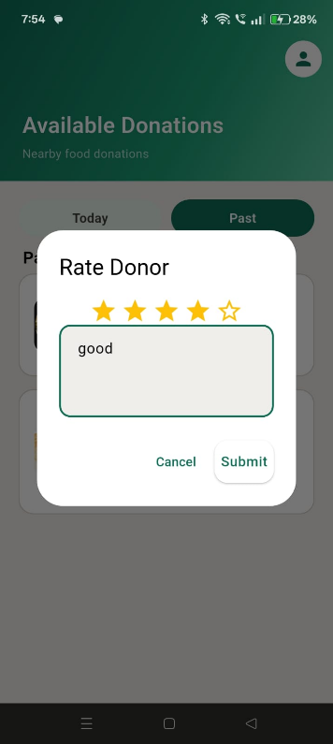

Fig 3.6.1 Review with comment Fig 3.6.2 overall rating
3.7 Notification 3.8 Phone calls
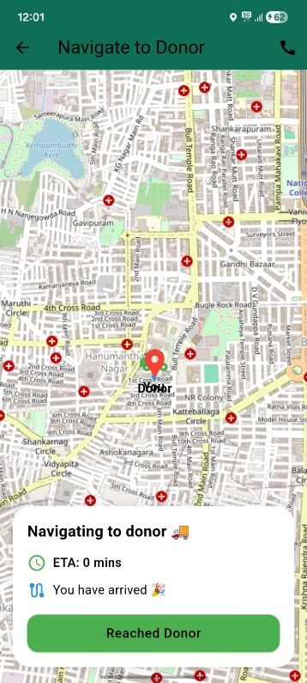
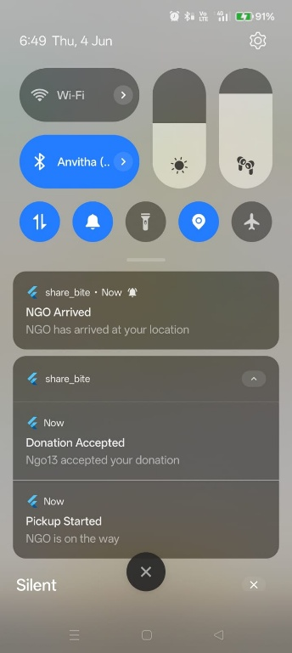

Fig 3.7 Real time Notifications Fig 3.8 Communication between Ngo and donor by phone calls
Chapter 4
Database Table Screen shots

Cloud Firestore is the primary database used in the ShareBite System. Unlike traditional relational databases that store data in tables, Firestore stores information in the form of collections and documents. Each collection contains multiple documents, and each document consists of fields and values representing application data.

4.1 Users Collection
Purpose:
The Users collection stores information related to donors and NGOs, including personal details, contact information, location data, and user roles.
4.1.1 Users Collection Structure
Field Name | Data Type | Description
address | String | Address of the donor or NGO
createdAt | Timestamp | Date and time when the account was created
email | String | User email address
latitude | Double | Latitude coordinate of the user's location
longitude | Double | Longitude coordinate of the user's location
name | String | Name of the donor or NGO
ngoRegId | String | NGO registration number (for NGOs)
phone | String | Contact number of the user
role | String | User role (donor or ngo)

4.1.2 Users Collection Screenshot
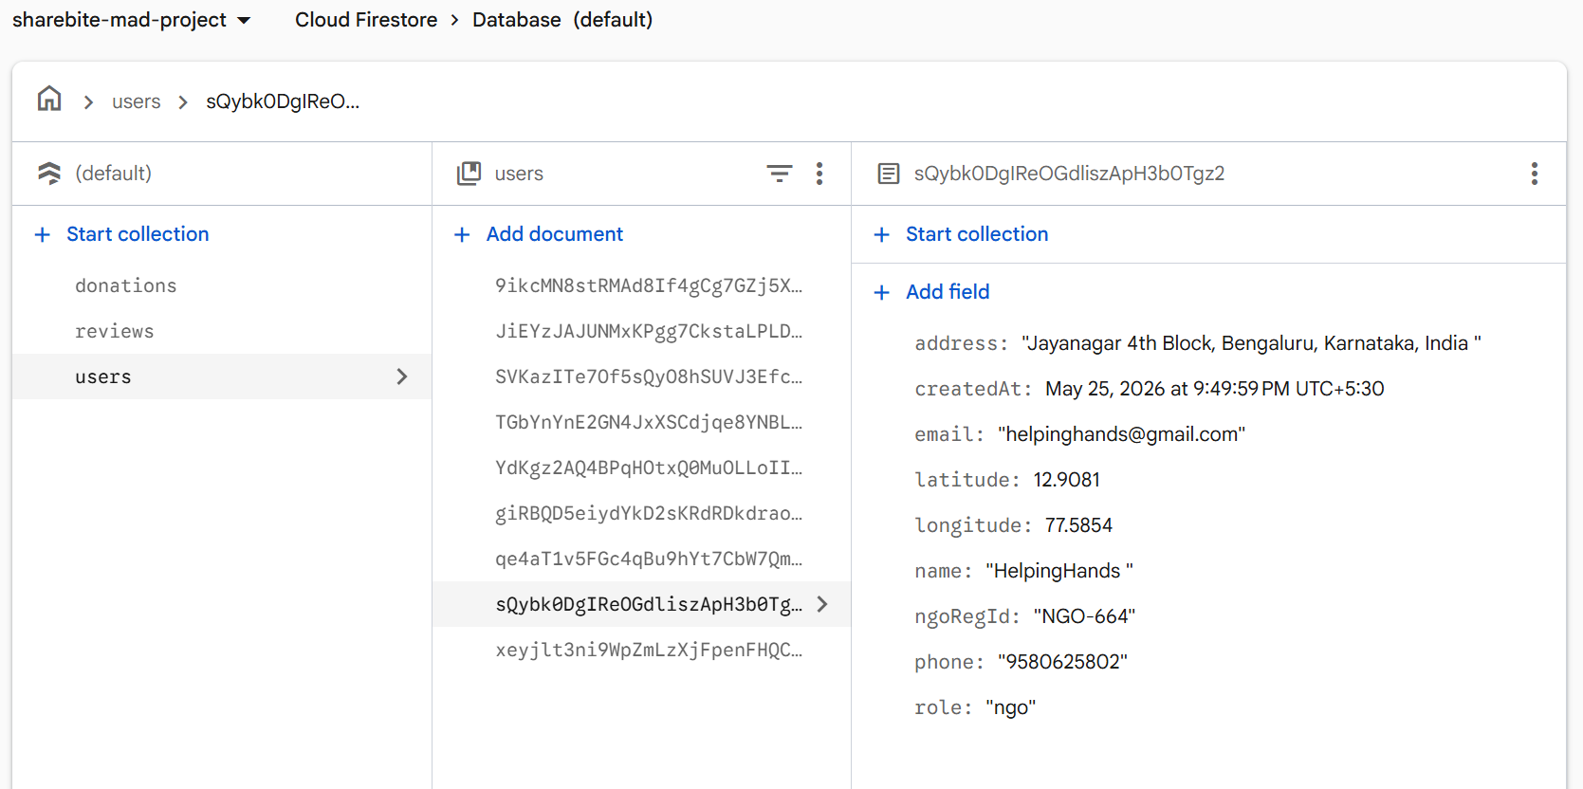

4.2 Donations Collection
Purpose:
The Donations collection stores information about food donations created by donors. It contains food details, location information, donation status, pickup information, OTP verification details, and NGO acceptance records

4.2.1 Donations Collection Structure
Field Name | Data Type | Description
acceptedAt | Timestamp | Date and time when the donation was accepted by an NGO
acceptedByNgoId | String | Unique identifier of the NGO that accepted the donation
address | String | Pickup location of the donated food
createdAt | Timestamp | Date and time when the donation was created
description | String | Additional details about the food item
donorAcknowledged | Boolean | Indicates whether the donor acknowledged donation completion
donorId | String | Unique identifier of the donor
donorName | String | Name of the donor
donorPhone | String | Contact number of the donor
expiryTime | Timestamp | Expiry time of the donated food
foodName | String | Name of the food item
imageUrl | String | URL of the uploaded food image stored in Cloudinary
latitude | Double | Latitude coordinate of the donor location
longitude | Double | Longitude coordinate of the donor location
ngoLat | Double | Latitude coordinate of the NGO during pickup
ngoLng | Double | Longitude coordinate of the NGO during pickup
ngoName | String | Name of the NGO that accepted the donation
ngoPhone | String | Contact number of the NGO
otpVerified | Boolean | Indicates whether OTP verification was successful
pickupOtp | String | OTP generated for donation handover
pickupStarted | Boolean | Indicates whether pickup has started
quantity | String | Quantity of food available for donation
reviewRating | Integer | Rating given after donation completion
reviewSubmitted | Boolean | Indicates whether a review has been submitted
status | String | Current status of the donation (Pending, Accepted, Pickup Started, Completed, etc.)

4.2.2 Donations Collection Screenshot
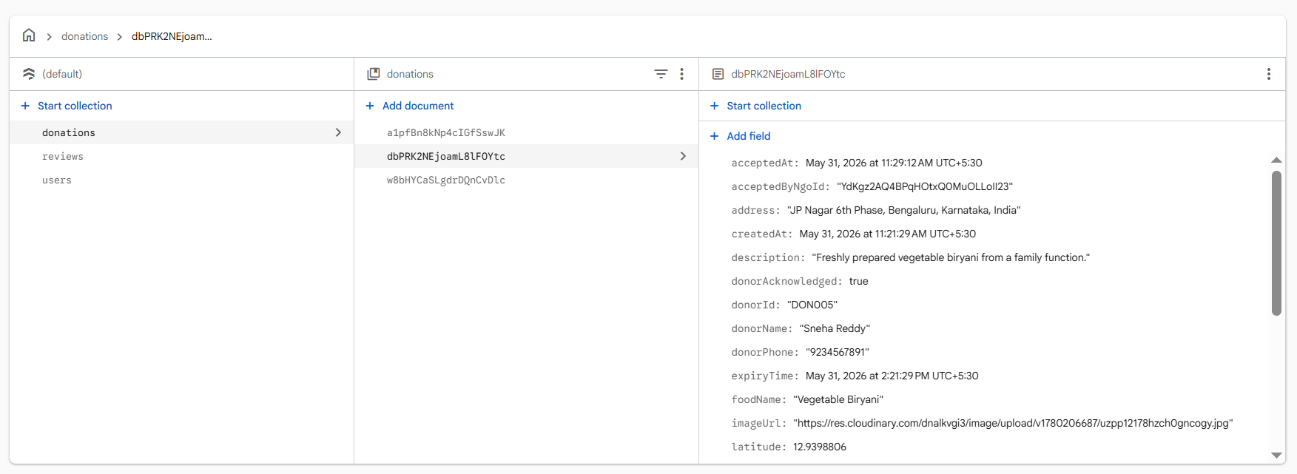

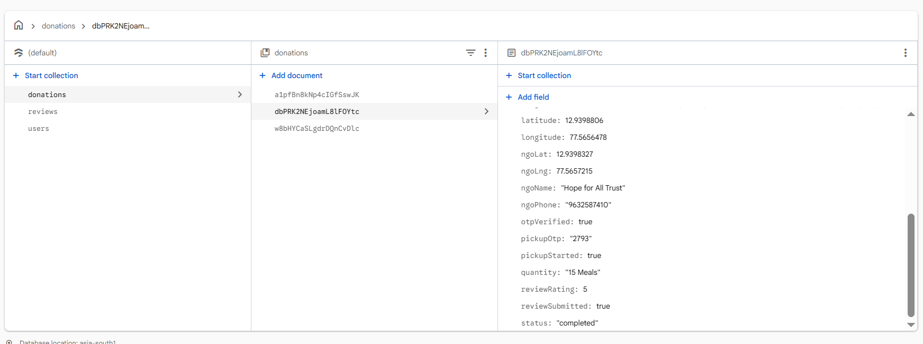

4.3 Reviews Collection
Purpose:
The Reviews collection stores ratings and feedback exchanged between donors and NGOs after successful completion of a donation.

4.3.1 Reviews Collection Structure
Field Name | Data Type | Description
createdAt | Timestamp | Date and time when the review was submitted
donationId | String | Unique identifier of the related donation
rating | Integer | Rating given by the reviewer (1–5)
review | String | Review comment provided by the reviewer
reviewType | String | Type of review (ngo_to_donor or donor_to_ngo)
reviewerId | String | Unique identifier of the reviewer
reviewerRole | String | Role of the reviewer (ngo or donor)
targetId | String | Unique identifier of the user receiving the review
targetRole | String | Role of the reviewed user (ngo or donor)

4.3.2 Reviews Collection Screenshot
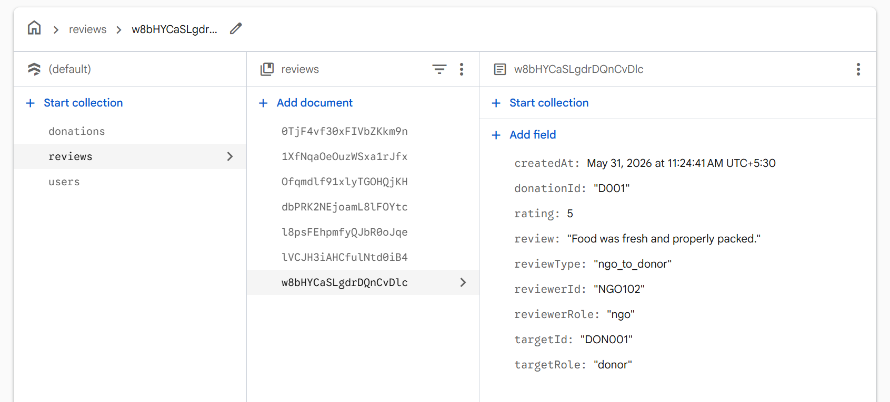
4.4 Notifications Collection
Purpose:
The Notifications collection stores all notification messages generated by the ShareBite System. These notifications inform donors and NGOs about important events such as donation acceptance, pickup initiation, and donation completion. The collection helps users track donation-related activities and ensures timely communication within the system.

4.4.1 Notifications Collection Structure

Field Name | Data Type | Description
createdAt | Timestamp | Date and time when the notification was generated
isRead | Boolean | Indicates whether the notification has been viewed by the user
message | String | Detailed notification message displayed to the user
title | String | Short title describing the notification event
userId | String | Unique identifier of the user receiving the notification

4.4.2 Notifications Collection Screenshot
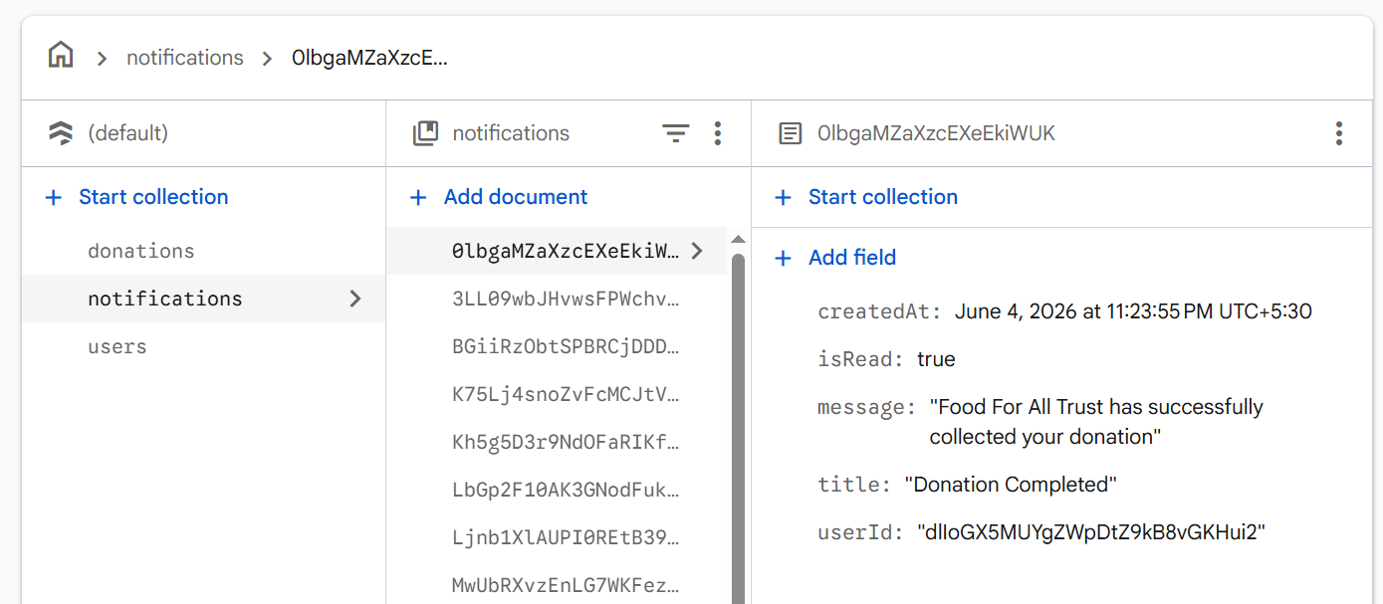

4.5 ER Diagram

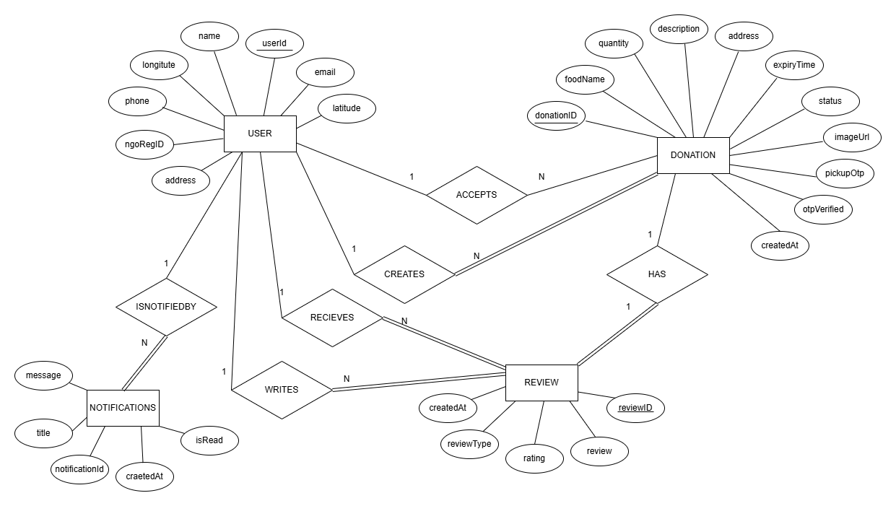

Fig 4.1: ER diagram of ShareBite Food Donation System

Chapter 5
Testing
5.1 Login Module Testing
TC ID | Test Scenario | Input Data | Expected Result | Actual Result | Status
TC_001 | Login with valid donor credentials | donor1@gmail.com / Donor@123 | Donor dashboard opens successfully | Dashboard displayed successfully | Pass
TC_002 | Login with valid NGO credentials | ngo1@gmail.com / Ngo@123 | NGO dashboard opens successfully | Dashboard displayed successfully | Pass
TC_003 | Login with incorrect password | donor1@gmail.com / wrong123 | Error message displayed | Error message displayed | Pass
TC_004 | Login with unregistered email | abc@gmail.com | User not found message | User not found message | Pass
TC_005 | Login with empty fields | Empty email and password | Validation message displayed | Validation message displayed | Pass

5.2 Donation Creation Module Testing
TC ID | Test Scenario | Input Data | Expected Result | Actual Result | Status
TC_006 | Create donation with valid details | Food, quantity, expiry time, image | Donation created successfully | Donation created successfully | Pass
TC_007 | Create donation without image | Missing image | Validation message displayed | Validation message displayed | Pass
TC_008 | Create donation with expired food time | Expiry time less than current time | Donation not created | Donation rejected | Pass
TC_009 | Create donation with empty fields | Missing mandatory fields | Validation message displayed | Validation message displayed | Pass

5.3 NGO Donation Management Testing
TC ID | Test Scenario | Input Data | Expected Result | Actual Result | Status
TC_010 | NGO accepts donation | Accept button clicked | Donation status updated to Accepted | Status updated successfully | Pass
TC_011 | NGO rejects donation | Reject button clicked | Donation status updated to Rejected | Status updated successfully | Pass
TC_012 | NGO starts pickup | Start Pickup button clicked | Pickup status activated | Pickup tracking started | Pass

5.4 OTP Verification Testing
TC ID | Test Scenario | Input Data | Expected Result | Actual Result | Status
TC_013 | Verify correct OTP | 2793 | Donation marked completed | Donation completed successfully | Pass
TC_014 | Verify incorrect OTP | 1234 | OTP verification failed | Error displayed | Pass
TC_015 | OTP field left empty | Empty OTP | Validation message displayed | Validation message displayed | Pass

5.5 Review and Rating Testing
TC ID | Test Scenario | Input Data | Expected Result | Actual Result | Status
TC_016 | NGO submits donor review | Rating 5, Comment | Review stored successfully | Review stored successfully | Pass
TC_017 | Donor submits NGO review | Rating 4, Comment | Review stored successfully | Review stored successfully | Pass
TC_018 | Submit review without rating | Empty rating | Validation message displayed | Validation message displayed | Pass

5.6 Profile Management Testing
TC ID | Test Scenario | Input Data | Expected Result | Actual Result | Status
TC_019 | Update donor profile | New name and phone | Profile updated successfully | Profile updated successfully | Pass
TC_020 | Update NGO profile | New address | Profile updated successfully | Profile updated successfully | Pass
TC_021 | Logout | Logout button clicked | User redirected to login page | Redirected successfully | Pass

5.7 Notification Testing
TC ID | Test Scenario | Input Data | Expected Result | Actual Result | Status
TC_022 | Donation Accepted Notification | NGO accepts donation | Donor receives notification mentioning the accepting NGO | Notification received successfully with NGO name | Pass
TC_023 | Pickup Started Notification | NGO clicks "Start Pickup" | Donor receives notification that NGO is on the way | Notification received successfully | Pass
TC_024 | Donation Completed Notification | NGO completes pickup after OTP verification | Donor receives donation completion notification | Notification received successfully | Pass
TC_025 | Notification Read Status Update | User opens notification | Notification is marked as read and not shown repeatedly | Notification marked as read successfully | Pass

Chapter 6
Conclusion and Future Work

6.1 Conclusion
The ShareBite Food Donation System was developed to address the problem of food wastage by providing a platform that connects food donors with NGOs. The system enables donors to create food donation requests, upload food details and images, and track the donation process. NGOs can view available donations, accept requests, initiate pickups, and verify successful food collection through OTP-based confirmation.
The application was developed using Flutter for the frontend, Firebase Authentication for user management, Cloud Firestore for database operations, Cloudinary for image storage, and Google Maps API for location services. The implemented features ensure secure authentication, efficient donation management, real-time status tracking, OTP verification, and a review and rating mechanism.
Overall, ShareBite provides a practical and user-friendly solution for reducing food wastage while supporting NGOs in distributing surplus food to people in need. The project successfully demonstrates the use of modern mobile application technologies to solve a real-world social problem.

6.2 Future Work
The following enhancements can be incorporated in future versions of the ShareBite System:
- AI-Based Donation Matching
Use machine learning algorithms to recommend suitable NGOs based on donation type, quantity, and location.
- Food Quality Assessment
Integrate image analysis techniques to assist in evaluating the quality and condition of donated food.
- Multi-Language Support
Provide support for regional languages to improve accessibility for users from different locations.
- Web-Based Administration Portal
Develop an admin dashboard for monitoring users, donations, reviews, and overall system activity.
- Analytics and Reporting
Generate reports on food donations, NGO performance, user participation, and food wastage reduction statistics.
- Expanded User Roles
Introduce additional stakeholders such as volunteers, food delivery partners, and community organizations.
- Scalability and Wider Deployment
Extend the system to support larger geographic regions and integrate with government and non-profit food distribution programs.
The future enhancements will improve the efficiency, scalability, and overall impact of the ShareBite Food Donation System, enabling it to contribute more effectively towards reducing food wastage and supporting community welfare.

References

[1] https://docs.flutter.dev/
[2] https://firebase.google.com/docs
[3] https://firebase.google.com/docs/firestore
[4] https://cloudinary.com/documentation
[5] https://developers.google.com/maps/documentation
[6] https://www.unep.org/resources/report/food-waste-index-report-2024

Appendix

Certification: TechA Git Foundation Certification

USN:1BF24CS151
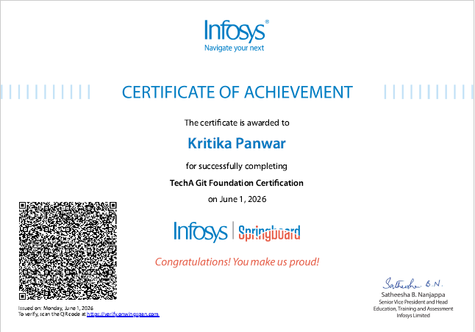

USN:1BF24CS127
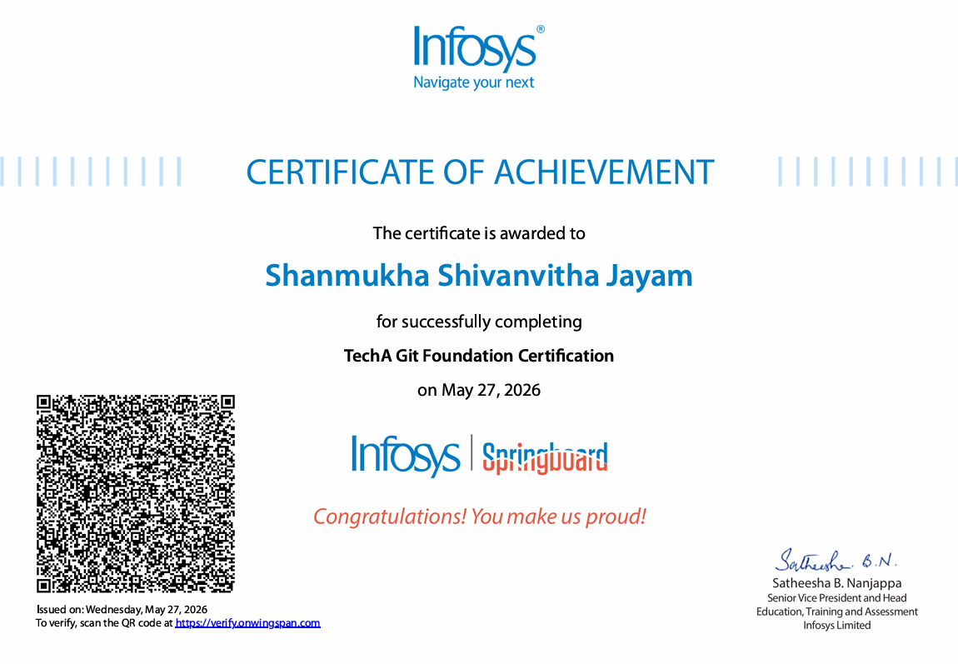

USN:1BF24CS133
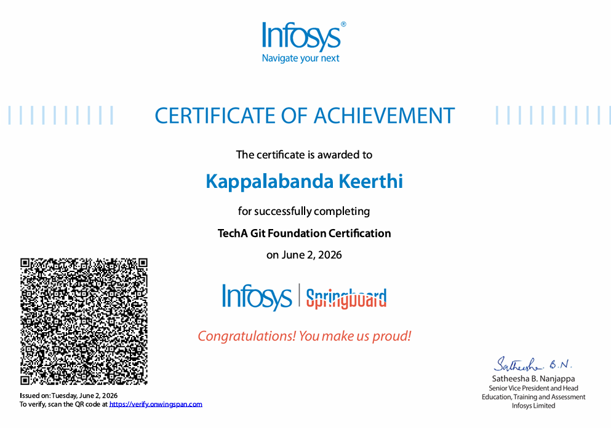

Topics Learned
- Introduction to Git and Version Control Systems.
- Installing and configuring Git.
- Creating and managing Git repositories.
- Working with commits and commit history.
- Branch creation and branch management.
- Merging branches and resolving merge conflicts.
- Using Git for collaborative software development.
- Understanding Git workflows and best practices.
- Managing project versions and source code efficiently.
- Using Git commands for tracking and maintaining changes.

How it Helped in the ShareBite Project
- Enabled efficient version control throughout the development of the ShareBite application.
- Helped track source code changes made by different team members.
- Facilitated collaboration by allowing multiple developers to work on separate features using branches.
- Assisted in merging completed features into the main project without losing existing code.
- Provided a backup and recovery mechanism through commit history.
- Improved project organization and software development practices.
- Simplified bug fixing by identifying and reverting problematic changes when required.
- Supported systematic development and maintenance of the Flutter-based ShareBite application.

