**United Technical College**

(Affiliated to Pokhara University)

**Bharatpur-11, Bhojad, Chitwan**

**[Subject Code: CMP-299]**



A MINOR PROJECT PROPOSAL REPORT ON

“**HEALTH CARE APPOINTMENT BOOKING SYSTEM”**

**Submitted by:**

**Bibek Poudel [BE Comp-2019-04]**

**Kushal Duwadi [BE Comp-2019-11]**

**Kritika Shrestha [BE Comp-2019-10]**

**Smriti Kafle [BE Comp-2019-24]**

**Paras Poudel [BE Comp-2019-13]**

**Submitted to:**

**Department of Computer Engineering**

**May-2022**

**HEALTH CARE APPOINTMENT BOOKING SYSTEM**

**Submitted by:**

**Bibek Poudel [BE Comp-2019-04]**

**Kushal Duwadi [BE Comp-2019-11]**

**Kritika Shrestha [BE Comp-2019-10]**

**Smriti Kafle [BE Comp-2019-24]**

**Paras Poudel [BE Comp-2019-13]**

**Submitted to:**

**Department of Computer Engineering**

**May-2022**

**Table of Contents:**

**Cover Page...................................................................................................i**

**Title Page.....................................................................................................ii**

**ABSTRACT....................................................................................................iii**

**Table of Contents.........................................................................................iv**

**LIST OF FIGURES...........................................................................................v**

**LIST OF TABLES.............................................................................................vi**

**LIST OF SYNONYMS AND ACRONYM.............................................................vii**

**CHAPTER ONE: INTRODUCTION.....................................................................1**

**1.1 Background**

**1.2 Statement of Problem**

**1.3 Objective**

**1.4 Application**

**CHAPTER TWO: LITERATURE REVIEW.............................................................2**

**2.1 Case Study**

**CHAPTER THREE: METHODOLOGY..................................................................3**

**3.1 Software Used**

**3.2 Software development**

**3.3 Database Management**

**CHAPTER FOUR: EPILOGUE……………………………………………………….………………...4**

**4.1 Expected Outcome**

**4.2 Work schedule**

**REFERENCES………………………………………………………………………………….………….…5**

**LIST OF FIGURES**

**Figure3.1: Different state of waterfall model**

**Figure 3.2: System flow diagram**

**Figure 3.3: E-R diagram for appointment of the doctor**

**Figure4.1: Gantt diagram**

**LIST OF ABBREVINATION AND ACRONYM**

**BEC: Bachelor of engineering in computer**

**PU: Pokhara University**

**ID: Identity Card**

**SDLC: Software Development Life Cycle**

**ERD: Entity-Relationship diagram**

**JDK: Java Development Kit**

**JVM: Java Virtual Machine**

**JRE: Java Runtime Environment**

**IDE: Integrated Development Environment**

**GUI: Graphical User Interface**

**Chapter one: Introduction**

**1.1 Background**

Healthcare booking system is a web based computerized system that provides a platform for hospitals, clinics and other health services providing organizations to manage hospital facilities through online medium. It provides online appointment with doctors of representative hospitals and clinics as well as it provides online booking of cabins and other facilities which are physically provided by respective hospitals and clinics. It also provides online health care services as well as appointment for home visit can be booked with the help of this platform.

Healthcare booking system has a main motive to make routine check-up and interaction with their doctors easier. It is mainly focused to provide the best facilities to each and every patients. This web based design will make easier to subscribe the package and further expansion on package will be possible with less effort. This project will take over the general task responsible by receptionist. In this rapidly growing world it is really hard to stand as a business without the use of latest technologies. Thus, this project will help the management system to be easier.

This system can be used by a non-programming/technical personal avoiding the human handled errors. This project can be used by two users:

**1. Patients/Normal users**

**2. Hospitals and Clinics**

Patients/Normal users have the free functionality for registering and making payment for the appointment. These users can only have limited rights to this system. These users cannot delete or add any offers or publish any official or unofficial functions linking to organizational administration.Hospitals and Clinics have the access to control the official package/offers or to add/delete/update information the doctors or the facilities available.

**1.2 Statement of Problem**

In this present situation where all the facilities are provided by the electronic means hospital facility should also be in the top most for providing facilities with less interaction with the peoples. Patients have to wait for the long procedure in hospital for the appointment and many wishes for having a private cabin inside hospital but due to the limited options it is a hard job. The most common problem of paper based reservation of appointment and other facilities are:

i. Hard to find the old Data

ii. Time consuming for reservation and appointment

iii. Data duplication and Over Reservation

**1.3 Objective**

The main objective or motive of our project is to provide all the facilities of health sector to the people in an easiest form. Many people don't know whom to consult for a particular diseases or health issues. Our project helps the patients to know about their diseases and to whom they should consult and provides best expert doctor in particular available hospitals or health sector. People have to be physically present for the appointment of doctors and other facilities. Our project makes it feasible for everyone to take appointment from anywhere.

**1.4 Application**

Our project can be implemented in several application areas for different purposes. Although our project won't have all the features required to be a good hospital management system, it will still manage to handle most important system which is taking appointment/reservations. The hospital and clinics will also have access and manage the following features:

**i. Patients database management**

It can manage or maintain the patient records and provide discounts and offer for the user who have visited the site.

**ii. Cabin and Appointment Availability**

The user can check whether the appointment or other facilities provided by hospital are available or not.

**iii. Reservation**

By using it reservation of appointment and other facilities can be done avoiding the overwriting/overbooking.

**iv. Search all previous patient's data**

Through using this system, admin will be able to search for the previous data of patients

**Chapter Two: LITERATURE REVIEW**

A lot of research has been done for this project by our team on online doctor's appointment and booking and here are some of the study's results:

**2.1 Case Study**

**1.Hamro Doctor**

**->** Hamro Doctor is a well managed online consulting website which provides patient to have a virtual routine consultation with the top doctors by charging its own rate types. It's a virtual based website which can provide appointment for online consultant and few of the physical appointment based on Kathmandu area only.(1)

**2.Clinic one**

**->** Clinic one is also a well-managed online consulting website but with limited features on it and only limited Health consultant can be found in this site and is completely online consultant based. It's also a Kathmandu based website.(2)

**3.Doctors on call**

**->** Doctors on call provides many features like home facility of doctor visit, physiotherapy at home, nursing care at home, laboratory test at home and so on. It's also a Kathmandu based website.(3)

**4.Mero Doctor**

**->** Mero Doctor is most advance feature having web-based system providing data and names of doctors of different working on different shift on different hospital making the appointment service easy to book and for the reservation this web-based system is most popular in its field.(4)

**Chapter Three: Methodology**

**3.1 Software Used**

**3.1.1 VS Code (Visual Studio Code)**

->Visual Studio Code is a lightweight but powerful source code editor which runs on your desktop and is available for Windows, macOS and Linux. It comes with built-in support for JavaScript, TypeScript and Node.js and has a rich ecosystem of extensions for other languages (such as C++, C#, Java, Python, PHP, Go) and runtimes (such as .NET and Unity). The main features of this software are:

**Emmet Abbreviations**: These useful shortcuts come built-in to VS Code, and they make writing HTML (and CSS) a lot faster.

**The Integrated CLI (Command Line Interface):** To save switching between windows, VS Code offers an integrated terminal or CLI. Simply, press CNTRL + ' or CMD + ' to open it up, and the same command to close it. It will automatically open in the directory you have open in VS Code, which saves the navigation step required for operations in a standard terminal.

**ESLint:** ESLint is a powerful and popular linting tool, which helps you spot errors in your code and fix them as you write and which helps you follow common best-practices. It’s also a great learning tool, since researching ESLint errors has taught me many best practices I didn’t know before, and it’s helped me understand why they are best practices.

**Prettier:** Prettier is an opinionated code-formatter. It prescribes a certain formatting style as the correct one, but its popularity is making its rules something of an established standard for JavaScript, CSS, and increasing numbers of other languages.

**Multi-Cursor Shortcuts:** The ability to edit with multiple cursors can be a huge time saver. To use this most effectively requires memorization of a handful of commands, but they’ll soon become second nature.

**Text Wrap:** There aren’t many cases where I’d prefer my text to run off the screen, forcing me to use the dreaded horizontal scroll. To toggle wrapping on or off on a per-file basis, simply press ALT + Z

**Execute and Debug JavaScript:** The best choice for debugging JavaScript within VS Code is Microsoft’s own “Debugger for Chrome” extension. How it works can be a little complex, so I recommend you take a look at the official documentation if you want to learn more. Suffice to say that this is a powerful tool, and it was a real eye-opener for me when I discovered it — it will take you a lot further than console.log() ! (7)

**3.1.2 XAMPP**

XAMPP stands for Cross-Platform (X), Apache (A), MariaDB (M), PHP (P) and Perl (P). Since XAMPP is simple, lightweight Apache distribution it is extremely easy for developers to create a local web server for testing and deployment purposes. Everything you needed is to set up a web server – server application (Apache), database (MariaDB), and scripting language (PHP). XAMPP works equally well on Linux, Mac, and Windows. Its features are:

XAMPP has been designed to be the easiest way to install and run a development server. There are numerous other WAMP packages available, but XAMPP is one of the most complete on offer. In addition to Apache, MySQL, and PHP, XAMPP includes other really useful tools such as the phpMyAdmin database administration tool, FileZilla FTP server, Mercury mail server, Perl programming language, and JSP server Tomcat.

XAMPP can also install an administration site as the home page of the server. From which you can undertake all manner of administrative tasks, such as checking the server status and security, launch tools like phpMyAdmin and Webalizer analytics.

**3.1.3 PHP**

**PHP** is a [general-purpose](https://en.wikipedia.org/wiki/General-purpose_programming_language) [scripting language](https://en.wikipedia.org/wiki/Scripting_language) geared toward [web development](https://en.wikipedia.org/wiki/Web_development).It was originally created by Danish-Canadian [programmer](https://en.wikipedia.org/wiki/Programmer) [Rasmus Lerdorf](https://en.wikipedia.org/wiki/Rasmus_Lerdorf) in 1994.The PHP [reference implementation](https://en.wikipedia.org/wiki/Reference_implementation) is now produced by The PHP Group.PHP originally stood for ***Personal Home Page***,[.](https://en.wikipedia.org/wiki/PHP#cite_note-History_of_PHP-8) but it now stands for the [recursive initialism](https://en.wikipedia.org/wiki/Recursive_initialism) ***PHP: Hypertext Preprocessor***.[8]

PHP code is usually processed on a [web server](https://en.wikipedia.org/wiki/Web_server) by a PHP [interpreter](https://en.wikipedia.org/wiki/Interpreter_(computing)) implemented as a [module](https://en.wikipedia.org/wiki/Plugin_(computing)), a [daemon](https://en.wikipedia.org/wiki/Daemon_(computing)) or as a [Common Gateway Interface](https://en.wikipedia.org/wiki/Common_Gateway_Interface) (CGI) executable. On a web server, the result of the [interpreted](https://en.wikipedia.org/wiki/Interpreter_(computing)) and executed PHP code – which may be any type of data, such as generated [HTML](https://en.wikipedia.org/wiki/HTML) or [binary](https://en.wikipedia.org/wiki/Binary_number) image data – would form the whole or part of an [HTTP](https://en.wikipedia.org/wiki/Hypertext_Transfer_Protocol) response. Various [web template systems](https://en.wikipedia.org/wiki/Web_template_system), web [content management systems](https://en.wikipedia.org/wiki/Content_management_system), and [web frameworks](https://en.wikipedia.org/wiki/Web_framework) exist which can be employed to orchestrate or facilitate the generation of that response. Additionally, PHP can be used for many programming tasks outside the web context, such as standalone [graphical applications](https://en.wikipedia.org/wiki/Graphical_user_interface) and [robotic](https://en.wikipedia.org/wiki/Robotics) [drone](https://en.wikipedia.org/wiki/Unmanned_aerial_vehicle) control. PHP code can also be directly executed from the [command line](https://en.wikipedia.org/wiki/Command-line_interface).[8]

**3.2.1. SDLC**

Waterfall approach was first SDLC Model to be used widely in Software Engineering to

ensure success of the project. In "The Waterfall" approach, the whole process of software development is divided into separate phases.

Since water fall method is one of the simplest methods to develop any small as well as large software package, we will be using water flow method to develop our project as well. Water flow method allows us to clearly see what requirements are and to develop software according to requirements. While using water fall method. Water fall methods forces us to develop our software step by step as also mentioned in Work Schedule. The following illustration is a representation of the different states of the Waterfall Model.

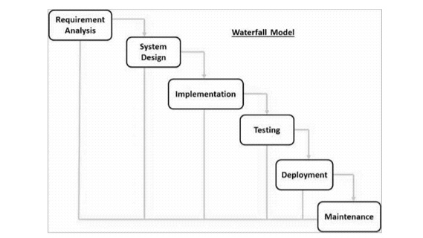

**Figure 3.1: different states of the Waterfall Model**

**3.2.3. System flow diagram**

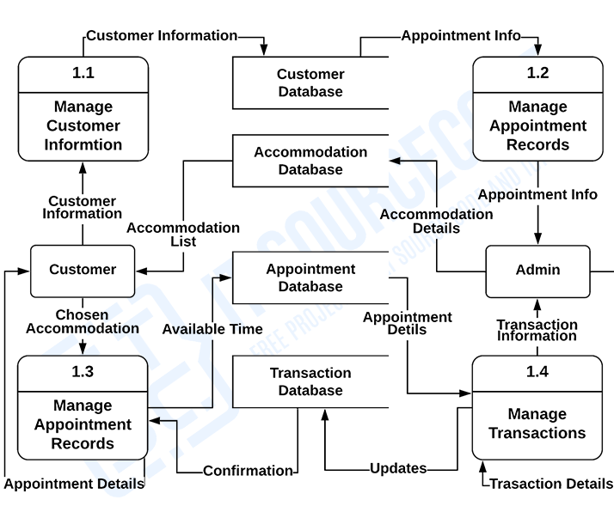

**3.2.4 ER Diagram**

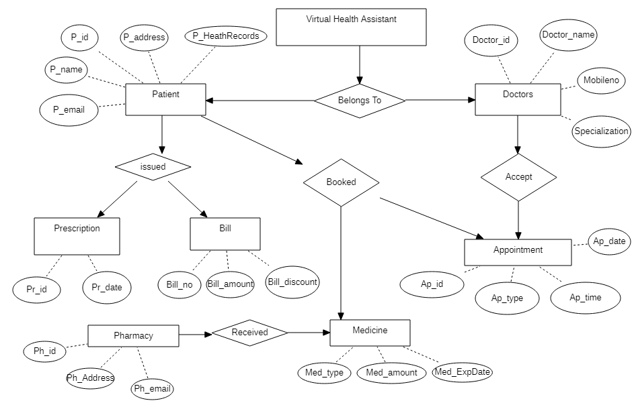

**Chapter Four: Time Estimation**

Before getting started with any project we have to prepare a working schedule consisting of several topics that we would be working on throughout the project development phase. We will try to balance between learning how code works and by researching necessary details about our project.

* Week 1-2: At the beginning of the project development, we will begin with research on different programming tools that will be used throughout the project. We will also begin preparing documentation during this time and keep updating information in it followed by our progress in the upcoming weeks for the project.And we will also consult with different doctors and health workers about aour projrct for their suggestion.
* Week 3-5: In the starting of third week, we will mainly focus on actual coding and use interface designing. Within the period of third week, we will finish our user interface designing as well as some major programming related to actual software and database management. We will also keep testing and monitoring our application during the fifth week for any issue related with portability and performance.
* Week 6-8: When the sixth week is about to start, we will start focusing on the operation, integration and deployment part along with continuous development phase. The testing phase would still go on till the end of 8th week along with deployment operation and monitoring.
* Week 9-10: This is the phase where we would be focusing mainly on the preparation of final project report and presentation along with all the documentations started during the beginning of the project development phase. Finally, at the end of 10th week we will complete our final project report and submit it to the respective department.

**Fig:4.1 Gantt diagram**

**Chapter Five: Expected Outcome**

Since, our project is platform for health service provides and the health service receiver(patients) we have consult with many health service providers and many health workers from their review we have expected to be top most online site providing facilities to the consumers. We will be shorting the distance between the lengthy paperwork or queue problems for booking and appointment. This platform is developed to reduce the health problem caused due to the unmanaged old paper based system with a minimal error.

**Reference:**

**1.Hamro Doctor "**[**https://www.hamrodoctor.com/**](https://www.hamrodoctor.com/)**"**

**2.Clinics One "**[**https://www.clinicone.com.np/online-consultation-in-nepal/**](https://www.clinicone.com.np/online-consultation-in-nepal/)**"**

**3.Doctors on Call "**[**https://doctorsoncall.com.np/appointment/**](https://doctorsoncall.com.np/appointment/)**"**

**4.Mero Doctor "**[**https://www.merodoctor.com/doctors/finddoctors?dep=true**](https://www.merodoctor.com/doctors/finddoctors?dep=true)**"**

**5.VScode "**[**https://bretcameron.medium.com/7-essential-features-of-visual-studio-code-for-web-developers-be77e235bf62**](https://bretcameron.medium.com/7-essential-features-of-visual-studio-code-for-web-developers-be77e235bf62)**"**

**6. Megan Morgan, “How to Write a Proposal”**

[**https://www.wikihow.com/Write-a-Proposal**](https://www.wikihow.com/Write-a-Proposal)**,June 11, 2019**

**7. w3schools,” Learn JAVA”**

[**https://www.w3schools.com/java/java_intro.asp**](https://www.w3schools.com/java/java_intro.asp)**, Unknown**

**8.**  **Lerdorf, Rasmus (2007-04-26).**[***"PHP on Hormones – history of PHP presentation by Rasmus Lerdorf given at the MySQL Conference in Santa Clara, California"***](https://web.archive.org/web/20190106230504/http:/web.archive.org/web/20130729204354id_/http:/itc.conversationsnetwork.org/shows/detail3298.html)**. The Conversations Network. Archived from**[***the original***](http://itc.conversationsnetwork.org/shows/detail3298.html)**on 2019-01-06*. Retrieved 2009-12-11*.**