PackProofAI: How It Works (Judges' Guide)
Oct 22, 2026 · @Ashkrit
PackProofAI turns a product's messy starting files (a carton PDF, a content sheet, notes) into a design brief an agency can use, with every value traced to its source and every number checked by code.
Built for the Esko AIForge Hackathon, Problem Statement 1. The rule that shapes everything below: AI reads and suggests. Code checks. Humans decide.

The problem
Packaging errors are found late, often on press. The facts live in several files that disagree: the artwork says 66 g carbohydrate, the content sheet says 15 g. Nobody can tell which file is right, who must decide, or what the designer should change.

What PackProofAI does
- Reads the artwork (dieline panels, text with positions, hidden layers) and the content sheet (cells and notes).
- Fills about 58 brief fields, each with proof: the artwork panel and position, or the Excel cell and its note.
- Checks with plain Python: nutrition math, claims against ingredients, allergens, files against each other, and label rules for the chosen market and category.
- Asks only real decisions, ranked and routed to the owner (R&D, Legal, Supply Chain, Brand).
- Hands off a designer brief (Keep / Change / Add / Remove / Unknown) as PDF and Word.

Why judges can trust it
- Nothing is invented. A value comes only from a file or a person. A missing value stays missing.
- Code beats AI on anything calculable. AI findings are always "needs human check" and never block a brief.
- It works without AI. With the AI provider off, the full pipeline still runs on code alone.
- Verified on the sample pack. The Dancing Fish Granola pack has planted errors (for example sugars 18 g above carbohydrate 15 g, calories 166 against 330 calculated). 164 automated tests pass, and they check each planted error and a list of false alarms that must not appear.

System architecture
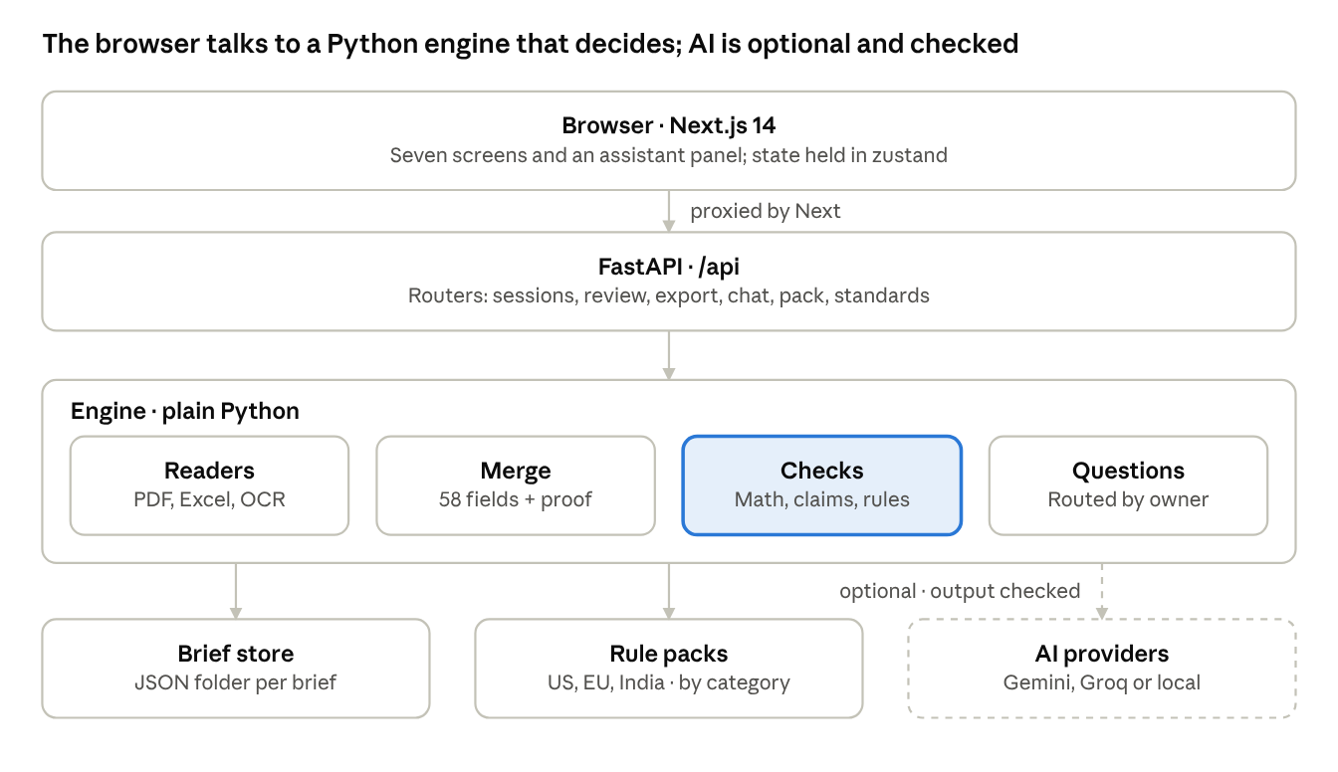
architecture · browser, API, engine, storage, optional AI
Every request goes through the FastAPI routers. The engine is plain Python and makes the decisions; the AI sits to the side, is optional, and its output is validated before it is used.

End-to-end workflow
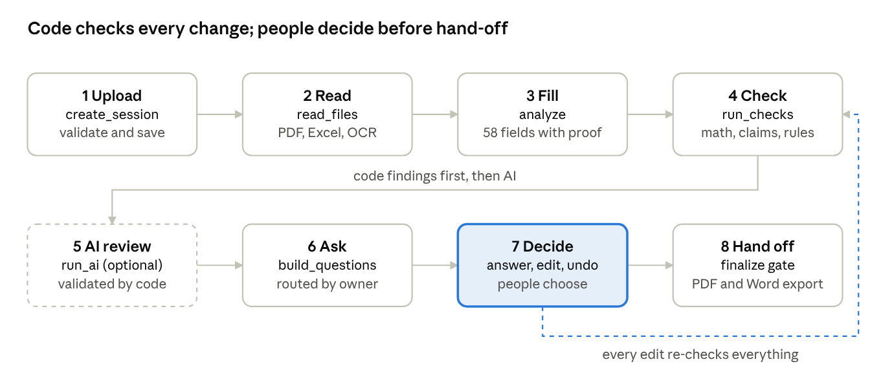
workflow · 8 steps, one loop back to the checks
A brief moves left to right, then down. Each box names the function that does the work (full list under Key functions reference). The dashed line is the loop: any answer, edit or file change re-runs the checks, rebuilds the questions and recomputes readiness, so nothing on screen is stale.

What the user does at each step
- Upload. Pick the situation, market and category; drop the files. The page returns at once and shows the live Autopilot timeline.
- Read and fill. Nothing to do. The brief appears with each value tied to its source.
- Check. Review the findings with evidence highlighted on the artwork.
- Decide. Answer only the questions that need a person, or edit a value after previewing its impact.
- Hand off. Finalize once no blocking decision is open, then download the designer brief.

Where AI is used, and how it is kept honest
AI is used in nine places. Each one has a code check that can reject its output, and each one has a fallback when AI is off.
# | Feature | Problem it solves | Guardrail in code | File
1 | Vision cross-check | The PDF text layer can differ from what is actually printed | Reads the rendered page; can only add an alternative value labelled "AI vision reading", never overwrite; readings below 0.6 confidence are dropped | ai_assist.py
2 | Rule review | Fixed checks cannot cover every clause of a market's label rules | Must cite a clause it was shown, name real fields, quote text that exists; below 0.85 confidence dropped; always "needs human check"; never blocking | ai_rules.py
3 | Claims review | Misleading wording slips past fixed rules, e.g. "vegan" beside honey | Quote must exist in the cited fields; "something is missing" findings are discarded; at most 5 | ai_assist.py
4 | Question rewording | System-style questions are hard for Legal or R&D to answer | Only rewords; if any number from the original is lost, the rewrite is discarded; options and answers stay code-made | ai_questions.py
5 | OCR | Images and scanned PDFs have no text layer | Tesseract first (gives positions and confidence); vision model second, confidence capped at 0.7; output always marked OCR | ocr.py
6 | Company rulebook import | Companies have their own packaging rules | Each proposed rule quotes its source sentence; only rules the user ticks apply, only to that brief | rulebook.py
7 | Export summary | The designer needs a one-page overview | A sentence containing a number not in the brief is dropped; cached per brief version | ai_summary.py
8 | Assistant chat | Teams need fast answers and guided changes | Product facts must come from the brief; citations checked by code; changes are proposed as cards and applied only when the user presses Apply | chat.py
9 | Talk to the Pack and Agency simulator | A reviewer asks "is this field compliant?" or "would a studio accept this?" | Code decides the score; AI only lists open questions; an AI fix may use only numbers already in the brief and is previewed first | pack.py, agency_simulator.py

How a model is called
llm.py gives one JSON client for Gemini or any OpenAI-compatible API (Groq, OpenRouter, a local Ollama). Six roles (vision, ocr, rules, claims, questions, chat) can each use a different model and key. A busy model retries once, and chat-style jobs move to the next configured model through chain().

What this means in practice
- AI never decides a number. Math, claims against ingredients and file comparisons are plain Python.
- AI findings are labelled "Needs human check" and never block finalizing.
- If every provider fails, the brief still builds, and the trace says which AI step did not run.
- With AI on, rendered artwork pages and brief text are sent to the provider. Teams with confidential packaging can point the roles at a local model instead.

Automations
Eleven things happen without the user asking. Each one removes a manual step that causes errors in packaging projects.
Automation | What it does | Where
Brief Autopilot | Runs read, extract, reconcile, check, AI review and question routing in order, timing each stage | autopilot.build
Background build with live timeline | The upload returns at once; the build runs in a thread and the page follows it by server-sent events, falling back to polling | sessions.create_session, trace.py, AutopilotTimeline.tsx
Parallel AI calls | Vision, rule review and claims review run side by side | ai_assist.run_ai
Automatic re-check | Every edit, answer or file change re-runs all checks, rebuilds the questions and recomputes readiness | pipeline.recompute
Source reconciliation | Compares every field across files and flags where they disagree | merge.group_candidates
Question routing | Turns findings into ranked questions for the right owner, with code-computed one-click answers | questions.build_questions
Change-impact preview | Shows which findings a change would fix or introduce before it is saved | review.py /impact
Decisions survive new files | Adding or replacing files re-reads everything but keeps reviewer-confirmed values, and rolls back if the re-read fails | sessions.add_files, common.restore_decisions
Duplicate to a new market | Creates a new brief from the same files, checked against another market's rules | sessions.duplicate_market, market_gap.py
Duplicate-upload detection | The same files uploaded again offer to open the existing brief | sessions._same_files
Model fallback and degradation | A busy model retries once, then the next configured model takes over; with AI off the brief still builds | llm.chain, ai_assist.run_ai

Readiness score
The score is computed by code, not by AI: confirmed fields divided by relevant fields, multiplied by 0.5 if any blocking decision is open and by 0.9 if any warning is open. The brief is "ready" only when no blocking decision is open, and finalizing is refused with a 409 listing the blockers until then.

Key functions reference
The functions below carry the workflow. Paths are under backend/app/.
Stage | Function | File | What it does
Upload | create_session | routers/sessions.py | Validates file names, count and size; stages files; blocks duplicates; starts the build (foreground or background)
Upload | _save_uploads | routers/sessions.py | Streams each file to disk and stops at 50 MB per file
Read | read_files | services/pipeline.py | Reads every file; a broken file is noted and does not stop the others
Read | parse_file, merge_extractions | services/file_parser.py | PDF text with positions, page renders, dieline panels and hidden text (PyMuPDF); Excel cells and notes (openpyxl); Word, text, images
Read | ocr.read_image | services/ocr.py | Tesseract or vision-model OCR for images and scans
Fill | read_artwork, read_sheets | services/extract_fields.py | Turn fragments into candidate values, each with its source
Fill | build_fields, group_candidates | services/merge.py | Pick the value per field and group candidates that mean the same thing
Fill | analyze | services/pipeline.py | Builds the ~58 fields; for a new product, keeps reference-artwork values out of the brief
Check | run_checks | services/checks/__init__.py | Runs the check steps, merges AI points into matching code findings, applies acknowledgements, sorts by severity
Check | check_nutrition, check_claims, check_conflicts, check_us_rules and others | services/checks/*.py | Math, claims against ingredients and allergens, file disagreements, market label rules, artwork leftovers
Rules | requirements, clauses_for, load_standards | services/guidelines.py | Loads the JSON rule packs for the chosen market, category and company rules
Recompute | recompute | services/pipeline.py | Marks mandatory fields, sets each field's status and confidence, runs checks, builds questions, scores readiness
Recompute | readiness | services/pipeline.py | The 0 to 100 score and the "ready" decision
Ask | build_questions | services/questions.py | One ranked question per decision, with code-computed options and a reason
Decide | answer_question, change_answer | routers/review.py | Apply or undo an answer, then re-check
Decide | apply_edit | routers/common.py | Logs old and new value, who and why, then updates sources
Decide | finalize, reopen | routers/review.py | Finalize returns 409 with the blockers while any blocking decision is open
AI | run_ai | services/ai_assist.py | Runs vision, rule review and claims review in parallel, then rewords questions
AI | vision_crosscheck, claims_review, rule_review, reword_questions, summarize | services/ai_*.py | The validated AI steps described above
AI | LLM.json, chain | services/llm.py | One JSON client for Gemini or OpenAI-compatible APIs, with retry and model fallback
Output | build_designer_brief | services/designer.py | Keep / Change / Add / Remove / Unknown items, approved copy, open questions, decisions, sources
Output | build_blueprint | services/blueprint.py | The flat plan with zones, type sizes and quiet zone from layout rules
Output | export_pdf, export_docx | services/brief_exporter.py | Writes the downloadable brief
Output | simulate | services/agency_simulator.py | Scores whether a studio would accept the brief
Market | market_gap | services/market_gap.py | What changes when a brief moves to another market
Assistant | answer, propose_deterministic | services/chat.py | Chat answers with checked citations; proposes changes as cards
Storage | SessionStore.save, load, lock | session_store.py | Atomic JSON writes, an in-memory cache and one lock per brief

Data model and storage
Each brief is one folder, backend/uploads/<12-hex id>/, holding the uploaded files, page renders and four JSON files. There is no database: JSON suits a single-team demo and keeps every brief portable and inspectable.
File | Holds
state.json | The brief: fields, issues, questions, answers, change log, readiness, trace (written last, which marks the brief complete)
context.json | Facts the checks need: artwork facts, sheet facts, AI findings, reworded questions
extraction.json | Everything read from the files: text fragments with positions, pages, dieline panels
chat.json | The assistant conversation for that brief
renders/ | Page images shown in the artwork viewer and sent to vision models

What a field carries
Every brief field records its value, sources (file, page, panel, position or Excel cell), all candidates found, a status (confirmed, needs review, missing), a confidence, a reviewer-confirmed flag, a not-applicable flag with reason, and its full edit history (who, when, old, new, why).

What an issue carries
Severity (blocking, warning, info), kind (definite, likely, needs human check), owner, evidence, a suggestion, who detected it (code or AI) and the rule clause it cites. A reviewer can pass an issue to the agency as an open question, which is logged and can be reopened.

Safety of the store
- Writes go to a temporary file and are swapped in, so a crash never leaves half a file.
- One lock per brief keeps a double click or an edit during an upload from interleaving.
- A damaged brief is skipped from the list and reported, and it can still be deleted.

Screens
The frontend is Next.js 14 with TypeScript and Tailwind. It calls the backend through /api, which Next proxies to FastAPI. State lives in a small zustand store (briefStore.ts) that also guards against stale responses and double actions.
Screen | Route | What the user does | Backend it uses
Landing | / | Understands the product; starts a brief | none
Projects | /projects | Lists, searches, opens, deletes briefs; duplicates one to a new market | GET /sessions, DELETE, POST /duplicate-market
New brief | /upload | Chooses the situation (refresh, new market, new product), market, category, rule sets, optional company rulebook; drops files; watches the Autopilot timeline | POST /sessions (background), GET /trace/stream, /standards/*
Findings | /analysis | Sees what was read, what passed, and what the checks found, with evidence highlighted on the artwork | GET /sessions/{id}
Questions | /questions | Answers real decisions grouped by owner, with one-click answers, "I don't know" and "Not applicable"; changes earlier answers | POST /questions/{qid}/answer, /change
Workbench | /review | Edits fields next to the artwork, previews impact, inspects a value on the pack, passes issues to the agency, finalizes | PUT /fields/{key}, /impact, /inspect, /audit, /finalize
Designer brief | /export | Reads the brief as the agency will, sees the layout plan and the agency-simulator score, downloads PDF or Word | GET /designer-brief, /blueprint, /agency-simulator, /export/{fmt}
An assistant panel (Ask) sits on every brief screen. It answers questions, cites the fields behind each answer, and prepares changes that apply only when the user presses Apply.

Testing, verification and honest limits

What was verified (22 Oct 2026)
Check | Result
Backend test suite (offline, AI disabled) | 164 passed, 0 failed
TypeScript type check | Clean
ESLint | No warnings or errors
Production build (next build) | Succeeds, 7 app routes
API probes: unknown session, path traversal, bad file type, bad category, unlisted origin | All rejected correctly
The tests assert specific planted errors in the sample pack, a list of false alarms that must not be flagged, a changed copy of the content sheet, and the full API flow: answer, re-check, finalize gate, export.

Limits we state openly
- AI paths are untested against a live provider. The test suite forces AI off. Treat the vision, rule, claims, OCR and summary steps as working by design and validated by code, not yet measured.
- Storage is JSON on disk, with no login. It suits a single team or a demo. A shared deployment needs authentication, per-user ownership and cleanup of old uploads and exports.
- Rule packs are drafts where marked. The upload screen shows each pack as Verified or Draft; legal wording should be reviewed by a regulatory expert before real use.
- Only the sample pack is covered by fixtures. More artwork samples would widen confidence.
- Frontend interaction is not yet covered by automated browser tests.

Known issues being tracked
A full audit is kept in the repository (AUDIT_REPORT.md, AUDIT_PAGE_WISE.md). Its top items: rotate API keys stored in plain files, upgrade Next.js to the latest 14.2 patch, add login before any shared deployment, and fix a few screen-level bugs such as the duplicate mounting of the artwork viewer on the workbench.

Suggested demo script (about 5 minutes)
Use the two files in samples/: the Dancing Fish Granola carton PDF and its US content sheet.
- Set the scene (30 s). "Packaging facts live in different files that disagree. We catch it in the brief, not on press." Show the landing page.
- Build the brief (60 s). Open New brief, choose Refresh an existing pack, market US, category Food. Drop both files and press Build. Point at the Autopilot timeline: read, fill, compare, check, AI review, route.
- Findings (60 s). Show the artwork with evidence boxes. Point out the errors code found: sugars above carbohydrate, calories that do not match the nutrients, the two files disagreeing on carbohydrate and sodium, and the hidden EU nutrition table under the US panel.
- Questions (45 s). Show that only real decisions appear, grouped by owner, each with "why am I asked this?" and a one-click answer calculated from the user's own files. Answer one.
- Workbench (60 s). Click a value to see its source on the box. Use Preview impact to show what a change would fix or break before saving. Show the readiness score move.
- The AI guardrail (30 s). Open a finding labelled "Needs human check" and say: AI suggested it, code verified the quote exists, and it cannot block the brief.
- Hand-off (45 s). Open Designer brief, show Keep / Change / Add / Remove / Unknown, then download the PDF. Mention the one-page summary is AI-worded but every number is checked against the brief.
- Close (15 s). "AI reads and suggests. Code checks. Humans decide."

If a judge asks
- What if the AI is wrong? It cannot overwrite a value or block a brief, and every AI output must pass a code check first.
- What if there is no AI key? The whole pipeline runs on code alone.
- How do you know it works? 164 automated tests, built around the planted errors in the sample pack and a list of false alarms that must stay silent.

