**EXPEDIA**

**ALL FLIGHT PRICES**

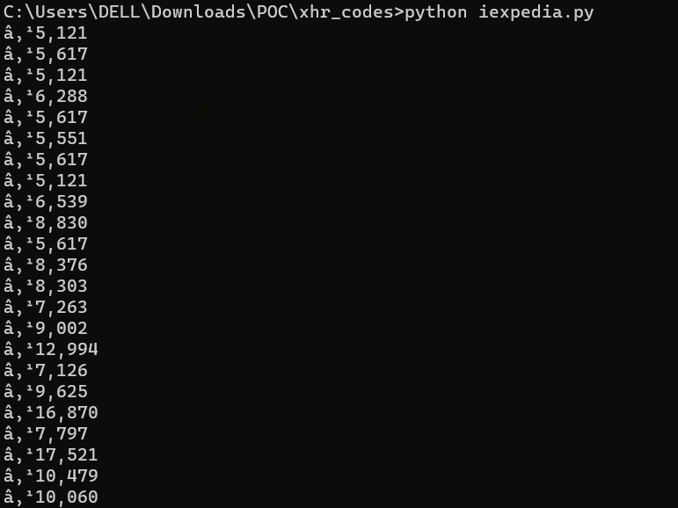

**EXPEDIA – TOP 5 CHEAPEST**

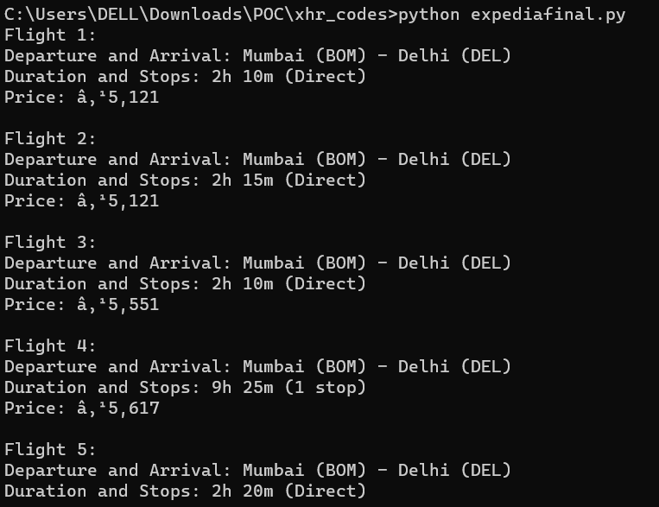

**BOOKING.COM**

