1.Introduction

1.1Explanation about the project

We care, is a skin care selling business where customers satisfaction is our top priority. Here we care about the customers and try to give our best to satisfy your needs and requirement. The program is developed by the business to help the customers work and daily life easier by giving them direct access to the store without being here physically. With the help of this developed program the product and be chosen with few clicks on the screen and will be delivered at your door with ease. Our website does not only save your time, but it also makes your shopping experience easy and smooth. With a range of skincare products to choose from, you can select and compare what suits you best at your convenience in the comfort of your home.

In this assigned individual coursework of “FUNDAMENTAL OD COMPUTING”, making a program to sell, buy goods using python program is the major objective. This program is assigned to be functional to make it user-friendly and easier for the customers to interact on. This program includes main, read, write and operation page which has different tasks of taking the user input what the customer wants to buy or sell and generate the invoice according to the purchase.it also includes a lot of logical thinking and challenges to develop an algorithm to make the program functional and user friendly. Additionally, the development cycle enhances critical thinking skills and reinforces the practical application of programming skills taught in class. This program comprises file handling, input/output operations, and logic-based flow, all of which are a close simulation of a transactional system attempting to deliver a seamless digital shopping experience to the user. Over the course and the lifetime of Application, we worked on the space of user interface design, structure of code and application performance. The aim was to have the software working but also one that was enjoyable and usable. The course work represented a good mix of technical skills and creativity that gave the students a solid experience in software development.

1.2. Aims & Objectives

Aims

The main aim of this coursework is development of functional program with the help of python programming, and to make the algorithm correct for the program to be user-friendly and usable, simple, clear, and helpful for users.

Objectives

This coursework helps us to learn more about the python program and enhance the skills and knowledge required. The major objective of this course work is:

- To create a simple program with Python that will help people buy and sell things.
- To learn how to take input from the users and display them what they want.
- To learn how to store, read, write with using txt files.
- To create a program that is user-friendly and is easy to use.
- To practice more of the basic skills of the Python program and coding better.
- To practice problem-solving and using deductive reasoning to make the program work correctly.
- To learn how to create invoices after purchasing for the customer.

1.3. Tools used

1.3.1. Python IDLE

Python is a programming language that is interpreted, Object-oriented, and considered to be high level. Python is one of the easiest yet most useful programming languages and is widely used in software industry. (GeeksforGeeks, 2023).
Figure 1: Python
IDLE is used in this coursework to develop the actual program. With the help of python and IDLE the development of the program is being successful. The coding part of the coursework is done in the IDLE to develop a functional program. IDLE provides a simple and user-friendly environment that is especially helpful for writing, testing, and debugging Python code.

1.3.2. Word


Microsoft Word is arguably the most widely used word processing program, famous for its flexibility and simplicity of use in document writing, editing, and formatting. Whether you're composing a simple letter, creating a resume, or producing a formal report MS-Word provides an enriched feature set to allow you to produce professional and well-organized content. (GeeksforGeeks,2021)
Figure 2: MS Word
This software is used during the course to make the report part and to be able to explain the entire project in a structured manner.Word has helps to explain the coursework by breking down the complex part into smaller chunks and in well-mannered structure.

1.3.3. Text Editor

A basic Windows word processor is called Notepad. It allows computer users to compose documents. It is an easy text editing program on Windows. It has been included in all releases of Microsoft Windows since 1985 when Windows 1.0 was released. Typically, the resulting files are saved with the extension .txt. You owe only a responsibility to your operating system in terms of how you organize, copy, and store your notes with Notepad to maintain them (as text files) where you choose in the same location. By exporting your notes through any program for reading text files, you are at liberty to move them to another program.

1.3.4. Draw.io


Draw.io is a technology stack for building diagramming applications, and the world’s most widely used browser-based end-user diagramming software.
draw.io is a registered trademark of JGraph Ltd and draw.io AG. JGraph Ltd is a company registered in England, draw.io AG is a company registered in Switzerland. Jointly, these companies develop and own the software, run the diagrams.net and draw.io sites and own the diagrams.net and draw.io brands. (draw.io, n.d.).

2. Discussion and Analysis

2.1. Algorithm

Step 1: Start
Step 2: Display the main menu
Step 3: Input number between 1-4
Step4: If number is 1 go to step 5
Step 5: Displays function of main menu go to step 2
Step 6: If number is 2 go to step 7.
Step 7: Input product id go to step 8
Step 8: If input is valid go to step 9 then go to step 11
Step9: Input quantity you want to buy Go to step 10
Step 10: If input quantity you want is valid go to step 12 then go to step 13
Step 11: Output enter a valid product id go to step 7
Step 12: Input if the user wants to buy more if yes go to step 7 then go to step 14
Step 13: Output invalid output or quantity out of stock go to step 9
Step 14: Input customer name go to step 15
Step 15: Input phone number go to step 16
Step 16: Display the invoice where bill_for_customer function is called and it writes all the purchase detail in a text file and displays in shell go to step 2
Step 17: If number is 3 go to step 18
Step 18: Input product id go to step 19
Step 19: If product id is valid go to step 20 then go to 21
Step 20: Input quantity go to 22
Step 21: Output Invalid id go to step 18
Step 22: If quantity is valid go to 23 then go to 24
Step 23: Input do you want to restock more if yes go to step 18 then go to step 25
Step 24: Output enter a valid input go to step20
Step 25: Input vendors name go to step 26
Step 26: Input phone number go to step 27
Step 27: Display the invoice where bill_for_vendors function is called and it writes all the restock detail in a text file and displays in shell goes to step 2
Step 28: if number is 4 go to step 29
Step 29: Input do you really want to exit if yes go to Step 30 then go to step 2
Step 30: Stop

2.2. Flow Chart

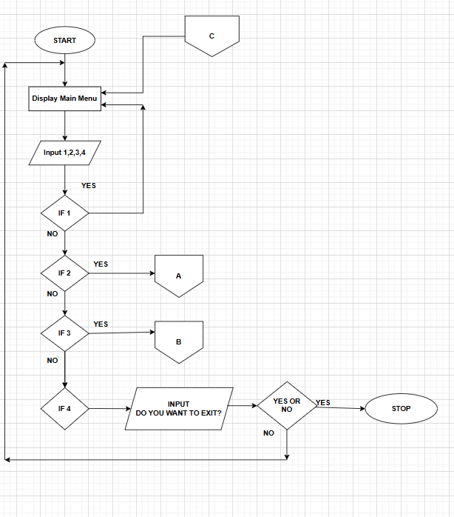
Figure 3:Main Flow Chart
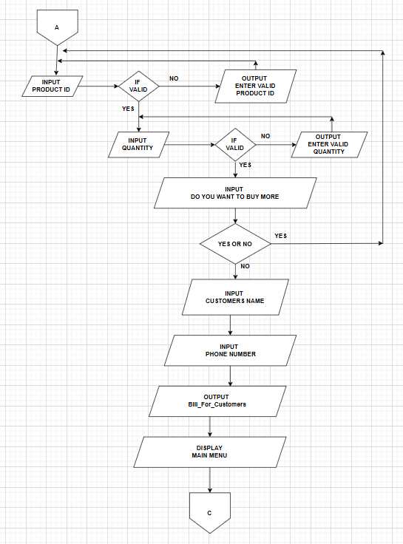
Figure 4:FlowChart A
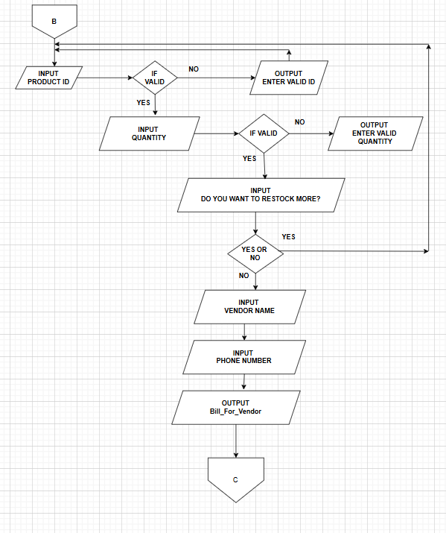
Figure 5:Flow Chart B

2.3. Pseudocode

2.3.1. Pseudocode for READ.py

ALGORITHM: READING

FUNCTION reading()

'''Summary:
this function reads the data from 'READ.txt', and displays
it in a tabular format with calculated selling price
and returns the data as a dictionary

Parameters: None

Returns:
it returns disc_ where the key is product ID (int),
and list containing:
[Product Name(str), Brand(str), Available Quantity(str), Price(str), Country Of origin(str)].

Raises:
FileNotFoundError: if 'READ.txt' file does not exist.
'''

OUTPUT "-" * 110
OUTPUT "ID", "\t", "Product Name", "\t\t", "Brand", "\t\t", "Available Quantity", "\t", "Price", "\t\t", "Country Of origin"
OUTPUT "-" * 110

WITH OPEN('READ.txt', 'r') AS file:
SET store = file.read()
END WITH

SET listen = store.split('\n')
file.close()
SET disc_ = {}

FOR i IN RANGE(LEN(listen)):
SET disc_[i + 1] = listen[i].split(',')
END FOR

FOR key, value IN disc_.items():
OUTPUT key, END='\t'

FOR i IN RANGE(LEN(value)):
IF i == 3:
SET cost_price = int(value[i])
SET selling_price = cost_price * 2
OUTPUT selling_price, END='\t\t'
END IF
IF i == 0:
OUTPUT value[i], END='\t\t'
ELSE:
OUTPUT value[i], END='\t\t'
END IF
END FOR

OUTPUT NEW LINE
END FOR

OUTPUT '-' * 110

RETURN disc_

END FUNCTION

END ALGORITHM

2.3.2. Pseudocode for WRITE.py

ALGORITHM: bill_for_customers

FUNCTION bill_for_customers(items_bought, customer_name, phone_number, amt_spent)

'''Summary:
This file generates and saves a text invoice of a customer
if they purchase anything.
The invoice is saved in txt file where customer details and all the
necessary details are stored.

Parameters:
items_bought (list of dictionary): includes:
'name'(str), 'quantity'(int), 'brand'(str), 'free'(int), 'price'(int), 'total'(int)
customer_name (str): Customer's name
phone_number (str): Customer's phone number
amt_spent (int): Total amount spent

Returns:
str: filename of the saved invoice

Raises:
TypeError: if incorrect data types are passed
'''

SET now = datetime.datetime.now()
SET date = str(now.year) + "-" + str(now.month) + "-" + str(now.day)
SET filename = "Bill_for C " + customer_name + "_" + date + ".txt"

WITH OPEN(filename, 'w') AS file:
file.write(" === WE CARE BEAUTY STORE ===\n")
file.write("\t == INVOICE OF PURCHASE ==\n")
file.write("\n")
file.write("Customer: " + customer_name + "\t\t\tDate: " + date + "\n")
file.write("Phone Number:" + phone_number + "\n")

file.write("-" * 60)

FOR item IN items_bought:
file.write("\n")
file.write("\tProduct" + "\t" * 4 + item['name'] + "\n")
file.write("\tQuantity" + "\t" * 3 + str(item['quantity']) + "\n")
file.write("\tBrand" + "\t" * 4 + item['brand'] + "\n")
file.write("\tFree" + "\t" * 4 + str(item['free']) + "\n")
file.write("\t Price" + "\t" * 4 + "Rs. " + str(item['price']))
file.write("\n")
END FOR

file.write("-" * 60)
file.write("\n")
file.write("\tTotal" + "\t" * 5 + str(item['total']) + "\n")
file.write("-" * 60)
file.write("\n")
file.write("\nInvoice saved as:" + filename)
file.write("\n")
file.write("Total Amount spent RS." + str(amt_spent) + "\n")
file.write("ThankYou for shopping with us!\n")
END WITH

RETURN filename

END FUNCTION

END ALGORITHM

ALGORITHM: bill_for_vendors

FUNCTION bill_for_vendors(restocked_items, total_cost, supplier_name, phone_number)

'''Summary:
This function generates and saves a text invoice
to restock items in the store.
This invoice includes supplier details, list of items restocked
with price and quantity.

Parameters:
restocked_items (list of dict): includes:
'name'(str), 'brand'(str), 'quantity'(str), 'cost_price'(int), 'total'(int)
total_cost (int): total cost of all the items
supplier_name (str): name of the supplier
phone_number (str): phone number of the vendor

Returns:
str: filename of the invoice file

Raises:
TypeError: if parameters are passed with incorrect type
'''

SET now = datetime.datetime.now()
SET date = str(now.year) + "-" + str(now.month) + "-" + str(now.day)
SET filename = "Bill for S" + supplier_name + "_" + date + ".txt"

WITH OPEN(filename, 'w') AS file:
file.write(" === WE CARE BEAUTY STORE ===\n")
file.write("\t == INVOICE OF RESTOCK ==\n")
file.write("Supplier Name : " + supplier_name + "\t\t\tDate: " + date + "\n")
file.write("Phone: " + phone_number + "\n")
file.write("-" * 75)

FOR item IN restocked_items:
file.write("\tProduct" + "\t" * 4 + item['name'] + "\n")
file.write("\tBrand" + "\t" * 5 + item['brand'] + "\n")
file.write("\tQty" + "\t" * 5 + str(item['quantity']) + "\n")
file.write("\tUnit Price" + "\t" * 4 + "Rs. " + str(item['cost_price']))
file.write("\n")
END FOR

file.write("\n")
file.write("-" * 75)
file.write("\tTotal" + "\t" * 4 + "Rs. " + str(item['total']) + "\n"))
file.write("-" * 75)
file.write("\n")
file.write("Total Cost" + "Rs. " + str(item['total']))
file.write("\nInvoice saved as:" + filename)
file.write("Restocking Complete.\n")
END WITH

RETURN filename

END FUNCTION

END ALGORITHM

2.3.3. Pseudocode for OPERATION.PY
ALGORITHM: SELLING
IMPORT MODULE WRITE (bill_for_customers, bill_for_vendors)
IMPORT MODULE READ (reading)
IMPORT MODULE DATETIME

FUNCTION selling()
'''
Summary:
This function handles the selling to the customers.It allows the user
to purchase product and they can also get "buy 3 get 1 free"offer,
updates the product,takes the necessary information fron the user and also
displays the invoice using 'biil_for_customers' function.

Parameters:
None

Returns:
None

Raises:
ValueError:If non integer value is entered in product id or quantity.
FileNotFoundError:If 'READ.txt' does not exist os is not accessible.
'''

SET all_the_products = reading()
SET items_bought = []
SET amt_spent = 0

WHILE TRUE
TRY
SET product_id = INT(INPUT("Enter the product ID that you want to buy (0 to exit): "))
IF product_id == 0
BREAK
END IF

IF product_id NOT IN all_the_products
OUTPUT "Enter a valid product id available!"
CONTINUE
END IF

SET product = all_the_products[product_id]
SET product_name = product[0]
SET brand = product[1]
SET available_qty = INT(product[2])
SET price = INT(product[3]) * 2

IF available_qty <= 0
OUTPUT "This product is out of stock. Please choose another product."
CONTINUE
END IF

WHILE TRUE
TRY
SET qty_to_buy = INT(INPUT("How much would you like to buy: "))
IF qty_to_buy <= 0
OUTPUT "Invalid quantity."
CONTINUE
END IF
IF qty_to_buy > available_qty
OUTPUT "The available quantity is:", available_qty
CONTINUE
END IF

SET found = FALSE
FOR item IN items_bought
IF item['id'] == product_id
SET item['quantity'] += qty_to_buy
SET total_qty = item['quantity']
SET item['free'] = total_qty // 3
SET paid_items = total_qty + item['free']
SET item['total'] = qty_to_buy * price
SET found = TRUE
BREAK
END IF
END FOR

IF NOT found
SET total_qty = qty_to_buy
SET free_items = total_qty // 3
SET paid_items = total_qty + free_items
SET item_total = qty_to_buy * price

CALL items_bought.APPEND({
'id': product_id,
'name': product_name,
'brand': brand,
'quantity': qty_to_buy,
'free': free_items,
'price': price,
'total': item_total
})
END IF

SET new_qty = available_qty - paid_items
IF new_qty < 0
SET new_qty = 0
END IF

SET product[2] = STR(new_qty)
SET amt_spent += item_total
BREAK
EXCEPT ValueError
OUTPUT "Please enter a valid number!"
END TRY
END WHILE

WITH OPEN('READ.txt', 'w') AS file
FOR pid IN SORTED(all_the_products.keys())
SET product = all_the_products[pid]
CALL file.write(','.join(product) + '\n')
END FOR
END WITH

WHILE TRUE
SET again = INPUT("Do you want to buy more product? (yes/no): ").lower()
IF again IN ('yes', 'no')
BREAK
END IF
OUTPUT "Please enter 'yes' or 'no'"
END WHILE

IF again == 'no'
BREAK
END IF
EXCEPT ValueError
OUTPUT "Error: Please enter a valid number!"
CONTINUE
END TRY
END WHILE

IF NOT items_bought
OUTPUT "\n No items were purchased."
RETURN
END IF

OUTPUT "\n=== CUSTOMER DETAILS FOR INVOICE ==="
WHILE TRUE
SET customer_name = INPUT("Enter customer name: ")
IF customer_name.isalpha()
BREAK
ELSE
OUTPUT "Name not valid."
END IF
END WHILE

WHILE TRUE
SET phone_number = INPUT("Enter phone number: ")
IF phone_number.isdigit()
BREAK
ELSE
OUTPUT "Enter a vaild phone number"
END IF
END WHILE

SET filename = bill_for_customers(items_bought, customer_name, phone_number, amt_spent)

OUTPUT "\n"
OUTPUT "\t\t === Invoice of purchase ==="
OUTPUT "\n"
OUTPUT "Customer: " + customer_name + "\t\t\t", "Date: " + STR(datetime.datetime.now())
OUTPUT "Phone: " + phone_number + "\n"
OUTPUT "-" * 65

FOR item IN items_bought
OUTPUT "\tProduct", "\t"*4 + item['name']
OUTPUT "\tQuantity", "\t"*4 + STR(item['quantity'])
OUTPUT "\tBrand", "\t"*5 + item['brand']
OUTPUT "\tFree", "\t"*5 + STR(item['free'])
OUTPUT "\tUnit Price", "\t"*4 + "Rs. " + STR(item['price'])
END FOR

OUTPUT "-" * 65
OUTPUT "\tTotal", "\t"*5 + STR(item['total']) + "\n"
OUTPUT "-" * 65

OUTPUT "\nInvoice saved as:", filename
OUTPUT "Total amount: Rs.", amt_spent
OUTPUT "Thank you for your purchase!"
OUTPUT "\n"*5
END FUNCTION
END ALGORITHM

ALGORITHM: RESTOCKING
IMPORT MODULE WRITE(bill_for_customers, bill_for_vendors)
IMPORT MODULE READ (reading)
IMPORT MODULE DATETIME

FUNCTION restocking()

'''
Summary:
This function handles the restocking preocess of the WE CARE.
It allows the user to update quantity ,cost price and calculates vat
and generates invoice using 'bill_for_vendors()' function.
Parameters:
None
Returns:
None
Raises:
ValueError:It is raised if non numeric input is provided in product id,quantity or price.
FileNotFound:If 'READ.txt' does not exist or is inaccessible.
'''

SET all_the_products = reading()
SET restocked_items = []
SET total_cost = 0

WHILE TRUE
TRY
SET product_id = INT(INPUT("Enter the product ID that you want to restock (0 to exit): "))
IF product_id == 0
BREAK
END IF

IF product_id NOT IN all_the_products
OUTPUT "Enter a valid product id available!"
CONTINUE
END IF

SET product = all_the_products[product_id]
SET product_name = product[0]
SET brand = product[1]
SET available_qty = INT(product[2])
SET unit_cost = INT(product[3])

WHILE TRUE
TRY
SET qty_to_add = INT(INPUT("How many units to add: "))
IF qty_to_add <= 0
OUTPUT "Quantity should be positive!"
CONTINUE
END IF

SET new_qty = available_qty + qty_to_add
SET product[2] = STR(new_qty)
SET item_total = qty_to_add * unit_cost

CALL restocked_items.APPEND({
'id': product_id,
'name': product_name,
'brand': brand,
'quantity': qty_to_add,
'unit_cost': unit_cost,
'total': total_cost
})

SET total_cost += item_total
BREAK
EXCEPT ValueError
OUTPUT "Enter a valid number!"
END TRY
END WHILE

WHILE TRUE
SET again = INPUT("Do you want to restock more product? (yes/no): ").lower()
IF again IN ('yes', 'no')
BREAK
END IF
OUTPUT "Please enter 'yes' or 'no'"
END WHILE

IF again == 'no'
BREAK
END IF
EXCEPT ValueError
OUTPUT "Please enter a valid number!"
CONTINUE
END TRY
END WHILE

IF NOT restocked_items
OUTPUT "\n No items were restocked."
RETURN
END IF

WITH OPEN('READ.txt', 'w') AS file
FOR pid IN SORTED(all_the_products.keys())
SET product = all_the_products[pid]
CALL file.write(','.join(product) + '\n')
END FOR
END WITH

OUTPUT "\n=== VENDOR DETAILS FOR INVOICE ==="
WHILE TRUE
SET vendor_name = INPUT("Enter vendor name: ")
IF vendor_name.isalpha()
BREAK
ELSE
OUTPUT "Name not valid."
END IF
END WHILE

WHILE TRUE
SET phone_number = INPUT("Enter vendor phone number: ")
IF phone_number.isdigit()
BREAK
ELSE
OUTPUT "Enter a valid phone number"
END IF
END WHILE

SET filename = bill_for_vendors(restocked_items, vendor_name, phone_number, total_cost)

OUTPUT "\n"
OUTPUT "\t\t === Invoice of restock ==="
OUTPUT "\n"
OUTPUT "Vendor: " + vendor_name + "\t\t\t", "Date: " + STR(datetime.datetime.now())
OUTPUT "Phone: " + phone_number + "\n"
OUTPUT "-" * 65

FOR item IN restocked_items
OUTPUT "\tProduct", "\t"*4 + item['name']
OUTPUT "\tQuantity", "\t"*4 + STR(item['quantity'])
OUTPUT "\tBrand", "\t"*5 + item['brand']
OUTPUT "\tUnit Cost", "\t"*4 + "Rs. " + STR(item['unit_cost'])
END FOR

OUTPUT "-" * 65
OUTPUT "\tTotal", "\t"*5 + STR(item['total']) + "\n"
OUTPUT "-" * 65

OUTPUT "\nInvoice saved as:", filename
OUTPUT "Total cost: Rs.", total_cost
OUTPUT "Restocking completed successfully!"
OUTPUT "\n"*5
END FUNCTION
END ALGORITNM

2.3.4. Pseudocode for MAIN.py

ALGORITHM: Main Menu
IMPORT MODULE OPERATION (selling, restocking)
IMPORT MODULE READ (reading)

FUNCTION main_class()
"""
Summary:
this function display the main menu of the WE CARE system and also
handels user interaction.
there are option to display,sell to customers,restock or exit the
program.

Parameters:
None

Returns:
None

Raises:
ValueError:If any non numeric values are given when number
should be (1-4).
"""

WHILE True
OUTPUT "*-*"*35
OUTPUT "\n\t\t\t*=== -------------- WE CARE ------------------ ===*"
OUTPUT "*-*"*35
OUTPUT "\n"
OUTPUT "\t\t\t WELCOME TO THE 'WE CARE' SKIN CARE COMPANY"
OUTPUT "_"*105
OUTPUT "\n"
OUTPUT "\t\t Insert one of the following command to connect with WE CARE"
OUTPUT "\n"
OUTPUT "1. Display the available products"
OUTPUT "2. To Sell from WE CARE to customer"
OUTPUT "3. To restock products from Supplier"
OUTPUT "4. To exit from the program"

SET user_choice = input("\nPlease choose an option (1-4): ")

IF user_choice == '1'
CALL reading()
END IF

IF user_choice == '2'
CALL selling()
END IF

IF user_choice == '3'
CALL restocking()
END IF

IF user_choice == '4'
SET decision = input("Are you sure you want to exit? (yes/no): ").lower()
IF decision == 'yes'
OUTPUT "\n\n\nThank you for choosing WE CARE. Hope you had a great experience here!!"
BREAK
END IF

IF decision == 'no'
CONTINUE
END IF

ELSE
OUTPUT "Invalid input! Please enter 'yes' or 'no'"
END IF
END IF

ELSE
OUTPUT "\nInvalid choice! Please choose options 1-4"
END IF

END WHILE

END FUNCTION

CALL main_class()

END ALGORITHM

2.4. Data Structure

2.4.1. Primitive Data Type

2.4.1.1 Int

Description

Int is the native Python type to represent values of integer (whole number). They are whole numbers with no decimal point and can be either positive, negative, or zero.

Purpose

Int data type is used here as the data stored to in the txt file is in string so the data can be accessed and be calculation can be done.
Figure 6: Int

2.4.1.2. String
Description
String is a group of characters. Anything that is quoted in Python is a string. It contains numbers, letters, and symbols. Python do not have any data type for a character so one character is a string of length.
Purpose
In one of the case in this program, string is used while converting to write in text file.so in here too the integers are being converted into string.
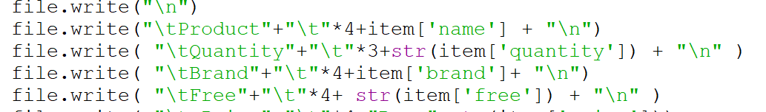
Figure 7:String

2.4.1.3. Float
Description
A float is a kind of data that is used to represent a number with a fraction part. It is used to store decimal numbers and math that needs to be precise.

2.4.1.4. Boolean

Description
Python Boolean type is among the data types that Python offers by default, which stores one of the two values i.e. True or False. It is typically used to store the truth values of the expressions.

2.4.2. Collection Datatype

2.4.2.1. List

Description
A list in Python is a dynamic sized array, native to Python. We can store all types of items in a list. List can contain mixed type of items this is because a list mainly stores reference at contiguous location and the actual items may be stored at other places.
Purpose
List is used here to store all the items bought do if there is same product being bought by one customer but separately then it helps to calculate and makes it easier. 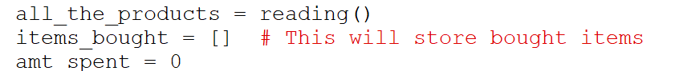
Figure 8:list initialize
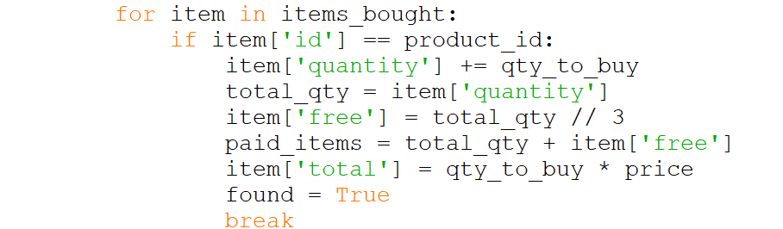
Figure 9:List Use case

2.4.2.2. Dictionaries

Description
Python dictionary is a data structure that stores the value in key: value pairs. The values in a dictionary can be of any data type and can be duplicated, whereas keys can’t be repeated and should be immutable.
Purpose
The dictionary is used in here to store all the values in an id key of the dictionaries.
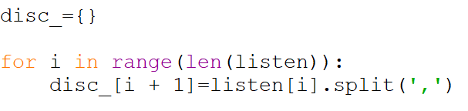
Figure 10: Dictionaries

2.4.2.3. Tuple

Description
Python Tuple is a list of objects arranged in order, separated by commas. Python tuple is like a Python list in terms of indexing, nested objects, and repetition but the main difference between them is Python tuple is immutable, unlike the Python list which is mutable.

2.4.2.4. Set

Description
A Python set is an unordered collection of unique items. It is a data structure in Python to store greater than one item in a variable but cannot be a duplicate.Sets can be changed, meaning you can add or remove items after the set is created.

3. Program

3.1. Implementation of read.py
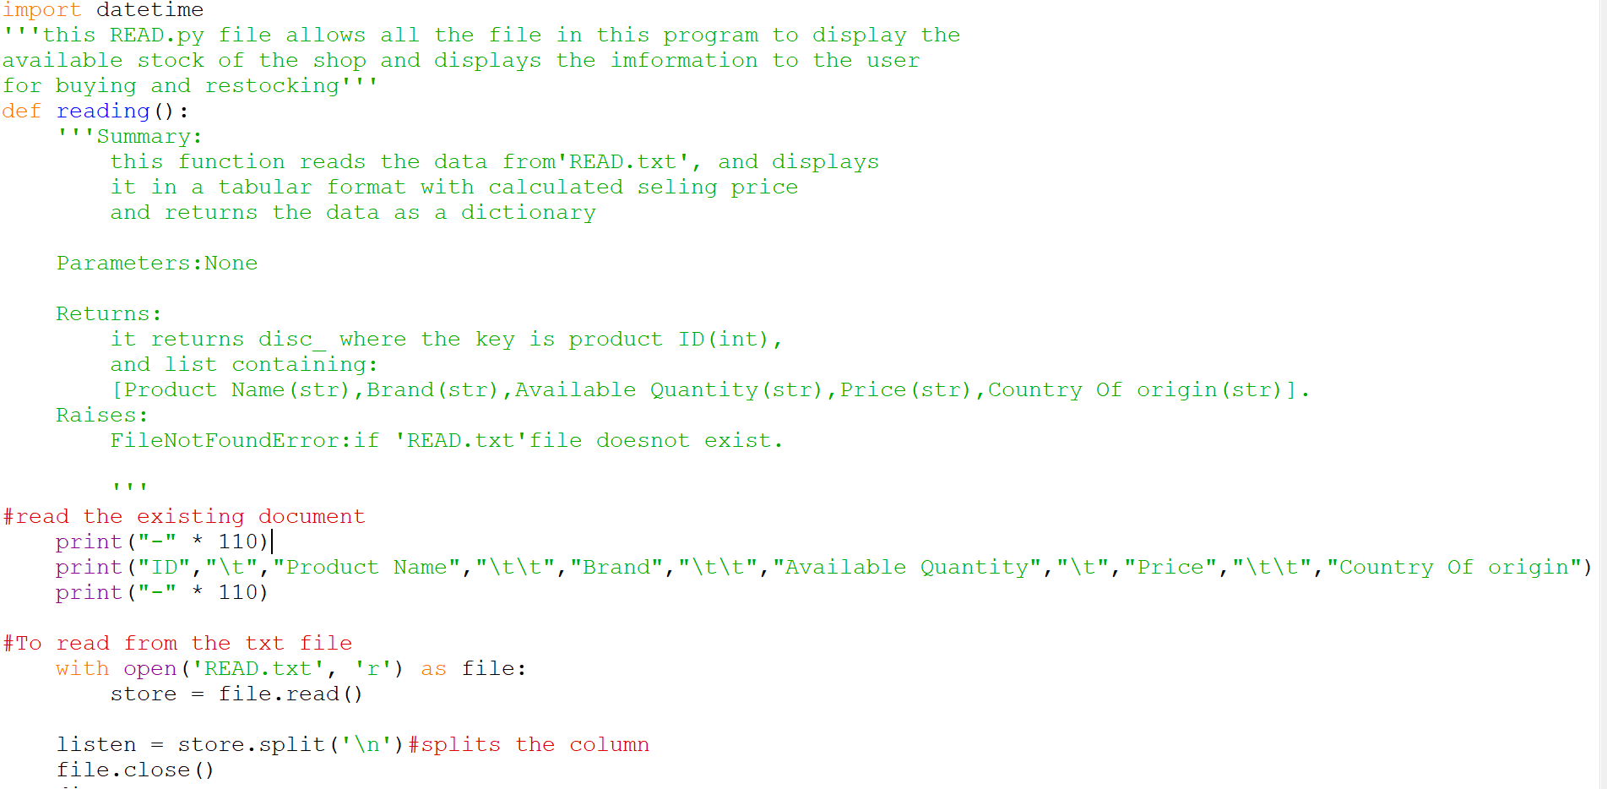
Figure 11:READ FILE (1)

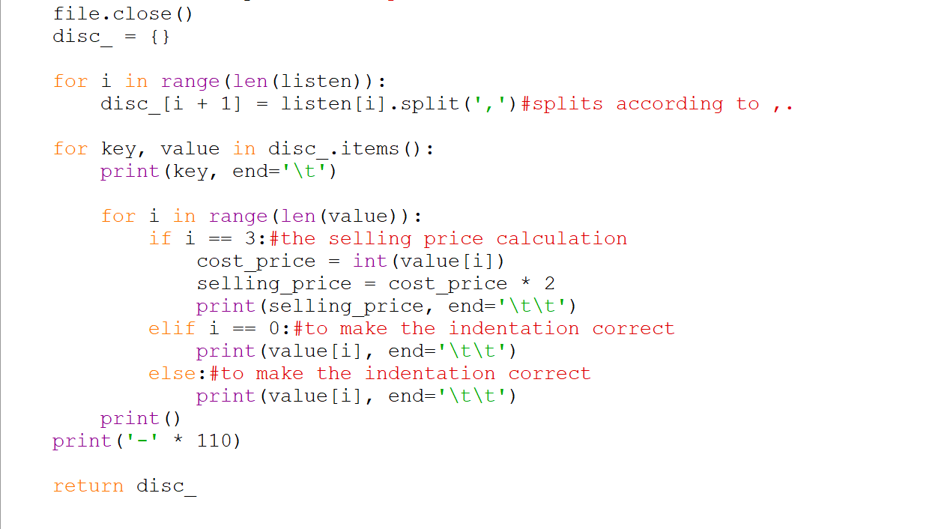
Figure 12:READ FILE (2)
This is READ.py file, in this code the program is reading the data from a text file to display to the user in a cleaner and usable manner. In this code the function reading is made which include all the code of the READ.py. Here, the data is read from the txt file then is being store in a dictionary and uses with the help of its keys. The selling price is also being calculated here while displaying the selling price should be there as it is for the customers to view.

3.2. Implementation of WRITE.py
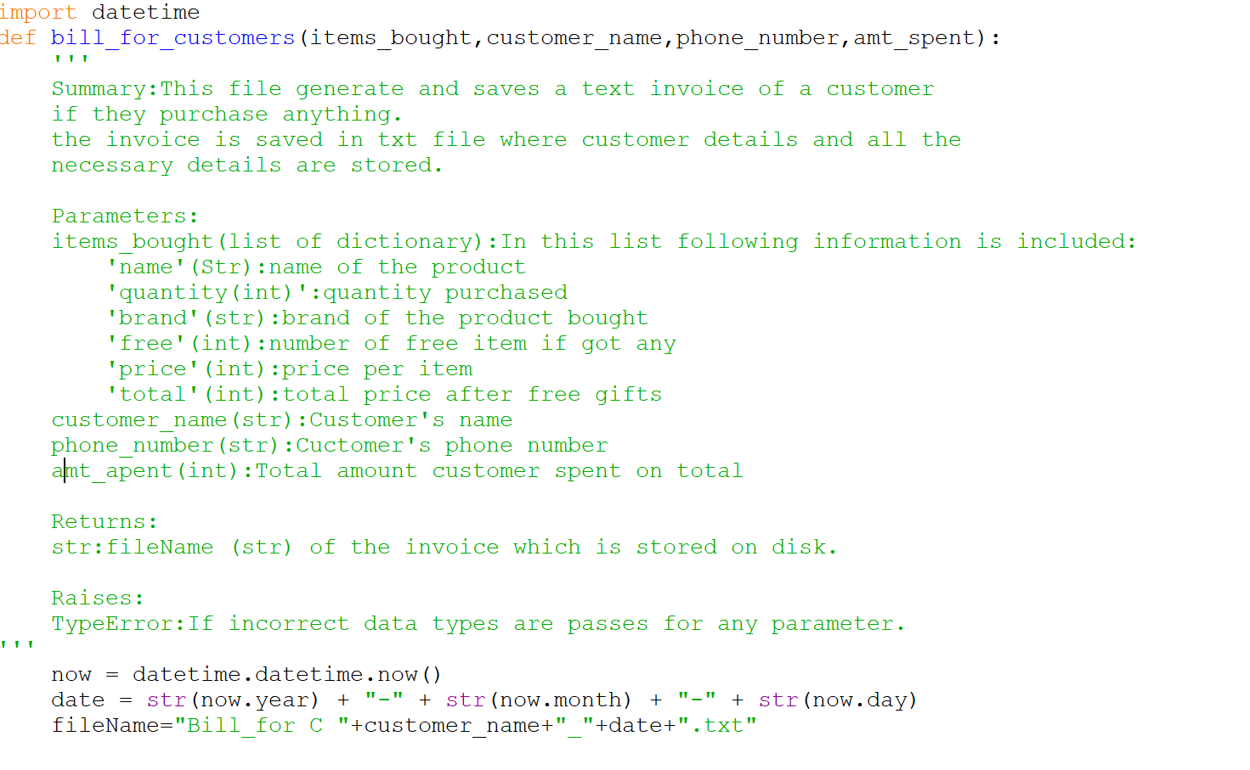
Figure 13: WRITE FILE (1)
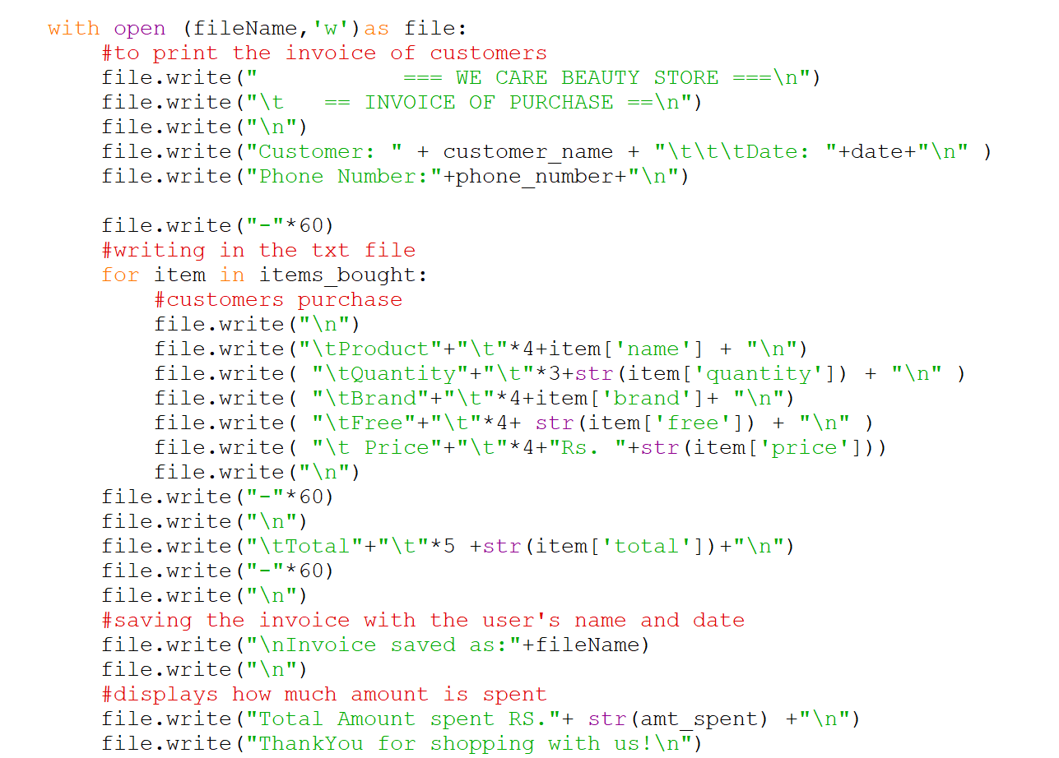
Figure 14:WRITE FILE(2)
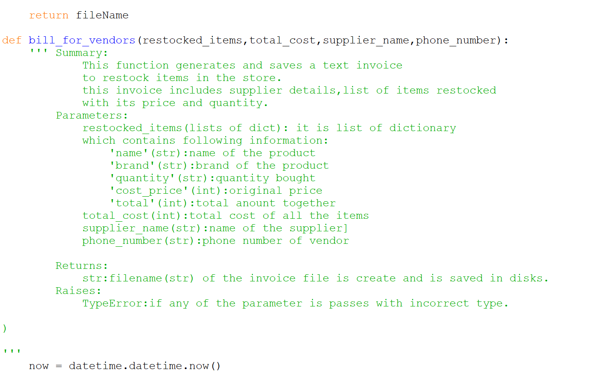
Figure 15:WRITE FILE (3)
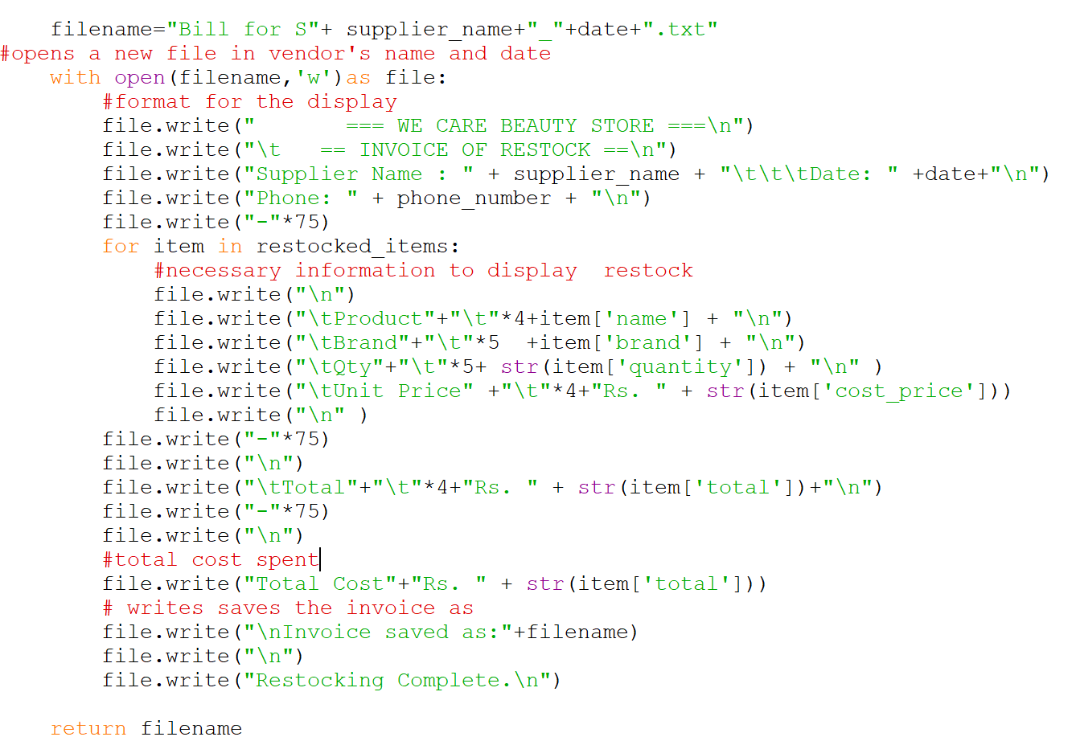
Figure 16: WRITE FILE (4)
The WRITE.py is code in which the invoice is being created. The invoice for both customer and vendor are created separately. But in the write file there are two functionsbill_for_customers and bill_for_vendors. Each function helps to generate bills in a text file. The task of these functions is to get the data from the stored list through the passed parameter and display it in a new txt file created under the name of the customer or vendor.

3.3. Implementation of operation.py
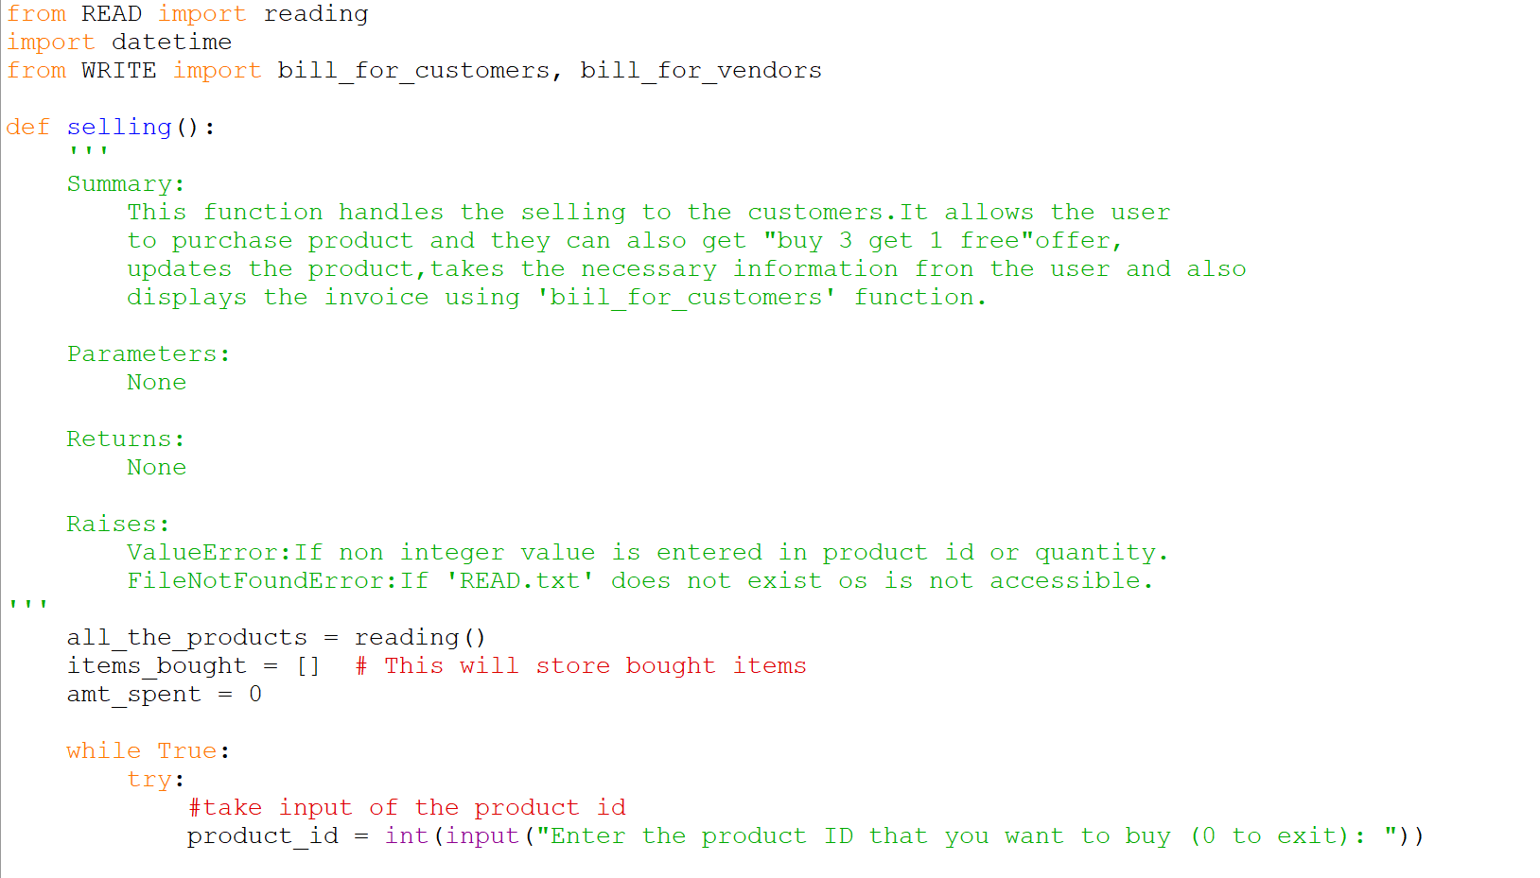
Figure 17: OPERATION FILE (1)

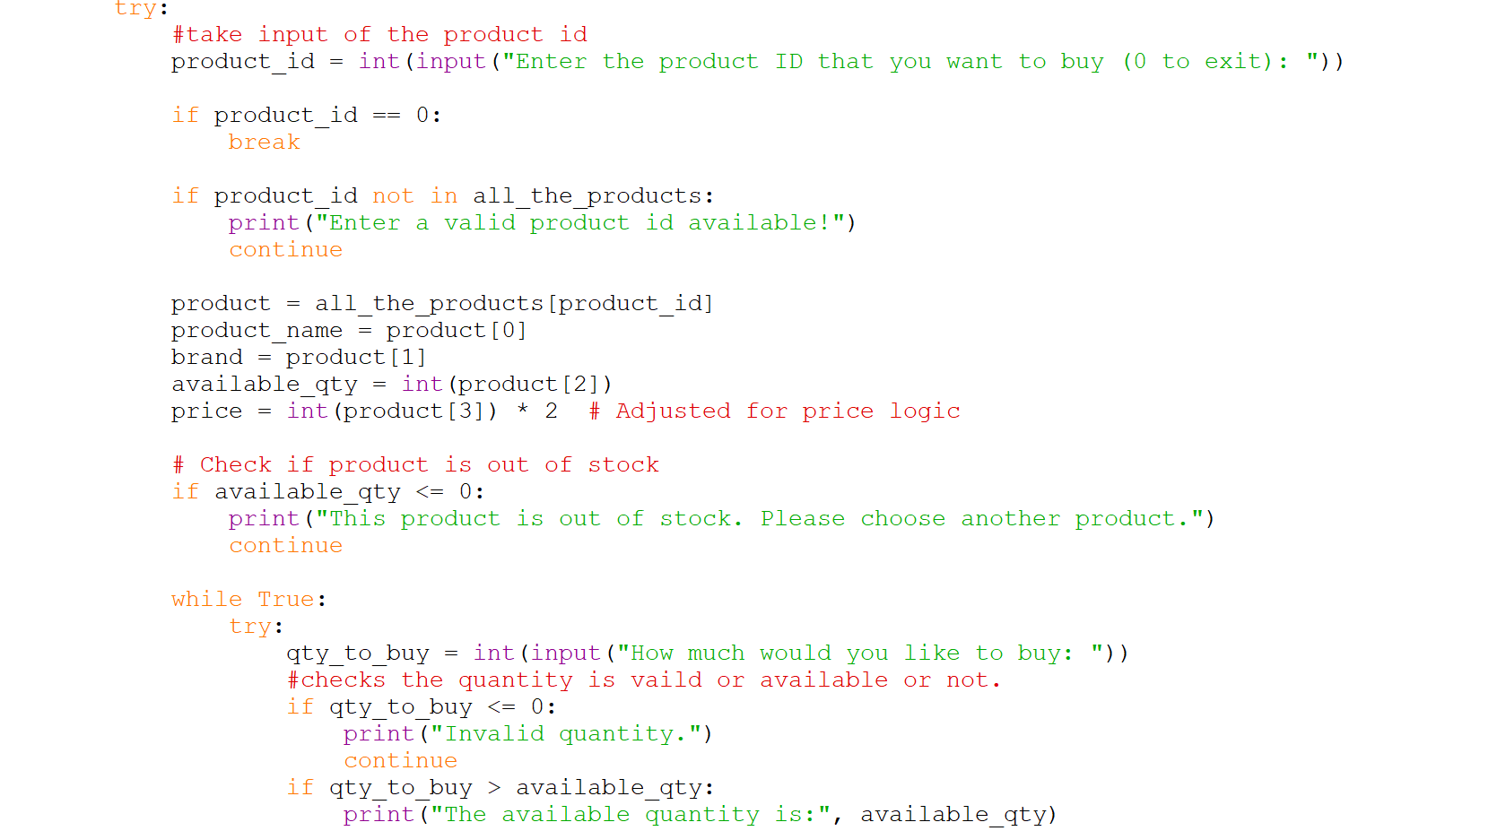
Figure 18:OPERATION FILE (2)

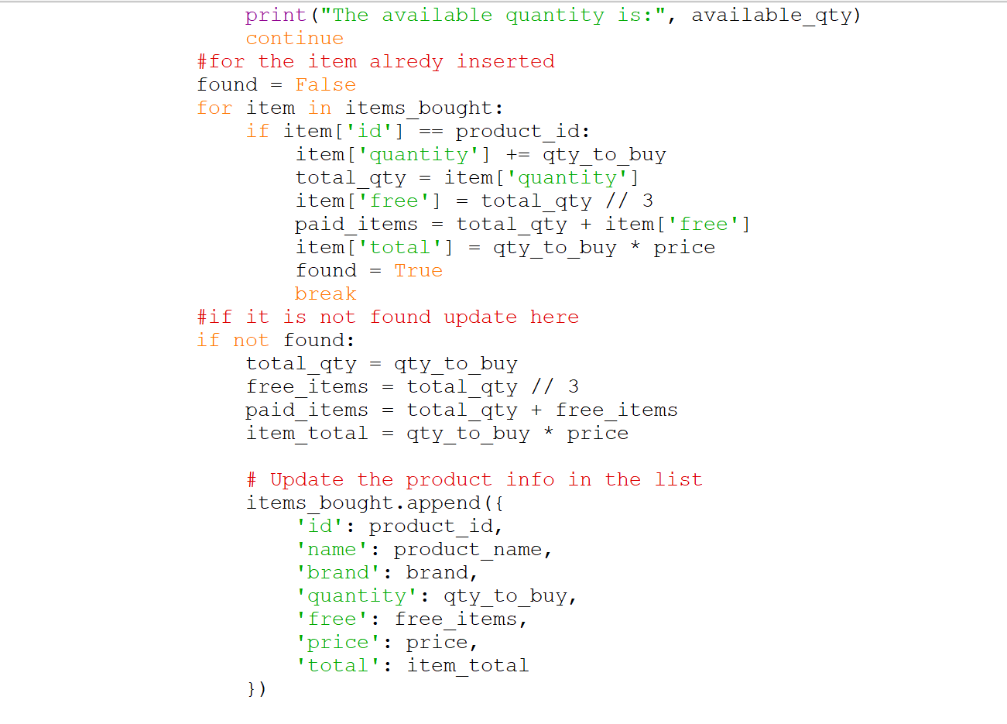
Figure 19:OPERATION FILE (3)
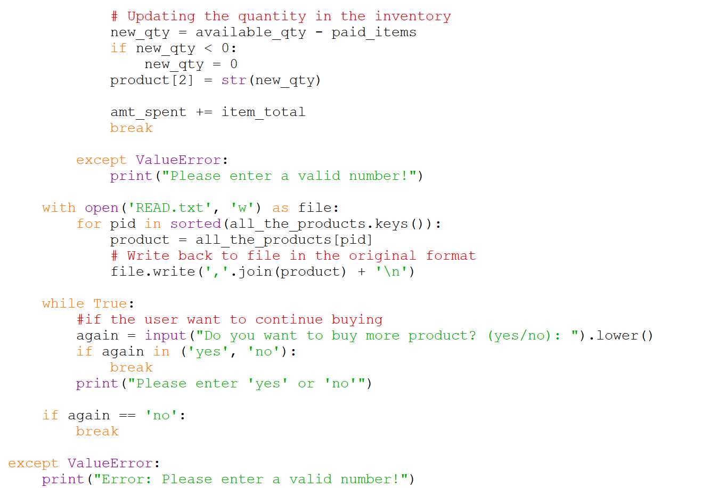
Figure 20: OPERATION FILE (4)
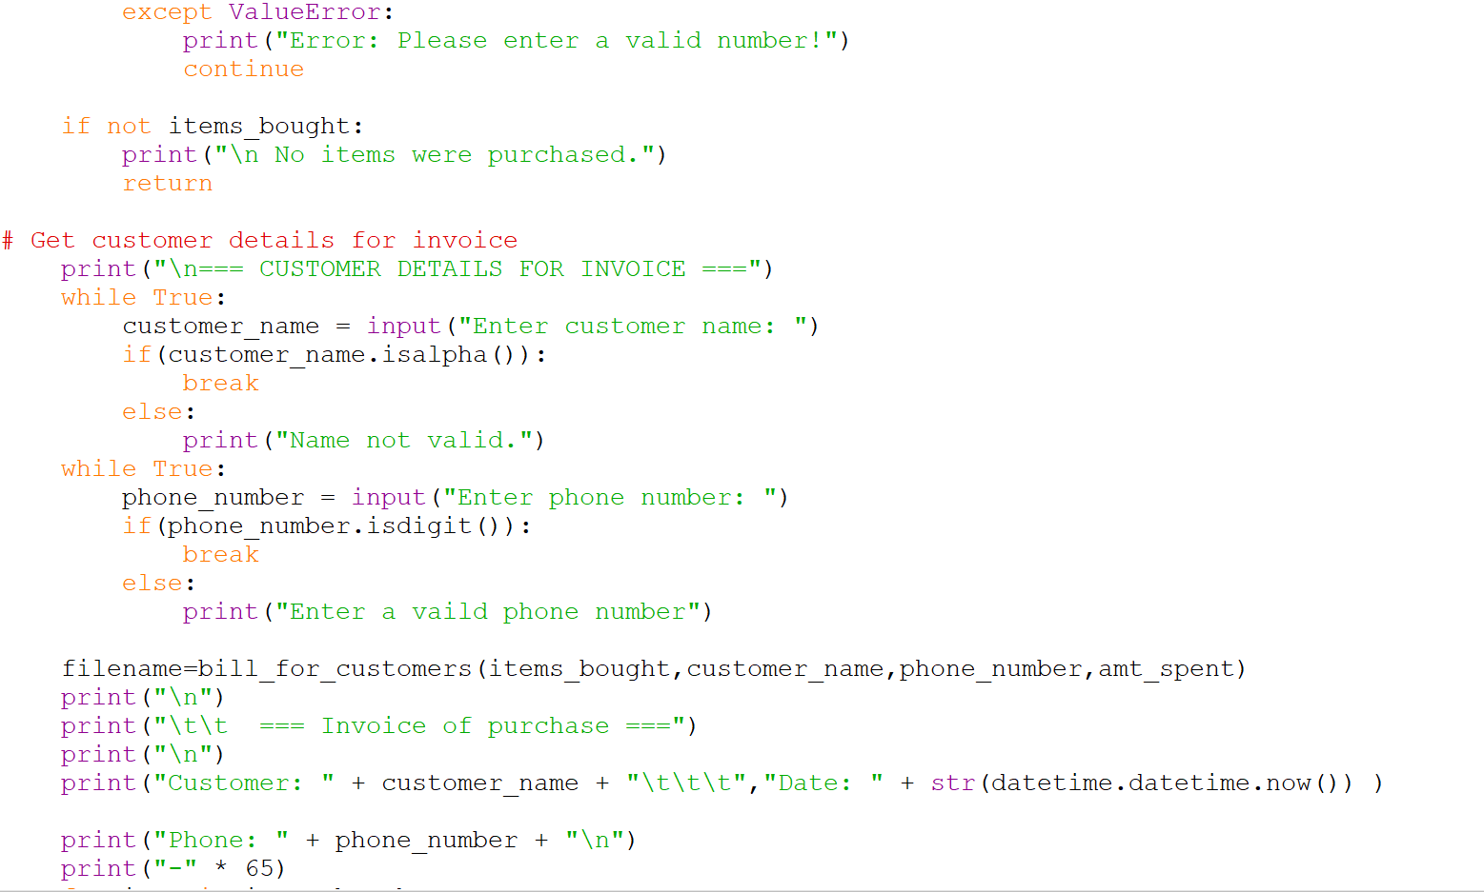
Figure 21: OPERATION FILE (5)
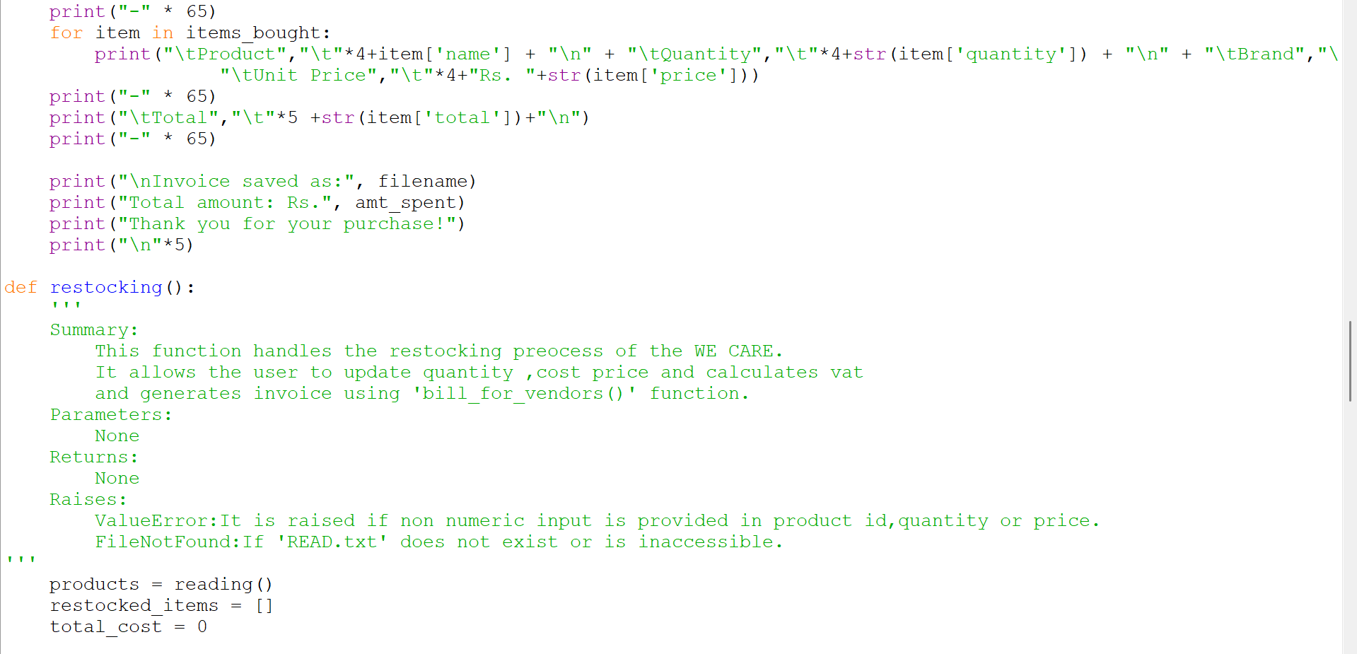
Figure 22: OPERATION FILE (6)
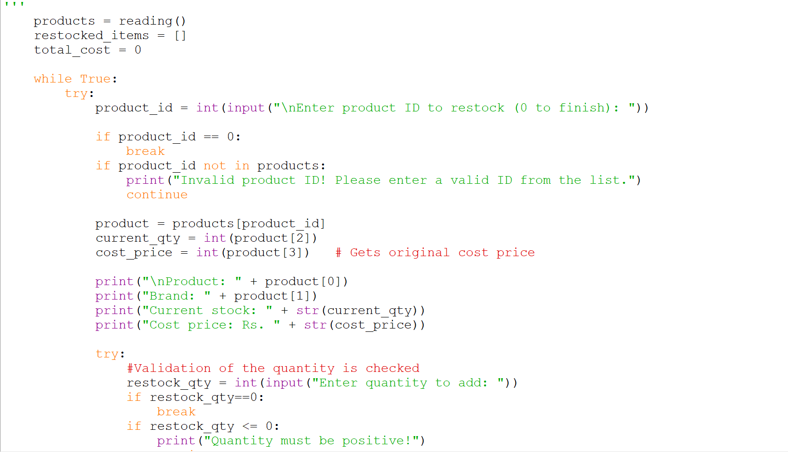
Figure 23: OPERATION FILE (7)
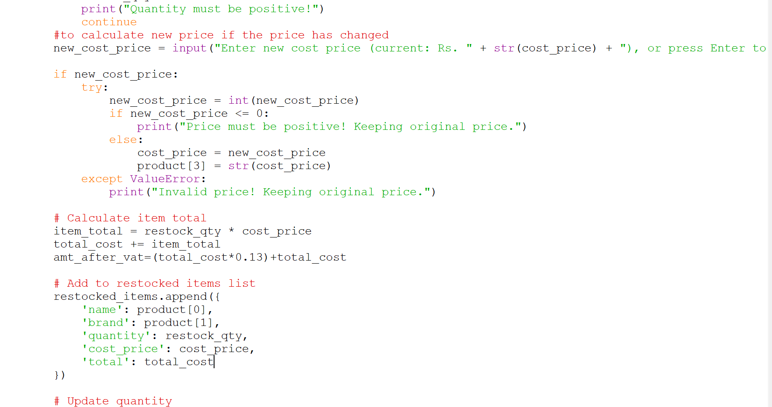
Figure 24:OPERATION FILE (8)
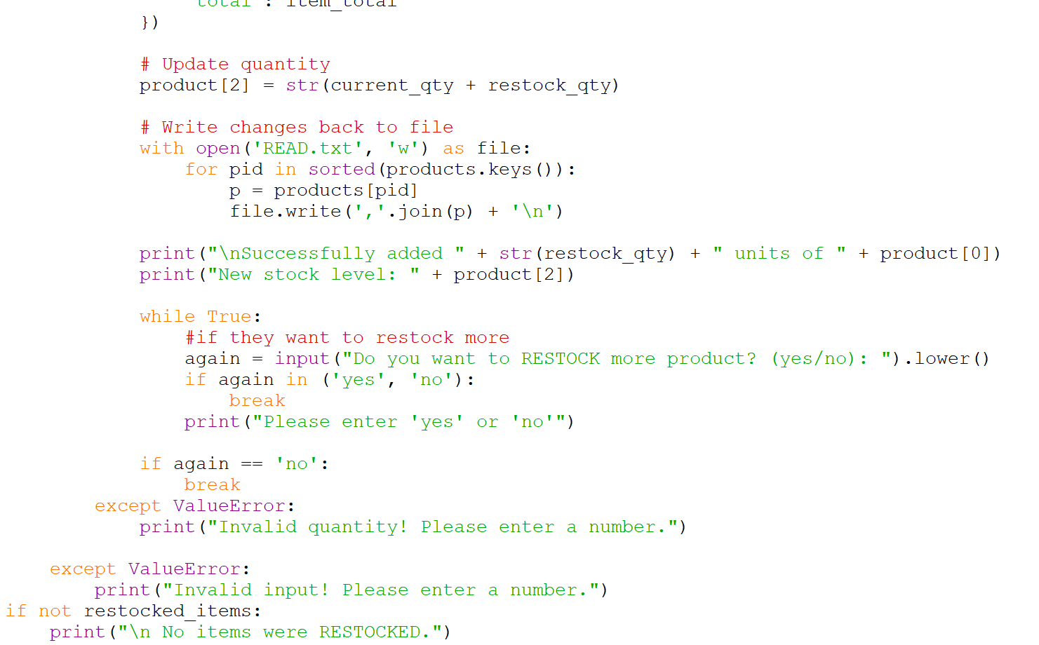
Figure 25:OPERATION FILE (9)
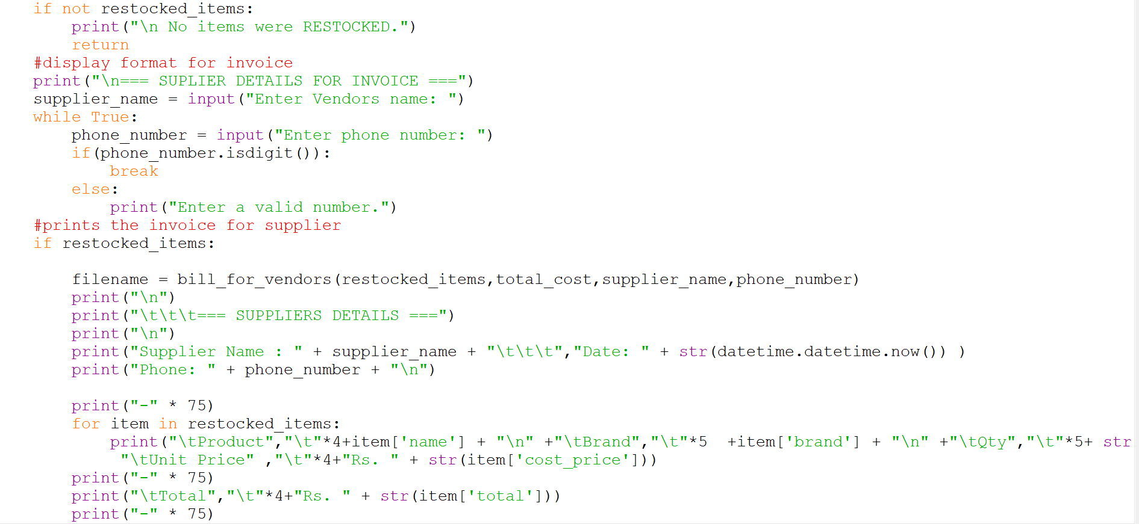
Figure 26:OPERATION FILE (10)

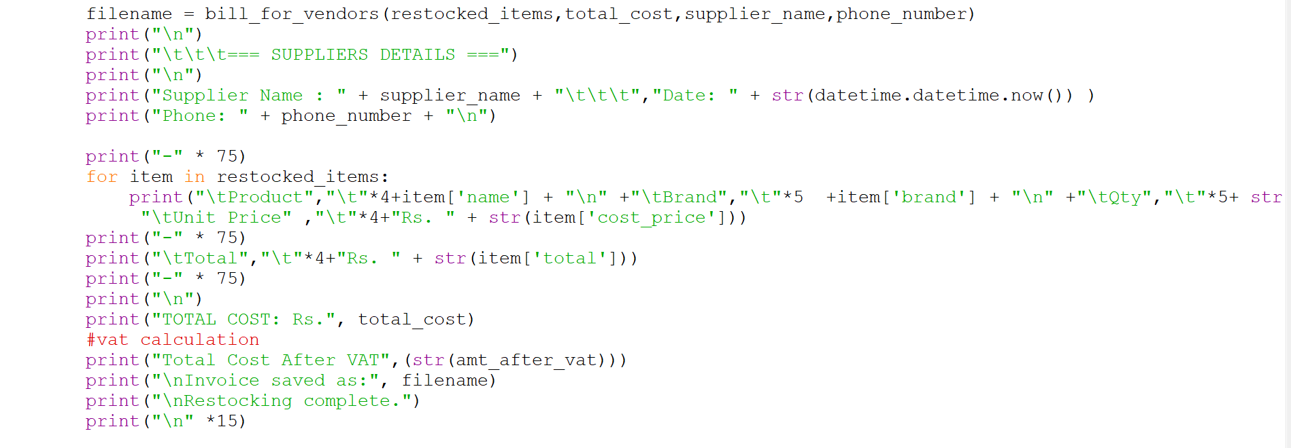
Figure 27:OPERATION FILE (11)

In the operation.py there are two functions. Selling is one of the functions which helps the customers to buy good from the store easier. The system asks for the valid product id, quantity from the customer and if the customer buys 3 product, then they get one more product for free. The selling function has parameters like id, name of the product, brand, quantity, price, etc. The selling function implements the logic for the customer to purchase from WE CARE.

Another function of the operation.py is restocking. This function helps the suppliers to restock in the shop as it also calculates vat and the bill is generated after both expression is done in this the txt file is also updated after every purchase and restock it increase or decrease the quantity available in stock. The restocking function has parameter like id , quantity , price, etc. Operation modules handle some exception if the product id, quantity is wrong.

3.4. Implementation of MAIN.py
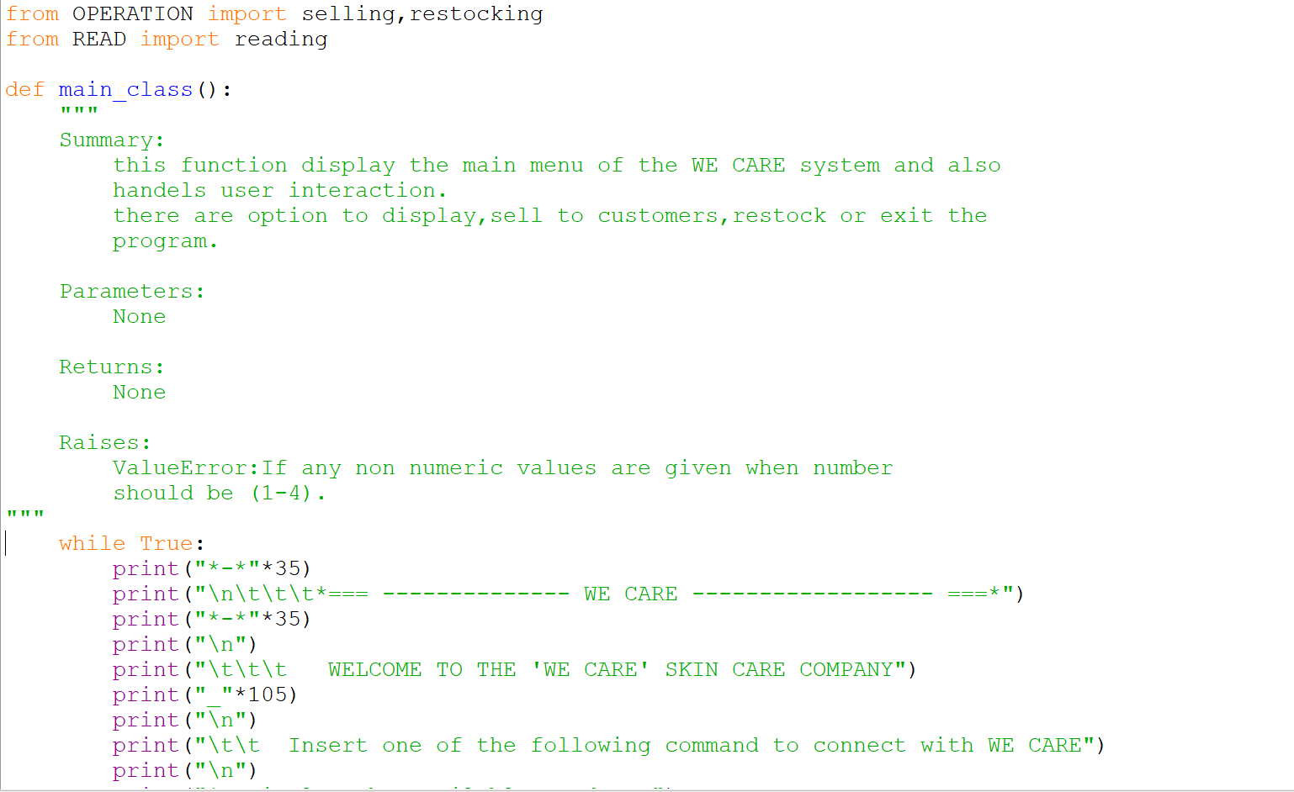
Figure 28:MAIN FILE (1)

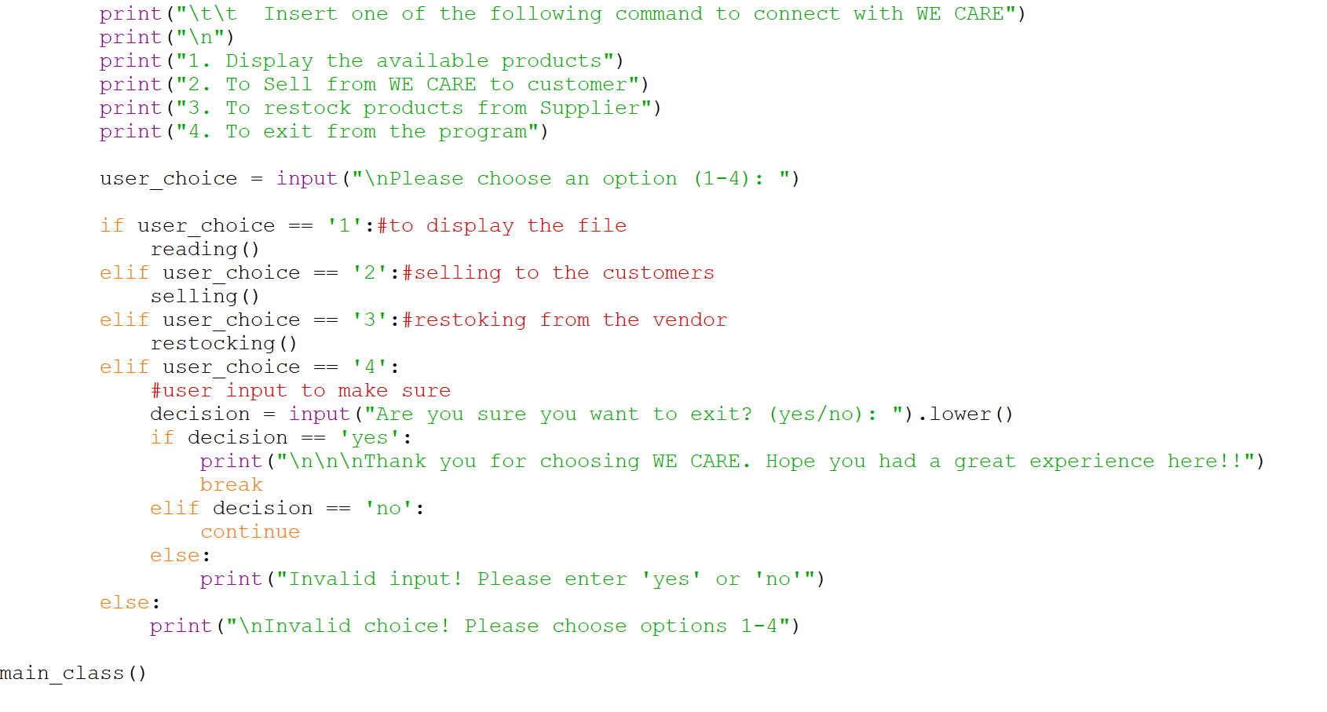
Figure 29:MAIN FILE (2)

The Main.py is the file that need to be run, and it is the actual page interacting with the user. In the main file the reading, selling and restocking functions are imported as in the main function you must perform specific task according to the user input so everything should be connected to the main function. While displaying there are 4 options given to the user to select from1-4.if 1 is pressed then all the items available in store will be displayed, if 2 is pressed then the user can input the product id, quantity they want and they can purchase from the store, if 3 is pressed then the store can restock items they want and for the both selling and restocking invoices are generated. And lastly, if 4 is pressed you can finally exit from the store system.

3.5. Output of selling to customer process
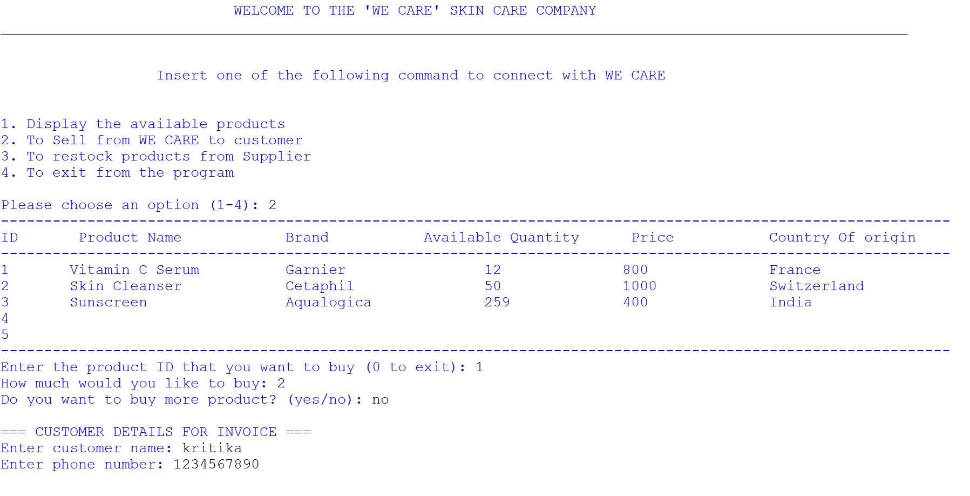
Figure 30:Selling to customers entry
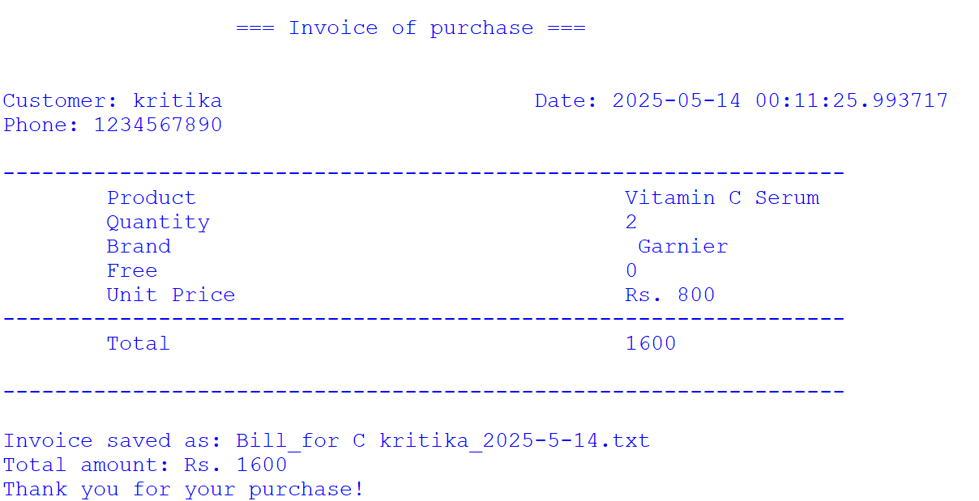
Figure 31:Selling to customer Invoice
This is the selling process to the customer. At first it will display all the product available with its price ,quantity available so when the user chosses a valid product id then it asks for a valid quantity and if the user wants to buy mre then the process repeats and if the user doesnot want to buy the system asks for customers name and phone number by which it generates invoice for the purchase.

3.6. Output of restocking process
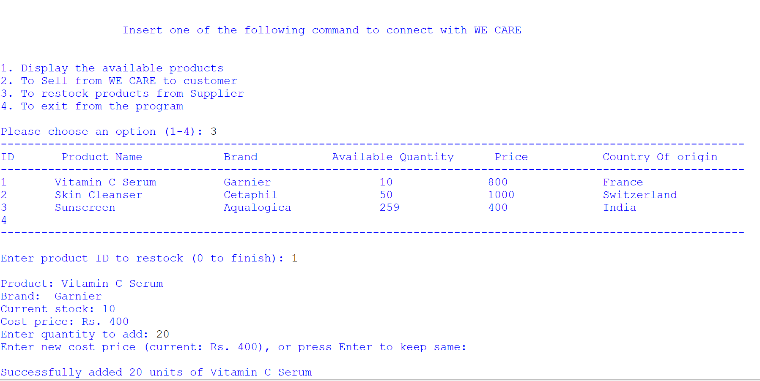
Figure 32:OUTPUT OF RESTOCK
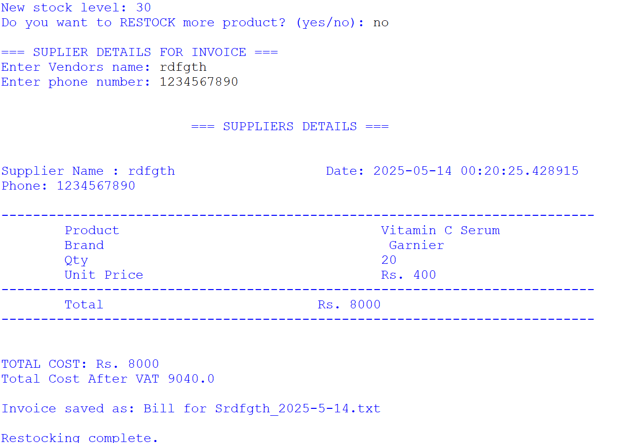
Figure 33:SUPPLIER INVOICE
In the restocking process, at first the system asks for a valid product id then quantity and if both are correct it lets you buy the product from the store and then it asks for vendors name and phone number from where the products are being restocked. Then with the help of that it generates an invoice in the shells and runs the program as usual.

3.7. Creation of text file

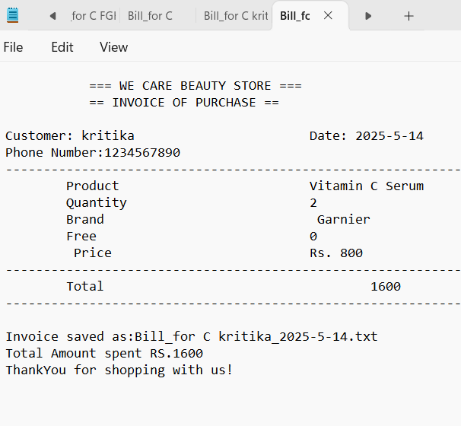
Figure 34:INVOICE IN OF PURCHASE IN .TXT
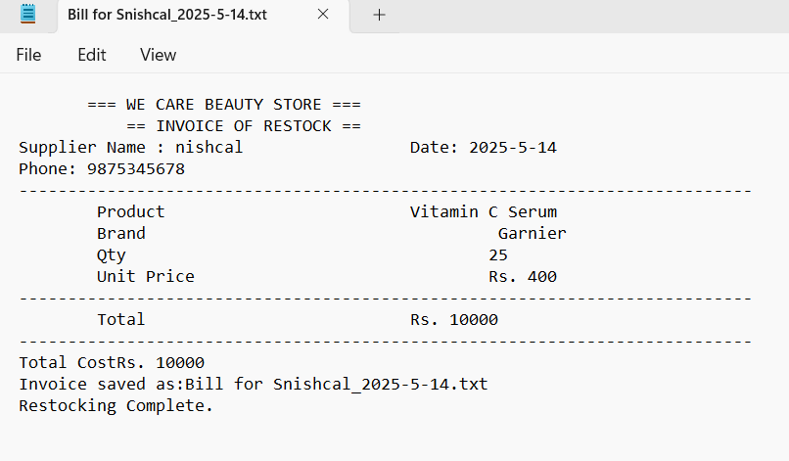
Figure 35:INVOICE OF PURCHSE IN .TXT
To generate an invoice, you must either sell something to a customer or just restock the items of the store. This invoice is generated when I purchased from the store and when all the input I gave was valid then the items were purchased and then the invoice is generated in both txt and shell. And the same thing will happen if you want to restock the stock in the system.

4. Testing

4.1. Test 1 : Showing the implementation of try, except

Table 1:TRY AND EXCEPT
Objective | To test the implementation of try and except
Action | - Run the program  - Enter 2 to sell product to customers  - Enter an alphabetical product id.
Expected Result | Error message invalid choice would be shown.
Actual Result | Error message invalid choice showed.
Conclusion | The implementation of try and except test was successful.

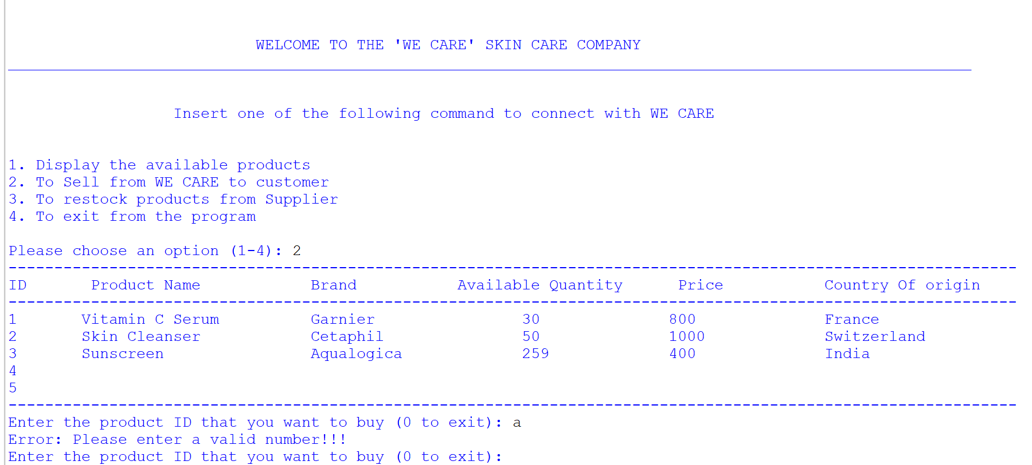
Figure 36:NON NUMERIC VALUE

4.2. Test 2 : Selection purchase and sale of products

Table 2:TESTING NEGATIVE AND NON EXISTED VALUE
Objective | To test the implementation on selling and restoking by providing negative and non-existed value.
Action | For purchase  - Run the program select 2 at first  - Enter -1 in the product id  - Enter 1 in the product id  - Enter 30 in the quantity  For sale  - Enter 3 to show the options  - Enter -1 in product id  - Enter 1 in the product id  - Enter -2 in the quantity
Expected Result | Error message should be shown.
Actual Result | Error message showed.
Conclusion | The test was successful.
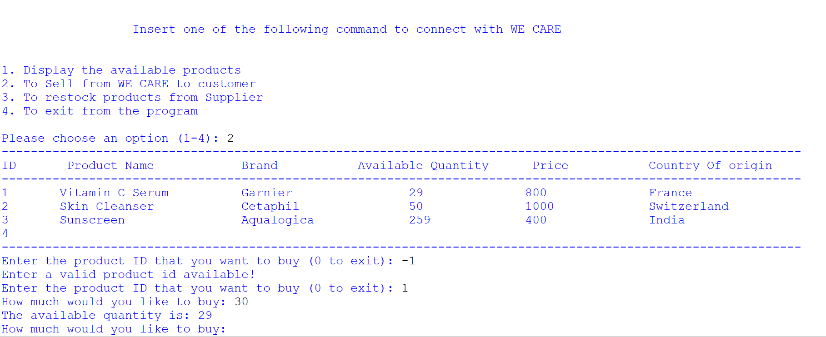
Figure 37:NEGATIVE VALUE WHILE SELLING
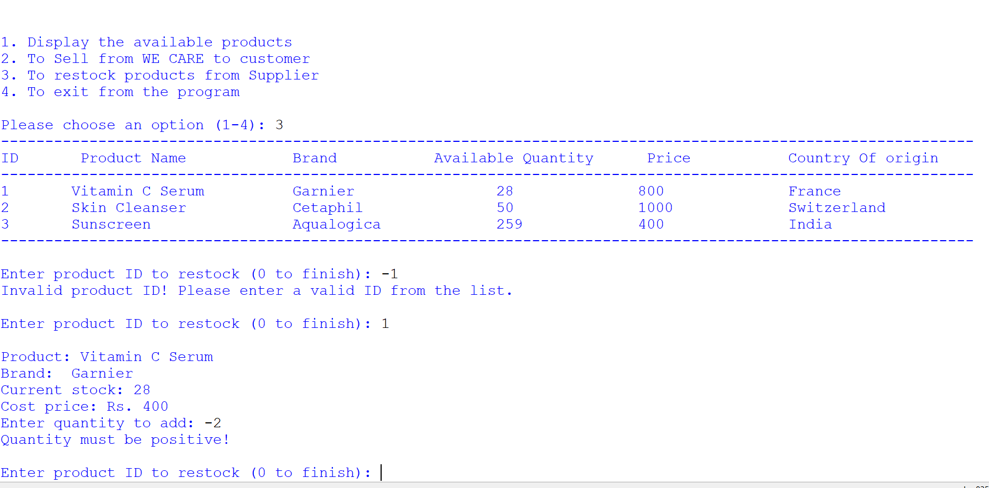
Figure 38:NEGATIVE VALUE WHILE RESTOCKING

4.3. Test 3: File generation of purchase of product(s) (Purchasing multiple product(s))

Table 3:FILE GENERATION OF PURCHASE OF CUSTOMERS
Objective | To test the file generation of products while purchased by customers.
Action | - Run the program  - Enter 2 to sell to customers  - Select the valid product id  - Select the valid quantity.  - Enter the name and phone number
Expected Result | A invoice should be generated in shell and text file.
Actual Result | A invoice generated in shell and text file.
Conclusion | The test was successful.
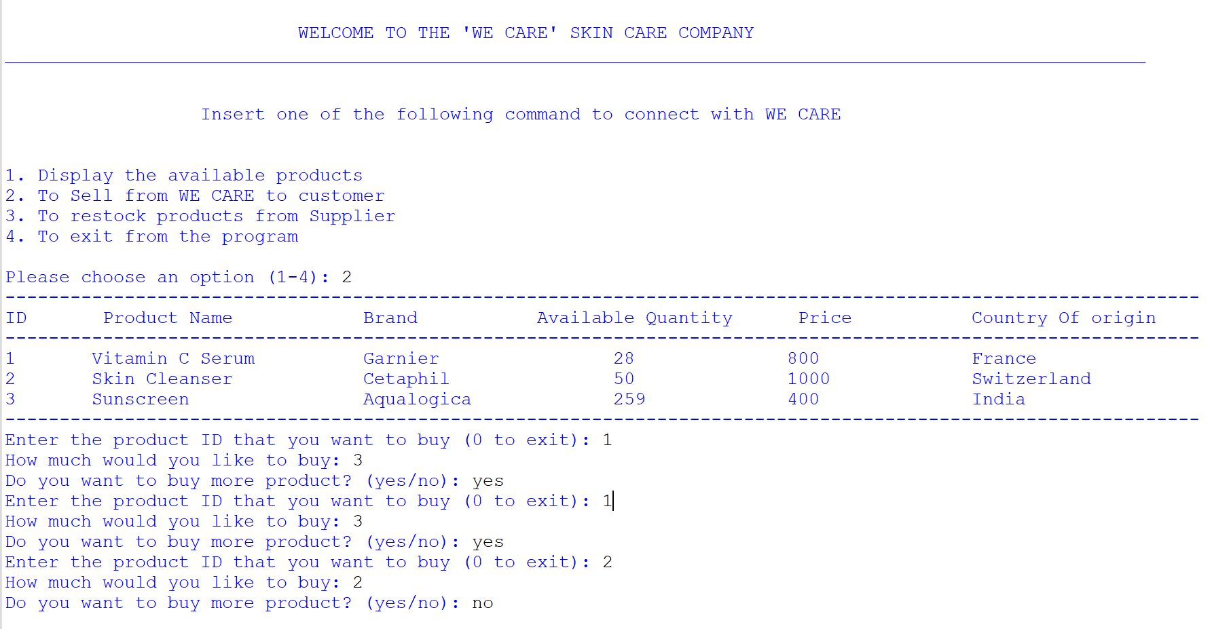
Figure 39:INPUT TO SELL TO CUSTOMERS
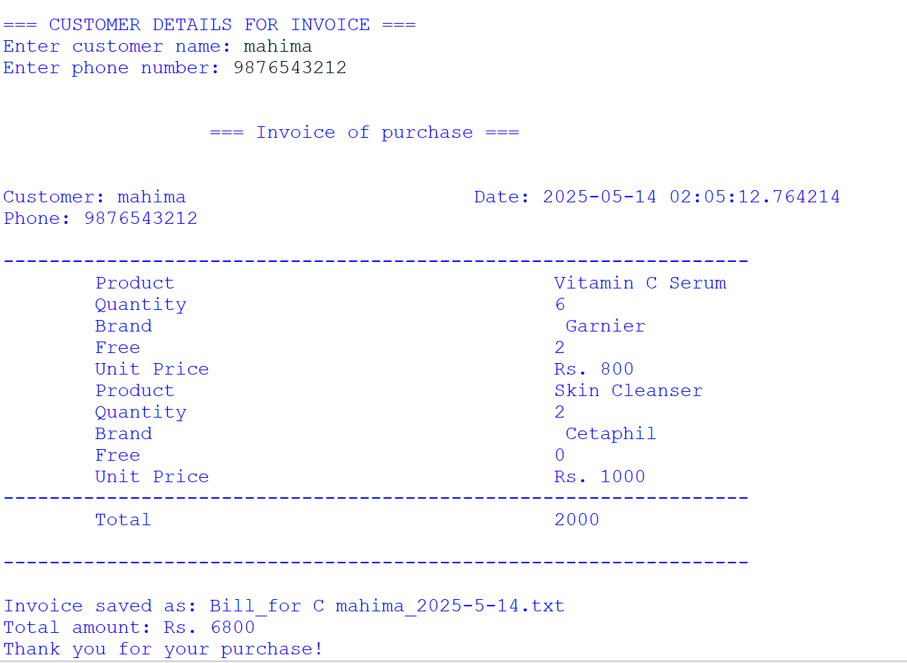
Figure 40:INVOICE IN SHELL
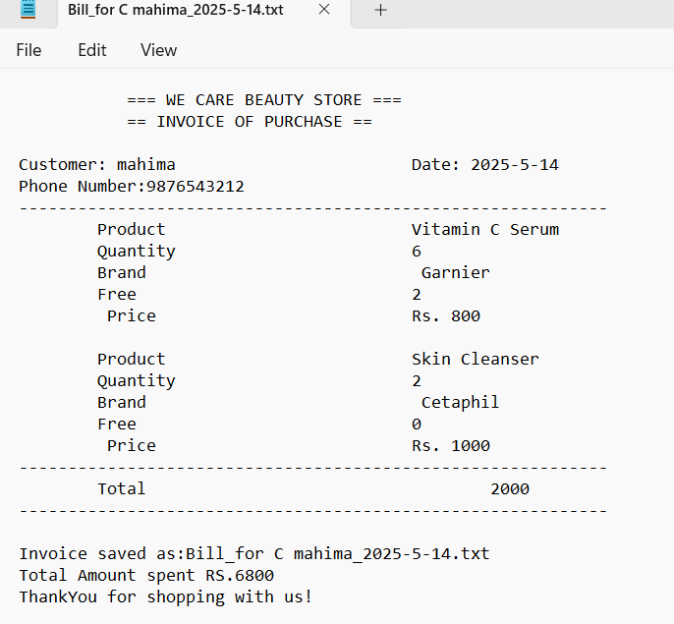
Figure 41:INVOICE IN .TXT

4.4. Test 4: File generation of sales process of product(s) (Selling multiple product(s))

table 4:RESTOCK PRODUCTS
Objective | To test the file generation of products while purchased by customers.
Action | - Run the program  - Enter the product id  - Enter the valid quantity  - Enter the name and phone number
Expected Result | An invoice should be generated in the shell and the txt file.
Actual Result | An invoice generated in the shell and the txt file.
Conclusion | The test was successful.
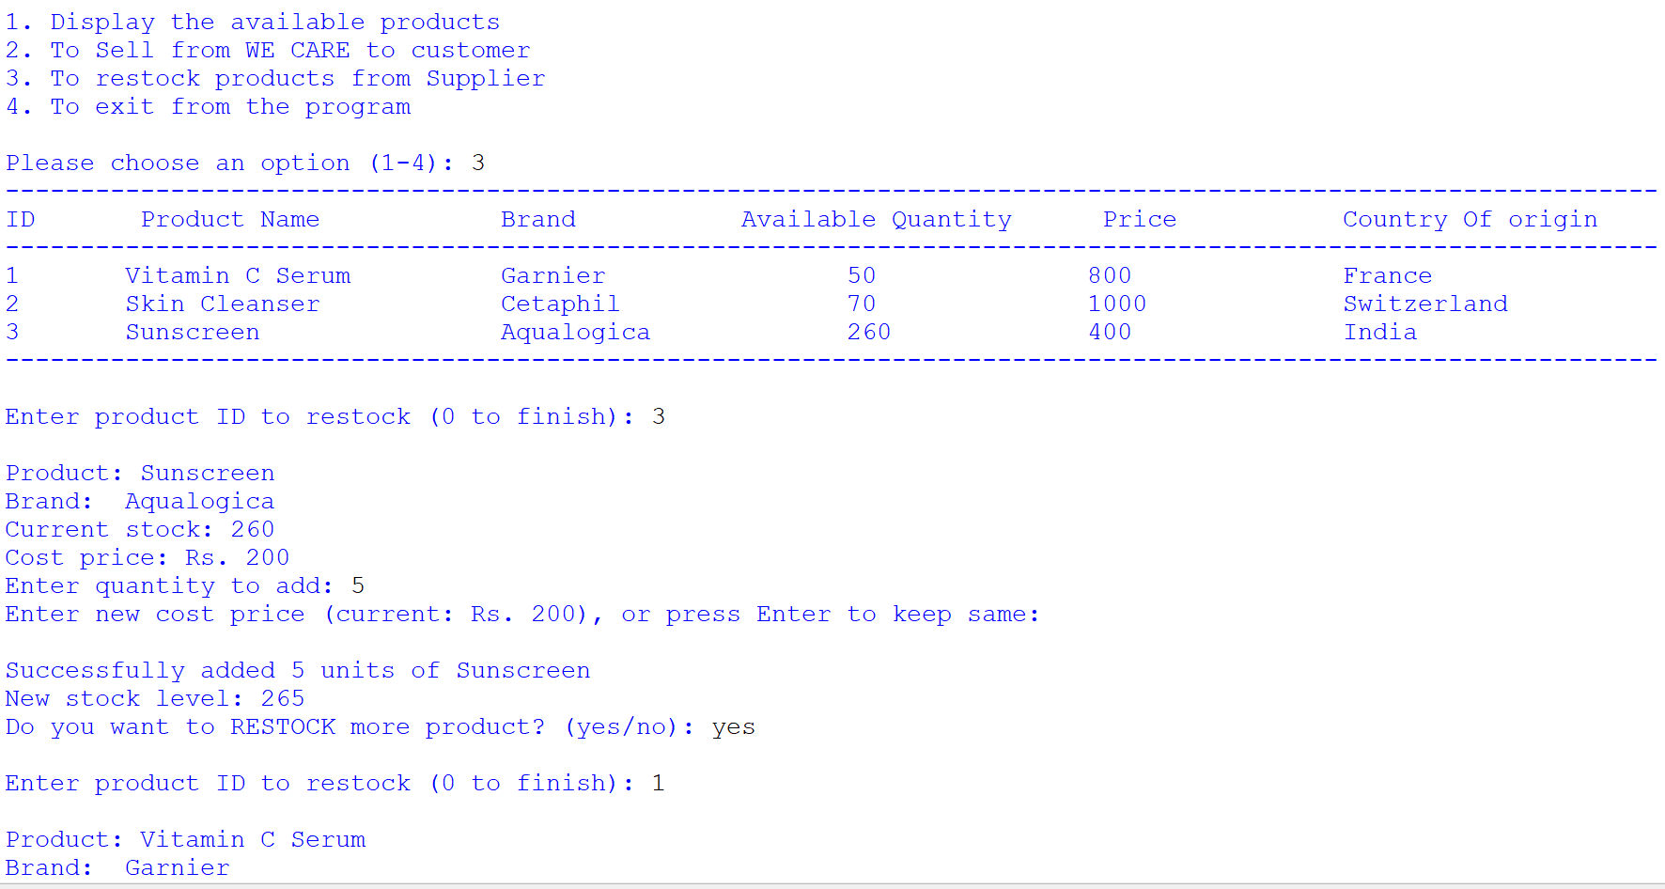
Figure 42:INPUT FOR RESTOCK
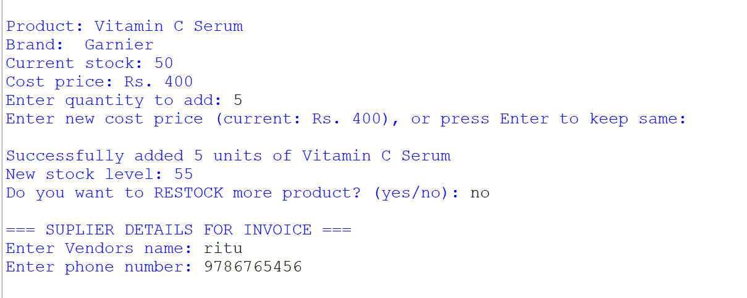
Figure 43:
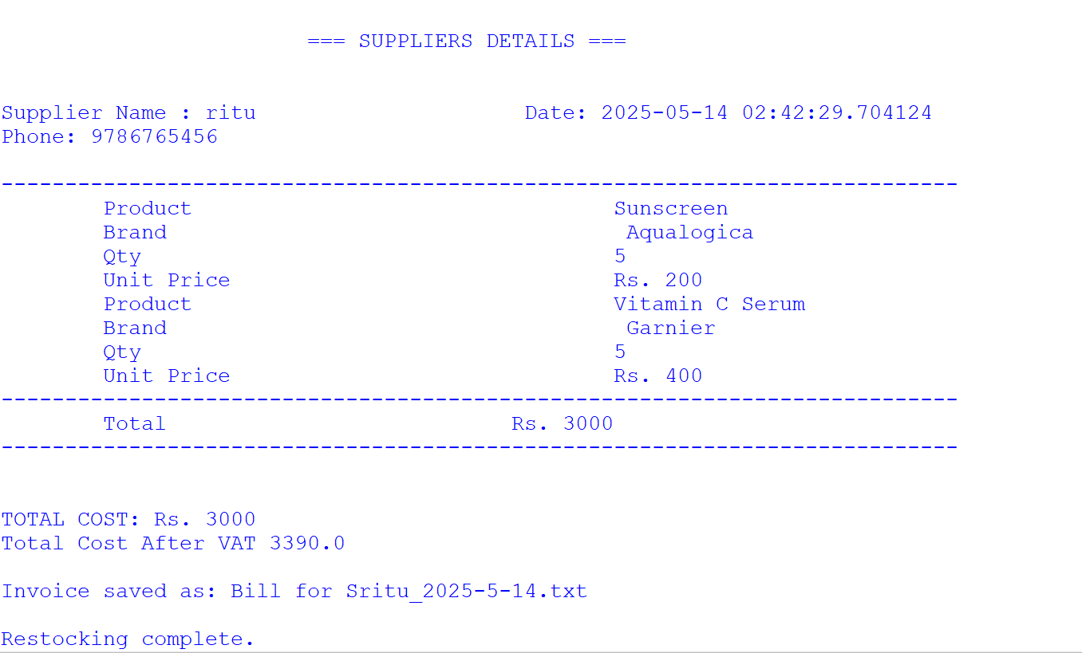
Figure 44:INVOICE IN SHELL
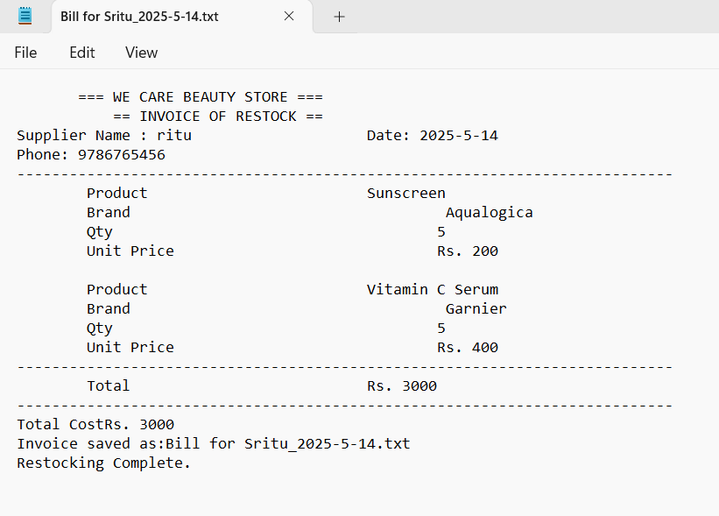
Figure 45:INVOICE IN.TXT

4.5. Test 5: Showing the update in the stock of product(s)

Table 5:UPDATE STOCK OF PRODUCTS
Objective | To show deduction in quantity while selling to the customers and added while restocking in .txt file
Action | For selling to customer  - Run the code  - Enter 2 to sell  - Enter 1 for product id  - Enter 5 for quantity  For restocking  - Run the code  - Enter 3 to restock  - Enter 1 for product id  - Enter 1 for quantity
Expected Result | At the time of selling the quantity should deducted and while restocking should be quantity added.
Actual Result | At the time of selling the quantity deducted and while restocking quantity added.
Conclusion | The test was successful.

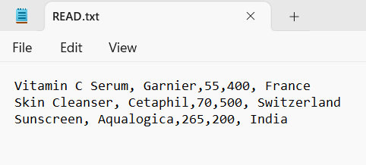
Figure 46:READ VALUE
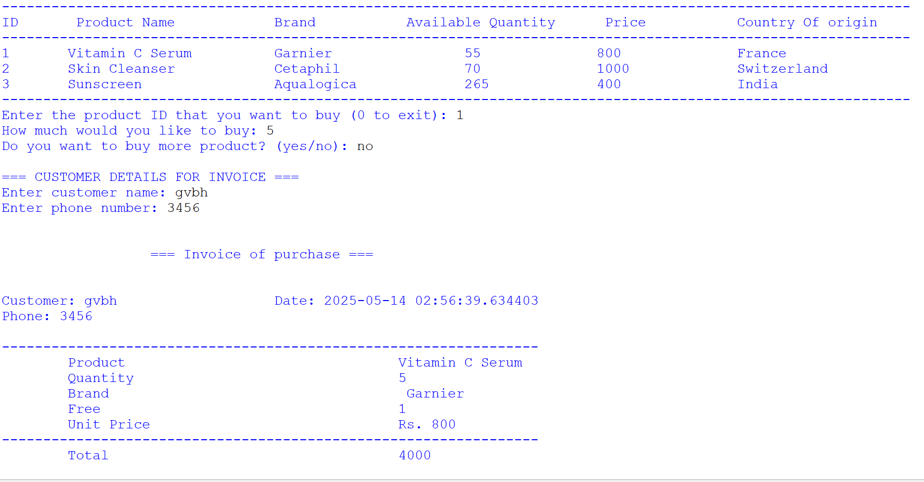
Figure 47:SELLING TO CUSTOMER

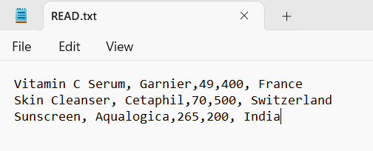
Figure 48:UPDATED DEDUCTED VALUE
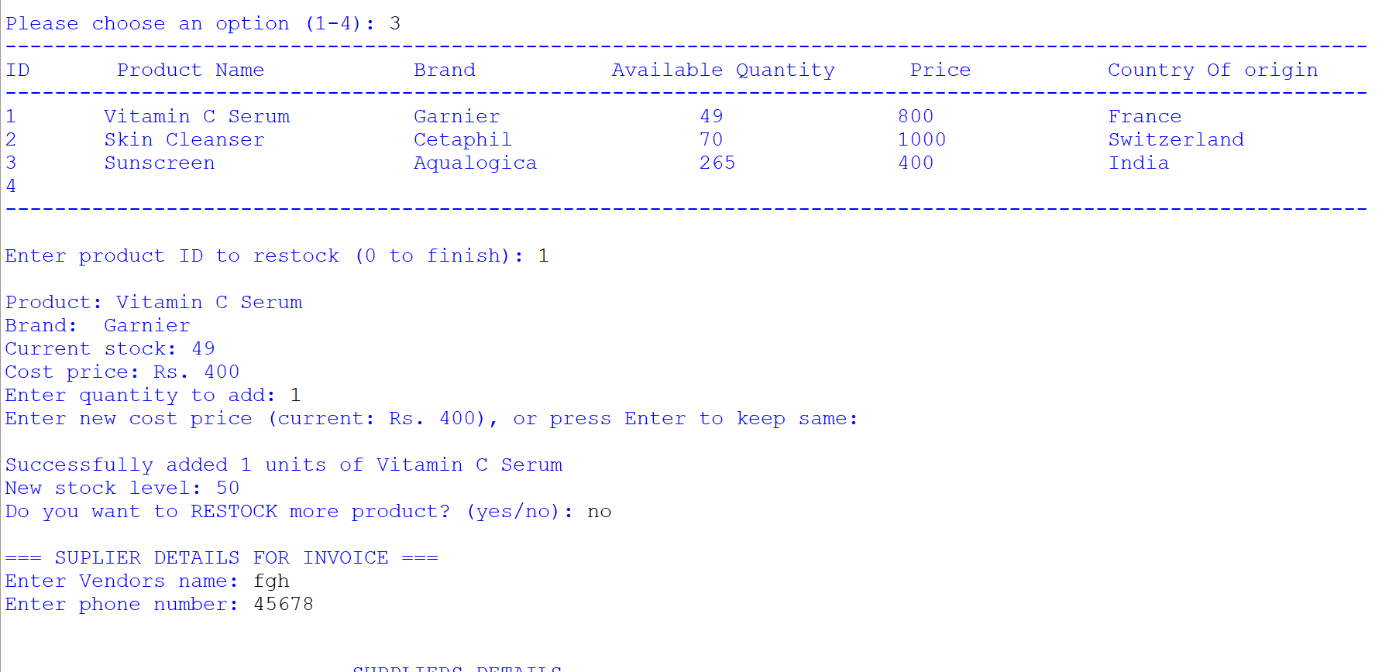
Figure 49:RESTOCKING PRODUCTS

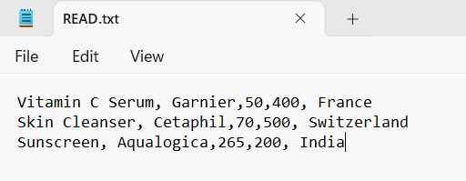
Figure 50:UPDATED ADDED VALUE

5. Conclusion

The development of the system of the ‘WE CARE’ has been successfully complete.this project’s major objective was to develop a user frieldly system for the store we care so the buying and selling would be a lot more easier. In this project a helpful technology was implemented by the WE CARE store by which they can benefit the customes as well as them by saving a lot of time and effort and also providing great deals to the customers.

To summon up the experience of the development of this project was very knowledgeable, and I get to learn a lot of about the python programming.in this project we learne to make a functulable program through python which can take input display available products,sell to the customers and restock from suppliers very efficiently and accurately.

Through this course the knowledge of the python programming has been a lot better .i got to explore on the new topics,learnes exceptional handlings and got a bit of exposure of how the logic works inoder to make a program.The creation of the program was itself very scary yet fun experience from not knowing anything to have some of the idea of the algorithm of the program has enhanced the knowledgeof python programming.

In conclusion,this project of creating a program has helped to have strong foundation for digital store management skills and getting to use our studies in reall ife program helps to make us understand better and improve the current potential of creativeness in us.with the help of the program it benefits the store and the and with further development plan the system can be expanded to be more better and we can learn a lot more from the system to make it much better.

