Employee Management Rest Api based Web application  
  
1. Add role – ADMIN and USER

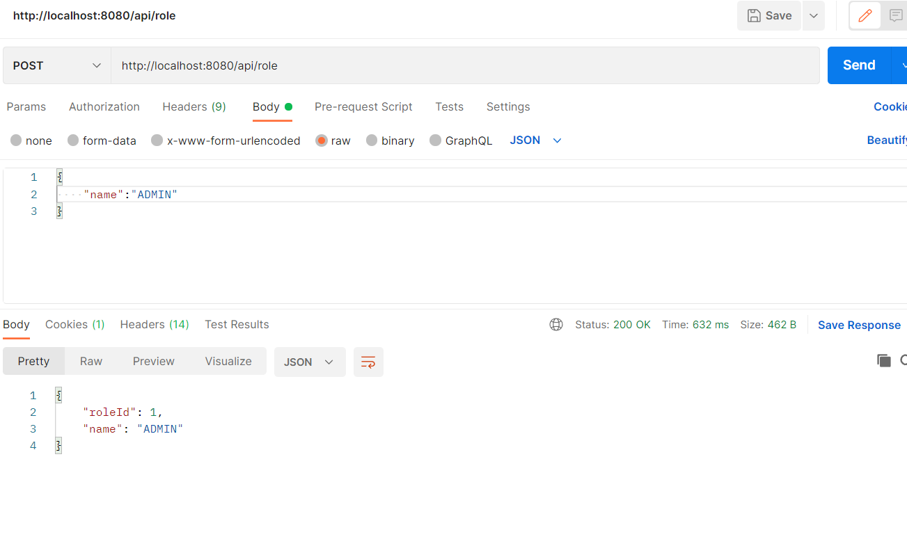

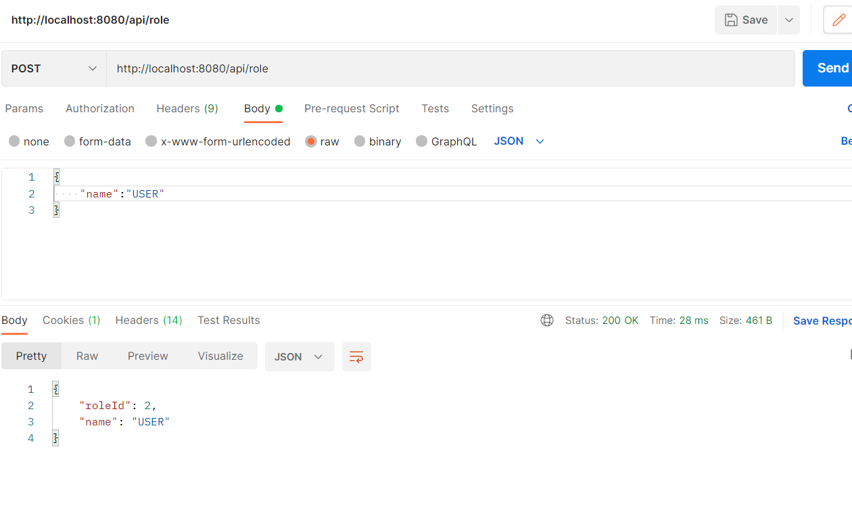

Validated the roles are added to database:

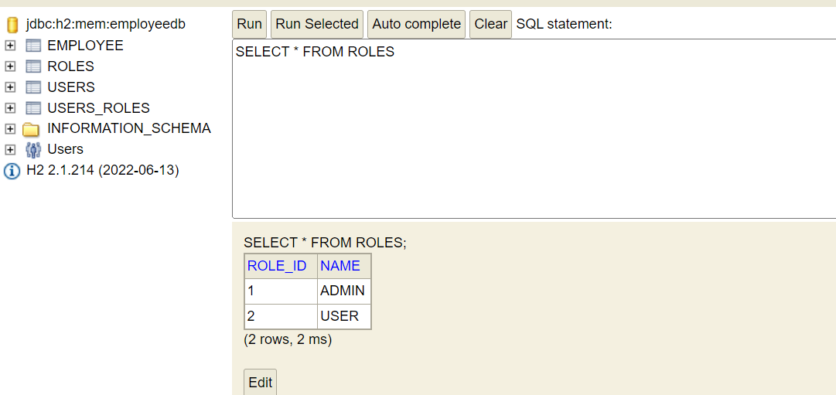

2. Add users (adminuser, guestuser) to databse that would be used for authentication  
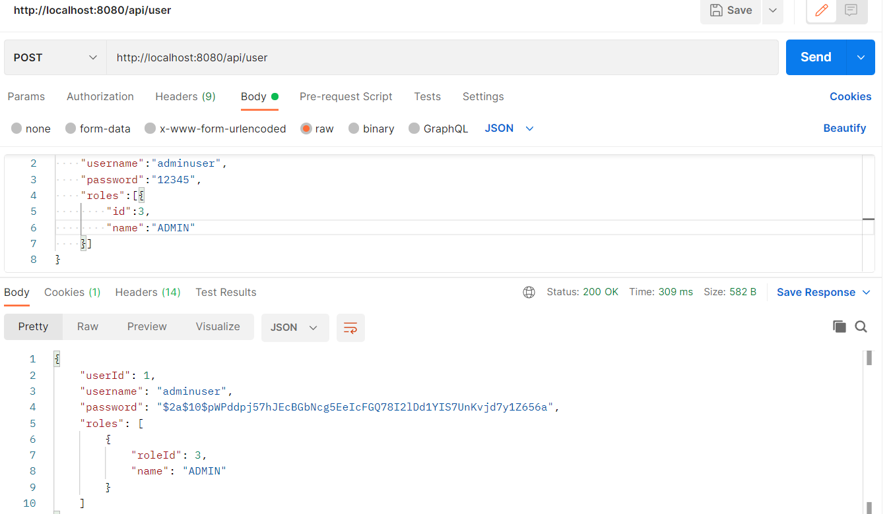

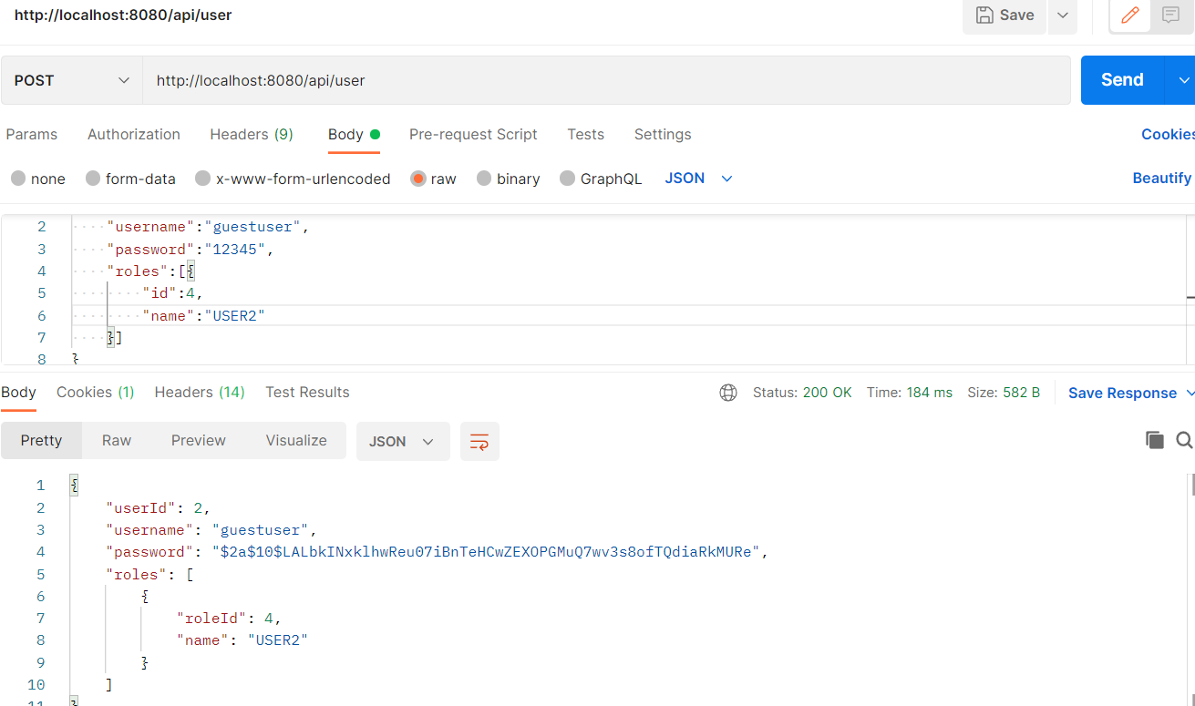

Validated the users are added to database.  
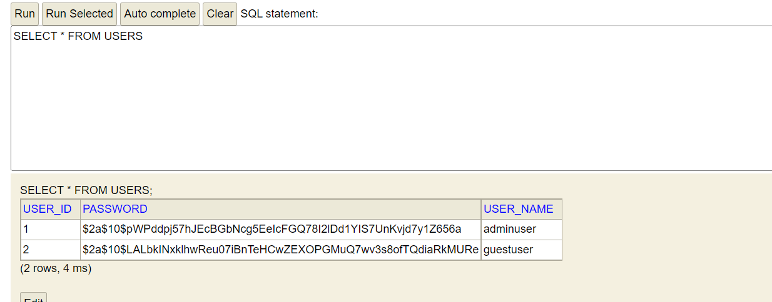

Validated user_roles are mapped in database.  
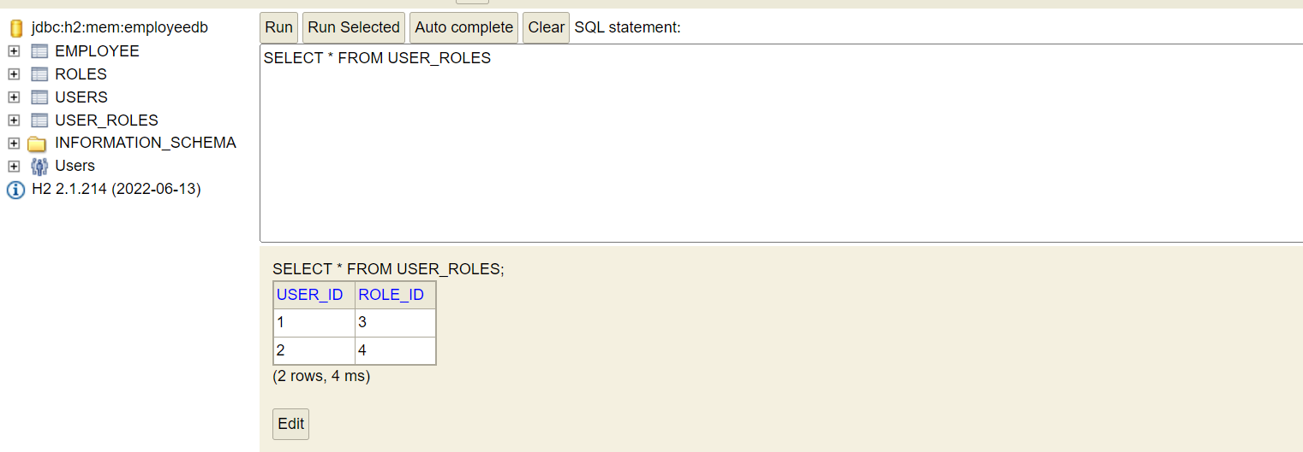

3. Add employee if the authenticated user is **adminuser and role is ADMIN**

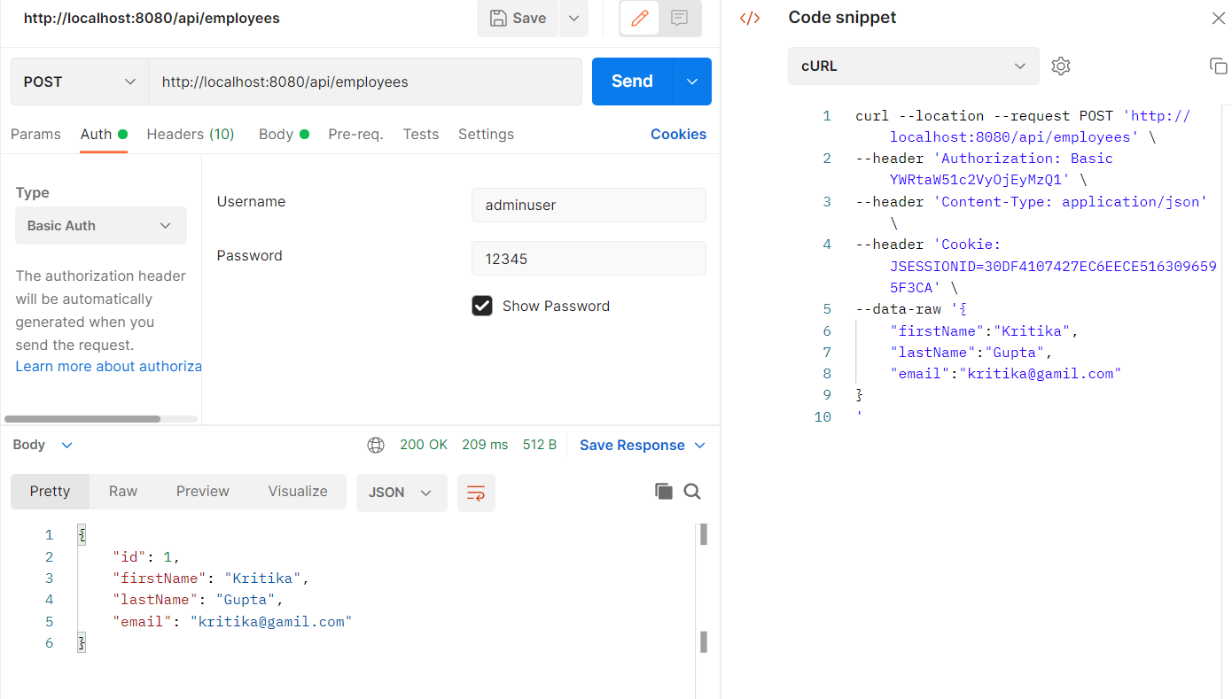

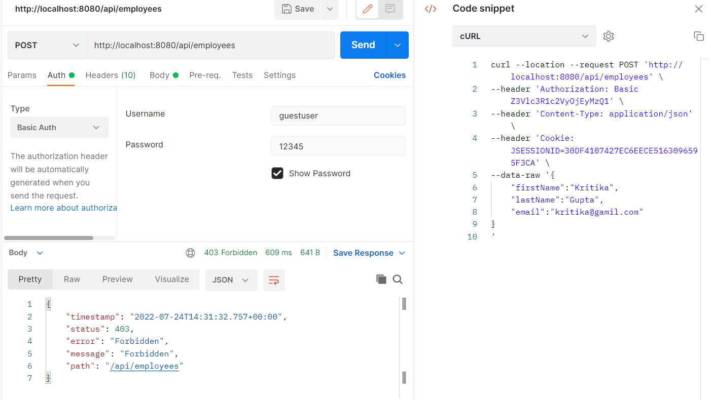

4. List all the employees stored in the database.

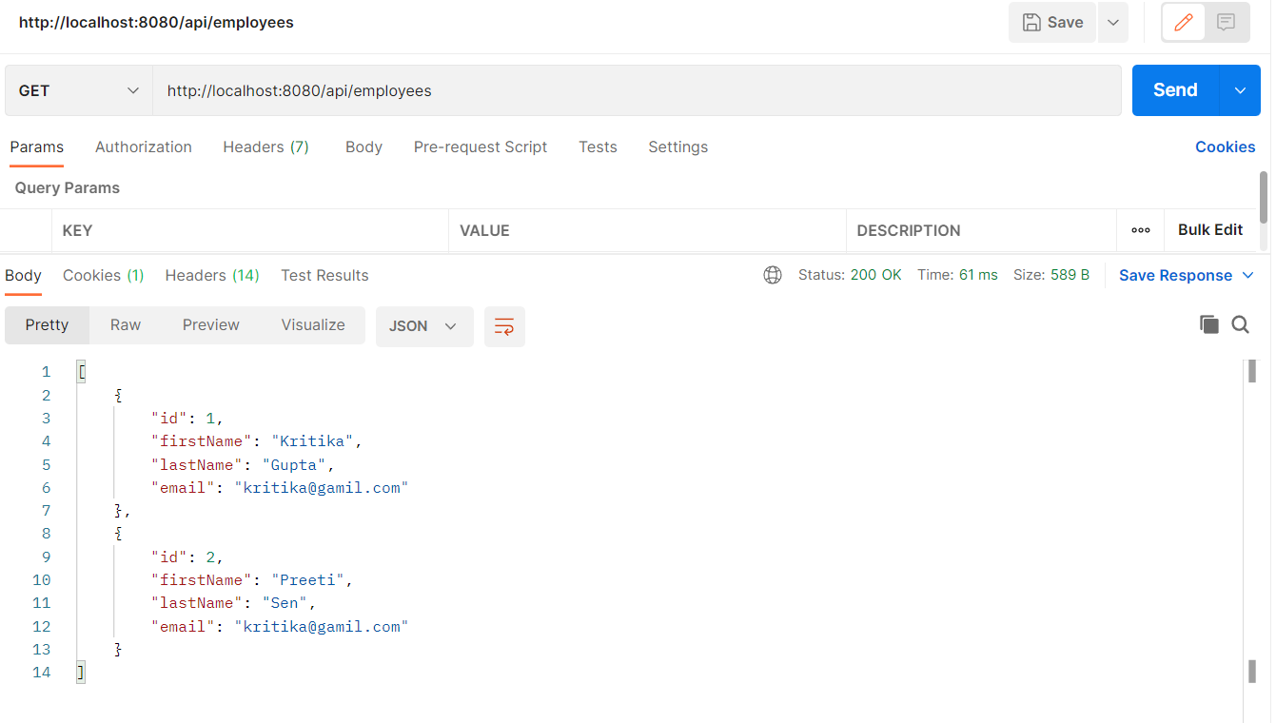

5. Fetch or get an employee record specifically based on the id of that employee

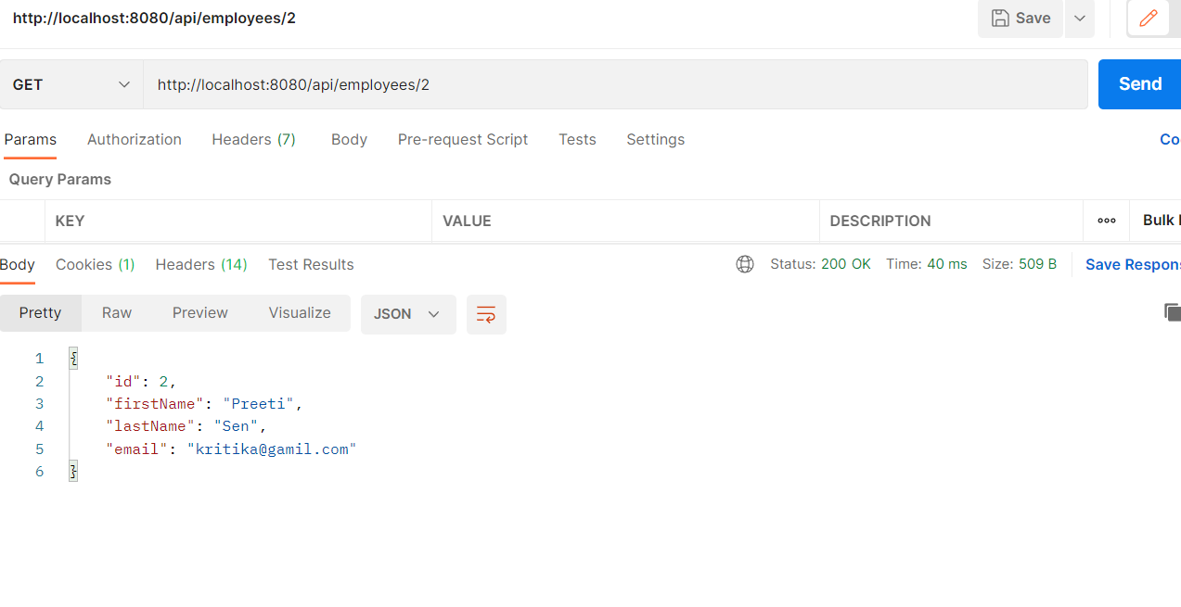

6. Update an existing employee record. (Changed email to [preeti@gmail.com](mailto:preeti@gmail.com) for id=2)

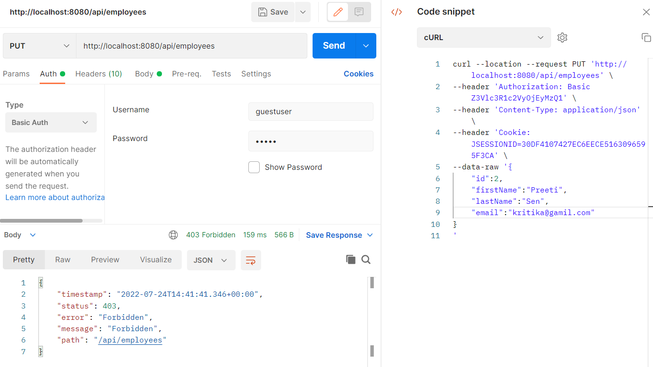

Updated record with adminuser  
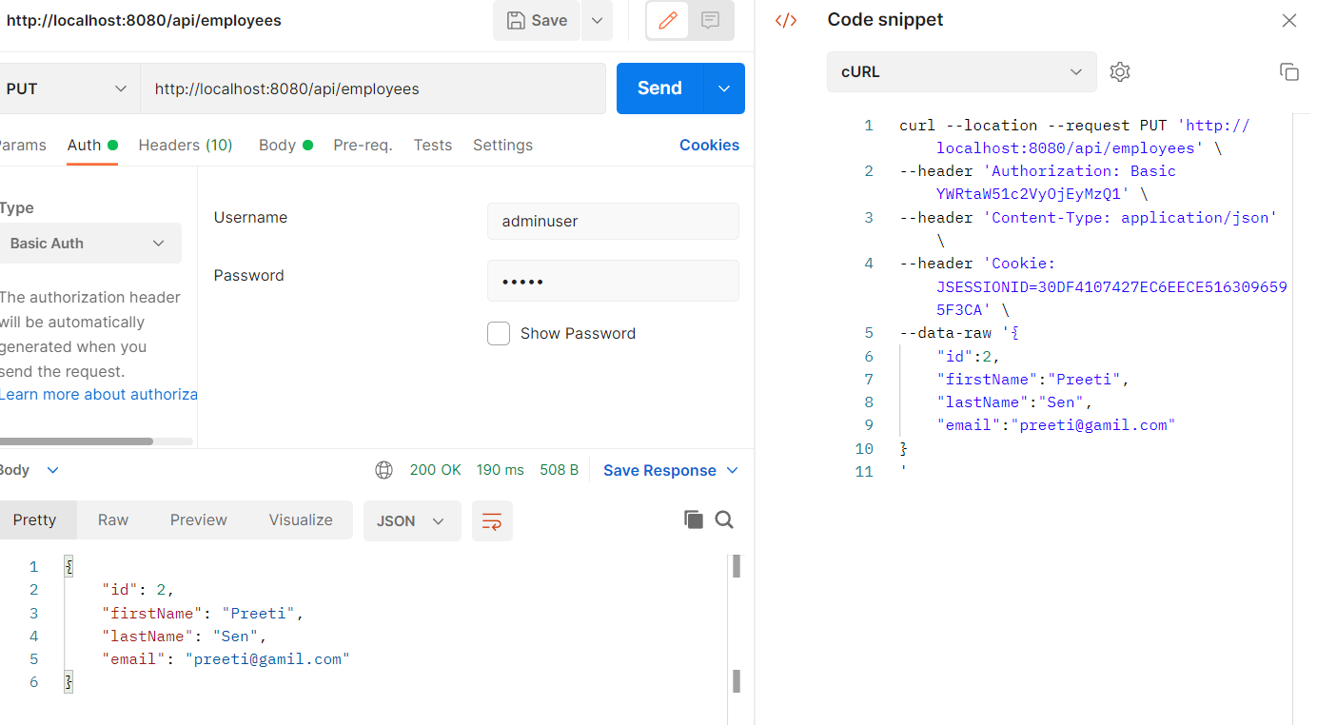

Validated record is updated with GetCall

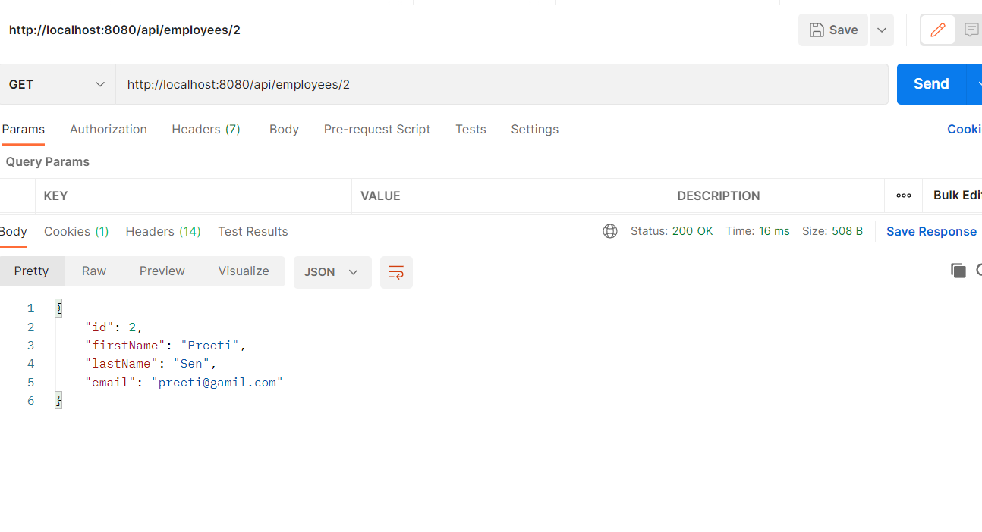

7. Delete record with id=2  
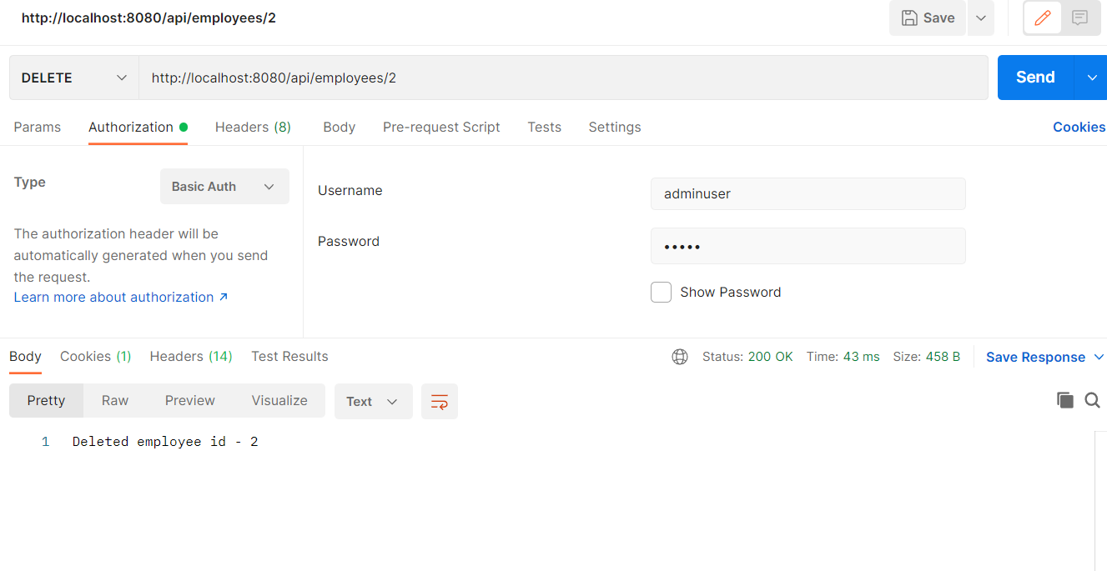

Validated delete is successful with GET call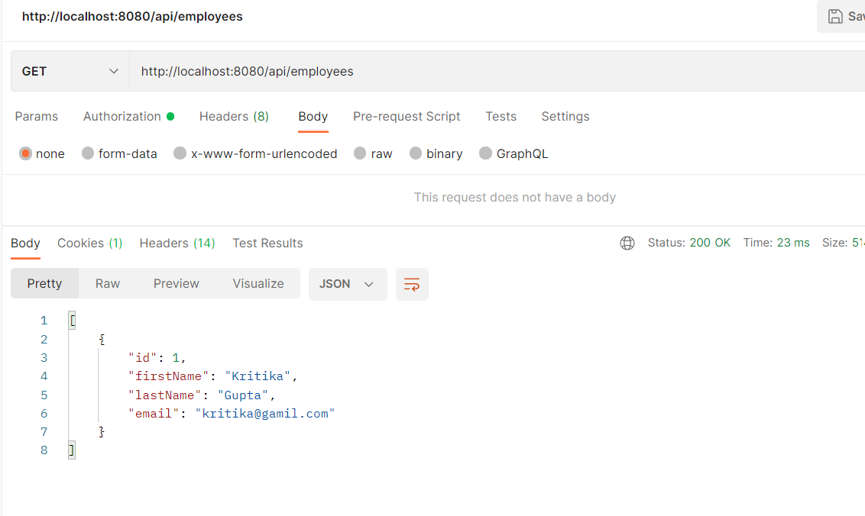

8. Fetch an employee by his/her first name

Search single record  
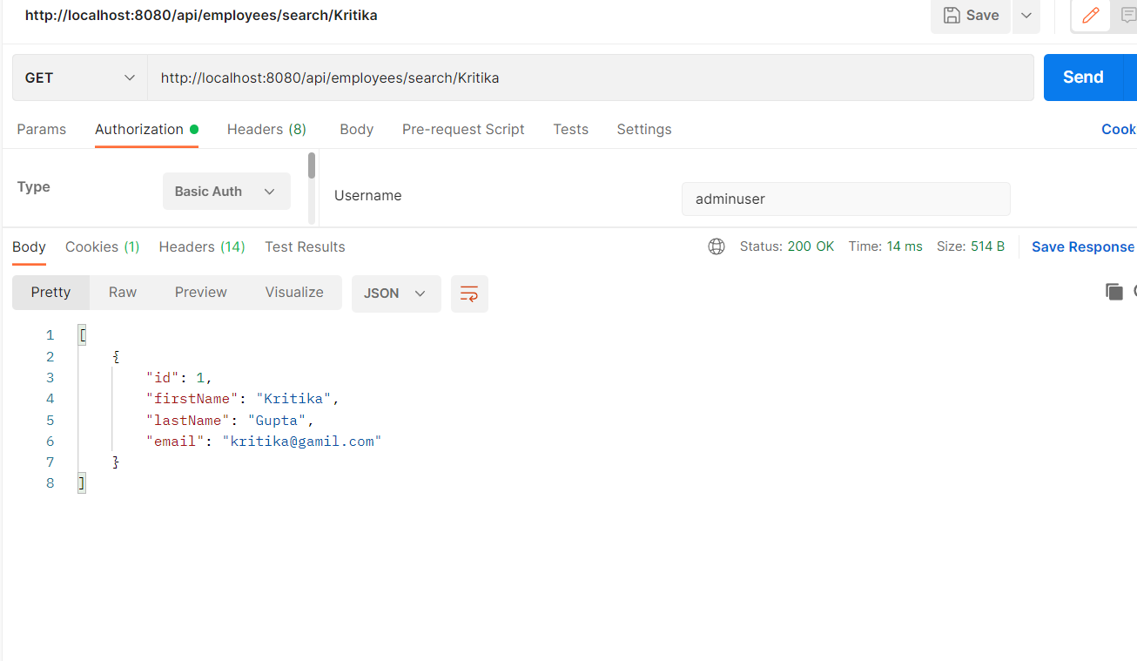

Able to fetch all the records for firstname: Preesha

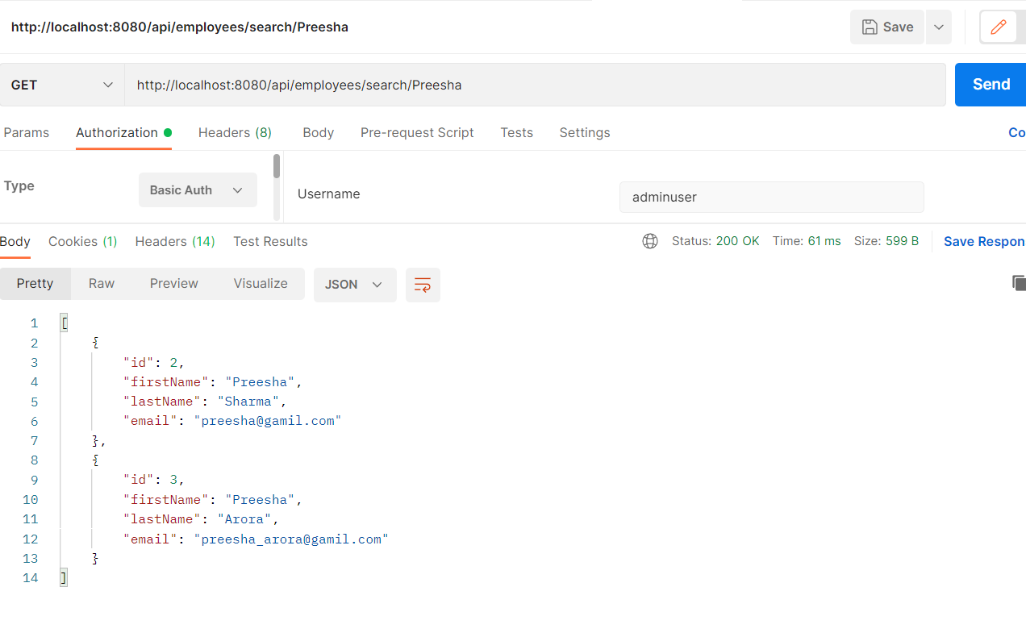

9. list all employee records sorted on their first name

