Customer Relationship Management Screenshots for CRUD operation

1. Added below records in the database.

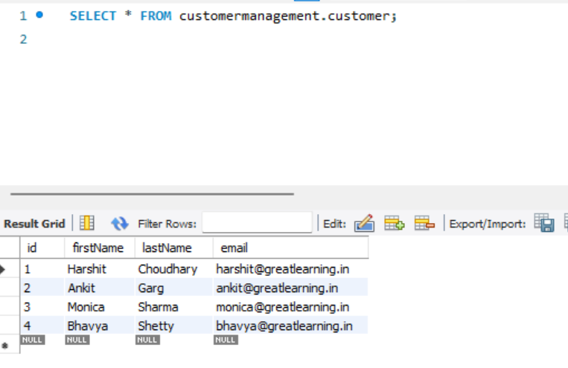

1. Home Page of the customer relationship management.

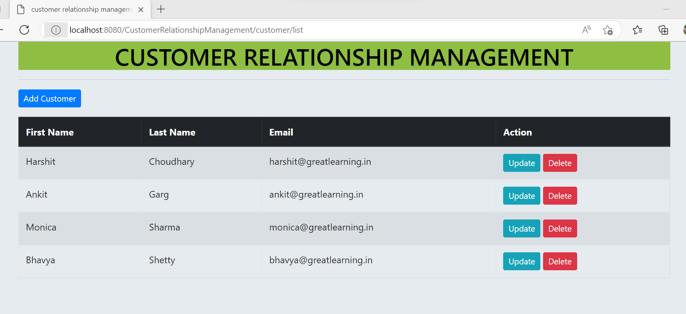

1. Upon clicking on Add Customer button, the user is redirected to the new form page to add the customer details and save them using Save button.

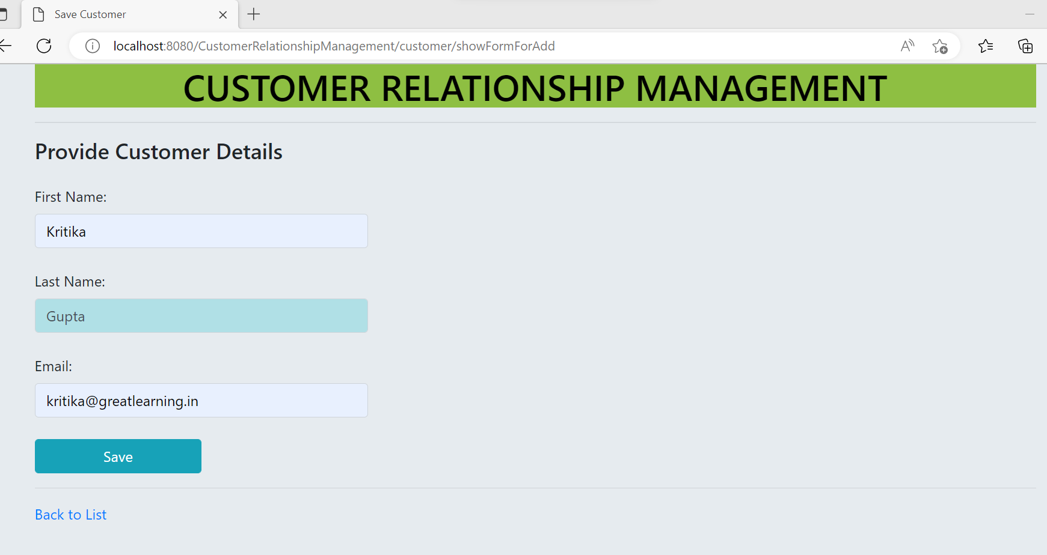

1. The list of customers is updated on saving the record.

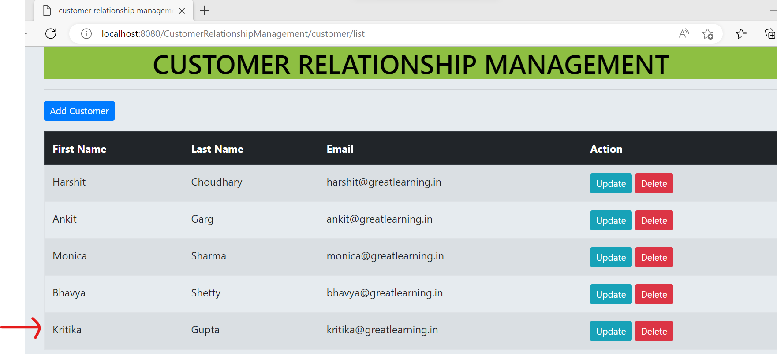

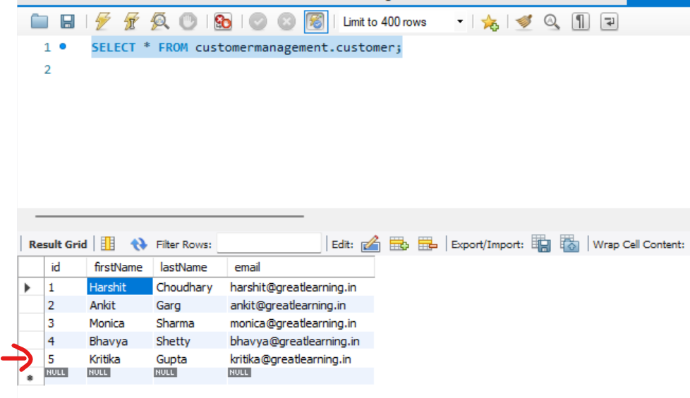

1. Update a record, in the portal by clicking on update button. Update email address for customer Monica Sharma from [monica@greatlearning.in](mailto:monica@greatlearning.in) to [monica@gmail.com](mailto:monica@gmail.com) . Click on Save button.

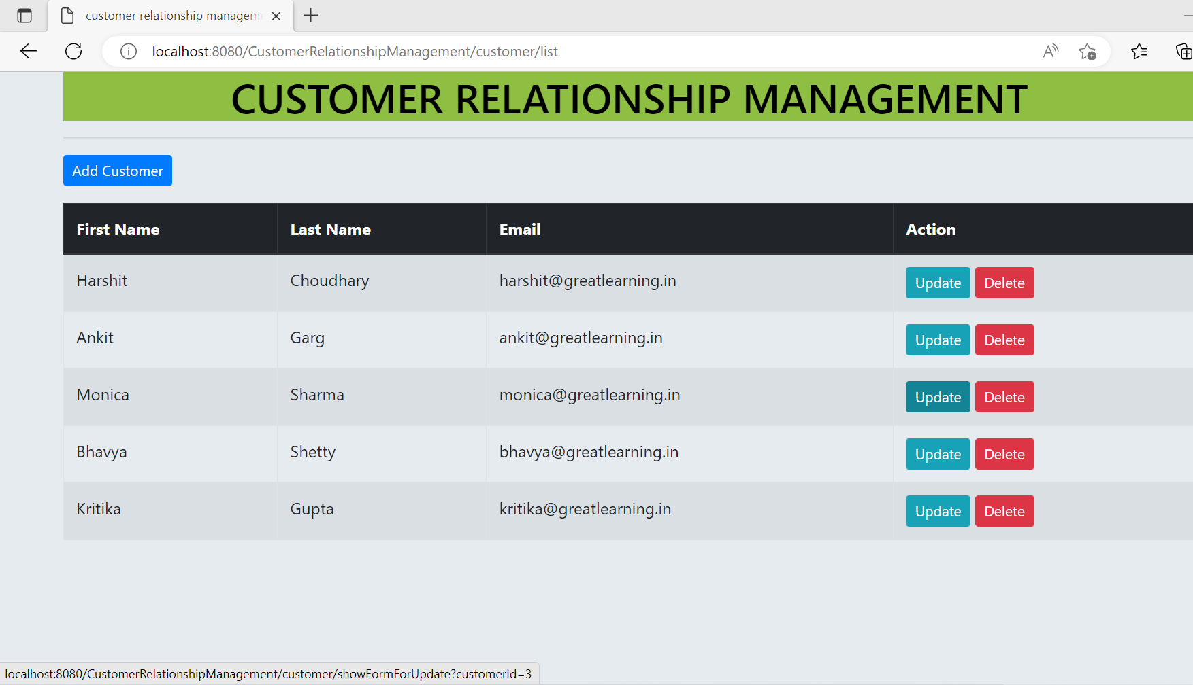

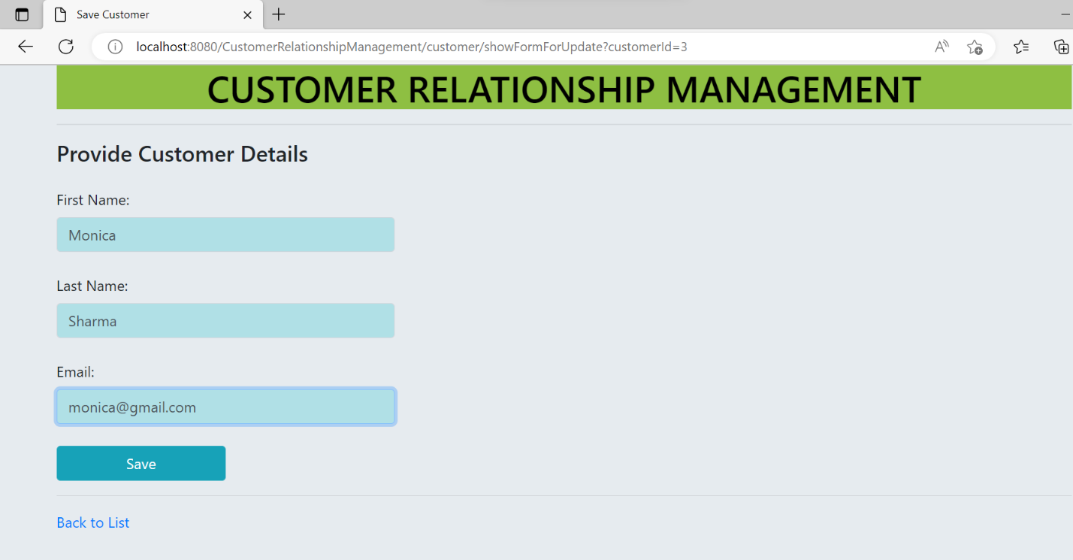

1. Verify the Updated record in portal and database.

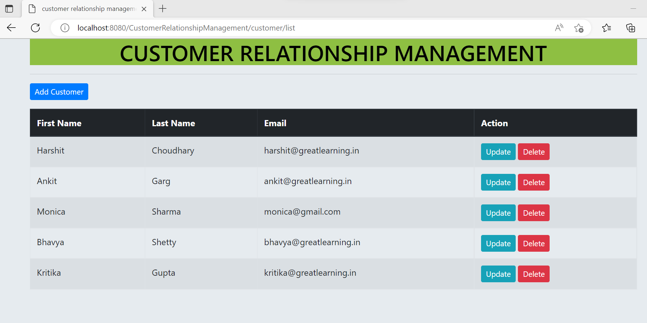

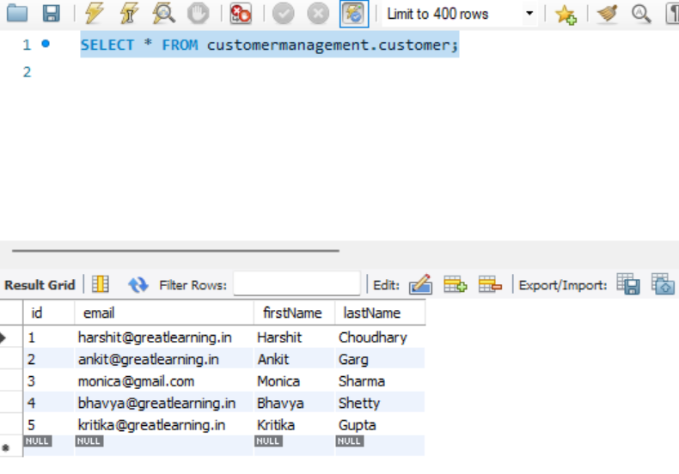

1. Verified the Back to List hyperlink. It redirects the user to view list of added customers.  
   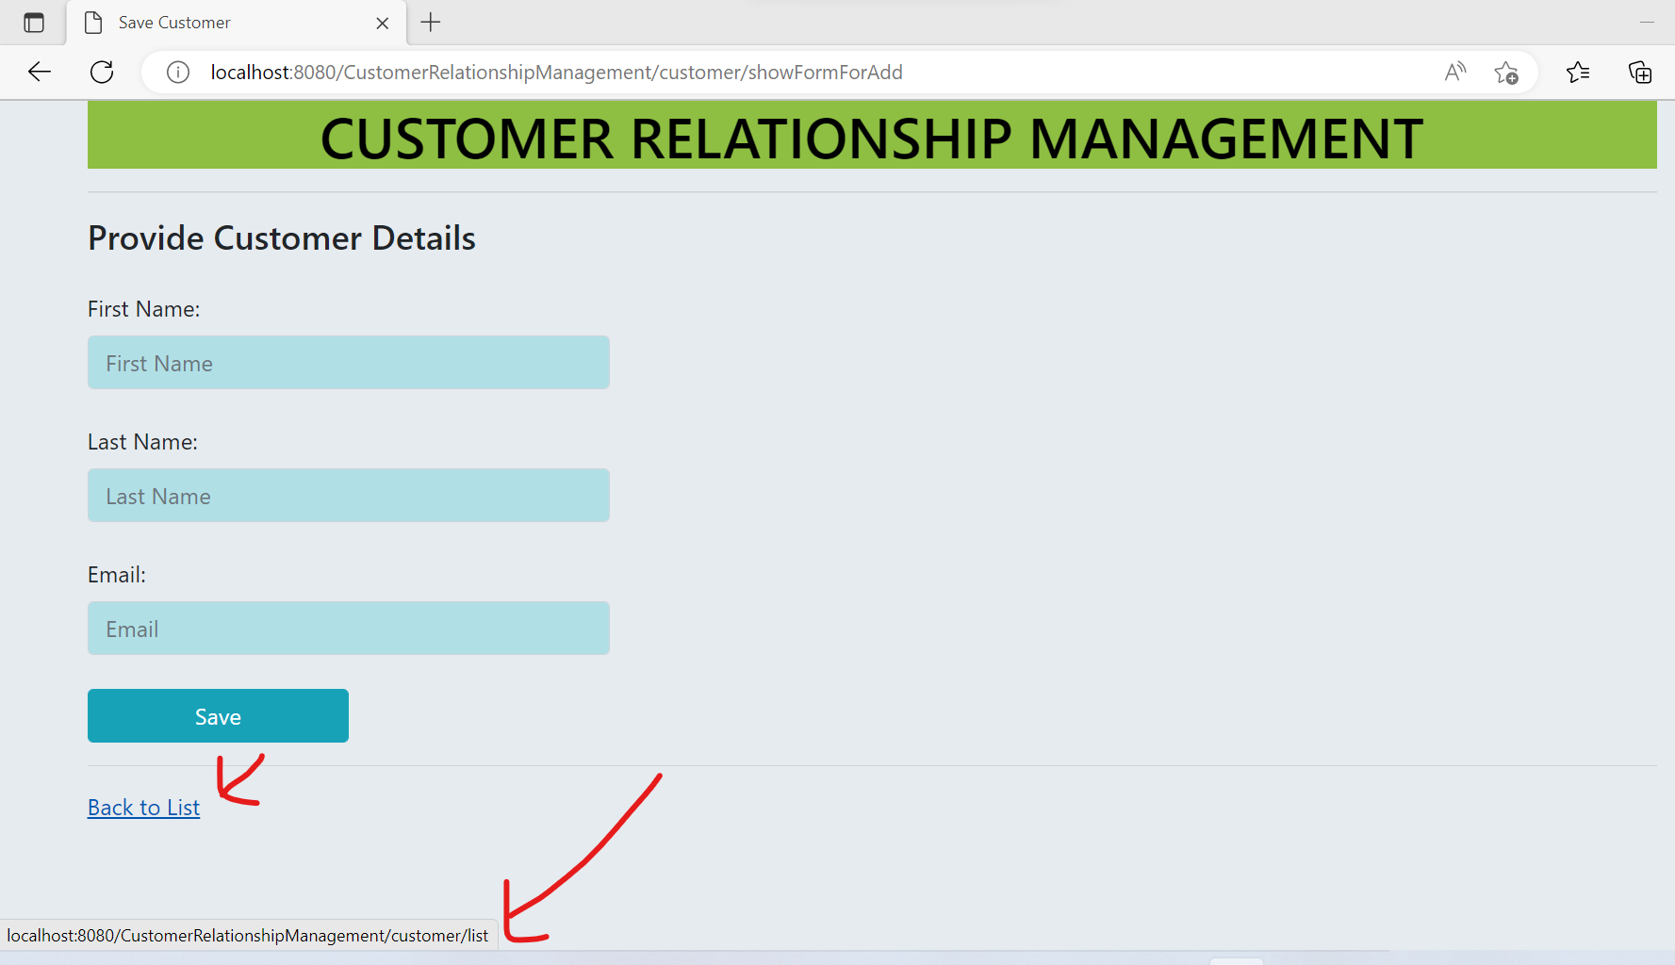

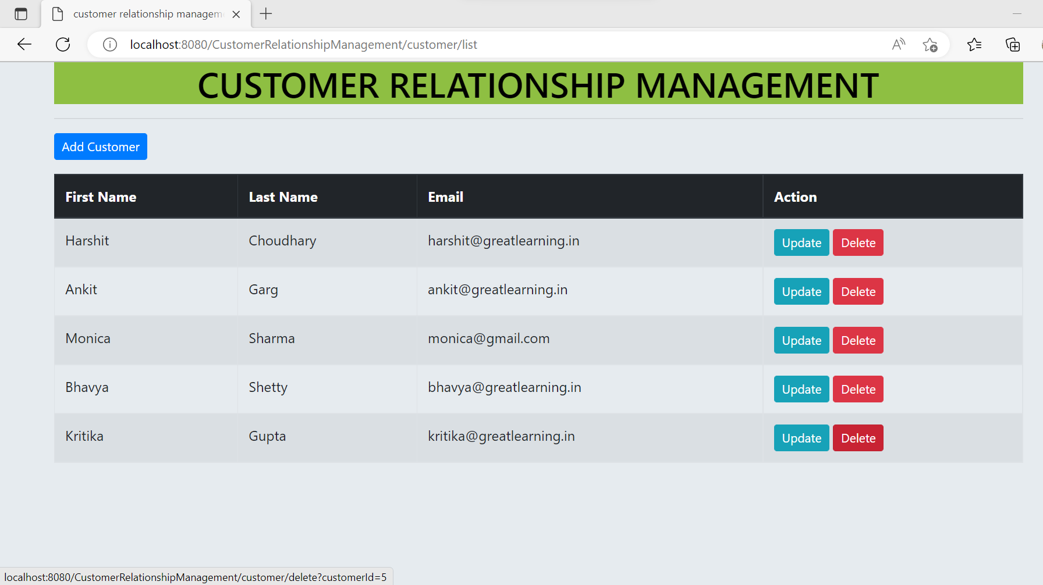

1. Delete a record with name Kritika Gupta. Upon clicking on Delete button, the pop is generated.

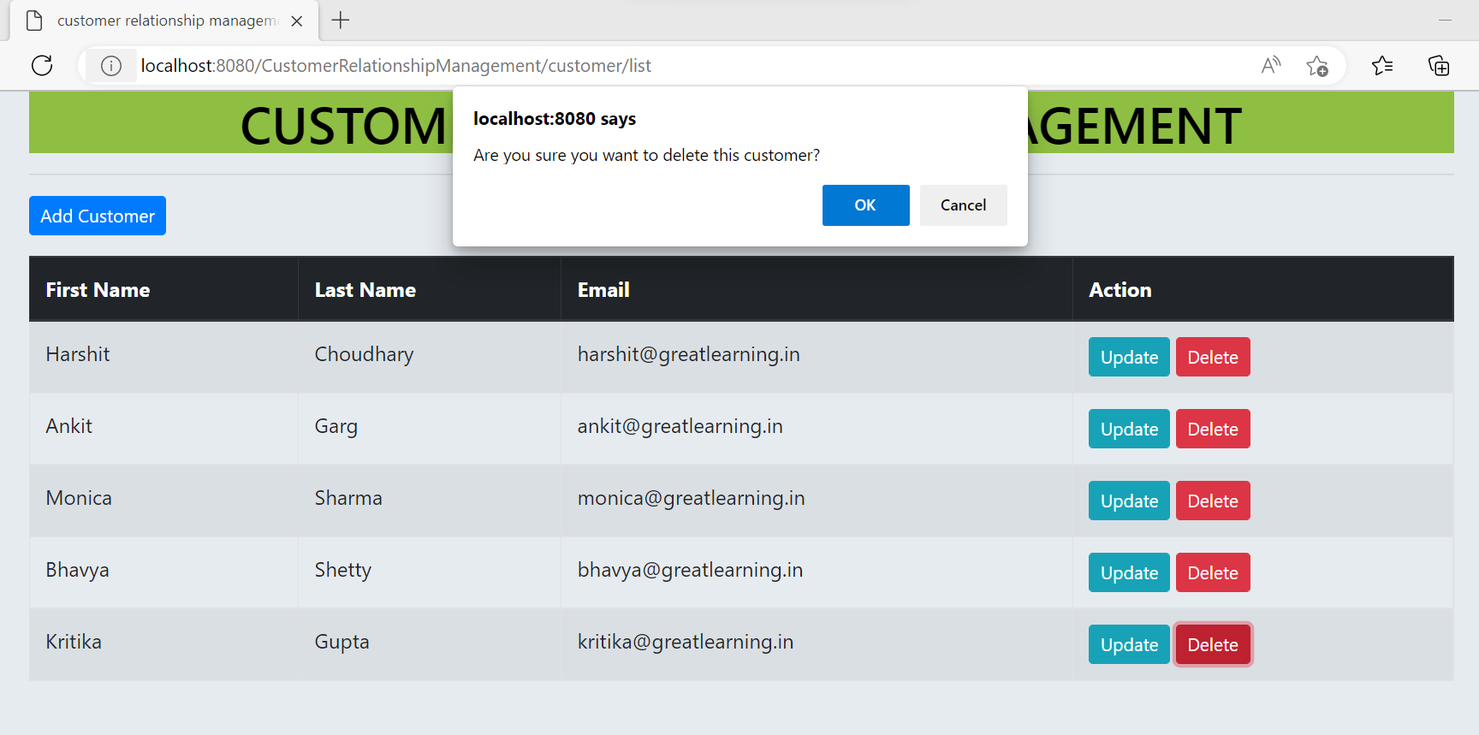

1. Verified that upon clicking on OK, the record is deleted.

