Mobile pass download, installation and activation procedure

How to download, install and activate Mobile pass?

Your SafeNet Token (Soft Token) is used when you are connecting to the Capgemini network from a remote location, such as your home, a client site, or when accessing certain global applications through Single Sign On (SSO) using a dynamic Pass code.

**MobilePASS can be installed for PC and your Mobile Phone with same procedure given below**

Following are the steps to download Mobile pass (Soft) token:

**Step 1. Click on Assign MobilePASS Token under the Actions menu on SafeNet Self Service Portal home page at** <http://selfportal.capgemini.com>

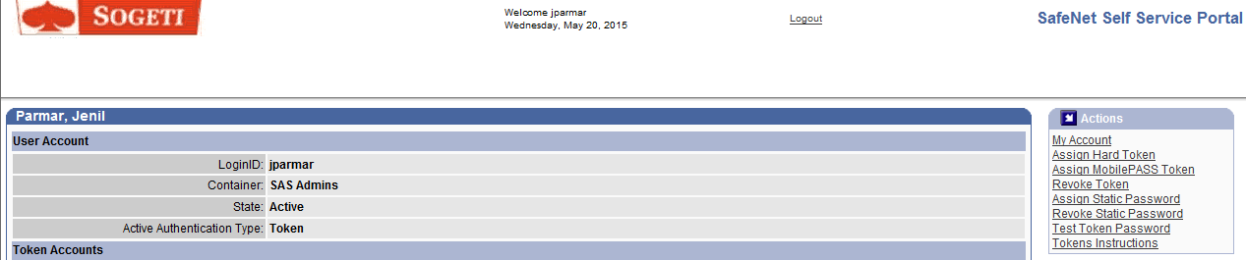

**Click on add value and set the start date validation (Date of Joining) and enter Manager Last Name, click on Save**

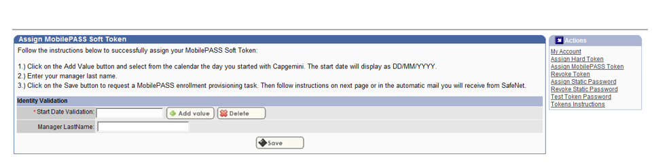

**Step 2. Click on the enrollment URL below to download the latest MobilePASS client on your device and then to activate it.**

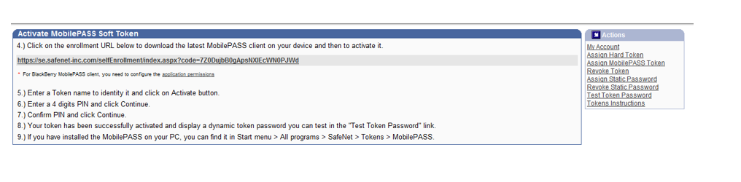

**Step 3. Your Self-enrollment account will be created and you will get below screen. Click on Download MobilePass Installer (.msi)**

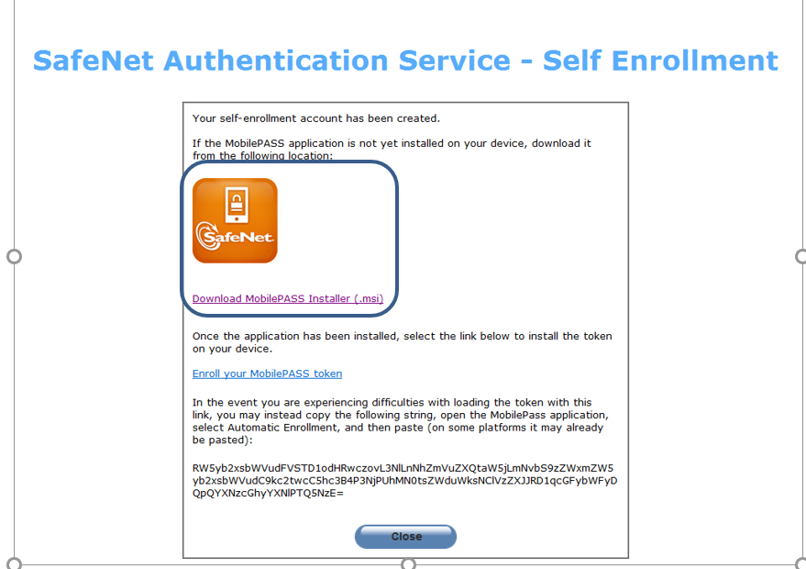

* **Click on run to install the Software**

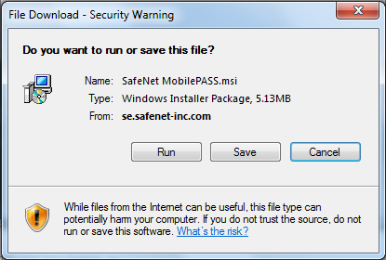

**Step 4. Once the application has been installed, click on Enroll your MobilePass token link**

**(In the event you are experiencing difficulties with loading the token with this link, you may instead copy the following string, open the MobilePass application, select Automatic Enrollment, and then paste (on some platforms it may already be pasted)**

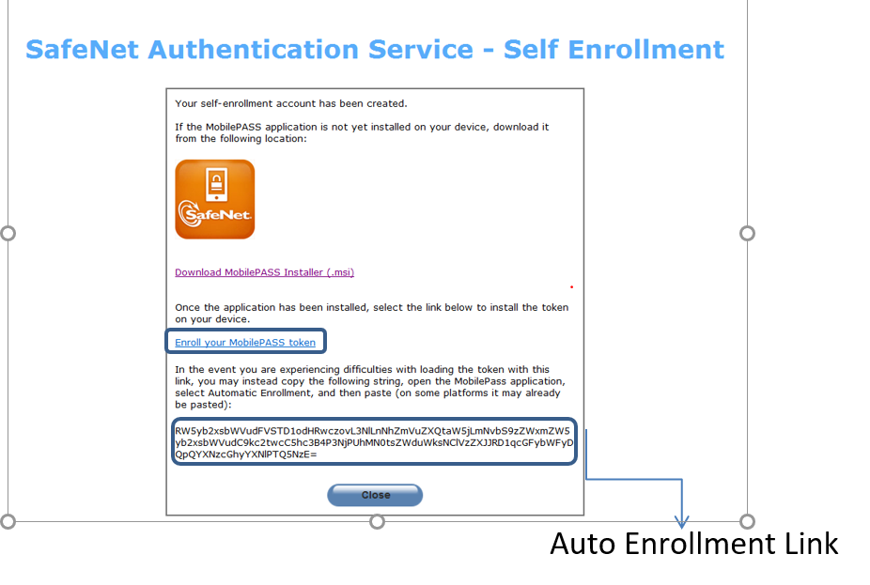

* **Click On Allow**

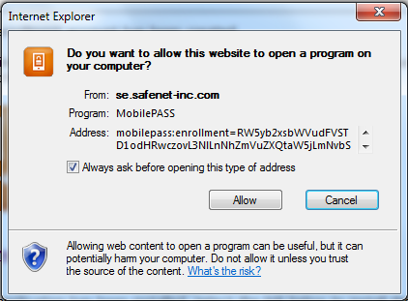

**Step 5.The following screen will prompt to Create a New Token name. Enter the CORP login ID or Display Name** and **click on Activate.**

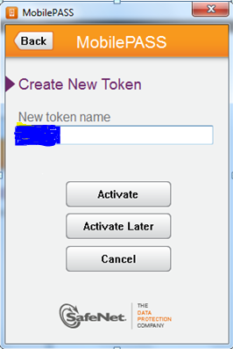

**Step 6. If it gives any error as shown below, when clicking on Auto Enrollment before setting the token Pin as shown in step 7.**

**Click on Auto Enrollment.**

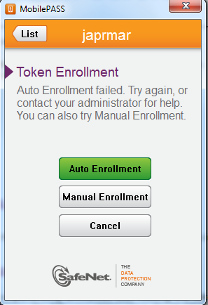

**You need to copy the Auto Enrollment Link from Safenet Authentication service – Self Enrollment page and paste in Enrollment string and click on continue**

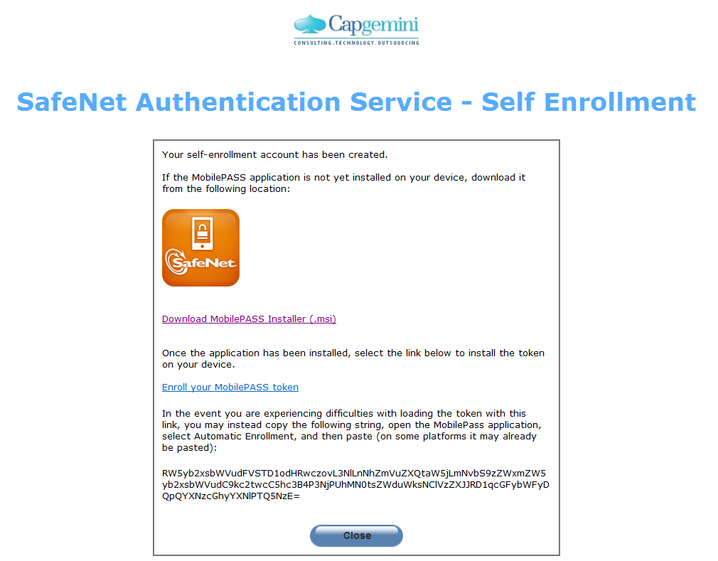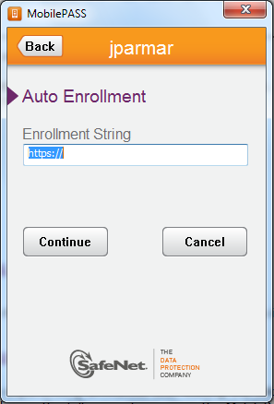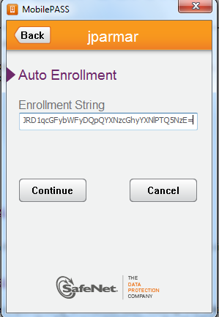

**Step 7.The following step is optional. Keep the Token Policy String blank and click on continue**

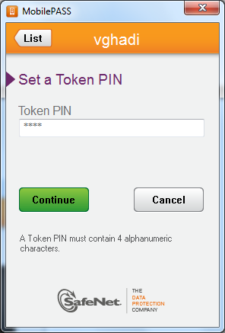 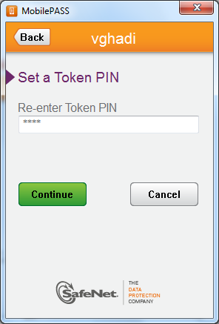 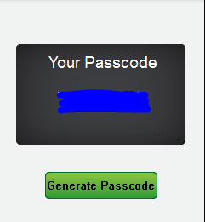

**Step 8: You need to test the token, Select Mobile Pass from the Drop down and generate the Code from Mobile pass application and enter in Token Password**

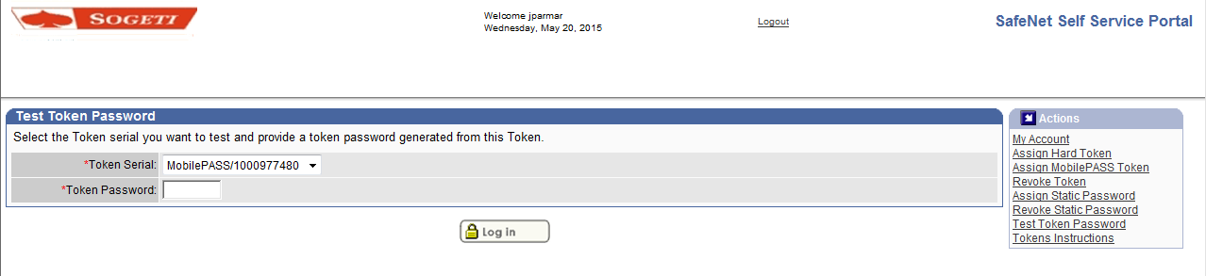

**It will give below message on scussefully test and activation of mobile pass.**

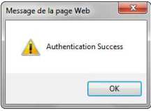

**Same procedure can be followed on any handheld devices (Android or Iphone).**

RW5yb2xsbWVudFVSTD1odHRwczovL3NlLnNhZmVuZXQtaW5jLmNvbS9zZWxmZW5yb2xsbWVudC9kc2twcC5hc3B4P3NjPXpLamVOMGJ5RmQNClVzZXJJRD1ua2lyYW4NClBhc3NwaHJhc2U9MjE1Mg==