PROJECT SYNOPSIS

“Army Recruitment Zone”

SYNOPSIS SUBMITTED FOR THE PARTIAL FULFILMENT OF THE
REQUIREMENT FOR THE BACHLOR IN COMPUTER APPLICATION

SUBMITTED TO
“YOUR COLLEGE NAME”
LUCKNOW

SUBMITTED BY:
STUDENT NAME

(College Enrolment Number- XXXXXXX )
2021-2024



Under the Guidance of

Er. Brijesh Mishra
Senior Consultant

SOFTPRO INDIA COMPUTER TECHNOLOGIES (P) LTD

INTRODUCTION

Welcome to 'The Army Recruitment Zone,' a dynamic and bilingual web-based application dedicated to providing comprehensive information for individuals aspiring to join the Indian Army. This project addresses the critical need for a centralized platform offering detailed insights into the recruitment process, upcoming rallies, and results. The primary goal is to empower candidates with accurate and timely updates, ensuring they are well-informed about qualification requirements, recruitment procedures, and the Army Recruitment Offices (AROs) in their respective states. The client of this project is Recruiting Zone, Lucknow for Uttar Pradesh and Uttarakhand.
The Army Recruitment Zone serves as a bridge between aspiring candidates and the Indian Army, facilitating efficient communication through a suggestion feature. The bilingual interface, available in both English and Hindi, enhances accessibility for a wider audience. Additionally, the project incorporates an administrative control feature, allowing the recruiting zone to manage and update information seamlessly. By fostering transparency and thwarting the influence of touts, this initiative aims to create a trustworthy environment, safeguarding candidates from forgery.

OBJECTIVE

- The foremost objective of this project is to provide a web-based application for Indian Army’s Recruitment Zone to display various recruitment processes related information.
- One of the objectives of this project is to give information related to recruitment Rallies.
- The next objective of this project is to give information related to recruitment result. The results will be published online on the portal.
- The next objective of this application is to provide information related to various ARO (Army Recruitment Office) in the state of UP & UK.
- Website interface is required in order to provide the candidate information, he/she needs to know for recruitment in Indian Army.
- Also, this portal provides various information related to recruitment like qualification required for a particular category, recruitment process and under which ARO Candidate’s district comes.
- The web application provide feature to send various suggestion to recruiting zone from the candidates so the communication and recruiting process can be done in efficient manner.
- An administrative control will be provided to recruiting zone so that they manage various information to be displayed on the web portal.
- Also, this web application will help candidates to be aware of touts.
- As this web application is bilingual so those who are not good in English, can view Hindi version.

BUSINESS NEEDS

This project is to provide various recruitment related information for those who are looking their careers in Indian Army. And also, this web application helps people to know about their recruitment result and next recruitment rally details (i.e. Venue, Location and ARO conducting the recruitment).

This project deals with developing Web based application which provides updated information, recruitment result and new rally programs conducted by recruiting zone, Lucknow for Uttar Pradesh and Uttarakhand. The system is implemented using a 3-tier approach, with a backend database, a middle tier of Microsoft Internet Information Services (IIS), Java with JSP and a web browser as the front-end client.

EXISTING SYSTEM DESCRIPTION

The existing system has following drawbacks:
- In current system, maximum information is provided by news papers. So, if some who does not have the access to news paper will not be able to know about result or rally details.
- Also, the current website of recruiting zone is static one so there is no advance feature for daily basis updates on the web.
- No feature to provide news and get suggestions or query and feedbacks from the candidates.

PROPOSED SYSTEM
- The proposed system will offer dynamic and advance features to update various News and information on daily basis.
- Candidate will get the information about rallies and result from anywhere in India or abroad.
- Also, it helps candidates to be aware of touts.
- Provides feature to send query or suggestions from candidate to the recruiting zone.
- Provides information related to recruiting process and ARO’s state.
- Provides information related to various post and qualification required.
- Provides various sample papers.

SOFTWARE REQUIREMENT FOR DEVELOPMENT
User Interface Designing | HTML5, CSS3, Java Script, Bootstrap
Programming Language | Python with Django Framework
Database | SQLite3
IDE | VS Code

MODULES

- Administration
- Manage results
- Manage rally details
- Suggestions and queries
- Content Update

MODULES DESCRIPTION

Administration:

- Add result
- Add news and update
- View Suggestion
- Reply Suggestion
Manage results:

- Add Result
- Update Result
- Delete Result

Manage Rally Details:

- Add rally
- View Rally and Update
- Delete Rally

Suggestions and queries:

- View Queries and Suggestion
- Reply to Queries and Suggestion

Content Update:

- Administrator can Update the detail displayed on the web application.
- Administrator can delete the detail displayed on the web application.

Table Name: Admin

S No | Fields Name | Size | Null/Not Null | Data type | Description
1. | User_NM | 10 | Not null | Varchar | Primary key
2. | Passwd | 20 | Not null | Varchar

Table Name: Result_File

S No | Fields Name | Size | Null/Not Null | Data type | Description
1. | File_id |  | Not null | Int | Primary key, autoincrement
2. | Result_caption | 100 | Not null | Varchar
3. | Result_date |  | Not null | Datetime
4. | File_path | 50 | Null | Varchar

Table Name: Result_Details

S No | Fields Name | Size | Null/Not Null | Data type | Description
1. | File_id |  | Not null | Int
2. | Aro_name | 50 | Not null | Varchar
3. | Aro_category | 50 | Not null | Varchar
4. | Aro_rollnumber | 50 | Not null | Varchar

Table Name: Rally_Details

S No | Fields Name | Size | Null/Not Null | Data type | Description
1. | Rally_id |  | Not null | Int | Primary key, auto increment
2. | Rally_Caption | 100 | Not null | Varchar
3. | Rally_DT |  | Not nul | DateTime
5. | Rally_Aro | 50 | Not null | Varchar
6. | Rally_PDF_Path | 50 | Not null | Varchar

Table Name: News

S No | Fields Name | Size | Null/Not Null | Data type | Description
1. | NW_id |  | Not null | Int | Primary key, auto increment
2. | NW_Caption | 100 | Not null | Varchar
3. | NW_DT |  | Not nul | DateTime

Table Name: Suggestion

S No | Fields Name | Size | Null/Not Null | Data type | Description
1. | Query_id |  | Not null | Int | Primary key, auto increment
2. | F_NM | 50 | Not null | Varchar
3. | L_NM | 50 | Null | Varchar
4. | Address | 100 | Null | Varchar
5. | Telephone | 20 | Null | Varchar
6. | Email | 50 | Null | Varchar
7. | Q_txt | 100 | Null | Varchar
8. | Q_type | 1 | Not null | char
HIGH LEVEL DESIGN

Data Flow Diagram

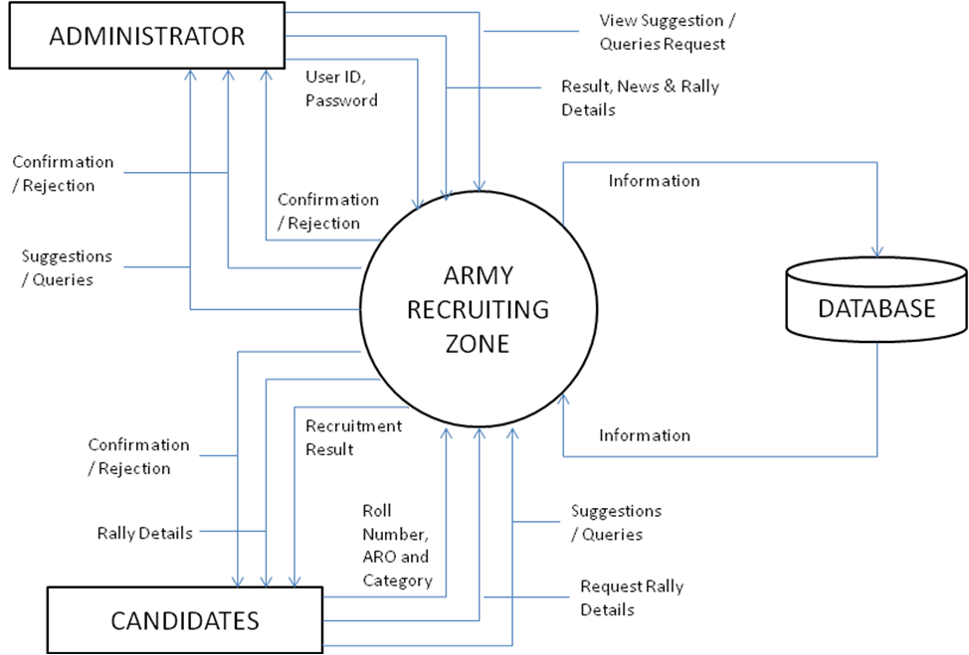

Data Flow Diagram

Entity Relationship Diagram

HAS
ADMIN
NEWS
RALLY_DETAILS
RESULT_FILE
RESULT_DETAILS
SUGGESTION
ARO
HAS
MANAGE
VIEW

FUTURE SCOPE OF PROJECT
The future scope of 'The Army Recruitment Zone' project is promising and multifaceted. Firstly, there is the potential for geographical expansion, allowing the platform to extend its reach and services to cover a broader spectrum of states and regions, thereby making critical information accessible to a wider audience across the nation. Additionally, embracing advanced technologies like artificial intelligence, machine learning or data analytics holds the promise of optimizing the recruitment process. These innovations could facilitate more precise matching of candidates with suitable roles based on their skills, qualifications and the evolving needs of the Indian Army.
Furthermore, the development of a dedicated mobile application could significantly enhance user accessibility, providing a user-friendly interface for candidates to access information seamlessly on their smartphones. This evolution aligns with the contemporary trend of increased mobile usage and would further streamline communication between aspiring candidates and the Army Recruiting Zone.
As technology advances and user needs evolve, the project can continue to adapt and innovate, ensuring it remains a relevant and indispensable tool for individuals aspiring to join the Indian Army.

