REPORT

KRITIKA PRAKASH

20161039

Problem 2:

Upon convolving cameraman.tif with the original matrix filter:

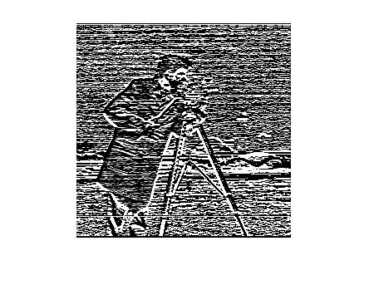

Upon convolving cameraman.tif with the transpose of the filter matrix:

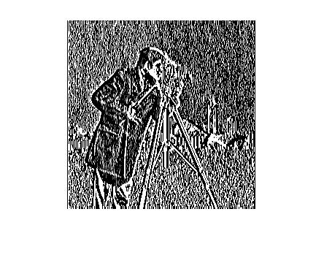

This shows us that upon convolution, the image blends and blurs more in a certain direction (x or y) depending on the filter matrix. It is a unidirectional filter.