Attendance management screen shots

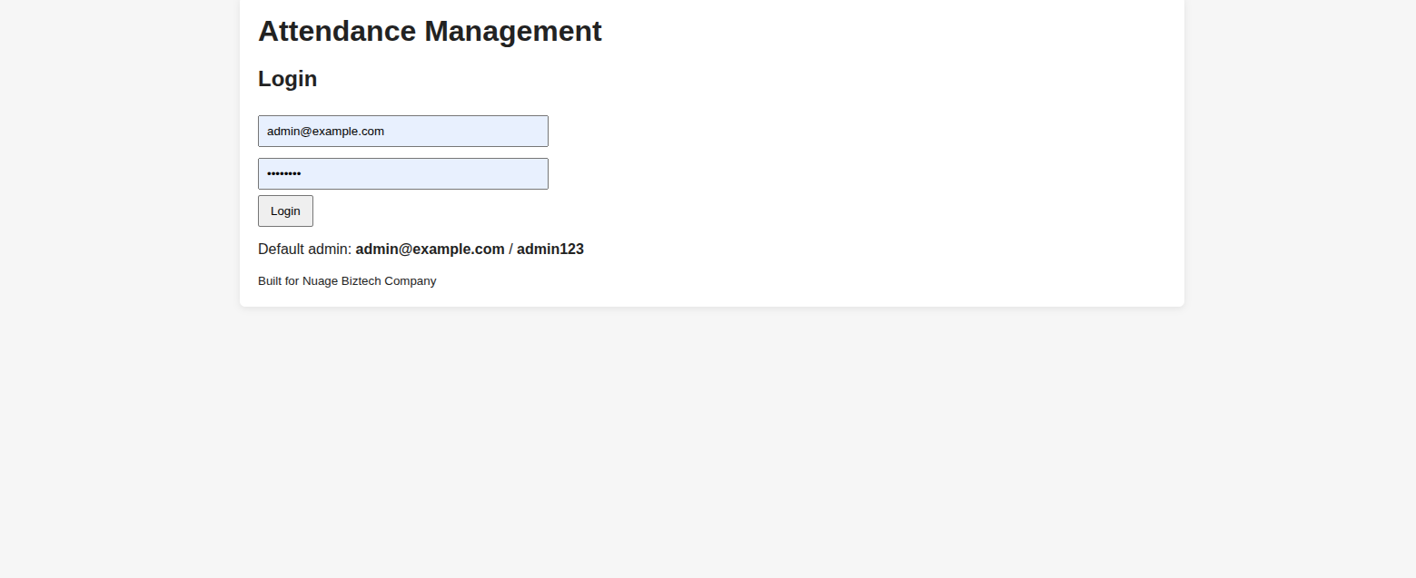
screen short 1 for login as admin user

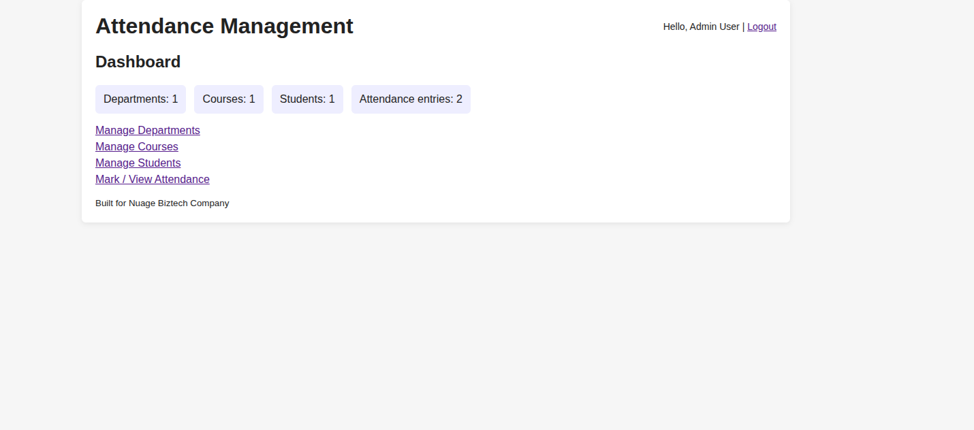
screenshot 2 to show dashboard area for management

