

**TRIBHUVAN UNIVERSITY**

**INSTITUTE OF SCIENCE AND TECHNOLOGY**

An INTERNSHIP REPORT ON

sIMPLE bILLING sOFTWARE

aT aXIS sOFTWARE

SUBMITTED TO

**DEPARTMENT OF STATISTICS AND COMPUTER SCIENCE**

**PATAN MULTIPLE CAMPUS**

**Patan Dhoka, Lalitpur**

***In partial fulfillment of the requirements for the Bachelor’s degree in Computer Science and Information Technology (B.Sc. CSIT)***

**Submitted by:**

**KRITI MANDAL 20047 [5-22-1330-2018]**

Under the Supervision of

**BIKASH BALAMI**

**ASHOJ, 2023**

# ABSTRACT

This report presents the work completed during a full stack development internship at Axis Software. The internship involved developing gahana billing software and user interface, as well as working with PHP frameworks such as CodeIgniter following the Model-View-Controller (MVC) pattern. The report covers the key learning outcomes of the internship, including the development of technical skills in PHP, JavaScript and CodeIgniter. The report also discusses the challenges faced during the internship and the solutions implemented to overcome them. The key achievements of the internship include the successful completion of Gahana Billing software projects and the development of custom website for specific client requirements. Overall, the internship provided a valuable opportunity to gain hands-on experience in backend development and to work collaboratively with a team of experienced developers at Axis Software.

*Keywords: MVC, MySQL, CodeIgniter, CSS, PHP, JavaScript*

# ACKNOWLEDGEMENT

I would like to express my deepest appreciation to all those who provided me the possibility to complete this report. A special gratitude I would like to give to, **Mr. Bikash Balami**, whose contribution in stimulating suggestions and encouragement, helped me to coordinate this internship. First and foremost, I would like to express my sincere gratitude to **Mrs. Salu Gupta** the CEO, who hired me in the company where I completed my internship. I express my gratitude to **Mr. Pratik Ghimire**, Senior Developer who has been a continuous source of inspiration as my intern mentor. My gratitude for his trust and generosity goes beyond words. I would like to thank Axis Software for providing this opportunity to undertake an internship which was a great opportunity for learning and developing professionalism.

I would like to express our special thanks of gratitude to our Campus Chief **Dr.Laxman Singh Kunwar** who gave me permission for this Internship. I would like to express my special gratitude and thanks to our BSC. CSIT Program Coordinator **Mr. Dadhi Ghimire** for his support and help for our personnel development and mainly for the completion of this Internship. I am highly indebted to Patan Multiple Campus for their guidance and constant supervision as well as for providing necessary information regarding the Internship and support in the completion.

In the end, I would also like to thank Tribhuvan University for giving us this opportunity via the course of CSIT to help us understand the work ethics at this early stage and helped us to evaluate my knowledge and expand it a little more.

Yours sincerely, Kriti Mandal

# TABLE OF CONTENTS

Contents

ABSTRACT 1

ACKNOWLEDGEMENT 2

TABLE OF CONTENTS 3

LIST OF ABBREVIATIONS 4

LIST OF FIGURES 5

LIST OF TABLES 6

CHAPTER 1 INTRODUCTION 1

1.1 Introduction 1

1.2 Problem Statement 2

1.3 Objectives 2

1.4 Scope and Limitation 2

CHAPTER 2 INTRODUCTION TO ORGANIZATION 4

2.1 Organization Details 4

2.2 Organizational Hierarchy 5

2.3 Working Domains of Organization 7

Content Writing 8

2.4 Period Of Internship 8

CHAPTER 3 INTERNSHIP ACTIVITIES 9

3.1. Roles and Responsibilities 9

3.2. Weekly Log 9

3.3. Description of the Project(s) Involved During 11

3.4. Tasks / Activities Performed 12

CHAPTER 5 20

5.1. Conclusion 20

5.2. Learning Outcomes 20

REFERENCES 22

# LIST OF ABBREVIATIONS

|  |  |
| --- | --- |
| API | Application Programming Interface |
| CRUD | Create, Read, Update and Delete |
| CSS | Cascading Style Sheet |
| JS | JavaScript |
| FSE | Full Site Editing |
| IT | Information Technology |
| MVC | Model View Controller |
| MySQL | Microsoft Server Structured Query Language |
| OOP | Object Oriented Programming |
| PHP | Hypertext Preprocessor |
| Rest | Representational State Transfer |

# LIST OF FIGURES

**Figure 1: Organization Hierarchy for Axis Software** 6

**Figure 2:Login page developed using project setup** 12

**Figure 3: Signup page developed during project setup** 13

**Figure 4: User listing page developed during project** 13

**Figure 5: Instagram Feed Section** 14

**Figure 6: Meter Reading Section** 15

**Figure 7: Day Book Record** 16

**Figure 8: Invoice Slip** 17

**Figure 9: Order Slip** 18

**Figure 10: Dashboard** 18

**Figure 11: In Progress Order List** 19

**Figure 12: Make Bill Section** 19

# LIST OF TABLES

**Table 1: Organization Details** 5

**Table 2 : Internship Duration** 8

**Table 3 : Weekly Log** 9

# CHAPTER 1 INTRODUCTION

## Introduction

An internship is a professional learning experience that offers meaningful, practical work related to a student’s field of study or career interest. An internship gives a student the opportunity for career exploration and development, and to learn new skills. It offers the employer the opportunity to bring new ideas and energy into the workplace, develop talent and potentially build a pipeline for future full-time employees. (Smith, 2020)

During my internship at Axis Software in Tinkune, Nepal, I worked as a Full Stack Intern for a duration of 3 months from Jestha 29, 2080, to Bhadra 30, 2080. I had applied for this internship through Merojob job portanl and successfully passed the interview and written exam. Although this was an unpaid internship, I was thrilled to gain valuable experience in the field of PHP full stack development.

My main responsibilities during the internship included building a basic website design and learning advanced PHP frameworks such as CodeIgniter. Additionally, I was trained in developing Gahana Billing software development. This allowed me to gain hands-on experience in building robust software application. Working at Axis Software was an enriching experience for me as I had the opportunity to work with experienced professionals who were always willing to guide me and share their knowledge. I was also able to collaborate with other interns and share my learning experience with them. One of my major achievements during the internship was building a basic ecommerce website using codeigniter framework that incorporated features such as routing, database connectivity, and template rendering. This helped me to gain a better understanding of how to build a scalable website from scratch.

Furthermore, learning advanced PHP frameworks such as CodeIgniter was a valuable experience as it allowed me to build complex web applications with ease. I was able to use the MVC pattern to separate concerns and create reusable components that made development faster and more efficient. During the second half of my internship, I focused on Gahana billing software development. I learned how to create a user friendly interface using JavaScript, and how to style them using CSS. Additionally, I learned how to create an order taking page, invoice and process the order for billing, which provided me with an in-depth understanding of how billing software works under the hood.

## Problem Statement

A Full Stack PHP Developer plays a pivotal role in ensuring the seamless functionality and performance of websites and web applications. They are responsible for both the front-end and back-end development, enabling them to create dynamic, interactive, and secure digital experiences. Their expertise extends from designing user interfaces to handling complex data manipulation, integrating various APIs and databases, and implementing server-side logic.

Without a skilled Full Stack PHP Developer, websites and applications may encounter usability issues, security vulnerabilities, and operational inefficiencies. As an intern in this role, I have had the opportunity to collaborate with experienced developers and acquire the essential skills needed to become a proficient Full Stack PHP Developer.

The problem I aimed to solve during the internship was to develop efficient and scalable web applications and billing software that meet the clients' requirements and expectations. Additionally, I aimed to gain hands-on experience in various backend technologies and programming languages.

## Objectives

* To develop a website for client using CodeIgniter framework and CSS, HTML, JS.
* To develop billing software for the client using CodeIgniter framework.

## Scope and Limitation

#### Scope

* + - * Learning and gaining practical experience in PHP programming.
      * Building a website from scratch.
      * Learning and working with CodeIgniter and Software development.
      * Developing a Gahana order taking and billing Software.
      * Developing User Interference and Bill printing using CSS, HTML and JS.
      * Writing query for fetching data from an Ajax and Mysql.

#### Limitations

* + - * As an unpaid intern, I faced limitations in terms of resources and support available to me.
      * The duration of the internship was limited, which did not allow me to fully explore and dive deep into certain topics.
      * The scope of the internship was focused on PHP full stack development and did not include other areas of web development such as Rest API.
      * I also faced challenges in working on real-world projects with deadlines and requirements, as opposed to academic projects.
      * I also faced challenges to satisfy the need of the client.

# CHAPTER 2 INTRODUCTION TO ORGANIZATION

## Organization Details

Axis Software is a modern and creative software company based in Gairigau, tinkune, Kathmandu, Nepal. It is a sister company of Axis Solutions Pvt. Ltd. The company was established in 2016 and has since been providing top-notch web development solutions to its clients. Axis Software works on client projects based on demand, offering a range of services that include Concept & Design, Web Strategy, Marketing, Analyze/SEO, Content Writing and SEO Optimization. (Axis Software)

The organization specializes in Software products and website development catering to both B2B and B2C customers. The company's team of experts excels in e-commerce development, providing solutions that are tailored to the client's needs. The company has a reputation for delivering high-quality work within the promised deadline. The company has a team of concept and design experts who work on creating unique and visually appealing designs for websites and digital platforms. Additionally, they have a web strategy team that provides customized solutions to clients based on their business goals and objectives. The marketing team is responsible for creating and executing effective digital marketing campaigns and collect leads by marketing software products. On other hand content writing team creates informative and engaging content for client’s website while the analyze/SEO team helps clients improve their online visibility and ranking through search engine optimization.

Axis Software has a strong focus on creativity and innovation, providing clients with modern and cutting-edge solutions that are in line with the latest trends in web development. The agency has a team of highly skilled and experienced professionals who are passionate about their work and constantly strive to deliver the best solutions to their clients. (Axis Software)

Axis Software is a leading web agency in Nepal that provides a range of software solutions to clients across various domains. With a focus on creativity, innovation, and client-centric approach, the agency has carved a niche for itself in the industry. The company's expertise in software development and e-commerce website solutions has made it a preferred choice for clients looking for modern and creative web solutions. The company's Intern Department/Unit provides an excellent opportunity for young professionals to gain practical experience.

**Table 1: Organization Details**

|  |  |
| --- | --- |
| **Name** | Axis Sofware |
| **Type** | Private Limited |
| **Address** | Gairi Gau, Kathmandu, Nepal |
| **Contact No** | 9841-296-586 |
| **Website** | https://www.axisoftech.com/ |
| **Email** | [axissoftwarenepal@gmail.com](mailto:axissoftwarenepal@gmail.com) |

## Organizational Hierarchy

In nearly every organization, there exists a hierarchy that defines work roles and authority. An organization's hierarchy can influence communication, productivity, and project success.

Axis Software has more than 15 employees working on different departments of the company. The organizational hierarchy of Axis Software is as follows:

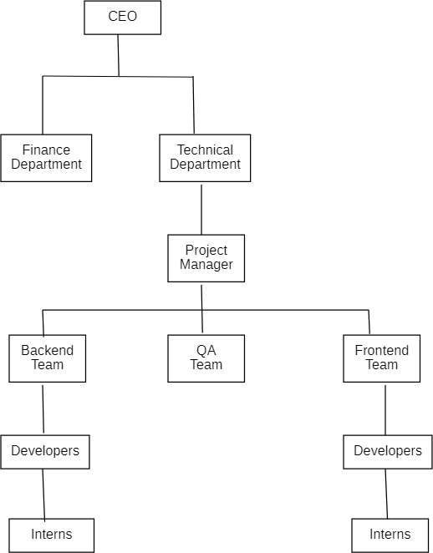

**Figure 1: Organization Hierarchy for Axis Software**

CEO is the top executive in the company, responsible for managing the overall operations of the company. They are responsible for implementing the plans and policies of the company.

Finance Department is responsible for managing the company's finances, including budgeting, financial reporting, and accounting. This department is headed by a Chief Financial Officer (CFO).

Technical Department is responsible for the development and maintenance of the software and technical infrastructure. This department is headed by a Chief Technology Officer (CTO). Project Manager is responsible for overseeing the development of specific software projects and ensuring that they are completed on time, within budget, and to the required quality standards.

Backend and Frontend Teams are responsible for the development of the software, with the backend team responsible for the server-side development and the frontend team responsible for the client-side development. Each team is led by a Senior Developer.

Quality Assurance (QA) Teams is responsible for testing the software to ensure that it meets the required quality standards.

Interns are hired on a temporary basis to gain experience in the company's software development process. They are assigned to work under the supervision of a senior developer or project manager.

## Working Domains of Organization

Axis Software is a company that provides web development and software development services for clients on demand. The company is also known for its expertise in marketing, content writing, analysis/SEO, and SEO optimization.

#### Software Development

Software development is a core part of Axis Software's business, as the company works on demand client projects. Their e-commerc expertise is particularly valuable for businesses looking to launch or improve their online stores. They provide solutions for setting up payment gateways, managing inventory, and fulfilling orders, among other things. (Axis Software)

#### Web Development

In addition to software development, Axis Software is also known for its expertise in Software development. The web development team is skilled in using the latest web technologies and programming languages. The team is capable of delivering high-quality web solutions that are responsive, scalable, and visually appealing. The company also follows best practices in web development, ensuring that the solutions they deliver are secure and optimized for search engines. They are focused on delivering high-quality solutions that are tailored to the needs of their clients. (Axis Software)

#### Digital Marketing

The company's marketing services include strategies for increasing traffic to websites and improving conversion rates. They provide in-depth analysis of websites and their content, identifying areas for improvement to achieve better search engine rankings. Their SEO optimization services help clients to optimize their websites and content for search engines, improving their visibility online. (Axis Software)

### Content Writing

Our company specializes in website content writing. We create engaging and SEO-optimized content to help businesses connect with their audience and boost online visibility. Whether you need engaging blog posts, informative articles, persuasive product descriptions, or any other type of web content, we're dedicated to delivering high-quality, tailor-made solutions that meet your specific needs.

## Period Of Internship

Axis Software has several intern departments catering to different areas of web development.

There are 2 interns in this department currently, with one junior developer, one mid-level developer and one senior developer. The mentor for this department is Yujesh Shrestha. He currently working as senior developer at Axis Software. The interns are responsible for writing code based on assigned tasks, submitting daily and weekly log reports, and reporting to their mentor every week. They are expected to work closely with the more experienced team members, collaborate on team projects, and participate in weekly meetings and planning sessions. Their primary responsibility is to learn and gain hands-on experience in software development.

**Table 2 : Internship Duration**

|  |  |
| --- | --- |
| **Start date** | 1 July, 2023 |
| **End date** | 30 Sep, 2023 |
| **Working hours** | 8 hours |
| **Office time** | 10:00 AM to 6:00 PM |
| **Total duration** | Three months |
| **Intern Position** | Backend Developer |
| **Mentor** | Pratik Ghimeree |
| **Contact** | 9840060654 |

# CHAPTER 3 INTERNSHIP ACTIVITIES

## 3.1. Roles and Responsibilities

#### Roles: Fullstack Developer Intern

During the internship, responsibilities as a fullstack developer intern are included as following:

* Writing HTML, CSS, and JavaScript to create responsive and user-friendly user interfaces.
* Building server-side logic and handling requests and responses.
* Writing PHP code to manage databases, user authentication, and application logic.
* Interacting with client to understand their requirement and designing website according to their request
* Identifying and fixing bugs and performance issues.
* Using version control systems like Git to track changes in code and collaborating with other developers using github.
* Ensuring the security of the application by implementing authentication and authorization mechanisms.
* Participating in code reviews and team meetings to discuss project progress and identify areas for improvement.
* Conducting research and testing new technologies to enhance the performance and functionality of web applications.

## 3.2. Weekly Log

Throughout the internship, I maintained a weekly log to keep track of my technical activities. The log included the following details:

**Table 3 : Weekly Log**

|  |  |
| --- | --- |
| **Time Duration** | **Task Performed** |
| Week 1 | * Started to work with HTML and CSS. * Bootstrap 5 and JS * Started to work with PHP arrays and recursive functions. * Worked on OOP PHP, MySQL and CRUD operations. |
| Week 2 | * Dynamic routing using MVC Pattern. * CodeIgniter Basics and its documentation. * Getting Familiar with Trello |
| Week 3 | * CodeIgniter methods, CRUD operations and filters. * Instagram access key generation and Integration with Website * Worked on eCommerce website * Git and GitHub and collaboration with team. |

|  |  |
| --- | --- |
| Week 4 | * Worked on Meter reading feature on APF fuel simple billing software * Worked on Gahana order taking feature (frontend and backend) |
| Week 5 | * Started readymade product and category add and edit development in Software. * Developed user management and catalog management feature. |
| Week 6 | * Development ledger management. * Development outsource and purchase management. |
| Week 7 | * Worked on Ajax and APIs. * Fetch JSON data and convert it into Software custom post type. |
| Week 8 | * Started implementing the backend of billing process, display day record, karigar management |
| Week 9 | * Designed order slip, invoice, purchase invoice and other reciepts as required. * Designed receipts for POS printers. |
| Week 10 | * Designed user interface, leftbar, header and footer of the software. |
| Week 11 | * Implemented woo commerce. * Developed a basic user manual. |
| Week 12 | * Final software testing and bug fixing. * Gahana billing software delivered to client. |

## 3.3. Description of the Project(s) Involved During

During the internship, I worked on several projects, including:

**Medicine Nepal**

Medicine Nepal is a cutting-edge e-commerce platform dedicated to providing a seamless and convenient way for individuals and healthcare professionals in Nepal to access essential medicines and medical supplies. Powered by a robust combination of PHP CodeIgniter, HTML, CSS, and JavaScript, this user-friendly website offers a secure and user-friendly shopping experience. Customers can browse a wide range of pharmaceutical products, medical equipment, and healthcare essentials, all while enjoying a smooth and responsive interface. Medicine Nepal is your trusted online destination for all your healthcare needs, bringing the pharmacy to your fingertips

**Fuel Simple Billing Software**

Fuel Simple Billing Software is a client based project. It is a powerful and efficient billing solution crafted using PHP CodeIgniter, designed to simplify and streamline your billing and invoicing processes. This user-friendly software offers businesses and professionals a hassle-free way to manage their financial transactions. With Fuel Simple, you can effortlessly create, customize, and send invoices to clients, ensuring prompt and accurate payment tracking.

This is a PHP project setup which follows MVC pattern. This project was done during the initial phase of internship where OOP concept of PHP is used to define separate Model, View and Controller are defined. There is a core controller which is responsible for loading views, models, include files and many other functions.

**Gahana Simple Billing Software**

Gahana Simple Billing Software, a client-based project, represents a robust and efficient billing solution meticulously developed using PHP CodeIgniter [1]. This software aims to simplify and optimize the billing and invoicing processes for Gahana Simple businesses, empowering professionals in the industry to manage their financial transactions effortlessly. With its user-friendly interface, Gahana Simple Billing Software provides a seamless and stress-free approach to handling financial operations.

Gahana Simple Billing Software is engineered to streamline the billing and invoicing procedures, making them more efficient and less time-consuming. Users can effortlessly create and tailor invoices to their specifications, reflecting their unique brand identity and maintaining a professional image. Comprehensive Financial Management: This software enables comprehensive financial management by allowing users to track payments, monitor outstanding balances, and gain insights into their financial health.

Following the Model-View-Controller (MVC) pattern, Gahana Simple Billing Software adopts an organized structure where separate models, views, and controllers are defined. This promotes code modularity and maintainability. During its development, Gahana Simple Billing Software leverages Object-Oriented Programming (OOP) concepts in PHP to create a clean and efficient codebase, enhancing code reusability and readability. The software includes a core controller responsible for loading views, models, include files, and various other functions, ensuring a well-structured and organized project. Gahana Simple Billing Software is your trusted partner in Gahana Simple business management, alleviating the complexities of financial transactions while adhering to best practices in software architecture and development. Experience a new level of efficiency and professionalism in the Gahana Simple industry with Gahana Simple Billing Software.

## 3.4. Tasks / Activities Performed

During internship period in the Axis Software, I have been part of several projects and hence have completed various tasks. Some of the major task relating to the internship are listed below:

#### 3.4.1. PHP Core and MVC Pattern

During this task, I started with PHP arrays and recursive functions and moved on to work with OOP PHP, MySQL and CRUD operations. I also explored dynamic routing using the MVC Pattern. Then using dynamic routing and MVC pattern, I developed a PHP project setup with core functionalities such as auto routing, core controller, helpers, models and views along with htaccess.

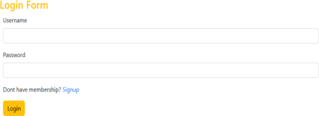

**Figure 2:Login page developed using project setup**

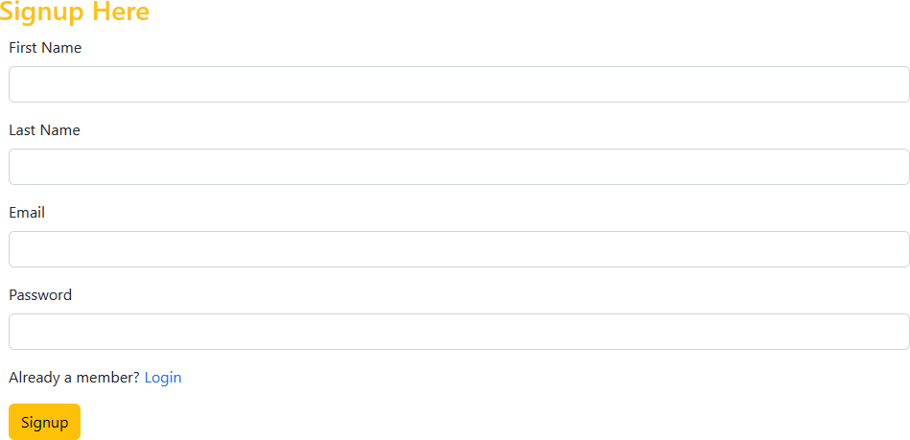

**Figure 3: Signup page developed during project setup**

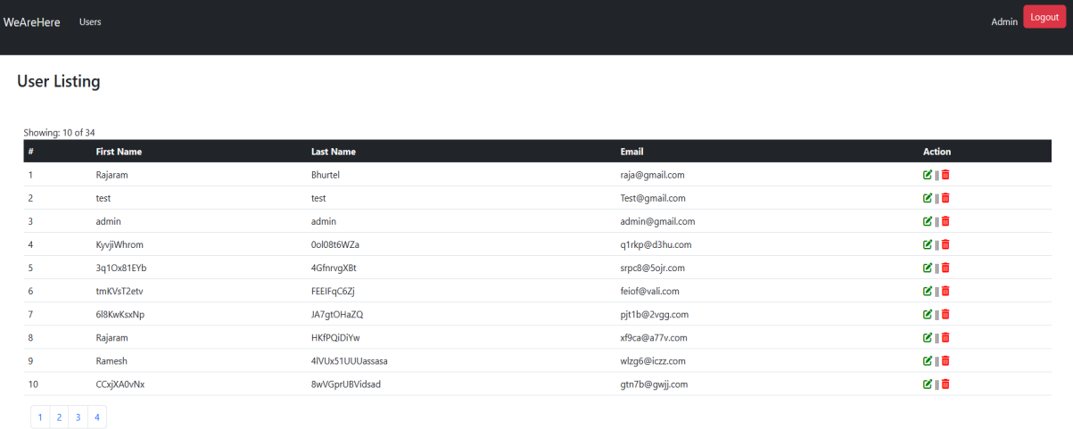

**Figure 4: User listing page developed during project**

**3.4.2. Setup CodeIgniter setup**

I got hands-on experience with CodeIgniter methods, CRUD operations and filters. Developed basic functionalities such as Login and Registration. Similarly, I prepared a presentation on CodeIgniter and delivered it in front of team members.

#### 3.4.3. Git & GitHub

I learned about Git and GitHub for collaboration with my team along with version controlling techniques.

**3.4.4. Medicine Nepal**

This is a website development project which was done using codeigniter framework. This project was done during the initial phase of internship where I generated an Instagram access token. I successfully implemented Instagram integration into a website, enhancing its visual appeal and user engagement. Through this integration, I seamlessly integrated Instagram's API to fetch. Then I display Instagram images, videos and posts directly on the website and designed it with html, CSS, bootstrap and JS. I also designed inner pages and created a form for upload doctor’s prescription.

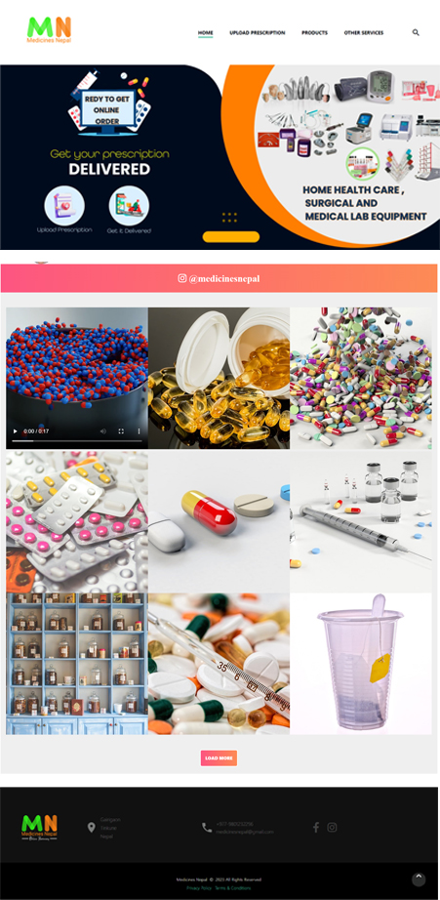

**Figure 5: Instagram Feed Section**

**3.4.4. Fuel Simple Billing Software**

In this project I worked on designing invoice, balance sheet, user interference using CSS, HTML and Bootstrap. I also used JS to add printing function, downloading file function and for sticky header and footer. Additionally, I worked on backend of taking reading of the fuel pump, CRUD operation was performed and the business logic was applied and populated the data on the day book record. Similarly, data table functionality is added along it.

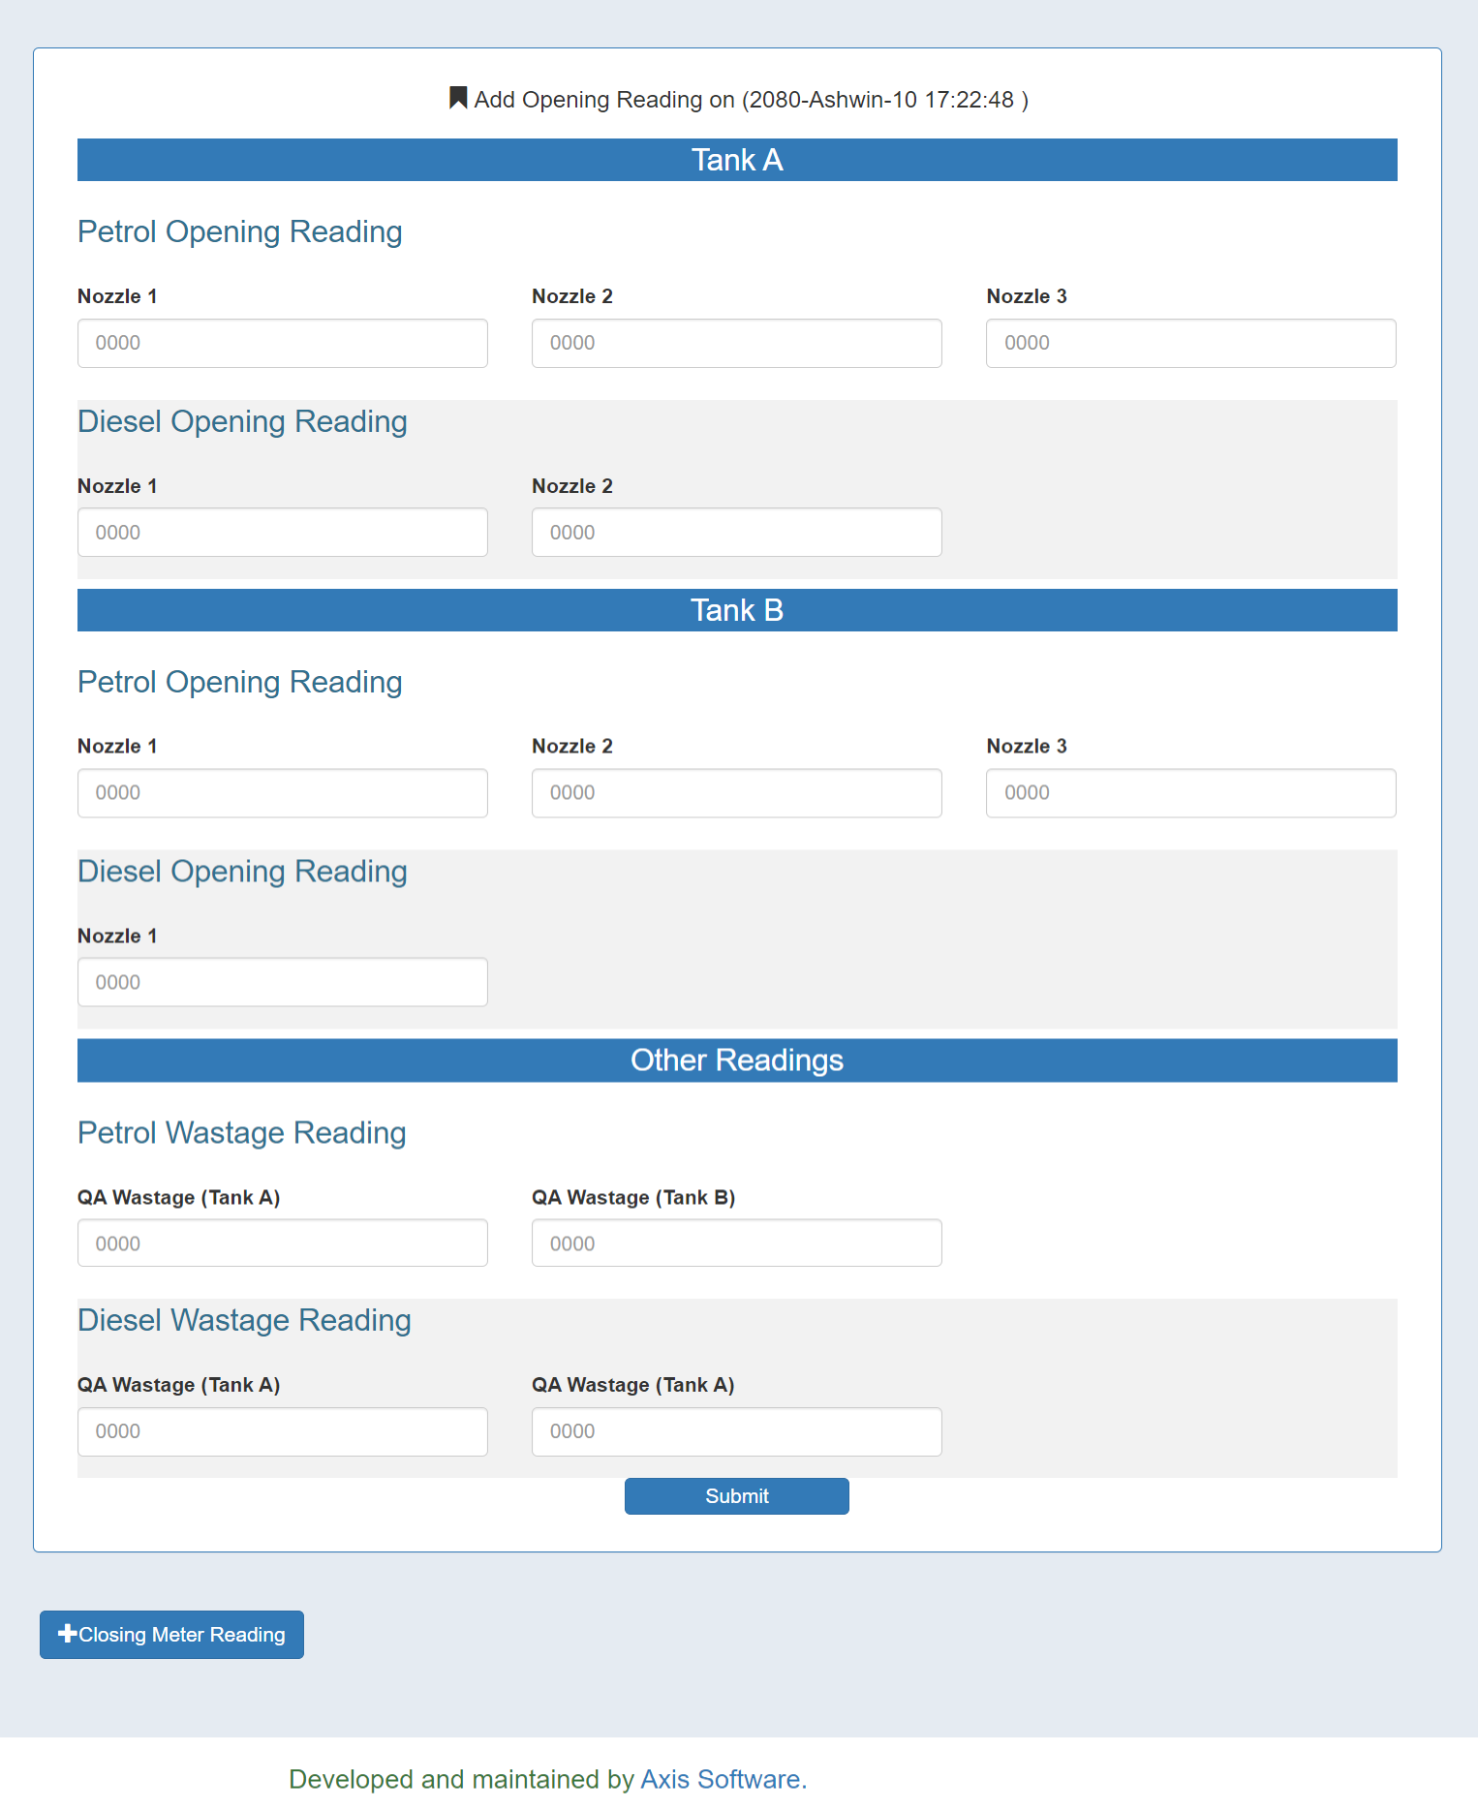

**Figure 6: Meter Reading Section**

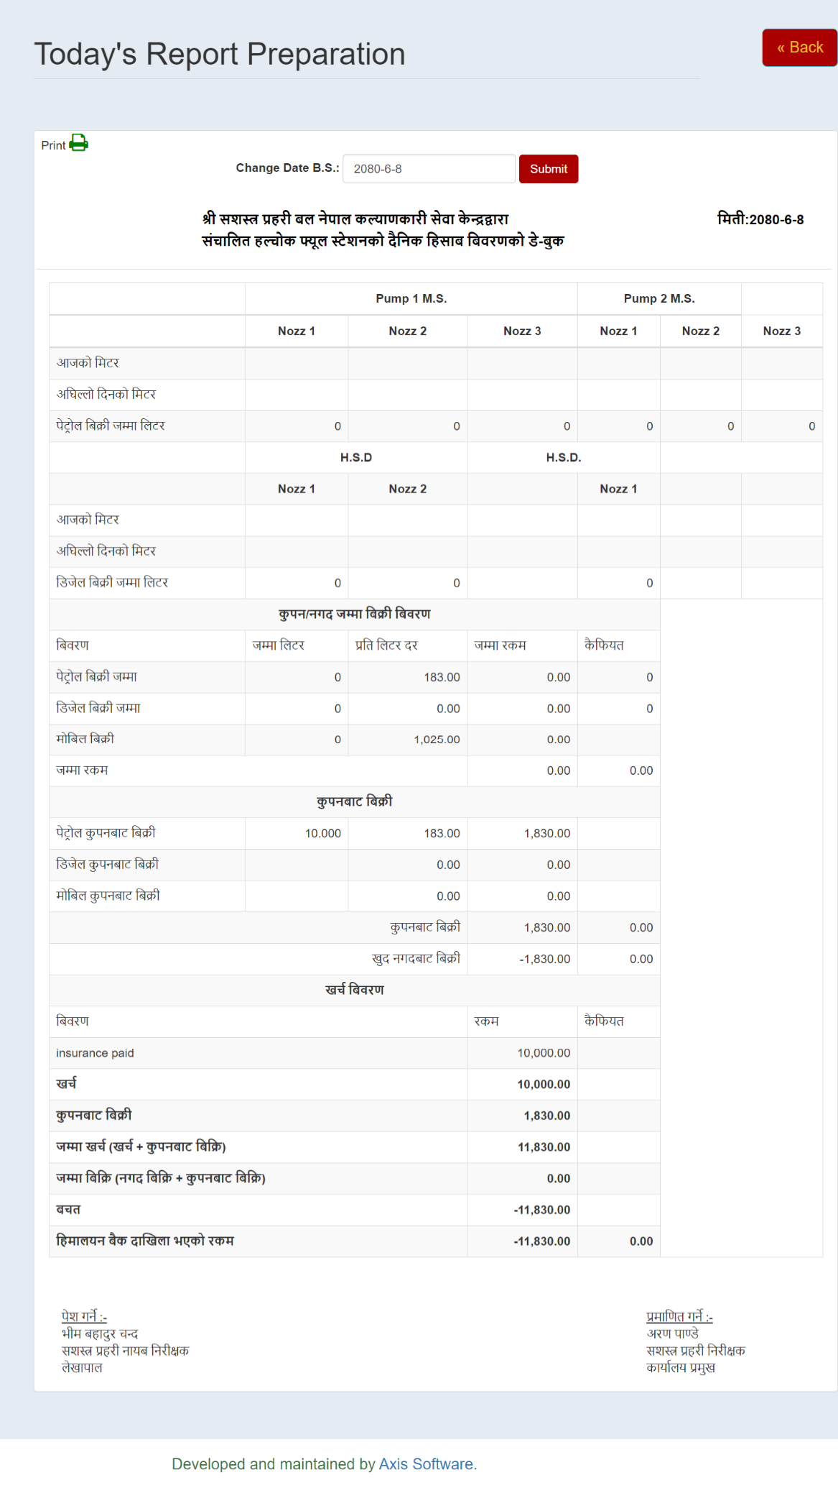

**Figure 7: Day Book Record**

#### 3.4.5 Gahana Simple Billing

During a two-month academic endeavor, I worked on the Gahana Simple Billing project, honing my skills in software development. In this role, I was responsible for creating essential features such as the Gahana order page, gemstone order page, and a versatile mode of payment selection. Leveraging the CodeIgniter framework, I built controllers and views from the ground up, ensuring a tailored user experience. Proficiency in MySQL allowed me to craft queries for data manipulation, maintaining the database's integrity. Effective client interaction was vital as I gathered requirements and implemented features like bill creation, return bill management, and buyback purchase tracking. Additionally, I designed visual elements, including order slips and invoices, using CSS, HTML, and Bootstrap, incorporating JavaScript for printing functionality and print media queries. Lastly, I expanded the software's utility with a readymade product catalog and streamlined billing for these items, making this academic project a comprehensive exploration of software development principles and practices.

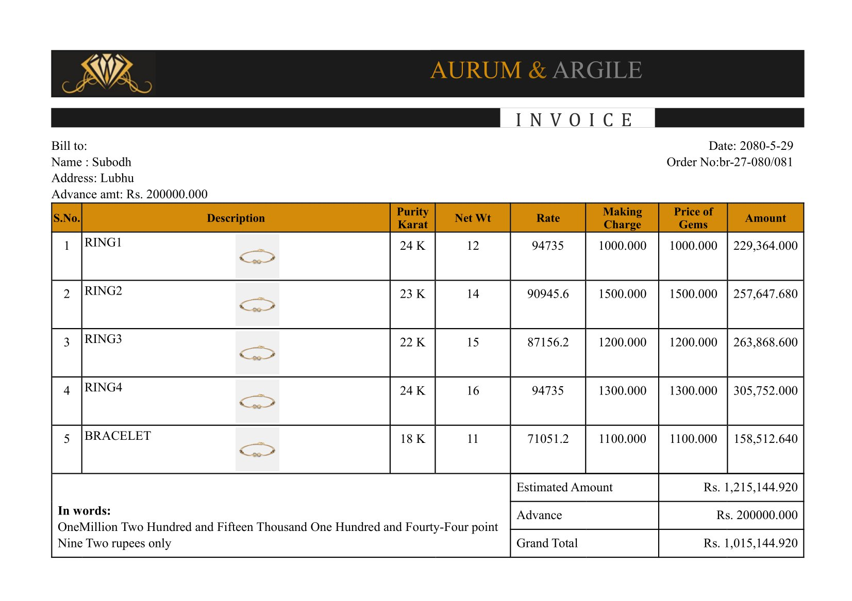

## Figure 8: Invoice Slip

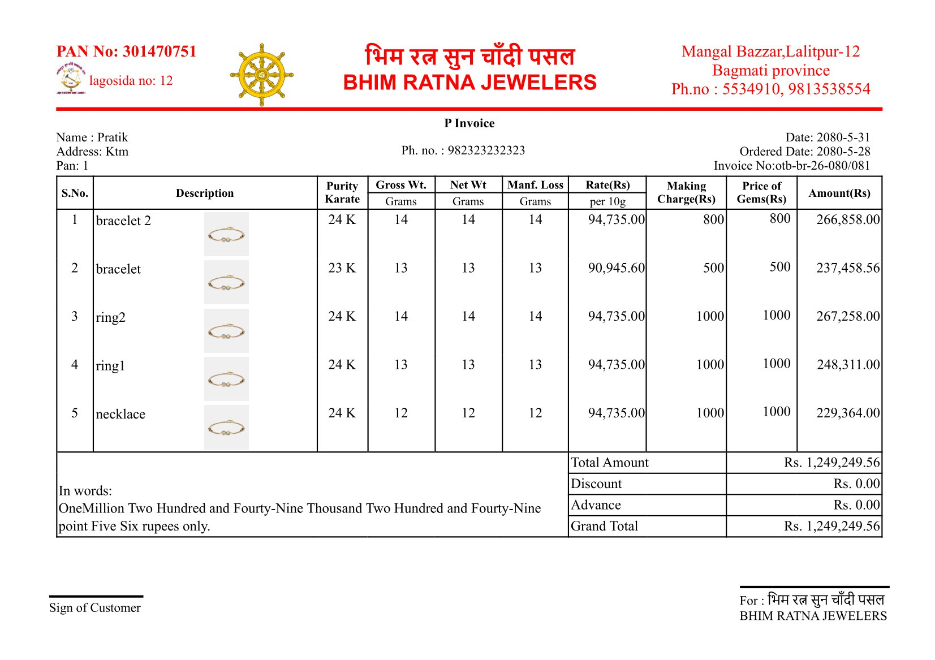

**Figure 9: Order Slip**

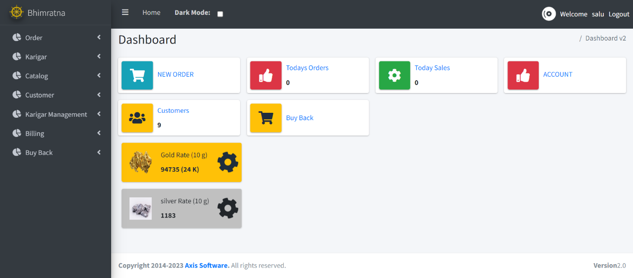

**Figure 10: Dashboard**

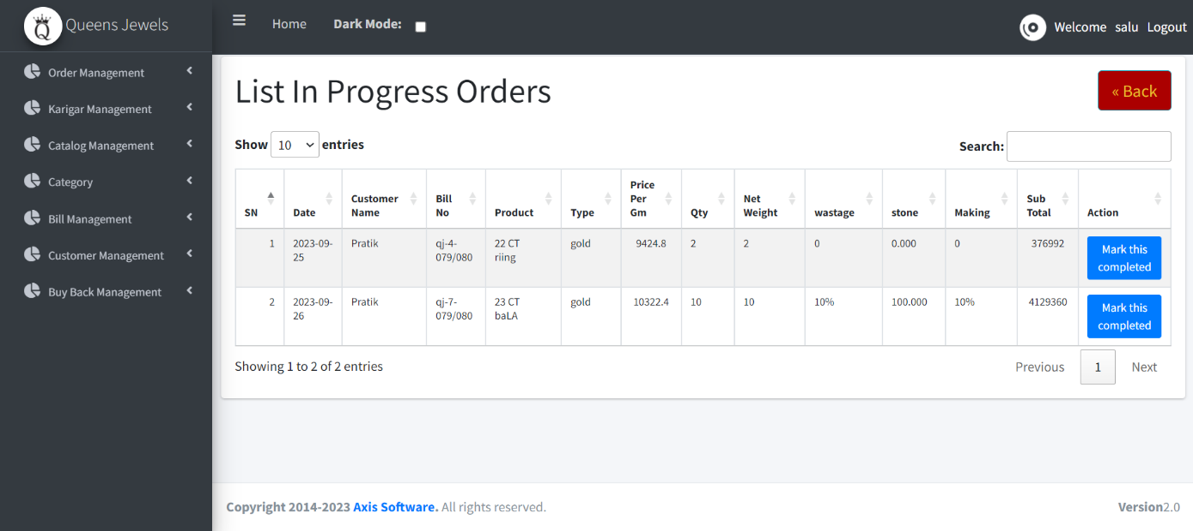

**Figure 11: In Progress Order List**

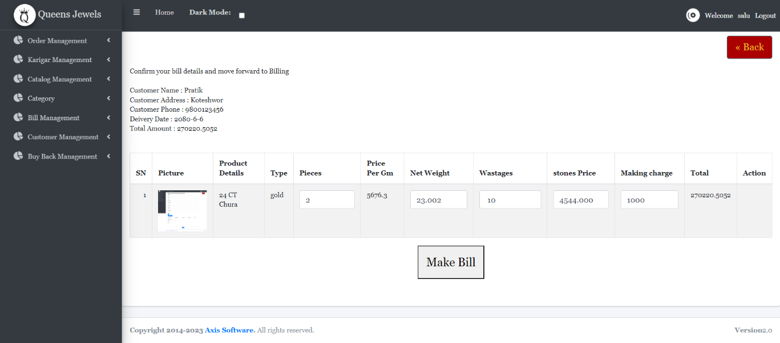

**Figure 12: Make Bill Section**

# CHAPTER 5

**CONCLUSION AND FUTURE RECOMMENDATIONS**

## Conclusion

The internship has been a valuable learning experience for developing a block-based theme using the Software block editor and working with API integration. Through the project, I was able to enhance my skills in PHP, Software, and designing using CSS and JS. Developing the theme allowed me to understand the importance of responsive design and the significance of custom post types in content management. Fetching data from the Meltwater API helped me to learn about the importance of API integration and its impact on website functionality. Overall, the internship has been an enriching experience in terms of hands-on experience, and I am grateful for the opportunity to have worked on such an exciting project.

Furthermore, my exposure to PHP, CodeIgniter, and the MVC pattern has helped me develop a more structured approach to coding, ensuring greater efficiency and scalability in my projects. My experience with GitHub has given me valuable insights into collaborative coding and version control. The involvement in theme development has helped me to develop a more refined understanding of Software theming and how to structure a theme for optimal functionality and ease of use.

## Learning Outcomes

The three months long internship program at Axis Software has provided me the opportunity to experience working in a real-world scenario. During this period, I learned the difference between theoretical knowledge and implementing them in a real-world working environment. During this internship period, I was able to develop interpersonal and professional skills which will surely help me in the forthcoming days. I got the opportunity to be familiar with the course related industry and real-world tactics to deal with any present and future situations.

This program has enhanced my skill and enthusiasm as I got knowledge of the company environments and to learn different aspects of working mechanisms that prevail in the organizations. Most of the subject I learned during BSC. CSIT courses including Data Structure

and Algorithms, Database Management System, Web Technology, Software Project Management and others have been well implemented during this internship program.

Some of the lesson that I have learned during this internship period:

* + - Improved knowledge and skills in Software development, particularly in developing billing software using the CodeIgniter framework.
    - Improved understanding of HTML, CSS, JS and how to use this to design website and Software.
    - Enhanced knowledge and skills in PHP programming, specifically in using PHP arrays, OOP, MySQL, and CRUD operations.
    - Enhanced understanding of MVC pattern.
    - Improved ability to work collaboratively with a team, particularly in using Git and GitHub for version control and collaboration.
    - Improved ability to research and self-learn new concepts and technologies in Software development and programming.
    - Improved communication skills, particularly in presenting and explaining technical concepts and issues to non-technical stakeholders.

Hence, this internship provided me with a valuable opportunity to gain hands-on experience in frontend and backend web development and enhance my technical skills and knowledge.

# REFERENCES

CodeIgniter. (2023, September 11). *Welcome to CodeIgniter3*. Retrieved from CodeIgniter <https://codeigniter.com/userguide3/general/welcome.html>

Axis Software. (2023, September 1). *About Us.* Retrieved from Axis Software <https://axisoftech.com/home/about-us.php>

GeeksforGeeks. (2023, September 1). *MVC Design Pattern*. Retrieved from GeeksforGeeks <https://www.geeksforgeeks.org/mvc-design-pattern/>