**Factor Analysis**

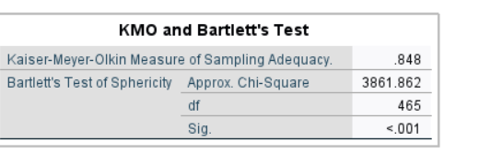

The KMO measures the sampling adequacy (which determines if the responses given with the sample are adequate or not) which should be close to 0.5 for satisfactory factor analysis to proceed. Kaiser recommends 0.5 (value for KMO) as a minimum (barely accepted), values between 0.7-0.8 are acceptable, and values above 0.9 are superb.

Looking at the table above value of .848 is acceptable.

Communalities:

The next item from the output is a table of commonalities which shows how much of the variance (i.e. the communality value which should be more than 0.5 to be considered for further analysis. Else these variables are to be removed from further steps of factor analysis) in the variables has been accounted for by the extracted factors. For instance, over here

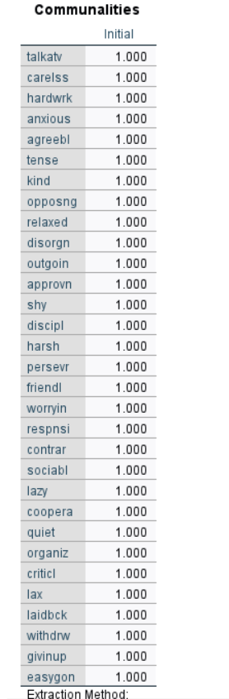

For analysis and interpretation purposes we are concerned only with Initial Eigenvalues and Extracted Sums of Squared Loadings. The requirement for identifying the number of components or factors stated by selected variables is the presence of eigenvalues of more than 1

Table below herein shows that for 1st component the value is 7.149 > 1, 2nd component is 4.334 > 1, 3rd component is 3.096 > 1, 4th component is 2.326 > 1, 5th component is 1.770>1, and 6th component 1.177 >1. Thus, the stated set of 31 variables represent six components.

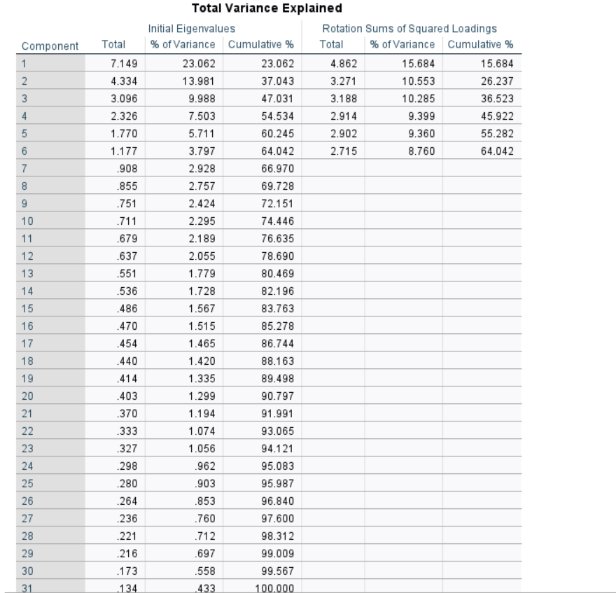

Scree Plot

The scree plot is a graph of the eigenvalues against all the factors. The graph is useful for determining how many factors to retain. The point of interest is where the curve starts to flatten. It can be seen that the curve begins to flatten between factors 6 and 7. Note also that factor 7 onwards has an eigenvalue of less than 1, so only six factors have been retained.

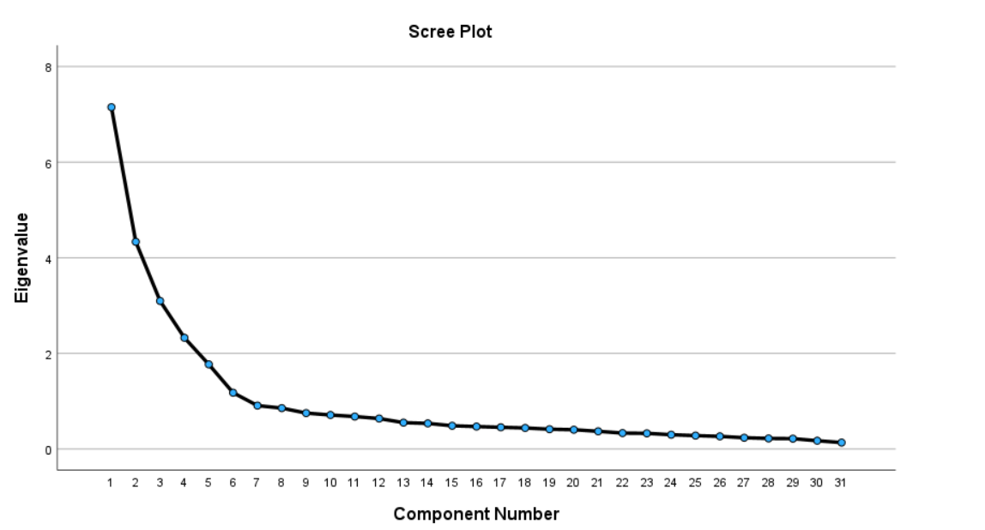

**Component Matrix**

Table below shows the loadings (extracted values of each item under 6 variables) of 31 variables on the six factors extracted. The higher the absolute value of the loading, the more the factor contributes to the variable. We have extracted six variables wherein the 31 items are divided into 6 variables according to the most important items which are similar responses in component 1 and simultaneously in components 2, 3, 4, 5, and 6.

There is a lack of explainability in this factor matrix, as some variables have a strong correlation with more than one factors. Hence, we might need to perform factor analysis with rotation.

|  |  |  |  |  |  |  |
| --- | --- | --- | --- | --- | --- | --- |
| **Component Matrix** | | | | | | |
|  | Component | | | | | |
| 1 | 2 | 3 | 4 | 5 | 6 |
| talkatv | .610 | .232 | -.169 | -.059 | .281 | -.185 |
| carelss | -.489 | -.263 | .609 | .080 | .009 | -.048 |
| hardwrk | .475 | -.407 | .287 | .204 | .106 | -.398 |
| anxious | -.462 | .547 | .147 | -.020 | .152 | -.293 |
| agreebl | .356 | .386 | .245 | .585 | -.049 | -.047 |
| tense | -.315 | -.164 | -.293 | .545 | .290 | -.062 |
| kind | .395 | .497 | .327 | .466 | -.122 | -.034 |
| opposng | -.517 | .142 | -.235 | .455 | .220 | .211 |
| relaxed | .338 | .075 | .525 | -.098 | .377 | .234 |
| disorgn | -.267 | -.539 | -.353 | -.142 | .432 | .075 |
| outgoin | .420 | -.581 | .189 | .241 | .058 | -.376 |
| approvn | -.676 | -.239 | .481 | .111 | -.044 | .008 |
| shy | -.517 | -.124 | -.081 | .340 | .230 | -.017 |
| discipl | .600 | .145 | -.486 | .165 | -.007 | .073 |
| harsh | -.323 | .567 | -.062 | -.103 | .262 | -.363 |
| persevr | .425 | .070 | .473 | -.173 | .389 | .006 |
| friendl | -.428 | .460 | .099 | .066 | .229 | -.317 |
| worryin | -.657 | -.078 | .119 | .448 | .061 | .091 |
| respnsi | .370 | .440 | .229 | .515 | -.218 | .083 |
| contrar | -.464 | .598 | -.113 | .004 | .218 | .073 |
| sociabl | .444 | .108 | .537 | -.063 | .384 | .130 |
| lazy | -.622 | -.326 | .354 | .169 | -.071 | .187 |
| coopera | .552 | -.440 | .055 | .263 | .010 | .277 |
| quiet | -.499 | -.047 | -.327 | .394 | .167 | -.011 |
| organiz | .569 | .245 | -.514 | .246 | .172 | .112 |
| criticl | -.495 | .573 | -.108 | -.189 | .074 | .340 |
| lax | .240 | .358 | .395 | -.125 | .413 | .288 |
| laidbck | .181 | -.531 | -.046 | .192 | .299 | .068 |
| withdrw | -.106 | -.550 | -.183 | -.117 | .457 | -.026 |
| givinup | .720 | .236 | -.258 | .016 | .240 | -.094 |
| easygon | .651 | -.101 | -.006 | .194 | -.084 | .170 |
| Extraction Method: Principal Component Analysis. | | | | | | |
| a. 6 components extracted. | | | | | | |

We can see here that the rotated factor matrix has much more explainability.

Factor 1 has a strong positive correlation with discipl, organiz and givinu, while it has a strong negative correlation with careless, lazy and approv.

Factor 2 has a strong positive correlation with harsh, and anxious, while it has a strong negative correlation with cooperation.

Factor 3 has a strong positive correlation with agreeble, responsi and kind, while it has a strong negative correlation with disorg and withdrawn.

Factor 4 has a strong positive correlation with hardworking and outgoing, while it has a mild negative correlation with criticle and contrar.

Factor 5 has a strong positive correlation with tense, and opposng, while it has a mild negative correlation with persevr.

Factor 6 has a strong positive correlation with relaxed, persevr, lax and sociabl, while it has a mild negative correlation with tense and quiet.

