MACHINE LEARNING LAB EXERCISE

## DATE: 06-02-2025

**QUESTIONS:  
Lab Exercise: Understanding the Perceptron Logically (Note: functions should not be called directly)**

**· Understand the working of a perceptron model through logical implementation.**

**· Implement a perceptron to classify linearly separable data.**

**1. Implementing Perceptron from Scratch: Implement a single-layer perceptron using Python (NumPy). Use a simpl AND gate or OR gate.**

**o Initialize weights and bias randomly.**

**o Use the sigmoid function as the activation function.**

**o Update weights using the perceptron learning rule or with guess**

**o Train the perceptron and test**

ANSWER:

CODE:  
import numpy as np

import matplotlib.pyplot as plt

#this is the activation function that i am using

def sigmoid(x):

return 1 / (1 + np.exp(-x))

# the derivative of the activation function is taken for the back propagation

def gradient_descent(x):

return x * (1 - x)

class Perceptron:

def __init__(self, input_size, learning_rate=0.1):

self.weights = np.random.rand(input_size)

self.bias = np.random.rand(1)

self.learning_rate = learning_rate

def predict(self, inputs):

linear_output = np.dot(inputs, self.weights) + self.bias

return sigmoid(linear_output)

def train(self, inputs, targets, epochs=100000):

for epoch in range(epochs):

for x, target in zip(inputs, targets):

prediction = self.predict(x)

error = target - prediction

self.weights += self.learning_rate * error * x * gradient_descent(prediction)

self.bias += self.learning_rate * error * gradient_descent(prediction)

x_vector = np.array([[0, 0], [0, 1], [1, 0], [1, 1]])

y_and = np.array([0, 0, 0, 1])

y_or = np.array([0, 1, 1, 1])

input_size = 2

epochs = 100000

perceptron_and = Perceptron(input_size)

perceptron_and.train(x_vector, y_and, epochs)

print("AND GATE PREDICTION")

for x, y in zip(x_vector,y_and):

print(f"Input: {x} -> Predicted: {perceptron_and.predict(x)} -> Actual : {y}")

perceptron_or = Perceptron(input_size)

perceptron_or.train(x_vector, y_or, epochs)

print("OR GATE PREDICTION")

for x, y in zip(x_vector,y_or):

print(f"Input: {x} -> Predicted: {perceptron_or.predict(x)} -> Actual : {y}")

OUTPUT

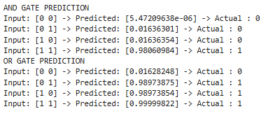

**2. Visualizing the Decision Boundary:**

**o After training, plot the decision boundary to show how the perceptron separates the classes.**

**o Use matplotlib for visualization.**

ANSWER:

CODE:

# Create a meshgrid for visualization by setting the max and min values as -1 and 2 appropriately. as the values are either way between 0 and 1

x_min, x_max = -1, 2

y_min, y_max = -1, 2

xx, yy = np.meshgrid(np.arange(x_min, x_max, 0.1), np.arange(y_min, y_max, 0.1))

# Flatten the meshgrid arrays of each x and y into a 1D array to pass them to the perceptron

xx_flat = xx.ravel()

yy_flat = yy.ravel()

# Stack the flattened meshgrid into a 2D array of input points that is coloumns will be of the x and rows will be y and they are transposed

grid_points = np.vstack((xx_flat, yy_flat)).T

# AND perceptron

predictions_and = perceptron_and.predict(grid_points)

predictions_and = predictions_and.reshape(xx.shape) # Reshaping the predictions to match the meshgrid

# OR perceptron

predictions_or = perceptron_or.predict(grid_points)

predictions_or = predictions_or.reshape(xx.shape)

# decision boundary

plt.figure(figsize=(12, 6))

# Subplot 1: AND gate

plt.subplot(1, 2, 1)

plt.contourf(xx, yy, predictions_and, alpha=0.8, cmap='coolwarm')

plt.colorbar()

plt.scatter(x_vector[:, 0], x_vector[:, 1], c=y_and, s=100, edgecolors='k', cmap='coolwarm')

plt.title("AND Gate Decision Boundary")

plt.xlabel("X1")

plt.ylabel("X2")

# Subplot 2: OR gate

plt.subplot(1, 2, 2)

plt.contourf(xx, yy, predictions_or, alpha=0.8, cmap='coolwarm')

plt.colorbar()

plt.scatter(x_vector[:, 0], x_vector[:, 1], c=y_or, s=100, edgecolors='k', cmap='coolwarm')

plt.title("OR Gate Decision Boundary")

plt.xlabel("X1")

plt.ylabel("X2")

plt.tight_layout()

plt.show()

OUTPUT:

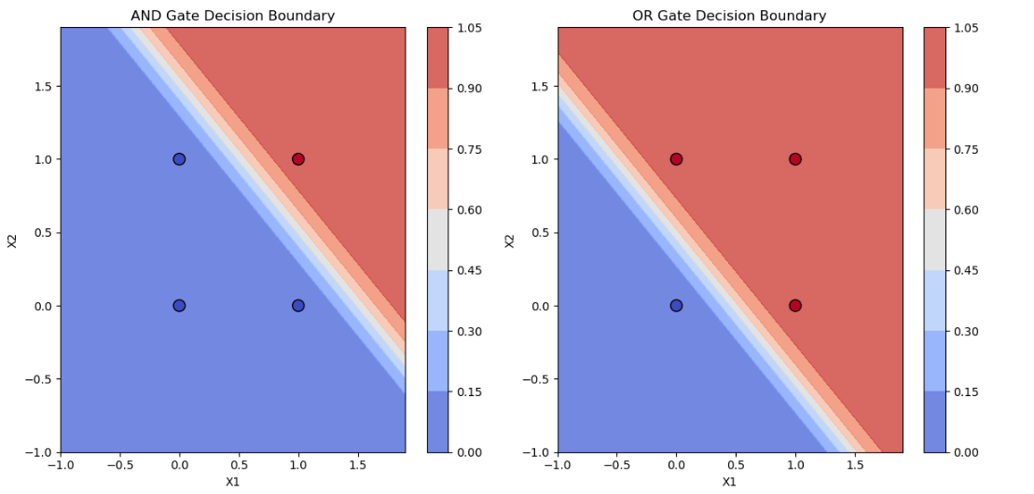

**3. Extension:**

**o implementing a perceptron for the XOR gate.**

**o Show a single-layer perceptron fails for XOR.**

**o Introduce multi-layer perceptrons (MLP) to overcome**

ANSWER:

CODE:

# XOR Gate data

y_xor = np.array([0, 1, 1, 0])

perceptron_xor = Perceptron(input_size)

perceptron_xor.train(x_vector, y_xor, epochs)

x_min, x_max = -1, 2

y_min, y_max = -1, 2

xx, yy = np.meshgrid(np.arange(x_min, x_max, 0.1), np.arange(y_min, y_max, 0.1))

xx_flat = xx.ravel()

yy_flat = yy.ravel()

grid_points = np.vstack((xx_flat, yy_flat)).T

predictions_xor = perceptron_xor.predict(grid_points)

predictions_xor = predictions_xor.reshape(xx.shape)

plt.figure(figsize=(6, 6))

plt.contourf(xx, yy, predictions_xor, alpha=0.8, cmap='coolwarm')

plt.colorbar()

plt.scatter(x_vector[:, 0], x_vector[:, 1], c=y_xor, s=100, edgecolors='k', cmap='coolwarm')

plt.title("XOR Gate Decision Boundary")

plt.xlabel("X1")

plt.ylabel("X2")

plt.show()

OUTPUT:

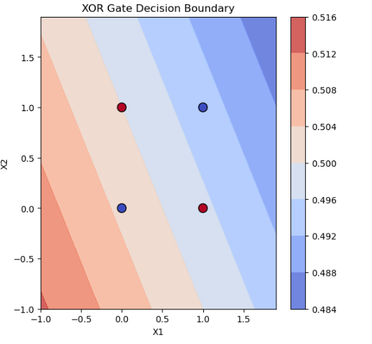

CODE:

y_xor = np.array([0, 1, 1, 0])

# MLP Training function

def train_mlp(x_vector, y_xor, hidden_neurons=2, epochs=10000, lr=0.1):

input_neurons = x_vector.shape[1]

output_neurons = 1

# Initialize weights and biases for the hidden and output layers

w1 = np.random.rand(input_neurons, hidden_neurons)

b1 = np.random.rand(hidden_neurons)

w2 = np.random.rand(hidden_neurons, output_neurons)

b2 = np.random.rand(output_neurons)

# Training loop

for _ in range(epochs):

# Forward propagation

hidden_input = np.dot(x_vector, w1) + b1 # Input to hidden layer

hidden_output = sigmoid(hidden_input) # Output from hidden layer

final_input = np.dot(hidden_output, w2) + b2 # Input to output layer

final_output = sigmoid(final_input) # Output from the networK

# Backpropagation

error = y_xor.reshape(-1, 1) - final_output # Calculate the error

d_output = error * gradient_descent(final_output) # Derivative of output layer

d_hidden = d_output.dot(w2.T) * gradient_descent(hidden_output) # Derivative of hidden layer

# Update weights and biases using gradient descent

w2 += hidden_output.T.dot(d_output) * lr # Update weights for output layer

b2 += np.sum(d_output, axis=0) * lr # Update bias for output layer

w1 += x_vector.T.dot(d_hidden) * lr # Update weights for hidden layer

b1 += np.sum(d_hidden, axis=0) * lr # Update bias for hidden layer

return w1, b1, w2, b2

# Train the MLP on XOR data

w1, b1, w2, b2 = train_mlp(x_vector, y_xor)

# MLP Prediction function

def mlp_predict(x_vector):

hidden_input = np.dot(x_vector, w1) + b1

hidden_output = sigmoid(hidden_input)

final_input = np.dot(hidden_output, w2) + b2

return sigmoid(final_input)

# Visualize the decision boundary for XOR

xx, yy = np.meshgrid(np.linspace(-0.5, 1.5, 100), np.linspace(-0.5, 1.5, 100)) # Create meshgrid

Z = mlp_predict(np.c_[xx.ravel(), yy.ravel()]).reshape(xx.shape) # Get predictions for each point

plt.contourf(xx, yy, Z, alpha=0.5) # Plot the decision boundary

plt.scatter(x_vector[:, 0], x_vector[:, 1], c=y_xor, edgecolors='k', marker='o') # Plot the training points

plt.title("Decision Boundary for XOR ")

plt.xlabel("X1")

plt.ylabel("X2")

plt.show()

OUTPUT:

