Business Template

**AUCTION HOUSE DATABASE**

Contents

1 Business Description 3

1.1 Business background 3

1.2 Problems. Current Situation 3

1.3 The benefits of implementing a database. Project Vision 3

2 Model description 3

2.1 Definitions & Acronyms 3

2.2 Logical Scheme 4

2.3 Objects 4

# Business Description

## Business background

The business specializes in the auctioning of antiques and artwork, offering a unique platform where sellers can present valuable items and buyers can acquire rare finds. The company operates within a niche market, dealing with a variety of items such as paintings, sculptures, and historical artifacts. This operation not only serves collectors and enthusiasts but also plays a crucial role in preserving cultural heritage. The business model relies on the accurate tracking of items, their provenance, auction details, and the transaction history to maintain trust and integrity in the market.

## Problems. Current Situation

* Data Disorganization: Information about items, auctions, sellers, and buyers is stored in disparate systems or even in physical ledgers, making data retrieval slow and prone to errors.
* Inefficiency in Sales Processing: Each auction's sales data is manually recorded and processed, leading to delays and potential inaccuracies in sales records.
* Difficulty in Tracking Provenance and Authenticity: Without a unified database, verifying the authenticity and provenance of items is cumbersome and often unreliable.
* Limited Accessibility and Reporting: Generating timely reports and accessing real-time data is difficult, hindering decision-making and strategic planning.

## the Benefits of implementing a database. Project Vision

* Enhanced Data Management: A database will centralize all information, making it easier to manage, access, and maintain. This will improve data accuracy and reduce administrative overhead.
* Improved Efficiency and Speed: Automated data entry and retrieval processes will significantly speed up operations, from sales processing to inventory management.
* Provenance and Authenticity Verification: With detailed records in one place, the database will facilitate easier tracking of the provenance and authenticity of items, enhancing buyer trust.
* Advanced Reporting Capabilities: The database will enable complex queries and reporting, providing insights into sales trends, buyer behavior, and auction performance. This will aid in better strategic planning and market analysis.
* Scalability and Security: As the business grows, the database can be scaled to accommodate more data and users while ensuring that sensitive information is securely stored.

The vision for this project is to create a robust database that not only addresses current operational inefficiencies but also positions the company for future growth and innovation in the auction industry. By leveraging modern database technologies, the company aims to enhance user experience, improve transaction security, and sustain its reputation as a trusted marketplace for antiques and artwork.

# Model description

## Definitions & Acronyms

## Logical Scheme

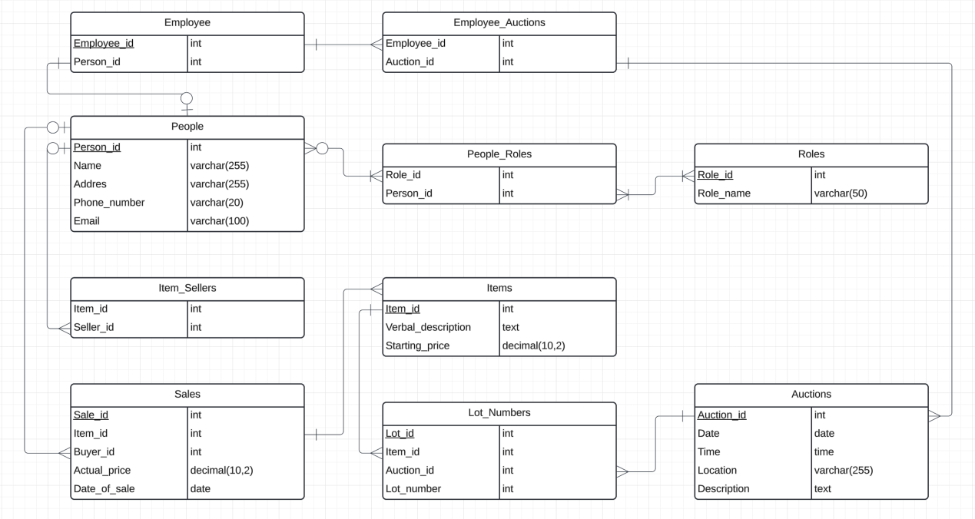

## Objects

1. People

Stores information about all individuals involved with the auctions, whether they are buyers, sellers, or employees. This table acts as a central repository for person-related details.

|  |  |  |  |
| --- | --- | --- | --- |
| Table Name | Field name | Field Description | Data Type |
| People | person_id | Unique identifier for each person, PK | INT |
| name | Full name of the person | VARCHAR(255) |
| address | Address of the person | VARCHAR(255) |
| phone_number | Contact phone number | VARCHAR(20) |
| email | Email address | VARCHAR(100) |

|  |  |  |  |  |
| --- | --- | --- | --- | --- |
| person_id | name | address | phone_number | email |
| 1 | Ali | 30-289 Poland | +48563658375 | test_email@gmail.com |

1. Roles

Defines the different roles that people can have in the auction system, such as "Seller" or "Buyer". This helps in categorizing the activities and permissions of each person.

|  |  |  |  |
| --- | --- | --- | --- |
| Table Name | Field name | Field Description | Data Type |
| Roles | role_id | Unique identifier for each role, PK | INT |
| role_name | Name of the role | VARCHAR(50) |

|  |  |
| --- | --- |
| role_id | role_name |
| 1 | seller |

1. People_Roles

Facilitates a many-to-many relationship between People and Roles, indicating which roles each person fulfills. This is essential for managing access and responsibilities within the system.

|  |  |  |  |
| --- | --- | --- | --- |
| Table Name | Field name | Field Description | Data Type |
| People_Roles | person_id | Reference to People, FK | INT |
| role_id | Reference to Roles, FK | INT |

This table is used to implement the many-to-many relationship between People and Roles.

|  |  |
| --- | --- |
| person_id | role_id |
| 1 | 13 |

1. Auctions

Contains all the necessary details about each auction event, such as its date, time, and location, as well as a description that may include specifics like the type of items being auctioned.

|  |  |  |  |
| --- | --- | --- | --- |
| Table Name | Field name | Field Description | Data Type |
| Auctions | auction_id | Unique identifier for each auction, PK | INT |
| date | Date of the auction | DATE |
| time | Time of the auction | TIME |
| location | Location of the auction | VARCHAR(255) |
| description | Description of the auction specifics | TEXT |

|  |  |  |  |  |
| --- | --- | --- | --- | --- |
| auction_id | date | time | location | description |
| 1 | 2024-04-16 | 14:30:00 | 30-259 Poland | Some text |

1. Items

Details each item available for auction, including a verbal description and the starting price. This is crucial for cataloging and presenting items during the auction.

|  |  |  |  |
| --- | --- | --- | --- |
| Table Name | Field name | Field Description | Data Type |
| Items | item_id | Unique identifier for each item, PK | INT |
| verbal_description | Brief description of the item | TEXT |
| starting_price | Starting price of the item, CHECK (>0) | DECIMAL(10,2) |

|  |  |  |
| --- | --- | --- |
| item_id | verbal_description | starting_price |
| 1 | Some text | 10.99 |

1. Lot_Numbers

Associates items with specific auctions and assigns them lot numbers. This table also tracks the final claimed price and the buyer, linking items to their respective auctions and buyers.

|  |  |  |  |
| --- | --- | --- | --- |
| Table Name | Field name | Field Description | Data Type |
| Lot_Numbers | lot_id | Unique identifier for each lot, PK | INT |
| item_id | Reference to Items, FK | INT |
| auction_id | Reference to Auctions, FK | INT |
| lot_number | Lot number assigned to the item at the auction | INT |
| claimed_price | Claimed price | DECIMAL(10,2) |
| buyer_id | Reference to Buyer, FK | INT |

|  |  |  |  |  |  |
| --- | --- | --- | --- | --- | --- |
| lot_id | item_id | auction_id | lot_number | claimed_price | buyer_id |
| 1 | 2 | 3 | 23 | 100.23 | 25 |

1. Item_Sellers

Links items to the sellers who provided them. This is important for tracking the source of each item and managing consignments.

|  |  |  |  |
| --- | --- | --- | --- |
| Table Name | Field name | Field Description | Data Type |
| Item_Sellers | item_id | Reference to Items, FK | INT |
| seller_id | Reference to People, FK | INT |

This table represents which seller provided which item.

|  |  |
| --- | --- |
| item_id | seller_id |
| 1 | 13 |

1. Sales

Records details of each sale transaction, including the actual price paid and the date of sale. It links items to the buyers and captures the financial outcome of the auction.

|  |  |  |  |
| --- | --- | --- | --- |
| Table Name | Field name | Field Description | Data Type |
| Sales | sale_id | Unique identifier for each sale, PK | INT |
| item_id | Reference to Items | INT |
| buyer_id | Reference to People | INT |
| actual_price | The actual price paid for the item | DECIMAL(10,2) |
| date_of_sale | The date when the sale was completed | DATE |

|  |  |  |  |  |
| --- | --- | --- | --- | --- |
| sale_id | item_id | buyer_id | actual_price | date_of_sale |
| 1 | 13 | 12 | 13.66 | 2023-12-01 |

1. Employee

Keeps track of individuals who are employees of the auction house. This table links employees to their personal details in the People table.

|  |  |  |  |
| --- | --- | --- | --- |
| Table Name | Field name | Field Description | Data Type |
| Employee | employee_id | Unique identifier for each employee, PK | INT |
| person_id | Reference to People, FK | INT |

|  |  |
| --- | --- |
| employee_id | person_id |
| 1 | 13 |

1. Employee_Auctions

Manages the assignments of employees to different auctions, ensuring that each event is adequately staffed and overseen by the auction house personnel.

|  |  |  |  |
| --- | --- | --- | --- |
| Table Name | Field name | Field Description | Data Type |
| Employee_Auctions | employee_id | Reference to Employee, FK | INT |
| auction_id | Reference to Auctions, FK | INT |

This table manages which employee is managing which auction.

|  |  |
| --- | --- |
| employee_id | auction_id |
| 1 | 13 |