# Introduction

Transport Control Protocol(TCP) and User Datagram Protocol(UDP) are the two most prevalent transport layer protocols in use today. Often, both protocols are contrasted against each other, TCP being slow and reliable, and UDP being fast and unreliable. This report analyses exactly how different these two protocols are. The results show that TCP is for all intents and purposes fully reliable, while UDP is significantly faster to the point where it might be a contender in some places where TCP is normally used.

# Analysis

Packet sizes that were tested were 1KB, 4KB, 20KB, and 60KB. These were sent over the internet in batches of 10 and 100 packets.

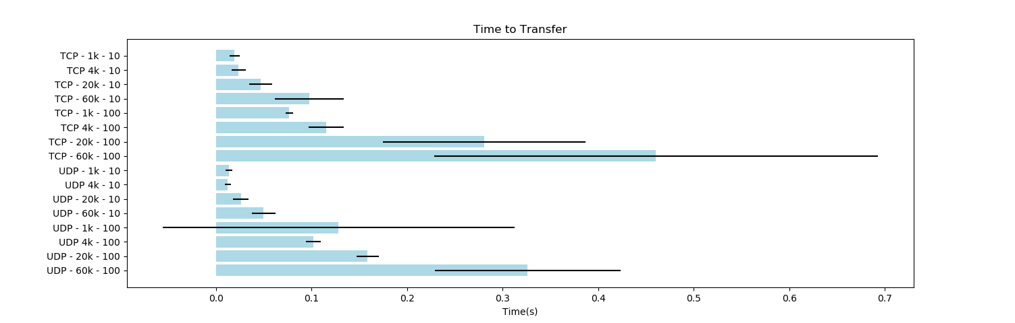In terms of speed, the following graph shows the total time to transfer for TCP and UDP. Overall UDP is faster than TCP but the speed gain is not as significant in some cases.

When it comes to lower packet counts such as 10, UDP is not much faster than TCP, even at larger packet sizes. On the other hand, at larger packet counts such as 100, UDP does show significant speed gains.

One interesting not is that UDP and TCP both show high standard deviations in their total transfer times. This could be causes by different routing paths being selected for the packets and a small sample size.

In terms of reliability, TCP does it job very well and did not drop any packets. Interestingly though, UDP only showed packet loss when either packet sizes were very large, or packet counts were high. This could be seen on the graph below.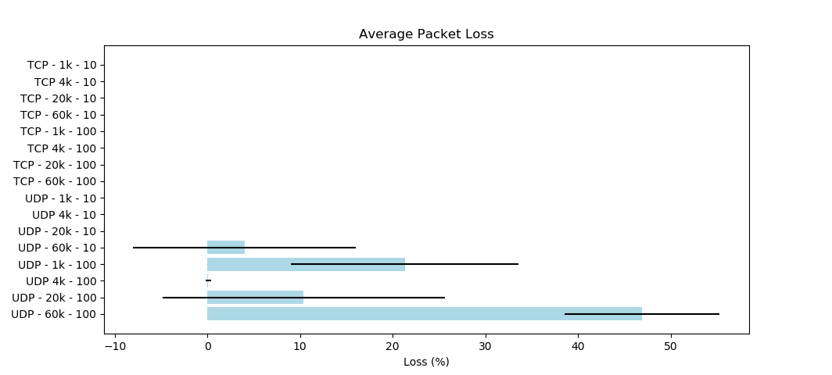

TCP show absolutely no loss, while UDP showed consistent loss when high packet counts were combined with large packet sizes.

# Conclusions

As expected, TCP was reliable and slow while UDP was fast and unreliable. But, it was interesting to see that TCP showed negligible performance loss in terms of speed at lower packet sizes.

UDP might also be a good choice in some high throughput scenarios do to be significantly faster. It might be faster to retransmit lost packets with UDP as compared to waiting on TCPs reliability.

# Appendix

Raw data can be found here - <https://gist.github.com/Krixium/97e03341523b27ccf8204f286d22f216>