**Module:1**

**SE-Overview of ITI Industry**

Q1. What is software? What is software engineering?

Ans. Software refers to a set of instructions, programs, or data that enable a computer to perform specific tasks or functions. It encompasses everything from operating systems and applications to games and utilities. Software can be categorized into system software, which provides a platform for other software to run, and application software, which performs specific tasks for users.

Software engineering, on the other hand, is the systematic approach to the design, development, testing, and maintenance of software. It involves applying engineering principles and methodologies to software development to ensure that the resulting software is reliable, efficient, and maintainable. Software engineers use various techniques, tools, and processes to manage the complexity of software systems and to deliver high-quality software products on time and within budget.

Software engineering is a discipline that involves the systematic application of engineering principles, techniques, and methodologies to the design, development, testing, and maintenance of software systems. It focuses on creating reliable, efficient, and maintainable software products that meet the needs and requirements of users and stakeholders.

Key aspects of software engineering include:

1. Requirements Engineering: Gathering, analyzing, and specifying the needs and expectations of users and stakeholders to define the functionality and behavior of the software system.

1. Software Design: Creating a blueprint or architectural plan for the software system, which outlines its structure, components, interfaces, and interactions.

1. Implementation:Writing code and building software components according to the design specifications, using programming languages and development tools.

1. Testing: Conducting various types of testing (such as unit testing, integration testing, and system testing) to verify that the software behaves as expected, meets requirements, and is free from defects.

1. Maintenance: Making modifications, enhancements, and updates to the software over its lifecycle to address changing requirements, fix bugs, and improve performance.

1. Project Management: Planning, organizing, and coordinating the activities and resources involved in software development projects to ensure they are completed on time, within budget, and to the required quality standards.

# Explain types of software

Software can be broadly categorized into several types based on its purpose, functionality, and usage. Here are some common types of software:

1. System Software: This type of software provides a platform for other software to run and interacts directly with the hardware. Examples include:

Operating Systems: Such as Windows, macOS, Linux, and iOS, which manage hardware resources and provide services to applications.

Device Drivers: Software that enables communication between hardware devices (e.g., printers, graphics cards) and the operating system.

Utilities: Tools for managing and optimizing system performance, such as antivirus software, disk cleanup tools, and backup software.

1. Application Software: This type of software is designed to perform specific tasks or functions for users. Examples include:

Productivity Software: Such as word processors (e.g., Microsoft Word, Google Docs), spreadsheets (e.g., Microsoft Excel, Google Sheets), and presentation software (e.g., Microsoft PowerPoint, Google Slides).

Media Players: Software for playing audio and video files, such as Windows Media Player, VLC Media Player, and iTunes.

Web Browsers: Applications used to access and view websites on the internet, such as Google Chrome, Mozilla

Firefox, and Safari.

Graphics Software: Tools for creating and editing images and digital artwork, such as Adobe Photoshop, GIMP, and CorelDRAW.

1. Programming Software: These are tools used by developers to create, debug, and maintain software applications. Examples include:

Integrated Development Environments (IDEs):** Software suites that provide comprehensive tools for writing, testing, and debugging code, such as Visual Studio, Eclipse, and IntelliJ IDEA.

Text Editors: Simple tools for writing and editing code, such as Notepad++, Sublime Text, and Atom.

Compilers and Interpreters: Software that translates source code into machine-readable instructions, such as GCC (GNU Compiler Collection) for C/C++ and Python Interpreter for Python.

1. Embedded Software: This type of software is built into hardware devices and is responsible for controlling their operation. Examples include:

Firmware: Software that is embedded into devices like smartphones, routers, and IoT (Internet of Things) devices to control their basic functions and behavior.

Real-Time Operating Systems (RTOS):Operating systems designed for embedded systems that require deterministic and timely responses, such as FreeRTOS and QNX.

These are just a few examples of the various types of software that exist, and there can be overlap between categories, as some software may serve multiple purposes or be classified differently depending on context.

3. What is SDLC? Explain each phase of SDLC

Ans. SDLC stands for Software Development Life Cycle. It is a process followed by software development teams to design, develop, test, and deploy high-quality software efficiently. SDLC consists of several phases, each with its own set of activities and goals. Here are the typical phases of SDLC:

1. Requirement Gathering and Analysis: In this phase, the development team gathers and analyzes requirements from stakeholders, including clients, end-users, and business analysts. The goal is to understand what the software needs to accomplish, its features, and functionalities. Requirements are documented in a Software Requirements Specification (SRS) document.

1. System Design: Once the requirements are gathered, the system architecture is designed. This phase involves creating a high-level design that outlines the system's structure, modules, interfaces, and database design. The design may include diagrams such as data flow diagrams, entity-relationship diagrams, and architectural diagrams.

1. Implementation (Coding): In this phase, developers start writing code based on the design specifications. The actual programming of the software takes place during this phase. Developers follow coding standards and best practices to ensure code quality and maintainability.

1. Testing: After the code is developed, it is tested rigorously to identify and fix defects. Testing can be divided into various types such as unit testing, integration testing, system testing, and acceptance testing. The goal of testing is to ensure that the software meets the specified requirements and functions correctly in different scenarios.

1. Deployment (or Implementation): Once the software passes testing, it is ready for deployment. In this phase, the software is installed and configured in the production environment. Deployment may involve migrating data, setting up servers, and providing user training.

1. Maintenance and Support: After deployment, the software enters the maintenance phase. During this phase, the development team provides ongoing support, bug fixes, and updates to ensure that the software continues to meet user needs and remains compatible with changing environments. Maintenance may include both corrective maintenance (fixing bugs) and adaptive maintenance (updating the software to adapt to new requirements or environments).

These phases are often depicted as a linear sequence, but in practice, SDLC is iterative and may involve revisiting previous phases as needed based on feedback and changing requirements. Additionally, modern SDLC approaches, such as Agile and DevOps, emphasize collaboration, flexibility, and continuous improvement throughout the development process.

4. What is DFD? Create a DFD diagram on Flipkart

Ans. A Data Flow Diagram (DFD) is a graphical representation of the flow of data within a system. It's a structured analysis and design tool used to model the flow of data through a system and illustrate how input data is transformed into output data by processes. DFDs are commonly used in software engineering and systems analysis to visualize and understand the structure and behavior of systems.

In a DFD, there are four main components:

1. External Entities: These represent sources or destinations of data outside the system being modeled. External entities interact with the system by providing input data or receiving output data.

1. Processes: Processes represent transformations or actions that are performed on data. They describe how input data is manipulated to produce output data. Processes can be manual or automated.

1. Data Stores: Data stores represent repositories of data within the system. They store data for later use or for sharing between processes. Data stores can be databases, files, or any other storage medium.

1. Data Flows: Data flows represent the movement of data between external entities, processes, and data stores. They show the flow of data from its source to its destination and indicate the direction of data movement.

DFDs use standardized symbols to represent these components, making them easy to understand and interpret. By creating DFDs, analysts and designers can gain insights into how data is processed within a system, identify potential bottlenecks or inefficiencies, and design effective solutions to

improve system performance and functionality.

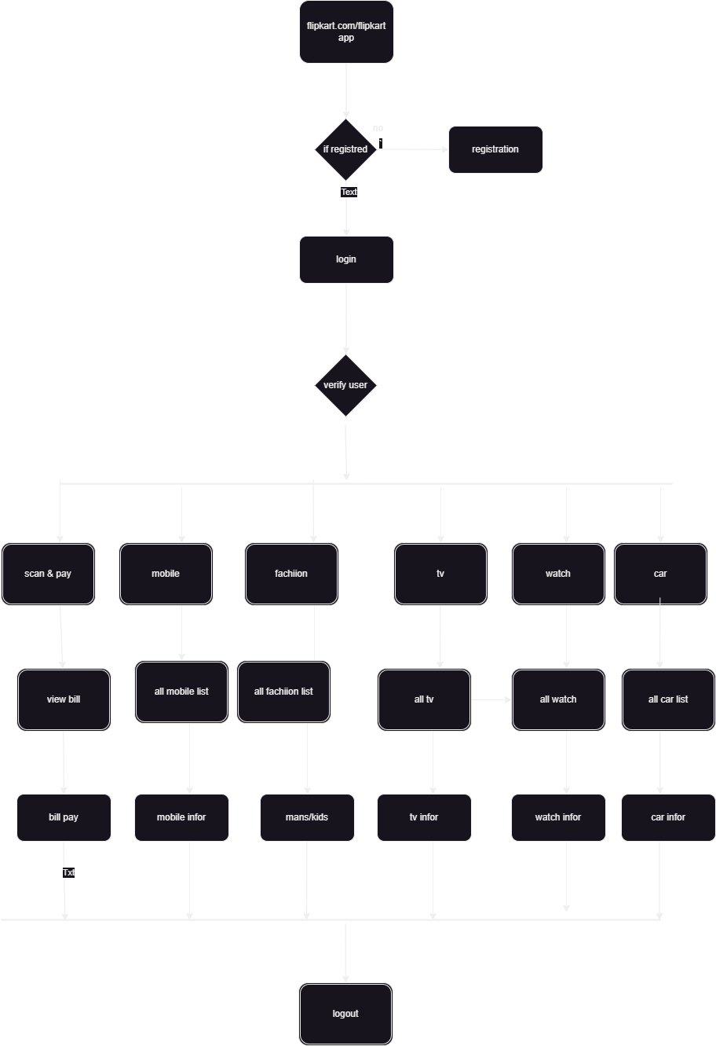

1. what is Flow chart?

Ans. A flowchart is a graphical representation of a process, system, or algorithm. It uses standardized symbols and shapes to depict the sequence of steps or actions involved in completing a task or solving a problem. Flowcharts are widely used in various fields such as software development, engineering, business management, education, and more.

The main purpose of a flowchart is to provide a visual representation of the logical flow of a process, making it easier to understand, analyze, and communicate. Flowcharts typically consist of various elements including:

1. Start/End Points: Indicate the beginning and end of the process.
2. Processes/Actions: Represent tasks, operations, or actions to be performed.
3. Decisions: Show points where the flow diverges based on conditions or criteria.
4. Connectors/Arrows: Illustrate the flow of control or direction between different elements.
5. Input/Output: Display data inputs or outputs at various stages of the process.

By using these elements and connecting them with arrows to show the flow of control, a flowchart provides a clear and concise overview of how a process works. Flowcharts are valuable tools for analyzing processes, identifying bottlenecks or inefficiencies, documenting procedures, designing systems, and communicating complex concepts in a visual manner.

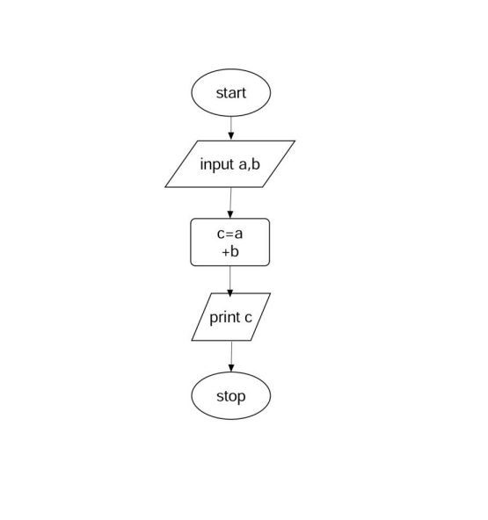

1. What is Use case Diagram?

Ans. A Use Case Diagram is a type of behavioral diagram in Unified Modeling Language (UML) used to visually represent the interactions between users (called actors) and a system. It illustrates the functional requirements of a system by defining the various ways users interact with it to achieve specific goals or tasks.

Key components of a Use Case Diagram include:

1. Actors: Actors represent the users or external systems that interact with the system being modeled. They are typically drawn as stick figures. Actors may include human users, other software systems, hardware devices, or even time-dependent processes.

1. Use Cases: Use cases represent the specific functionalities or tasks that the system provides to its users. Each use case describes a sequence of interactions between the system and one or more actors to achieve a particular goal. Use cases are depicted as ovals or ellipses within the diagram.

1. Relationships: Relationships between actors and use cases are depicted using lines or arrows. The main types of relationships include:

Association: Shows that an actor interacts with a particular use case.

- Generalization: Indicates that one use case is a specialized version of another use case. This relationship is similar to inheritance in object-oriented programming.

Include: Indicates that one use case includes another use case as part of its behavior.

Extend: Indicates that one use case extends another use case by adding additional behavior under certain conditions.

1. System Boundary**: The system boundary represents the scope of the system being modeled. It encloses all the use cases and actors related to the system.

Use Case Diagrams are valuable tools for capturing and visualizing the functional requirements of a system from the perspective of its users. They help stakeholders understand the system's behavior, define system boundaries, identify system functionalities, and communicate system requirements effectively during the software development process.

