HARDWARE–SOFTWARE CO-DESIGN
Hardware-Accelerated AES-128 CTR
Image Encryption and Decryption
Implementation and Evaluation on the AMD/Xilinx ZCU104

Technical Project Report
Karan Kumar
B.Tech — Electronics and Communication Engineering
Indian Institute of Information Technology Bhagalpur
September 2026
Vivado 2026.1 • Vitis Embedded 2026.1 • Zynq UltraScale+ MPSoC

Executive Summary
This project demonstrates full-image AES-128 Counter (CTR) encryption and decryption on an AMD/Xilinx ZCU104 development board. A bare-metal application runs on the Zynq UltraScale+ ARM Cortex-A53 processing system, controls a custom AES accelerator in programmable logic over AXI4-Lite, stores image buffers in processor memory, and transfers the encrypted and recovered images to a laptop through the PS UART.
The implemented test used a 256 × 256 RGB888 image containing 196,608 bytes, equivalent to 12,288 AES blocks. Hardware execution completed encryption in 34.766 ms and decryption in 34.747 ms. The recovered raw pixels matched the original exactly: zero differing pixels, mean-squared error of zero, and identical SHA-256 values.
Project outcome A real image was encrypted in ZCU104 programmable logic, decrypted through the same CTR datapath, returned to the laptop, reconstructed as PNG, and verified byte-for-byte. The complete hardware-to-laptop path passed.

Results at a Glance
Metric | Measured result | Interpretation
Input | 256 × 256 RGB888 (196,608 bytes) | 12,288 independent 128-bit CTR blocks
Functional recovery | PASS; 0 differing pixels | Original and recovered raw data are identical
Encryption | 34.766 ms; 5.655 MB/s | 45.24 Mbit/s effective throughput
Decryption | 34.747 ms; 5.658 MB/s | 45.26 Mbit/s effective throughput
Timing closure | WNS +0.342 ns; TNS 0 | All constraints met at 75.002 MHz
PL utilization | 10,779 LUT; 2,866 FF | AES core dominates programmable-logic use
Power estimate | 3.872 W total on-chip | Vectorless Vivado estimate, medium confidence
Cipher entropy | 7.9991 bits/byte combined | Ciphertext distribution is near uniform

Report Scope
The measurements in this report distinguish implementation results from design assumptions. Timing and utilization come from the implemented Vivado design; processing time comes from the running ARM application; image-security statistics were computed from the returned image and counter-sensitivity captures. Power is reported as an implementation estimate rather than a bench measurement.

1. System Architecture
The solution partitions control and data orchestration into the processing system (PS) while executing the AES block transformation in programmable logic (PL). This division makes the cryptographic datapath hardware-accelerated but keeps image loading, result checking, and UART transport flexible in software.
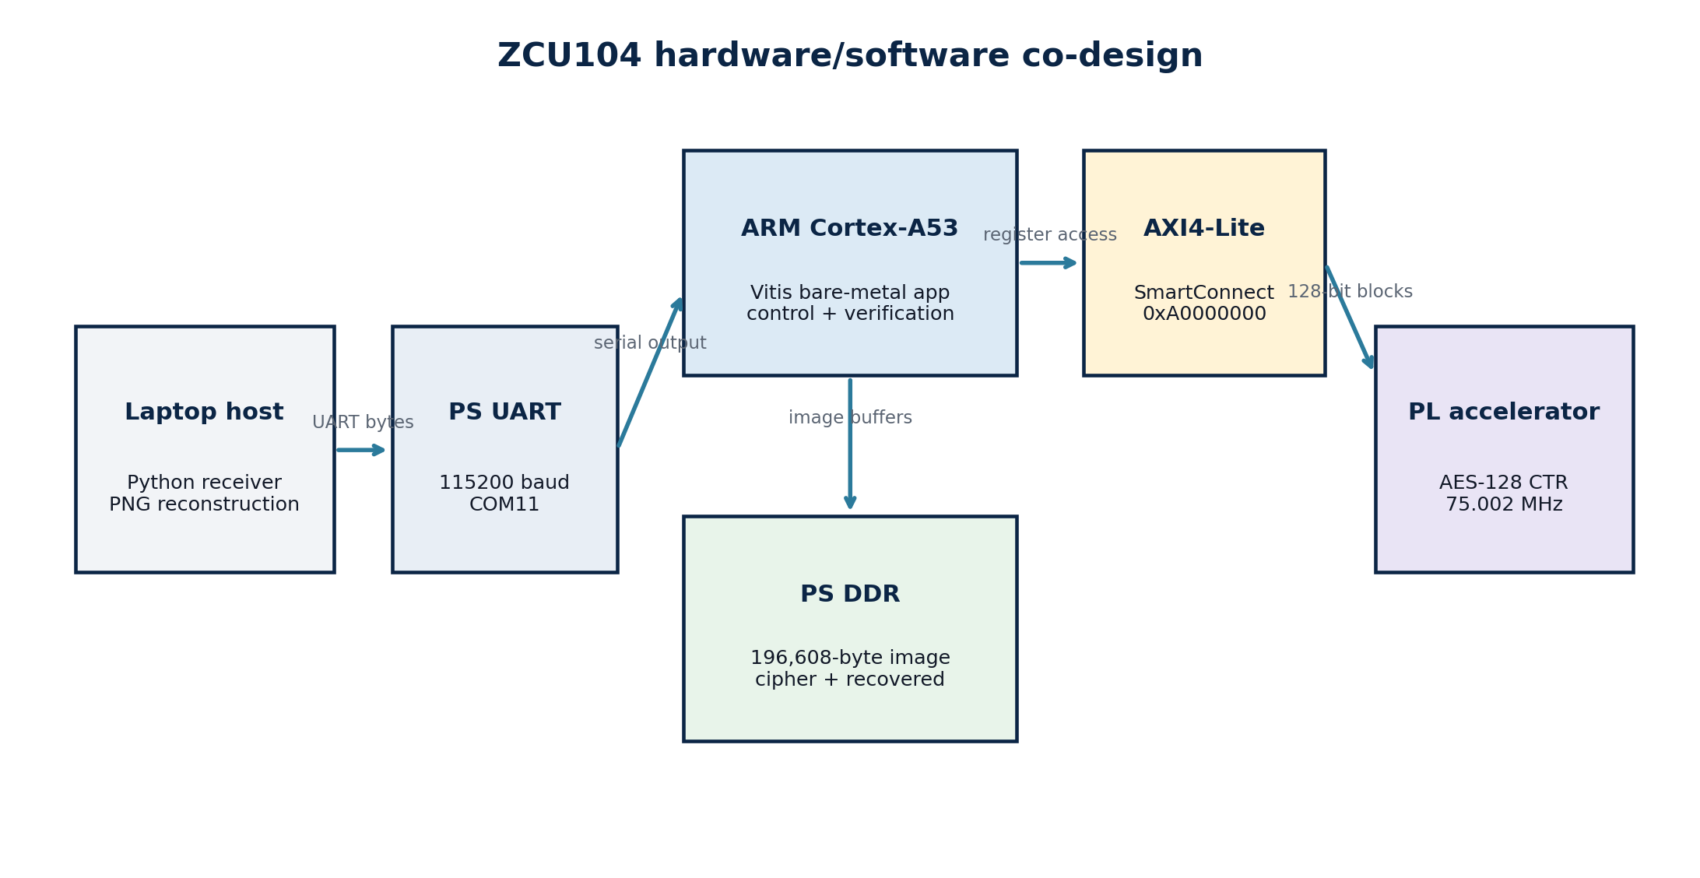
Figure 1. ZCU104 hardware/software architecture and data path.
Subsystem | Implementation | Responsibility
Host laptop | Python 3 receiver; COM11 at 115200 baud | Receives framed ciphertext and recovered bytes; writes PNG and BIN files
Processing system | ARM Cortex-A53, standalone BSP | Loads embedded image, controls registers, polls completion, verifies recovery
Interconnect | AXI4-Lite SmartConnect | Maps processor transactions to the accelerator at 0xA0000000
Programmable logic | Custom AES-128 CTR RTL | Generates AES keystream and XORs one 128-bit data block per command
Memory | PS DDR / application arrays | Holds original, ciphertext, and recovered image buffers
Why no BRAM appears in utilization The full image is stored in processor memory and streamed block-by-block through memory-mapped registers. The PL accelerator therefore needs no image-sized block RAM.

2. Cryptographic Method

2.1 AES-128 Counter Mode
CTR mode converts AES into a stream-like construction. For block index i, the hardware encrypts a counter value and XORs the resulting 128-bit keystream with the 128-bit input block. The same operation performs both encryption and decryption:
Cᵢ = Pᵢ ⊕ AESₖ(CTR + i) and Pᵢ = Cᵢ ⊕ AESₖ(CTR + i)
A 128-bit key is expanded into AES round keys. SubBytes, ShiftRows, MixColumns, and AddRoundKey implement the ten AES-128 rounds. CTR does not require a separate inverse-AES datapath, which reduces architectural complexity and lets encryption and decryption reuse the same core.

2.2 Demonstration Parameters
Parameter | Value
AES key | 2B7E1516 28AED2A6 ABF71588 09CF4F3C
Initial counter | F0F1F2F3 F4F5F6F7 F8F9FAFB FCFDFEFF
Block size | 128 bits / 16 bytes
Image payload | 196,608 bytes
Number of blocks | 12,288
Reference validation | NIST SP 800-38A AES-CTR known-answer baseline
Security requirement A counter value must never be reused with the same key for a different image. Reuse exposes the XOR of the plaintexts. The fixed counter in this demonstration provides repeatability only; a deployed system must generate and store a unique nonce/counter for every message.

2.3 Confidentiality versus Integrity
AES-CTR protects confidentiality but does not authenticate the ciphertext. An attacker can flip selected ciphertext bits and cause corresponding changes after decryption. A production medical-image system should use an authenticated mode such as AES-GCM, or pair CTR with a separately verified message authentication code.

3. Vivado and Vitis Development Workflow
Vivado and Vitis contribute different halves of the system. Vivado creates the FPGA hardware and exports the hardware description. Vitis uses that exported hardware to compile and run the processor application.
Stage | Tool | Output | Purpose
1 | Vivado 2026.1 | Synthesized and implemented design | Integrates Zynq PS, SmartConnect, clocks/resets, and AES RTL
2 | Vivado 2026.1 | Bitstream + XSA | Programs PL and describes addresses, clocks, and processors
3 | Vitis Embedded 2026.1 | Platform/BSP | Provides standalone drivers and processor support
4 | Vitis Embedded 2026.1 | AArch64 ELF application | Controls the accelerator and sends results through PS UART
5 | Python host script | Ciphertext/recovered PNG and BIN | Receives packets, reconstructs images, computes hashes

3.1 ARM Application Sequence
- Initialize the board platform, UART, timer, and memory-mapped AES base address.
- Load the 256 × 256 RGB image compiled into the application as an RGB byte array.
- Write the AES key and initial counter to AXI4-Lite registers.
- For each 16-byte block, write input data, start the accelerator, poll DONE, and read output.
- Repeat the CTR process over ciphertext to produce the recovered image.
- Compare original and recovered buffers and print RECOVERY_PASS or RECOVERY_FAIL.
- Frame ciphertext and recovered buffers over UART for the laptop receiver.

3.2 AXI4-Lite Register Interface
Offset | Register | Direction | Function
0x00 | CONTROL | PS → PL | START, LOAD_COUNTER, SOFT_RESET, CLEAR_DONE
0x04 | STATUS | PL → PS | DONE and status flags
0x10–0x1C | KEY[127:0] | PS → PL | AES-128 key, four 32-bit words
0x20–0x2C | COUNTER[127:0] | PS → PL | Current 128-bit CTR value
0x30–0x3C | DATA_IN[127:0] | PS → PL | Plaintext or ciphertext block
0x40–0x4C | DATA_OUT[127:0] | PL → PS | Ciphertext or recovered block

4. Hardware Validation

4.1 Board and Host Setup
The ZCU104 was connected to the laptop with the board power supply and the USB/JTAG-UART cable. The PL bitstream and ARM ELF were downloaded through JTAG. The laptop receiver opened the PS UART on COM11 at 115200 baud before launching the Vitis application.
Item | Configuration
Board | AMD/Xilinx ZCU104 Evaluation Board
Device | xczu7ev-ffvc1156-2-e
Vivado / Vitis | 2026.1 / 2026.1
Host serial port | COM11, 115200 baud, 8-N-1
Image format | 256 × 256, RGB888, 196,608 bytes
Hardware address | AES AXI4-Lite base 0xA0000000

4.2 Observed Console Evidence
Board-to-host transcript ZCU104_AES_CTR_START • IMAGE 256 256 RGB888 196608 • AES_BLOCKS 12288 • RECOVERY_PASS • ZCU104_AES_CTR_DONE
Check | Observed value | Status
Encrypted payload | 196,608 / 196,608 bytes received | PASS
Recovered payload | 196,608 / 196,608 bytes received | PASS
Original SHA-256 | aa237d9a507990a9144c055ace0f484b3f4c055b8ce5ecd9c4da8aa18ed861e4 | PASS
Recovered SHA-256 | aa237d9a507990a9144c055ace0f484b3f4c055b8ce5ecd9c4da8aa18ed861e4 | PASS
Equality test | Original == recovered | PASS
The encrypted baseline SHA-256 was 20a3d2aa8fae11e68c32b35be8ecdbc957697c1fa66f4c8c302470d1d28f46ef. File-level PNG hashes need not match when encoders store different metadata or compression; the decisive recovery check is the raw RGB pixel buffer, which matched exactly.

5. Image Results
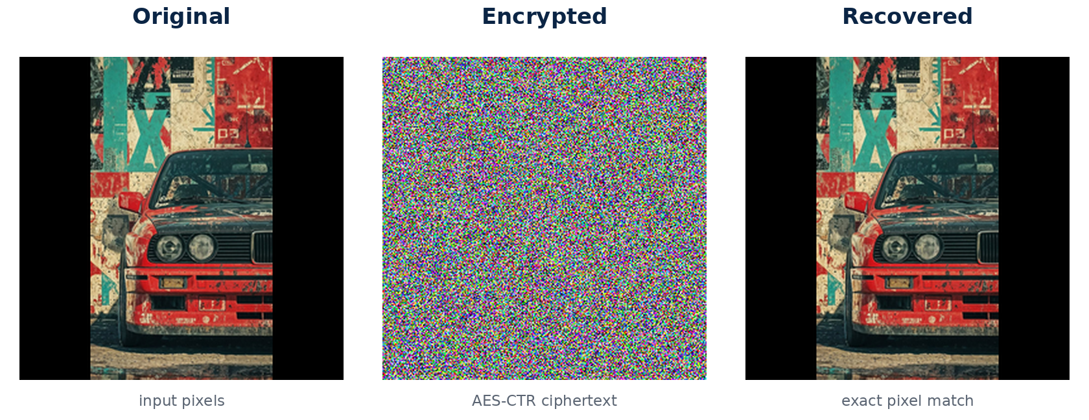
Figure 2. Original image, ZCU104 ciphertext visualization, and recovered image.
The encrypted image has no visible object structure, while the recovered image is visually indistinguishable from the original. Pixel-level comparison confirms that this is not merely visual similarity: every channel value at every location is identical after recovery.
Recovery metric | Result
Different pixels | 0 of 65,536
Different RGB channel values | 0 of 196,608
Mean-squared error (MSE) | 0
Peak signal-to-noise ratio (PSNR) | ∞
Maximum absolute channel error | 0
Raw pixel equality | PASS
Interpretation Exact recovery proves that the AES-CTR transform, word ordering, counter progression, AXI register access, UART packet framing, and laptop reconstruction are mutually consistent.

6. Performance Evaluation
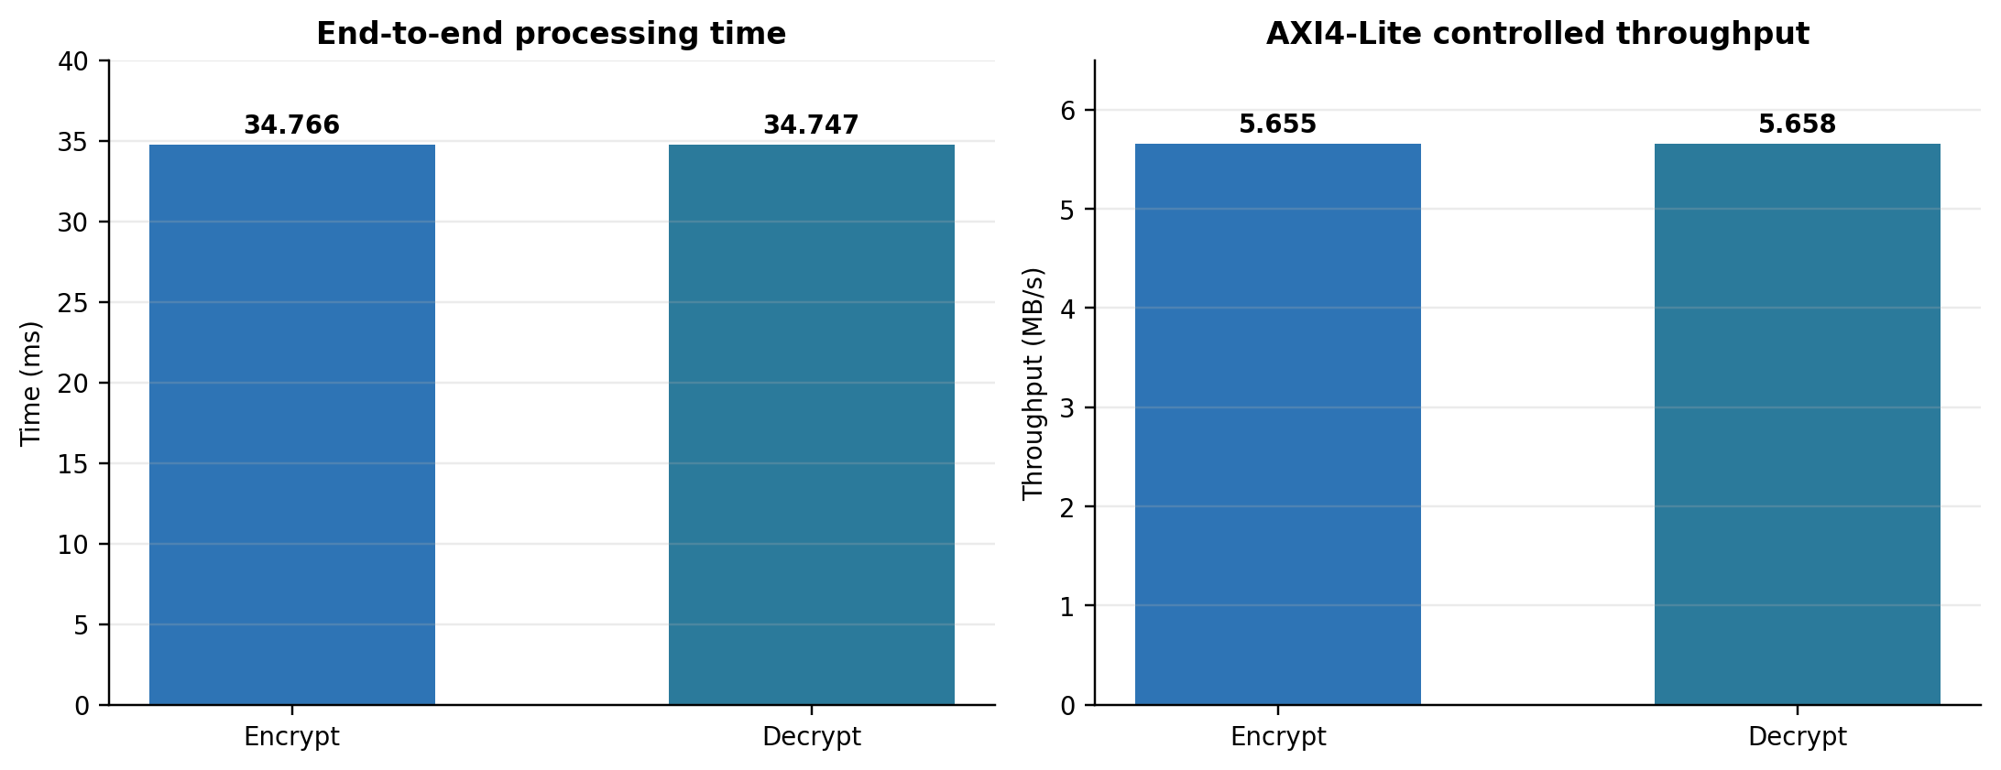
Figure 3. Measured end-to-end processing time and effective throughput.
Metric | Encryption | Decryption
Time | 34.766 ms | 34.747 ms
Effective throughput | 5.655 MB/s | 5.658 MB/s
Equivalent bit rate | 45.24 Mbit/s | 45.26 Mbit/s
Time per 128-bit block | 2,829 ns | 2,827 ns
Blocks processed | 12,288 | 12,288
Encryption and decryption times are almost identical because CTR mode uses the same AES encryption primitive in both directions. The combined cryptographic processing time was 69.513 ms for the complete image.
Measurement boundary These results measure the ARM-controlled AXI4-Lite workflow, including register writes, status polling, and register reads. They are not the intrinsic one-block-per-cycle throughput of the AES datapath. The memory-mapped transaction loop is the dominant system bottleneck.

6.1 Throughput Improvement Path
- Replace per-block AXI4-Lite data movement with AXI4-Stream.
- Use AXI DMA between PS DDR and the PL accelerator.
- Pipeline the AES datapath and overlap counter generation with block processing.
- Measure pure core latency separately from software and data-transfer overhead.

7. Implementation Results

7.1 Resource Utilization
Hierarchy | LUTs | FFs | BRAM/URAM | DSP
Complete system wrapper | 10,779 | 2,866 | 0 | 0
AES-CTR AXI4-Lite accelerator | 10,244 | 2,227 | 0 | 0
AXI SmartConnect | 536 | 639 | 0 | 0
The AES accelerator accounts for about 95% of system LUTs and 78% of system flip-flops. Zero DSP utilization is expected because AES relies primarily on substitutions, permutations, and XOR operations. Zero BRAM utilization reflects processor-memory image storage rather than missing image data.

7.2 Timing Closure
Parameter | Implemented result
PL clock | 75.002 MHz (13.333 ns period)
Worst negative slack | +0.342 ns
Total negative slack | 0 ns
Failing endpoints | 0
Critical data path | key_reg3_reg[21] → ciphertext_reg[68]
Critical path delay | 12.724 ns: 4.568 ns logic + 8.156 ns routing
Logic levels | 55
The implemented design meets all timing constraints at 75.002 MHz. Routing contributes about 64.1% of the critical path delay, indicating that physical distance and fan-out are as important as combinational logic depth. This also explains why the earlier 100 MHz target was too aggressive without additional pipelining or restructuring.

7.3 Power Estimate
Power component | Estimate
Total on-chip power | 3.872 W
Dynamic power | 3.177 W
Static power | 0.695 W
AES hierarchy dynamic power | 0.491 W
Processing system dynamic power | 2.680 W
Estimated junction temperature | 28.8 °C
Confidence | Medium; vectorless activity propagation
Power caveat Vivado power is an implementation estimate based on assumed switching activity. It is not a wall-plug or board-rail measurement. The report also warned that reset activity could reduce estimate accuracy.

8. Image-Security Analysis
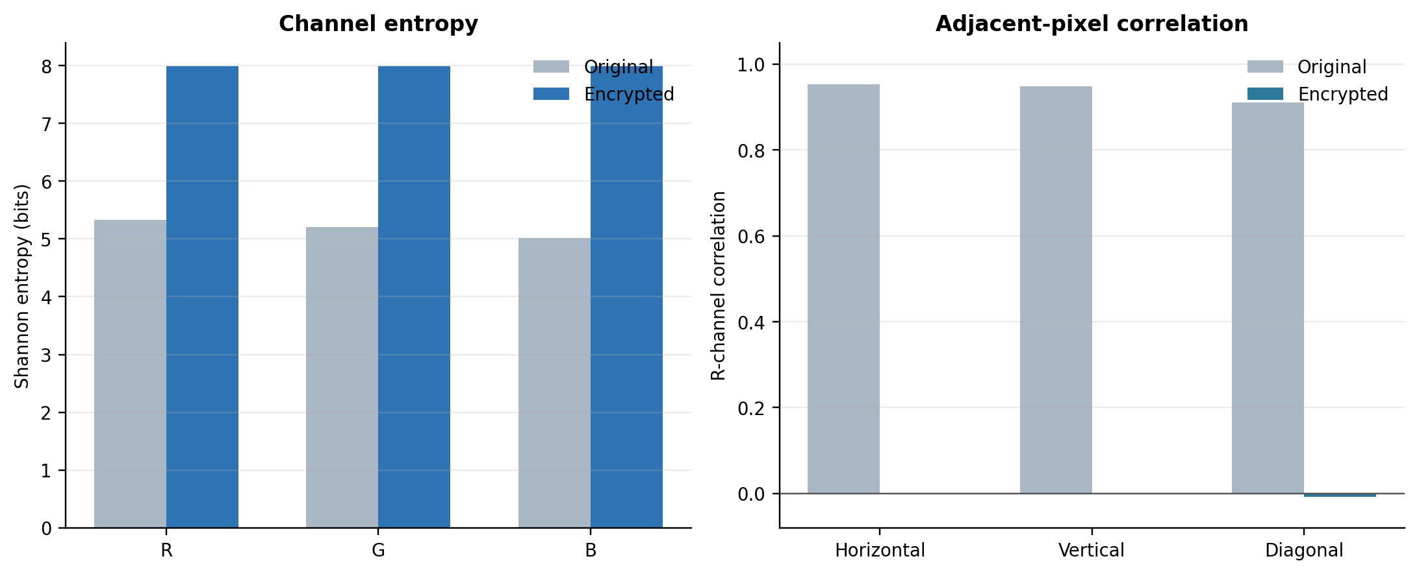
Figure 4. Entropy and adjacent-pixel decorrelation after AES-CTR encryption.

8.1 Entropy
Data | Red | Green | Blue | Combined
Original | 5.3347 | 5.2127 | 5.0186 | 5.2836
Encrypted | 7.9973 | 7.9973 | 7.9975 | 7.9991
Recovered | 5.3347 | 5.2127 | 5.0186 | 5.2836
For 8-bit data, the maximum entropy is 8 bits. The encrypted image reaches 7.9991 bits/byte when all color channels are combined, consistent with a near-uniform ciphertext distribution.

8.2 Adjacent-Pixel Correlation
Channel | Original H / V / D | Encrypted H / V / D
Red | 0.95236 / 0.94790 / 0.91131 | 0.00018 / 0.00012 / −0.00734
Green | 0.94660 / 0.95119 / 0.91340 | −0.00150 / 0.00352 / −0.00603
Blue | 0.94493 / 0.94814 / 0.91227 | −0.00119 / −0.00398 / 0.00334
Strong spatial correlation in the original image collapses to values close to zero after encryption, so neighboring ciphertext pixels do not preserve the visual relationships of the source image.

8.3 Histogram Uniformity
Channel | Chi-square | p-value
Red | 245.484 | 0.6544
Green | 248.383 | 0.6049
Blue | 229.273 | 0.8750
All p-values exceed 0.05, so the test does not reject the hypothesis that encrypted channel values follow a uniform distribution. These statistical tests support the absence of obvious image structure, but they do not replace standard cryptographic validation of AES.

9. Counter-Sensitivity Test
A second hardware run changed only the least significant counter word from FCFDFEFF to FCFDFEFE while keeping the image and AES key unchanged. This is the relevant diffusion experiment for CTR mode: it tests whether a one-bit change in the keystream input produces an independently different encrypted image.
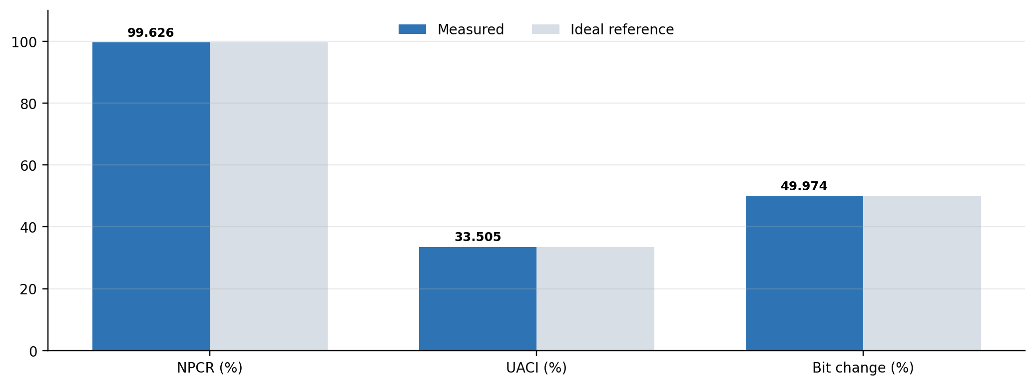
Figure 5. Ciphertext sensitivity to a one-bit initial-counter change.
Metric | Measured | Ideal reference
Different ciphertext bytes | 195,873 / 196,608 | —
Byte-level NPCR | 99.6262% | 99.6094%
UACI | 33.5052% | 33.4635%
Changed ciphertext bits | 786,017 / 1,572,864 | —
Bit-change rate | 49.9736% | 50.0000%
Different RGB pixels | 65,536 / 65,536 (100%) | —
The measured values closely match random-cipher expectations. Every output pixel changed, about 99.63% of all ciphertext bytes changed, and almost exactly half of the ciphertext bits flipped. This confirms strong counter sensitivity in the implemented hardware/software system.
Why plaintext NPCR is not used In CTR mode, changing one plaintext bit changes only the corresponding ciphertext bit when key and counter remain fixed because ciphertext is produced by XOR. Counter or key sensitivity is therefore the meaningful full-ciphertext diffusion test.

10. Conclusions and Future Work

10.1 Conclusions
The project successfully implemented and demonstrated a complete AES-128 CTR image-security pipeline on the ZCU104. The FPGA accelerator operated under ARM control, processed a 196,608-byte RGB image, and returned both ciphertext and recovered data to a laptop. Exact recovery, passing hashes, near-ideal ciphertext statistics, successful timing closure, and counter-sensitivity results together show that the system is functionally correct and suitable as a hardware/software co-design prototype.
The measured 5.66 MB/s performance reflects a simple, reliable AXI4-Lite control architecture. It proves the concept but leaves substantial throughput headroom. The design’s main value is the verified end-to-end platform: RTL cryptography, Zynq PS/PL integration, embedded control software, physical board programming, UART transport, and host-side image reconstruction all operate together.

10.2 Limitations
- AES-CTR provides no built-in authentication or tamper detection.
- The fixed demonstration counter is not safe for reuse across independent images.
- AXI4-Lite moves only small register words and limits sustained throughput.
- Power results are vectorless estimates rather than instrumented board measurements.
- The current application is launched through JTAG and is not yet an autonomous SD/QSPI boot image.

10.3 Recommended Next Steps
Priority | Improvement | Expected benefit
1 | Add unique nonce/counter generation and transmission | Prevents catastrophic CTR keystream reuse
2 | Add AES-GCM authentication or a verified MAC | Detects ciphertext modification and wrong keys
3 | Replace register data transfer with AXI DMA + AXI4-Stream | Raises throughput and reduces processor overhead
4 | Pipeline or floorplan the critical AES path | Improves maximum clock frequency and timing margin
5 | Create an SD/QSPI boot image with required firmware | Enables standalone power-on operation
6 | Repeat tests for larger medical images and measure board rails | Improves application relevance and power accuracy

References
1. National Institute of Standards and Technology, FIPS 197: Advanced Encryption Standard (AES). Official source
2. National Institute of Standards and Technology, SP 800-38A: Recommendation for Block Cipher Modes of Operation. Official source
3. AMD, ZCU104 Evaluation Board User Guide, UG1267. Official source
4. AMD, Zynq UltraScale+ Device Technical Reference Manual, UG1085. Official source
5. AMD, Vitis Unified Software Platform Documentation: Embedded Software Development, UG1400. Official source

Reproducibility Record
Artifact | Recorded value
Vivado reports | real_image_utilization.rpt; real_image_timing.rpt; real_image_power.rpt
Image evidence | car_256_original.png; car_256_encrypted_from_zcu104.png; car_256_recovered_from_zcu104.png
Counter captures | cipher_counter_FCFDFEFF.bin; cipher_counter_FCFDFEFE.bin
Toolchain | Vivado 2026.1 and Vitis Embedded Development 2026.1
Hardware | ZCU104 / xczu7ev-ffvc1156-2-e

