The purpose of the application is to determine whether a baby is healthy, lower than average, or a super baby based on the measurements.

The Application is built on Python using skLearn to implement the tree. Using the dataset in the code, the application will generate a Decision Tree. The tree would then be used when the user inputs the measurements into the application.

For now, the application is only accessible through py console.

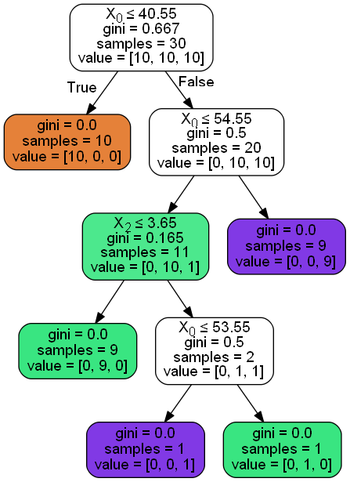

The tree above is generated by GraphViz, and is a representation of how the application works. The actual determining factor is baby length and baby weight. This is because baby head circumference is actually just an attribute dependant to Length, as it is calculated by halfing the baby length and adding 10. Therefore, the features that has the best information gains are baby length and baby weight.

First, the tree asks if the length is less than or equal to 40.55. If yes, then it labels the baby as lower than average. Then, it asks if the length is less than or equal to 54.55. Then it splits the data again, labeling the ones above the value as super babies. Then it asks if the weight is lower than or equal to 3.65. The ones that are lower are labeled as healthy, and it splits the remaining data based on the length, if it is lower than 53.55, then it is labeled super, and the one that isn’t is labeled healthy.

To improve the application, developer (me) should add a GUI for better presentation, and add more datasets, and possibly new features that will determine the baby health more significantly. More features means that the tree will be better at labeling datas, and the results will be more accurate.

**References**

Josh Gordon

https://www.youtube.com/watch?v=cKxRvEZd3Mw

https://www.youtube.com/watch?v=tNa99PG8hR8

Gopal Malakar

https://www.youtube.com/watch?v=f85ARatXIFA