Report

Exercise 1

1.It is needed to create a program that would help to calculate monthly bills for 3 services: telephone, internet, television. Each service has its own tariff.

2.Program must prompt the user:

a. enter his account number.

b. enter the service code (until the right code will be entered).

c. enter consumption of the service in minutes.

d. enter the TV pack code if service code is ‘t’.

Program must output:

1. user account number.
2. amount of money for consumed service.

Program should recognize as much as possible wrong data inputs.

3.Algorithm

1. Prompt user for account number.
2. Save user’s account number.
3. Prompt user for service code.
4. Change this code it is in a lower case
5. Save it’s code if it’s not wrong, if it is return to c item.
6. Prompt user for a time in minutes of using the service.
7. Save the value.
8. If it is TV service, prompt the user for pack code.
9. Save the Tv pack code
10. Using all the data calculate fee
11. If it is telephone fee = 15+minutes*0.05£
12. If it is internet and minutes are less than 1000 fee = 20£ else fee = 20 + (minutes - 1000)*0.02£
13. If it is TV pack Basic fee = 5£ if minutes are less than 60 and fee = 5+(minutes-60)*0.01£
14. If it is TV pack Premium fee = 10£ if minutes are less than 60 and fee = 10+(minutes-60)*0.02£
15. Output users account number
16. Output calculated amount of money

4.List of functions

1. double telephone(unsigned int mins);
2. double internet(unsigned int mins);
3. double television(unsigned int mins, unsigned int pack_type);

Each function implements a part of a j item of the algorithm.

5. 1) 100 minutes of phone service fee = 15 + 100*0.05 = 20£

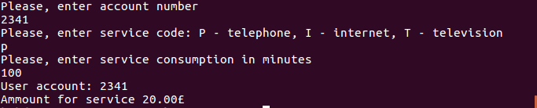

2) 500 minutes of internet service (as 500<1000) fee = 20£

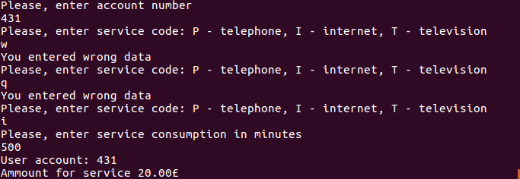

3) 2000 minutes of internet service (as 2000>1000) fee = 20+(2000-1000)*0.02=40£

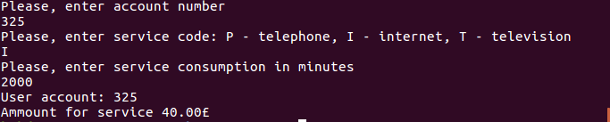

4) 1000 minutes of basic TV pack (as 1000>60) fee = 5+(1000-60)*0.01=14.4£

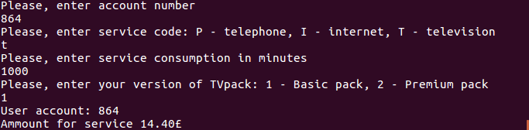

5) 1000 minutes of premium TV pack (as 1000>60) fee = 10+(1000-60)*0.02=28.8£

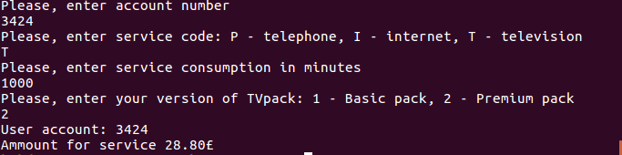

Exercise 2

1. Calculate the value of a metric kurtosis.

2. Program must prompt the user for values, if user inputs value less than 0 the program calculates kurtosis value based on previous inputs. Maximum can be inputed 10 values. Program outputs all inserted values by the user and then kurtosis value

3. Algorithm

1. Program prompt user to input values
2. Program is reading and saving the values if until negative one then stop saving values and goes to the next step, also if user enter 10 values program stops reading and goes to the next step
3. Program calculate the kurtosis
4. It calculates the average value
5. It calculates numerator
6. It calculates denominator
7. It divides numerator by denominator values
8. Program outputs all the values one by one as it is required in the task
9. Program outputs kurtosis value

4. List of functions

1. double kurtosis(double* x, int numberOfx); - used in c item of algorithm.
2. double numerator(double* x, int numberOfx); - used in c.2 item of algorithm.
3. double denominator(double* x, int numberOfx); - used in c.3 item of algorithm.
4. double average(double* x, int numberOfx); - used in c.1, c.2, c.3 items of algorithm.
5. double power(double value, int power);- used in c.2 and c.3 items of algorithm.

5. a. first example : Input (x1 = 10, x2 =15, x3 = 20, x4=25,x5=30, x6 = 35)

$$\overline{x}= \frac{10+15+20+25+30+35}{6}=22.5$$

Numerator

|  |  |
| --- | --- |
| $${(x_{1}-\overline{x})}^{4}$$ | 24414.0625 |
| $${(x_{2}-\overline{x})}^{4}$$ | 3164.0625 |
| $${(x_{3}-\overline{x})}^{4}$$ | 39.0625 |
| $${(x_{4}-\overline{x})}^{4}$$ | 39.0625 |
| $${(x_{5}-\overline{x})}^{4}$$ | 3164.0625 |
| $${(x_{6}-\overline{x})}^{4}$$ | 24414.0625 |

Denominator

|  |  |
| --- | --- |
| $${(x_{1}-\overline{x})}^{2}$$ | 156.25 |
| $${(x_{2}-\overline{x})}^{2}$$ | 56.25 |
| $${(x_{3}-\overline{x})}^{2}$$ | 6.25 |
| $${(x_{4}-\overline{x})}^{2}$$ | 6.25 |
| $${(x_{5}-\overline{x})}^{2}$$ | 56.25 |
| $${(x_{6}-\overline{x})}^{2}$$ | 156.25 |

$Numerator= \frac{24414.0625+3164.0625+39.0625+39.0625+3164.0625+24414.0625}{6}=9205.72916$

$$Denominator={(\frac{156.25+56.25+6.25+6.25+56.25+156.25}{6})}^{2}=5316.84$$

$$Kurtosis=\frac{numerator}{denominator}=1.73143$$

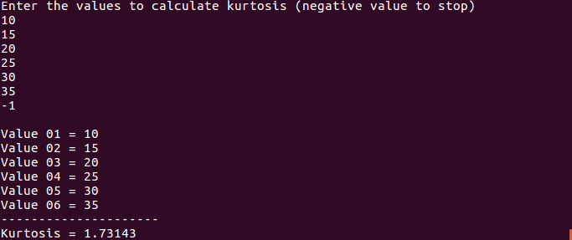

b. second example: input(xi = i; i = 1,2,3,...,15)

$$\overline{x}= \frac{1+2+3+4+5+6+7+8+9+10}{10}=5.5$$

Numerator

|  |  |
| --- | --- |
| $${(x_{1}-\overline{x})}^{4}$$ | 410.0625 |
| $${(x_{2}-\overline{x})}^{4}$$ | 150.0625 |
| $${(x_{3}-\overline{x})}^{4}$$ | 39.0625 |
| $${(x_{4}-\overline{x})}^{4}$$ | 5.0625 |
| $${(x_{5}-\overline{x})}^{4}$$ | 0.0625 |
| $${(x_{6}-\overline{x})}^{4}$$ | 0.0625 |
| $${(x_{7}-\overline{x})}^{4}$$ | 5.0625 |
| $${(x_{8}-\overline{x})}^{4}$$ | 39.0625 |
| $${(x_{9}-\overline{x})}^{4}$$ | 150.0625 |
| $${(x_{10}-\overline{x})}^{4}$$ | 410.0625 |

Denominator

|  |  |
| --- | --- |
| $${(x_{1}-\overline{x})}^{2}$$ | 20.25 |
| $${(x_{2}-\overline{x})}^{2}$$ | 12.25 |
| $${(x_{3}-\overline{x})}^{2}$$ | 6.25 |
| $${(x_{4}-\overline{x})}^{2}$$ | 2.25 |
| $${(x_{5}-\overline{x})}^{2}$$ | 0.25 |
| $${(x_{6}-\overline{x})}^{2}$$ | 0.25 |
| $${(x_{7}-\overline{x})}^{2}$$ | 2.25 |
| $${(x_{8}-\overline{x})}^{2}$$ | 6.25 |
| $${(x_{9}-\overline{x})}^{2}$$ | 12.25 |
| $${(x_{10}-\overline{x})}^{2}$$ | 20.25 |

$$Numerator= \frac{410.0625+150.0625+39.0625+5.0625+0.0625+0.0625+5.0625+39.0625+150.0625+410.0625}{10}=120.862$$

$$Denominator={(\frac{20.25+12.25+6.25+2.25+0.25+0.25+2.25+6.25+12.25+20.25}{10})}^{2}=68.0625$$

$$Kurtosis=\frac{numerator}{denominator}=1.77576$$

