Patrick Ware

Abstract

C# Console Application To Track Monthly Expenditure

Monthly expense Tracker

Contents

Introduction 2

App Configuration 2

FoodVendors.txt 2

Purpose 2

Configuration Steps 2

PetrolVendors.txt 2

Purpose 2

Configuration Steps 2

VendorsToIgnore.txt 3

Purpose 3

Configuration Steps 3

Instructions for use 3

# Introduction

The Expense Tracker console application is a C# program specifically designed to help track users monthly expenditure of variable expenditure such as food and petrol/transport. This acheinved by reading in a csv bank statement file and filters relevant transations based on the food and petrol vendors provided in the appropriate txt files.

The information is then printed to the console and also saved as a new csv file in the programs directory which is shown below   
 ***/bin/debug/net6.0***

Currently the application is only setup to process bank statement from kiwbank accounts only.

# App Configuration

The Expense Tracker console application allows users to configure vendor lists to tailor the analysis to their specific needs. Here's a guide on how to configure the application using the provided configuration files which are as follows

## FoodVendors.txt

### Purpose

This file contains a list of food vendors that will be considered during the food transactions analysis.

### Configuration Steps

* Open the FoodVendors.txt file using a text editor of your choice.
* Add each food vendor on a separate line.
* Save the file.

## PetrolVendors.txt

### Purpose

Similar to FoodVendors.txt, this file contains a list of petrol vendors that will be considered during the petrol transactions analysis.

### Configuration Steps

* Open the PetrolVendors.txt file using a text editor.
* Add each petrol vendor on a separate line.
* Save the file.

## VendorsToIgnore.txt

### Purpose

This file contains a list of vendors whose transactions will be ignored during the analysis. Transactions from these vendors will be excluded from both food and petrol calculations.

### Configuration Steps

* Open the VendorsToIgnore.txt file using a text editor.
* Add each vendor to be ignored on a separate line.
* Save the file.

# Instructions for use

To use the application simply download a bank statement for the desired month as a CSV (Comma separated Value file) Using the settings shown below:   
  
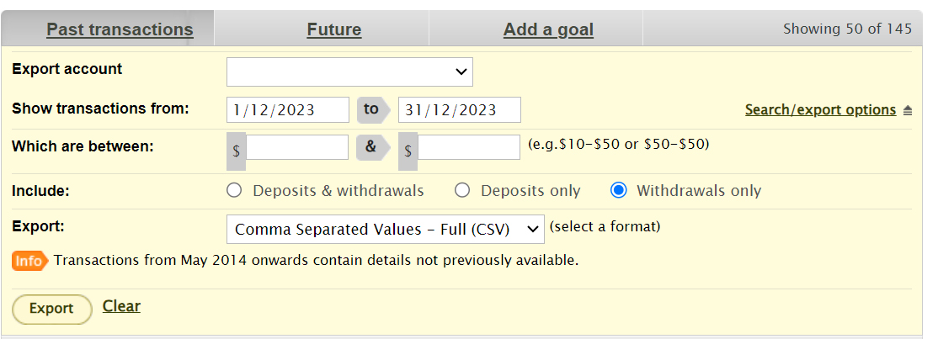

Execute the application and drag a csv file onto terminal and press enter

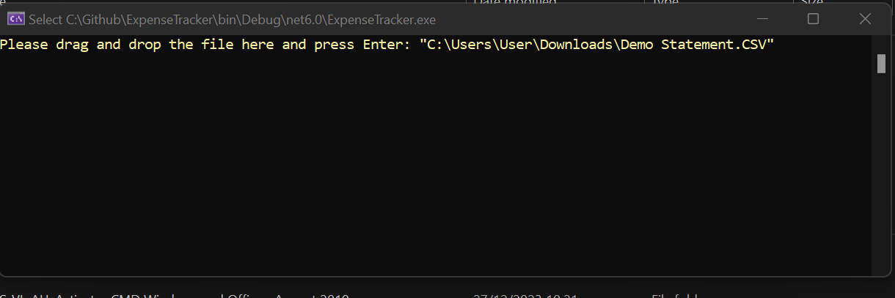

Once processed the following information will displayed on screen and written to both CSV and txt files   
  
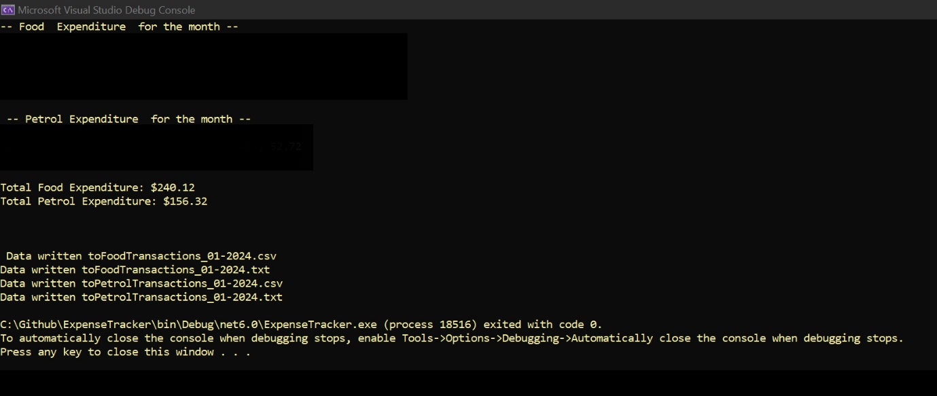

** for privacy and security reasons program output has been redacted, however for error checking purposes the transaction date, the vendor and the amount will be shown for each of the relevant transactions.