Create a prior structure for the network by hand (see the instructions in the R-script). Regarding the prior structure, suppose that YOL007C has an effect on YBR088C, and that YNL327Whas an effect on YER124C, YHR143W and YNR067C. Plot your prior structure and include it in your report.

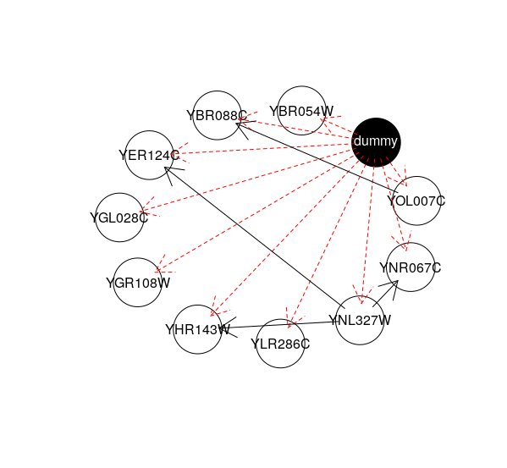

Inspect the local probability distributions either by clicking on the nodes or via the localprob command. What is the output for gene YBR088C?

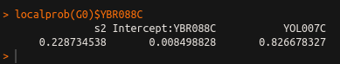

Generate a prior distribution for the parameters of the joint distribution using the jointprior command. Learn the initial Bayesian network. What is its score?

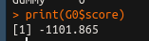
Score is

Perform a local search for an optimal network. Plot the network obtained and include it in your report. This optimal network is called BN*. What is the score now?

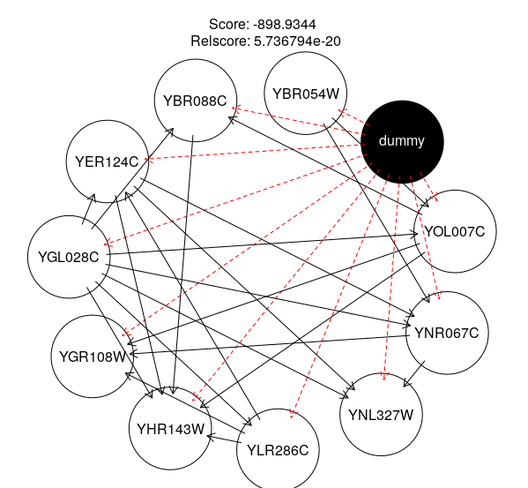

For each of the 10 genes calculate the variance 𝜎among the experiments and include them in your report.

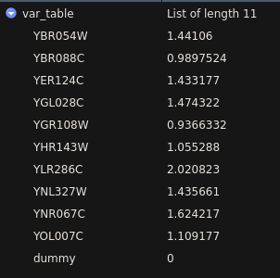

Perturb the experimental values of each gene i by adding a noise term to each entry in the column corresponding to gene i. Repeat this procedure 30times for each gene such that you generate 30 perturbed datasets. For gene YHR143W, generate the following box plot: The horizontal axis should display each experiment, i.e., the values 1 to 77. The vertical axis should display one box per experiment. In other words, the box for experiment j encodes the empirical distribution based on the 30samples of experiment j for the gene YHR143W. Include this in your report.

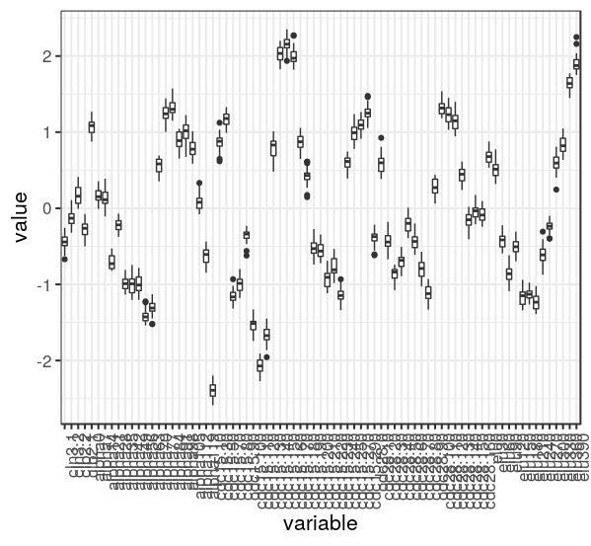

Repeat steps 2-6 (this time ignore the requests for your report) with each of the 30 perturbed datasets. The optimal networks obtained are called PBN1,...,PBN30. Plot the graph corresponding to the network PBN5 and include it in your report.

