Report the length of bothM1 and M2 models (1 point).

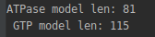

Report the dimensions of your T,mE and iE for both models (1 point)

For position 50 in each model, plot the transition and emission frequencies. (3 points)

I printed position. I am not sure because 49 is more interesting so I attached also this one. There is difference in lists in python: starts from zero, it corresponds to your example. If you wanted position number 50 in R notation it is described as position 49.
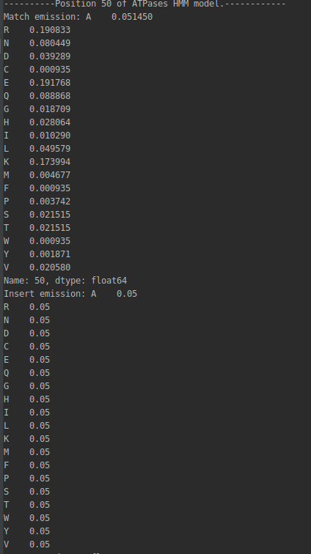
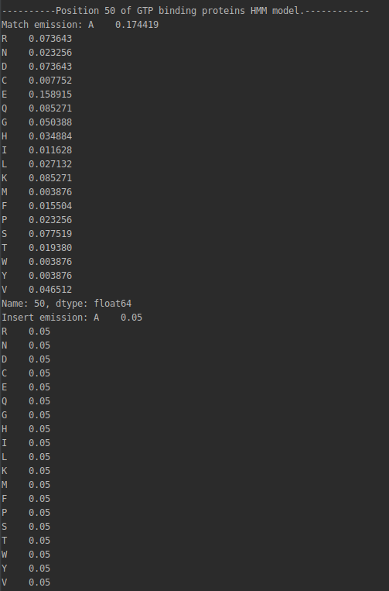

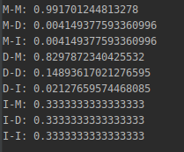
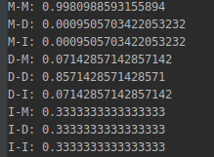

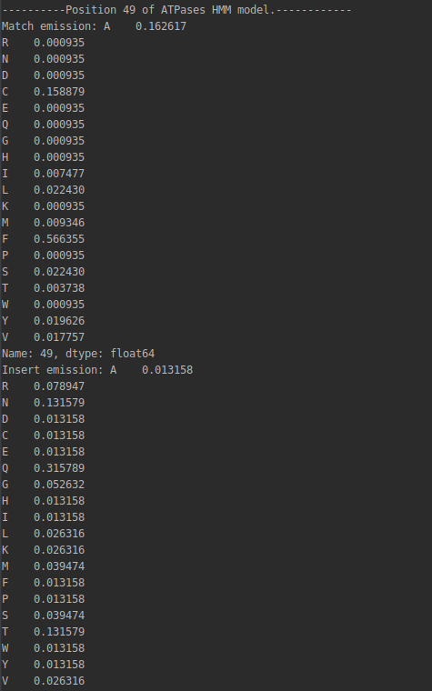
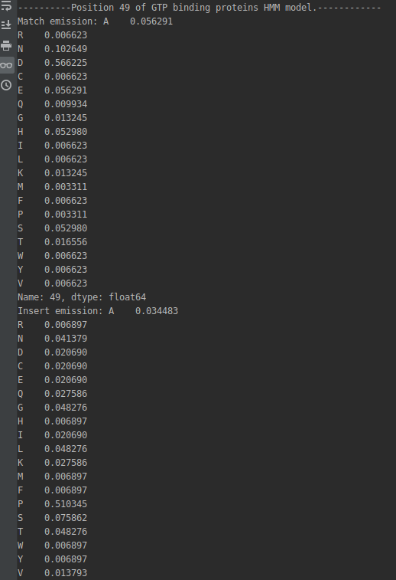

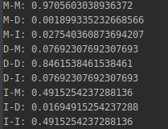
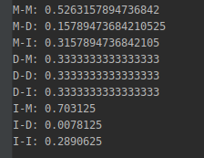

Plot the values q(xi) and include this in your report. Which proteins in the list belong to which family? Can you clearly decide for each protein? (5 points)

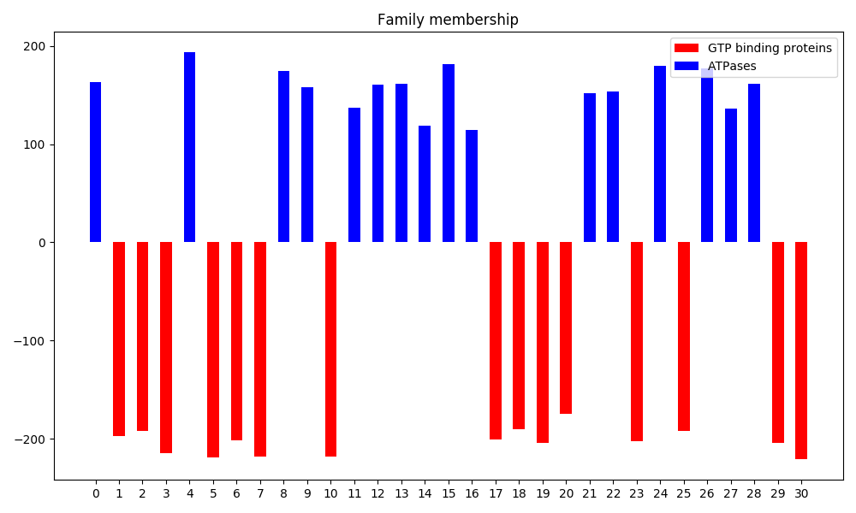
I can really clearly decide to which class given proteins belong.

