Welcome to Scrumbles, a better way to Agile!

*User Guide and Trouble Shooting Manual*

|  |  |
| --- | --- |
| Ryan Feeney | ryanq.feeney@ufl.edu |
| Jesse Martinez | kroronos@ufl.edu |
| Tony Strother | semphy@ufl.edu |
| Stephen Berkner | sberkner@ufl.edu |
| Kyle Collins | Kcoll196@ufl.edu |
| Bryan Fallin | fallinbryan@ufl.edu |

Table of Contents

# 

# **1 FEATURE EXPLANATIONS**

### **1.1 Big Picture**

SRS version 2.0 for Group16 Scrum Manager

Scrumbles is built to show each user all of what they need and none of what they don’t. Depending on a user’s permission levels what they see on the screen will physically change. The views that are available to each user are as follows:

* Developer
  + Customized Developer Home View
  + Team Manager View
  + Sprint View
  + Backlog View
* Scrum Master
  + Customized Scrum Master Home View
  + Team Manager View
  + Sprint View
  + Backlog View

### **Home View**

**Scr**

### **1.1 Team Manager**

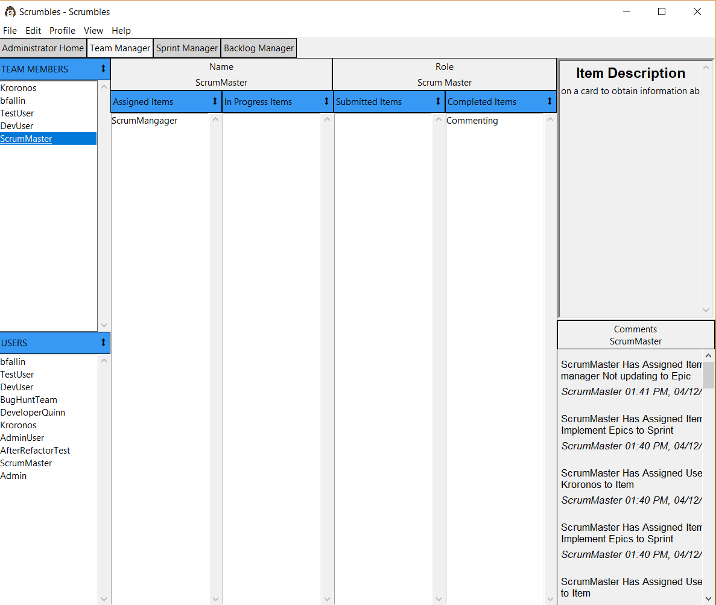

The Team manager view is built around the items that each person is assigned. It answers the question, “What is everyone on my team working on right now?” From within the view the user can look at:

* All the users available in the system.
* All the other users on the user’s team
* The user’s:
  + *Assigned Items*
  + *In Progress Items*
  + *Submitted Items*
  + *Completed Items*
* Each item’s card description and comments