**Software**

**Architecture**

**Document**

*Crossyn Automotive BV*

|  |
| --- |
| **Date** **:** **24-11-2021** |
| **Version** **:** **1.0** |
| **State** **:** **Done** |
| **Author** **:** **Group 4** |

Table of Contents

C1 3

C2 4

C3 5

C4 6

# C1

# C2

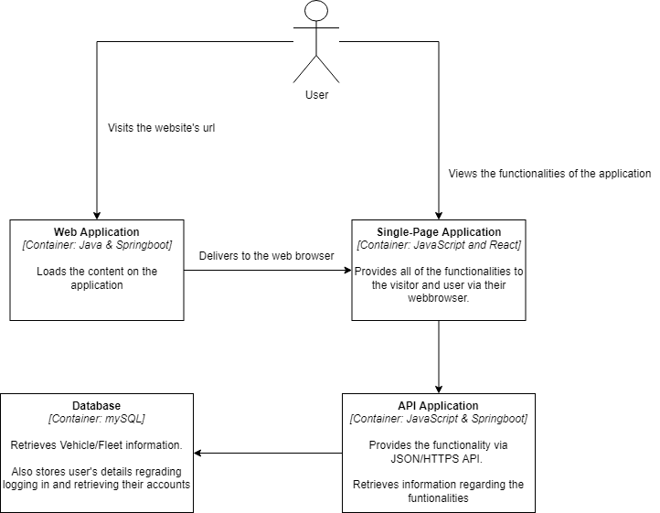

# C3

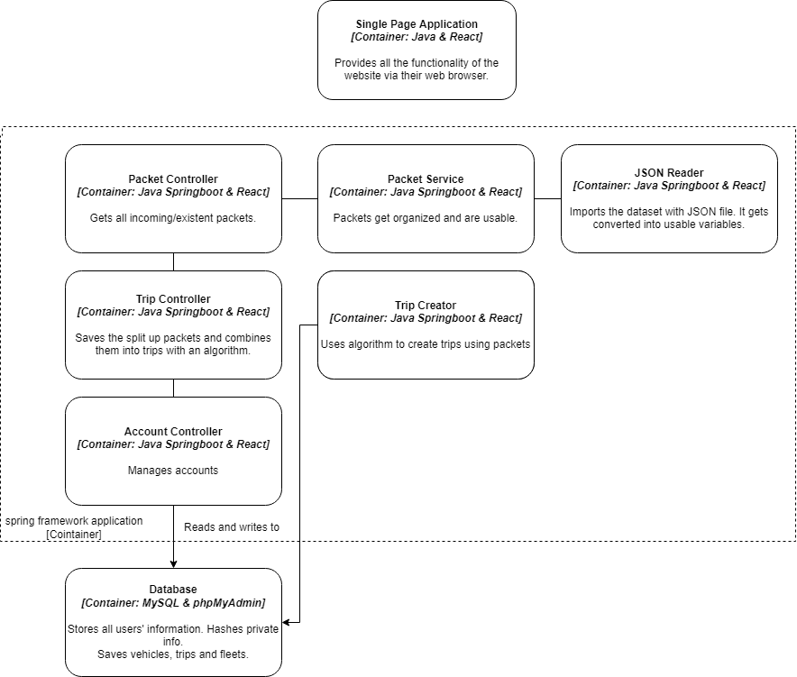

# C4

