**Project Plan**

*Crossyn Automotive BV*

|  |
| --- |
| **Date** **:** **28-09-2021** |
| **Version** **:** **1.0** |
| **State** **:** **Review** |
| **Author** **:** **Group 4** |

#### Version history

|  |  |  |  |  |
| --- | --- | --- | --- | --- |
| **Version** | **Date** | **Author(s)** | **Changes** | **State** |
| 1.0 | 22.09.2021 | Bogaard, Lucas  Rutjens, Jordy  Preslavski, Kaloyan  Hristov, Svetoslav  Savov, Kristian | Created document | Done |
| 1.1 | 28.09.2021 | Bogaard, Lucas  Rutjens, Jordy  Preslavski, Kaloyan  Hristov, Svetoslav  Savov, Kristian | Edited and formatted some parts of the document | Review |
|  |  |  |  |  |

**Distribution**

|  |  |  |
| --- | --- | --- |
| **Version** | **Date** | **Receivers** |
| 1.0 | 22.09.2021 | Roopali Gupta |
| 1.0 | 22.09.2021 | Bram van Herwijnen |

Contents

1. Project assignment 4

1.1 Context 4

1.2 Goal of the project 4

1.3 Scope and preconditions 4

1.4 Strategy 4

1.5 Research questions and methodology 5

1.6 End products 5

2. Project organisation 6

2.1 Stakeholders and team members 6

2.2 Communication 6

3. Activities and time plan 7

3.1 Phases of the project 7

3.2 Time plan and milestones 7

4. Testing strategy and configuration management 9

4.1 Testing strategy 9

4.2 Test environment and required resources 9

4.3 Configuration management 9

5. Finances and risk 10

5.1 Project budget 10

5.2 Risk and mitigation 10

# Project assignment

## Context

To begin with, Crossyn is a company which specializes in data analysis in the automotive world. They collect, analyze and enrich data they receive from vehicles connected to their platform and provide it to the specific customer. The vehicle data may include anything from reporting technical malfunctions to tracking different trips and analyzing driving behaviour. What is more, Crossyn provides their service to both corporate and private clients. Corporate clients may include but are not limited to insurers, vehicle fleet owners and dealerships.

## Goal of the project

Crossyn has alot of data provided by cars they want to use. To be precice they want to make trips out of this data. This way they can take valubale information out of the data they collected. They asked us to create a app that can do this for them.

The goal of the app is to transform the provided data into correct routes. This is done by filtering the data and splitting and mergeing it at the correct places.

The advantage of an app is that it could handle a lot of information at the same time. If someone had to make all the trips by hand it will take ages.

By this application we achieve an automated assessment systeem for the collected trips.

## Scope and preconditions

|  |  |
| --- | --- |
| **Inside scope:** | **Outside scope:** |
| 1. API that can provide trips | 1. Mobile app |
| 1. Simple interface to view trips | 1. Admin interface for CRUD-actions |

## Strategy

In our case we will be using the scrum approach. Due to the educational purpose of the project, every sprint a different team member will be the scrum master, so every one of us can learn what the responsibility of a scrum master is. Each sprint will be 3 weeks long, due to the amount of time we have to complete the project.

The reason why we are using the scrum approach is because scrum is an adaptable, fast, flexible and effective agile framework. Using this kind of strategy will give the customer a way more transparent look on the project and can actively react on the progress of each sprint. Because of this, the development team can react on a timely manner and make sure that the customer wishes are worked on correctly.

We start every workday with a standup meeting to keep all the group members up to date.

After a sprint is completed, it is reviewed. This is done in a sprint review. This meeting includes all the stakeholders of the project. Points are made regarding the progress that has been made.

## Research questions and methodology

**Questions:**

* How to filter data the right way?
* How to create trips out of the given data?
* What types of roads are there?
* How to store the trips before/after creating them?
* How to determine if a car is in a safe parking spot?

To conduct our research we will be relying on the DOT framework.

**Library –** The process of library research is done in order to check for already existing techniques that could help further for the design.

**Field** – In the field research you get to know the end user of the product, their needs, limitations, and the environment that the product is going to be used in.

**Lab –** Lab research consists of testing separate parts of the final product, to check if they work the way you intended them in different scenarios.

**Showroom** – Showroom research can be comparing your work to an already existing product with similar functionalities.

**Workshop –** This kind of research is done by making prototypes and example designs which help gain insight on what can be made and how a certain feature could work.

## End products

* **Trip splitter**
  + The trip splitter would be able to analyze the provided data and will determine if a trips needs to be split, depending on the time difference between data packets.
* **Trip merger**
  + Trip merger would be to analyze the provided trips and determine if there is a need of a trip merge. If the given 2 trips meet the criteria, they would be merged into 1. This will be mainly utilized for cars with start/stop systems.
* **Trip Enricher**
  + The trip enrichment would be used for adding more details to the trip data, making it more precise. In order to achieve that, it would associate the GPS coordinates of the trip to the nearest road, providing additional information regarding the road type, conditions, etc.

# Project organisation

## Stakeholders and team members

|  |  |  |
| --- | --- | --- |
| **Name** | **Role and functions** | **Availability** |
| *Hristov, Svetoslav* *s.hristov@student.fontys.nl* | *Student* | *One day a week min.* |
| *Preslavski, Kaloyan*  *k.preslavski@student.fontys.nl* | *Student* | *One day a week min.* |
| *Rutjens, Jordy* *j.rutjens@student.fontys.nls* | *Student* | *One day a week min.* |
| *Savov, Kristian* *k.savov@student.fontys.nl* | *Student* | *One day a week min.* |
| *Bogaard, Lucas* *lucas.bogaard@student.fontys.nl* | *Student* | *One day a week min.* |
| Gupta,Roopali r.gupta@fontys.nl | *Teacher* | *Wednesday* |
| Bram van Herwijnen | *Stakeholder and product owner* | *At the end of every sprint* |

## Communication

To make sure every memeber of the project is updated in the right way we have a few different meetings.

|  |  |  |  |
| --- | --- | --- | --- |
| Meeting name | Participants | Time | Location |
| Stand-up meeting | Students | At least once per week | School |
| Feedback meeting | Students and teacher | Once a week | School |
| Sprint review | Students, teacher, and stakeholders | At the end of every sprint | School, 2 times at Crossyn |

# Activities and time plan

## Phases of the project

**Initiation:**

* Create Project Vision
* Identify Scrum Master and Stackeholders
* Form Scrum Team
* Create Prioritized Product Backlog

**Planning and Estimation:**

* Create User Stories
* Approve, Estimate, Commit User Stories
* Create Tasks
* Estimate Tasks
* Create Sprint Backlog

**Implementation:**

* Create Deliverables
* Conduct Daily Standup
* Filter Prioritized Product Backlog

**Review and Retrospect:**

* Demonstrate and Validate Sprint
* Retrospect Sprint

**Release:**

* Ship Deliverables
* Retrospect Project

## Time plan and milestones

**Sprint A:**

* Way to read the file with the packets
* Data ingestion from JSON file
* Database and file structure setup
* Trip/data model
* Research document

In our case each sprint is going to be 3 weeks long, set by the Software Development course for semester 3. For educational purposes each sprint there is going to be a different scrum master. We are goung to rotate so everyone can experience what being a scrum master is. A stand up meeting is going to be organized once a week, on Wednesday, when we gather in the building.

|  |  |  |
| --- | --- | --- |
| **Phasing** | **Start date** | **Finish date** |
| Sprint A | 20.09.2021 | 08.10.2021 |
| Sprint B | 11.10.2021 | 05.11.2021 |
| Sprint C | 08.11.2021 | 26.11.2021 |
| Sprint D | 29.11.2021 | 17.12.2021 |
| Sprint E | 10.01.2022 | 14.01.2022 |

# Testing strategy and configuration management

## 

## Testing strategy

For this project we aim for a minimum of 60% code covarage. We are using Continuous integration in GitLab. This will run automated unit- and intergrationtests for our code. Because the main focus for this project is on the back-end we are not sure if we are gonna make a front-end or not yet. So we cant tell if we are gonna use system tests or not.

## Test environment and required resources

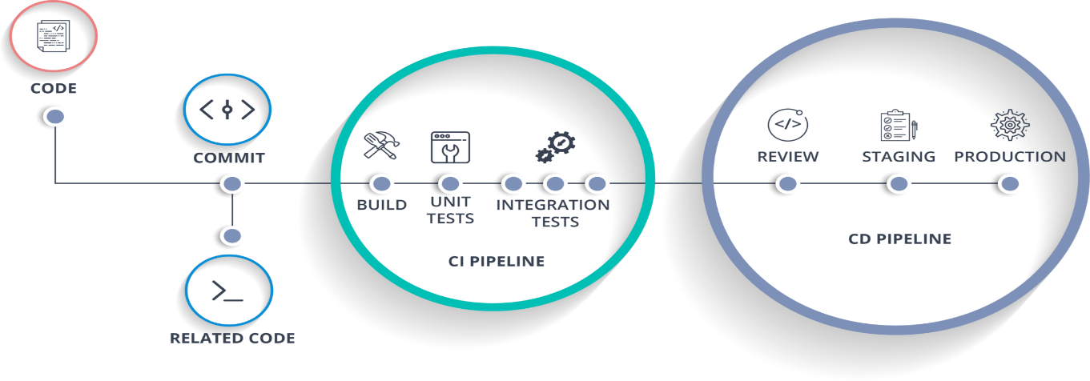

The test environment that we will be using is CI/CD. For the usage of this environment we will be using GitLab, a key component for it is automation. This automation is applied as a pipeline you use to process work, it will make work process simpler to make small code changes, due to the small changes we will be able to get more accurate tests. End-user involvement and feedback during continuous development leads to usability improvements. You can add new requirements based on customer’s needs on a daily basis.

## Configuration management

The version control system used for the project will be GitLab, managed by the educational institution. We will focus on the Git Flow strategy for branching, because it is known to reduce the chance for introduction of bugs. We are going to have a separate branch for each sprint. From the sprint branch we are going to have additional branches for each feature that we are working on.

# Finances and risk

## Project budget

The project is created with an educational purpose, therefore it is not being monetized. All the needed tools are supplied by the educational institution and the product owners, respectively Fontys University of Applied Sciences and Crossyn Automotive BV.

## Risk and mitigation

|  |  |  |
| --- | --- | --- |
| **Risk** | **Prevention activities** | **Mitigation activities** |
| Poor Time Management | Not leave tasks for the last moment | Work regularly and regularly ask for feedback |
| Data Loss | Regular commits to version control system | Never work directly on master branch, make a separate branch instead |
| Lack of communication | Have regular meetings and discuss every issue | Attend all meetings or if a meeting is missed try to catch up as soon as possible |