**Individual Project**

**Software Architecture Document**

**Software Engineering**

**beer.io**

**Fontys**

**University of Applied Sciences**

Prepared by:

Kristian Savov

Table of Contents

Context diagram 3

Container diagram 4

Component diagram 5

# Context diagram

The diagram shows the types of possible users. There are an admin, a moderator and all other uses are normal players. An admin can manage other players’ information, such as changing their login credentials and deleting accounts. The moderator can change data not related to the users. Finally, a player can play the game, look at their collection and see the scoreboard.

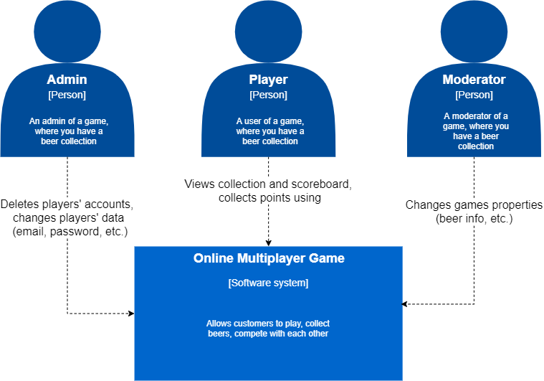

# Container diagram

The container diagram shows a structured way of how the user interacts with the application and how each container is responsible for the user’s interaction.

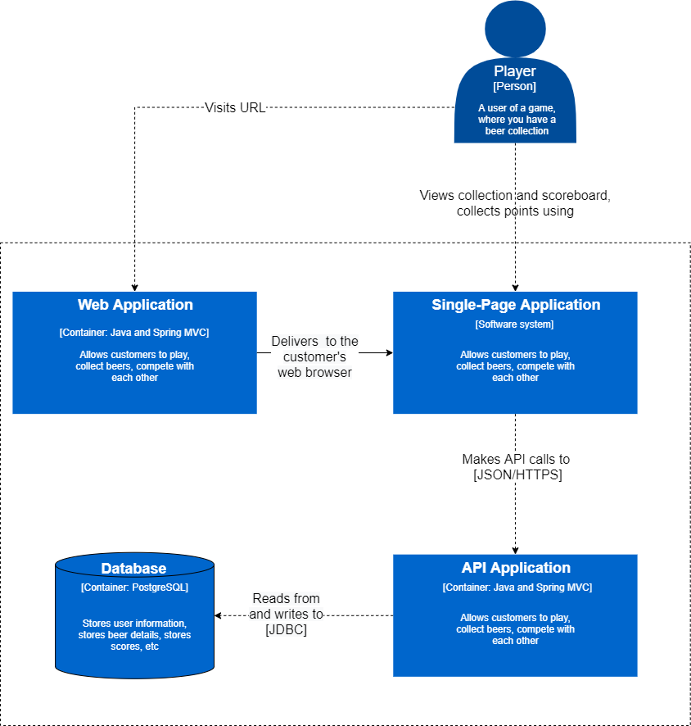

# Component diagram

The component diagram is a more detailed look on how a container works and how its components are structured on a lower level.

