Пензенский государственный университет

Кафедра «Вычислительная техника»

ОТЧЕТ

по практике №2

на тему: «Базы данных»

Выполнил студент группы 22ВВВ1

Николаев А.А.

Принял:

Синев М.П.

Пенза 2024

**Ход работы**

1). SELECT * FROM bookings.seats WHERE seat_no = '15F' ORDER BY aircraft_code DESC;|  
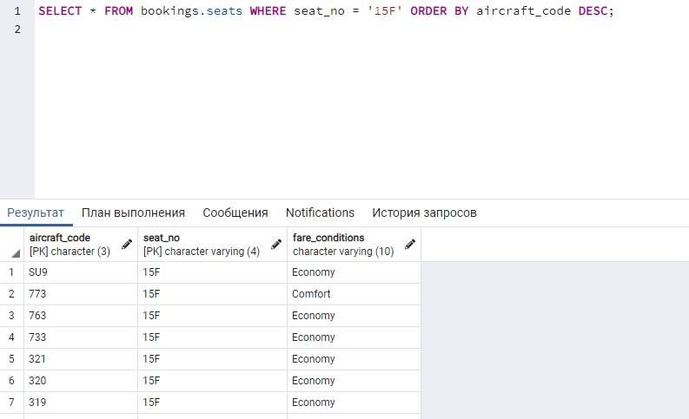

2). SELECT * FROM bookings.flights WHERE status NOT IN ('Arrived', 'Scheduled');  
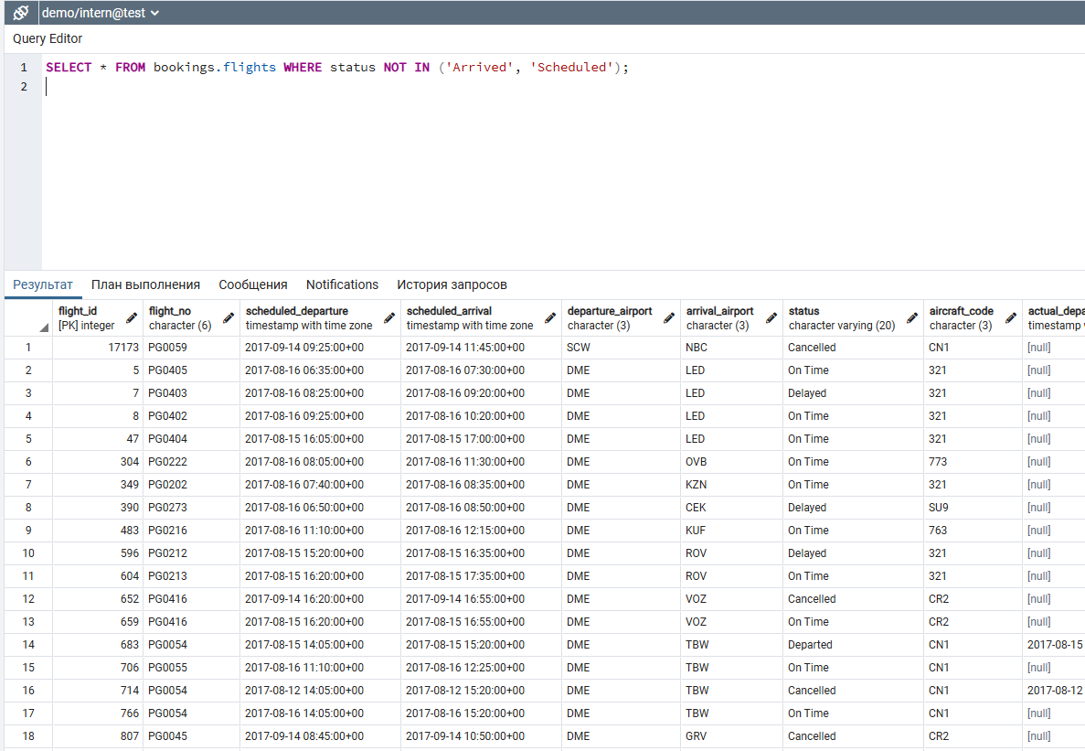  
3). SELECT COUNT(*) FROM bookings.aircrafts_data WHERE "range" BETWEEN 3000 AND 5650;  
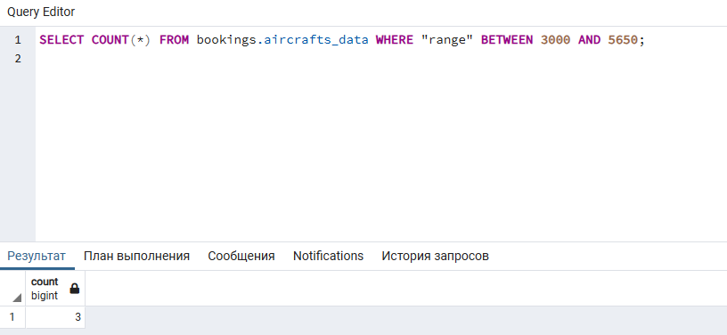

4). SELECT DISTINCT timezone FROM bookings.airports_data ORDER BY timezone LIMIT 5;  
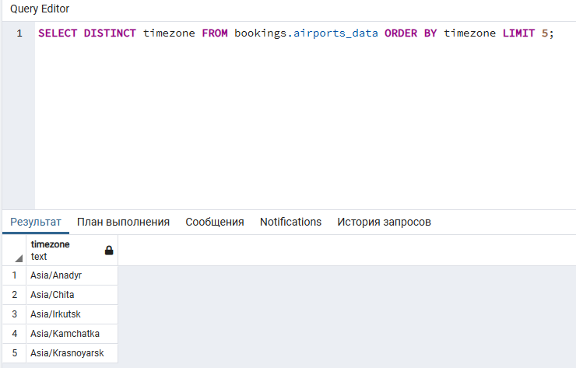

5). SELECT aircrafts_data.aircraft_code, seats.seat_no FROM bookings.aircrafts_data JOIN bookings.seats ON aircrafts_data.aircraft_code = seats.aircraft_code WHERE aircrafts_data.aircraft_code = '320';  
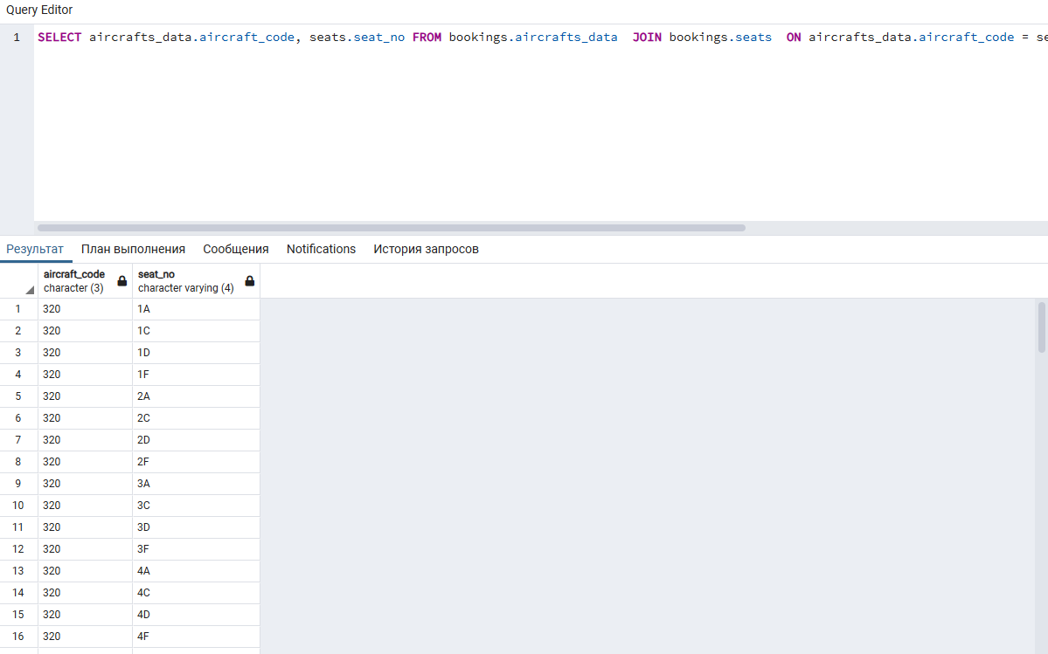

6). SELECT AVG(amount) AS avg_business FROM bookings.ticket_flights WHERE fare_conditions = 'Business';

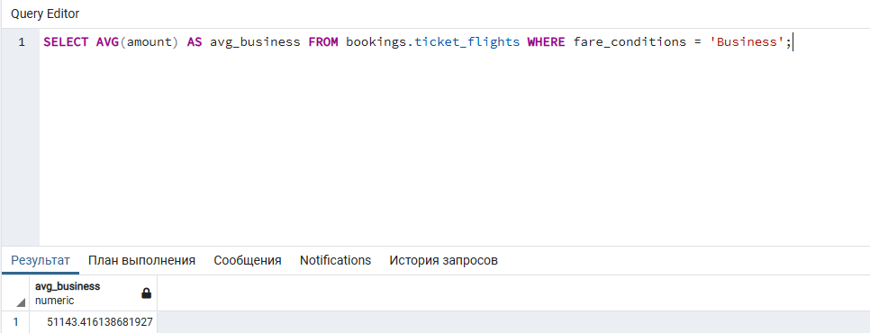

7). SELECT timezone, COUNT(*) AS airport_count FROM bookings.airports_data GROUP BY timezone HAVING COUNT(*) > 3;

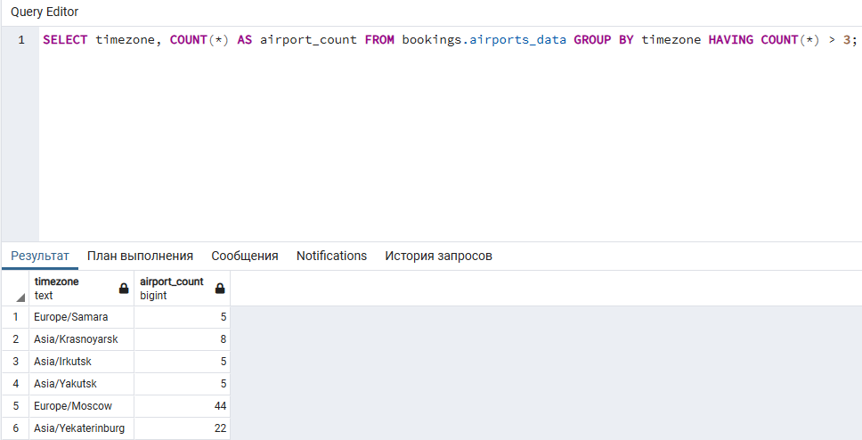

8). SELECT MIN(amount) AS cheapest_ticket_price, COUNT(*) AS cheapest_tickets_count FROM bookings.ticket_flights

WHERE amount = (

SELECT MIN(amount)

FROM bookings.ticket_flights

);  
  
