Mapping Star Clusters

2012/03/04

After talking with Dr. Seab yesterday, he thought it would be neat to make a 3d star map, where I feed some coordinates and it gives you a map of the region. I decided to start with the Hercules’ Cluster since it’s a dense region of space:
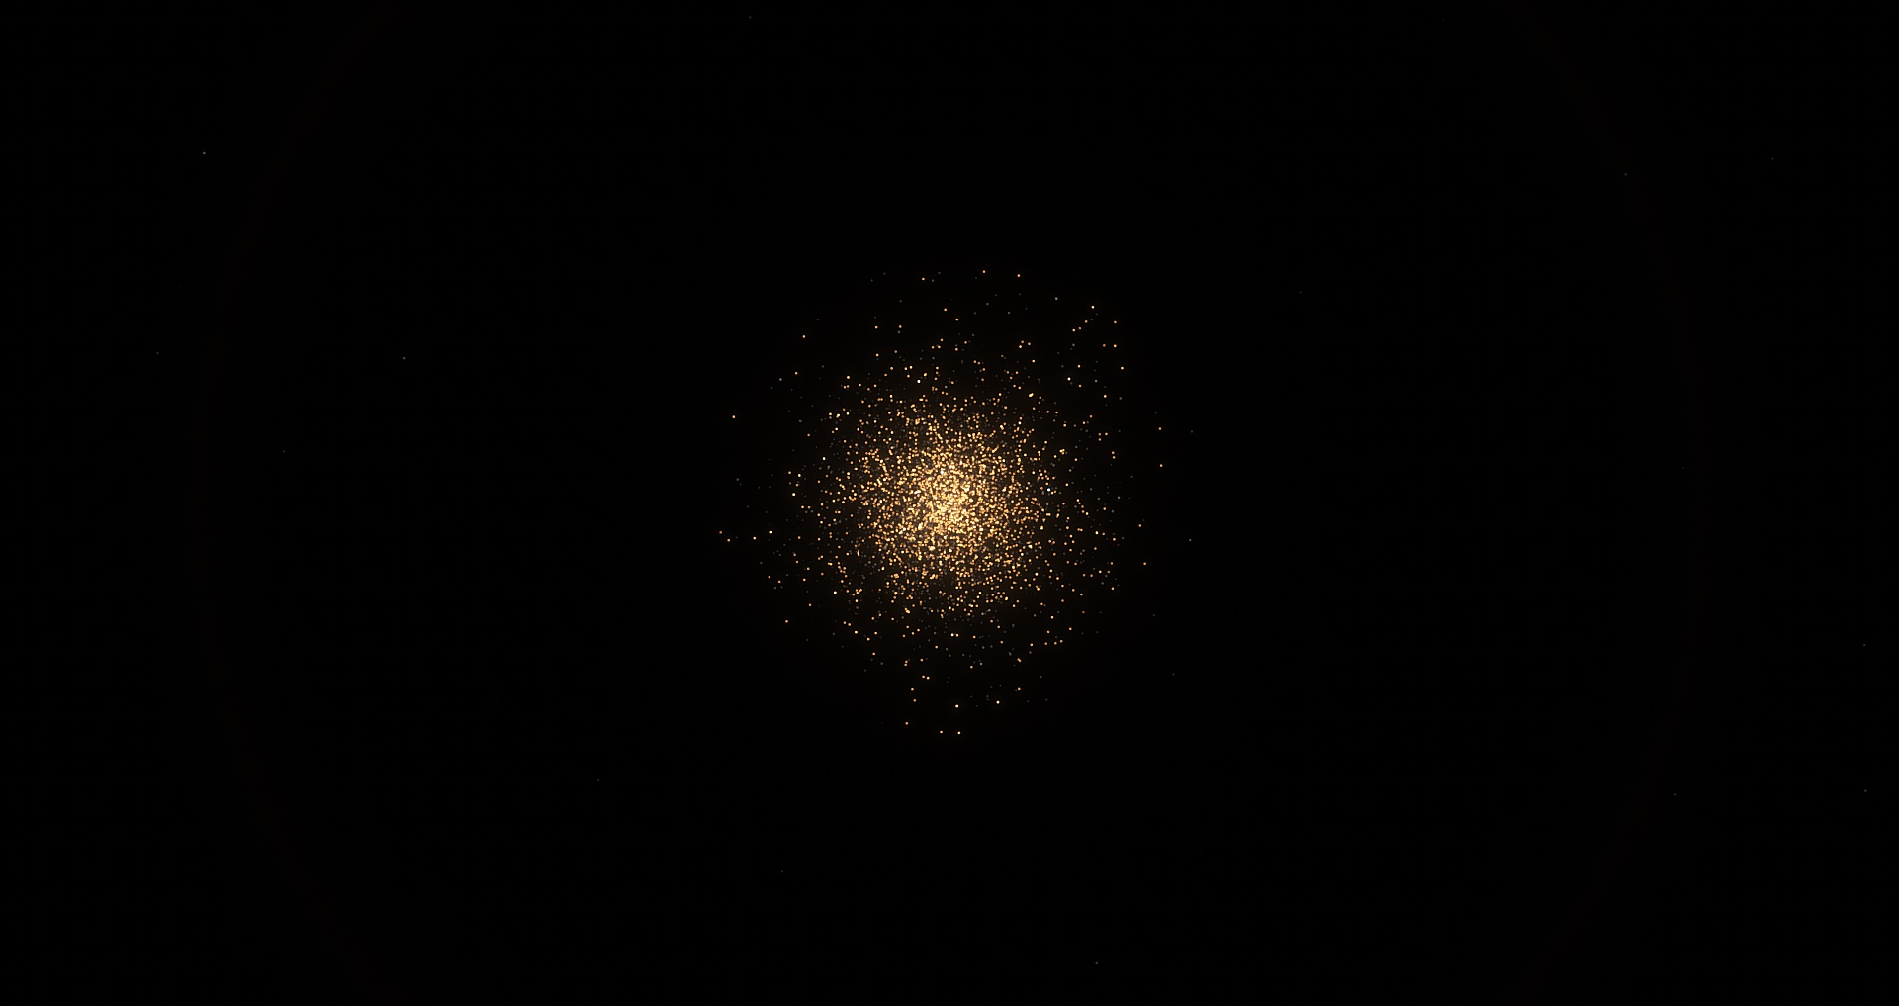
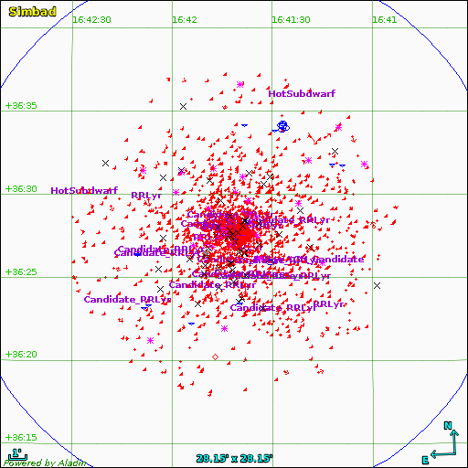
Researching, I found this

(http://simbad.u-strasbg.fr/simbad/sim-plot?ident=M++13&coo=16+41+41.634%2B36+27+40.75&radius.unit=arcmin&x=57&y=57&radius=10)

This website has an interactive map where you can click on the objects and it brings up the star in question. For example, http://simbad.u-strasbg.fr/simbad/sim-id?Ident=NGC%20%206205%20%20%20%2045, which has information on it. I am mainly interested in a coordinate system, so I can map the stars relative to each other accurately on a plane, and the parallax, which gives me distance, so I can properly position them correctly in 3d space. It seems clicking on the outer stars gives me something I need, but the inner stars lack a parallax angle. Nonetheless, I think I can work with this.

Exploring the website for a bit, I found that you can collect the data. http://simbad.u-strasbg.fr/simbad/sim-coo?Coord=16+41+41.634%2B36+27+40.75&CooFrame=ICRS&CooEqui=2000.0&CooEpoch=J2000&Radius=10.0&Radius.unit=arcmin&submit=get+the+list+of+objects

There are around 9000 stars in this plot. It’s way less than 300,000, which is how many are in the Hercules’ cluster, but it’s a great starting point and might be the best I can get it. It does have a list of distances in arcseconds, and it uses a consistent coordinate system called ICRS, or International Celestial Reference System, which seems to be very to equatorial coordinates used in hobby observational astronomy, which I am familiar with, and Dr. Seab is very familiar with, so he can possible be of great help with this part.

I noticed that there’s a “Query” command being “coord 16 41 41.634+36 27 40.75 (ICRS, J2000, 2000.0), radius: 10.0 arcmin”, which to me seem pretty intutitive. You choose a spot in the sky and the radius around it and it gives you your stars. Since, there seems to be no way to just download the current data. I wonder if I can pull it from their website in Python, so I will begin searching for a way to do so.

A beautiful thing about python is that there is almost always a library to do exactly what you want. In this case it’s astroquery. This page tells me how to query SIMBAD, which is where I want to pull the data from.

https://astroquery.readthedocs.io/en/latest/simbad/simbad.html

To install it, I did it as you would any normal python package. I opened a terminal (Linux) and ran:

# pip install astroquery

Then I ran a python3 environment and did the following commands

>>> from astroquery.simbad import Simbad
>>> result_table = Simbad.query_region("m13",radius='0d10m0s')
>>> print(result_table)
MAIN_ID RA ... COO_BIBCODE
"h:m:s" ...
----------------------------- ------------- ... -------------------
M 13 16 41 41.634 ... 2006AJ....131.1163S
NGC 6205 576 16 41 41.6158 ... 2014A&A...566A..58K
Cl* NGC 6205 CGY 5656 16 41 41.7343 ... 1997AJ....113..669C
Cl* NGC 6205 CGY 5665 16 41 41.7393 ... 1997AJ....113..669C
Cl* NGC 6205 CGY 5561 16 41 41.6307 ... 1997AJ....113..669C
Cl* NGC 6205 CGY 5472 16 41 41.5287 ... 1997AJ....113..669C
... ... ... ...
SDSS J164148.72+361755.2 16 41 48.7256 ... 2018yCat.1345....0G
Cl* NGC 6205 CM 1 16 40 53.1433 ... 2018yCat.1345....0G
[SLB2011b] 250.61825+36.41084 16 42 28.381 ... 2009yCat.2294....0A
SDSS J164212.27+361954.6 16 42 12.2725 ... 2018yCat.1345....0G
Cl* NGC 6205 KAD 610 16 42 01.0633 ... 2018yCat.1345....0G
Cl* NGC 6205 KAD 686 16 42 29.3988 ... 2018yCat.1345....0G
SDSS J164228.01+362408.2 16 42 28.0162 ... 2018yCat.1345....0G
Length = 8239 rows

Which seems to be the same exact data I was looking for. I was able to write the data into a .csv file using Astropy
>>> from astropy.io import ascii
>>> ascii.write(result_table, 'm13.csv', format='csv', fast_writer=False)

The file can be read in excel for convenience, or in my case, since I don’t have access to excel because I use Linux, LibreOffice Calc can be used as well.

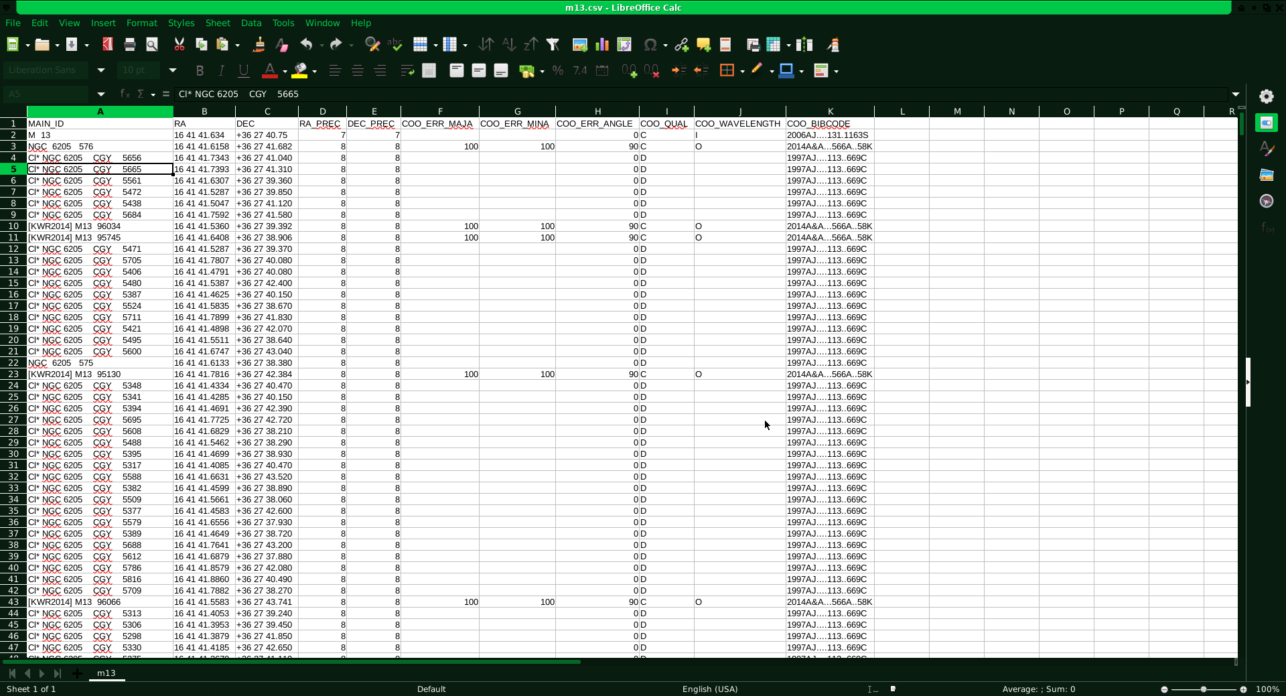
I will try to plot these stars in python so I can see if it indeed resembles M13.

END OF 2021/03/04

3/8/2021

Dr. Seab recommended that I use an open cluster rather than a globular cluster, so I will try everything on m37 for now on, and he gave me more websites to check out. “That may be sufficient, but look at NAVO and CDS as well, and MAST of course.”

NAVO has instructions on how to pull from their catalog in Python: https://github.com/NASA-NAVO/navo-workshop/blob/master/CS_Catalog_Queries.ipynb

Going through it, it seems rather complicated when I want to just plot a group of static stars, so I would only need location and various magnitudes in filters. SIMBAD gives me an easy way to do this.

CDS points me to SIMBAD so they might be related

MAST seems even easier to pull from. I just searched up “m37” and got all the cataloged stars in it https://mast.stsci.edu/portal/Mashup/Clients/Mast/Portal.html

I got a CSV file from them. I will send them (and from SIMBAD) to Dr. Seab and see what he might think be better for creating a map.

03/09/2021

I will begin writing the code to plot these stars.

I can simply read the data like so

from astropy.io import ascii #importing datasets
data = ascii.read("SIMBAD_m37.csv")

for a star, the Right Ascension and Declination coordinates can be read like data[i][1] and data[i][2] where “i” is just any number.

They are not in the most friendly format: 05 52 18 and +32 33.2, for example, so I would need to convert to a usable number to plot.

Nevermind, it’s not tricky, astropy has an object called a “skycoord” and they can accept inputs like that. So to generate a skycoord for a star I do

from astropy import units as u
from astropy.coordinates import SkyCoord
c = SkyCoord(data[0][1] + " " + data[0][2], unit=(u.hourangle, u.deg))
print(c)

and for my first object specifically, I get

<SkyCoord (ICRS): (ra, dec) in deg (88.075, 32.55333333)>

Which seems easily workable with. Thanks astropy!

I ended up plotting it like so:

data = ascii.read("SIMBAD_m37.csv")

ra = data["RA"]
dec = data["DEC"]

star_coords = SkyCoord(ra, dec, unit=(u.hourangle, u.deg), frame='icrs')
ra_rad = c.ra.wrap_at(180*u.deg).radian
dec_rad = c.dec.radian

plt.plot(ra_rad, dec_rad, 'o')

#now we plot!
print(star_coords)

I got

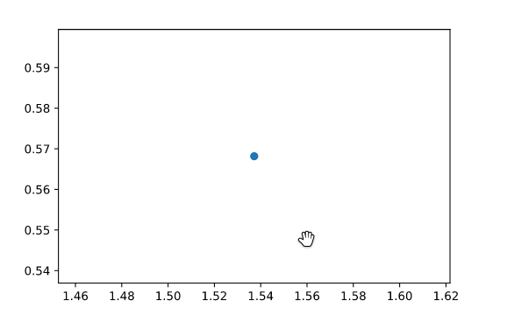

Which is obviously wrong. I’ve been at this for about an hour and a half so I think I will stop here

END OF 3/8/2021

3/9/2021

I will get this plot right, I will just try plotting the coordinates directly.
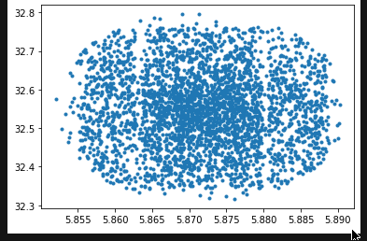

I just did plt.plot(star_coords.ra, star_coords.dec, '.')

It’s something, I will aim to make it look more like a star chart.

Compared to:
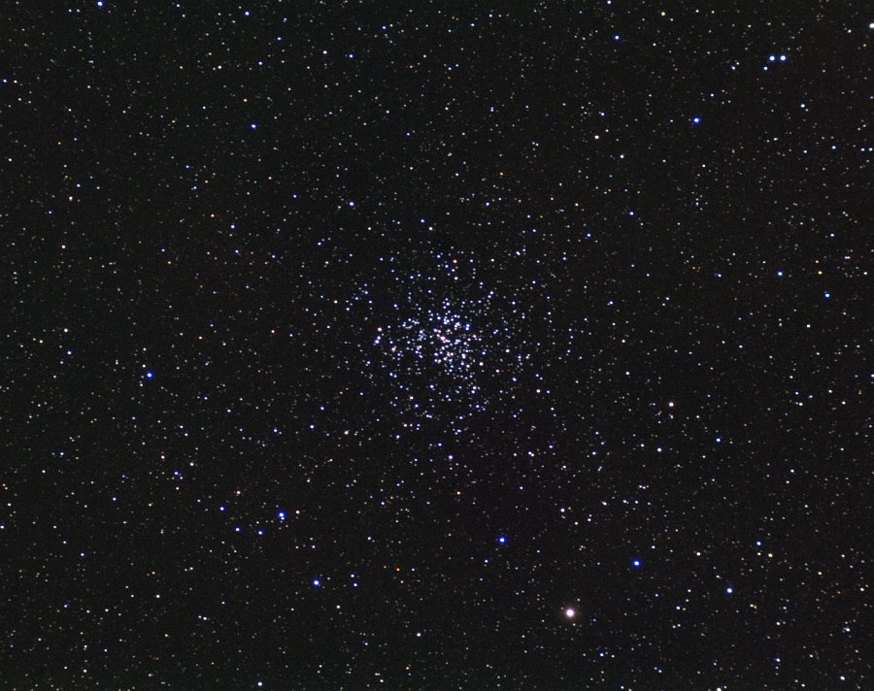

I can’t see and similarities. I imagine my plot is not suitable for a star map. There’s probably a projection I need to apply or something.

From SIMBAD:

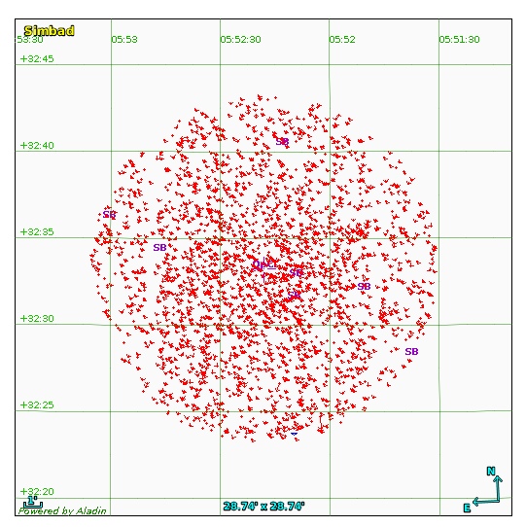
My y-axis is similar in ticking, and the x-axis is similar too but flipped like a typical star map. One thing I should do is make the plot a square.

This is done with plt.figure(figsize=(6, 6))
before the plt.plot().

Plus, I need to flip the x-axis, and add a grid.

After tinkering I was able to look like this:

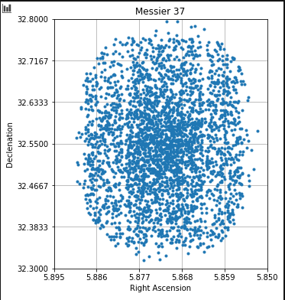

It bares some resemblance to the SIMBAD plot. Although getting an accurate star map plot is not the biggest concern to me, since I will eventually go 3d, and I will be converting these coordinates to 3D Cartesian coordinates and I won’t have to worry about scaling as much.

This was my generation code

from astropy.io import ascii #importing datasets
from astropy import units as u
import astropy.coordinates as coord
import numpy as np
import matplotlib.pyplot as plt

data = ascii.read("SIMBAD_m37.csv")

ra = data["RA"]
dec = data["DEC"]

star_coords = coord.SkyCoord(ra, dec, unit=(u.deg, u.deg), frame='icrs')

plt.figure(figsize=(5, 6))

plt.grid()

plt.xlim(5.895,5.85)
plt.ylim(32.3, 32.8)

plt.xticks(np.linspace(5.895,5.85,6))
plt.yticks(np.linspace(32.3,32.8,7))

plt.title("Messier 37")
plt.xlabel("Right Ascension")
plt.ylabel("Declenation")
plt.plot(star_coords.ra, star_coords.dec, '.')

Now I know that the data isn’t messed, up I can start working towards determining what the z coordinate would be so I can map this cluster in 3d.

END OF 3/10/2021

