Gavin Dominique
Prof. Pradeep Chowriappa
CSC-4993 Foundations of Data Model Selection and Validation
28 October 2025

Bayesian Network Scoring Metrics: AIC, BIC, K2, and BDeu

This report compares four scoring metrics, K2, BDeu, AIC, and BIC, and analyzes their outputs and implications. It is important to explain what each scoring metric does and how they are to be interpreted before analyzing the data found in Exercise 5.

First is the Akaike Information Criterion (AIC) metric. AIC’s goal is to measure how well a model fits the viewed dataset, while also penalizing the model’s overall complexity. It is commonly used to evaluate regression and probabilistic models where the likelihood can be computed simply. It uses the formula:
$AIC= -2ln\left(L\right)+2k$
where L is the likelihood of the model and K is the number of parameters the model contains. The formula uses the log-likelihood as a measure of “best fit” and penalizes for the number of parameters used, since more parameters means the model is more likely to overfit the dataset. The value of this metric can be interpreted as a smaller AIC value indicates a balance between how well the model fits the dataset and how generalized the model can be used.

Next, is the Bayesian Information Criterion (BIC) metric. BIC’s goal is very similar to AICs in that it aims to measure how well a model fits a dataset while also penalizing the model’s complexity. It very commonly used in Bayesian Networks and probabilistic models. It uses the formula:
$BIC=-2\ln\left(L\right)+\ln\left(n\right)k$
Where L is the likelihood of the model, K is the number of parameters the model contains, and n is the model’s sample size. The formula similarly uses the log-likelihood as a measure of “best fit” but includes a penalty for the number of parameters based on the sample size. This leads to larger datasets being penalized more for each parameter used in the model. The metric value can be similarly interpreted as a smaller BIC value indicates a balance between how well the model fits and how simple the model is.

Finally, are the K2 Scoring metric, proposed by Cooper & Herskovits, and the Bayesian Dirichlet equivalent uniform (BDeu). K2 is a score-based algorithm with the goal of finding the most probable network structure given a dataset. Unlike AIC and BIC, which attempt to balance model fit and complexity with penalties, K2 instead uses a Bayesian approach that directly computes a probability of a model for a given dataset. The algorithm assumes that all possible network structures are equally likely and uses the given dataset to find how likely it is that a given model would produce said data. The BDeu method is a more refined Bayesian scoring method that builds on what the K2 algorithm already does. It uses the same overall structure but includes an adjustment so that network structures that represent the same relationships receive the same overall score. The score from both K2 and BDeu can then be interpreted as a higher score means the network structure is more likely to match the given dataset.

Now we can look at the data given from Exercise 5 and see what it tells us.

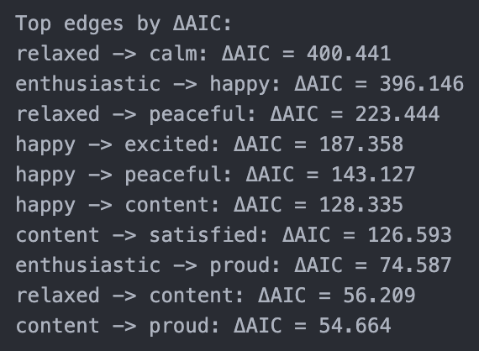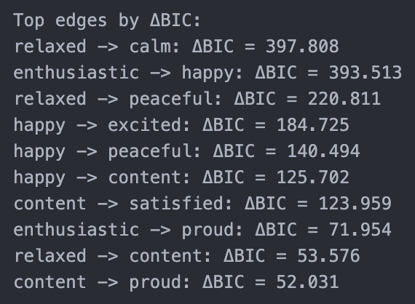
Figure 1: ΔAIC values calculated in the notebook. Figure 2: ΔBIC values calculated in the notebook

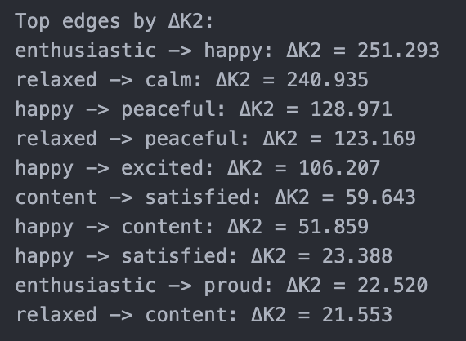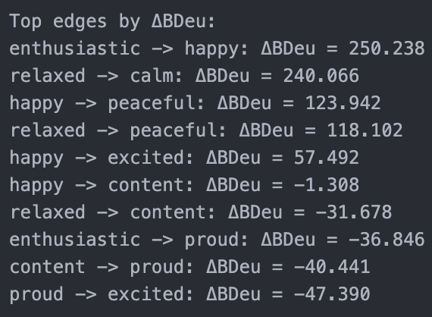
Figure 3: ΔK2 values calculated in the notebook. Figure 4: ΔBDeu values calculated in the notebook

Normally, AIC and BIC metric values are viewed as smaller means better. However, the Δ values are different as they are representing how much the metric has improved after adding a node, hence why the edges from (relaxed -> calm) and (enthusiastic -> happy) are listed as the two strongest relationships based on the model criteria. These values help show that as nodes, edges, and subsequentially relationships, are added to the model, the overall metric values become better. The ΔK2 and ΔBDeu values can be viewed in a similar manner; The greater the Δ value, the greater improvement to the overall metric score. Interestingly enough, the K2 and BDeu metrics also list the edges from (relaxed -> calm) and (enthusiastic -> happy) as the two strongest relationships in the model.
Viewing the calculated values for the different scoring metrics shows that, despite having different methodologies and ways of viewing the models, they all help answer the same question: How good is our model?

