Before Patching

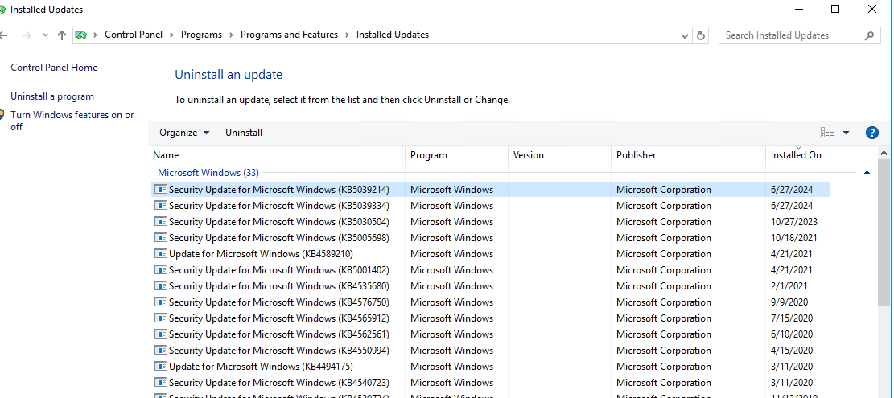

Instance not reachable to Internet

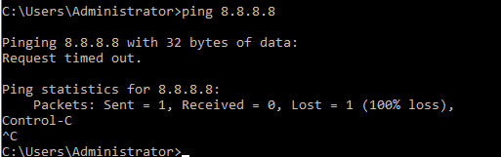

Ran ansible.ps1 script

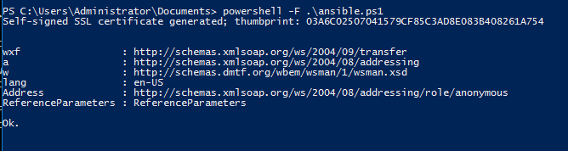

Able to connect ansible to windows server on Winrm 5986 port:

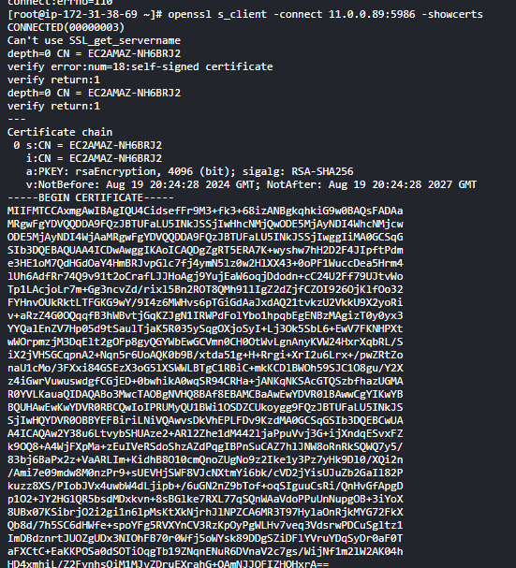

Windows Host file

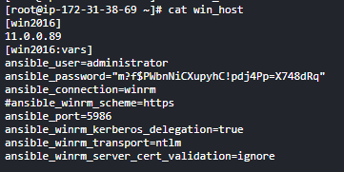

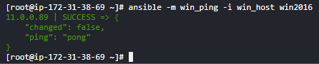

Ansible playbook for July updates

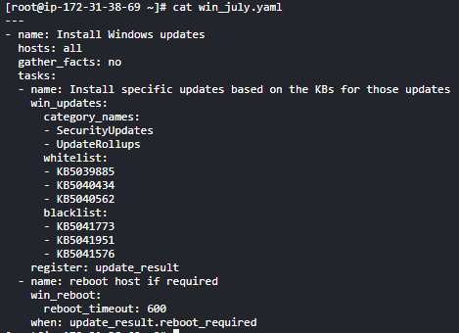

Without internet, error

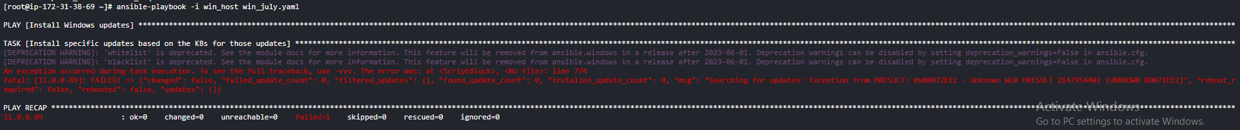

Check ssm agent status

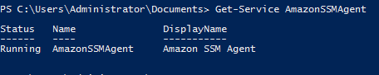

After enabling NAT gateway

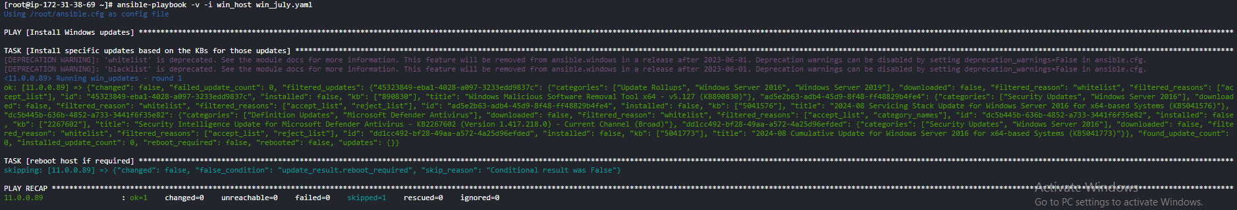

Still Windows didn't get updated

Downloaded all updates to ansible server



Ran playbook sucessfully

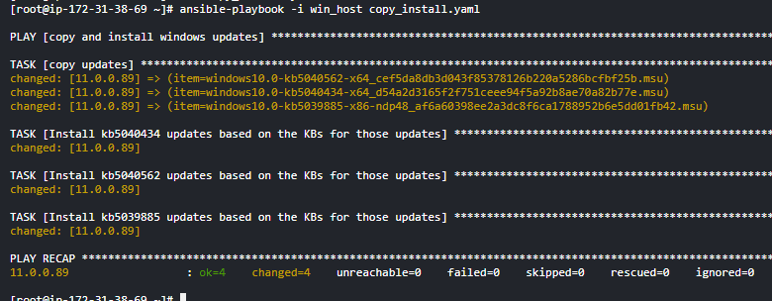

Files got copied to windows

