
SIES GRADUATE SCHOOL OF TECHNOLOGY DEPARTMENT OF COMPUTER ENGINEERING

DATA WAREHOUSING AND MINING (DWM) – LAB ASSIGNMENT REPORT

Group and Project Details
Project Title: CNC Machine Condition Classifier (Gower-style k-NN)
Group No.: 10 Faculty Name: Prof. Kranti Bade Submission Date: 30-10-2026
Student Names and Roll Numbers (all group members):
- Krrish Ankat – 124A1005
- Atharva Amrutkar – 124A1004
- Tanweer Alam – 124A1003
- Kashif Khan – 124A1060

Abstract
Industrial plants need a consistent way to compare CNC machines that differ in configuration, sensor readings and maintenance history. This project implements a mixed-attribute, Gower-style similarity measure and a k-nearest neighbors (k-NN) classifier that assigns a new machine one of three conditions: Normal, Warning or Critical. The labelled dataset has 240 records (80 per condition) with three categorical/ordinal and four numeric features. The system is written in Python 3.14+ using only the standard library, with a command-line interface, a reusable API and nine unit tests. On a deterministic stratified holdout (seed 42; 192 training and 48 test records) with k = 5, it classified 33 of 48 machines correctly (68.8%). This is a preliminary result on one small dataset; the tool supports maintenance decisions and is not production-ready or a guarantee of advance failure detection.

Introduction and Problem Statement
Background. A maintenance team often wants to know how a machine's state compares with machines that have already been assessed. CNC (computer numerical control) machines are described by mixed data: machine type (nominal), coolant leak (binary), maintenance priority (ordinal) and numeric sensor readings. Ordinary Euclidean distance cannot handle such mixtures directly, so a Gower-style distance, which scales every feature to a 0–1 difference and averages them, is used.
Problem statement. An industrial manufacturing company operates CNC machines with different configurations, sensor readings, operating conditions and maintenance histories. It wants an intelligent system that can (1) calculate similarity between machines described by nominal, binary, ordinal and numeric interval-scaled attributes; (2) identify machines with similar operating and degradation patterns; (3) classify a new machine as Normal, Warning or Critical from its engineering characteristics; and (4) use similarity-based analysis to support predictive maintenance decisions. The solution is a mixed-attribute Gower-style similarity measure combined with a k-nearest neighbours (k-NN) classifier.
  - Objectives: (1) load and validate the labelled CSV data; (2) compute similarity between mixed-type machines; (3) predict condition with k-NN and expose neighbours, distances, similarities and votes; (4) provide a CLI and Python API; (5) verify behaviour with unit tests and a preliminary holdout evaluation.
  - Scope and assumptions: decision support only; predictions do not replace engineering judgment. Similarity to past machines does not prove causation. Training labels are assumed to be correct.
  - Constraints: no third-party runtime dependencies; one 240-record dataset; no time-separated or production validation has been performed.

Existing System / Literature Review
Maintenance and condition monitoring. Machine-learning methods are widely studied for predictive maintenance (PdM) and condition monitoring. Carvalho et al. [1] systematically reviewed ML methods applied to PdM and conclude that application performance depends on choosing a suitable method. Surucu et al. [2] reach a similar view in their review of ML-based condition monitoring: effectiveness depends on both data processing and model selection. For CNC machining specifically, Yedurkar et al. [3] review data-driven monitoring of cutting tools in drilling, milling and turning, covering sensors, feature extraction and decision-making models. Many of these approaches are sensor-signal oriented and are not designed to show a maintenance engineer which comparable machines support a result.
Mixed-type similarity. Gower [4] proposed a general similarity coefficient for objects described by a mixture of variable types: each variable yields a comparison score between 0 and 1 (numeric differences are divided by the variable range), and the scores are combined by averaging. Podani [5] later extended the coefficient to ordinal characters, and D'Orazio [6] discusses modified Gower coefficients for distance-based methods with mixed-type variables. This avoids one-hot encoding or rescaling each attribute type separately.
k-nearest neighbours. The nearest-neighbour rule of Cover and Hart [7] classifies a new point using previously labelled points; they showed that, for large samples, its error probability is bounded above by twice the Bayes error. The k-NN form assigns the class most represented among the k nearest points. Because the result depends entirely on the distance used, a Gower-style distance is a natural choice for CNC records that mix machine type, coolant leak, maintenance priority and sensor readings.
Gap addressed. This project combines these established ideas in a small, dependency-free tool whose every prediction is accompanied by the similar labelled machines, their distances and the vote counts. No comparison with other classifiers or threshold-based methods was performed here, so no claim of superiority is made.

Dataset and Requirements
  - Source and size: data/cnc.csv, 240 labelled records, balanced at 80 Normal, 80 Warning and 80 Critical. Format: CSV with one machine per row.
Column | Type / role | Description
machine_id | Identifier (not a feature) | Unique machine identifier
machine_type | Nominal feature | Lathe, Milling or Drilling
coolant_leak | Binary feature | Yes or No
maintenance_priority | Ordinal feature | Low < Medium < High
temperature_c | Numeric feature | Temperature (°C)
vibration_mm_s | Numeric feature | Vibration (mm/s)
spindle_hours | Numeric feature | Operating hours
oil_particle_ppm | Numeric feature | Oil particle reading (ppm)
condition | Target label (not a feature) | Normal, Warning or Critical

  - Input checks (implemented): required columns present; nonempty values; valid condition, priority and coolant-leak values; parseable and finite numeric readings; unique machine IDs. These checks do not verify that readings are physically plausible.
  - Functional requirements: load data; compute distance and similarity; predict condition; list similar machines; reject invalid k, empty or duplicate training data, and prediction before fitting.
  - Non-functional / environment: Python 3.14 or newer, uv for package management, standard library only; modular, typed, immutable data structures. Output: predicted condition, vote counts, and nearest machines with similarity and distance.

Proposed Methodology and System Design
The system is a small modular Python package. Data flow: CSV file → loader/validator → labelled training records → similarity model fitted on numeric ranges → k-NN ranking of training machines for a query machine → majority vote → prediction with neighbours.
Module | Responsibility
cnc_classifier/domain.py | Immutable typed dataclasses and enums: features, machines, labelled records, neighbours, predictions, priorities, conditions
cnc_classifier/data.py | Loads and validates the labelled CSV
cnc_classifier/similarity.py | Fits numeric feature ranges from training machines; computes Gower-style distance and similarity
cnc_classifier/knn.py | Trains the k-NN classifier, finds nearest labelled machines, predicts condition
cnc_classifier/__init__.py | Exposes the public API
main.py | Command-line interface
tests/test_classifier.py | Unit tests (nine)
README.md, pyproject.toml, uv.lock | Documentation of usage and method; uv project setup

Preprocessing and features. No separate normalisation step is applied; instead each feature difference is scaled to 0–1 inside the distance. Seven input features are used: machine type, coolant leak, maintenance priority and four numeric readings. machine_id and condition are never used as features. Reason for k-NN: it handles the custom mixed-type distance naturally and explains each prediction with concrete similar machines.

Algorithm Design
Per-feature difference between machines x and y (each in [0, 1]):
  - Machine type and coolant leak: 0 if equal, 1 if different.
  - Maintenance priority: |rank(x) − rank(y)| / 2, so Low-to-High = 1.
  - Each numeric feature: |x − y| / (max − min of that feature in training data), capped at 1. A feature with zero training range is omitted rather than divided by zero.
Distance and similarity: d(x, y) = mean of the included normalised per-feature differences; similarity(x, y) = 1 − d(x, y). The method is Gower-style and does not claim to implement every feature of every formal Gower variant.
fit(records): # k default = 5
reject invalid k, empty input, duplicate machine IDs
learn min/max of each numeric feature from training set
predict(machine):
for each training record r: d_r = distance(machine, r)
sort records by (d_r ascending, machine_id)
N = first k records
votes = count of condition labels in N
winners = labels with highest vote count
if one winner: return it
else: return winner with greatest total similarity among N
# prediction also exposes neighbours, distances, similarities, votes
Complexity (analytical). For n training records and f features, one prediction computes n distances (O(n·f)) and a sort (O(n log n)); storage is O(n).

Implementation
  - Tools: Python 3.14+, standard library only, uv for environment management; no database. Complete code and setup are in the project repository (README.md).
  - Setup and CLI example:
uv sync
uv run python main.py `
--machine-type Milling `
--coolant-leak No `
--maintenance-priority Medium `
--temperature-c 60 `
--vibration-mm-s 1.2 `
--spindle-hours 5000 `
--oil-particle-ppm 12
  - Optional CLI flags: --k (default 5), --data (CSV path; default data/cnc.csv), --machine-id. The CLI prints the predicted condition, vote counts, and the closest machines with condition, similarity and distance.
  - Python API: load_machines(path); GowerSimilarity().fit(machines) then distance(a, b) or similarity(a, b); KNNClassifier(k=5).fit(training_records) then predict(machine), find_similar(machine) or predict_with_neighbors(machine).
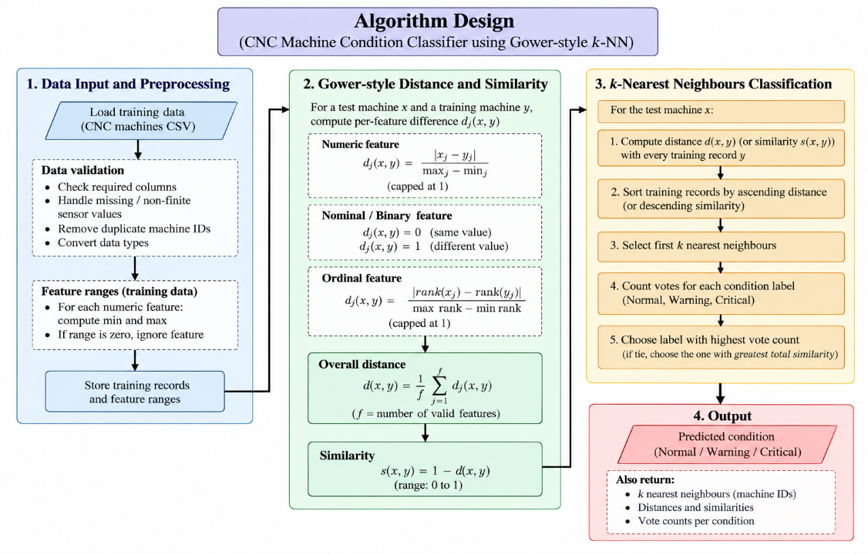

Testing and Validation
Nine unit tests pass. Python syntax checks and Pylance workspace diagnostics were also run, with no diagnostics remaining. Status below reflects the reported passing test run.
Test Case / Input | Expected Result | Actual Result | Status
Mixed-type distance | Correct per-feature differences averaged | As expected | Pass
Numeric scaling and capping | Scaled by training range; capped at 1 | As expected | Pass
Non-finite sensor value | Rejected by loader | Rejected | Pass
Nearest-neighbour prediction | Closest machines drive predicted label | As expected | Pass
Invalid k value | Rejected | Rejected | Pass
Predict before fit | Error raised | Error raised | Pass
Load included CSV | All 240 records and all 3 labels | 240 records, 3 labels | Pass
Train/predict on included dataset | Prediction returned | Prediction returned | Pass

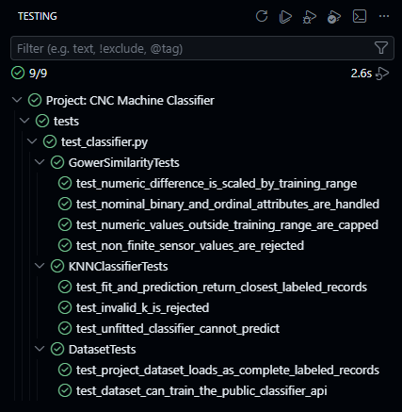

Results and Discussion
  - Evaluation procedure: deterministic, stratified holdout, seed 42; 16 records from each condition (48 test records), remaining 192 for training; k = 5.
Metric | Value | Note
Test records | 48 | 16 per condition
Training records | 192 | Remaining records
Correct predictions | 33 of 48 | Default k = 5
Accuracy | 68.8% | Preliminary, this dataset only

  - Interpretation: the classifier is clearly better than a three-class chance rate of about 33%, but roughly one in three holdout machines was misclassified. No confusion matrix, per-class precision/recall or F1 was computed, so which conditions are confused is unknown.
  - Limitations: one small holdout does not establish performance on future machines, other plants, different sensor distributions or changing operating conditions. Neighbour similarity shows resemblance to past labelled machines, not causes, and the system does not detect failures before they occur. It is not production-ready.
  - Objectives: the implementation objectives (loading, similarity, prediction, CLI/API, tests) were met; predictive reliability is not yet established. (Execution screenshots can be inserted here.)
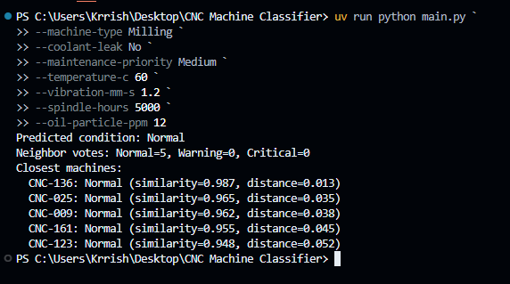

Team Contributions
Student Name / Roll No. | Assigned Role | Contribution / Module
Krrish Ankat – 124A1005 | Team Lead and Integrator | Coordinated development and integrated the command-line interface in main.py.
Atharva Amrutkar – 124A1004 | Data and Domain Developer | Implemented machine data models and CSV loading/validation in domain.py and data.py.
Tanweer Alam – 124A1003 | Similarity Algorithm Developer | Implemented mixed-attribute Gower-style distance and similarity in similarity.py.
Kashif Khan – 124A1060 | Classifier and Testing Developer | Implemented k-NN predictions and unit tests in knn.py and test_classifier.py.
Ensure that contributions of all 10 group members are documented. Add rows or use a compact two-column layout if needed.

Conclusion and Future Scope
The project delivers a transparent, dependency-free Gower-style k-NN tool that classifies CNC machines as Normal, Warning or Critical and shows the similar machines behind each prediction. Tests pass and a preliminary holdout accuracy of 68.8% (33/48) was obtained, which should be treated as an initial indication only.
Future Scope: repeated or time-based validation; class-specific metrics and a confusion matrix; threshold calibration; drift monitoring; validation on representative, time-separated production data; and engineering review of all predictions before operational use.

References
[1] T. P. Carvalho et al., "A systematic literature review of machine learning methods applied to predictive maintenance," Computers & Industrial Engineering, vol. 137, art. 106024, 2019. doi:10.1016/j.cie.2019.106024
[2] O. Surucu, S. A. Gadsden and J. Yawney, "Condition monitoring using machine learning: A review of theory, applications, and recent advances," Expert Systems with Applications, vol. 221, art. 119738, 2023. doi:10.1016/j.eswa.2023.119738
[3] D. P. Yedurkar, T. Schlech and M. G. R. Sause, "A systematic review on smart and predictive maintenance in tool condition monitoring," IEEE Access, 2025. doi:10.1109/ACCESS.2025.3579204
[4] J. C. Gower, "A general coefficient of similarity and some of its properties," Biometrics, vol. 27, no. 4, pp. 857-871, 1971. doi:10.2307/2528823
[5] J. Podani, "Extending Gower's general coefficient of similarity to ordinal characters," Taxon, vol. 48, no. 2, pp. 331-340, 1999. doi:10.2307/1224438
[6] M. D'Orazio, "Distances with mixed-type variables, some modified Gower's coefficients," arXiv:2101.02481, 2021.
[7] T. M. Cover and P. E. Hart, "Nearest neighbor pattern classification," IEEE Trans. Information Theory, vol. 13, no. 1, pp. 21-27, 1967. doi:10.1109/TIT.1967.1053964

