Object Oriented Programming Lab File


LAB – 1

Submitted by Submitted To
Krrish Batra Satyam Tiwari
Btech CSE (CCVT)
Sem-4
500119657
R2142230486

Title-1: Introduction to Java Environment
- Explore the role of JDK, JRE, and JVM
Role of JDK-
The Java Development Kit (JDK) is a key part of the Java environment. It includes everything needed to write, compile, debug, and run Java programs. Since JDK is platform-specific, different versions are available for Windows, Mac, and Unix systems.
JDK contains the Java Runtime Environment (JRE) along with additional tools like the Java compiler and debugger. This means JDK is a superset of JRE, making it essential for developers who want to create Java applications.

Role of JRE –
The Java Runtime Environment (JRE) is what allows Java programs to run. It includes the Java Virtual Machine (JVM), Java libraries, and other essential components needed to execute Java applications.
However, JRE does not include development tools like the Java compiler, debugger, or JShell. It is meant only for running Java programs, not for writing or compiling them.
If you just want to run Java applications and don’t need to write or compile Java code, installing JRE alone is enough—you don’t need the full JDK.

Role of JVM –
The Java Virtual Machine (JVM) is the core of the Java programming language. It converts Java bytecode into machine-specific code, enabling program execution. JVM is platform-dependent and handles key functions like memory management, garbage collection, and security. It is also customizable, allowing users to adjust settings like minimum and maximum memory allocation.
JVM is called "virtual" because it creates an abstraction layer between Java programs and the underlying operating system and hardware. This makes Java "write once, run anywhere," ensuring compatibility across different platforms.
- JDK is for development purpose whereas JRE is for running the java programs.
- JDK and JRE both contains JVM so that we can run our java program.
- JVM is the heart of java programming language and provides platform independence.

- Install the latest available JDK 23 and verify the Java Environment.

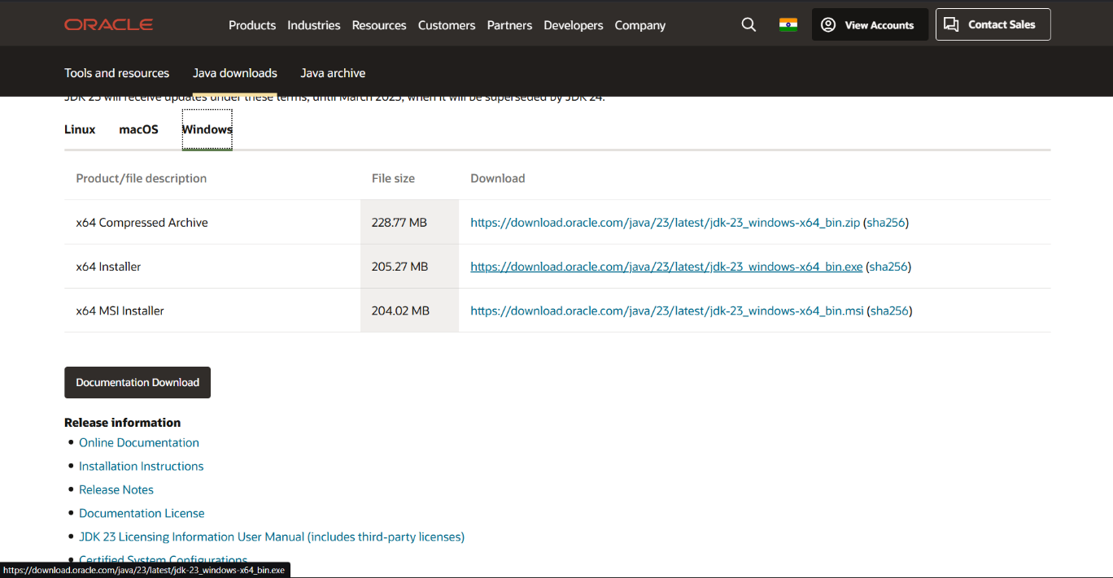

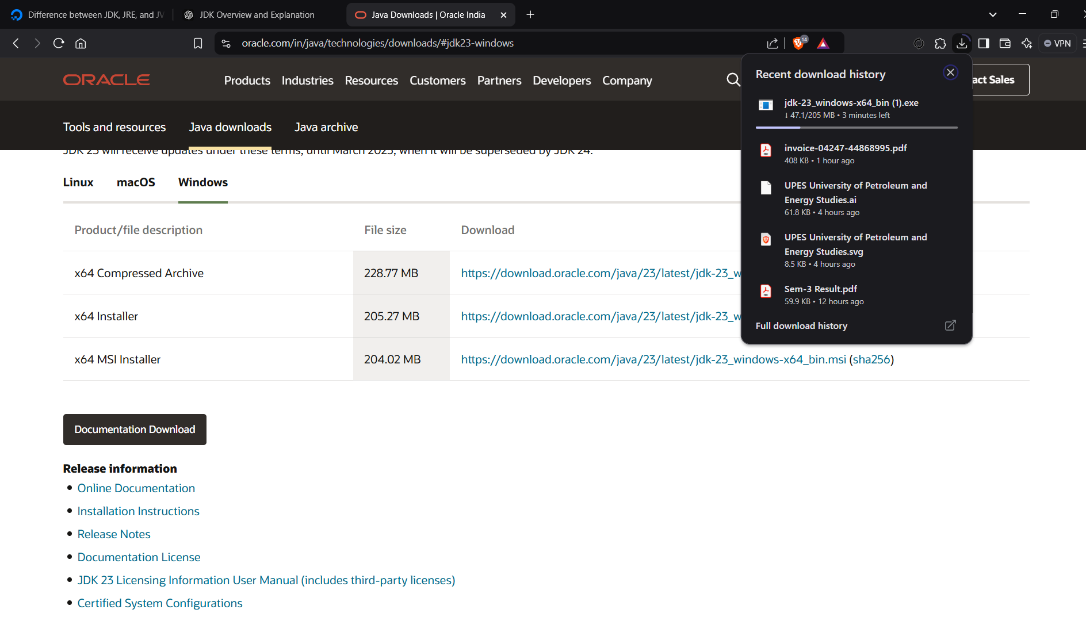
- Create a sample Hello world program using a simple text editor like, notepad and show the steps to compile and execute the program using command line.
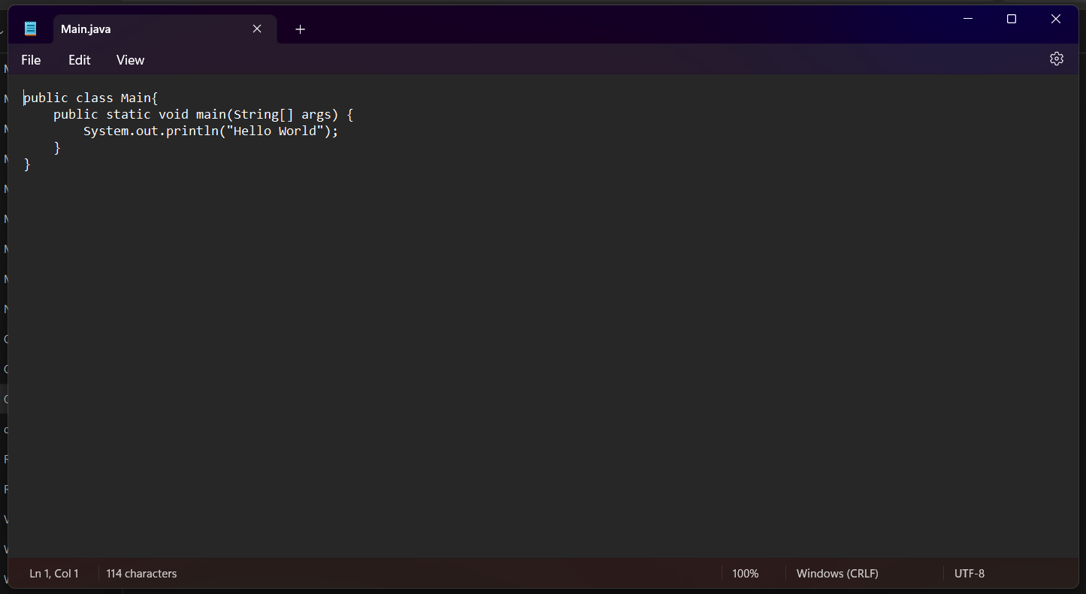

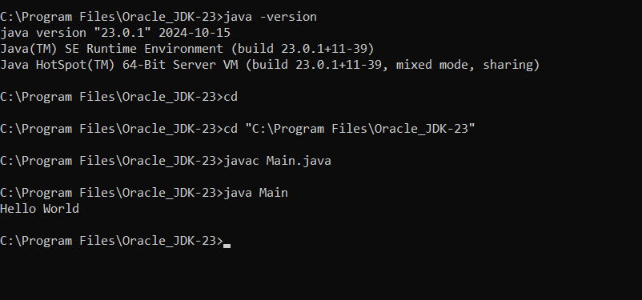

- Display your name and complete address in different lines.
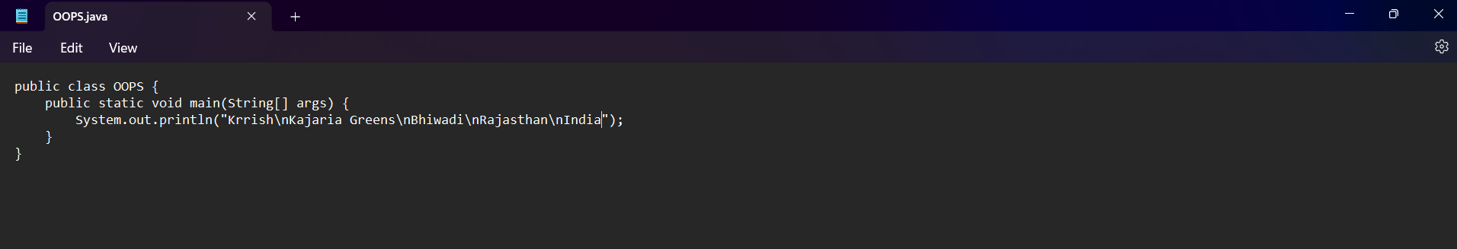

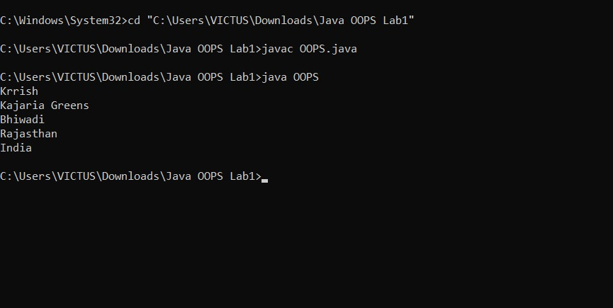
Output-

