Chat-with-Policy-Docs:
A Retrieval-Augmented Generation System
for Government Policy Question Answering

NLP Project Report — Part 1

April 2026

1. Introduction

1.1 Problem Statement
Government policy documents, such as guidelines for Ayushman Bharat - Pradhan Mantri Jan Arogya Yojana (AB-PMJAY), Mid-Day Meal Scheme, and Pradhan Mantri Kaushal Vikas Yojana (PMKVY), are lengthy, complex PDF documents that often span hundreds of pages. Citizens, policy researchers, and implementing officers frequently need to locate specific information — eligibility criteria, coverage amounts, procedural timelines, or compliance requirements — buried within these dense texts. Manual searching is time-consuming and error-prone, particularly when answers span multiple sections or require cross-referencing between documents.
This project addresses the challenge of building an automated question-answering system capable of accurately retrieving and synthesizing answers from unstructured policy PDFs. The core research question is: Can a lightweight, from-scratch Retrieval-Augmented Generation (RAG) pipeline — combining multiple retrieval strategies with a custom-trained decoder-only Transformer — deliver grounded, citation-backed answers from government policy documents?

1.2 Background and Motivation
Retrieval-Augmented Generation (RAG) has emerged as the dominant paradigm for knowledge-grounded question answering, combining the precision of information retrieval with the fluency of neural language generation. While commercial systems rely on large pre-trained models (GPT-4, Claude, etc.) with billions of parameters, this project investigates whether a purpose-built, research-grade RAG system can be constructed entirely from open-source components and a custom Transformer language model trained from scratch on domain-specific data.
The motivation is threefold. First, policy documents in the Indian government context contain domain-specific terminology, abbreviations (AB-NHPM, SECC, FCI, HAFED), and structural patterns (numbered sections, annexures, tabular data) that generic retrieval models may not handle well. Second, building the entire pipeline from scratch — from PDF extraction to language model training — provides deep insight into the strengths and limitations of each component. Third, the system demonstrates that meaningful RAG capabilities can be achieved with a compact model (approximately 20 million parameters) without requiring cloud-scale compute, making it practical for educational and resource-constrained deployments.

1.3 Objectives
The project pursues the following objectives:
- Design and implement a complete document ingestion pipeline that converts raw policy PDFs into semantically coherent, section-aware text chunks suitable for retrieval.
- Build and compare four retrieval strategies — BM25 (sparse), Dense (semantic), Hybrid (score fusion), and Hybrid with Cross-Encoder Reranking — to identify the optimal retrieval configuration for policy documents.
- Train a custom decoder-only Transformer language model from scratch using PyTorch, including a BPE tokenizer trained on the policy corpus, and fine-tune it on question-answer pairs derived from the document collection.
- Develop an answer grounding and citation pipeline that attributes each generated sentence to specific source chunks, computes a faithfulness score, and falls back to extractive answers when generative quality is low.
- Evaluate the complete system using standard retrieval metrics (Recall@K, MRR@K, nDCG@K) and answer quality metrics (Token-F1, Exact Match, Faithfulness) on a curated 597-item QA benchmark.
- Deliver the system as a web application with a REST API and interactive chat interface for real-time policy document querying.

1.4 Significance
This project contributes to the understanding of RAG systems in several ways. It provides a controlled experimental environment where every component — from tokenization to generation — is implemented and trainable, enabling ablation studies that are impossible with black-box commercial APIs. The comparative evaluation of four retrieval methods on Indian government policy documents fills a gap in the literature, which has primarily focused on English Wikipedia or web-scale corpora. The extractive answer fallback mechanism addresses a practical limitation of small language models: even when the generative output is incoherent, the system can still deliver accurate, directly-quoted answers from the source documents with proper citations. Finally, the lightweight architecture demonstrates that useful RAG systems can run on consumer hardware (Apple M-series laptop with MPS acceleration), broadening accessibility.

1.5 Challenges
Several technical challenges were encountered and addressed during the project:
- PDF Extraction Quality: Government PDFs contain inconsistent formatting, scanned pages, multi-column layouts, headers/footers repeated on every page, and tables that break across pages. Robust extraction required boilerplate deduplication via frequency analysis and careful section boundary detection using regex-based heading patterns.
- Small Vocabulary BPE Fragmentation: The BPE tokenizer, trained on a relatively small policy corpus with a vocabulary of 5,182 tokens, fragments common English words (e.g., 'context' becomes 'con te x t'). Since the tokenizer's decoder was not configured for subword joining, a post-processing defragmentation module was necessary to reassemble words while preserving legitimate short words.
- Language Model Quality at Small Scale: A 20-million parameter Transformer trained for 8 epochs on domain-specific QA data produces text that, while topically relevant, often suffers from repetition, echoing of training format artifacts, and inability to perform precise reading comprehension. This motivated the extractive-first answer strategy.
- Cross-Scheme Retrieval Noise: When multiple policy documents are indexed together, queries about one scheme (e.g., PMJAY) may retrieve chunks from unrelated schemes (e.g., PMKVY). Document-scope filtering was implemented to restrict retrieval to a single document when specified.
- Signal Handling in Threaded Environments: The retrieval models' timeout mechanism used Unix signals (SIGALRM), which fail in non-main threads. This required detection of the current thread context to conditionally disable signal-based timeouts when running under the FastAPI/uvicorn web server.

2. Methodology

2.1 Proposed Approach
The system follows a modular Retrieval-Augmented Generation (RAG) architecture comprising five stages: (1) document ingestion and chunking, (2) multi-method indexing, (3) hybrid retrieval with optional reranking, (4) context-augmented generation using a custom Transformer, and (5) answer grounding with citation attribution. Figure 1 presents the complete system architecture.
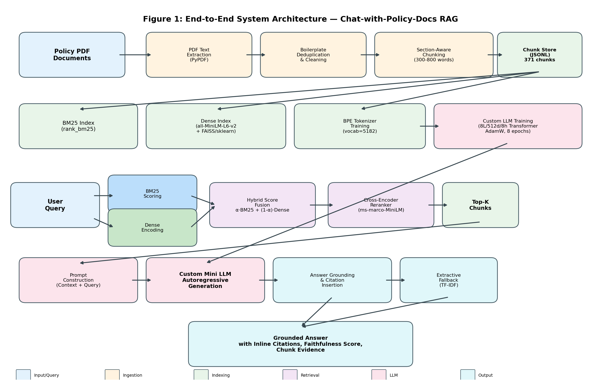
Figure 1: End-to-End System Architecture of the Chat-with-Policy-Docs RAG Pipeline. The pipeline flows from PDF ingestion (top) through indexing, query-time retrieval, generation, and grounded answer output (bottom).

2.2 Tools, Techniques, and Models
Document Ingestion
Raw policy PDFs are processed using PyPDF for page-level text extraction. A boilerplate deduplication step identifies and removes repeated headers, footers, and page numbers by computing line frequency across all pages and filtering lines that appear on more than 40% of pages. Section boundaries are detected using regular expression patterns that match common heading formats (numbered sections like '2.3.6', chapter headers, and annexure markers). Text is then chunked into segments of 300-800 words, respecting section boundaries to preserve semantic coherence. Each chunk is assigned a deterministic chunk_id encoding the document name, section identifier, page range, and counter, ensuring stable cross-referencing. The final corpus contains 371 chunks across three policy documents.
Retrieval Methods
Four retrieval methods are implemented and compared, as illustrated in Figure 2. (a) BM25 Baseline: Uses the Okapi BM25 algorithm (via the rank_bm25 library) with simple whitespace tokenization. BM25 excels at exact keyword matching and is robust to vocabulary gaps. (b) Dense Retrieval: Encodes queries and chunks into 384-dimensional vectors using the sentence-transformers all-MiniLM-L6-v2 model. Nearest-neighbor search is performed with FAISS (IndexFlatIP) on platforms where FAISS is available, with a scikit-learn cosine similarity fallback on macOS. Embeddings are cached with SHA-256 validation to avoid redundant computation. (c) Hybrid Retrieval: Combines BM25 and Dense scores via weighted linear fusion. Each method independently retrieves a candidate pool of 20 chunks. Scores are min-max normalized to [0, 1], then fused as: S_final = alpha * S_BM25_norm + (1 - alpha) * S_Dense_norm, where alpha is a configurable fusion weight (default 0.5). Overlapping chunks from both pools are merged, retaining the higher fused score. (d) Hybrid + Cross-Encoder Reranking: The hybrid method first generates a larger candidate pool of 30 chunks, which are then reranked using the cross-encoder/ms-marco-MiniLM-L-6-v2 cross-encoder. This model scores each (query, chunk_text) pair jointly, providing more accurate relevance estimation at the cost of increased latency.
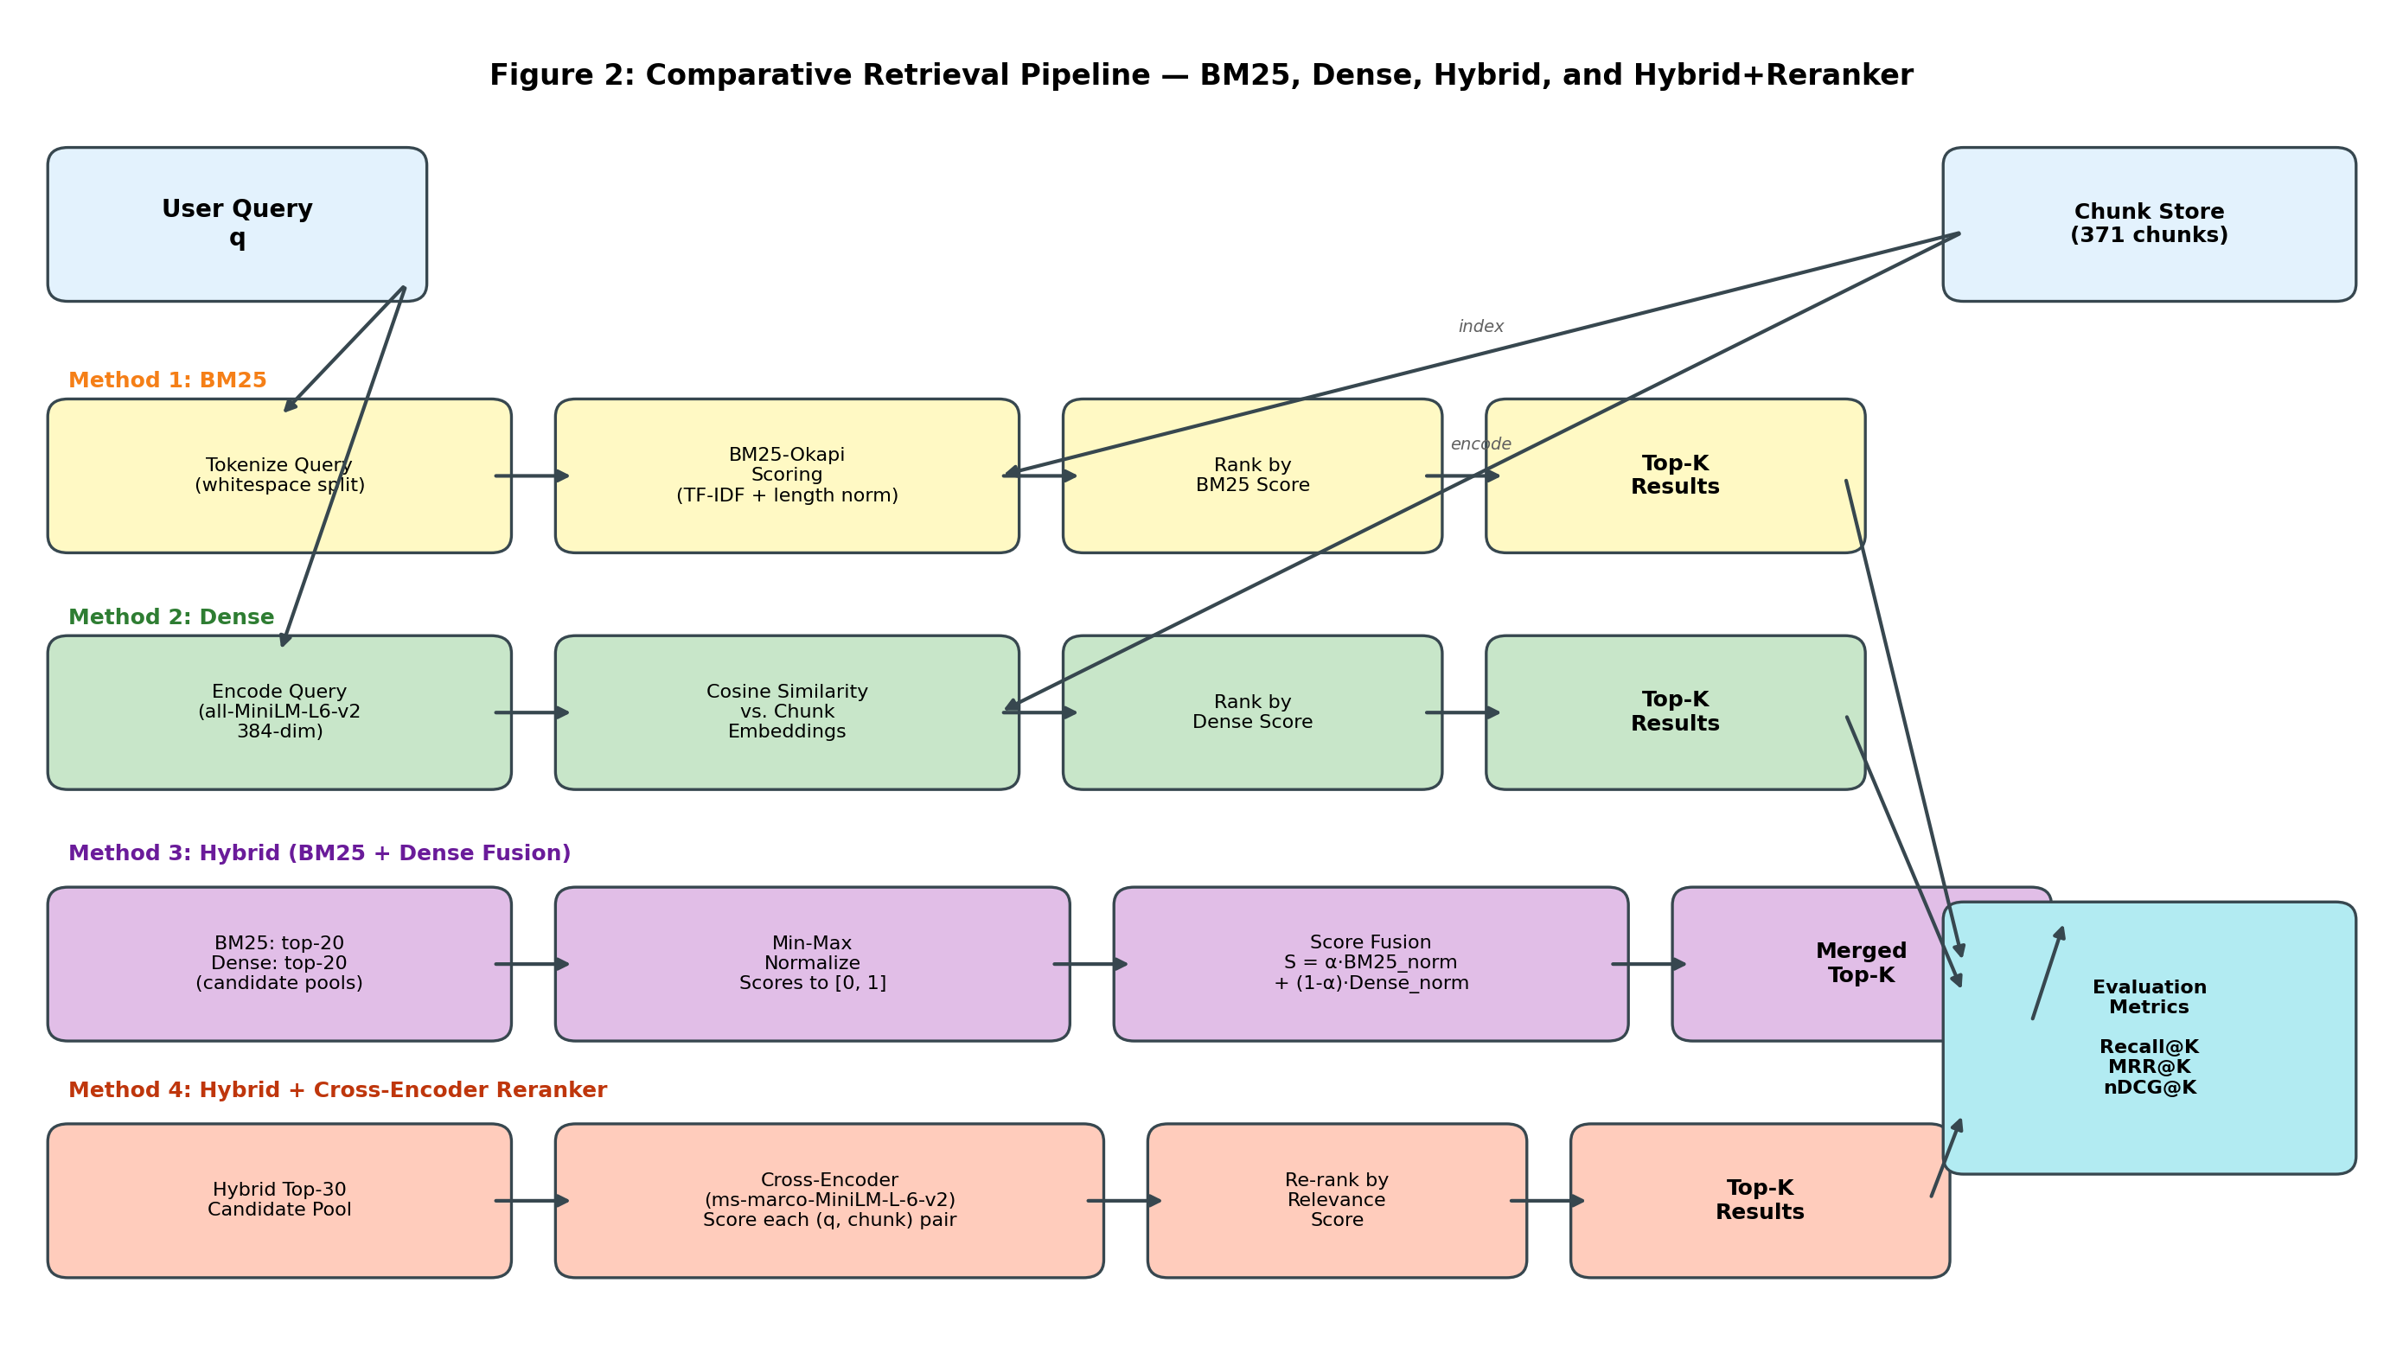
Figure 2: Comparative Retrieval Pipeline. Four methods are evaluated: BM25 (sparse keyword matching), Dense (semantic embedding), Hybrid (weighted score fusion), and Hybrid + Cross-Encoder Reranker. All methods are evaluated using Recall@K, MRR@K, and nDCG@K metrics.
Custom Language Model
A decoder-only Transformer language model is implemented from scratch in PyTorch (without using pre-built Hugging Face model classes). The architecture consists of 8 decoder blocks, each containing multi-head causal self-attention (8 heads, 64 dimensions per head) and a position-wise feed-forward network with GELU activation and 4x expansion (512 to 2048 dimensions). Pre-LayerNorm is applied before each sub-layer, and dropout (p=0.1) is used throughout. Learnable position embeddings support a context window of 512 tokens. The model contains approximately 20 million trainable parameters.
A BPE tokenizer with a vocabulary of 5,182 tokens is trained on the chunk corpus using the Hugging Face tokenizers library, with NFC normalization and whitespace pre-tokenization. The model is trained on a QA-formatted corpus of 597 question-answer pairs (derived from the policy documents) for 8 epochs using AdamW optimization (learning rate 3e-4) with gradient clipping (max_norm=1.0). Training uses a sliding-window approach with block_size=512 and stride=128, running on Apple MPS (Metal Performance Shaders). The final training loss converges to 0.217 with a perplexity of 1.24.
Answer Grounding and Citation
Raw LLM output undergoes a multi-stage post-processing pipeline. First, training artifacts (instruction echoes, stop-string remnants) are stripped via pattern matching. BPE tokenizer fragmentation is corrected using a defragmentation algorithm that merges adjacent short tokens while preserving real short English words via a 200+ word exclusion list. Each sentence in the answer is then checked against retrieved chunks using token-overlap scoring (threshold: 0.3). Grounded sentences receive inline [chunk_id] citations; ungrounded sentences are flagged. A faithfulness score is computed as the fraction of grounded sentences.
When the generative answer is low quality, the system falls back to an extractive strategy that selects the highest-relevance sentences directly from the retrieved chunk text using TF-IDF-weighted scoring. This ensures that even when the small LLM fails to produce coherent text, the user receives accurate, directly-quoted information from the source documents.

2.3 Workflow Explanation
The end-to-end workflow operates in two phases:
Offline Phase (Indexing)
- PDF documents are placed in data/raw_pdfs/ and processed by the ingestion pipeline.
- Text is extracted, cleaned, and chunked into 371 section-aware segments (data/chunks.jsonl).
- A BM25 inverted index is built in-memory from the chunk texts.
- Dense embeddings are computed using all-MiniLM-L6-v2 and cached to data/indexes/dense/ with FAISS indexing.
- The BPE tokenizer is trained on the chunk corpus (data/tokenizer/tokenizer.json).
- QA training examples are generated from the QA dataset by pairing each question with its gold evidence chunks in a structured prompt format (CONTEXT / QUESTION / ANSWER / <END>).
- The custom Transformer is trained on the QA corpus for 8 epochs (data/llm/model.pt, 117 MB).
Online Phase (Query Processing)
- A user submits a natural language question through the web UI or REST API.
- The hybrid retriever fetches candidate chunks from both BM25 and dense indexes, normalizes and fuses scores.
- Optionally, the cross-encoder reranker refines the ranking of the top 30 candidates.
- The top-K chunks are formatted into a context block and inserted into the generation prompt.
- The custom Transformer generates an answer autoregressively with temperature-controlled top-k sampling.
- The answer grounding module attributes sentences to source chunks, computes faithfulness, and applies extractive fallback if needed.
- The final response — including the answer, inline citations, faithfulness score, and chunk evidence — is returned via the API and rendered in the web interface.
Evaluation
System performance is measured using a curated benchmark of 597 QA pairs with gold chunk identifiers and reference answers. Retrieval quality is evaluated with Recall@5, MRR@10, and nDCG@10 across all four retrieval methods. Answer quality is assessed with Token-F1 (token-level overlap with reference answers after stopword removal), Exact Match (normalized string equality), and Faithfulness (fraction of answer sentences grounded in retrieved evidence).

