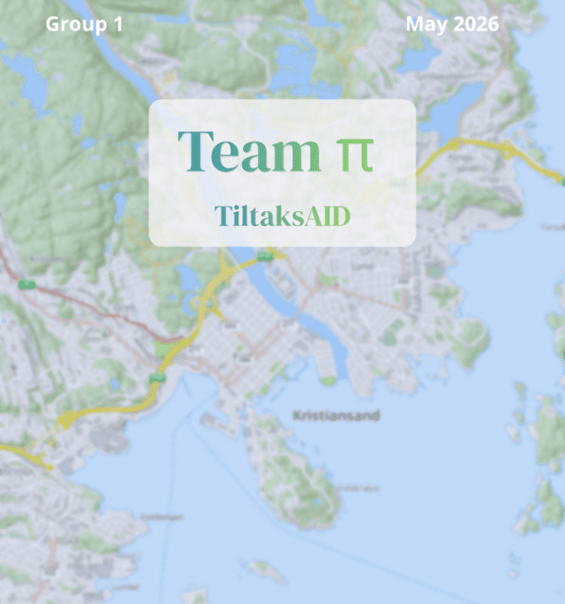


Faculty of Social Sciences
IS-314 26V Bachelor’s Thesis in IT and Information Systems
Team-PI: A map-based guide for construction without planning permission
Group name and candidates: authored by Group 1
Recognised contributors to this assignment:
Mathias José Bull Jørgensen (mjjorgense@uia.no)
Fredrik Schjølberg Husebø (fredriksh@uia.no)
Aaron Silber (aarons@uia.no)
Akinkunmi Oni Akintola (akinkunmia@uia.no)
Elias D. Simonsen (eliasds@uia.no)

Subject code & name | IS-314 Bachelor’s thesis in IT and Information Systems
Client | Kristiansand Municipality
Supervisor | Leona Chandra
Date | 06.05.2026

We confirm that we do not quote or otherwise use other people's work without this being stated and that all references are stated in the bibliography. | Yes  X | No
Can the answer be used for teaching purposes? | Yes  X | No
We confirm that everyone in the team has contributed to the assignment. | Yes  X | No

Preface
This bachelor thesis marks the conclusion of our three-year academic journey in the IT and Information Systems program at the University of Agder. Throughout the project, the team has gained valuable insight into how digital solutions can improve various aspects of society, as well as the importance of structured teamwork, communication, and effective team organization in achieving a successful project outcome.
In the process of writing this thesis, we have made use of AI-based tools, including Claude, Gemini, ChatGPT and Microsoft Copilot, to support our own improvements in language, structure, and clarity. These tools were used solely as writing aids, and all changes were made by the authors.
We would like to express our sincere gratitude to Rune Ødegård and Dagfinn Øksendal for their guidance, coordination, and valuable feedback throughout the project. We also thank Sebastian Thune for his technical support. Finally, we would like to thank our supervisor, Leona Chandra, for her guidance and feedback during the development of this thesis.
This project has been both challenging and rewarding, offering opportunities for professional growth, teamwork, and practical application of our studies. We are proud of the result and hope that our work will contribute to further digital development within Kristiansand Kommune, and potentially inspire similar solutions across other municipalities in Norway.

Table 1: Links to new and old guidance tool solution
TiltaksAID (Demo in appendix 11) | http://dibkveiviser.geokrs.no/  Username: fou  Password: kkfou2026
DiBK’s guidance tool | https://www.dibk.no/verktoy-og-veivisere/bygg-uten-a-soke-garasje

Abstract
This bachelor project was carried out in collaboration with Kristiansand Kommune’s Planning and Building Department and focuses on developing a minimum viable product (MVP) that improves on the DiBK guidance tool solution.
The DiBK’s current solution involves answering many complex regulatory questions while navigating through a maze of external websites trying to find the answer. Our solution demonstrates that introducing a map with the use of drawing tools, and map-metadata to answer many of the questions automatically, decreases cognitive load, improves spatial-to-text translation and can potentially reduce operational strain on municipal workers.
The report outlines the stages necessary to deliver a robust MVP, including several additional features beyond the original requirements. This progress was achieved through effective teamwork, structured work methodologies, and close communication with the municipality. Throughout the process, multiple user-testing and evaluation interviews were conducted to ensure that the team remained on the right track. As the solution is intended for end users, usability was the central focus of the MVP. The resulting MVP has been developed under the name TiltaksAID.
The result is an MVP that showcases how automation and user interaction can enhance the quality and efficiency of municipal digital self-services. The solution also holds potential for broader adoption, as the municipality aims to present it to other municipalities and explore its use as a nationwide model.
Quality assurance has been a central focus throughout the project. In addition to applying structured project quality management practices, we also evaluated the quality of the solution with end-users and expert-users. The insights from these evaluations helped to improve the solution and strengthen the overall quality of the product.

Table of contents:
Preface 2
Abstract 3
List of figures 6
List of tables 7
1 Introduction 8
1.1 Background and context 8
1.2 Research question 9
1.3 The team & DevOps roles 9
1.4 Working with Kristiansand Kommune Planning and Building 10
2 Project management & design methodology 11
2.1 Scrum as Team-level Method 11
2.2 SAFe for Cross-team Collaboration 12
2.3 Planning, time-estimation and resource allocation 14
2.3.1 Planning 14
2.3.2 Time estimation 15
2.3.3 Resource allocation 16
2.3.4 Github projects 17
2.4 Quality Assurance of the Agile process 18
2.5 Risk analysis 19
3 Problem analysis 20
3.1 Data collection 21
3.2 General issues 21
3.2.1 Spatial to Text Translation 22
3.2.2 The Issue of Cognitive Load 22
3.2.3 The Issue of Operational Strain 23
4 Requirements 24
4.1 User Requirement 26
4.2 System Requirements 26
4.3 Organizational Requirements 27
4.4 Branding and identity 28
5 Solution - TiltaksAID 28
5.1 Solution description 29
5.1.1 Justification 29
5.1.2 Solution scope 30
5.2 Solution architecture 31
5.2.1 Device layer 31
5.2.2 Network layer 32
5.2.3 Service layer 32
5.2.4 Contents layer 33
5.3 Deployment architecture 34
5.3.1 CI/CD pipeline & GitHub Actions 34
5.3.2 Docker 35
5.3.3 Azure VM 36
5.3.4 Traefik 36
6 Evaluation 36
6.1 Evaluation criteria 37
6.2 Evaluation method 37
6.3 Evaluation results 38
6.4 Additional observatory findings 40
7 Project execution 41
PI 1(Week 2 - Week 8) 42
PI 2(Week 9 - week 16) 42
PI 3(Week 17 - week 22) 43
8 Discussion 44
8.1 The Confidence and Accuracy Gap 44
8.2 Data correctness and the Value of an Imperfect system 45
8.3 Design Implications and older-user findings 45
8.4 Prioritized changes 46
9 Conclusion 46
10 Reference list 48
11 Appendix: 52
Appendix 1 – Reference from employer 52
Appendix 2 – Record of Logged Hours 53
Appendix 3 – Case (User-testing) 54
Appendix 4 - Summary of findings (User-testing) 55
Appendix 5 – Risk analysis 56
Appendix 6 – The way forward 58
Appendix 7 – Product Increment (PI) Documentation 59
Product increment 1 59
Product increment 2 60
Product increment 3 61
Appendix 8 – Interview guideline (User-testing) 62
Appendix 9 – Evaluation result 63
Status 1 video & evaluation 67
Self evaluation - Aaron Silber 67
Self evaluation - Mathias José Bull Jørgensen 68
Self evaluation - Fredrik Schjølberg Husebø 69
Self evaluation - Akinkunmi Oni Akintola 70
Self evaluation - Elias D. Simonsen 71
Appendix 10 – Group contract 72
Appendix 11 – Demo video 73

List of figures
Figure 1 - Overview of the different group members' roles, scrum values and devops principles. 9
Figure 2: Milestoneplan 15
Figure 3: Burn up chart showing open (green) and finished (purple) tasks over time 15
Figure 4 - DiBK’s guidance tool solution 23
Figure 5: A typical user journey of this solution 29
Figure 6: Solution architecture of TiltaksAID 31
Figure 7: CI/CD deployment process using GitHub Actions and Azure VM. Note. Created by the authors using an AI image generation tool (OpenAI, 2026). 35
Figure 8: Visualization of each PI and sprints 41
Figure 9 - Early prototype 42
Figure 10 - Almost finalized product 43
Figure 11 - Finalized product 43
Figure 12: Statement from Kristiansand Kommune 52
Figure 13: Spreadsheet of logged hours for week 6 53
Figure 14: Case 1 and Case 2 used during user-testing and evaluation 54
Figure 15: Part of the summary of findings, from the initial user testing 55
Figure 16: Commit document made during PI 1-start ceremony 59
Figure 17: Commit document made during PI 2-start ceremony 60
Figure 18: Commit document made during PI 3-start ceremony 61
Figure 19: Parts of the interview guide for user testing with normal users 62
Figure 20: Parts of the interview guide for user testing with expert users 63
Figure 21: Evaluation result for evaluation interview 63
Figure 22: Evaluation result for evaluation interview 2 64
Figure 23: Evaluation result for evaluation interview 3 64
Figure 24: Evaluation result for evaluation interview 4 65
Figure 25: Evaluation result for evaluation interview 5 65
Figure 26: Evaluation result for evaluation interview 6 65
Figure 27: Evaluation result for evaluation interview 7 66
Figure 28: Evaluation result for evaluation interview 8 66
Figure 29: Evaluation result for evaluation, avg results from all interviews 67
Figure 30: Group contract 72

List of tables
Table 1: Links to new and old guidance tool solution 2
Table 2 - Shows specific group roles for each team member 9
Table 3: Quality criteria for the agile process 19
Table 4: Overview showing risks and measurement of risks. 20
Table 5: Summary of requirements 24
Table 6: Evaluation criterion and how to assess them 37
Table 7: Compiled data from evaluation interviews 39
Table 8: improvement for future solution 46
Table 9: Overview of potential risks 56
Table 10: Risk matrix 57
Table 11: The way forward 58

TiltaksAID: A Map-based MVP for Building Permit Guidance

1 Introduction
This bachelor’s thesis was initiated by Kristiansand Kommune, with the goal of creating a clearer and more helpful guide for users planning small construction projects, such as garages, sheds, or annexes. This project focused on developing a Minimum Viable Product (MVP) that would support the creation of a future solution, offering citizens clearer guidance and earlier feedback in the building application process.
The thesis examines how such a solution can contribute to decreased cognitive load, increased spatial-to-text translation and potentially reduce operational strain among municipal workers compared to Direktoratet for Byggkvalitet’s (DiBK) guidance tool. Throughout the project, the group incorporated quality assurance, through the use of agile methodologies, devops, discussions with stakeholders and end-user feedback to maintain consistency in the workflow and ensure that the developed solution aligned with stakeholder expectations.

1.1 Background and context
In Norway, small construction projects such as garages, annexes and sheds are often characterized by strict regulations. While many such projects often don’t need formal planning permission to break ground, determining this is far from straight forward. Citizens must interpret rules concerning building sizes, placement, regulation plans and distances to buildings, roads and neighbours to name a few. These rules are rarely familiar to the general public and often misinterpreted.
To support citizens through this process, DiBK provides a digital guidance tool, designed to help users determine whether they need a permit or not. While the tool represents a meaningful step toward accessible self-service guidance, citizens are expected to supply information about their property by retrieving data from multiple external sources, and translate abstract regulatory requirements into their own specific spatial context.

1.2 Research question
While the digital guidance tool by DiBK attempts to help citizens determine whether their project requires a permit, our research shows that it places a significant cognitive demand on users and provides limited spatial support, leaving many citizens unable to reach a correct assessment on their own. These issues motivated the question: “How can a digital solution be designed to reduce users' cognitive load and support spatial understanding in building-permit processes?” Chapter 3 provides a detailed description of the underlying challenges and introduces the analytical perspectives used to explore this question.

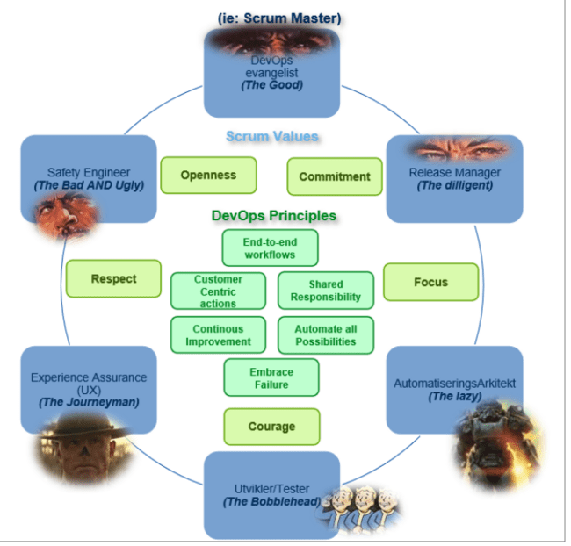
1.3 The team & DevOps roles

Figure 1 - Overview of the different group members' roles, scrum values and devops principles.
The student group behind the project consisted of five members: Mathias José Bull Jørgensen, Akinkunmi Akintola, Fredrik Schjølberg Husebø, Elias D. Simonsen and Aaron Silber. The team has previously collaborated during their studies, and the members are therefore well acquainted with each other’s working methods. To ensure that each member’s skills were used effectively, roles were assigned based on individual competencies and project needs. Figure 1 and table 2 illustrate the different roles assigned to each group member. However, it is important to note that responsibilities overlapped, and some members held multiple roles. This occurred both because some members wanted to gain experience beyond the scope of their primary role and because their existing skills were valuable across different areas of the project.

Table 2 - Shows specific group roles for each team member
Name | Role | Responsibility area
Fredrik Husebø | Experience assurance | Delivers an optimal user experience through aligned prototypes and design elements, and supports the overall website development.
Aaron Silber | Scrum master | Ensures effective team collaboration, clears impediments, and keeps the sprint process aligned and efficient. Developing website
Akinkunmi Akintola | Automation Architect | Oversees CI/CD pipeline integration and DevOps workflows, and contributes to the website’s development as an Automation Architect.
Elias Simonsen | Developer/Tester | Develops and integrates integration tests to ensure code quality and reliability.
Mathias Bull | Safety engineer | Maintains a secure website environment and supports CI/CD integration, DevOps workflows, and broader website development as a safety engineer

1.4 Working with Kristiansand Kommune Planning and Building
The team had weekly office hours at the municipality every Thursday. These sessions were used to work collaboratively on the application, discuss design and technical decisions, and ask clarifying questions related to the ongoing development. Some days were dedicated to meetings with stakeholders to refine the problem understanding and ensure that the solution was progressing in the right direction, while others were used to present our work, demonstrate prototypes, and explain our reasoning.
Our primary contacts within the municipality were Dagfinn Øksendal and Rune Ødegård, who acted as the link between the student group and the municipal organisation. In total, 21 students from the Information Systems programme collaborated with Kristiansand Kommune. The students were distributed across four bachelor projects and one master’s thesis.
The municipality also facilitated several opportunities for collaboration and knowledge-sharing across the student groups. This included team syncs attended by all students working at the municipality, an architecture forum for those in architecture‑related roles, and a Scrum Master forum for students responsible for coordinating team processes. These arenas proved highly valuable, enabling idea exchange, and discussions of shared challenges. They also provided space to ask questions, receive guidance, and align solutions across teams, contributing to a more coherent and well‑informed development process.

2 Project management & design methodology
Developing software systems requires close integration between project management practices and the software development process (Ebert, 2002). For this reason, the team adopted structured methods to plan, coordinate, and evaluate the work throughout the project. This chapter describes the working process the team followed during the development of the application and, in some cases, during the writing of the bachelor thesis. It outlines the methods and practices used, including the Scrum framework, the municipality’s SAFe‑inspired Scrum approach, planning and time-estimation, github projects, quality assurance, a risk analysis and the measures taken to ensure quality in the application. The chapter also explains how tasks were planned, estimated, and prioritised during the development process.

2.1 Scrum as Team-level Method
Scrum was the development methodology used at team level. It was chosen because it is a lightweight framework for developing and evolving complex products, grounded in empiricism and lean thinking (Schwaber & Sutherland, 2020). Through iterative sprints, the team adapted to stakeholder feedback and technical challenges while delivering incremental improvements to TiltaksAID and reduced the risk of misalignment.
The team followed the standard Scrum roles defined in The Scrum Guide: Product Owner, Scrum Master, and Developers. The Scrum Team was self‑managing, without sub‑teams or hierarchies, and shared collective accountability for delivering value each sprint (Schwaber & Sutherland, 2020). The scrum master role supported coordination and removed impediments without introducing hierarchical control, while preserving team autonomy.
The team held a short Daily Scrum each morning to review progress, adjust plans, and identify blockers, using the recurring questions of what was done, what will be done next, and what is preventing progress. When a team member had been stuck for more than a day, the meeting forced the problem into the open where the rest of the team could help resolve it. This helped in removing blockers early and kept work flowing by ending each meeting with a clear sense of what task each person would pick up next.
The team conducted a sprint retrospective at the end of each sprint. The retrospective provided a structured opportunity to evaluate the process, team interactions, and overall effectiveness, and to identify improvements for the next sprint (Schwaber & Sutherland, 2020). In practice this surfaced issues the team could act on. For example, early ceremonies identified inconsistent story-point estimation, and later ceremonies identified that less engaging tasks were accumulating on the board, which the Scrum Master then prioritized in subsequent sprint planning. Identifying these patterns early and acting on them in the following sprint was what made the retrospectives valuable rather than ceremonial.
While Scrum typically includes a sprint review at the end of each sprint, this was replaced by a product-increment (PI) end-ceremony held every seventh week to better accommodate stakeholder availability. This helped with making sure that progress was going in the right direction and stakeholders' vision was incorporated into the solution. Continuous feedback was maintained through ongoing dialogue with stakeholders throughout the sprints, including the weekly Thursday office hours at the municipality, which compensated for the longer interval between formal review ceremonies.
Scrum defines three key artifacts designed to ensure transparency and support empirical decision‑making: the product backlog, the sprint backlog, and the increment. Together, they provided a clear overview of the planned work, sprint progress, and delivered value (Schwaber & Sutherland, 2020). In this project, the team maintained two parallel backlogs in GitHub Projects, one for product development and one for the thesis itself which kept MVP tasks and writing tasks visible without conflating them. These artifacts all aided in effective development by being tools to organise tasks and keeping track of what was planned, what was in progress, and what was actually delivered, which proved especially valuable when reprioritizing in response to user testing feedback.

2.2 SAFe for Cross-team Collaboration
Agile methods were originally developed for small, co-located teams. In large-scale settings with multiple teams, complex products, and external stakeholders, challenges arose related to coordination, prioritisation, and alignment between strategy and execution. The “Scaled Agile Framework” (SAFe) offers a structured and scalable approach for implementing lean and agile methods in large organisations (SAFe Explained, n.d).
In this project, SAFe was treated as a source of inspiration, rather than a doctrine to be implemented in its entirety. This deviation from SAFe in its prescriptive form as described in the official documentation was intentional and grounded by the group's tech contact Rune Ødegård. According to Rune (R. Ødegård, personal communication, January 16, 2026), full SAFe implementation is most effective when the problem-space is relatively stable, can be planned with a reasonable amount of confidence and when the dominant challenge is large-scale coordination rather than exploration and learning. This program operated in a research and development environment characterized by uncertainty, evolving problem definitions and variations in technical requirements between the teams. In such cases, full SAFe governance mechanisms risk constraining learning, reducing team autonomy, and creating a false sense of control though formal procedures rather than actual progress. Therefore, selected concepts were adopted where they add clear value, while other concepts were deliberately removed when they conflict with the exploratory nature of work.
Central to this selective adoption of SAFe, was the use of Agile Release Trains (ARTs) and program increments to establish a shared sense of direction and cadence across teams, without reducing team autonomy.
In this project, the work was structured into three program increments (PIs) of seven weeks each. Cross-team transparency was emphasized to ensure that dependencies and overall progress was visible beyond the backlog of other teams. This was achieved through cross-team ceremonies, including scrum master meetings, architect forums, team-syncs, PI-start- and PI-end meetings orchestrated by Rune Ødegård. Decisions at program-level were deliberately kept in use to ensure alignment with the overarching program goals. Additionally, the release train engineer (RTE) role was used to support communication and dependency management across teams, rather than to impose hierarchical control. This approach preserved team autonomy, while still enabling effective coordination across teams throughout the project.
Although our project was largely independent, the SAFe framework enabled valuable exchanges with the other groups whose perspectives and challenges helped us avoid similar mistakes. The primary benefit, however, was the synchronized rhythm across all teams, which enabled stakeholders to monitor progress throughout the project's lifecycle.

2.3 Planning, time-estimation and resource allocation
This section describes how the project was planned, how we estimated progress, workload and managed resources. Together, these aspects form the basis for carrying out the work effectively and adapting to changes along the way.

2.3.1 Planning
Effective planning is foundational for any project. It defines scope, allocates resources and establishes a shared sense of direction. Critically, it also shapes all subsequent actions and decisions throughout the project lifecycle. Planning also establishes a benchmark against which progress can be measured and priorities be reassessed (Ayele, 2023). Without it, teams risk scope creep, misaligned effort, and schedule overrun.
Given the nature of this project, a fixed upfront plan would have been counterproductive. In traditional project management the assumption is that the events affecting the project are predictable and that once a task is finished it won't be revisited (Zhang et al., 2010). These assumptions are not suitable in environments where requirements evolve and knowledge is developed during the project. As a result, the project required an agile planning approach inspired by SAFe scrum. Initially, the team defined a high-level vision of the MVP to establish direction and scope. Based on this, the team followed a general milestone plan developed by the RTE, which guided overall progress and served as a benchmark against which progress could be measured. Within that structure, work was broken into PIs and shorter Scrum sprints, allowing priorities to be reassessed continuously as the team's understanding of the problem evolved. The figure below shows the milestone plan.
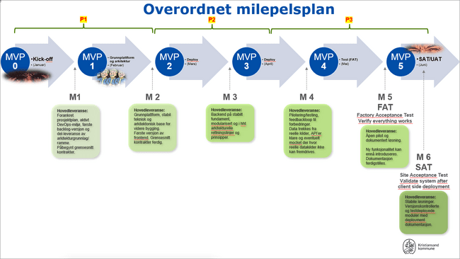

Figure 2: Milestoneplan

2.3.2 Time estimation
Story points are a relative unit used to estimate the required effort to complete a work item in agile software development. Rather than measuring time directly, story points represent the relative effort of a task, taking into account factors such as complexity, size and uncertainty (Pasuksmit et al., 2022). During sprint planning and backlog refinements the team estimated story points using Planning Poker to ensure collective input and shared understanding among team members. By assigning relative values to tasks, the team was able to prioritise work and, balance sprint capacity and monitor progress across iterations.
Progress was tracked using burn up charts, which plots completed story points against total planned scope over time. This way, progress was made visible to the whole team and surfaced scope changes when they occurred.
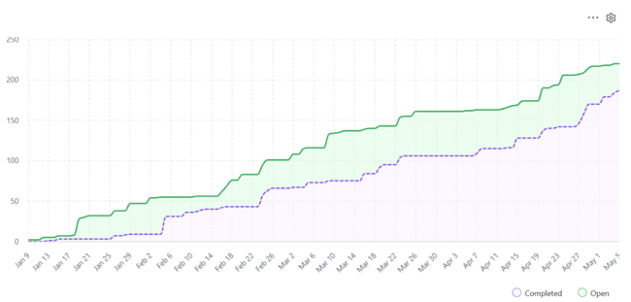

Figure 3: Burn up chart showing open (green) and finished (purple) tasks over time
The use of story points aligns well with the project's uncertain and evolving project contexts, where tasks cannot be fully defined in advance. For the team this meant that planning focused on relative effort rather than getting stuck on precise time predictions, keeping sprint planning productive even when uncertainty was high. Story points also suit self-organized scrum teams particularly well, as the collective estimation process ensures that all members have a shared understanding of scope and effort, rather than having workload defined top-down (Maha et al., 2026).
Story points proved useful for structuring sprint planning but also revealed several limitations. Estimates were inherently subjective and depended on team experience and shared understanding, which took time to develop. Early in the project, before the team had an established velocity, these challenges were particularly evident. The team struggled to balance the number of tasks per sprint and align appropriate story points per task.
Without a historical reference, estimates were largely based on intuition. Sprint retrospectives helped identify where estimates had been inaccurate and why, allowing the team to gradually establish a consistent velocity. Over time, burn‑up charts became a reliable reflection of actual progress rather than initial estimates.
During the task allocation it became evident that bigger tasks were harder to estimate and more often lead to people feeling stuck. These issues were fixed by dividing the tasks into smaller more concrete tasks which lead to better workflow and time estimation overall.

2.3.3 Resource allocation
Resource allocation as it is described by Karlsen (2021) is centralized and predictive, where the project manager estimates hours, matches tasks to people, and produces a schedule that allocates available resources to maximize their use. In a self organized scrum team using story points, this mechanism was absent.
Still, resource allocation happened, but in a different way. As mentioned in section 2.2.2, story points were used as a relative estimation technique to capture complexity, effort, and uncertainty, rather than as a direct mechanism for resource allocation. Resource allocation was instead performed indirectly through the team’s observed velocity, which provided an empirical indication of team capacity per sprint. This allowed the team to regulate workload and scope without translating estimates into time.
In the self-organized environment, team members were able to assign themselves to tasks as they became available. As a result, workload distribution emerged from capacity rather than being imposed by the scrum master. This way, autonomy was preserved without creating chaos. The next task could begin without needing anyone to coordinate work, reducing idle time. Furthermore, a team member who chooses their own task takes ownership of it, meaning there was little grounds for claiming confusion of responsibility. This is consistent with Self-Determination Theory, which suggests that autonomous behavior is associated with a greater sense of ownership and autonomy (Deci & Ryan, 2000).
The biggest challenge the team faced was estimating how many productive hours could be delivered in a set period. The deviation between planned and actual hours was driven mainly by the unpredictability of a student’s schedule. Teaching-assistant work, paid jobs, illness, job interviews and exam preparation all reduced available hours in ways that fluctuated week-to-week and rarely showed up clearly in advance. The team had a system to encourage attendance, including a small fine for being late without 24 hours' notice, which had little measurable effect on the deviation.
Having clear sprint goals based on the PI goals and only allocating work to tasks that lead to the closure of these goals helped in minimizing scope creep. Internal enthusiasm and stakeholder interest produced recurring pressure to expand scope, and defending the MVP was itself an allocation choice. Scope creep isn’t always a bad thing, but in our case the goal is to make an MVP which means, finishing the initial scope had a higher priority over adding additional features.

2.3.4 Github projects
Github projects served as the team's primary tool for implementing scrum within the project. The tool was a requirement from the RTE, which meant it served an audience beyond the team itself. Operating under the same github organization, each team's project board was visible to the other teams, which supported cross-team transparency that the SAFe-inspired framework depended on, rather than solely relying on SAFe ceremonies to understand where teams stood, dependencies and progress were observable throughout the project lifecycle (SAFe Explained, n.d).
Within the team, the board translated scrum artifacts into daily practice. Each task was registered as an issue with a storypoint estimate, priority, a descriptive title and description. GitHub Projects gave the team's Scrum process a concrete and shared structure. By linking tasks to sprints, story point estimates and priorities, the board made scope visible, progress transparent, and priorities harder to ignore.
However, the board was only as reliable as the discipline behind it. One challenge the team specifically faced was that less engaging tasks, like documentation and refactoring had a tendency to remain unpicked. This wasn’t a flaw with the tool itself, but rather a source of tension in the self-assignment model. In practice this was managed through sprint planning, where the scrum master would flag tasks that lingered and prioritize those tasks. Scrum methodology, together with Github Projects proved vital for breaking down tasks into manageable components and coordinating progress through structured planning.

2.4 Quality Assurance of the Agile process
Quality assurance (QA) was closely integrated into the agile development process. This ensured that quality was continuously monitored and improved throughout development. Within Scrum, QA was achieved through regular ceremonies such as daily stand-ups, sprint planning, and sprint retrospectives. These ceremonies ensured continuous evaluation of both progress and process, allowing the team to identify inefficiencies, address blockers and dependencies, and improve workflows throughout the project lifecycle.
At a broader level, the SAFe-inspired approach contributed to QA by ensuring alignment between team-level work and overall program goals. SAFe ceremonies like PI-end and PI-start had the same benefit as the scrum ceremonies but at a cross-team level, and helped ensure quality across the different teams.
To support this, the team defined a set of measurable criteria at the start of each product increment (PI). The criteria described what needed to be completed during the period, included estimates of expected working hours, and were supported by a Definition of Done (DoD). Together, these elements provided a structured basis for evaluating both performance and process quality throughout the project. Table 3 presents the defined quality criteria for the agile process.

Table 3: Quality criteria for the agile process
Effort tracking | Monitored work hours should match estimated work hours for each PI.
Story point delivery | Monitor completed story points to assess sprint performance and team velocity. Subsequent sprints should then match estimated velocity.
Sprint goals | Each sprint must be evaluated based on whether its defined goals were achieved.
Milestones | Progress should align with milestones.
PI goals | Achieving the PI objectives serves as a key indicator of cross-team progress and alignment.

Following these criteria helped the team to steadily improve throughout the project’s lifecycle. Specific improvements were seen in areas such as time estimation and the use of story points, which contributed to more predictable delivery and a more effective agile workflow.
Quality assurance was important to the team because it provided a structured way to ensure quality in both the MVP and the process in developing it. This helped us maintain consistency, reduce uncertainty, and deliver a solution that met stakeholder expectations. Additional aspects of QA are discussed throughout the report where relevant.

2.5 Risk analysis
According to Dash & Dash (2010), risk analysis in software development projects is used to identify, assess, and manage uncertainties that may affect project outcomes. Through risk analysis, potential risks are systematically identified and evaluated in order to support realistic project planning and decision-making.
In this project, the application of risk analysis provided the team with a systematic overview of potential risks. This made it possible to define targeted risk mitigation measures, aimed at reducing both the likelihood of the risk occurring and the associated consequences.
The identified risks were analysed by assessing both probability and consequence on a scale from 1 to 5. A risk matrix was then used to calculate the total risk based on the likelihood and consequences. Table 4 shows the highest risks identified in the project, while the full overview of the risks are in Appendix 5.

Table 4: Overview showing risks and measurement of risks.
Risk | Total risk | Risk measure
Misinterpretation of building permit regulations | Very high | Have an active conversation with people with domain expertise at the municipality, and integrate continuous feedback during the development.
Too large functional scope for an MVP | High | Narrow down what the MVP actually is and only prioritize what is truly necessary.
Solution is more complex than expected | High | Start with a simplified scope and prototype early to uncover technical challenges and adjust scope accordingly.
Time constraints in the bachelor | High | Plan early, work consistently, and prioritize tasks based on realistic time estimates through Scrum practices.
Technical issues requiring rework late in the project | High | Use git version control and CI/CD pipelines to review pull requests collaboratively and ensure code quality through modern development practices.
Scope creep | High | Define the MVP early and use Scrum routines to maintain focus and prevent scope expansion.

3 Problem analysis
Determining whether a building project requires a building permit is a complex task for many citizens. The process requires users to cross-reference information from multiple governmental and municipal websites, interpret overlapping map layers with different spatial constraints such as zoning boundaries, and property-specific regulations. When this interpretation fails, the consequences affect both citizens and municipal authorities, leading to unnecessary or faulty applications, false green lights to start building and increased administrative workload. To gain a deeper understanding of the problem several user interviews were conducted continuously throughout the project's lifecycle. This helped to gather insights about user experiences with both the DiBK’s current guidance tool and the current prototype of the solution.

3.1 Data collection
A semistructured interview was chosen as the data gathering method because it provided an effective way to capture user insights. Qualitative data collection was chosen over quantitative research as it allowed for a more in-depth understanding of the user experience and made it possible to observe the subject, ask them follow-up questions, understand their behaviour and get real-time feedback.(Islam & Aldaihani, 2022) The subjects consisted of “normal” people of ages between 21-60. Two of the subjects were experts in the field, one was a caseworker that handles building applications and the other had experience in the building industry. These individuals were additionally asked relevant questions about their jobs and work experience.
The semi-structured interviews were done digitally and in person with 8 people. During the interviews the participants were asked to do a case. The case (Appendix 3) involved having the subjects check whether a project needed a permit or not, using DiBK’s guidance tool. The subjects got minimal help and were only guided through the process when they were stuck for a prolonged amount of time. Additionally expert subjects were asked questions about the processes around building applications and how it affected their workflow.

3.2 General issues
The feedback (Appendix 4) from the different interviews were compiled and several key issues were found. Expert users, including caseworkers, expressed frustration with cases where individuals had already begun construction under the assumption that a permit was not required. The Directorate of Building Quality created a digital guidance tool intended to aid in this process. However, the tool leaves a big cognitive burden on the citizens, effectively sending users on a digital scavenger hunt to interpret complex items such as regulatory plans, LNF area, and technical measures like BYA, BRA, TU.
To better understand the underlying causes of these challenges, the problem is analysed through three perspectives: spatial cognition, cognitive load, and operational strain. These perspectives were selected because they reflect the patterns identified through the interviews.

3.2.1 Spatial to Text Translation
In the current guidance tool provided by the DiBK, users are required to answer a sequence of questions related to their planned construction project, including building size, height, distance to neighbouring properties and the placement on their property. To respond to these questions, users must interpret and translate spatial requirements into predefined form responses, such as yes or no answers, without visual support into their own physical property context. This requires forming internal representations of distances, boundaries, and spatial constraints without direct support from the system. Research shows that such mental representations are known to omit and regularize information, mix perspectives, reduce dimensionality and exaggerate (Tversky, 2000), which can increase the likelihood of misinterpretation and incorrect assessments. This was also reflected in user interviews, where participants reported difficulty estimating distances and boundaries in the context of their property.

3.2.2 The Issue of Cognitive Load
Cognitive load refers to the amount of mental effort a user must invest to operate an interface and consists of several components including intrinsic and extraneous load. Intrinsic cognitive load reflects the inherent complexity of the subject matter itself and how difficult the content is regardless of how it is presented. Extraneous cognitive load, on the other hand, stems from unnecessary processing, elements that consume mental resources without contributing to the user’s understanding (Klepsch, 2020).
The existing DiBK guidance tool places relatively high cognitive demands on users, particularly in terms of intrinsic cognitive load. Klepsch (2020) highlights that the number of interacting elements determines the amount of perceived intrinsic cognitive load. This became evident during user interviews, where some participants struggled with understanding the many different terminology and regulatory terms and requirements referenced in the questions. As a result, they had to spend considerable mental effort trying to understand more than ten unfamiliar concepts and requirements presented in the complex field of planning and building.
In addition, the interface combines intrinsic burden with a considerable extraneous load, not because of too much information, but rather the lack of. The current DiBK guidance tool functions like a maze of interconnected external links, which places the burden of finding the right information on the user. Participants spent a significant amount of time searching for necessary information on external websites, as the guidance tool didn’t provide it directly. This absence of contextual help and lack of definitions, forced the user to resolve uncertainties on their own, which lead to frustration, interruptions in their progress and considerable extraneous load.
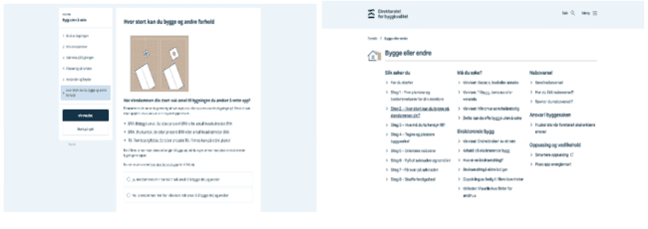

Figure 4 - DiBK’s guidance tool solution

3.2.3 The Issue of Operational Strain
The expert interviews revealed that operational strain in the municipality diverts resources away from core tasks and slows down case-processing for all parties involved. The interviews highlighted problems related to incomplete applications, missing building permits or inquiries about the build application process.
When citizens struggle to interpret building regulations or determine whether their project requires a permit, they often submit unnecessary or incomplete applications or skip it entirely and build assuming they don’t need to apply. This issue is highlighted by the Norwegian government, which in 2025 reported that more than 30% of building applications lack the required information. The lack of required information often leads to longer processing times, as it requires repeated communication between applicants and municipal caseworkers to obtain the missing information (Regjeringen, 2024).
In many cases, citizens break ground without obtaining proper permission. A recent case from Kristiansand directly illustrates this. A cabin owner on Herøya built a garden structure in the protected coastal zone, having been inaccurately advised in 2015 that no permit was required. Only after construction finished a formal application was submitted for approval. The municipality rejected it and the owner now faces a demolition order (Drivdal, 2026). Such cases frequently lead to disputes with neighbors and the municipality. Highlighting that cases like these generate additional administrative work and follow‑up processes.

4 Requirements
To address the issues described in chapter 3, a list of requirements was continuously developed to guide the development of TiltaksAID. The requirements were derived from user insights, observations and stakeholder input from the Kristiansand Kommune. These were then divided into four categories: User requirements, describing how the user interacts with the system, system requirements, describing technical and functional constraints, organizational requirements, describing goals and constraints imposed by the municipality, and lastly branding and identity, describing how the user interface should conform to the municipality's brand and identity.
To prioritize these requirements, the MoSCoW method was used. MoSCoW is a prioritization technique used in Agile software development, originally introduced as part of the Dynamic Systems Development Method (Business, 2022). It classifies requirements into four categories: Must Have, Should Have, Could Have, and Won't Have. This provided a clear framework for managing scope under time and resource constraints.

Table 5: Summary of requirements
Must Haves | Should haves | Could haves | Won't haves
User requirements
Specify planned position and footprint of a structure on their property. | PDF downloads | Mobile device interface | Specific questions towards regulation plans
Minimize manual data entry. | Contact info for municipality | Link to dictionary / definitions
Clear and correct indicator for whether they can build without needing to apply. | Automatic retrieval of regulatory plans | Explanatory pictures
 | Tutorial / onboarding | Log in automatic property search
System requirements
Codebase needs to be modular, scalable and easy to reuse. |  |  | Data outside Kristiansand kommune
Follow principles of DevOps (e.i. CI/CD)
Codebase must follow principles of API-first.
Efficient handling and validation of data
Organizational requirements
Non-binding result | API documentation for future teams
Careful handling of sensitive geographical data.
Same technology stack as other bachelor groups in the municipality.
Branding and identity
Follow the municipalities standard for branding and identity,which is specified in the municipalities brand manual. | Defined color palette
 | Typography / font
 | Consistent branding across UI

4.1 User Requirement
User requirements often deal with how a user will interact with a system and what that user expects (Kraeling & Tania, 2019). TiltaksAID had several requirements in order to function as a foundation for further development. The user requirements address the two problems most directly experienced by citizens: the spatial-to-text translation gap (Section 3.2.1) and the cognitive load imposed by the existing guidance tool (Section 3.2.2). Each user requirement below targets at least one of these.
First, users must be able to specify the planned position and footprint of a structure on their property. This requirement addresses the spatial-to-text translation problem identified in Section 3.2.1, by allowing users to externalize spatial information onto a visual interface, the system removes the need for the omission-prone mental representations Tversky (2000) describes. This allows the system to automatically get spatial boundaries that would otherwise require manual input.
The system must minimize manual data entry and simplify complex regulatory questions. This addresses the extraneous and intrinsic cognitive load identified in Section 3.2.2, the "scavenger hunt" across external websites, and understanding of the regulatory terminology that participants reported as the most frustrating element of the DiBK tool.
Additionally, users need a clear and correct indicator for whether their proposal needs a permit or not. This addresses operational strain described in Section 3.2.3, reducing the number of citizens who either submit unnecessary applications or as in the Herøya case (Drivdal, 2026), built without applying because they were uncertain.

4.2 System Requirements
The system's requirements describe requirements for the system that are not visible to the user (Kraeling & Tania, 2019). Where user requirements respond primarily to the problems analysed in Chapter 3, system requirements integrate concerns across the whole project. Firstly the municipality's strategic ambition for cross-municipal adoption (Section 1.1), cross-team coordination with parallel bachelor projects, risks identified in the project's risk analysis (Section 2.5), the architectural ambitions developed in Chapter 5, and the conditions under which the user-centered solution can actually deliver on Chapter 3's problems. Each requirement below traces back to one or more of these sources, and several anticipated findings later confirmed or challenged in the evaluation.
The code base must be scalable, modular and easy to reuse. This requirement is grounded primarily in the municipality's strategic ambition introduced in Section 1.1. Namely, TiltaksAID is not intended only as a local tool, but as a foundation for other municipalities to adopt and extend. Chapter 5 returns to this ambition through Yoo, Henfridsson & Lyytinen's (2010) layered modular architecture which introduces the concept of generativity.
The system's development and deployment must follow DevOps principles, particularly Continuous Integration and Continuous Delivery. This requirement has three sources. First, it reflects municipal development standards conveyed by the project's release train engineer. Second, it directly addresses the risk analysis, "technical issues requiring rework late in the project", by enabling collaborative pull-request review and automated quality checks (Section 2.4). Third, it supports the deployment architecture described in Section 5.3, where GitHub Actions, Docker, Azure VM, and Traefik form an automated pipeline that minimises manual deployment steps and enables handoff to future student teams.
Development must follow the principle of API-first whenever applicable. This requirement reflects municipal development standards conveyed by the Release Train Engineer and supports the architectural separation between device, network, service, and content layers described in Section 5.2.
The system must ensure efficient handling and validation of data. These are the only system requirements that connect directly back to Chapter 3. This requirement is to ensure correctness of the generated result. A map-based interface that displays incorrect spatial boundaries does not reduce the cognitive load described in Section 3.2.2. On the contrary, it might add the risk that the user trusts the false output more than they would trust their own uncertain reasoning.

4.3 Organizational Requirements
Organizational requirements in this report refers to the internal rules, constraints, and standards our system must satisfy in order to align with the goals, policies, and responsibilities of the municipality. The requirements are derived from Kristiansand Kommune's responsibilities as a public body in its position as a trusted authority.
It’s important that the output of the system must not be perceived as an official government approval. The guidance provided by the application must be presented as a summary and not as an approval for construction. This ensures that responsibility remains with the user and not the municipality. From an organizational standpoint, this requirement reduces legal liability while still allowing the system to function as a guidance tool.
Another important organizational requirement relates to the handling of sensitive geographical data. Information about water infrastructure is considered sensitive, as it represents critical national infrastructure. As a result, the system must be designed in a way that prevents exposure of such data to unauthorized users.
The codebase must also use the same technology stack as the other bachelor groups in the municipality. This originates from the cross-team setup described in Section 1.4, where four bachelor groups work on closely related projects. This allows seamless integration of the different solutions.

4.4 Branding and identity
The user interface must follow the municipality's brand and identity, but must also be easily customizable to conform to other municipalities if needed. The brand and identity requirements are well defined in the municipality’s brand manual where it states how the use of typography, colors and layout should be used (Kristiansand kommune, 2021). This ensures consistency across all the municipality's digital solutions.

5 Solution - TiltaksAID
This chapter introduces the proposed solution that follows the previously set requirements from chapter 4 and aims to solve the problem outlined in chapter 3. It describes the solution as well as the use of layered modular architecture, deployment architecture and the technology stack.

5.1 Solution description
The solution integrates a map with interactive drawing tools into a similar looking guidance tool as DiBKs guidance tool. This combination allows users to mark the exact location, and size of their build proposition directly on a digital map, which then enables the system to automatically retrieve and interpret the relevant spatial data. This feature allows the system to automatically answer most of the questions from the original guidance tool, reducing uncertainty and cognitive load for the user. The solution also visualizes the area in which the user is allowed to build without submitting an application, while simultaneously providing feedback on distances to relevant boundaries, helping with the spatial to text translation. Finally, it generates a summary of the user’s inputs and provides an assessment of whether the proposed building complies with national regulations.
Additionally, some interview subjects had experience with applying for building permits and didn't have any issues with answering the questions from the original guidance tool. A hybrid solution was then developed to also give the option to answer the question normally just like DiBK’s guidance tool.
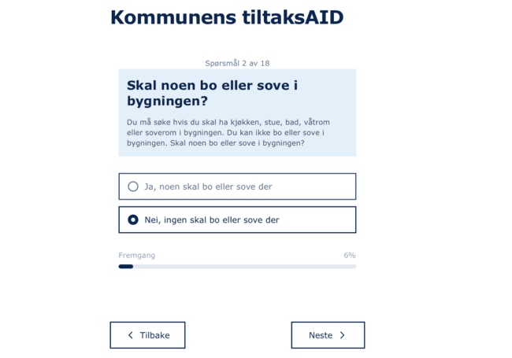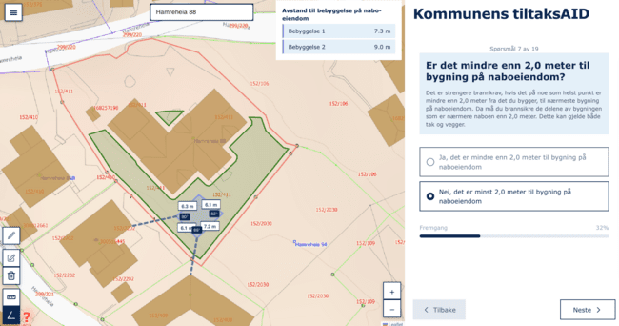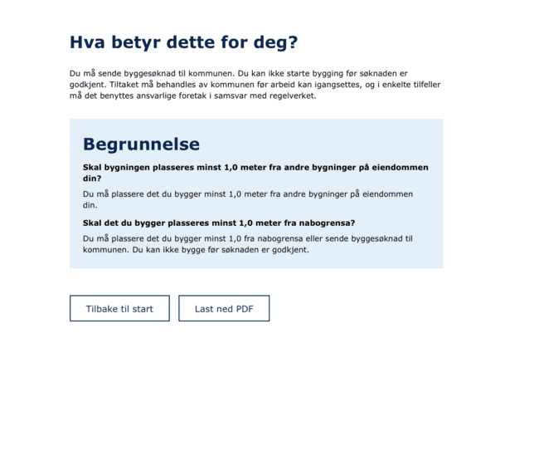

Figure 5: A typical user journey of this solution

5.1.1 Justification
Epstein et al., 2017 argues that the brain builds a unified representation of spatial environments, suggesting that map-based representations are effective because they align with the brain's map-like organization of spatial information. Based on this the team argues that spatial interfaces, such as map-based systems, will improve understanding when users need to reason about physical locations or spatial relationships. Cognitive tools such as a map-interface also augment the mind by reducing both memory load and processing load (Tversky, 2000). The solution aimed to reduce the load by providing the user with a visual representation of space rather than mentally reconstructing spatial relationships.
A system that helps users better understand spatial regulations and determine whether a permit is required could reduce unnecessary and faulty applications, thus reducing the operational strain on casehandlers. In addition, the solution will support more informed decision-making in the early stages of the planning process. Guiding users toward development options that comply with regulations, even when it may differ from their initial plans, which could reduce the total number of applications.

5.1.2 Solution scope
Throughout the development of the solution several key functionalities were limited by lack of data, geo-politics and the project's lifecycle. One limitation was the need for manual data input from the user for a small selection of questions that are impossible to answer only using map metadata. These are questions like: “What type of building are you going to build?” and “Is the building going to have more than one room?” and so on.
Some datasets are also not publicly available as they are categorized as critical infrastructure and may be misused by bad actors. This means that the question about water/sewage pipes can’t be answered automatically and also needs manual user input. One way to solve this would be to have a secure log in that only shows data relevant to the users property, but this kind of functionality falls outside of the project's scope and is tightly dependent on another bachelor groups project (team Delta).
Lastly, the solution still needs the user to double check regulatory plans, as it only conforms to national regulations and not property-specific regulatory plans. Since TiltaksAID is intended to be delivered only as an MVP and time was limited, implementing property specific questions was considered beyond the scope of the project.
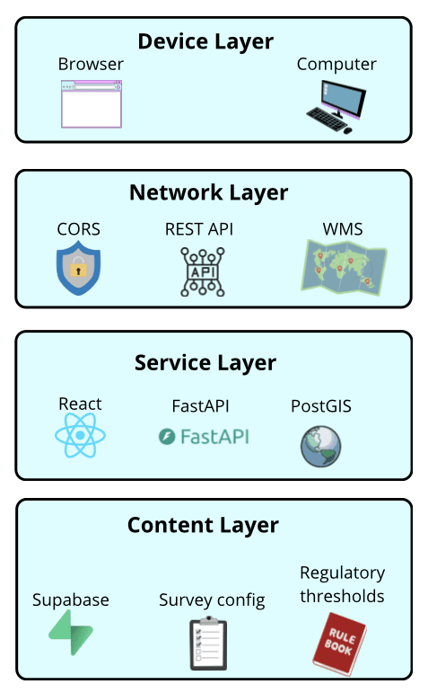

Figure 6: Solution architecture of TiltaksAID

5.2 Solution architecture
This chapter presents an overview of TiltaksAID's architecture through the lens of Yoo, Henfridsson and Lyytinen's (2010) layered modular architecture. The municipality’s stated ambition is not to only adopt a single guidance tool for National rules, but to explore a solution that other municipalities can adopt and extend. The power of layered modular architecture lies in what Yoo et al. call generativity, the capacity of a system to produce unanticipated uses and extensions, driven by heterogeneous actors whose contributions are not foreseen by the original designers. This will allow the solution to outlive the original project and integrate with external regulatory and geospatial data sources and be reused across organizations with different local rules and constraints.
The solution developed in this project sits meaningfully on the continuum that Yoo et al. describe between traditional modular and fully layered architectures. Built as an MVP today, TiltaksAID is structured to approximate a layered modular architecture, but retains partial coupling due to the distribution of spatial and validation logic across client and backend components. Despite this, the separation between device layer, network layer, and spatial processing remains sufficiently distinct to support future evolution toward the municipality’s ambitions. Figure 6 demonstrates how our solution approximates to layered modular architecture.

5.2.1 Device layer
The device layer in Yoo et al.'s framework consists of the physical machine and the logical capability that hosts software (Yoo et al., 2010). For the final solution, the device layer is any web browser running on a desktop or mobile device, making the artifact device-agnostic at the architectural level. At the implementation level, however, the current interface was built for desktop use only, as mobile support was not prioritised in the MVP requirements. An optimised mobile interface could be added without changes to the layers below, which is the architectural property the device layer's separation is meant to enable.

5.2.2 Network layer
The network layer consists of the protocols and connections that transport data to the service layer (Yoo et al., 2010; Hylving & Schultze, 2020). TiltaksAID’s network structure is split. Map tiles are fetched directly from external sources like Kartverket and NVE by the browser, using Leaflets WMS client, while authentication dependent or CORS-restricted sources are proxied through the backend. The split keeps tile rendering responsive.
The backend exposes a REST interface with HTTP GET methods with query-string parameters and JSON-encoded responses. Any consumer that can make HTTP requests and parse JSON can reach the service layer, regardless of what device type, framework, or programming language the consumer uses.
The significance lies in what it standardizes rather than what it transports. In principle, the device layer can be replaced without changes to the backend, and external data sources can be redirected to different municipalities endpoints, supporting the municipalities ambition of interoperability and reuse across municipalities.

5.2.3 Service layer
The service layer deals with application functionality that directly serves users by creating, manipulating, and processing content (Yoo et al., 2010). In TiltaksAID, this functionality takes the form of spatial reasoning, survey execution, and the transformation of regulatory checks into structured outputs.
As mentioned earlier, Yoo et. al.’s device layer encompasses both physical hardware and the logical capability that hosts the software. For web applications this raises an interpretive question whether the device layer only includes the browser or if it extends to the application framework running within it. In this report, the React application itself is treated as service layer code running on top of that platform.
Parts of the service layer are implemented in TypeScript within the React application. Crucially, spatial reasoning and external data interactions are not embedded directly within presentational components. Instead, the map component delegates processing to functions such as handleDrawingData() and checkViolations(data), and receives results through callbacks.
The survey functionality follows a similar separation. Question content is defined independently from the traversal logic, allowing the survey engine to operate without specific domain knowledge. This separation could be further strengthened by keeping configurations external through a database or API, further reducing the need for source code changes when modifying regulatory content.
The backend is implemented in Python using FastAPI, but functions primarily as a thin API layer that exposes the endpoints and mediates access to data sources. In practical terms, the service layer is not fully centralized. Spatial calculations are handled by Supabase RPC functions, while parts of the violation logic remain in the TypeScript client.
This distribution means that the service layer is not fully encapsulated, as parts of the logic are executed within the client-side environment. As a result, the architecture approximates Yoo et al.’s layered modular architecture rather than fully realizing it. A practical factor shaped this distribution. The Supabase RPC functions were inherited and further developed from earlier student work at the municipality. Also, PostGIS is specifically designed for spatial data storage, querying, and geometric operations, allowing distance and boundary calculations to be performed close to the geospatial data (PostGIS, 2023). Rebuilding this spatial reasoning in a separate service layer would have duplicated functionality that was already supported by the contents layer and was not justified within the MVP scope.

5.2.4 Contents layer
The contents layer is the data the system reasons about (Yoo et al., 2010). In tiltaksAID this consists of three categories. First, geospatial datasets accessed through Supabase. Property polygons, regulatory zones, building footprints, road and coastline geometries, and other layers used in distance and boundary calculations. Second, regulatory thresholds consist of the distances, heights, areas, that the rule evaluation compares against. Third, survey configuration, meaning, the question text, branching logic, and answer types declared in QuestionConfig.tsx.
The content layer in TiltaksAID is partially decoupled from the layers that operate on it, but the decoupling is uneven. The geospatial datasets are accessed through configured queries rather than being embedded in client code, so the same service-layer functions can in principle operate over different municipalities' datasets. Regulatory thresholds are similarly stored as data rather than embedded as constants in the service layer, allowing thresholds to be adjusted without modifying logic. The survey configuration, however, is separated from the survey engine that traverses it but coupled to the build process, changing the guidance flow currently requires editing the configuration file and redeploying the application, not loading content at runtime.
This unevenness matters for the municipality's cross-municipal reuse ambition. Replacing one municipality's geospatial data and threshold values with another's is feasible without code changes; replacing the survey flow is not. A future iteration could close this gap by serving the survey configuration from a database or API rather than bundling it into the build, which would let other municipalities supply their own question sets without modifying any other layer. The architecture is designed to support this level of flexibility but has not yet fully achieved it.

5.3 Deployment architecture
The project's MVP framing shaped what the deployment architecture needed to do. As described by Atlassian (2026), an MVP is meant to enable quick validation of assumptions and guide the team’s next iteration once the artifact is in users' hands, which meant the cost of shipping a change had to be low enough that feedback could be acted on quickly. The deployment process also had to be robust enough that future student teams or municipality developers could extend the system.
DevOps practices, recommended by the Release Train Engineer, supported both continuous integration, that ensured changes were merged frequently and validated automatically, and continuous delivery, which automated the path to deployment (Faustino et al., 2022). The following sections describe the four components that realized this. GitHub Actions, Docker, the Azure VM, and Traefik.

5.3.1 CI/CD pipeline & GitHub Actions
The deployment architecture used a CI/CD pipeline implemented with GitHub Actions. Continuous Integration (CI) enables developers to frequently merge code into a shared repository, while Continuous Delivery (CD) ensures that changes can be automatically prepared for deployment (Anyanwu, 2025). The team chose CI/CD as it promoted faster production, better product and software quality, and a more efficient team overall while reducing risks as is also demonstrated by Saleh et al. (2025).
Within this system, GitHub Actions automated the deployment process. When changes were pushed to the main branch, a workflow connected to the Azure Virtual Machine via secure shell (SSH), transferred the updated files, and redeployed the application using Docker Compose. This process is visualized in figure 7. SSH is a software package that enables secure system administration and file transfer over insecure networks (SSH Communications Security, n.d.). In our context, it was used to connect to the Azure virtual machine. This DevOps automation minimized manual deployment steps and reduced the risk of human error. For the team, this enhanced collaboration and operational efficiency, allowing more focus on code quality rather than manual deployment.
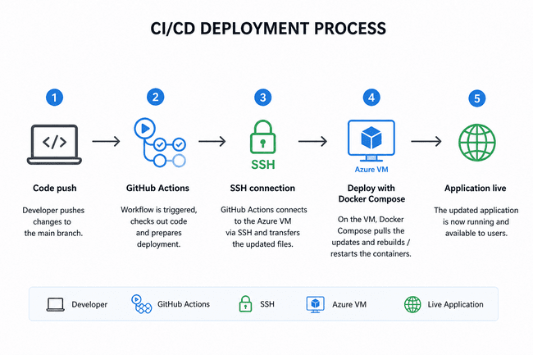

Figure 7: CI/CD deployment process using GitHub Actions and Azure VM. Note. Created by the authors using an AI image generation tool (OpenAI, 2026).

5.3.2 Docker
Docker was chosen to containerize the application, over other similar services, because of the team’s familiarity from previous projects, reducing the time to learn new technologies. Containerization allowed other benefits like simplifying and accelerating the group's workflow (Why Docker | Docker, 2025). Containerization allowed the application to run in isolated and reproducible environments, which minimized bugs, gave consistent and reliable software performance, and improved productivity during development (Cotton, 2023).
Using Docker Compose, the frontend and backend services were managed as separate containers, while the reverse proxy Traefik was deployed through a separate Docker Compose configuration on the server, allowing it to run independently from the application stack.

5.3.3 Azure VM
The municipality provided access to an Azure VM that was used to host the application in the cloud. Azure Virtual Machines (VMs) are scalable, on-demand computing resources provided by Microsoft Azure. They allow users to run virtualized servers in the cloud without the need to purchase, maintain, or manage physical hardware (Microsoft, 2025). This proved crucial for realizing the MVP, as the deployment process made it possible to have the application run around the clock, which made getting feedback from stakeholders and users easier as they could access it whenever they had spare time.

5.3.4 Traefik
Traefik is an open‑source application proxy that integrates with Docker and automatically discovers running containers, generating routing configuration dynamically based on container labels (traefik.io, n.d.). The implementation of Traefik was necessary to route incoming traffic to the correct Docker containers and expose the frontend and backend services through a single entry point.

6 Evaluation
This section covers a formative evaluation with certain characteristics of summative evaluation. The goal is to find insights and potential ways to improve on the current product while also measuring it up against DiBKs solution. Together this section gives valuable insight on future development options and a measure of success.
The evaluation focuses on three key aspects: reduction of cognitive load, improvement of spatial to text translation, and reduction of operational strain. Since the final product delivery of TiltaksAID is a MVP, the evaluation also emphasizes usability and perceived usefulness rather than just the full technical performance.

6.1 Evaluation criteria
The evaluation criteria were derived from the criteria set in chapter 4 and gave measurable data points that could compare DiBK’s guidance tool to TiltaksAID, and helped in checking if TiltaksAID solved any of the problems outlined in chapter 3.

Table 6: Evaluation criterion and how to assess them
Spatial to text translation | Error rate | Number of wrong answers.
 | Ease of visualization | The user rate their ability to find and visualize spatial boundaries.(Scale 1-10)
Cognitive load | Case completion time | Measure how long the user takes to finish the case using a stopwatch.
 | External data dependency | Count how many times the user needs to visit external resources to find relevant information.
 | User confidence level | Post-case completion the user is asked how confident the users are that what they have answered is correct.(Scale 1-10)
 | Amount of guessing | Ask users to talk loud and speak out when they are unsure about which answer is correct, and decide to guess.
Operational strain | Non-binding result | Ask users if they think the results are an official government approval/denial.

6.2 Evaluation method
A qualitative evaluation approach using semistructured interviews was conducted to assess how the current product performed in practice, as this provided the depth needed to understand how real users navigated the solution. The evaluation participants consisted of 8 people between the ages of 26-55, with moderate to no experience with building applications and regulatory plans. The earlier interviews mentioned in chapter 3 were also conducted on the current product which gave additional formative insight from 8 participants. These interviews did not include the evaluation criteria mentioned earlier, so their insight didn’t affect the summative evaluation results.
The interviews were conducted in a controlled environment and took around one hour each. The sessions were conducted digitally or physically based on the participants preference. Participants were asked to speak-out-loud what they were thinking and feeling and notes were taken throughout the interviews where it was relevant to the criterion. Additional notes were taken when users showed frustration, to identify friction points of the system.
Participants were asked to do two cases, one on each version and without knowing who made which. This aimed to reduce social desirability bias, which is the tendency for individuals to align their answer with what is socially acceptable, rather than what they truly mean (Bergen & Labonté, 2020). In this context, this could make participants favor TiltaksAID simply because it was made by the group. Having two different cases also helped to reduce the practice effect, which is the tendency for participants to perform better when repeating a test (Wesnes, 2002).
Each attempt at solving a case was timed. The correct amount of answers, answers that were guesses, and the perceived confidence to build after finishing, were recorded to get numeric data values from both cases. When participants finished each case they were asked if it was easy to visualize the different boundaries, as well if they thought the results were an official government approval/denial.

6.3 Evaluation results
The data gathered through the summative part of the evaluation interviews was stored in a dataset (Appendix 9). This dataset was compiled into table 7 by taking the average values for both TiltaksAID and DiBK’s guidance tool. Table 7 shows how TiltaksAID compares against DiBK’s guidance tool in relation to the evaluation criteria, and which insights was extracted from these results.

Table 7: Compiled data from evaluation interviews
Criteria | DiBK Guidance tool | TiltaksAID | Insight
Case completion time | 21min:42sec | 13min:57sec | Users completed cases significantly faster using TiltaksAID compared to the DiBK guidance tool. This improvement is largely due to automated question answering in TiltaksAID, which reduces the need for manual input.
Error rate | 0.625 | 1.5 | Error rates were higher on TiltaksAID. This stems from incorrect input from the user when drawing, such as inaccurate shape, size or placement. This in turn affected the answers to the question.
External data dependency | 8.75 | 2.375 | Users depend less on external sites on TiltaksAID. Questions like distances to sea, train track and roads didn’t need any external site and were answered automatically, compared to DiBK’s guidance tool where the users needed to guess or check distances on google maps. Many users still felt the need to look up regulatory plans or ask LLMs when they didn’t understand certain questions .
Amount of guessing | 3.875 | 2 | The amount of guessing is less on TiltaksAID. This is because questions were answered automatically and the users trusted that the answers were correct.
User confidence level | 5.63/10 | 7.63/10 | Users reported higher confidence when using TiltaksAID. In DIBKs guidance tool, the process of searching for regulatory plans introduced new regulatory terms many users struggled to understand. In contrast TiltaksAID required far less manual searching, which kept the users confidence high throughout the process.
Ease of visualization | 5/10 | 7.75/10 | Users found it easier to visualise boundaries and distances on TiltaksAID. Because the map and its drawing tools gave them a clear spatial overview.
Legally binding approval  0=NO  1=Yes | 0.5 | 0.875 | When using TiltaksAID, more users thought that the summary was an official government approval for starting to build without need to apply. This is the case for both guidance tools, but even more for TiltaksAID.

The results indicate that TiltaksAID reduced several observable indicators associated with cognitive load, including completion time, external data dependency, amount of guessing, and increasing the ease of visualisation. It also shows that the average completion time was reduced where it was 7.5 minutes less on TiltaksAID compared to DiBKs guidance tool.
An important finding was that while TiltaksAID had a higher confidence score and ease of visualization it still didn’t help with the spatial to text translation as the error rate was higher than on DiBK’s Guidance tool. This might be because of an unclear tutorial and unintuitive drawing tools, which several evaluation participants mentioned to be a friction point of the product. The team argues that this is an issue of UX and not a reflection of the solution's potential. When participants were told how to use the drawing tools, correctness improved and future drawing became more precise. To be sure if this is a weakness of the solution or just the current product, additional evaluations need to be done after fixing these UX issues. An important factor which needs to be addressed is that participants in general got more stuck and needed more help from the interviewers when doing DiBKs guidance tool. This additional help may have made them answer more correctly than if they didn’t get any help, which could have skewed the error rates to favor DiBKs guidance tool.
Additionally, the findings show that TiltaksAID both had higher error rates and a higher number of users who thought the answer was an official government approval. This could be a weakness of the solution which could lead to more operational strain by having users start building projects thinking their results were correct and an official government approval. The higher confidence level could also increase the chances of these types of projects happening. Additional research needs to be done here as well after fixing the aforementioned UX issues, to get a conclusive answer.
A major weakness of the evaluation method is that operational strain can’t be correctly assessed. To get reliable data, the application needs to be publicly deployed. Which could give data that links Tiltaksaid’s use up against higher/lower numbers of faulty applications, wrongful building projects, and lessening of operational resources for caseworkers in the municipality. The team can only theorize that if error rates decrease, that it may have positive effects and reduce operational strain down the line.

6.4 Additional observatory findings
Many participants struggled using the drawing tools, especially older individuals. These individuals didn’t find the tutorial button, which needed to be clicked in order to show how the drawing tools worked. For the individuals that found the tutorial, many pressed skip on the initial popup and didn’t finish the tutorial.
A second pattern also emerged. Some properties have different regulatory restrictions that override national regulations. This makes it so the need to find regulatory plans is also necessary when using TiltaksAID.
Furthermore, the team recognized potential limitations in the evaluation process that could affect the result. For instance, some users might rush through the guidance tool without fully understanding the questions. This could happen because they viewed it as simply testing the application, not using it for something real. If they were using the application to plan their own building project, they would likely take more care and pay closer attention.

7 Project execution
The project timeline was divided into 3 PI periods where one PI equals seven weeks. Together with the RTE and product owner, we met regularly to decide what kind of work should be completed during each PI period. This was documented and used as a reference image for each sprint period. For this project it was determined that the most effective approach was to organize each PI into three two-week sprint periods, followed by one test week as shown in Figure 8. Detailed documentation for each PI, including the defined goals, Definition of Done, confidence voting, etc., can be found in figures 16-18 in Appendix 7.

Figure 8: Visualization of each PI and sprints

Before starting the development of the project, the team contacted two students who had contributed to the development of an earlier prototype. This allowed us to ask questions about the code, identify potential pitfalls, and gain a better understanding of both the codebase and its surrounding context.

PI 1(Week 2 - Week 8)
Main Goals: Initial research, analysis and design of product.
Estimated amount of Hours: 1225 hours
Total hours worked: 415 hours (data missing from week 2 - week 5)
During PI 1 the team did initial research, created guidelines and routines for how to move forward with the project. A simple prototype was also made implementing the earlier student group's database functions and datasets, and was used as a foundation for user testing in the next PI.
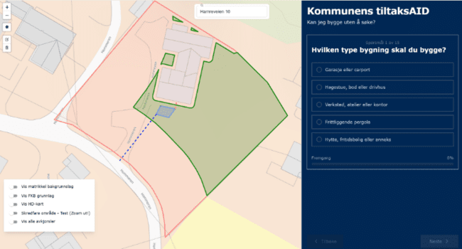

Figure 9 - Early prototype

PI 2(Week 9 - week 16)
Main goals: Containerization and deployment of product, user testing
Estimated amount of hours: 1137,5 hours
Total hours worked: 926 hours
During PI 2 the team managed to containerize and deploy the application as well as creating a CI/CD pipeline. User evaluation of the current product was done and feedback was converted to tasks for later sprints. The feedback led to a directional change of the development, where focus went from functionality to user experience. This redirection is what the MVP framing exists to enable. Real-user feedback reshaping what gets built next (Atlassian, 2026). Late stages of the PI were used to prepare for the formal evaluation in PI 3.
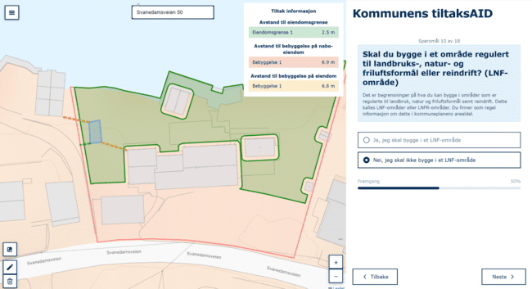

Figure 10 - Almost finalized product

PI 3(Week 17 - week 22)
Main goals: Finalization of product, make way for future development, evaluation
Estimated amount of hours: 875 hours
Time used before hand in of report: 396.5 hours
PI 3 marks the end of the project’s lifecycle. Evaluation interviews were conducted and finalization of the report was done. This PI extends beyond the reports due date so early stages of the PI were heavily focused on finalization of the report. After the hand in of the report all focus will go on further development of the product. Where the goals are to optimize queries, creating good documentation for future development and fixing bugs.

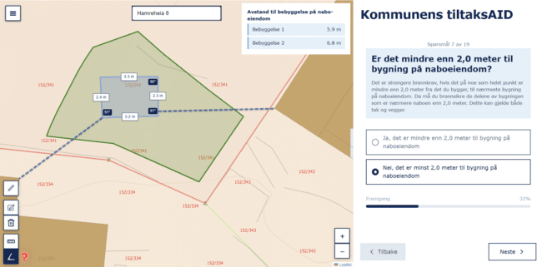

Figure 11 - Finalized product

8 Discussion
TiltaksAID had a clear positive value and perceived usefulness, but also produced findings that complicated the central claims of the thesis. This section discusses the tension between user confidence and accuracy that emerged in the data, the question of whether the system can achieve value with imperfect data and design implications for the older users.

8.1 The Confidence and Accuracy Gap
The most important finding from the evaluation is the high confidence level and the high error rate in TiltaksAID. Compared to the DiBK guidance tool, the TiltaksAID users finished faster, looked up fewer external sources, guessed less reported higher confidence and rated the interface easier to use. This was the expected pattern, however, the error rates roughly doubled and a larger majority believed the summary was an official approval. What this means is that the MVP currently produces more confidence than what the actual tool’s accuracy warrants. A tool that increases confidence while also increasing the error rate is exactly the type of failure that could increase operational strain.
Evidence indicates the increased error rates can be attributed to the drawing tool, as there is evidence that the error rates dropped after users were shown how the tools work. In hindsight, the team underestimated the importance of a tutorial/onboarding in the MoSCoW analysis in chapter 4. However, treating this purely as a UX issue assumes that the drawing step can be cleanly separated from the spatial reasoning the tool is meant to support. In TiltaksAID the drawing is the spatial-to-text translation. If users struggle to externalize their plan accurately on a map the issue has just been relocated rather than solved. This is something the evaluation doesn't fully distinguish. Resolving this requires an evaluation after the UX improvements.
The confidence findings also deserve attention. The system already introduces a checkbox in which the user accepts that responsibility lies with them. Still, several interview participants still read the summary as an official approval. This suggests that disclaimers alone may not be sufficient enough when the surrounding interface presents the result as a decision. Although the checkbox formally transfers responsibility to the user, the generated summary may still be interpreted as official confirmation because users tend to place excessive trust in automated decision support (Goddard et al., 2012). Several participants also stated that they expected the result to be binding as it comes from an authoritative source.

8.2 Data correctness and the Value of an Imperfect system
This brings up the question of correctness of the system and how can we make sure the system is correct? Many of the datasets don’t have a 100% coverage, some dataset may be outdated and some inaccurate, which could mean certain real world features are wrong or missing. Take the FKB-Bygning dataset from GeoNorge as an example, this dataset is used in the application, but has a reported coverage of only 90% (Kartverket, 2026). These issues are reflected in the solution, where for example some houses are part of two properties and some regulatory plans overlap. Some measures have been taken for specific scenarios, like when a property overlaps two regulatory plans. In this scenario the problem was fixed by shrinking the property polygon during search in the database. While this accounts for one special scenario, more may still be prevalent. Making sure these scenarios have been corrected in the system is important to make sure this doesn't negatively affect the correctness of the application and final result/summary of the guidance tool.
This raises the question: “What value does the system provide when the underlying data is incomplete or inaccurate?” Based on discussions with the product owner, the strategic argument for the system is that it creates pressure to improve municipal data quality, and that adoption by other municipalities would require them to reach data quality comparable to Kristiansand Kommune's, which is among the better in Norway (D. Øksendal, personal communication, January 29, 2026).

8.3 Design Implications and older-user findings
After user testings and evaluation interviews, a pattern arose among older individuals. Older individuals seemed to struggle more with the drawing tools compared to younger individuals. This aligns with Gottwald et. al. (2016), where their study shows that older individuals struggled with maps and drawings on a public participation GIS (PPGIS) solution, which included a similar looking map based solution. Their conclusion was that older individuals struggled because of a lack of experience using web based maps, drawing tools and computers in general, as well as sensory and motor issues which made precise drawings difficult to accomplish. Our solution tries to combat this by enabling the users to choose between answering using the map or doing it manually, but a better solution might be to make the map based solution more accessible for older individuals. In order to do this effectively more feedback from individuals of higher age needs to be incorporated into development and design.

8.4 Prioritized changes
Based on the evaluation’s findings a new set of improvements for the current product were identified and compiled into table 8:

Table 8: improvement for future solution
Tutorial | A clearer and more informative tutorial that shows the drawing tools and the fact that the questions get answered automatically. This should be shown automatically after searching for the address. This would aim to reduce intrinsic cognitive load by making the system easier to understand.
Automatic retrieval of regulatory plans | Automatic retrieval of property specific regulatory plans and display them to the user. This could reduce external data dependency even more and lessen extraneous load.
Visualizations of regulatory terms | Adding pictures to the questions could increase confidence and reduce intrinsic cognitive load by visualizing what different terms and words mean.

9 Conclusion
This bachelor thesis set out to explore how a map-based digital solution could reduce cognitive load and improve spatial understanding building-permit process. The project resulted in TiltaksAID, an MVP developed in collaboration with Kristiansand Kommune, and a qualitative evaluation comparing it to DiBK's existing guidance tool.
Quality control activities were used throughout the project to assess the actual quality of the artifact after features had been implemented. This included validating whether the solution met requirements and evaluating the system with users. Although TiltaksAID was developed as an MVP, this project still provided stakeholder value by demonstrating a working concept, revealing concrete usability issues, and identifying where further development should be prioritised.
The findings indicate that TiltaksAID reduces several indicators for cognitive load compared to DiBK’s guidance tool. By minimizing the need for external data dependencies, lowering the amount of guesswork and increasing the ease of visualization. This is reflected in shorter completion times and higher user confidence compared to DiBK’s guidance tool. By translating complex regulatory requirements into an interactive spatial interface, the solution addresses key challenges related to spatial-to-text translation.
However, the evaluation also revealed important limitations. While users found the system easier to understand, the increased error rate highlights challenges related to accuracy from user input, particularly when using the drawing tools. In addition a significant number of users perceived the results as an official government approval for building without applying. This introduces a risk regarding real-world decisions that could lead to an increase in operational strain within municipal caseworkers. These findings show that not only focusing on improving the usability is important, but also a clear communication to users so that the results are correctly interpreted.
Beyond the empirical findings, the project also delivered an architectural foundation that approximates a layered modular architecture. The separation between device, network, service and content layers is sufficient to support extension by other municipalities, although the decoupling is uneven and the survey configuration remains build-coupled. Closing this gap is a clear next step toward the cross-municipal ambition.
TiltaksAID represents a promising step toward more accessible and efficient building guidance services. With further development, particularly in improving input accuracy, reducing external data dependencies, fixing certain UX elements and clarification of the results, the solution has the potential to be expanded and adopted more broadly, contributing to more effective digital public services.

10 Reference list
Anyanwu, C. (2025, April 14). How to Automate CI/CD with GitHub Actions and Streamline
Your Workflow. FreeCodeCamp.org. https://www.freecodecamp.org/news/automate-cicd-with-github-actions-streamline-workflow/
Atlassian. (2026, March 13). What is a minimum viable product (MVP)? How to get started.
https://www.atlassian.com/agile/product-management/minimum-viable-product
Ayele, Y. G. (2023). The Significance of Planning and Scheduling on the Success of Projects.
Economics & Management Information, 1–10. https://doi.org/10.58195/emi.v2i1.66
Bergen, N., & Labonté, R. (2020). “Everything is perfect, and we have no problems”: detecting
and limiting social desirability bias in qualitative research. Qualitative health research,
30(5), 783-792.
Business, A. (2022). MoSCoW Prioritisation - DSDM Project Framework Handbook | Agile
Business Consortium. Agilebusiness.Org.
https://www.agilebusiness.org/dsdm-project-framework/moscow-prioritisation.html
Cotton, B. (2023, August 14). 5 Benefits of a Container-First Approach to Software
Development | Docker. Docker. https://www.docker.com/blog/5-benefits-of-a-container-first-approach-to-software-development/
Dash, R., & Dash, R. (2010). Risk assessment techniques for software development. European
journal of scientific research, 42(4), 629-636.
Deci, E. L., & Ryan, R. M. (2000). The “What” and “Why” of Goal Pursuits: Human
needs and the Self-Determination of Behavior. Psychological Inquiry, 11(4), 227–268. https://doi.org/10.1207/S15327965PLI1104_01
Direktoratet for byggkvalitet. (n.d.). Bygg uten å søke – garasje, bod eller anneks.
https://www.dibk.no/verktoy-og-veivisere/bygg-uten-a-soke-garasje
Drivdal, M. (2026, January 21). Risikerer å måtte rive utestua – hytteeier mener kommunen
bedriver forskjellsbehandling. KRS - Avisen Kristiansand. https://www.krs.no/risikerer-a-matte-rive-utestua-hytteeier-mener-kommunen-bedriver-forskjellsbehandling/s/5-157-583000
Ebert, L. (2002). Successful project management for software product and information system
development. Paper presented at Project Management Institute Annual Seminars & Symposium, San Antonio, TX. Newtown Square, PA: Project Management Institute.
Epstein, R. A., Patai, E. Z., Julian, J. B., & Spiers, H. J. (2017). The cognitive map in humans:
spatial navigation and beyond. Nature Neuroscience, 20(11), 1504–1513. https://doi.org/10.1038/nn.4656
Faustino, J., Adriano, D., Amaro, R., Pereira, R., & Silva, M. M. (2022). DevOps benefits: A
systematic literature review. Software, Practice & Experience, 52(9), 1905–1926.
https://doi.org/10.1002/spe.3096
Goddard, K., Roudsari, A., & Wyatt, J. C. (2012). Automation bias: A systematic review of
frequency, effect mediators, and mitigators. Journal of the American Medical Informatics
Association, 19(1), 121–127. https://doi.org/10.1136/amiajnl-2011-000089
Gottwald, S., Laatikainen, T. E., & Kyttä, M. (2016). Exploring the usability of PPGIS among
older adults: Challenges and opportunities. International Journal of Geographical
Information Science, 30(12), 2321–2338.https://doi.org/10.1080/13658816.2016.1170837
Hylving, L., & Schultze, U. (2020). Accomplishing the layered modular architecture in digital
innovation: The case of the car’s driver information module. The Journal of Strategic Information Systems, 29(3), 101621. https://doi.org/10.1016/j.jsis.2020.101621
Islam, M. A., & Aldaihani, F. M. F. (2022). Justification for adopting qualitative research
method, research approaches, sampling strategy, sample size, interview method,
saturation, and data analysis. Journal of International Business and Management, 5(1),
01-11.
Karlsen, J. T. (2021). Prosjektledelse: Fra initiering til gevinstrealisering. Fagbokforlaget.
Kartverket. (2026). FKB-Bygning [Dataset]. GeoNorge.
https://kartkatalog.geonorge.no/metadata/fkb-bygning/8b4304ea-4fb0-479c-a24d-fa225e
2c6e97
Kraeling, M., & Tania, L. (2019). Software development process. In R. Oshana & M. Kraeling
(Eds.), Software engineering for embedded systems (2nd ed., pp. 33–87). Newnes. https://doi.org/10.1016/B978-0-12-809448-8.00002-3
Kristiansand kommune. (2021). Profilmanual: Slik bruker du profilen [PDF]. Kristiansand
kommune.
https://www.kristiansand.kommune.no/contentassets/606cbef2839849adb34e2ea6d14112
6a/profilmanual-slik-bruker-du-profilen-l_2021_2.pdf
Klepsch, M., Seufert, T. Understanding instructional design effects by differentiated
measurement of intrinsic, extraneous, and germane cognitive load. Instr Sci 48, 45–77
(2020). https://doi.org/10.1007/s11251-020-09502-9
Maha, L., Rahman, T., & Roy, C. (2026). Agile Story-Point Estimation: Is RAG a Better Way to
Go?. arXiv preprint arXiv:2604.03443.
Microsoft. (2025, December). Overview of virtual machines in Azure - Azure Virtual Machines.
Microsoft.com. https://learn.microsoft.com/en-us/azure/virtual-machines/overview
Pasuksmit, J., Thongtanunam, P., & Karunasekera, S. (2022). Story points changes in agile
iterative development. Empirical Software Engineering, 27(6).
https://doi.org/10.1007/s10664-022-10192-9
PostGIS. (2023). PostGIS. https://postgis.net/
Regjeringen. (2024, May 14). Raskere behandling og tydeliggjøring av dokumentasjonskrav i
byggesøknader.
https://www.regjeringen.no/no/aktuelt/raskere-behandling-og-tydeliggjoring-av-dokumen
tasjonskrav-i-byggesoknader/id3099225/
SAFe Explained -Succeeding with Lean and Agile at Scale 1 SAFe ® Explained Succeeding
with Lean and Agile at Scale. (n.d.). https://go.scaledagile.com/rs/983-XYR-522/images/SAFe_Explained_Ebook_2025.pdf?version=1
Schwaber, K., & Sutherland, J. (2020). The Scrum Guide.
https://scrumguides.org/docs/scrumguide/v2020/2020-Scrum-Guide-US.pdf
Saleh, S. M., Madhavji, N., & Steinbacher, J. (2025). A systematic literature review on
continuous integration and deployment (CI/CD) for secure cloud computing. arXiv preprint arXiv:2506.08055.
SSH Communications Security. (n.d.). What is SSH (Secure Shell)? SSH Academy.
https://www.ssh.com/academy/ssh
Tversky, B. (2000). Some Ways that Maps and Diagrams Communicate. Lecture Notes in
Computer Science, 72–79. https://doi.org/10.1007/3-540-45460-8_6
traefik.io. (n.d.). Traefik Docker Documentation - Traefik. Traefik.Io. Retrieved April 28, 2026,
from https://doc.traefik.io/traefik/reference/install-configuration/providers/docker/
Wesnes, K., & Pincock, C. (2002). Practice effects on cognitive tasks: a major problem?. The
Lancet Neurology, 1(8), 473.
Why Docker | Docker. (n.d.). Docker. Retrieved April 28, 2026, from
https://www.docker.com/why-docker/
What is SSH? | Secure Shell (SSH) protocol. (2026). Cloudflare.Com.
https://www.cloudflare.com/en-gb/learning/access-management/what-is-ssh/
Yoo, Y., Henfridsson, O., & Lyytinen, K. (2010). Research Commentary—The New
Organizing Logic of Digital Innovation: An Agenda for Information Systems Research.
Information Systems Research, 21(4), 724–735. https://doi.org/10.1287/isre.1100.0322
Zhang, Y., Lam, H., & Andreas, S. (2010). An exploratory study of organisational adaptation to
agile project management: An investigation of the IT industry in China (Master’s thesis,
Umeå School of Business). DiVA Portal.
https://www.diva-portal.org/smash/get/diva2:397150/FULLTEXT01.pdf

11 Appendix:

Appendix 1 – Reference from employer
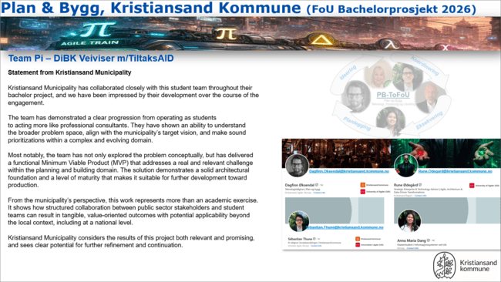

Figure 12: Statement from Kristiansand Kommune

Appendix 2 – Record of Logged Hours
Spreadsheet of registered work hours

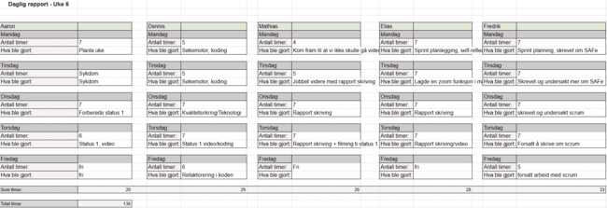Figure 13: Spreadsheet of logged hours for week 6

Appendix 3 – Case (User-testing)
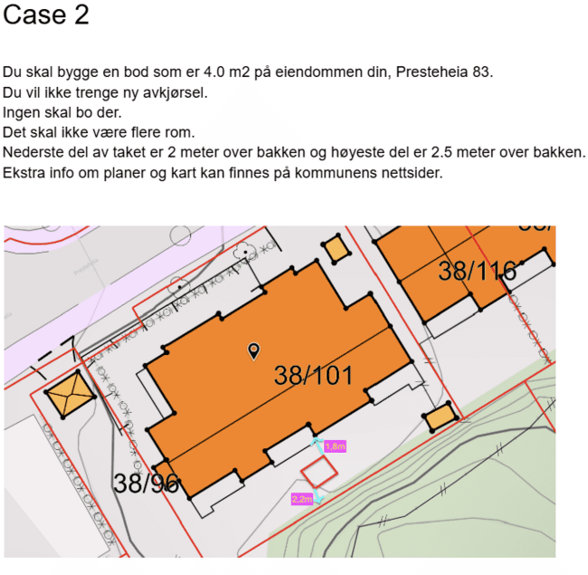
Case for evaluering - Google Dokumenter
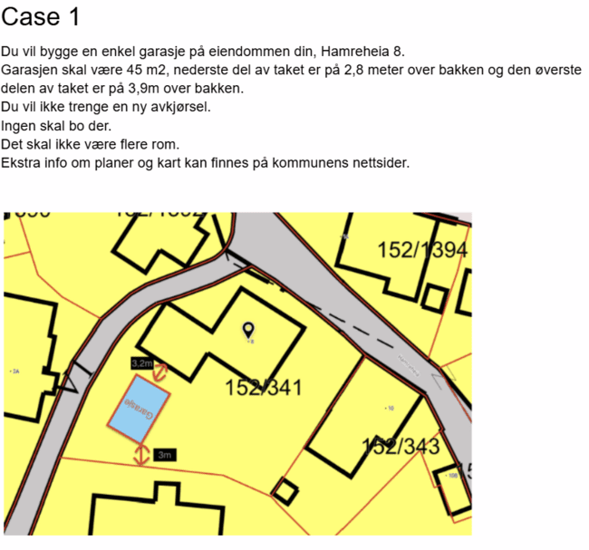

Figure 14: Case 1 and Case 2 used during user-testing and evaluation

Appendix 4 - Summary of findings (User-testing)
Summary of finding from initial user testing
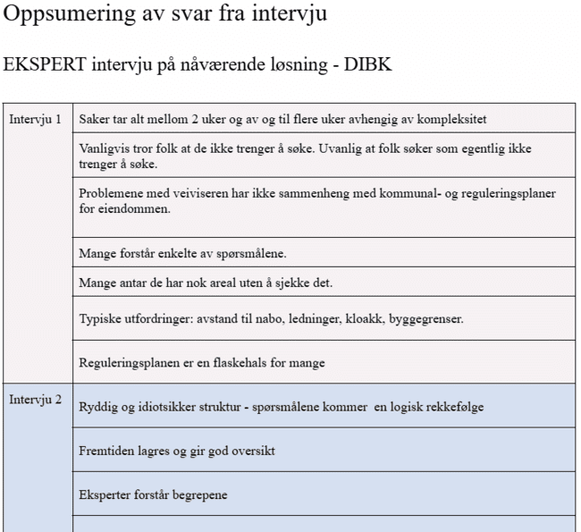

Figure 15: Part of the summary of findings, from the initial user testing

Appendix 5 – Risk analysis

Table 9: Overview of potential risks
Uncertainty | Type | Likelihood | Negative consequences | Total risks
Solution is more complex than expected | Technical | Middle | Very high | High
Lack of experience with mapping and geospatial tools | Technical | Very low | Middle | Low
Too large functional scope for an MVP | Methodically | Middle | High | High
Limited access to actual users | Methodically | Very low | Very high | Low
Misinterpretation of building permit regulations | Domain | High | Very high | Very high
Time constraints in the bachelor project | Project | Low | Very high | High
Insufficient documentation during the process | Project | Very low | Very high | Middle
Technical issues requiring major rework in the project | Technical | Middle | Very high | High
Internal conflict in the team | Social | Very low | Middle | Low
Scope creep | Methodically | Middle | High | High

Table 10: Risk matrix
Likelihood (Y) \ Consequences (X) | Very low | Low | Middle | High | Very high
Very high | Middle | High | Very high | Very high | Very high
High | Low | Middle | High | Very high | Very high
Middle | Low | Middle | Middle | High | Very high
Low | Very low | Low | Middle | High | High
Very low | Very low | Very low | Low | Middle | Middle

Appendix 6 – The way forward

Table 11: The way forward
Identified issues | Implications for users/system | Proposed future developement
Difficult regulatory terms (e.g., gesimshøyde, mønehøyde, LNF‑område) | Users struggle to understand key concepts without explanation, increasing cognitive load and risk of misinterpretation | Add simple visual or textual explanations that clarify terms without overwhelming the user
Confusion about which regulatory plans apply | Users make incorrect assumptions about applicable plans; difficult to locate relevant documents | Implement automatic retrieval of relevant regulatory plans for the selected property
MVP scope too narrow (only small detached buildings) | Real-world projects often involve extensions, demolition, reconstruction, or complex structures; system cannot support these cases | Expand scope to include extensions, partial demolition, reconstruction, and more specific building categories
Summary PDF is static and underutilized | Limited value for users and caseworkers; does not support workflow integration | Enable users to send the summary PDF directly to municipal caseworkers as part of the application process
Summary PDF content lacks caseworker‑relevant information | Caseworkers receive only user input, not structured or decision‑relevant data | Conduct interviews with caseworkers to identify required information and redesign the summary to include these insights

Appendix 7 – Product Increment (PI) Documentation

Product increment 1
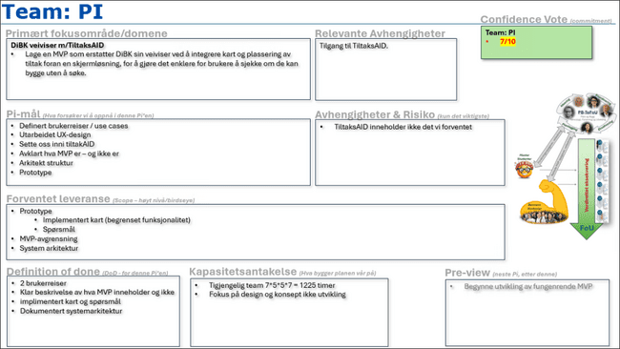

Figure 16: Commit document made during PI 1-start ceremony

Product increment 2
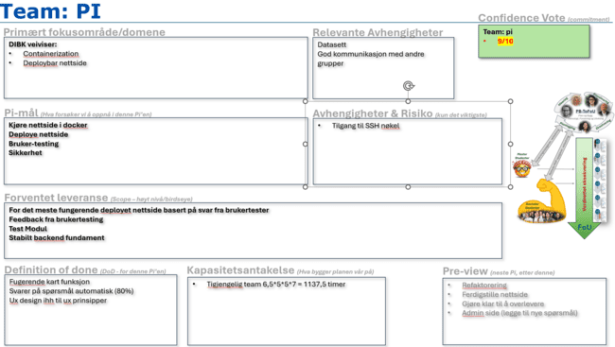

Figure 17: Commit document made during PI 2-start ceremony

Product increment 3
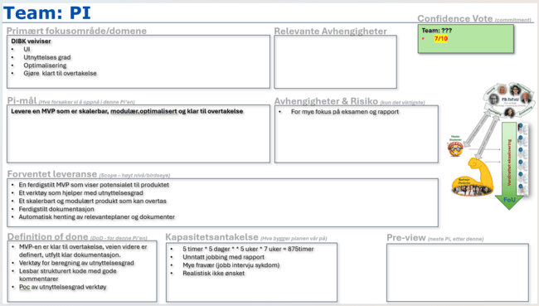

Figure 18: Commit document made during PI 3-start ceremony

Appendix 8 – Interview guideline (User-testing)
Interview guide for interview with normal users:
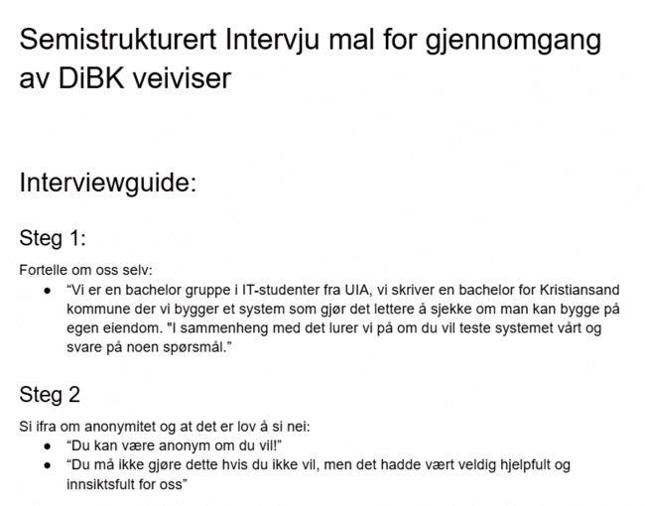

Figure 19: Parts of the interview guide for user testing with normal users

Interview guide for interview with expert users:
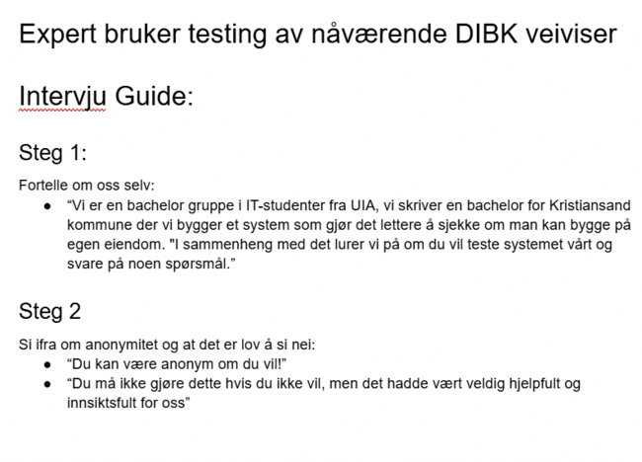

Figure 20: Parts of the interview guide for user testing with expert users

Appendix 9 – Evaluation result
Evaluation result
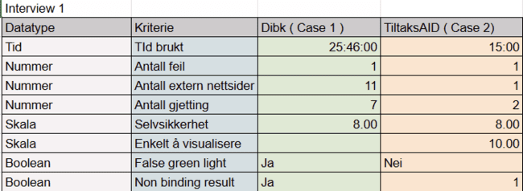

Figure 21: Evaluation result for evaluation interview

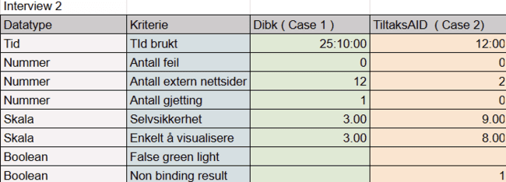Figure 22: Evaluation result for evaluation interview 2
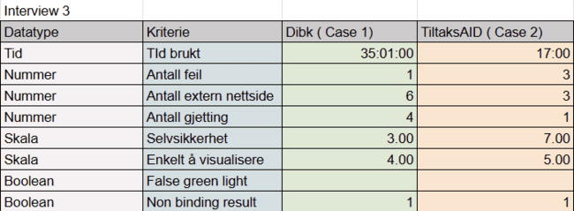

Figure 23: Evaluation result for evaluation interview 3
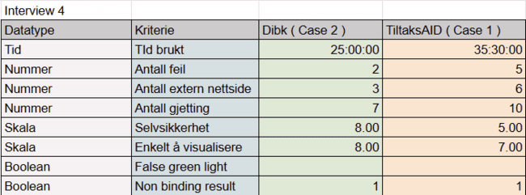

Figure 24: Evaluation result for evaluation interview 4

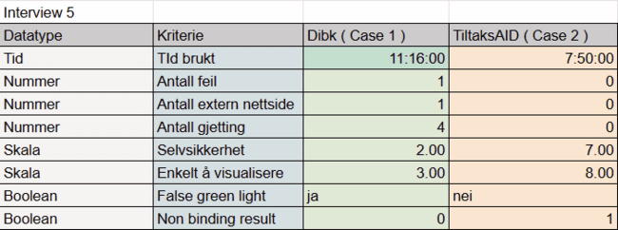

Figure 25: Evaluation result for evaluation interview 5
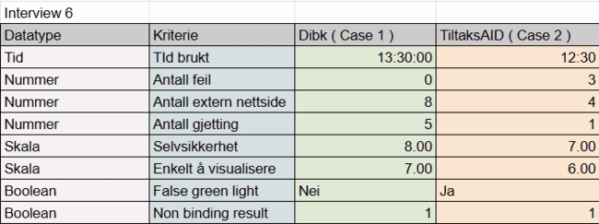

Figure 26: Evaluation result for evaluation interview 6

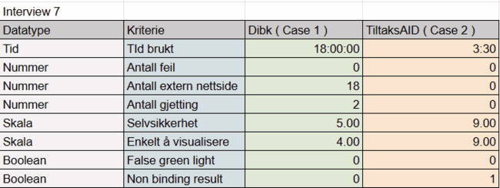

Figure 27: Evaluation result for evaluation interview 7

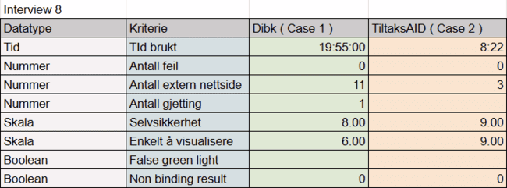

Figure 28: Evaluation result for evaluation interview 8

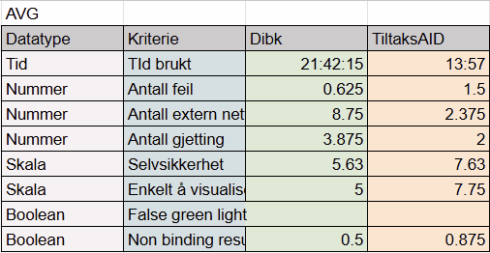

Figure 29: Evaluation result for evaluation, avg results from all interviews

Status 1 video & evaluation
Video link
A video of the early stage of the status, showcasing the groups progression and understanding around the problem issue and the stage in solving it.

Self evaluation - Aaron Silber
My role:
In this group, I have mostly been the Scrum Master in terms of organizing the work for this project. I also like to do creative work such as putting together a video or doing frontend coding work.
My contributions:
I have contributed just as much as the average amount of the group members. As a group, we meet every day, and I have almost not missed anything. I have been doing heavy writing on the bachelor report in terms of research and analysis, but I have also contributed to the main coding project as well. Most of the work I have been doing has been around my main role as the group Scrum Master, and I therefore have an extra work role where I have to meet with the other Scrum Master to recap what we have been doing and also learn from each other.
Group cooperation:
The group works well together, and the chemistry is amazing. Our biggest strength is that we are honest and direct with each other. We are also good friends, so we are good at joking around and having a little bit of fun too. This is important because the semester is long, and we have to enjoy our work as well. All in all, I think the group is happy with each other, and we don’t have many problems to complain about.

Self evaluation - Mathias José Bull Jørgensen
My role:
My role in this bachelor project is mainly in coding and report writing. More specifically, I'm the one handling code in the database and connecting the frontend of the app to the backend.

In the context of DevOps my role is “safety engineer” and “tester/developer”. This means that I'm the one testing the code, trying to find bugs. As well as developing with information security in mind.

My role in the reportwriting is the same as everybody else where we sometimes have dedicated days to continue writing on the report.

Socially I try to be a nice and happy guy trying to lift the mood and make sure everybody is both happy and also updated on how the code works.
My contribution:
As of status 1 I have managed to connect the app to the database as well as use multiple of the database's functions. I have managed to use the output of the database as usable data in the project and also continued the development of some of the functions in the database. I have made several layers for proximity lines, HD map and fixed some bugs with the other layers. I have also made it possible to draw on the map and send this polygon to the database.

My contribution to the report is that I have written about architecture and other small parts here and there. Currently I'm writing about the analysis phases. I have also contributed to the design process and overall logical structure of how the application is supposed to work.
Group cooperation:
I think the group works well together. Everybody has different skills that together makes for a well rounded team, both technically and socially. I think we have been good at starting at the project early and set a good foundation for future work on the bachelor. The application we are working on is also coming along greatly and everybody has had a key role in the development.

Things we can do better is include everybody in the development process of the code.

Self evaluation - Fredrik Schjølberg Husebø
Min rolle:
Min rolle i prosjektet er gruppeleder, ansvar for brukeropplevelse og “release manager”, et ansvarsområde fra DevOps som fungerer som en bro mellom utvikling, drift og forretning.
Bidrag:
I løpet av disse første ukene har fremdriften vært stor. I rapporten har jeg skrevet om bakgrunn, kontekst og metodikk og prosjektplanlegging. Dette har vært veldig lærerikt, spesielt å sette seg i SAFe, som er et skalert agilt rammeverk. Gruppa hadde en lang diskusjon for å få oppklart hvorfor vi burde bruke SAFe fremfor andre skalerte agile metodikker som Scrum of Scrums med Rune. Det skal sies at vi bruker et tilpasset safe rammerverk som passer til forskning og utviklingsmiljøet prosjektet opererer i med spesielt fokus på Agile tog, felles rytme og selvstendighet i hvordan vi selv jobber internt i gruppene. Jeg har også skrevet om story points og burn up charts.

I selve prosjektet har jeg som hovedansvar for alt som dreier seg om UX design brukervennlighet. I begynnelsen var det mye ny teknologi å sette seg inn i som typescript og tailwind som var nytt for meg. Jeg har laget hele spørsmål systemet hvor spørsmål som kan automatiseres skal gjøres etterhvert. Hele systemet er lagd på en modulær måte hvor det er lett å legge til spørsmål uten at det skaper problemer. Flere tiltak er gjort på frontend delen slik at farger kan endres lett. Dette prosjektet skal kunne skaleres nasjonalt og derfor kan andre kommuner som også bruke systemet eventuelt endre farger lett slik at det passer til deres kommune profil.

Samarbeid:
Jeg føler at alle i gruppa har jobbet godt og til sin beste evne deltatt der hvor styrkene deres strekker til. Vi har ikke støtt på store konflikter, men vi har avdekket noen områder som kan forbedres. Først og fremst tidsestimering. Slik ting har gått har vi kommet oss i mål, men vi har ikke hatt kontroll på hvor lang tid ting tar. Vi har nå begynt å benytte oss av story points for å forhåpentligvis klare å måle teamets kapasitet over tid. Burn up chart vil hjelpe oss å se om vi estimerer riktig. En annen ting vi har tatt opp er å ta scrum seremonier mer seriøst for å få mest mulig ut av dem.

Self evaluation - Akinkunmi Oni Akintola
My role:
My role in the group has mainly been technical, while also helping ensure that everyone understands the technology stack we are using. In addition, I have taken responsibility for organizing meetings and booking rooms when we meet on campus or elsewhere
My contributions:
My contributions include writing parts of the document, reviewing the overall content, and making necessary improvements where needed. I have also implemented features in the codebase and carried out refactoring certain areas in the codebase.

Group cooperation:
So far, the cooperation within the group has been good. One thing that could be improved is a more even distribution of technical tasks, even though everyone is free to pick tasks from the GitHub Kanban board. Another area for improvement is how we meet. It’s not always necessary to meet physically, especially since technical work often requires deep focus with as few distractions as possible, something that can be difficult on campus. By including some digital meetups, we could get a better sense of how daily scrums actually affect our workflow.

Self evaluation - Elias D. Simonsen
My role:
My role in the group is not as technical as I initially wanted, that is because the others are better than me technical so it is easy to let them do most of the technical tasks and I myself do the less technical tasks. I do some easy technical tasks but I mostly write in the final report and do the readme files in the project.

My contributions:
As I said in the my role part, my contributions mostly consist of less technical problems, like writing in the final report and making the readme files in the project. In the future I want to take on more technical problems.

Group cooperation:
The group works well together. What I wish we could do better is to assign tasks more evenly, so that everyone does a little bit of everything, instead of only doing what we are good at. This is something I can fix myself. I think it is scary to take on a technical problem so I let the others do it.
Another thing I think we can do better is not leave as early. When planning we are agreeing that we will work till 16:00 but we leave around 14:00. We should stick to the plan, and maybe change it to 14:00 so we do not lie to ourselves.

Appendix 10 – Group contract
Signed contract
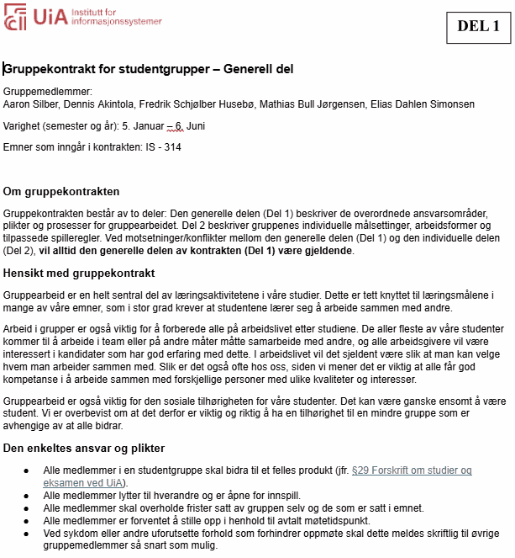

Figure 30: Group contract

Appendix 11 – Demo video
Demonstration video

