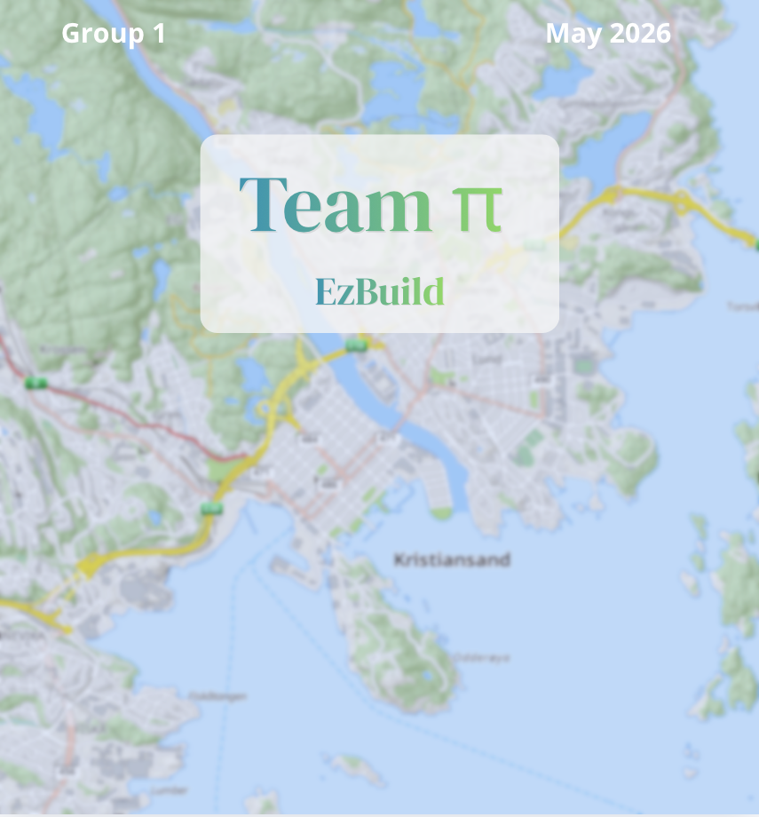



Faculty of Social Sciences
IS-314 26V Bachelor’s Thesis in IT and Information Systems
Team-PI: A map-based guide for construction without planning permission
Group name and candidates: authored by Group 1
Recognised contributors to this assignment:
Mathias José Bull Jørgensen (mjjorgense@uia.no)
Fredrik Schjølberg Husebø (fredriksh@uia.no)
Aaron Silber (aarons@uia.no)
Akinkunmi Oni Akintola (akinkunmia@uia.no)
Elias D. Simonsen (eliasds@.uia.no)

Subject code & name | IS-314 Bachelor’s thesis in IT and Information Systems
Client | Kristiansand Kommune
Supervisor | Leona Chandra
Date | 06.05.2026

We confirm that we do not quote or otherwise use other people's work without this being stated and that all references are stated in the bibliography. | Yes  X | No
Can the answer be used for teaching purposes? | Yes  X | No
We confirm that everyone in the group has contributed to the assignment. | Yes  X | No

Preface
This bachelor thesis marks the conclusion of our three-year academic journey in the IT and Information Systems program at the University of Agder. Throughout the project, the group has gained valuable insight into how digital solutions can improve various aspects of society, as well as the importance of structured teamwork, communication, and effective team organization in achieving a successful project outcome.
In the process of writing this thesis, we have made use of AI-based tools, including ChatGPT and Microsoft Copilot, to support our own improvements in language, structure, and clarity. These tools were used solely as writing aids, and all changes were made by the authors.
We would like to express our sincere gratitude to Rune Ødegård and Dagfinn Øksendal for their guidance, coordination, and valuable feedback throughout the project. We also thank Sebastian Thune for his technical support. Finally, we would like to thank our supervisor, Leona Chandra, for her guidance and feedback during the development of this thesis.
This project has been both challenging and rewarding, offering opportunities for professional growth, teamwork, and practical application of our studies. We are proud of the result and hope that our work will contribute to further digital development within Kristiansand municipality, and potentially inspire similar solutions across other municipalities in Norway.

Abstract
‌This bachelor project was carried out in collaboration with Kristiansand municipality’s Plan and Building Department and focuses on developing a minimum viable product (MVP) that builds on the DIBK Veiviser solution (Direktoratet for byggkvalitet, n.d.). The project demonstrates the possibility of enabling users to receive automated feedback based on what they draw on a map. The report outlines the stages necessary to deliver a robust MVP, including several additional features beyond the original requirements.
This progress was achieved through effective teamwork, structured work methodologies, and close communication with the municipality. Throughout the process, multiple user-testing interviews were conducted to ensure that the team remained on the right track. As the solution is intended for end users, usability was the central focus of the MVP. The resulting MVP has been developed under the name EzBuild.
The result is a functional prototype that showcases how automation and user interaction can enhance the quality and efficiency of municipal digital services. The solution also holds potential for broader adoption, as the municipality aims to present it to other municipalities and explore its use as a nationwide model for similar services.

Table of contents:
Preface 2
Abstract 3
List of figures 6
List of tables 6
1Introduction 7
1.1 Background and context 7
1.2 Research question 7
1.3 Scope and limitations 8
1.4 The group & DevOps role 8
1.5 Working with Kristiansand Municipality Planning and Building 9
2 Project management & design methodology 10
2.1 Development Methology 10
2.2 Scrum as the Primary Team-level Method 11
2.2.1 SAFe for Cross-team Collaboration 12
2.3 Planning and time-estimation 13
2.3.1 Planning 13
2.3.2 Time estimation 14
2.3.3 Github projects 16
2.4 Quality assurance 17
2.5 Risk analysis 18
3 Problem analysis 19
3.1 Qualitative data collection 20
3.2 General issues 20
3.2.1 Spatial to Text Translation 21
3.2.2 The Issue of Cognitive Load 21
3.2.3 The Issue of Operational Strain 22
4 Requirements 23
4.1 User Requirement 24
4.2 System Requirements 24
4.3 Organizational Requirements 25
4.4 Branding and identity 25
5 Solution - EzBuild 25
5.1 Solution description 26
5.1.1 Justification 27
5.1.2 Solution scope 27
5.3 Solution architecture 28
5.3.1 Architecture pattern 29
5.3.1.1 Presentation layer 29
User Interface 30
5.3.1.2 Business logic layer 31
5.3.1.3 Data access layer 31
Supabase DB 32
5.3.1.4 Flaws with layered architecture 32
5.3.2 Deployment architecture 32
CI/CD pipeline & GitHub Actions 33
Docker 33
Azure VM 34
Traefik 34
6 Formative evaluation 34
6.1 Evaluation criteria 34
6.2 Evaluation method 35
6.3 Evaluation results 36
6.3.1 Additional findings worth mentioning 38
6.4 New goals for future development of solution 38
7 Project execution 39
7.1 PI 1(Week 2 - Week 8) 39
7.2 PI 2(Week 9 - week 15) 40
7.3 PI 3(Week 17 - week 22) 40
8 Reflection 41
8.1 Reflection on the methodology, project execution and communication 41
8.2 Reflection on the solution 42
8.3 Adoption for other groups 43
9 Conclusion 43
9.1 The way forward 43
9.1.1 Problems that came to light under usertesting 43
9.1.2 The teams own thoughts for further development 44
10 Reference list 45
11 Appendix: 51
11.1 Status 1 video & evaluation 51
11.3 Appendix 1 – Record of Logged Hours 52
11.6 Appendix 4 – Risk analysis 52
Appendix 5 – Product Increment (PI) Documentation 54
PI - 1 54
PI - 2 55
PI - 3 55

List of figures
Figure 1 - The figure above to the right shows an overview of the different group members' roles, scrum values and devops principles. 9
Figure 2: Overview of story points against the project scope 14
Figure 2 - Overview of Kanbanboard (Board used for task delegation) 16
Figure 3 above to the right - Initial labels used to classify tasks. 16
Figure 4 - Examples of backlog tasks and assignees 17
Figure 7 - Evolution of the problem 22
Figure 8 - The current solution 24
Figure 9 - The groups solution 28
Figure 10 - Azure virtual machines 30
Figure 11 - Shows the process of how CI/CD and GitHub Actions interact at a basic level. 35
Figure 13 - Early prototype 41
Figure 14 - Almost finalized product 41
Figure 15 - Finalized product 42

List of tables
Figure 1 - The figure above to the right shows an overview of the different group members' roles, scrum values and devops principles. 8
Table 1 - Shows specific group roles for each team member 9
Table 2 - Risk matrix showing uncertainties and measurement of risks. 19
Table 3: Evaluation criterion and how to assess them 37
Table 4 - Evaluation table results 39
Table 5 - Compiled data from evaluation interviews…………………………………………….40

1.Introduction
This bachelor’s thesis is based on a digitalisation project initiated by the Directorate for Building Quality (DiBK), with the goal of creating a clearer and more helpful guide for users planning small construction projects, such as garages, sheds, or annexes. EzBuild focuses on developing a Minimum Viable Product (MVP) that will support the creation of a future solution offering citizens clearer guidance and earlier feedback in the building application process through a more intuitive and visual experience. The thesis examines how such a solution can contribute to increased usability, improved information flow, and more efficient interaction between citizens and municipalities.

1.1 Background and context
In Norway, small construction projects such as garages, annexes and sheds are often characterized by strict regulations and digital solutions that require extensive prior knowledge of regulatory frameworks to use. While many such projects often don’t need formal planning permission to break ground, determining this is far from straight forward. Citizens must interpret rules concerning building sizes, placement, regulation plans and distances to buildings, roads and neighbours to name a few. These rules are rarely familiar to the general public and often misinterpreted.

To support citizens through this process, DiBK provides a digital guidance tool, designed to help users determine whether they need a permit or not. While the tool represents a meaningful step toward accessible self-service guidance, citizens are expected to supply information about their property by retrieving data from multiple external sources, and translate abstract regulatory requirements into their own specific spatial context. As this project’s user interviews confirmed, this creates a real barrier for users.

1.2 Research question
While the digital guidance tool by DiBK attempts to address the issue of making building without a permit more accessible, it places a significant cognitive demand on users and provides limited spatial support, leaving many citizens unable to reach a correct assessment on their own. This causes a downstream pressure on the casehandlers. These issues motivated the question: “How can a digital solution be designed to reduce users' cognitive load, support spatial understanding in building-permit processes, and reduce operational strain in municipal administration?” Chapter 3 provides a detailed description of the underlying challenges and
introduces the analytical perspectives used to explore this question.

1.3 Scope and limitations
This bachelor’s thesis is limited to the development of a Minimum Viable Product (MVP) that conceptually replaces the Directorate for Building Quality’s existing guidance tool for “Garage, shed or annexe”. The scope of the thesis is limited to exploring how a more intuitive and user‑centred guidance service can be designed through a map‑based interface and the visual placement of measures on a property. The focus is on the conceptual use of these components, without implementing production‑ready integrations or authentic connections to municipal specialist systems
This thesis is delimited from full case processing, legal assessments, and responsibility related to the interpretation of planning and building regulations. Any regulatory clarifications are addressed only at a higher level of competence to support the guidance logic in the prototype and should not be understood as legally binding. The thesis focuses on concept, user flow, and overall functionality, rather than full-scale technical realisation or organisational anchoring within public administration.

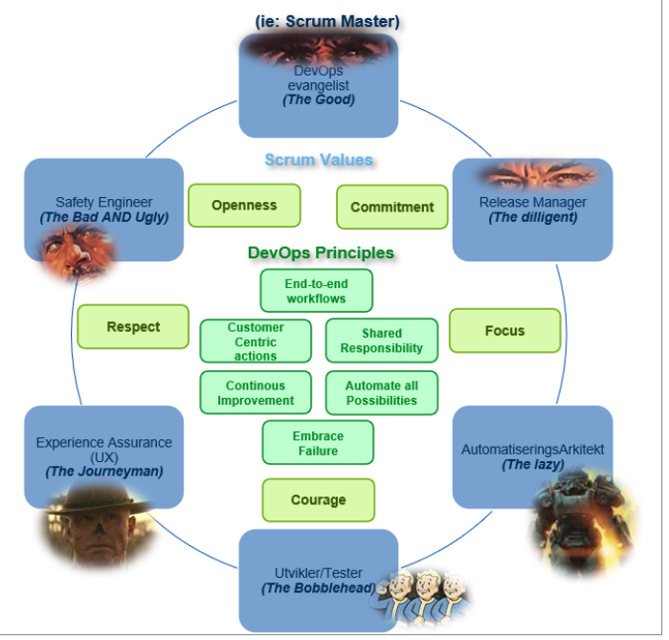
1.4 The group & DevOps role

Figure 1 - Overview of the different group members' roles, scrum values and devops principles.
The student group behind the project consists of five members: Mathias José Bull Jørgensen, Aaron Silber, Akinkunmi Akintola, Fredrik Schjølberg Husebø, and Elias Dahlen Simonsen. The group has previously collaborated across disciplines during their studies, and the members are therefore well acquainted with both one another and each other’s working methods.To ensure that each member’s skills were used effectively, roles were assigned based on individual competencies and project needs. Figure 1 and table 1 illustrate the different roles assigned to each group member. However, it is important to note that responsibilities overlapped, and some members held multiple roles. This occurred both because some members wanted to gain experience beyond the scope of their primary role and because their existing skills were valuable across different areas of the project.

Table 1 - Shows specific group roles for each team member
Name | Role | Responsibility area
Fredrik Husebø | Experience assurance | Delivers an optimal user experience through aligned prototypes and design elements, and supports the overall website development.
Aaron Silber | Scrum master | Ensures effective team collaboration, clears impediments, and keeps the sprint process aligned and efficient. Developing website
Akintola | Automation Architect | Oversees CI/CD pipeline integration and DevOps workflows, and contributes to the website’s development as an Automation Architect.
Elias Simonsen | Developer/Tester | Develops and integrates unit tests to ensure code quality and reliability.
Mathias Bull | Safety engineer | Maintains a secure website environment and supports CI/CD integration, DevOps workflows, and broader website development as a safety engineer

1.5 Working with Kristiansand Municipality Planning and Building
The group had weekly office hours at the municipality every Thursday. These sessions were used to work collaboratively on the application, discuss design and technical decisions, and ask clarifying questions related to the ongoing development. Some days were dedicated to meetings with stakeholders to refine the problem understanding and ensure that the solution was progressing in the right direction, while others were used to present our work, demonstrate prototypes, and explain our reasoning.
Our primary contacts within the municipality were Dagfinn Øksendal and Rune Ødegård, who acted as the link between the student group and the municipal organisation. In total, 21 students from the Information Systems programme collaborated with Kristiansand municipality. The students were distributed across four bachelor projects and one master’s thesis.
The municipality also facilitated several opportunities for collaboration and knowledge‑sharing across the student groups. This included team syncs attended by all students working at the municipality, an architecture forum for those in architecture‑related roles, and a Scrum Master forum for students responsible for coordinating team processes. These arenas proved highly valuable, enabling idea exchange, collective problem‑solving, and discussions of shared challenges. They also provided space to ask questions, receive guidance, and align solutions across teams, contributing to a more coherent and well‑informed development process.
However, communication between our group and the other student groups at the municipality outside the structured collaboration activities was limited. Some interaction occurred early and midway through the project with another individual from one of the municipal groups to align on an interactive visual component and deployment setup.
The limited communication during the project did not cause any problems, as our project had no dependencies on the other groups that required constant coordination. Working closely with the municipality provided valuable insight into how structured communication channels can support progress even when collaboration across groups is limited.

2 Project management & design methodology
Developing software systems requires close integration between project management practices and the software development process (Ebert 2002). For this reason, the group adopted structured methods to plan, coordinate, and evaluate the work throughout the project. This chapter describes the working process the group followed during the development of the application and, in some cases, during the writing of the bachelor thesis. It outlines the methods and practices used, including the Scrum framework, the municipality’s SAFe‑inspired Scrum approach, planning and time-estimation, github projects, quality assurance, the risk analysis conducted by the group, and the measures taken to ensure quality in the application. The chapter also explains how tasks were planned, estimated, and prioritised during the development process.

2.1 Development Methology
The team based its development approach on prior experience with agile methodologies from previous academic projects. Drawing on this experience, the team applied an iterative and collaborative workflow that emphasized flexibility, continuous feedback, and incremental development.

2.2 Scrum as Team-level Method
Scrum was the development methodology used at team level. It was chosen because it is a lightweight framework for developing and evolving complex products, grounded in empiricism and lean thinking (Schwaber & Sutherland, 2020). Through iterative sprints, the team adapted to stakeholder feedback and technical challenges while delivering incremental improvements to Ezbuild and reduced the risk of misalignment.
The team followed the standard Scrum roles defined in The Scrum Guide: Product Owner, Scrum Master, and Developers. The Scrum Team was self‑managing, without sub‑teams or hierarchies, and shared collective accountability for delivering value each sprint (Schwaber & Sutherland, 2020).
The team held a short Daily Scrum each morning to review progress, adjust plans, and identify blockers, using the recurring questions of what was done, what will be done next, and what is preventing progress. These measures were vital, acting as the catalyst for the group's productivity.

The group conducted a sprint retrospective at the end of each sprint. The retrospective provided a structured opportunity to evaluate the process, team interactions, and overall effectiveness, and to identify improvements for the next sprint (Schwaber & Sutherland, 2020). While Scrum typically includes a sprint review at the end of each sprint, this was replaced by a PI‑end (product increment) ceremony held every seventh week to better accommodate stakeholder availability. Continuous feedback was maintained through ongoing dialogue with stakeholders throughout the sprints.

Scrum defines three key artifacts designed to ensure transparency and support empirical decision‑making: the product backlog, the sprint backlog, and the sprint goal. Together, they provided a clear overview of the planned work, sprint progress, and delivered value (Schwaber & Sutherland, 2020). These artifacts were then used in two different boards, one for the development of the product and one for writing of the report. This greatly helped in keeping track of tasks and guided the development forward. This flexibility helped with strengthening communication and clarified responsibility.

2.2.1 SAFe for Cross-team Collaboration
Agile methods were originally developed for small, co-located teams. In large-scale settings with multiple teams, complex products, and external stakeholders, challenges arise related to coordination, prioritisation, and alignment between strategy and execution. The “Scaled Agile Framework” (SAFe) offers a structured and scalable approach for implementing lean and agile methods in large organisations (SAFe Explained, n.d).
In this project, SAFe was treated as a source of inspiration, rather than a doctrine to be implemented in its entirety. This deviation from SAFe in its prescriptive form as described in the official documentation was intentional and grounded by the group's tech contact Rune Ødegård. According to (R. Ødegård, personal communication, January 16, 2026), full SAFe implementation is most effective when the problem-space is relatively stable, can be planned with a reasonable amount of confidence and when the dominant challenge is large-scale coordination rather than exploration and learning. This program operated in a research and development environment characterized by uncertainty, evolving problem definitions and variations in technical requirements between the teams. In such cases, full SAFe governance mechanisms risk constraining learning, reducing team autonomy, and creating a false sense of control though formal procedures rather than actual progress.
Therefore, selected concepts were adopted where they add clear value, while other concepts were deliberately removed when they conflict with the exploratory nature of work. Central to this selective adoption of SAFe, was the use of Agile Release Trains (ARTs) and program increments to establish a shared sense of direction and cadence across teams, without reducing team autonomy.
In this project, the work was structured into three program increments (PIs) of seven weeks each. Cross-team transparency was emphasized to ensure that dependencies and overall progress was visible beyond the backlog of other teams. This was achieved through cross-team ceremonies, including scrum master meetings, architect forums, team-syncs, PI-start- and PI-end meetings orchestrated by Rune Ødegård. Decisions at program-level were deliberately kept in use to ensure alignment with the overarching program goals. Additionally, the release train engineer role was used to support communication and dependency management across teams, rather than to impose hierarchical control. This approach preserved team autonomy, while still enabling effective coordination across teams throughout the project.
SAFe improved autonomy within the group and provided a clear overview of how our solutions relate to those developed by other teams. Although our project was largely independent, the SAFe framework enabled valuable exchanges with the other groups whose perspectives and challenges helped us avoid similar mistakes. The primary benefit, however, was the synchronized rhythm across all teams, which enabled stakeholders to monitor progress throughout the project's lifecycle.

2.3 Planning and time-estimation
This section describes how the project was planned and how we estimated progress and workload. Together, these aspects form the basis for carrying out the work effectively and adapting along the way.

2.3.1 Planning
Effective planning is foundational for any project. It defines scope, allocates resources and establishes a shared sense of direction. Critically, it also shapes all subsequent actions and decisions throughout the project lifecycle. Planning also establishes a benchmark against which progress can be measured and priorities reassessed (Ayele, 2023). Without it, teams risk scope creep misaligned effort, and schedule overrun.

Given the nature of this project however, a fixed upfront plan would have been counterproductive. In traditional project management the assumption is that the events affecting the project are predictable and that once a task is finished it won't be revisited (Zhang et al., 2010). These assumptions are not suitable in environments where requirements evolve and knowledge is developed during the project. As a result, the project required an agile planning approach inspired by SAFe scrum. Initially, the group defined a high-level vision of the minimum viable product to establish direction and scope. Based on this, a general milestone plan was developed to guide the overall progress and serve as a benchmark for progress. Within that structure, work was broken into program increments and shorter scrum sprints, allowing priorities to be reassessed continuously as the team's understanding of the problem evolved. The figure below describes the milestone plan.
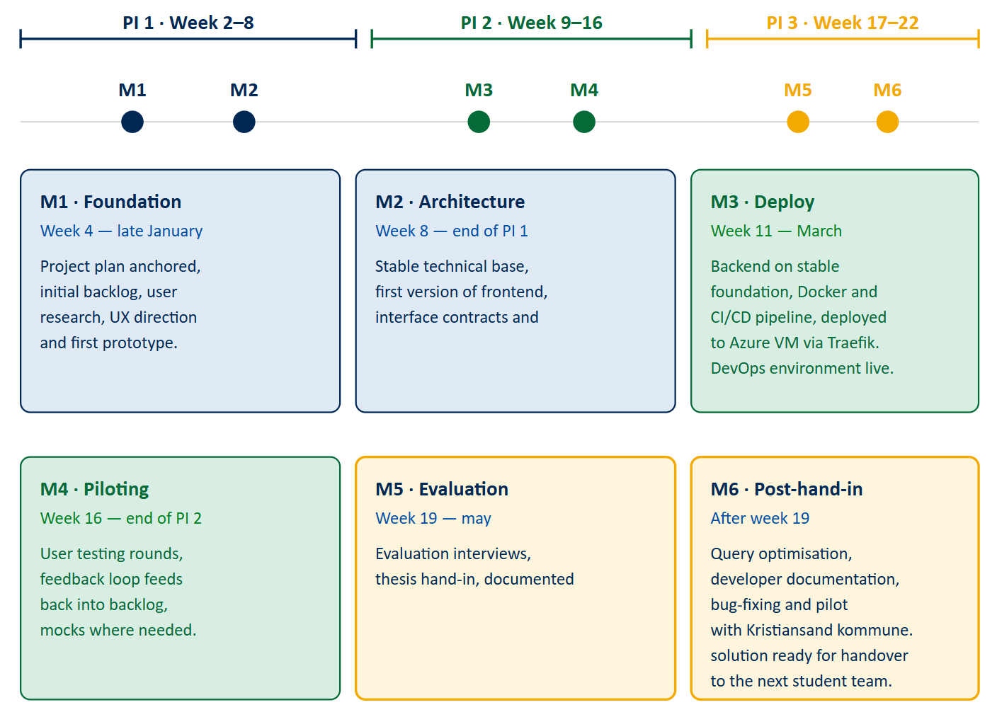

Figure 2: Milestoneplan

2.3.2 Time estimation
Story points are a relative unit used to estimate the required effort to complete a work item in agile software development. Rather than measuring time directly, story points represent the relative effort of a task, taking into account factors such as complexity, size and uncertainty (Pasuksmit et al., 2022). During sprint planning and backlog refinements the team estimated story points using Planning Poker to ensure collective input and shared understanding among team members. By assigning relative values to tasks, the team was able to prioritise work and, balance sprint capacity and monitor progress across iterations.

Progress was tracked using burn up charts, which plots completed story points against total planned scope over time. This way, progress was made visible to the whole team and surfaced scope changes when they occurred.
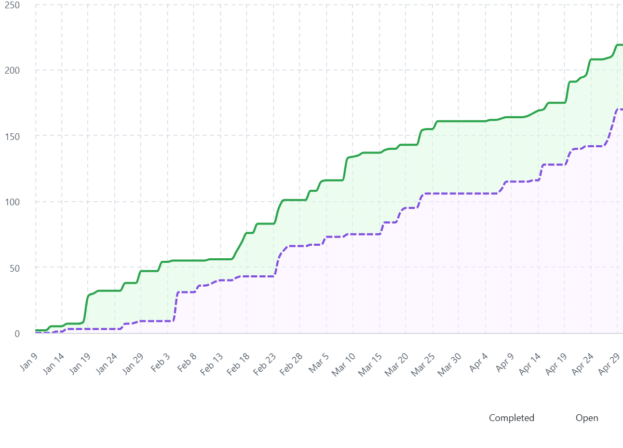

Figure 3: Overview of story points against the project scope

The use of story points aligns well with the project's uncertain and evolving project contexts, where tasks cannot be fully defined in advance. For the team this meant that planning focused on relative effort rather than getting stuck on precise time predictions, keeping sprint planning productive even when uncertainty was high. Story points also suit self-organized scrum teams particularly well, as the collective estimation process ensures that all members have a shared understanding of scope and effort, rather than having workload defined top-down (Maha et al., 2026).

Story points proved useful for structuring sprint planning but also revealed several limitations. Estimates were inherently subjective and depended on team experience and shared understanding, which took time to develop. Early in the project, before the team had an established velocity, these challenges were particularly evident. The group struggled to balance the number of tasks per sprint and align appropriate story points per task.

Without a historical reference, estimates were largely based on intuition. Sprint retrospectives helped identify where estimates had been inaccurate and why, allowing the team to gradually establish a consistent velocity. Over time, burn‑up charts became a reliable reflection of actual progress rather than initial estimates.

During the task allocation it became evident that bigger tasks were harder to estimate and more often lead to people feeling stuck. These issues were fixed by dividing the tasks into smaller more concrete tasks which lead to better workflow and time estimation overall.

2.3.3 Github projects
Github projects served as the team's primary tool for implementing scrum within the project. The tool was a requirement from the product owner, which meant it served an audience beyond the team itself. Operating under the same github organization, each team's project board was visible to the others, which supported cross-team transparency that the SAFe-inspired framework depends on. Rather than solely relying on SAFe ceremonies to understand where teams stood, dependencies and progress were observable throughout the project lifecycle (SAFe Explained, n.d).

Within the team, the board translated scrum artifacts into daily practice. Each task was registered as an issue with a storypoint estimate, priority, an initial label, a descriptive title and description. Labels were used to classify tasks, including “Report” for thesis-related work and “MVP” for development activities. Additional labels covered submissions, meetings, and supervisory interactions. GitHub Projects gave the team's Scrum process a concrete and shared structure. By linking tasks to sprints, story point estimates and priority labels, the board made scope visible, progress transparent, and priorities harder to ignore.

In the self-organized environment team members were able to assign themselves to tasks as they became available. As a result, workload distribution emerged from capacity rather than being imposed by the scrum master. This way autonomy was preserved without creating chaos and the next task could begin without needing anyone to coordinate work, reducing idle time.

Furthermore, a team member who chooses their own task takes ownership of it, meaning there was little grounds for claiming confusion of responsibility. This is consistent with Self-Determination Theory, which suggests that autonomous behavior is associated with a greater sense of ownership and autonomy (Deci & Ryan, 2000).

That being said the board was only as reliable as the discipline behind it. One challenge the team specifically faced was that the less engaging tasks, like documentation, testing and refactoring had a tendency to remain unpicked. This wasn’t a flaw with the tool itself, but rather a tension in the self-assignment model. In practice this was managed through sprint planning, where the scrum master would flag tasks that lingered and prioritize those tasks. Scrum methodology, together with Github Projects proved vital for breaking down tasks into manageable components and coordinating progress through structured planning.

Another major challenge was scope creep, where there was pressure from stakeholders and within the group to increase the scope and functionality beyond the initial scope. Having clear sprint goals based on the PI goals and only working on tasks that lead to the closure of these goals helped in minimizing scope creep and finishing the most important tasks first. Scope creep isn’t always a bad thing, but in our case the goal is to make an MVP which means, finishing the initial scope has a higher priority over adding additional features.

2.4 Quality assurance
This chapter focuses on quality assurance (QA), including software quality assurance (SQA) and process quality assurance (PQA). Quality assurance is implemented to reduce the risk of developing software that does not meet the needs and expectations from the stakeholders (Laporte & April, 2018). In this context, SQA focuses on ensuring quality of the software product, while PQA emphasizes the quality and improvement of the development processes used to create it.

2.4.1 Software quality assurance
To ensure quality in the product, the group defined several criteria to follow, and by following these criteria the product reached a certain degree of quality. However, even though these criteria have been fulfilled, it does not mean the product has achieved real quality. It only proves the development process met the standards the group set for itself. According to Laporte & April, 2018, one must identify the components of a system and their interactions to ensure quality. That means that real quality depends not only on the following predefined criteria, but also on evaluating how the system works as a whole, how its parts function together, and whether or not it meets the stakeholders expectations

The predefined criteria the group identified to ensure quality for the solution are following:
- Systematic activities that tell us, throughout the project's lifecycle, that certain corrections are required.
- Techniques that demonstrate the level of quality reached. (Laporte & April, 2018)
- Double checking code before pushing it into main.
- Writing tests that verifies the software works as intended.

To address the first criteria, the group conducted user tests throughout the developement

o address the requirement for systematic activities that reveal when corrections are needed, the group conducted user testing throughout development. This provided continuous feedback and helped identify issues early. To demonstrate the level of quality reached, the group performed an evaluation where a user tested both the old solution and the new one and answered a set of structured questions, allowing for a direct comparison of perceived quality. Code quality was ensured by having someone review and double‑check all code before it was merged into the main branch. Finally, the group wrote tests for the most important parts of the codebase, ensuring that critical functionality behaved as intended and reducing the risk of regressions.

Here is how the group chose to follow these criteria and what it led to. For the systematic requirements that tell us that certain corrections are required, the group chose to perform user testing. The technique that demonstrated the level of quality reached the group performed an evaluation where a user tested the old solution and our solution and answered some questions. Someone always double checked the code before it was pushed to main and we have written tests for the most important code.

2.4.2 Process quality assurance

Quality assurance in software development is the process of ensuring that a software product meets defined standards and performs its intended functions in an effective, efficient, and reliable way. It involves assessing key qualities such as functionality, performance, usability, reliability, maintainability, and portability. By using approaches like Agile, DevOps, and Continuous Integration/Continuous Deployment (CI/CD), development teams can improve workflows, strengthen collaboration, and deliver high-quality, robust software solutions (Software Quality Assurance, 2026).

Since the project relies a lot on user interaction, the group focused strongly on UX design and usability throughout the development process to make sure the user experience is good. Usability was considered from the start and improved step by step during development.

In addition, end-user feedback was incorporated as part of an ongoing quality assurance process once EzBuild reached a functional stage.

Along the way, quality assurance was strengthened through the introduction of a CI/CD pipeline using GitHub Actions and automated testing, which was strongly encouraged by the municipal supervisor throughout the project. A more detailed description of the CI/CD pipeline and GitHub Actions is provided in Section x. Overall, the DevOps methodology supports quality assurance by promoting continuous testing, test automation, cross-functional collaboration with shared responsibility for quality, and a balanced use of manual and automated testing (The Role of Quality Assurance in a DevOps Workflow: Transforming Your Business Operations - TestCrew, 2025).

The group chose not to prioritise comprehensive system-wide testing, as this would have required too much time away from EzBuilds`s development. Therefore, testing was focused on the core functions considered essential for EzBuild`s best possible outcome.

2.5 Risk analysis
According to Dash & Dash (2010), risk analysis in software development projects is used to identify, assess, and manage uncertainties that may affect project outcomes. Through risk analysis, potential risks are systematically identified and evaluated in order to support realistic project planning and decision-making.
In this project, the application of risk analysis provided the group with a systematic overview of potential risks. This made it possible to define targeted risk mitigation measures, aimed at reducing both the likelihood of the risk occurring and the associated consequences.
The identified risks were analysed by assessing both probability and consequence on a scale from 1 to 5. Based on the conducted risk analysis, a risk matrix has been developed that visualises the relationship between probability and negative consequences in the appendix in x.x. Table 2 shows the highest risks identified in the project.

Table 2 - Risk matrix showing uncertainties and measurement of risks.
Nr. | Risk (Uncertainty) | Total risk | Risk measure
1 | Misinterpretation of building permit regulations | Very high | Have an active conversation with people with domain expertise at the municipality, and integrate continuous feedback during the development.
2 | Too large functional scope for an MVP | High | Narrow down what the MVP actually is and only prioritize what is truly necessary.
3 | Solution is more complex than expected | High | Start with a simplified scope and prototype early to uncover technical challenges and adjust scope accordingly.
4 | Time constraints in the bachelor | High | Plan early, work consistently, and prioritize tasks based on realistic time estimates through Scrum practices.
5 | Technical issues requiring rework late in the project | High | Use git version control and CI/CD pipelines to review pull requests collaboratively and ensure code quality through modern development practices.
6 | Scope creep | High | Define the MVP early and use Scrum routines to maintain focus and prevent scope expansion.

3 Problem analysis
- Skrive om hvordan problemet utvikler seg fra spatial to text translation. Hele veien til operational strain.
Determining whether a building project requires a building permit is a complex task for many citizens. The process requires users to cross-reference information from multiple governmental and municipal websites, interpret overlapping map layers with different spatial constraints such as zoning boundaries, and property-specific regulations. When this interpretation fails, the consequences affect both citizens and municipal authorities, leading to unnecessary or faulty applications, false green lights to start building and increased administrative workload. To gain a deeper understanding of the problem several user interviews were conducted continuously throughout the project's lifecycle. This helped to gather insights about user experiences with both the DiBK’s current guidance tool and the current prototype of the solution.

3.1 Qualitative data collection
A semistructured interview was chosen as the data gathering method because it provides the most effective way to capture user insights. Qualitative data collection was chosen over quantitative research as it allowed for a more in-depth understanding of the user experience and made it possible to observe the subject, ask them follow-up questions, understand their behaviour and get real-time feedback. The subjects consisted of “normal” people of ages between 21-60. Two of the subjects were experts in the field, one was a caseworker that handles building applications and the other had experience in the building industry. These individuals were additionally asked relevant questions about their jobs and work experience.
The semi-structured interviews were done digitally and in person with 8 people. During the interviews the participants were asked to do a case. The case involved having the subjects check whether a project needed a permit or not(appendix), using DiBK’s guidance tool. The subjects got minimal help and were only guided through the process when they were stuck for a prolonged amount of time. Additionally expert subjects were asked questions about the processes around building applications and how it affected their workflow.

3.2 General issues
The feedback from the different interviews were compiled(appendix) and several key issues were found. Expert users, including caseworkers, expressed frustration with cases where individuals had already begun construction under the assumption that a permit was not required. The Directorate of Building Quality created a digital guidance tool intended to aid in this process. However, the tool leaves a big cognitive burden on the citizens, effectively sending users on a digital scavenger hunt to understand municipal and regulatory plans.
To better understand the underlying causes of these challenges, the problem is analysed through three perspectives: spatial cognition, cognitive load, and operational strain. These perspectives were selected because they reflect the patterns identified through the interviews.

3.2.1 Spatial to Text Translation
Spatial cognition involves the ability to represent, organize, understand, and interact with spatial information about objects and their relationships in the environment (Gabbard, 2015). In the current guidance tool provided by the DiBK, users are required to answer a sequence of questions related to their planned construction project, including building size, height, distance to neighbouring properties and the placement on their property. To respond to these questions, users must interpret spatial requirements without visual support into their own physical property context. This requires forming internal representations of distances, boundaries, and spatial constraints without direct support from the system. Research shows that such mental representations are known to omit and regularize information, mix perspectives, reduce dimensionality and exaggerate (Tversky, 2000), which can increase the likelihood of misinterpretation and incorrect assessments. This was also reflected in user interviews, where participants reported difficulty estimating distances and boundaries in the context of their property.

3.2.2 The Issue of Cognitive Load
Cognitive load refers to the amount of mental effort a user must invest to operate an interface and consists of several components including intrinsic and extraneous load. Intrinsic cognitive load reflects the inherent complexity of the subject matter itself and how difficult the content is regardless of how it is presented. Extraneous cognitive load, on the other hand, stems from unnecessary processing, elements that consume mental resources without contributing to the user’s understanding (Klepsch, 2020).
The existing DiBK guidance tool places relatively high cognitive demands on users, particularly in terms of intrinsic cognitive load. This became evident during user interviews some participants struggled with understanding the terminology and regulatory requirements referenced in the questions. As a result, they had to spend considerable mental effort trying to understand unfamiliar concepts and requirements presented in the complex field of planning and building.
In addition, the interface combines intrinsic burden with a considerable extraneous load, not because of too much information, but rather the lack of. The current DiBK guidance tool functions like a maze of interconnected external links, which places the burden of finding the right information on the user. Participants spent a significant amount of time searching for necessary information on external websites, as the guidance tool didn’t provide it directly. This absence of contextual help and lack of definitions, forced the user to resolve uncertainties on their own, which lead to frustration, interruptions in their progress and considerable extraneous load.
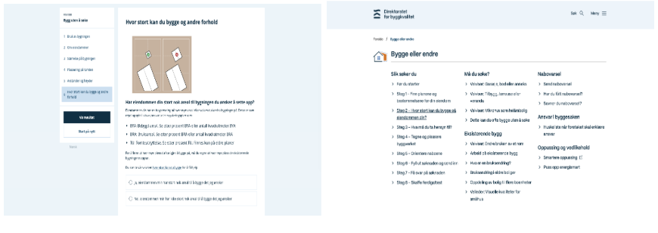

Figure 4 - The current solution

3.2.3 The Issue of Operational Strain
The expert interviews revealed that operational strain in the municipality diverts resources away from core tasks and slows down case-processing for all parties involved. The interviews highlighted problems related to incomplete applications, missing building permits or inquiries about the build application process.
When citizens struggle to interpret building regulations or determine whether their project requires a permit, they often submit unnecessary or incomplete applications or skip it entirely and build assuming they don’t need to apply. This issue is highlighted by the Norwegian government, which in 2025 reported that more than 30% of building applications lack the required information. The lack of required information often leads to longer processing times, as it requires repeated communication between applicants and municipal caseworkers to obtain the missing information (Regjeringen, 2024).
In many cases, citizens break ground without obtaining proper permission. A recent case from Kristiansand directly illustrates this. A cabin owner on Herøya built a garden structure in the protected coastal zone, having been inaccurately advised in 2015 that no permit was required. Only after construction finished a formal application was submitted for approval. The municipality rejected it and the owner now faces a demolition order (Drivdal, 2026). Such cases frequently lead to disputes with neighbors and the municipality. Highlighting that cases like these generate additional administrative work and follow‑up processes.

4 Requirements
To address the issues described in chapter 3, a list of requirements was continuously developed to guide the development of EzBuild. The requirements were derived from user insights, observations and stakeholder input from the Kristiansand municipality. These were then divided into four categories: User requirements, describing how the user interacts with the system, system requirements, describing technical and functional constraints, organizational requirements, describing goals and constraints imposed by the municipality, and lastly branding and identity, describing how user interface should conform to the municipality's brand and identity.

Table 3: Summary of requirements
User requirements
Specify planned position and footprint of a structure on their property.
Minimize manual data entry.
Clear and correct indicator for whether they can build without needing to apply.
System requirement
Efficient handling of data.
Codebase must follow principles of API-first.
Same technology stack as other bachelor groups in the municipality.
Codebase needs to be modular, scalable and easy to reuse.
High level of data accuracy.
Organizational requirement
Careful handling of sensitive geographical data.
Non-binding results.
Branding and identity
Follow the municipalities standard for branding and identity,which is specified in the municipalities brand manual.

4.1 User Requirement
EzBuild had several requirements in order to function as a foundation for further development.
User requirements often deal with how a user will interact with a system and what that user expects (Kraeling & Tania, 2019).

First, users must be able to specify the planned position and footprint of a structure on their property to help with the spatial to text translation. This allows the system to automatically get spatial boundaries that would otherwise require manual input. The system must minimize manual data entry and simplify complex regulatory questions. This is to increase likelihood of completion. Additionally, users need a clear and correct indicator for whether their proposal needs a permit or not. This could reduce the amount of wrongful building projects that could increase the administrative burden on municipal caseworkers and lead to a lengthy post-construction legal dispute.

4.2 System Requirements
The system's requirements describe requirements for the system that are not visible to the user (Kraeling & Tania, 2019). These are requirements that are needed for the system to work reliably and correctly.

The system must ensure efficient handling and validation of data. This is to ensure correctness of the generated result. Development must follow the principle of API-first whenever applicable and use DevOps principles, particularly Continuous Integration and Continuous Delivery. This is to ensure alignment with municipal development standards and long term maintainability. The codebase must use the same technology stack as the other bachelor groups in the municipality. This allows seamless integration of the different solutions. As the project is expected to continue beyond the current development phase, it’s also important that the codebase is modular, scalable and easy to reuse. A high level of data accuracy and reliability is also required to ensure spatial boundaries are calculated correctly and minimize inaccurate results.

4.3 Organizational Requirements
Organizational requirements refer to the internal rules, constraints, and standards that a system must satisfy in order to align with the goals, policies, and responsibilities of the organization.

An important organizational requirement relates to the handling of sensitive geographical data. Information about water infrastructure is considered sensitive, as it represents critical national infrastructure. As a result, the system must be designed in a way that prevents exposure of such data to unauthorized users.
It’s important that the output of the system must not be perceived as an official government approval. The guidance provided by the application should be presented as a summary and not as an approval for construction. This ensures that responsibility remains with the user and not the municipality. From an organizational standpoint, this requirement reduces legal liability while still allowing the system to function as a guidance tool.

4.4 Branding and identity
The user interface follows the municipality's brand and identity, but it is also easily customizable to conform to other municipalities if needed. The brand and identity requirements are well defined in the municipality’s brand manual where it states how the use of typography, colors and layout should be used (Kristiansand kommune, 2021). This ensures consistency across all the municipality's digital solutions.

5 Solution - EzBuild
This chapter introduces the developed MVP that follows the previously set requirements and aims to solve the problem described in the problem description. The chapter describes the solution as well as the use of layered architecture, deployment architecture, the different parts that make up each layer and technology stack. ….blablabla dennis fiks

5.1 Solution description
The solution integrates a map with interactive drawing tools into a similar looking guidance tool as DiBKs guidance tool. This combination allows users to mark the exact location, and size of their build proposition directly on a digital map, which then enables the system to automatically retrieve and interpret the relevant spatial data. This allows the system to automatically answer most of the questions from the original guidance tool, reducing uncertainty and cognitive load for the user. The solution also visualizes the area in which the user is allowed to build without submitting an application, while simultaneously providing feedback on distances to relevant boundaries. Finally, it generates a summary of the user’s inputs and provides an assessment of whether the proposed building complies with national regulations.

By merging geospatial interaction with a familiar guidance workflow, the solution provides a more intuitive, efficient, and error‑reducing alternative to the current process.

Some interview subjects had experience with sending building applications and didn't have any issues with answering the questions, so a hybrid solution was developed that gives the option to answer the question normally just like DiBK’s guidance tool.

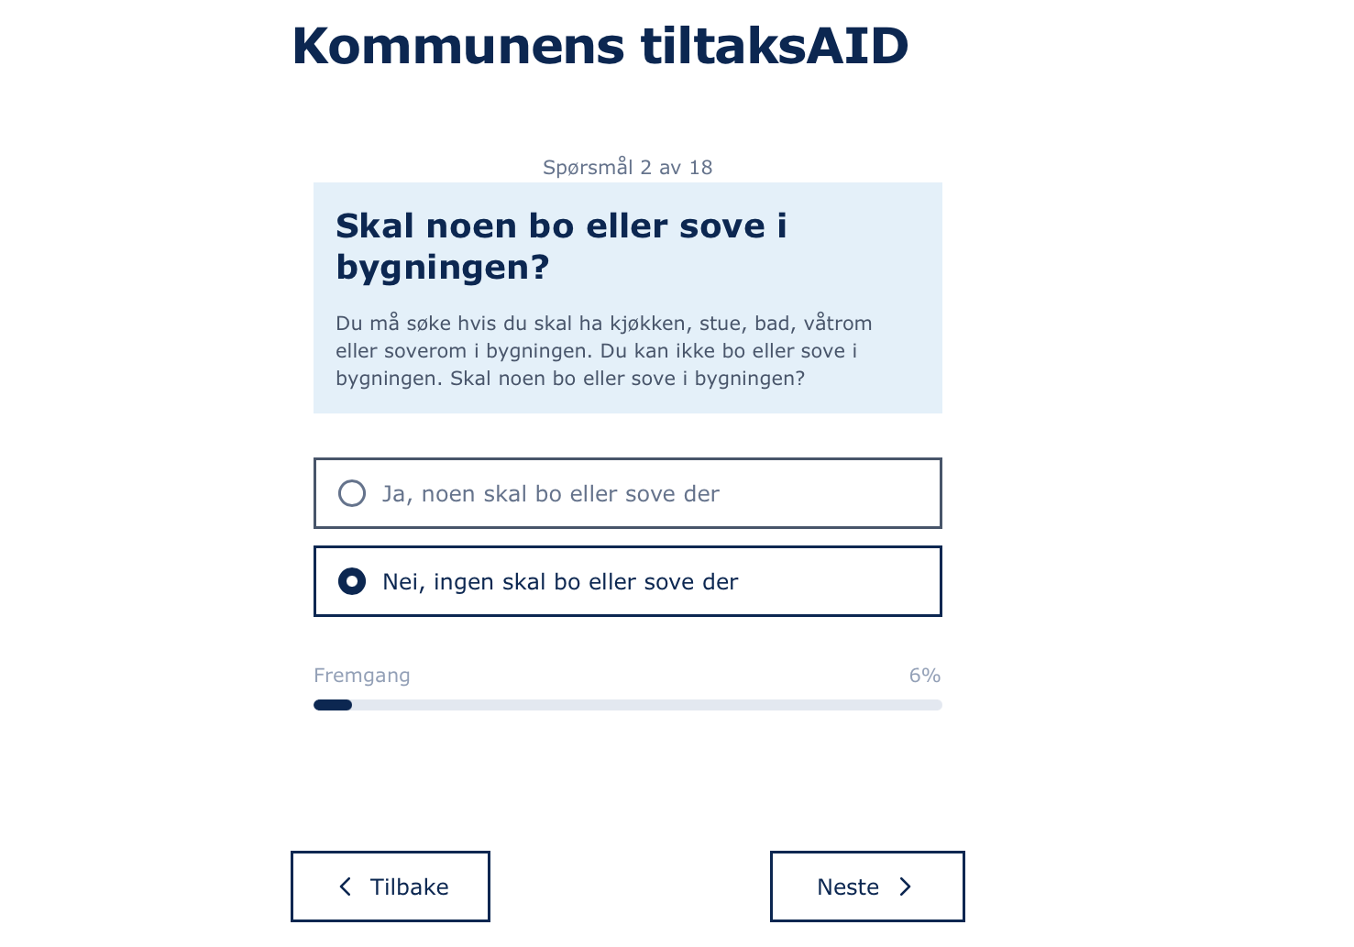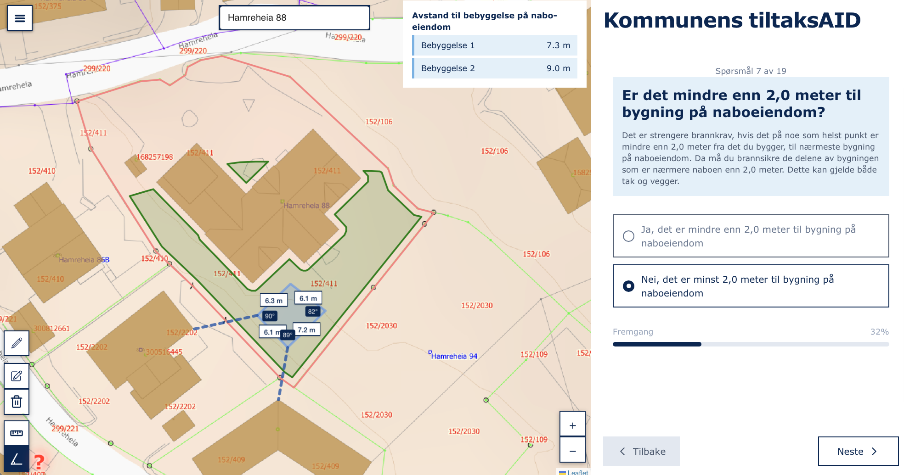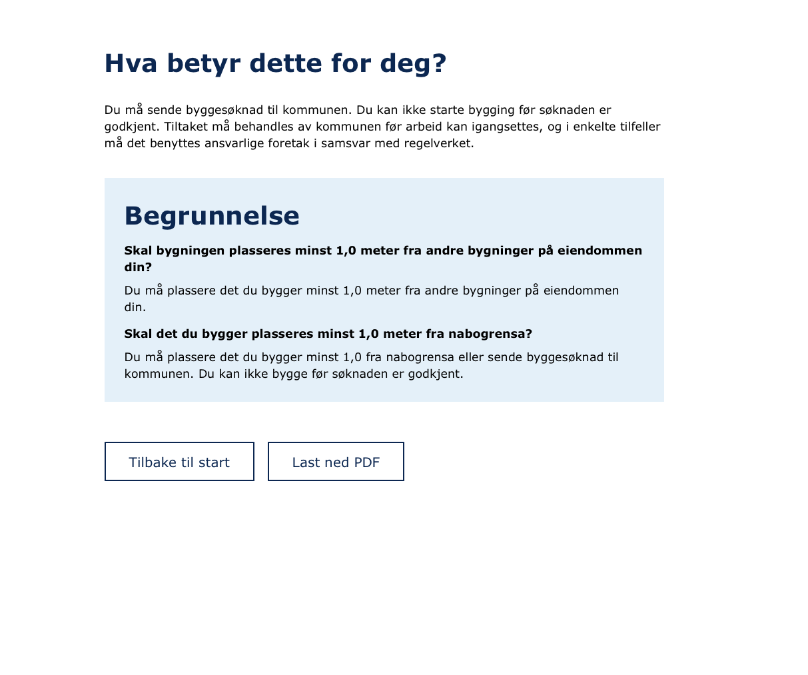

Figure 5: A typical user journey of this solution

5.1.1 Justification
Epstein et al., 2017 argues that the brain builds a unified representation of spatial environments, suggesting that map-based representations are effective because they align with the brain's map-like organization of spatial information. Based on this the group argues that spatial interfaces, such as map-based systems, will improve understanding when users need to reason about physical locations or spatial relationships. Cognitive tools such as a map-interface also augment the mind by reducing both memory load and processing load (Tversky, 2000). The solution aimed to reduce the load by providing the user with a visual representation of space rather than mentally reconstructing spatial relationships.
The solution also reduces the amount of cognitive load by taking away the need to look up regulation plans on external sites, thus reducing the system's complexity and minimizing cognitive load.
A system that helps users better understand spatial regulations and determine whether a permit is required will reduce unnecessary and faulty applications, thus reducing the operational strain on casehandlers. In addition, the solution will support more informed decision-making in the early stages of the planning process. Guiding users toward development options that comply with regulations, even when it may differ from their initial plans, could reduce the total number of applications.

5.1.2 Solution scope
Throughout the development of the solution several key functionalities were limited by lack of data, geo-politics and the project's lifecycle. One limitation was the need for manual data input from the user for a small selection of questions that are impossible to answer only using map metadata. These are questions like “What type of building are you going to build” and “Is the building going to have more than one room”. Some datasets are also not publicly available as they are categorized as critical infrastructure and may be misused by bad actors. This means that the question about water/sewage pipes can’t be answered automatically and also needs manual user input. One way to solve this would be to have a secure log in that only shows data relevant to the users property, but this kind of functionality falls outside of the project's scope and is tightly dependent on another bachelor groups project(Min Eiendom). Lastly, the solution still needs the user to double check regulatory plans as it only conforms to national regulatory plans and not property-specific regulatory plans. As EzBuild is intended to be delivered only as an MVP and time was limited, implementing such functionality was considered beyond the scope of the project.

5.3 Solution architecture
This chapter draws on Yoo, Henfridsson and Lyytinen's (2010) theory of layered modular architecture and aims to answer the following question: what kind of thing has been built, how does it create value, and how is it positioned to evolve in its surrounding ecosystem of users, data sources, and other digital services? This question matters. The municipality’s stated ambition is not to only adopt a single guidance tool for National rules, but to explore a solution that other municipalities can adopt and extend. The power of layered modular architecture lies in what Yoo et al. call generativity, the capacity of a system to produce unanticipated uses and extensions, driven by heterogeneous actors whose contributions are not foreseen by the original designers. This will allow the solution to outlive the original project and integrate with external regulatory and geospatial data sources and be reused across organizations with different local rules and constraints.

Yoo et al. argue that digitization introduces a distinct architectural paradigm. Digital artifacts follow a layered modular architecture composed of four loosely coupled layers: Device, network, service, and content. Each layer has its own design hierarchy and can be developed and recombined independently. The solution developed in this project sits meaningfully on the continuum that Yoo et al. describe between traditional modular and fully layered architectures. Built as an MVP today, it is structured to approximate a layered modular architecture, but retains partial coupling due to the distribution of spatial and validation logic across client and backend components. Despite this, the separation between user device layer, network layer, and spatial processing remains sufficiently distinct to support future evolution toward the municipality’s ambitions.

5.3.1 The four layers in context

Device layer
The device layer is the user's web browser and is only responsible for the rendering, input handling, and orchestration calls to the layers below. The group concluded that React was the most suitable framework as React uses a JavaScript syntax extension called JSX. This, together with a big library of components helps programmers to easily create, maintain or delete user interfaces or parts of it (Meta Platforms, Inc., n.d.). React was especially useful when creating a single-page application, as it efficiently handles updates of components in response to state changes. Its ecosystem also provides useful libraries like React Router, that help with navigation between components without needing to reload the page. In addition, Typescript was used on top of React. One of its key advantages is that Typescript compiles to Javascript while performing static type checking, allowing errors to be detected before code execution (TypeScript Documentation, 2026).

Crucially for this layer, no spatial reasoning or external data endpoints are hard coded into any component. The map component interacts with the service layer through two functions, handleDrawingData() and checkViolations(data), and receives results through callbacks. The question content is similarly separated from the engine that traverses it. QuestionConfig.tsx declares every question, while the engine itself contains no knowledge of building permits. Although the engine and the content remain cleanly separated, this could be further abstracted by supplying the configurations through a database or an API. This way changes in the device layer wouldn’t require changes in the other layers below.

Network layer
The network layer consists of the protocols and connections that transport data to the service layer (Hylving & Schultze, 2020). EzBuild’s network structure is split. Firstly, map tiles are fetched directly from Kartverket and NVE by the browser, using leaflets WMS client.This keeps tile rendering fast, while auth dependent or CORS-restricted sources are proxied though the backend.

Secondly the backend exposes a small REST surface withGET endpoints, query-string parameters and JSON responses. Two of these wrap Supabase RCP calls perform the applications core spatial analysis, returning geometry and regulatory attributes and the other handles distances to nearby buildings, roads and protected zones.

The significance lies in what it standardizes rather than what it transports. In principle, the device layer can be replaced without changes to the backend, and external data sources can be redirected to different municipalities endpoints, supporting the municipalities ambition of interoperability and cross-municipality reuse.

Service layer
The service layer deals with application functionality that directly serves users by creating, manipulating, and processing content (Yoo et al., 2010). In EzBuild, this functionality takes the form of spatial reasoning, survey execution, and the transformation of regulatory checks into structured outputs.

The backend is implemented in Python using FastAPI, but functions primarily as a thin API layer that exposes the endpoints and mediates access to data sources. In practical terms, the service layer is not fully centralized. Spatial calculations are handled by Supabase RPC functions, while parts of the violation logic remain in the TypeScript client. As a result, this created a degree of coupling between the device layer and service layer, meaning the architecture approximates Yoo et al.’s layered modular architecture rather than fully realizing it.

This deviation improves client-side responsiveness at the cost of stricter layer separation. However, the main architectural separation remains meaningful because geospatial data, spatial calculations, and user interface rendering are handled by distinct components.

Content layer

5.3.2 Deployment architecture
DevOps architecture was adopted as the methodology for managing the deployment and development workflow of the system as instructed by the Release train engineer at the municipality. According to Faustino et al. (2022) the DevOps approach has the benefits of cross team collaboration and communication, increase in code quality, faster and better feedback, decrease of manual work and increase of team performance among other benefits. The following section describes the DevOps architecture and tools chosen to support the development, integration, and deployment of the system throughout the project.

CI/CD pipeline & GitHub Actions
The deployment architecture uses a CI/CD pipeline implemented with GitHub Actions. Continuous Integration (CI) enables developers to frequently merge code into a shared repository, while Continuous Delivery (CD) ensures that changes can be automatically prepared for deployment (Anyanwu, 2025). CI/CD promotes faster production, better product and software quality, and a more efficient team overall while reducing risks (Saleh et al., 2025 ).
Within this system, GitHub Actions automates the deployment process. When changes are pushed to the main branch, a workflow connects to the Azure Virtual Machine via SSH, transfers the updated files, and redeploys the application using Docker Compose. This automation reduces manual deployment steps and lowers the risk of human error. For the team, this enhances collaboration and operational efficiency, allowing more focus on code quality rather than routine manual processes.
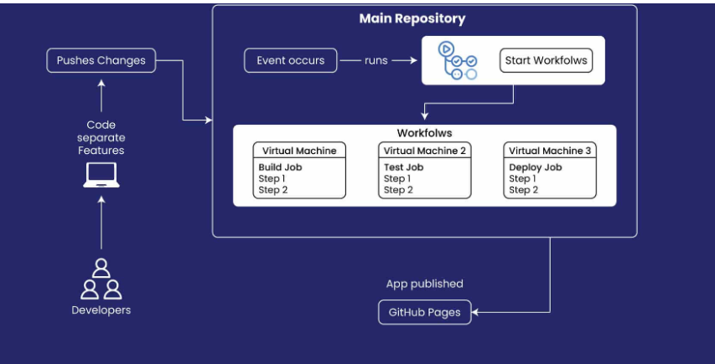

Figure 7 (Gopalakrishnan, 2024) shows the process of how CI/CD and GitHub Actions interact at a basic level.

Docker
Docker was used to containerize the application because of its familiarity from previous projects as well as other benefits like simplifying and accelerating the group's workflow (Why Docker | Docker, 2025). Containerization allows the application to run in isolated and reproducible environments, which minimizes bugs, gives consistent and reliable software performance, and improves productivity during development (Cotton, 2023). Using Docker Compose, the frontend and backend services were managed as separate containers. The reverse proxy Traefik was deployed through a separate Docker Compose configuration on the server, allowing it to run independently from the application stack.

Azure VM
The municipality provided access to an Azure VM that was used to host the application in the cloud. Azure Virtual Machines (VMs) are scalable, on-demand computing resources provided by Microsoft Azure. They allow users to run virtualized servers in the cloud without the need to purchase, maintain, or manage physical hardware. Azure VMs can be used for a wide range of purposes, such as hosting applications, running development environments, or managing infrastructure services (Microsoft, 2025).

Traefik
Traefik is an open‑source application proxy that integrates with Docker and automatically discovers running containers, generating routing configuration dynamically based on container labels (traefik.io, n.d.). The implementation of Traefik was necessary to route incoming traffic to the correct Docker containers and expose the frontend and backend services through a single entry point.

6 Formative evaluation
The goal of the evaluation is to assess to what degree the developed artifact addresses the challenges identified in the problem description and how development should continue based on the results. The evaluation focuses on three key aspects: reduction of cognitive load, improvement of spatial to text translation, and reduction of operational strain. Since the final product delivery of EzBuild is a Minimum Viable Product (MVP), the evaluation also emphasizes usability and perceived usefulness rather than just the full technical performance.

6.1 Evaluation criteria
The evaluation criteria are derived from the three problems identified in the problem description. The criterion needs to give measurable data that can clearly compare DiBK’s guidance tool to EzBuild and help in checking if EzBuild has solved any of the problems.

Table 4: Evaluation criterion and how to assess them
Spatial to text translation | Error rate | Number of wrong answers.
 | Ease of visualization | The user rate their ability to find and visualize spatial boundaries.(Scale 1-10)
Cognitive load | Case completion time | Measure how long the user takes to finish the case using a stopwatch.
 | External data dependency | Count how many times the user needs to visit external resources to find relevant information.
 | User confidence level | Post-case completion the user is asked how confident the users are that what they have answered is correct.(Scale 1-10)
 | Amount of guessing | Ask users to talk loud and speak out when they are unsure about which answer is correct, and decide to guess.
Operational strain | False green lights | Count how many cases of false positives (where the system incorrectly suggests that the user doesn’t need a permit).
 | Non-binding result | Ask users if they think the results are a legally binding answer.

6.2 Evaluation method
A qualitative evaluation approach using semistructured interviews was conducted to assess how the current product performed in practice, as this provides the depth needed to understand how real users navigate the solution. The evaluation participants consisted of 8 people between the ages of 26-55, with no moderate experience with building applications and regulatory plans.
The interviews were conducted in a controlled environment and took around one hour each. The sessions were conducted digitally or physically based on the participants preference. Participants were asked to speak-out what they were thinking and feeling, notes were taken throughout the interviews where it was relevant to the criterion. Additional notes were taken when users showed frustration to identify friction points that can be fixed in future development.
Participants were asked to do two cases, one on each version and without knowing who made which. This aimed to reduce any bias from liking the EzBuild solution better because of personal relation between participant and interviewers. Having two cases also minimizes bias from understanding the case better when doing a second attempt.
Each attempt at solving a case was timed with the correct amount of answers, answers that were guesses, and the perceived confidence to build after finishing were recorded to get numeric data values from both cases. Participants finished each case and were asked if it was easy to visualize the different boundaries and if they thought the results were legally binding.

6.3 Evaluation results
Data gathered throughout the evaluation interviews was stored in a dataset. This dataset was compiled into table 4 by taking the average values for both EzBuild and DiBK’s guidance tool.

Table 5: Compiled data from evaluation interviews
Criteria | DiBK Guidance tool | EzBuild | Insight
Case completion time | 21min:42sec | 13min:57sec | Users completed cases significantly faster using EzBuild compared to the DiBK guidance tool. This improvement is largely due to automated question answering in EzBuild, which reduces the need for manual input.
Error rate | 0.625 | 1.5 | Error rates were higher on EzBuild. This stems from incorrect input from the user when drawing, such as inaccurate shape, size or placement.This in turn affects the answers to the question.
External data dependency | 8.75 | 2.375 | Users depend less on external sites on EzBuild. Questions like distances to sea, train track and roads didn’t need any external site and were answered automatically, compared to DiBK’s guidance tool where the users needed to guess or check distances on google maps. Many users still felt the need to look up regulatory plans or ask LLMs when they didn’t understand certain questions .
Amount of guessing | 3.875 | 2 | The amount of guessing is less on EzBuild. This is because questions were answered automatically and the users trusted that the answers were correct.
User confidence level | 5.63/10 | 7.63/10 | Users are more confident when using EzBuild. This is because when they were searching for regulatory plans in DiBK’s guidance tool, a lot of new regulatory terms and words were introduced which many users didn’t understand. This decreased confidence in DiBK’s guidance tool, while EzBuild had less searching which didn’t lower their confidence.
Ease of visualization | 5/10 | 7.75/10 | Users found it easier to visualise boundaries and distances on EzBuild. Because of the map and its drawing tools.
False green Lights |  |  | False green lights was
Legally binding approval  0=NO/1=Yes | 0.5 | 0.875 | More users thought that the summary was a legally binding approval for starting to build without need to apply, when using EzBuild’s guidance tool. This is the case for both guidance tools, but even more for EzBuild.

Based on the evaluation criterions set, EzBuild has clear positive value over DiBK’s existing guidance tool. EzBuild has reduced the cognitive load by reducing the external data dependency, amount of guessing, and increasing the ease of visualisation. This is also reflected in the average completion time which was 7.5 minutes less on EzBuild compared to DiBKs guidance tool. While EzBuild had a higher confidence score and ease of visualization it still didn’t help with the spatial to text translation as the error rate was higher than on DiBK’s Guidance tool. To fix this …

As for operational strain, there were higher error rates and more users who thought the answer was legally binding which could lead to more operational strain by having users start building projects thinking their results were correct and the result a legally binding approval. The higher confidence level could also increase the chances of users starting building projects.

The issue of operational strain can’t be correctly assessed without publicly deploying the application for mass use. But based on the data it might seem that Ezbuild might reduce the operational strain slightly by…

6.3.1 Additional findings worth mentioning
Many participants struggled using the drawing tools, especially older individuals and many didn’t find the tutorial, showing how the drawing tools worked. For the individuals that found the tutorial, many pressed skip on the initial popup and didn’t finish the tutorial.
Some properties have different rules in the regulatory plans than what EzBuilds internal rules say. This makes it so the need to find regulatory plans is also necessary when using EzBuild.

Furthermore, the group recognized potential limitations in the evaluation process that could affect the result. For instance, some users might rush through the guidance tool without fully understanding the questions. This could happen because they viewed it as simply testing the application, not using it for something real. If they were using the application to plan their own building project, they would likely take more care and pay closer attention.

The group also noted a familiarity risk, after the user tested one solution, they might form a mental model of the tasks, making it easier and faster to complete the next test. For example, once they have used one version of the application, they might already understand how the question works and therefore complete the next test more quickly.

6.4 Reflection
EzBuild had clear positive value and perceived usefulness, yet there were still many potential improvements. Lack of a good tutorial and some misunderstanding when it came to symbol and color choices may have increased the intrinsic cognitive load from not only understanding regulatory plans, but also understanding the drawing tools and how the guidance tools worked. Since the guidance tool only follows national regulatory laws and doesn't go into property-specific regulatory plans, the burden of both finding and understanding regulatory plans still falls onto the user.

This brings up the question of correctness of the system. Does the system have any value if the data or logic isn’t correct? And how can we make sure the system is correct? Many of the datasets come from drone/plane photos which makes them have slight inaccuracy when it comes to locational data. Some houses are part of two properties and some regulatory plans overlap. Some measures have been taken for specific scenarios, like when a property overlaps two regulatory plans. In this scenario the problem was fixed by shrinking the property polygon during search in the database. While this accounts for one special scenario, more may still be prevalent. Making sure these scenarios have been corrected is important to make sure this doesn't affect the correctness of the system and final result/summary of the guidance tool.
The evaluation showed an increase in confidence when using EzBuild. Can this confidence be a bad thing, and lead to people making uninformed decisions from blindly following the guidance tool? The caseworkers from the expert interviews said that they would rather have people apply when they don’t need to, rather than have people wrongfully building without applying. Additionally, many interview subjects also answered yes when asked if they thought the summary could be used as an official government approval for building without applying, even though the last question makes the user click a checkbox saying the responsibility lies on the user. This highlights a potential problem where lack of clear indication and increase in confidence could lead to additional operational strain for caseworkers.

After user testings and evaluation interviews, a pattern arose among older individuals. Older Individuals seemed to struggle more with the drawing tools compared to younger individuals. This aligns with Sarah et. al. (2016) where their study shows that older individuals struggled with a public participation GIS (PPGIS) solution, which included a similar looking map based solution. Their conclusion was that older individuals struggled because of a lack of experience using web based maps, drawing tools and computers in general, as well as sensory and motor issues which made precise drawings difficult to accomplish. Our solution tries to combat this by enabling the users to choose between answering using the map or doing it manually, but a better solution might be to make the map based solution more accessible for older individuals. In order to do this effectively more feedback from individuals of higher age needs to be incorporated into development and design.

6.4 New goals for future development of solution
Based on the evaluation findings a new set of new improvements for the solution were identified.
A clearer and more informative tutorial that shows the drawing tools and the fact that the questions get answered correctly is needed. In addition, it should automatically be viewed when searching for an address. Having an automatic retrieval of regulatory plans could reduce external data dependency even more. Adding pictures to the questions could increase confidence and reduce cognitive load by visualizing what different terms and words mean. This could also decrease external data dependency as the need to search what things mean are less necessary. These should be prioritised first in future development to ensure it meets the set requirements and solves the problems in the problem description.

7 Project execution
The project timeline was divided into 3 PI periods where one PI equals seven weeks. Together with the release train engineer and product owner, we met regularly to decide what kind of work should be completed during each PI period. This was documented and used as a reference image for each sprint period. For this project it was determined that the most effective approach was to organize each PI into three two-week sprint periods, followed by one test week as shown in Figure 10.

Figure 8: Visualization of each PI and sprints

Before starting the development of the project, the group contacted two students who had contributed to the development of an earlier prototype. This allowed us to ask questions about the code, identify potential pitfalls, and gain a better understanding of both the codebase and its surrounding context.

7.1 PI 1(Week 2 - Week 8)
Main Goals: Initial research, analysis and design of product.
Estimated amount of Hours: 1225 hours
Total hours worked: 415 hours (data missing from week 2 - week 5)

During P1 the group did initial research, created guidelines and routines for how to move forward with the project. A simple prototype was also made implementing the earlier student groups’s database functions and datasets.
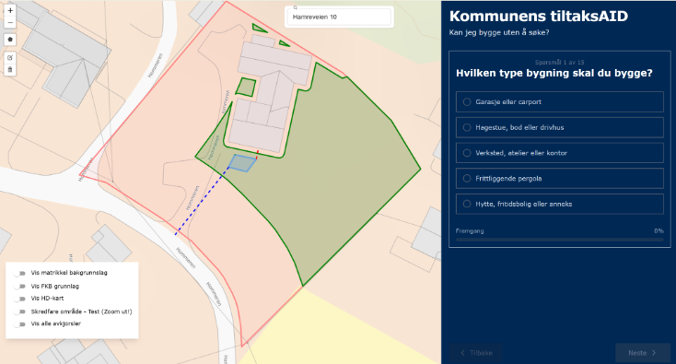

Figure 9 - Early prototype

7.2 PI 2(Week 9 - week 15)
Main goals: Containerization and deployment of product, user testing
Estimated amount of hours: 1137,5 hours
Total hours worked: 770 hours

During PI 2 the group managed to containerize and deploy the application as well as creating a CI/CD pipeline. User testing of the current prototypes were done and feedback was converted to tasks for later sprints. Late stages of the PI were also used in preparations for evaluation.
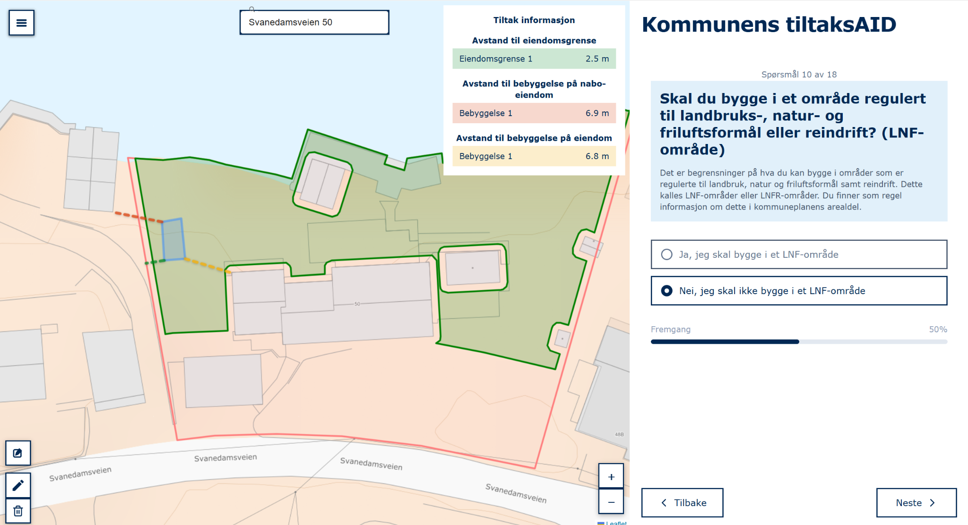

Figure 10 - Almost finalized product

7.3 PI 3(Week 17 - week 22)
Main goals: Finalization of product, make way for future development, evaluation
Estimated amount of hours: 875 hours
Time used before hand in of report: (HUSK)

PI 3 marks the end of the project’s lifecycle. Evaluation interviews were conducted and finalization of the report was done. This PI extends beyond the reports due date so early stages of the PI were heavily focused on finalization of the report. After the hand in of the report all focus will go on development of the product. Where the goals are to optimize queries, creating good documentation for future development and fixing bugs.

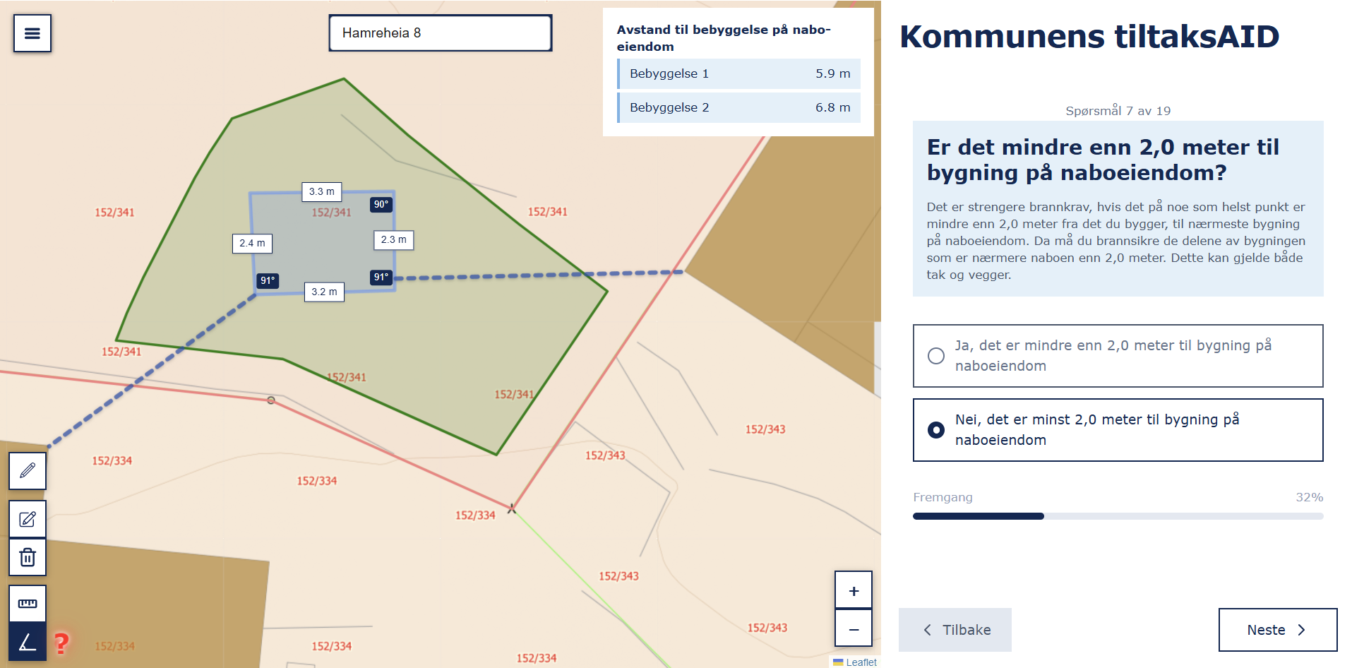

Figure 11 - Finalized product

8. Conclusion
This bachelor thesis set out to explore how a map-based digital solution could reduce cognitive load, improve spatial understanding and alleviate operational strain. The project demonstrates that a map-based user-centered approach can improve how users interact and understand complex regulatory information.

The finding shows that EzBuild successfully reduces cognitive load by minimizing the need for external data dependencies, lowering the amount of guesswork and increasing the ease of visualization. This is reflected in shorter completion times and higher user confidence compared to DiBK’s guidance tool. By translating complex regulatory requirements into an interactive spatial interface, the solution addresses key challenges related to spatial-to-text translation.

However, the evaluation also revealed important limitations. While users found the system easier to understand, the increased error rate highlights challenges related to accuracy from user input, particularly when using the drawing tools. In addition a significant number of users perceived the results as an official government approval for building without applying. This introduces a risk regarding real-world decisions that could lead to an increase in operational strain within municipal caseworkers. These findings show that not only focusing on improving the usability is important, but also a clear communication to users so that the results are correctly interpreted.

Overall, the project demonstrates that digital, map-based guidance tools have strong potential to improve public self-service systems and reduce pressure on municipal caseworkers. At the same time, it highlights the importance of careful UX design, especially in preventing misinterpretation and overconfidence.

In conclusion, EzBuild represents a promising step toward more accessible and efficient building guidance services. With further development, particularly in improving input accuracy, reducing external data dependencies, fixing certain UX elements and communication of system limitations, the solution has the potential to be expanded and adopted more broadly, contributing to more effective digital public services.

10 Reference list
Ali, Z. (2024, June 9). The Weaknesses and Strengths of Layered Architecture in Software
Development. Medium.
https://zeeshan01.medium.com/the-weaknesses-and-strengths-of-layered-architecture-in-software-development-81ba1206a17b
Anyanwu, C. (2025, April 14). How to Automate CI/CD with GitHub Actions and Streamline
Your Workflow. FreeCodeCamp.org. https://www.freecodecamp.org/news/automate-cicd-with-github-actions-streamline-workflow/
Ayele, Y. G. (2023). The Significance of Planning and Scheduling on the Success of Projects.
Economics & Management Information, 1–10. https://doi.org/10.58195/emi.v2i1.66
Bass, L., Clements, P., & Kazman, R. (2021). Software architecture in practice.
Cotton, B. (2023, August 14). 5 Benefits of a Container-First Approach to Software
Development | Docker. Docker. https://www.docker.com/blog/5-benefits-of-a-container-first-approach-to-software-development/
Dash, R., & Dash, R. (2010). Risk assessment techniques for software development. European
journal of scientific research, 42(4), 629-636.
Deci, E. L., & Ryan, R. M. (2000). The “What” and “Why” of Goal Pursuits: Human needs and
the Self-Determination of Behavior. Psychological Inquiry, 11(4), 227–268. https://doi.org/10.1207/S15327965PLI1104_01
Direktoratet for byggkvalitet. (n.d.). Bygg uten å søke – garasje, bod eller anneks.
https://www.dibk.no/verktoy-og-veivisere/bygg-uten-a-soke-garasje
Drivdal, M. (2026, January 21). Risikerer å måtte rive utestua – hytteeier mener kommunen
bedriver forskjellsbehandling. KRS - Avisen Kristiansand. https://www.krs.no/risikerer-a-matte-rive-utestua-hytteeier-mener-kommunen-bedriver-forskjellsbehandling/s/5-157-583000
Epstein, R. A., Patai, E. Z., Julian, J. B., & Spiers, H. J. (2017). The cognitive map in humans:
spatial navigation and beyond. Nature Neuroscience, 20(11), 1504–1513. https://doi.org/10.1038/nn.4656
Ebert, L. (2002). Successful project management for software product and information system
development. Paper presented at Project Management Institute Annual Seminars & Symposium, San Antonio, TX. Newtown Square, PA: Project Management Institute.
FastAPI. (2025). Tiangolo.Com. https://fastapi.tiangolo.com/
Faustino, J., Adriano, D., Amaro, R., Pereira, R., & Silva, M. M. (2022). DevOps benefits: A
systematic literature review. Software, Practice & Experience, 52(9), 1905–1926.
https://doi.org/10.1002/spe.3096
Gabbard, C. (2015). Perception of action space: Using multiple frames of reference. In
International Encyclopedia of the Social & Behavioral Sciences (2nd ed., Vol. 17, pp.
703–707). Elsevier. https://doi.org/10.1016/B978-0-08-097086-8.57009-3
Gopalakrishnan, S. (2024, February 26). How to build a CI/CD pipeline with GitHub Actions.
VLink; Vlink. https://vlinkinfo.com/blog/how-to-build-a-cicd-pipeline
Hylving, L., & Schultze, U. (2020). Accomplishing the layered modular architecture in digital
innovation: The case of the car’s driver information module. The Journal of Strategic Information Systems, 29(3), 101621. https://doi.org/10.1016/j.jsis.2020.101621
Kraeling, M., & Tania, L. (2019). Software development process. In R. Oshana & M. Kraeling
(Eds.), Software engineering for embedded systems (2nd ed., pp. 33–87). Newnes. https://doi.org/10.1016/B978-0-12-809448-8.00002-3
Kristiansand kommune. (2021). Profilmanual: Slik bruker du profilen [PDF]. Kristiansand
kommune.
https://www.kristiansand.kommune.no/contentassets/606cbef2839849adb34e2ea6d14112
6a/profilmanual-slik-bruker-du-profilen-l_2021_2.pdf
Klepsch, M., Seufert, T. Understanding instructional design effects by differentiated
measurement of intrinsic, extraneous, and germane cognitive load. Instr Sci 48, 45–77
(2020). https://doi.org/10.1007/s11251-020-09502-9

Laporte, C. Y., & April, A. (2018). Software quality assurance. John Wiley & Sons.

Maha, L., Rahman, T., & Roy, C. (2026). Agile Story-Point Estimation: Is RAG a Better Way to
Go?. arXiv preprint arXiv:2604.03443.
Meta Platforms, Inc. (n.d.). React documentation. https://react.dev
Microsoft. (2025, December). Overview of virtual machines in Azure - Azure Virtual Machines.
Microsoft.com. https://learn.microsoft.com/en-us/azure/virtual-machines/overview
Pasuksmit, J., Thongtanunam, P., & Karunasekera, S. (2022). Story points changes in agile
iterative development. Empirical Software Engineering, 27(6).
https://doi.org/10.1007/s10664-022-10192-9
Regjeringen. (2024, May 14). Raskere behandling og tydeliggjøring av dokumentasjonskrav i
byggesøknader.
https://www.regjeringen.no/no/aktuelt/raskere-behandling-og-tydeliggjoring-av-dokumen
tasjonskrav-i-byggesoknader/id3099225/
React Router. (n.d.). Feature overview.
https://reactrouter.com/6.28.0/start/overview#feature-overview
SAFe Explained -Succeeding with Lean and Agile at Scale 1 SAFe ® Explained Succeeding
with Lean and Agile at Scale. (n.d.). https://go.scaledagile.com/rs/983-XYR-522/images/SAFe_Explained_Ebook_2025.pdf?version=1
Sarah Gottwald, Tiina E. Laatikainen & Marketta Kyttä (2016) Exploring the usability of PPGIS
among older adults: challenges and opportunities, International Journal of Geographical
Information Science, 30:12, 2321-2338, DOI: 10.1080/13658816.2016.1170837
Software Quality Assurance. (2026). Sonarsource.Com; Sonar.
https://www.sonarsource.com/resources/library/software-quality-assurance/
Schwaber, K., & Sutherland, J. (2020). The Scrum Guide.
https://scrumguides.org/docs/scrumguide/v2020/2020-Scrum-Guide-US.pdf
Saleh, S. M., Madhavji, N., & Steinbacher, J. (2025). A systematic literature review on
continuous integration and deployment (CI/CD) for secure cloud computing. arXiv preprint arXiv:2506.08055.
Supabase. (n.d.). Supabase. https://supabase.com
TypeScript Documentation. (2026). TypeScript for the new programmer. TypeScriptlang.
https://www.typescriptlang.org/docs/handbook/typescript-from-scratch.html
‌Tu, Z. (2023). Research on the application of layered architecture in computer software
development. J. Comput. Electron. Inf. Manag, 11(3), 34-38.
Tversky, B. (2000). Some Ways that Maps and Diagrams Communicate. Lecture Notes in
Computer Science, 72–79. https://doi.org/10.1007/3-540-45460-8_6
The Role of Quality Assurance in a DevOps Workflow: Transforming Your Business Operations
- TestCrew. (2025, August 10). TestCrew.
https://testcrew.com/the-role-of-quality-assurance-in-a-devops-workflow-transforming-y
our-business-operations/
traefik.io. (n.d.). Traefik Docker Documentation - Traefik. Traefik.Io. Retrieved April 28, 2026,
from https://doc.traefik.io/traefik/reference/install-configuration/providers/docker/
Why Docker | Docker. (n.d.). Docker. Retrieved April 28, 2026, from
https://www.docker.com/why-docker/
Yablonski, J. (n.d.). Doherty Threshold | Laws of UX. Laws of UX. Retrieved March 4, 2026,
from https://lawsofux.com/doherty-threshold/

Yoo, Y., Henfridsson, O., & Lyytinen, K. (2010). Research Commentary—The New Organizing Logic of Digital Innovation: An Agenda for Information Systems Research. Information Systems Research, 21(4), 724–735. https://doi.org/10.1287/isre.1100.0322

Zhang, Y., Lam, H., & Andreas, S. (2010). An exploratory study of organisational adaptation to
agile project management: An investigation of the IT industry in China (Master’s thesis,
Umeå School of Business). DiVA Portal.
https://www.diva-portal.org/smash/get/diva2:397150/FULLTEXT01.pdf

11 Appendix:

11.1 Status 1 video & evaluation
Video link
A video of the early stage of the status, showcasing the groups progression and understanding around the problem issue and the stage in solving it

Self evaluation - Aaron Silber
Self evaluation - Mathias José Bull Jørgensen
Self evaluation - Fredrik Schjølberg Husebø
Self evaluation - Akinkunmi Oni Akintola
Self evaluation - Elias D. Simonsen

11.3 Appendix 1 – Record of Logged Hours
Excel spreadsheet of registered work hours

11.4 Appendix 2 – Interview guideline
Intervju dokument

11.5 Appendix 3 – Evaluation criteria data
Evaluation result

11.6 Appendix 4 – Risk analysis
Nr. | Uncertainty | Type | Likelihood | Negative consequences | Total risks
1 | Solution is more complex than expected | Technical | Middle | Very high | High
2 | Lack of experience with mapping and geospatial tools | Technical | Very low | Middle | Low
3 | Too large functional scope for an MVP | Methodically | Middle | High | High
4 | Limited access to actual users | Methodically | Very low | Very high | Low
5 | Misinterpretation of building permit regulations | Domain | High | Very high | Very high
6 | Time constraints in the bachelor project | Project | Low | Very high | High
7 | Insufficient documentation during the process | Project | Very low | Very high | Middle
8 | Technical issues requiring major rework in the project | Technical | Middle | Very high | High
9 | Internal conflict in the team | Social | Very low | Middle | Low
10 | Scope creep | Methodically | Middle | High | High
(Figur x1 risk management - uncertainty table)

Likelihood (Y) \ Consequences (X) | Very low | Low | Middle | High | Very high
Very high | Middle | High | Very high | Very high | Very high
High | Low | Middle | High | Very high | Very high
Middle | Low | Middle | Middle | High | Very high
Low | Very low | Low | Middle | High | High
Very low | Very low | Very low | Low | Middle | Middle

11.7 Appendix 5 – The way forward
Identified issues | Implications for users/system | Proposed future developement
Difficult regulatory terms (e.g., gesimshøyde, mønehøyde, LNF‑område) | Users struggle to understand key concepts without explanation, increasing cognitive load and risk of misinterpretation | Add simple visual or textual explanations that clarify terms without overwhelming the user
Confusion about which regulatory plans apply | Users make incorrect assumptions about applicable plans; difficult to locate relevant documents | Implement automatic retrieval of relevant regulatory plans for the selected property
MVP scope too narrow (only small detached buildings) | Real-world projects often involve extensions, demolition, reconstruction, or complex structures; system cannot support these cases | Expand scope to include extensions, partial demolition, reconstruction, and more specific building categories
Summary PDF is static and underutilized | Limited value for users and caseworkers; does not support workflow integration | Enable users to send the summary PDF directly to municipal caseworkers as part of the application process
Summary PDF content lacks caseworker‑relevant information | Caseworkers receive only user input, not structured or decision‑relevant data | Conduct interviews with caseworkers to identify required information and redesign the summary to include these insights

Appendix 6 – Product Increment (PI) Documentation

PI - 1
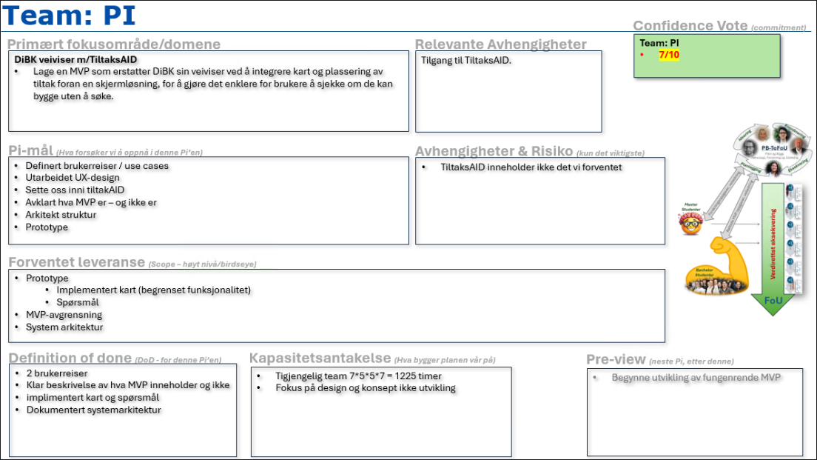

PI - 2
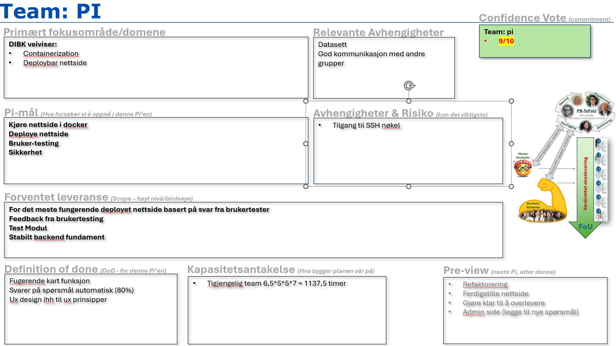

PI - 3
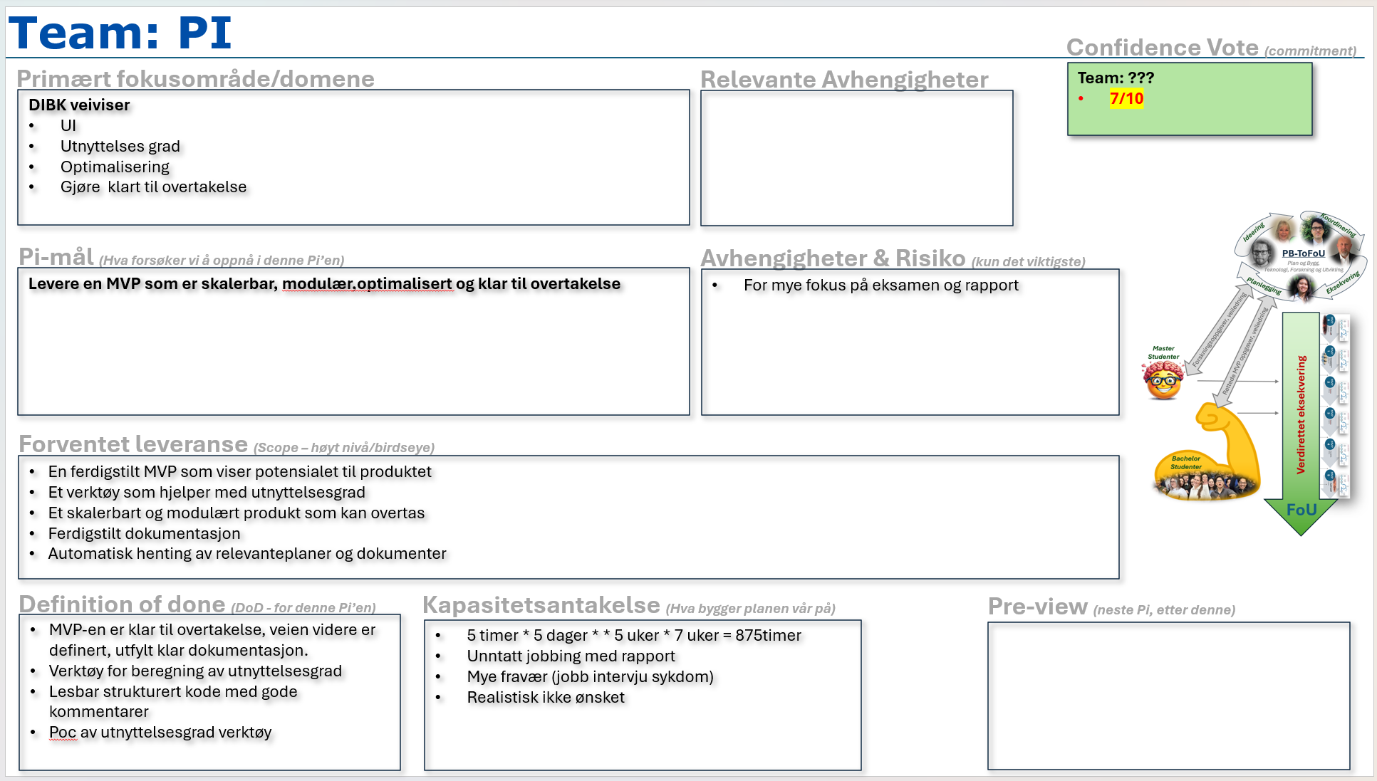

5.3.2 Software realization
The following section describes the technology stack and architecture pattern used to implement the solution. The solution was designed with careful consideration of key UX laws, ensuring that the user interaction section aligns with established usability and interaction‑design principles. Technologies were selected based on performance, scalability, and compatibility with geospatial data processing. Some of these were selected directly by the project group, while others were strongly recommended by the municipality.
A software system is composed of several structures, none of which independently defines its architecture. Grouping these structures into architectural categories makes it easier to analyse how the system is organized and how its components interact (Bass et al., 2021).
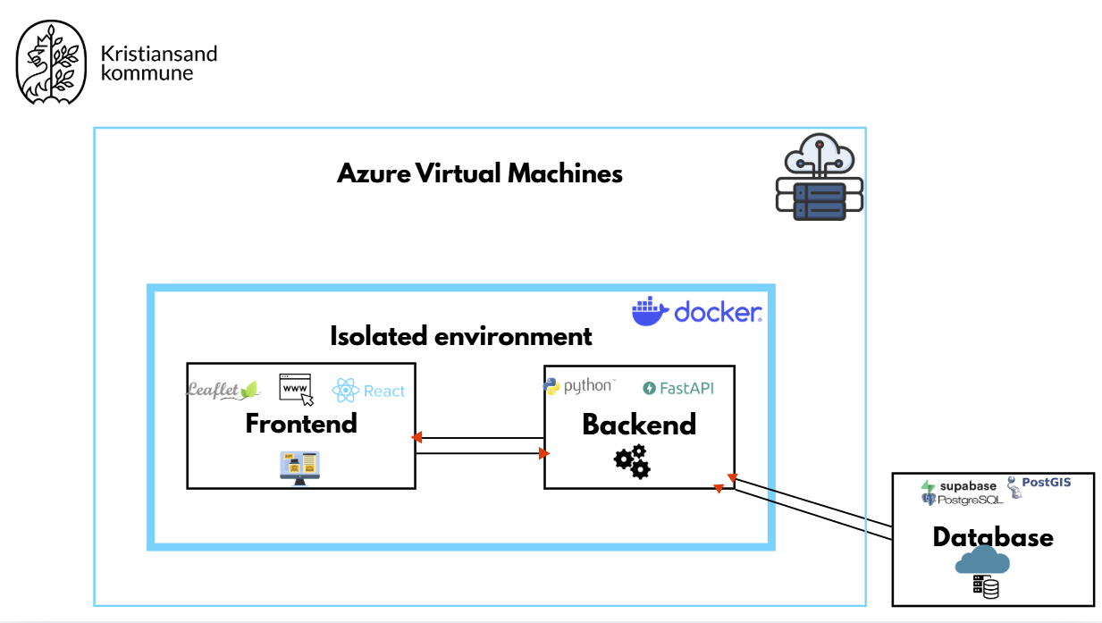

Figure 6 - Azure virtual machines
The group chose to implement a layered architecture as it is a widely used design approach that structures a system into multiple layers, where each layer is responsible for a specific set of tasks. These layers are typically organized hierarchically, meaning that higher layers depend on services provided by lower layers. In most implementations, layered architecture consists of three main layers: the presentation layer, the business logic layer, and the data access layer. This separation of concerns reduces system complexity and allows each layer to be developed, tested, and maintained independently (Tu, 2023).

5.3.1.1 Presentation tier
The presentation layer handles user interaction and passes user requests to the business logic layer for processing (Tu, 2023). In this project, the presentation layer includes the web interface where users interact with the map, answer questions, and receive feedback regarding their planned construction measures. The group concluded that React was the most suitable framework for implementing the presentation layer. React uses a JavaScript syntax extension called JSX. This, together with a big library of components helps programmers to easily create, maintain or delete user interfaces or parts of it (Meta Platforms, Inc., n.d.). React was especially useful when creating a single-page application, as it efficiently handles updates of components in response to state changes. Its ecosystem also provides useful libraries like React Router, that enables client side routing, which navigates between components without needing to reload the page (React Router, n.d.).
In addition, Typescript was used on top of React. One of its key advantages is that Typescript compiles to Javascript while performing static type checking, allowing errors to be detected before code execution (TypeScript Documentation, 2026) .

User Interface
The user interface was designed to turn a regulational “scavenger hunt” into a simple and guided process. The user interface consists of three separate views and were designed with the laws of UX in mind to follow typical design choices that better user experience.

Onboarding view
Firstly, the mandatory questions that can’t be answered automatically. These questions appear sequentially and one at a time to follow the UX law XX.

It also supports the Doherty Threshold principle, which suggests that system feedback should occur within approximately 400 milliseconds to maintain user attention and increase productivity (Yablonski, n.d.).

Workspace view
Secondly, the workspace view uses a split screen approach. Having the map on the left and questions on the right. The questions follow the same approach as the onboarding view and are sequential to minimize cognitive load. For each question follows the visualized boundaries on the map as well as a pop up with a summary of the relevant boundaries and their distances. This is to help with the spatial to text translation and minimizes the users need to calculate distances on their own. Lastly the map has drawing tools and a dedicated tutorial with gifs showing how to use the different tools and what the different polygons mean. This reduces cognitive load and aids the users in understanding the given tools.

Results view
This view gives users a clear summary and result from the finished guide. There is additionally an option to download the summary as pdf, which the user can show to municipal caseworkers and help municipal workers understand the intentions and restrictions within the building plan.

5.3.1.2 Business logic tier
The business logic layer is the core part of the system and is responsible for implementing the application’s business rules and logic. In this layer, data received from the presentation layer is processed according to the system’s requirements before being passed to the data access layer for storage or retrieval operations (Tu, 2023). The business logic layer therefore acts as an intermediary between the presentation layer and the data access layer, ensuring that all operations follow the defined rules of the application.
Python was adopted as the backend language on the recommendation from the municipality. Python is a widespread programming language, making it easier to recruit programmers and it has the benefit of a large code library that includes frameworks like fastAPI. Given that the solution is intended to outlive the project's lifecycle, it was a reasonable recommendation to accept. The FastAPI framework was used due to its high performance and straightforward API development (FastAPI, 2025)

5.3.1.3 Data access tier
The data access layer manages the communication with data storage systems such as databases, file systems, and other storage solutions. It supports tasks like retrieving, storing, and updating data, as well as ensuring data is valid. This layer works closely with the business logic layer by supplying data for processing. The processed results either get sent back to storage or to the presentation layer (Tu, 2023). In this project, the data access layer interacts with the database through the Python client provided by Supabase.

Supabase DB
Previous groups who worked on a similar solution at the municipality had used Supabase. Therefore many relevant datasets and database functions were already prevalent. This along with good documentation, made using the same Supabase database a natural choice. Supabase is a Postgres-based development platform that provides backend services like database, file storage, automatically generated APIs, which meant that storage and database functionality could be accessible online during both development and deployment of the product (Supabase, n.d.). The database uses PostgreSQL with a PostGIS extension which gives access to many GIS functions which are relevant when calculating distances and boundaries.

5.3.1.4 Flaws with layered architecture
Although layered architecture provides a clear structural organization, it also introduces certain limitations. Because each layer adds an additional level of abstraction, the architecture can introduce performance overhead and increased latency. In addition, layered architectures may become rigid if changes require modifications across multiple layers. These potential limitations were considered during the design process (Ali, 2024), but they were considered minor when looking at the advantages of layered architecture.

