1.) Write a SQL statement to rename the table countries to country_new.  
Here is the list of tables. tablename | tableowner  
---------------+------------  
orders | postgres  
employees | postgres  
job_history | postgres  
jobs | postgres  
locations | postgres  
regions | postgres  
countries | postgres

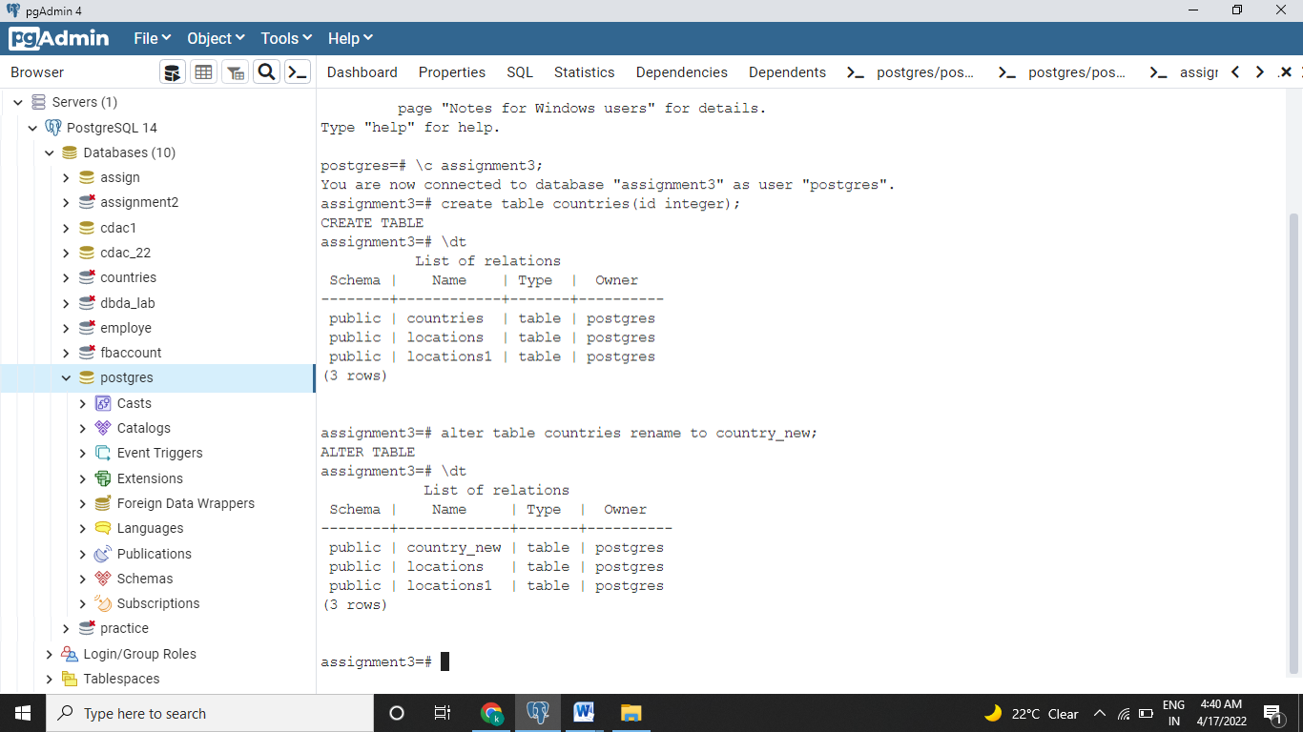

2.) Write a SQL statement to add a column region_id to the table locations.  
Here is the structure of the table locations.  
postgres=# \d locations  
Column | Type | Modifiers  
----------------+-----------------------+-----------   
 location_id | numeric(4,0) |   
 street_address | character varying(40) |   
 postal_code | character varying(12) |   
 city | character varying(30) |   
 state_province | character varying(25) |  
 country_id | character varying(2) |

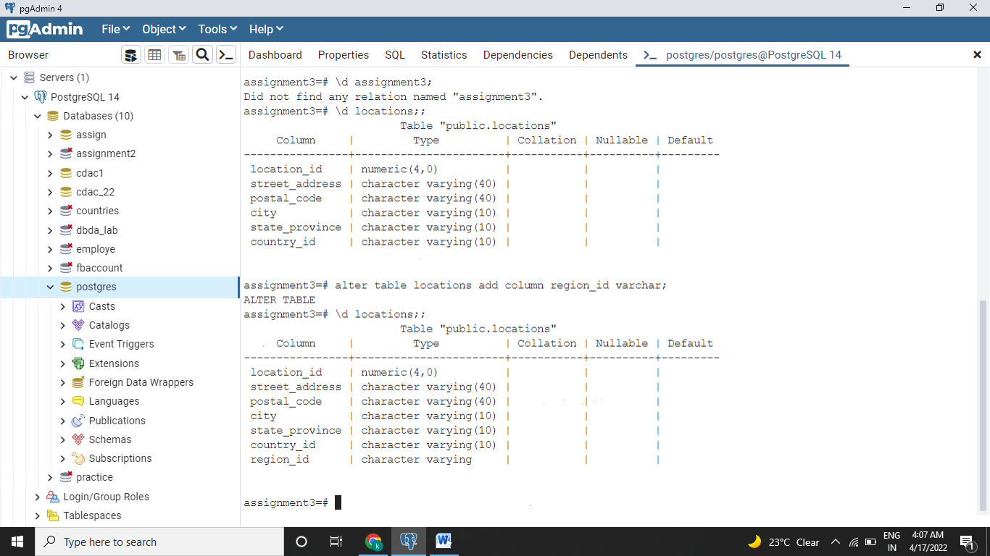

3. Write a SQL statement to change the data type of the column region_id to text in the table locations

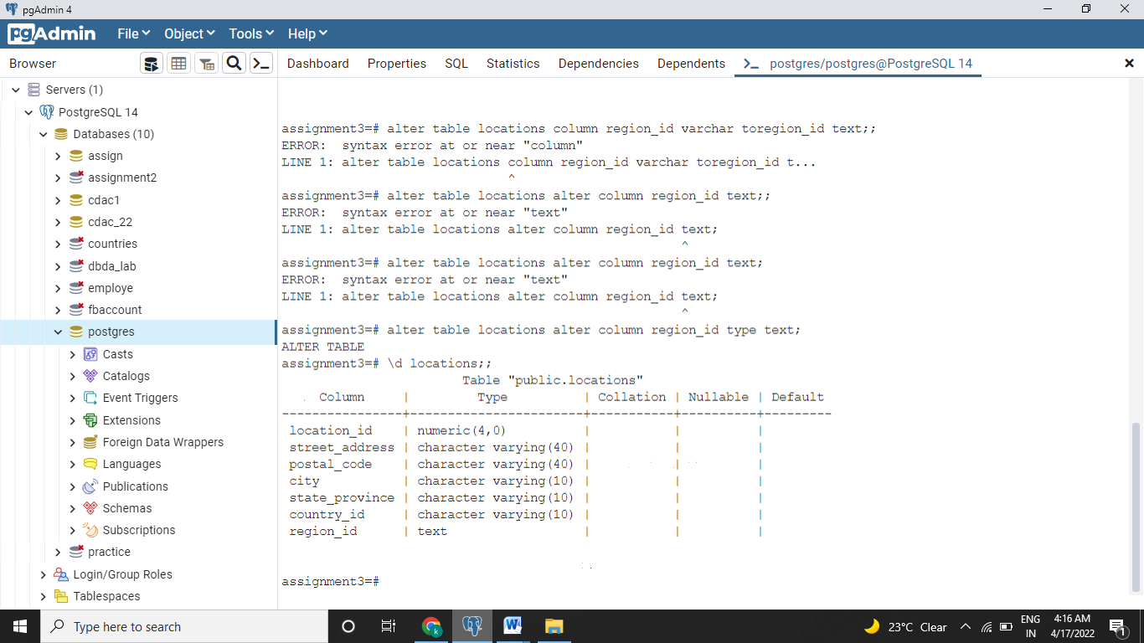

4.) Write a SQL statement to drop the column city from the table locations

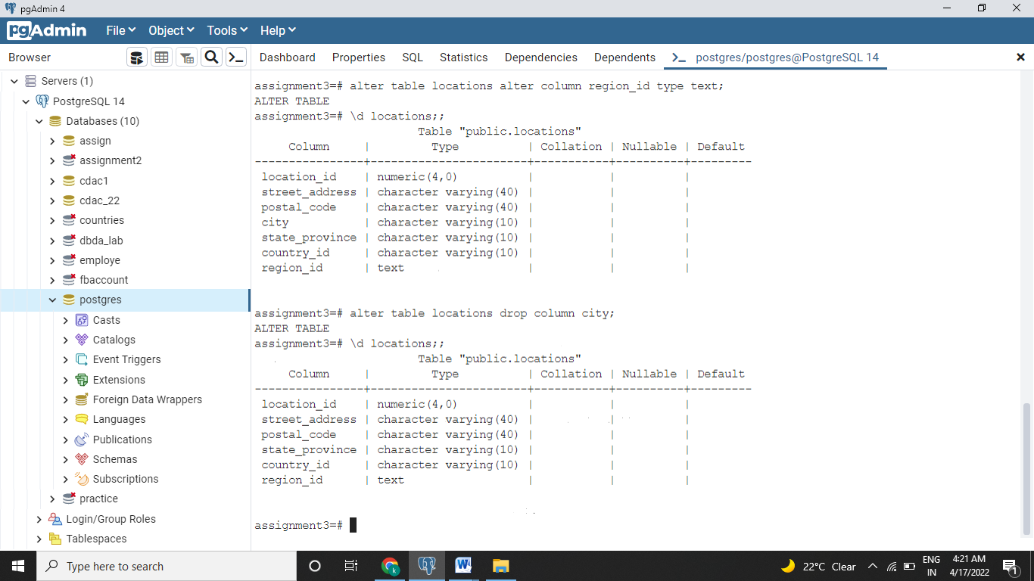

5.) Write a SQL statement to add a primary key for the columns location_id in the locations table.  
Here is the structure of the table locations.  
postgres=# \d locations  
Column | Type | Modifiers  
----------------+-----------------------+-----------   
 location_id | numeric(4,0) |   
 street_address | character varying(40) |   
 postal_code | character varying(12) |   
 city | character varying(30) |   
 state_province | character varying(25) |   
 country_id | character varying(2) |

