1.)Write a SQL statement to change the salary of an employee to 8000 whose ID is 105, if the existing salary is less than 5000.

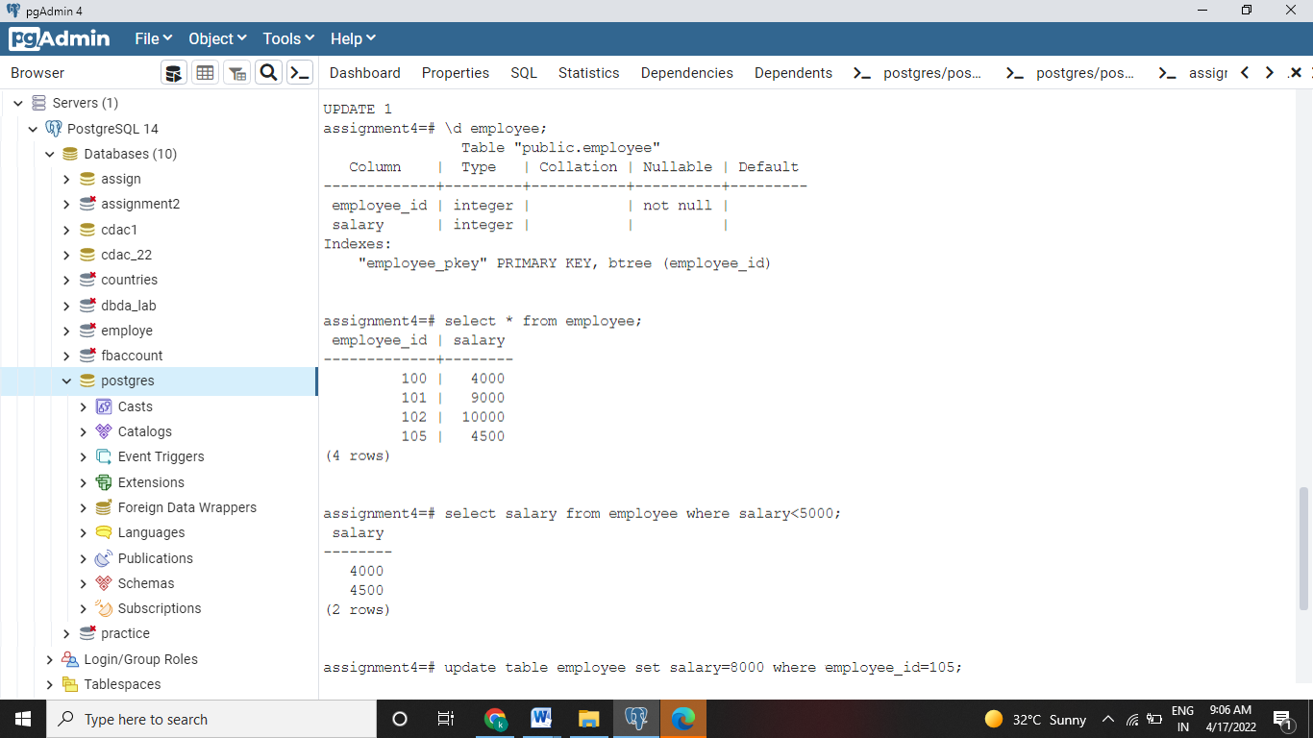

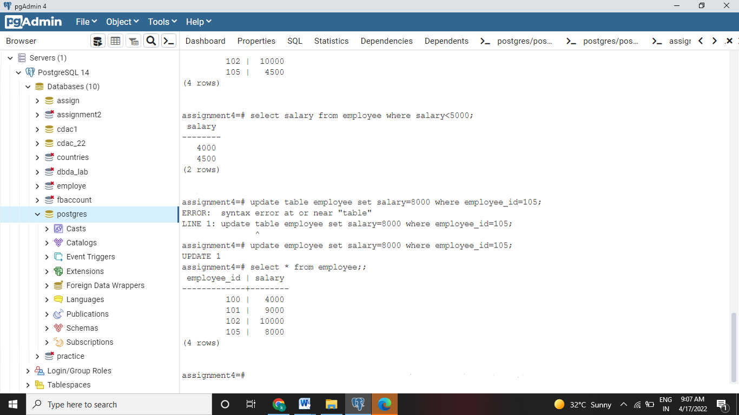

2.)Write a SQL statement to change the job ID of the employee which ID is 118 to SH_CLERK if the employee belongs to a department which ID is 30 and the existing job ID does not start with SH.

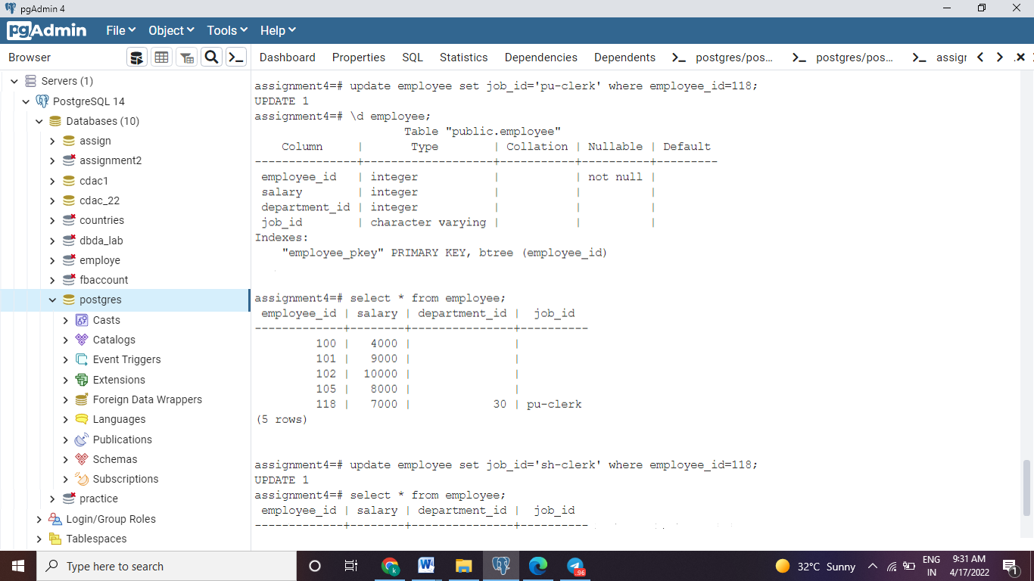

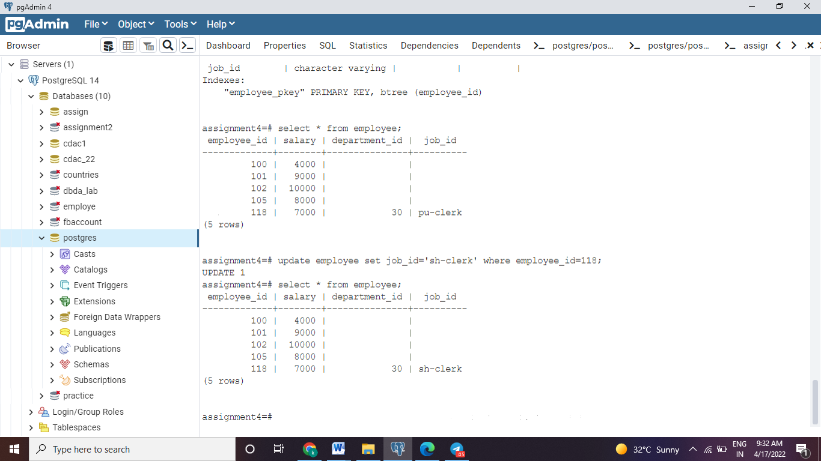

3.) Write a SQL statement to increase the salary of employees under the department 40, 90 and 110 according to the company rules that, the salary will be increased by 25% of the department 40, 15% for department 90 and 10% of the department 110 and the rest of the department will remain same.

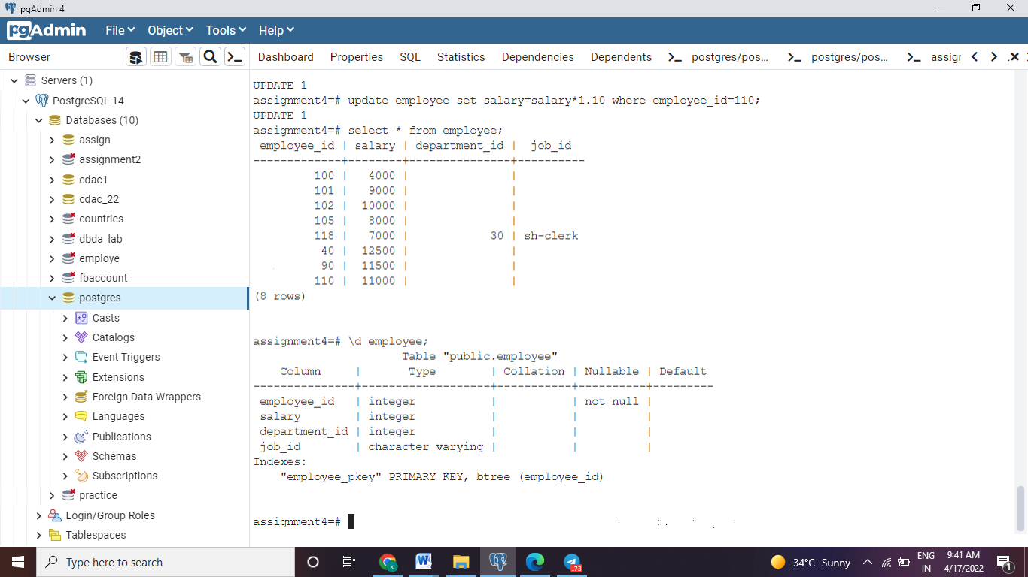

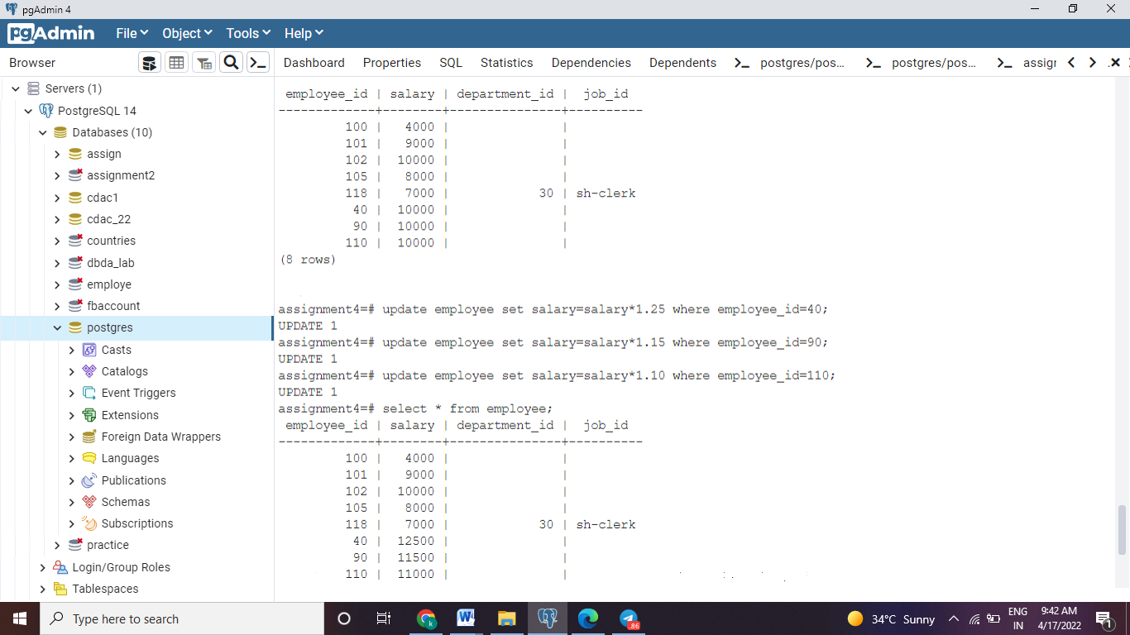

Write a SQL statement to change the email column of the employees table with 'not available' for those employees who belongs to the 'Accounting' department.

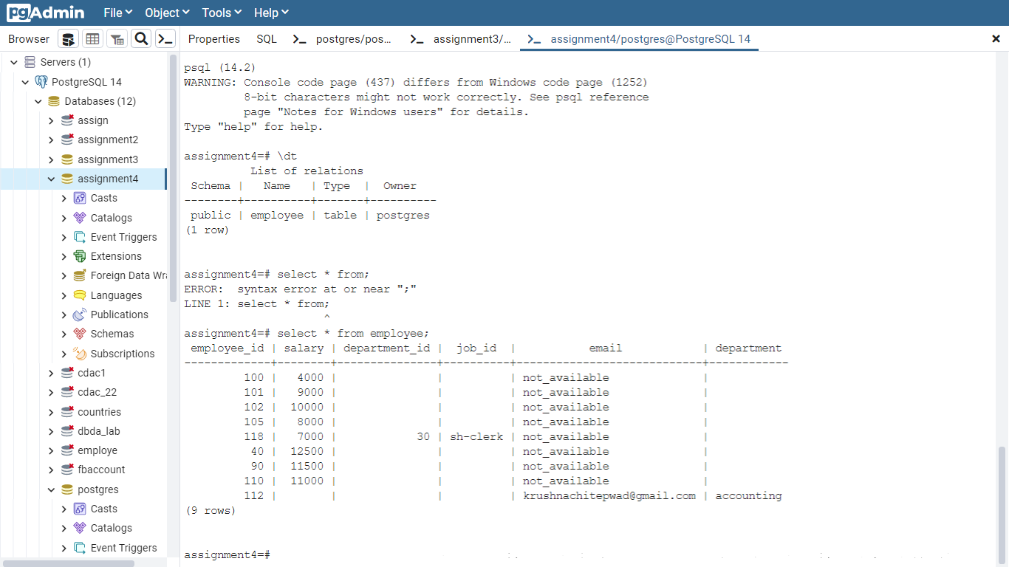

5.) Write a SQL statement to change the email column of employees table with 'not available' for those employees whose department_id is 80 and gets a commission is less than.20%.

6.) Write a SQL statement to change the email and commission_pct column of the employees table with 'not available' and 0.10 for all employees.

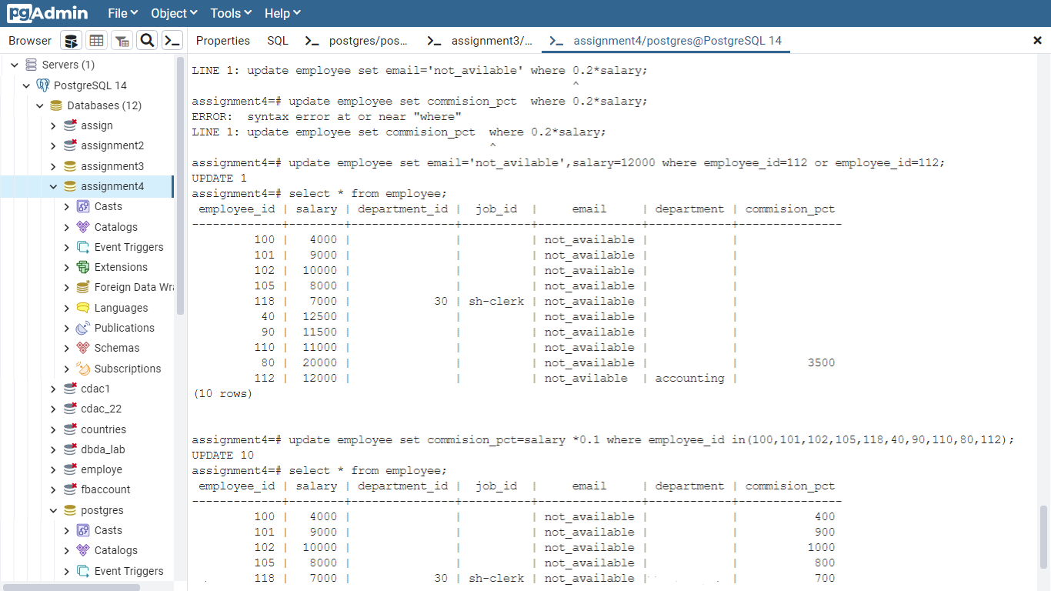

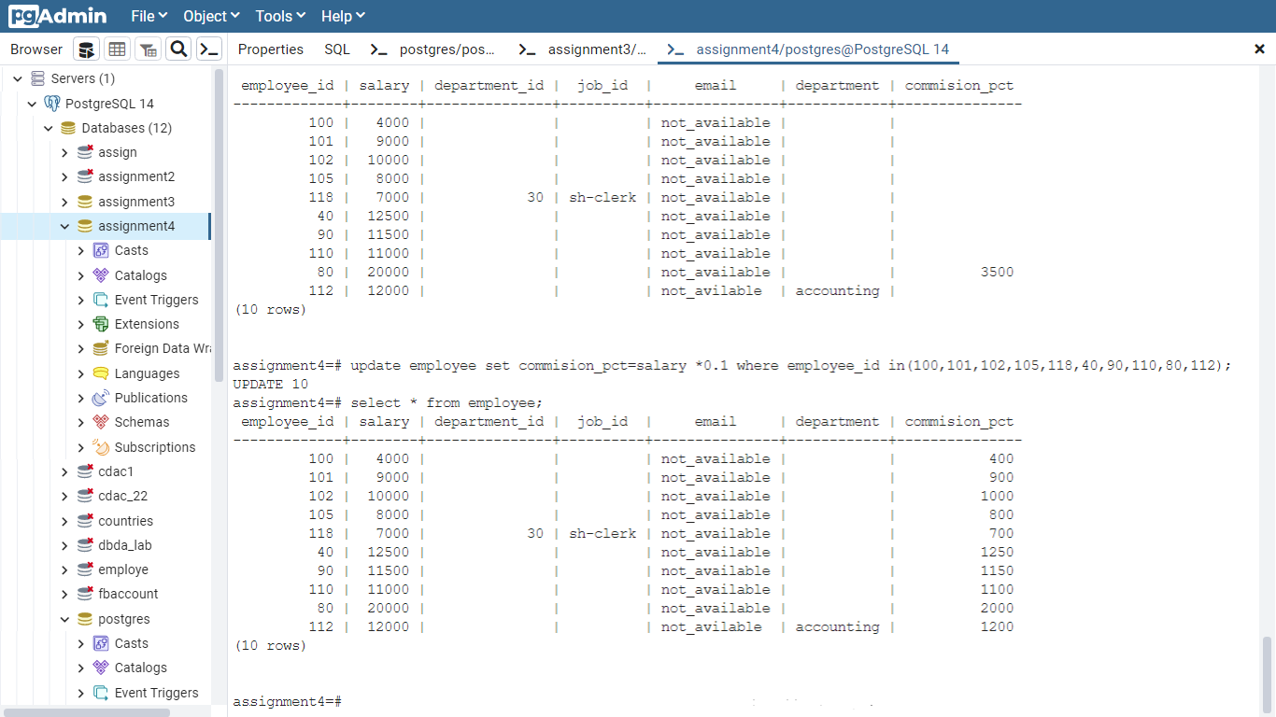

7.) CREATE TABLE employees (  
    employee_id numeric(6,0) DEFAULT (0)::numeric NOT NULL,  
    first_name character varying(20) DEFAULT NULL::character varying,  
    last_name character varying(25) NOT NULL,  
    email character varying(25) NOT NULL,  
    phone_number character varying(20) DEFAULT NULL::character varying,  
    hire_date date NOT NULL,  
    job_id character varying(10) NOT NULL,  
    salary numeric(8,2) DEFAULT NULL::numeric,  
    commission_pct numeric(2,2) DEFAULT NULL::numeric,  
    manager_id numeric(6,0) DEFAULT NULL::numeric,  
    department_id numeric(4,0) DEFAULT NULL::numeric  
);