1. Write a R program to create a sequence of numbers from 20 to 50 and find the mean

of numbers from 20 to 60 and sum of numbers from 51 to 91.

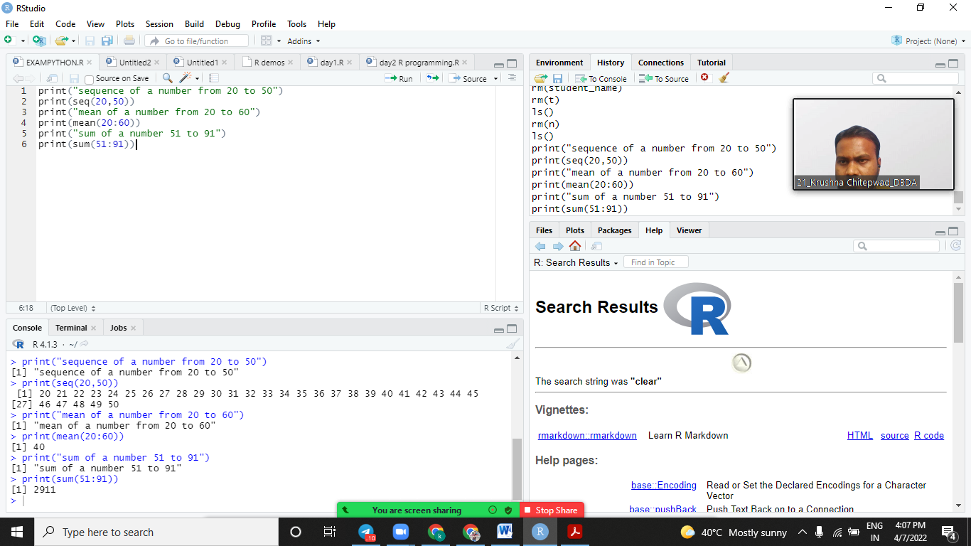

2. Write a R program to print the numbers from 1 to 100 and print "Fizz" for multiples

of 3, print "Buzz" for multiples of 5, and print "FizzBuzz" for multiples of both.

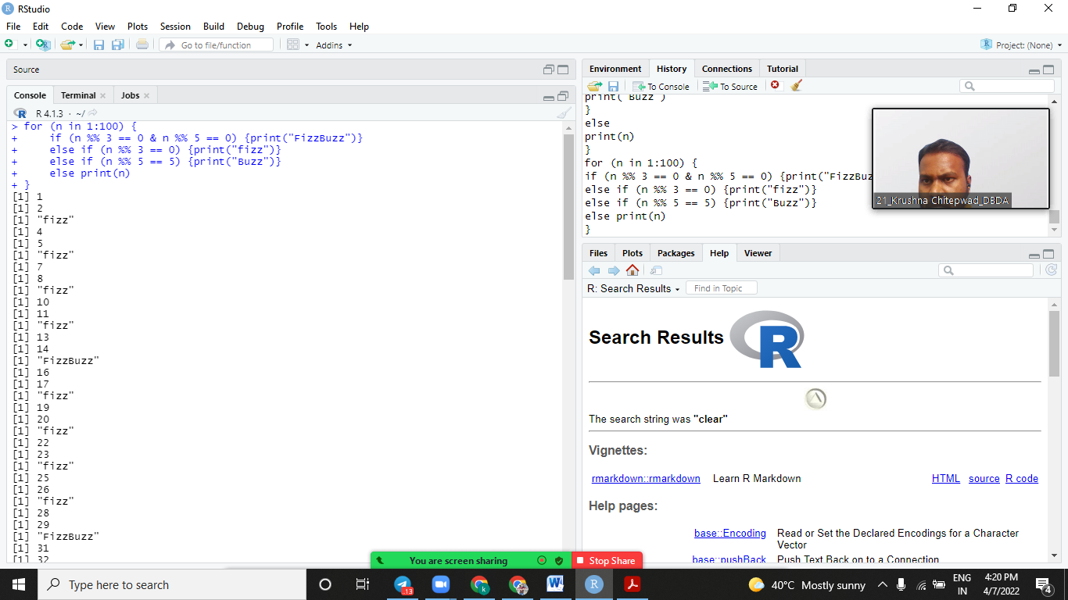

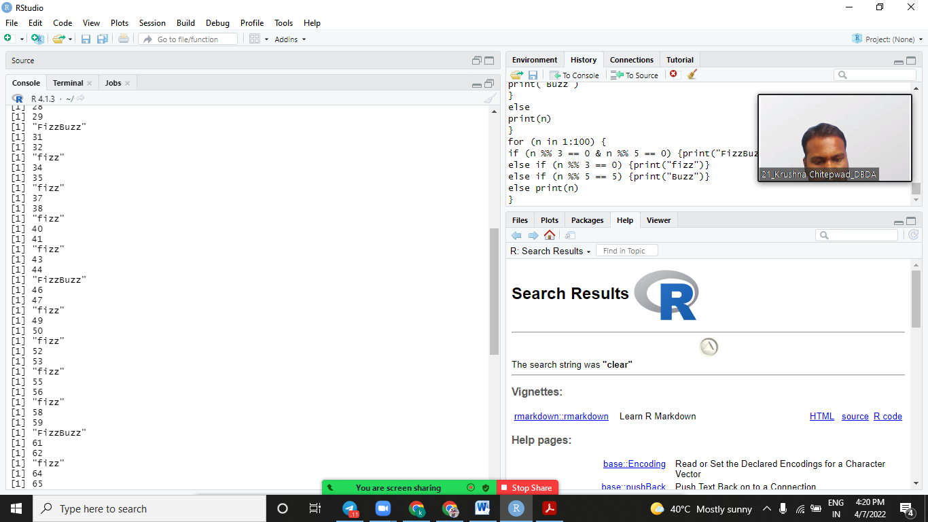

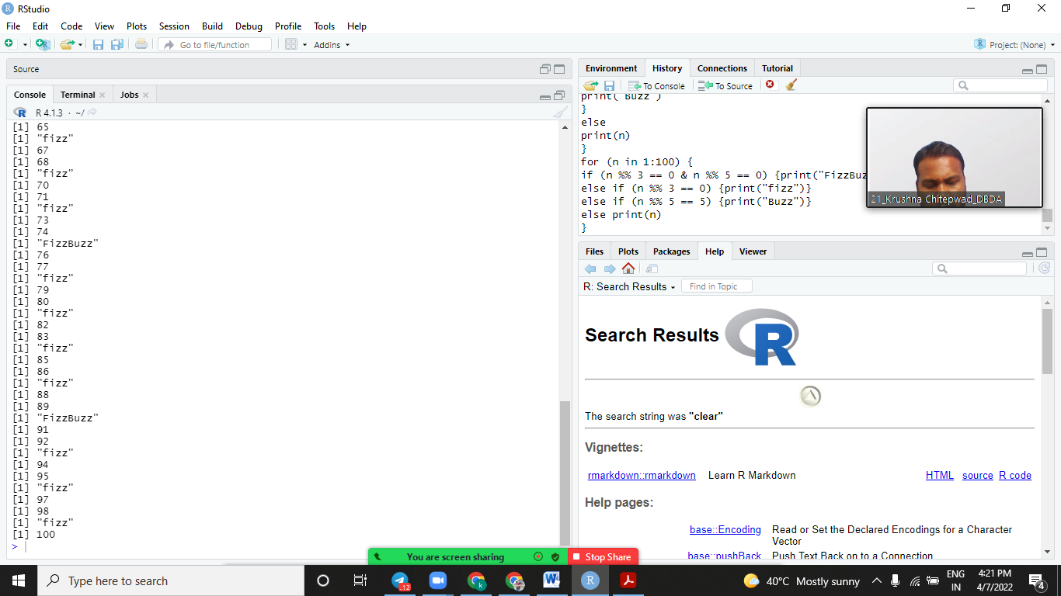

Q.9) Accept String & print only alternate

characters on a string.

Ex: this i s a _ test

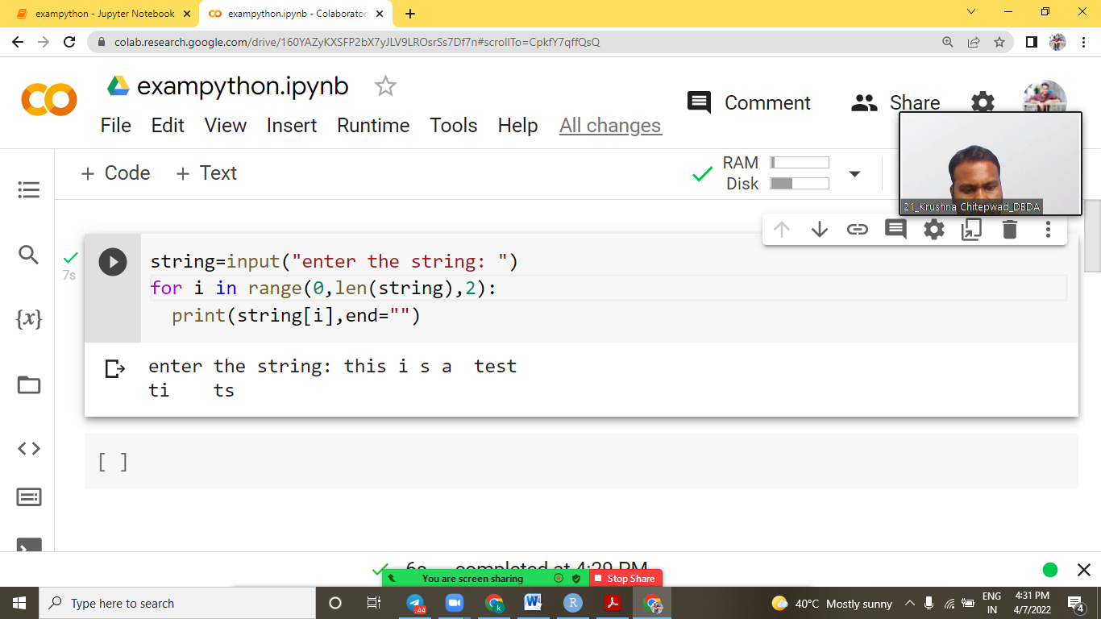

Q.3) Print

1

0 1

0 1 0

1 0 1 0

1 0 1 0 1

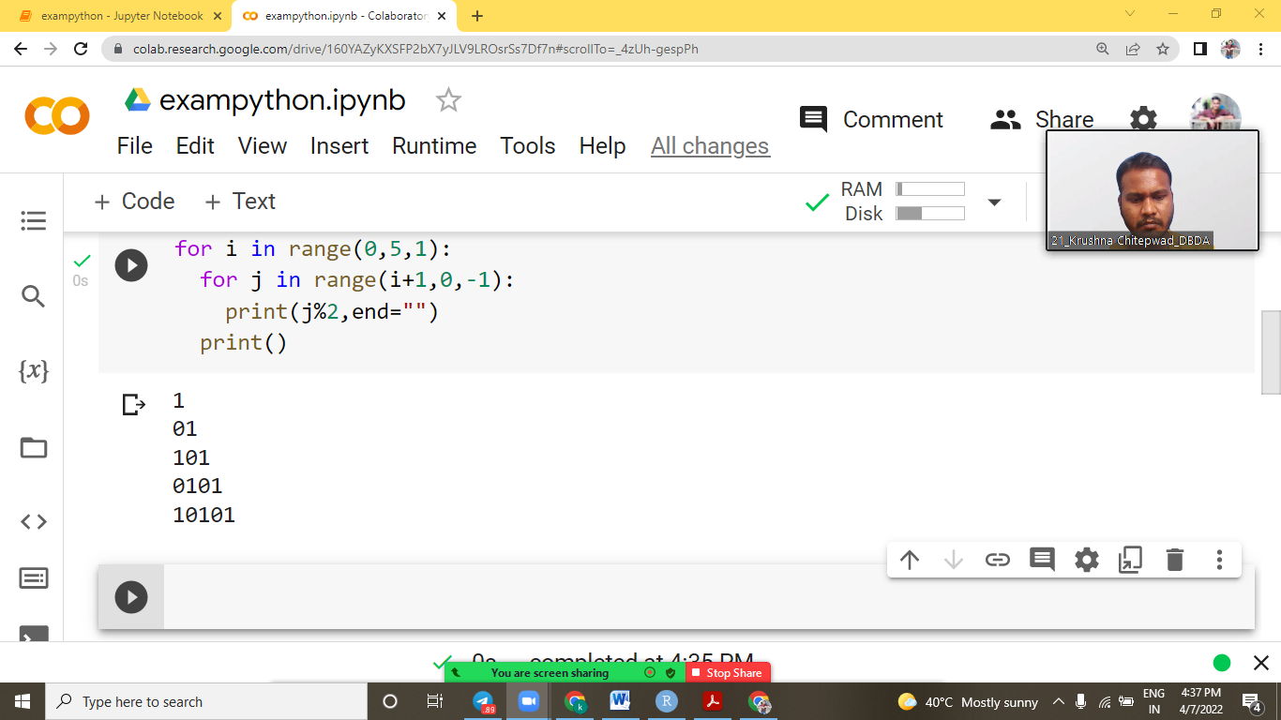

Q.1) Convert given hrs & mins in second.

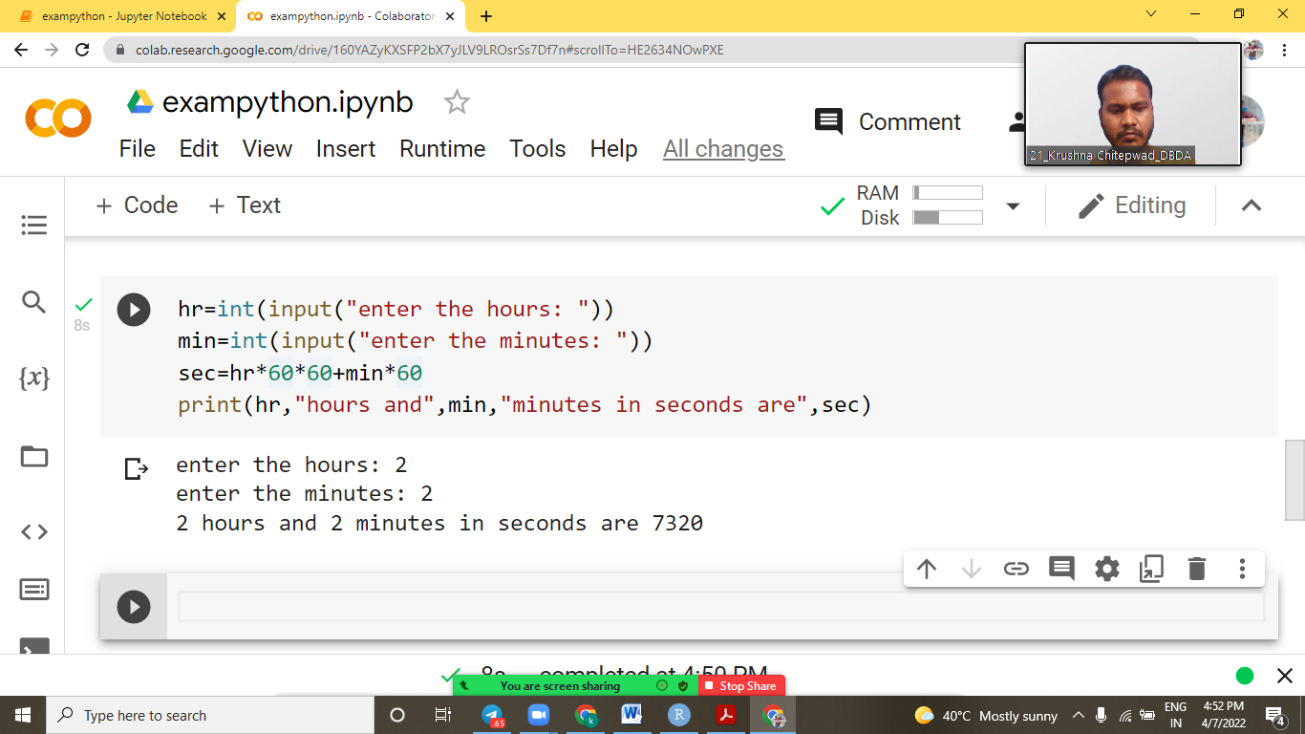

Q.2) Write code to find the average of ‘n’

numbers entered by the user to function avg ( ).

Ex: avg (10, 20, 30, 40) => average is: 70

avg (5, 10, 15) => average is: 10

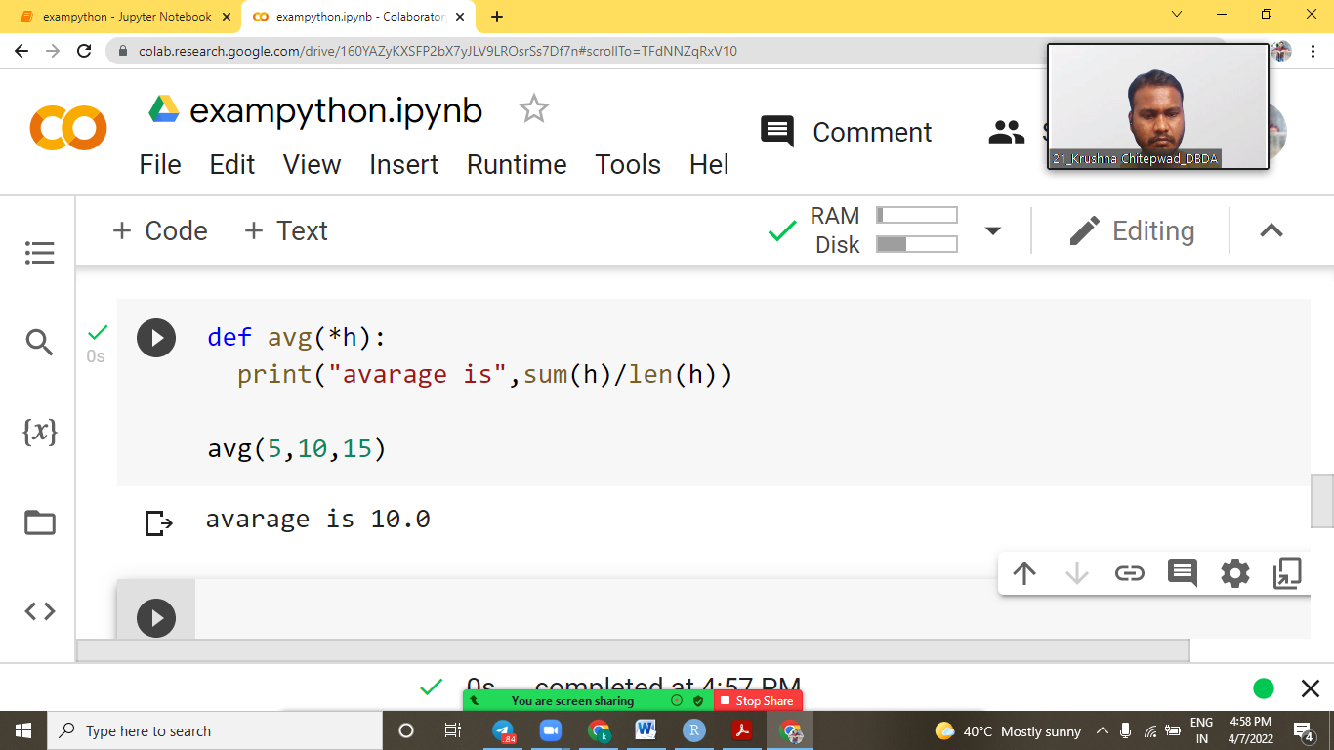

Q.5) Create a class

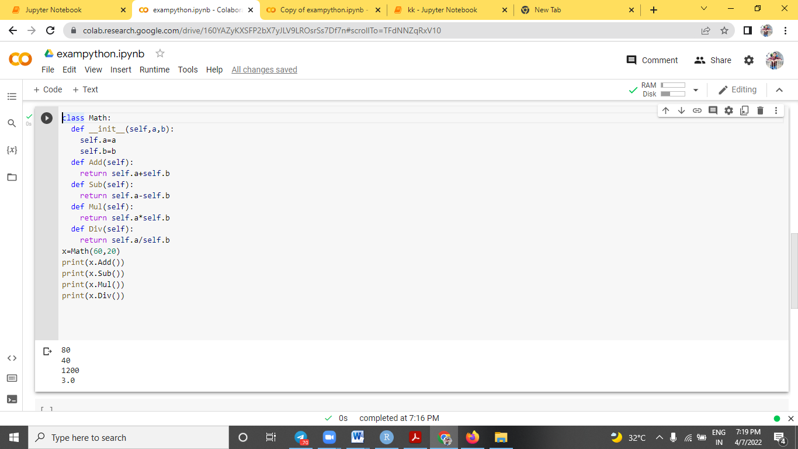

Q.7) Convert Paise in Rupees &

Paises

Ex: 350 is 3 Rupees 50 Paise

3.50 print Rupees: 3

Paise: 50

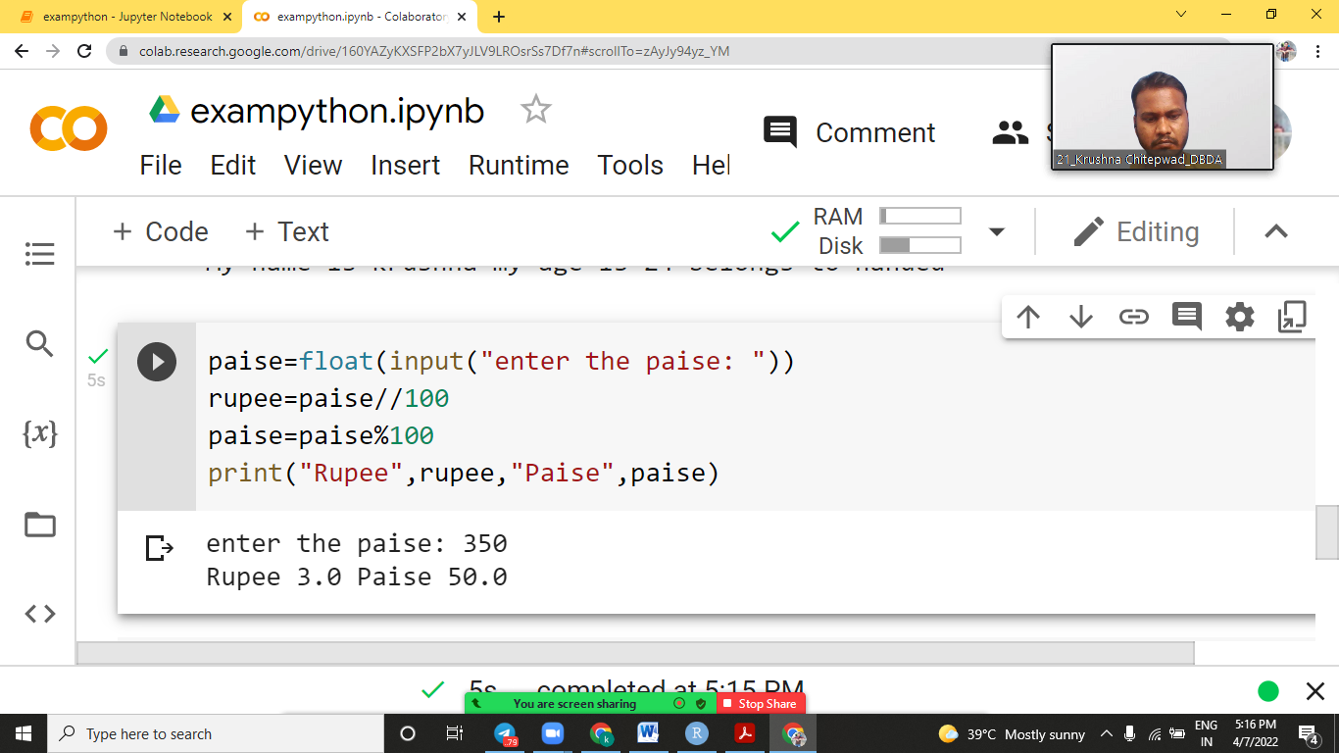

Q.8) Print

1

3 3

5 5 5

6 6 6 6

7 7 7 7 7

