Group 21Database Principles Coursework

short line

UP2122177

UP2122796

UP2166428

# Contents

**Contents 1**

**Entity Relationship Diagram (ERD) 2**

Assumptions 3

**Data Dictionary 3**

**Security 9**

Manager 9

General 10

Technician, Engine Technician and Hull Specialists 10

**Optimisation 11**

**Professional, Legal and Ethical Issues 13**

Professional Issues 13

Legal Issues 14

Ethical Issues 14

**Queries 15**

Query One 15

Query Two 16

Query Three 17

Query Four 17

Query Five 18

# 

# Entity Relationship Diagram (ERD)

## Assumptions

* A boat can only be owned by one person.
* A boat can only be registered to one country.
* A boat can only be within one dockyard.
* A boat can be modified from a manufacturer, therefore it might have something different compared to the original OEM state.
* A customer/staff can share an address.
* A customer/staff may not have a middle name.
* A yard can only have one address.
* A staff member can work at several different yards, to fill shortages etc.
* A staff/yard email address will be the yard/staff name and @solent, therefore an extra attribute for the email is not required.
* A service cost may not be finalised until the end of a service marked as ‘COMPLETE’.
* A customer will most likely not be a private client, thus customer_priv will be set to ‘false’ unless stated otherwise.
* A customer may have alternative contact methods i.e. daytime/nighttime telephone number.
* A service can have many history statuses, for tracking purposes.
* A service may need notes about what was done, which can be updated at a later time.
* A boat identification (boat_mic) is used for parts, along with the service identification.

# Data Dictionary

| **ADDRESS** | | | | | | |
| --- | --- | --- | --- | --- | --- | --- |
| **Attribute Name** | **KEY** | **INDEX** | **Data Type & Size** | **Domains & Constraints** | **FK Reference** | **Description** |
| address_id | **PK** |  | **SERIAL** |  |  |  |
| city_id | **FK** |  | **INT** | **NOT NULL** | city.city_id |  |
| address_postcode |  | **Y** | **VARCHAR(8)** | **NOT NULL** |  |  |
| address_one |  |  | **VARCHAR(50)** | **NOT NULL** |  |  |
| address_two |  |  | **VARCHAR(50)** |  |  |  |

| **BOAT** | | | | | | |
| --- | --- | --- | --- | --- | --- | --- |
| **Attribute Name** | **KEY** | **INDEX** | **Data Type & Size** | **Domains & Constraints** | **FK Reference** | **Description** |
| boat_id | **PK** |  | **SERIAL** |  |  |  |
| customer_id | **FK** | **Y** | **INT** | **NOT NULL** | customer.customer_id |  |
| manufacture_id | **FK** |  | **INT** | **NOT NULL** | manufacture.manufacture_id |  |
| country_id | **FK** |  | **INT** | **NOT NULL** | country.country_id |  |
| boat_mic |  | **Y** | **VARCHAR(50)** | **UNIQUE, NOT NULL** |  | The boat(s) unique identifier, also used to cross reference parts used in a service |
| boat_built |  |  | **DATE** | **NOT NULL** |  | Date of boat built |
| boat_oem |  |  | **BOOLEAN** | **NOT NULL** |  | Check whether the boat is modified or an |

| **SERVICE** | | | | | | |
| --- | --- | --- | --- | --- | --- | --- |
| **Attribute Name** | **KEY** | **INDEX** | **Data Type & Size** | **Domains & Constraints** | **FK Reference** | **Description** |
| service_id | **PK** |  | **SERIAL** |  |  |  |
| boat_id | **FK** | **Y** | **INT** | **NOT NULL** | boat.boat_id |  |
| yard_id | **FK** |  | **INT** | **NOT NULL** | yard.yard_id |  |
| service_cost |  |  | **DECIMAL(10, 2)** | **NOT NULL** |  |  |
| service_type |  | **Y** | **ENUM** | **NOT NULL** |  | SERVICE, CHECKUP, REPAIR, OTHERX |
| service_note |  |  | **VARCHAR(254)** |  |  | A note to explain the service description in a bit more depth, etc. |

| **YARD** | | | | | | |
| --- | --- | --- | --- | --- | --- | --- |
| **Attribute Name** | **KEY** | **INDEX** | **Data Type & Size** | **Domains & Constraints** | **FK Reference** | **Description** |
| yard_id | **PK** |  | **SERIAL** |  |  |  |
| address_id | **FK** |  | **INT** | **NOT NULL** | address.address_id |  |
| yard_size |  |  | **INT** | **NOT NULL** |  | Square foot of the yard |
| yard_name |  | **Y** | **VARCHAR(64)** | **NOT NULL** |  |  |
| yard_tel |  |  | **VARCHAR(20)** | **NOT NULL** |  |  |

| **YARD_FACILITIES** | | | | | | |
| --- | --- | --- | --- | --- | --- | --- |
| **Attribute Name** | **KEY** | **INDEX** | **Data Type & Size** | **Domains & Constraints** | **FK Reference** | **Description** |
| yard_id | **PK/FK** |  | **INT** | **NOT NULL** | yard.yard_id |  |
| facilities_id | **PK/FK** |  | **INT** | **NOT NULL** | facilities.facilities_id |  |

| **CITY** | | | | | | |
| --- | --- | --- | --- | --- | --- | --- |
| **Attribute Name** | **KEY** | **INDEX** | **Data Type & Size** | **Domains & Constraints** | **FK Reference** | **Description** |
| city_id | **PK** |  | **SERIAL** |  |  |  |
| country_id | **FK** |  | **INT** | **NOT NULL** | country.country_id |  |
| city_name |  | **Y** | **VARCHAR(34)** | **NOT NULL** |  |  |

| **CUSTOMER** | | | | | | |
| --- | --- | --- | --- | --- | --- | --- |
| **Attribute Name** | **KEY** | **INDEX** | **Data Type & Size** | **Domains & Constraints** | **FK Reference** | **Description** |
| customer_id | **PK** |  | **SERIAL** |  |  |  |
| address_id | **FK** |  | **INT** | **NOT NULL** | address.address_id |  |
| customer_fname |  |  | **VARCHAR(64)** | **NOT NULL** |  |  |
| customer_mname |  |  | **VARCHAR(64)** |  |  |  |
| customer_lname |  |  | **VARCHAR(64)** | **NOT NULL** |  |  |
| customer_tel1 |  | **Y** | **VARCHAR(20)** | **UNIQUE, NOT NULL** |  |  |
| customer_tel2 |  |  | **VARCHAR(20)** |  |  | Alternative Telephone |
| customer_email1 |  | **Y** | **VARCHAR(50)** | **UNIQUE, NOT NULL** |  |  |
| customer_email2 |  |  | **VARCHAR(50)** |  |  | Alternative Email |
| customer_priv |  |  | **BOOLEAN** | **DEFAULT ‘F’** |  | Used for private clients, specifically for businesses |
| customer_represent_company |  | **Y** | **VARCHAR(64)** |  |  | Business Name |

| **COUNTRY** | | | | | | |
| --- | --- | --- | --- | --- | --- | --- |
| **Attribute Name** | **KEY** | **INDEX** | **Data Type & Size** | **Domains & Constraints** | **FK Reference** | **Description** |
| country_id | **PK** |  | **SERIAL** |  |  |  |
| country_name |  | **Y** | **VARCHAR(54)** | **UNIQUE, NOT NULL** |  |  |

| **FACILITIES** | | | | | | |
| --- | --- | --- | --- | --- | --- | --- |
| **Attribute Name** | **KEY** | **INDEX** | **Data Type & Size** | **Domains & Constraints** | **FK Reference** | **Description** |
| facilities_id | **PK** |  | **SERIAL** |  |  |  |
| facilities_name |  |  | **VARCHAR(24)** | **NOT NULL** |  | The facilities of a yard |

| **ROLE** | | | | | | |
| --- | --- | --- | --- | --- | --- | --- |
| **Attribute Name** | **KEY** | **INDEX** | **Data Type & Size** | **Domains & Constraints** | **FK Reference** | **Description** |
| role_id | **PK** |  | **SERIAL** |  |  |  |
| role_name |  |  | **VARCHAR(32)** | **NOT NULL** |  |  |

| **STAFF** | | | | | | |
| --- | --- | --- | --- | --- | --- | --- |
| **Attribute Name** | **KEY** | **INDEX** | **Data Type & Size** | **Domains & Constraints** | **FK Reference** | **Description** |
| staff_id | **PK** |  | **SERIAL** |  |  |  |
| address_id | **FK** |  | **INT** | **NOT NULL** | address.address_id |  |
| staff_fname |  |  | **VARCHAR(64)** | **NOT NULL** |  |  |
| staff_mname |  |  | **VARCHAR(64)** |  |  |  |
| staff_lname |  |  | **VARCHAR(64)** | **NOT NULL** |  |  |
| staff_tel |  | **Y** | **VARCHAR(20)** | **UNIQUE, NOT NULL** |  |  |
| staff_email |  | **Y** | **VARCHAR(50)** | **UNIQUE, NOT NULL** |  |  |

| **STAFF_ROLE** | | | | | | |
| --- | --- | --- | --- | --- | --- | --- |
| **Attribute Name** | **KEY** | **INDEX** | **Data Type & Size** | **Domains & Constraints** | **FK Reference** | **Description** |
| role_id | **PK/FK** |  | **INT** | **NOT NULL** | role.role_id |  |
| staff_id | **PK/FK** |  | **INT** | **NOT NULL** | staff.staff_id |  |

| **HISTORY** | | | | | | |
| --- | --- | --- | --- | --- | --- | --- |
| **Attribute Name** | **KEY** | **INDEX** | **Data Type & Size** | **Domains & Constraints** | **FK Reference** | **Description** |
| history_id | **PK** |  | **SERIAL** |  |  |  |
| service_id | **FK** |  | **INT** | **NOT NULL** | service.service_id |  |
| history_type |  | **Y** | **ENUM** | **NOT NULL** |  | BOOKED, ONGOING, COMPLETE |
| history_date |  |  | **DATE** | **NOT NULL** |  |  |

| **MANUFACTURE** | | | | | | |
| --- | --- | --- | --- | --- | --- | --- |
| **Attribute Name** | **KEY** | **INDEX** | **Data Type & Size** | **Domains & Constraints** | **FK Reference** | **Description** |
| manufacture_id | **PK** |  | **SERIAL** |  |  |  |
| manufacture_name |  | **Y** | **VARCHAR(128)** | **UNIQUE, NOT NULL** |  |  |
| manufacture_model |  |  | **VARCHAR(64)** | **NOT NULL** |  | Model Name |
| manufacture_height |  |  | **DECIMAL(10, 2)** | **NOT NULL** |  |  |
| manufacture_length |  |  | **DECIMAL(10, 2)** | **NOT NULL** |  |  |
| manufacture_width |  |  | **DECIMAL(10, 2)** | **NOT NULL** |  |  |
| manufacture_fuel |  |  | **ENUM** | **NOT NULL** |  | FUEL, PETROL, HYBRID |
| manufacture_engine |  |  | **VARCHAR(32)** | **NOT NULL** |  | Engine of the Boat |
| manufacture_bhp |  |  | **SMALLINT** | **NOT NULL** |  | Horse Power of the Engine |
| manufacture_hull |  |  | **VARCHAR(64)** | **NOT NULL** |  | Hull of the Ship i.e. V-Shaped |
| manufacture_capacity |  |  | **SMALLINT** | **NOT NULL** |  | How many people can fit on a boat |
| manufacture_email |  | **Y** | **VARCHAR(64)** | **UNIQUE, NOT NULL** |  |  |
| manufacture_phone |  | **Y** | **VARCHAR(20)** | **UNIQUE, NOT NULL** |  |  |

| **STAFF_YARD** | | | | | | |
| --- | --- | --- | --- | --- | --- | --- |
| **Attribute Name** | **KEY** | **INDEX** | **Data Type & Size** | **Domains & Constraints** | **FK Reference** | **Description** |
| staff_id | **PK/**  **FK** |  | **INT** | **NOT NULL** | staff.staff_id |  |
| yard_id | **PK/**  **FK** |  | **INT** | **NOT NULL** | yard.yard_id |  |

| **STAFF_SERVICE** | | | | | | |
| --- | --- | --- | --- | --- | --- | --- |
| **Attribute Name** | **KEY** | **INDEX** | **Data Type & Size** | **Domains & Constraints** | **FK Reference** | **Description** |
| staff_id | **PK/**  **FK** |  | **INT** | **NOT NULL** | staff.staff_id |  |
| service_id | **PK/**  **FK** |  | **INT** | **NOT NULL** | service.service_id |  |

| **SERVICE_FAULT** | | | | | | |
| --- | --- | --- | --- | --- | --- | --- |
| **Attribute Name** | **KEY** | **INDEX** | **Data Type & Size** | **Domains & Constraints** | **FK Reference** | **Description** |
| service_id | **PK/**  **FK** |  | **INT** | **NOT NULL** | service.service_id |  |
| fault_id | **PK/**  **FK** |  | **INT** | **NOT NULL** | fault.fault_id |  |

| **FAULT** | | | | | | |
| --- | --- | --- | --- | --- | --- | --- |
| **Attribute Name** | **KEY** | **INDEX** | **Data Type & Size** | **Domains & Constraints** | **FK Reference** | **Description** |
| fault_id | **PK/**  **FK** |  | **SERIAL** |  |  |  |
| fault_cat |  |  | **ENUM** | **NOT NULL** |  | MINOR, SERIOUS, DANGEROUS |
| fault_name |  |  | **VARCHAR(64)** | **NOT NULL** |  |  |

# Security

Security in a database is critical for protecting sensitive information and ensuring the integrity and confidentiality of the data that is stored on it. Below are the privileges and roles that are integrated into the database system.

### Manager

The managerial role holds the second-highest level of authority within the database hierarchy, superseded only by the Database Administrator (DBA). The manager possesses comprehensive privileges, including the ability to query, insert, update, and delete data across all tables within the database system. However, the manager is expressly restricted from creating and dropping tables, as these tasks are exclusively within the purview of the Database Administrator, who retains sole authority over such operations.

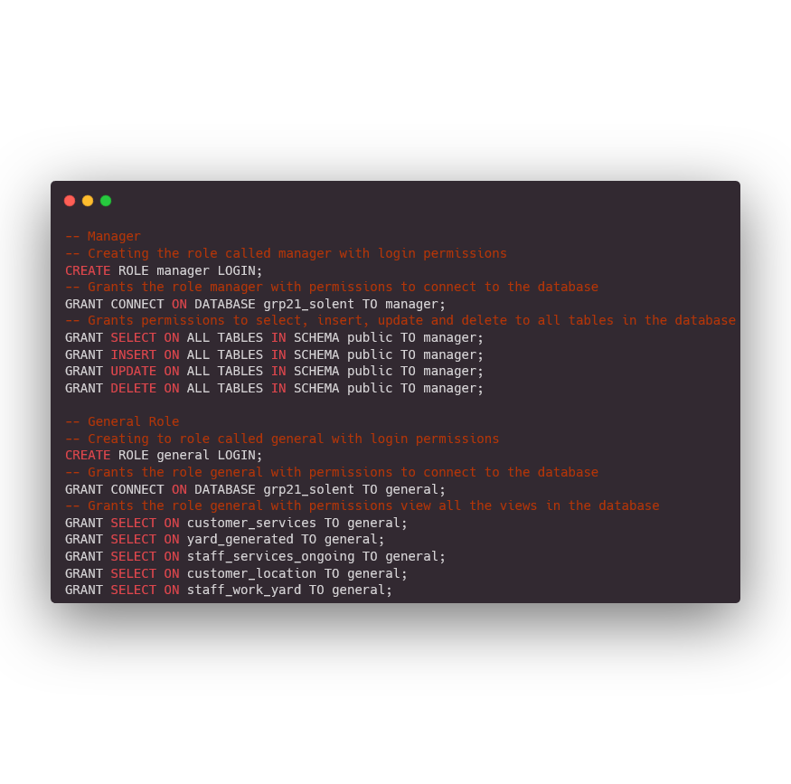

### 

### General

The general role is assigned the most restricted level of permissions within the database system. This role is limited to the privilege of selecting views created in the database, with explicit restrictions imposed on adding, modifying, or deleting any data. This stringent access control is implemented to safeguard the integrity of the data by preventing unauthorised modifications or deletions.

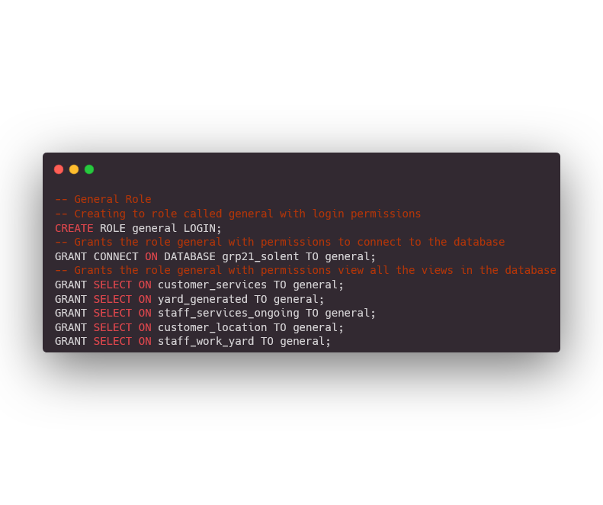

### 

### 

### 

### 

### 

### 

### Technician, Engine Technician and Hull Specialists

All engineering roles are granted permissions to access a comprehensive set of tables pertaining to engineering and service domains, encompassing tables such as manufacture, boat, and services, among others. These roles are endowed with the privileges to select, insert, and update data within the designated tables. Notably, the sole restriction within the scope of these accessible tables is the absence of the right to delete data, ensuring data integrity is preserved within this context.

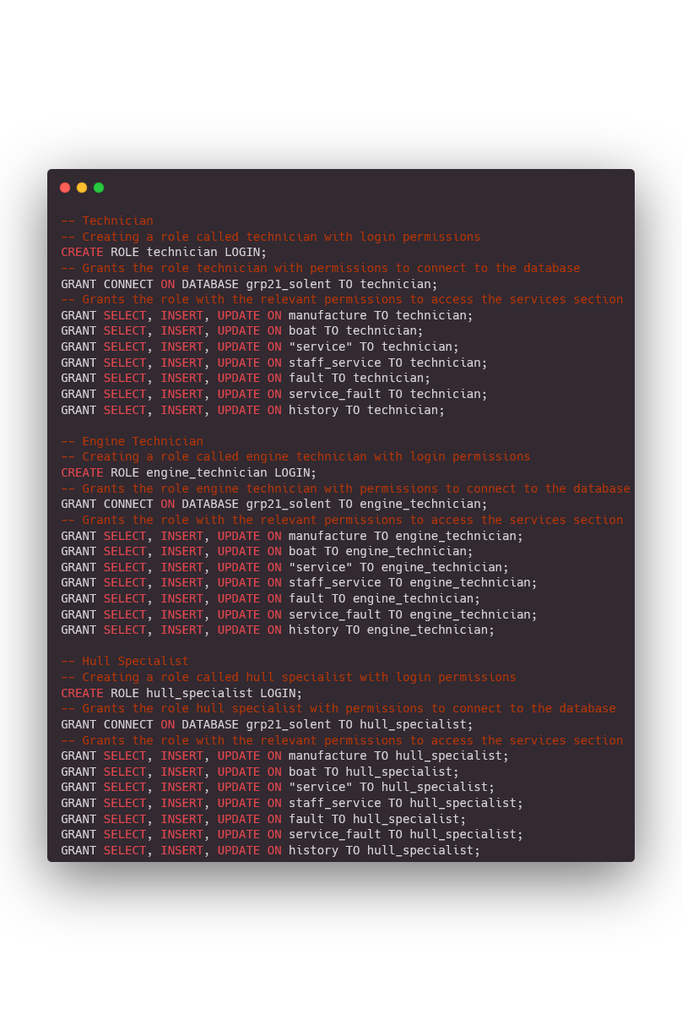

# Optimisation

| TRANSACTION TABLE | BOAT | | | | SERVICE | | | | HISTORY | | | | STAFF_SERVICE | | | | STAFF | | | |
| --- | --- | --- | --- | --- | --- | --- | --- | --- | --- | --- | --- | --- | --- | --- | --- | --- | --- | --- | --- | --- |
| C | R | U | D | C | R | U | D | C | R | U | D | C | R | U | D | C | R | U | D |
| Finding the staff assigned to the services that are ongoing |  | X |  |  |  | X |  |  |  | X |  |  |  | X |  |  |  | X |  |  |

| TRANSACTION TABLE | ADDRESS | | | | CUSTOMER | | | | BOAT | | | | MANUFACTURER | | | | SERVICE | | | | HISTORY | | | | CITY | | | |
| --- | --- | --- | --- | --- | --- | --- | --- | --- | --- | --- | --- | --- | --- | --- | --- | --- | --- | --- | --- | --- | --- | --- | --- | --- | --- | --- | --- | --- |
| C | R | U | D | C | R | U | D | C | R | U | D | C | R | U | D | C | R | U | D | C | R | U | D | C | R | U | D |
| Finding all the customer details with completed services |  | X |  |  |  | X |  |  |  | X |  |  |  | X |  |  |  | X |  |  |  | X |  |  |  | X |  |  |

| TRANSACTION TABLE | STAFF_YARD | | | | STAFF | | | | STAFF_ROLE | | | | ROLE | | | | YARD | | | |
| --- | --- | --- | --- | --- | --- | --- | --- | --- | --- | --- | --- | --- | --- | --- | --- | --- | --- | --- | --- | --- |
| C | R | U | D | C | R | U | D | C | R | U | D | C | R | U | D | C | R | U | D |
| Generating a boatyard report |  | X |  |  |  | X |  |  |  | X |  |  |  | X |  |  |  | X |  |  |
| ADDRESS | | | | CITY | | | | YARD_FACILITIES | | | | STAFF_SERVICE | | | |  | | | |
| C | R | U | D | C | R | U | D | C | R | U | D | C | R | U | D |
|  | X |  |  |  | X |  |  |  | X |  |  |  | X |  |  |

Queries that are regularly executed on a database system need to be optimised. This is to ensure that queries can be executed more quickly and efficiently meaning the users experience reduced wait times and receive query results in a more timely and efficient manner. Another reason why queries need to be optimised is to reduce cost, reducing the load on hardware resources can translate to cost savings.

A way a query can be optimised is shown in the following query below

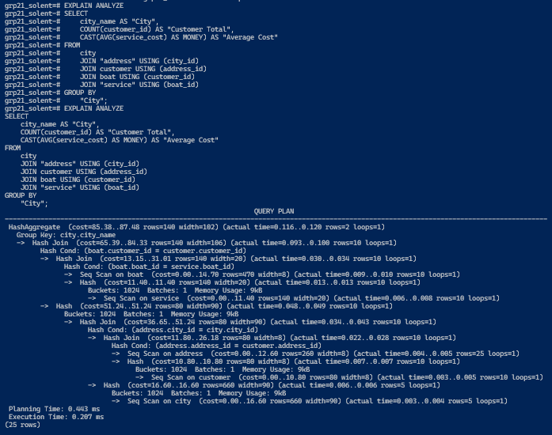

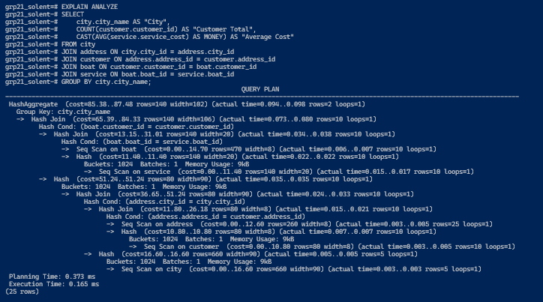

The query has been optimised by joining the different tables with the “ON” syntax instead of the “USING” syntax. Even though the execution time in processing this query is small with a difference of 0.042 milliseconds over time, that small time difference will decrease the cost of running the query through the life cycle of the database system.

# Professional, Legal and Ethical Issues

Developing a database system for a real-world client involves several considerations relating to the professional, legal and ethical aspects of that system. Below are the key issues that will need to be taken into account if this system is implemented into real-world use.

## Professional Issues

The professional issue when designing and implementing a database system for a client is to make sure the design of the database adheres to industry standards and best practices to ensure compatibility, interoperability and scalability of the system with other systems a client would use in conjunction with the database while following coding standards and naming conventions for consistency and maintainability of the database system for future improvements and maintenance with other Database Administrators that were not directly involved in designing and implementing the first iteration of the system.

## Legal Issues

This issue would be one of the most important ones, complying with data protection regulations in the countries in which the company operates. In the United Kingdom under the Data Protection Act 2018, the company would be required to follow the strict rules called “data protection principles” when using the personal data of staff and customers. The company must make sure the data is:

* Used fairly, lawfully and transparently
* Used for specified, explicit purposes
* Used in a way that is adequate, relevant and limited to only what is necessary
* Accurate and where necessary kept up to date
* Kept for no longer than is necessary
* Handled in a way that ensures appropriate security, including protection against unlawful or unauthorised processing, access, loss destruction or damage

The company would have to abide by the rights of the staff and customers under the Act for the information that is stored ensuring the right to:

* Be informed about how that data is being used
* Access personal data
* Have incorrect data updated
* Have data erased
* stop or restrict the processing of the data
* Data portability (allowing the right to get and reuse your data for different services)
* Object to how the data is processed in certain circumstances

These principles are also in place in the European Union under the General Data Protection Regulation (GDPR) meaning the company would have to abide by these regulations if their operations are within countries that are members of the European Union.

***Sources***

GDPR. (2018). General Data Protection Regulation (GDPR). General Data Protection Regulation (GDPR); Intersoft Consulting. https://gdpr-info.eu/

GOV.UK. (2018). Data Protection Act. Gov.uk; Gov.uk. https://www.gov.uk/data-protection

## Ethical Issues

The ethics within creating and managing a database for a client are making sure that the data you collect and store are only the necessary data for the intended purpose and ensuring transparent communications about the way the data within the database is collected. Another ethical implementation that is needed is to make sure the database system is accessible to individuals with diverse needs and abilities and consider the needs of all potential users to avoid excluding specific groups of users.

# Queries

The queries have been designed to meet the business requirements, specifically to drive revenue in the appropriate direction for Solent, thus the majority of the queries focus on expansion, clients, and cash flow.

## Query One

This query is used to check all customers who have had a service marked as ‘**COMPLETE**’, showing all the detail(s) of the customer i.e. name, and contact information. Whilst also showing the boat information and the total cost of the service.

This query is specifically helpful to see which customers have had the most services/repairs to their boat, however, this query can also be extended to get a report of all the services/repairs that took place during a certain date range period i.e. from the ‘2023-11-21’ to ‘2023-12-08’ for data-analysis, this could be achieved by adding **‘AND history_status BETWEEN xxxx-xx-xx AND xxxx-xx-xx**’. 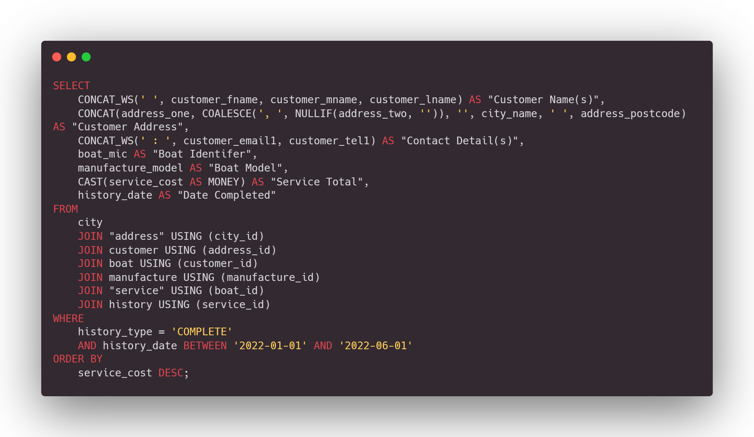

## Query Two

This query is used for an overall report of a yard, including the yard name, yard contact information, the manager, address, the number of facilities, the total of staff working at a yard, and finally the total revenue the yard has generated.

This query is especially useful for managing each individual yard, for staff shortages, expansion, etc.

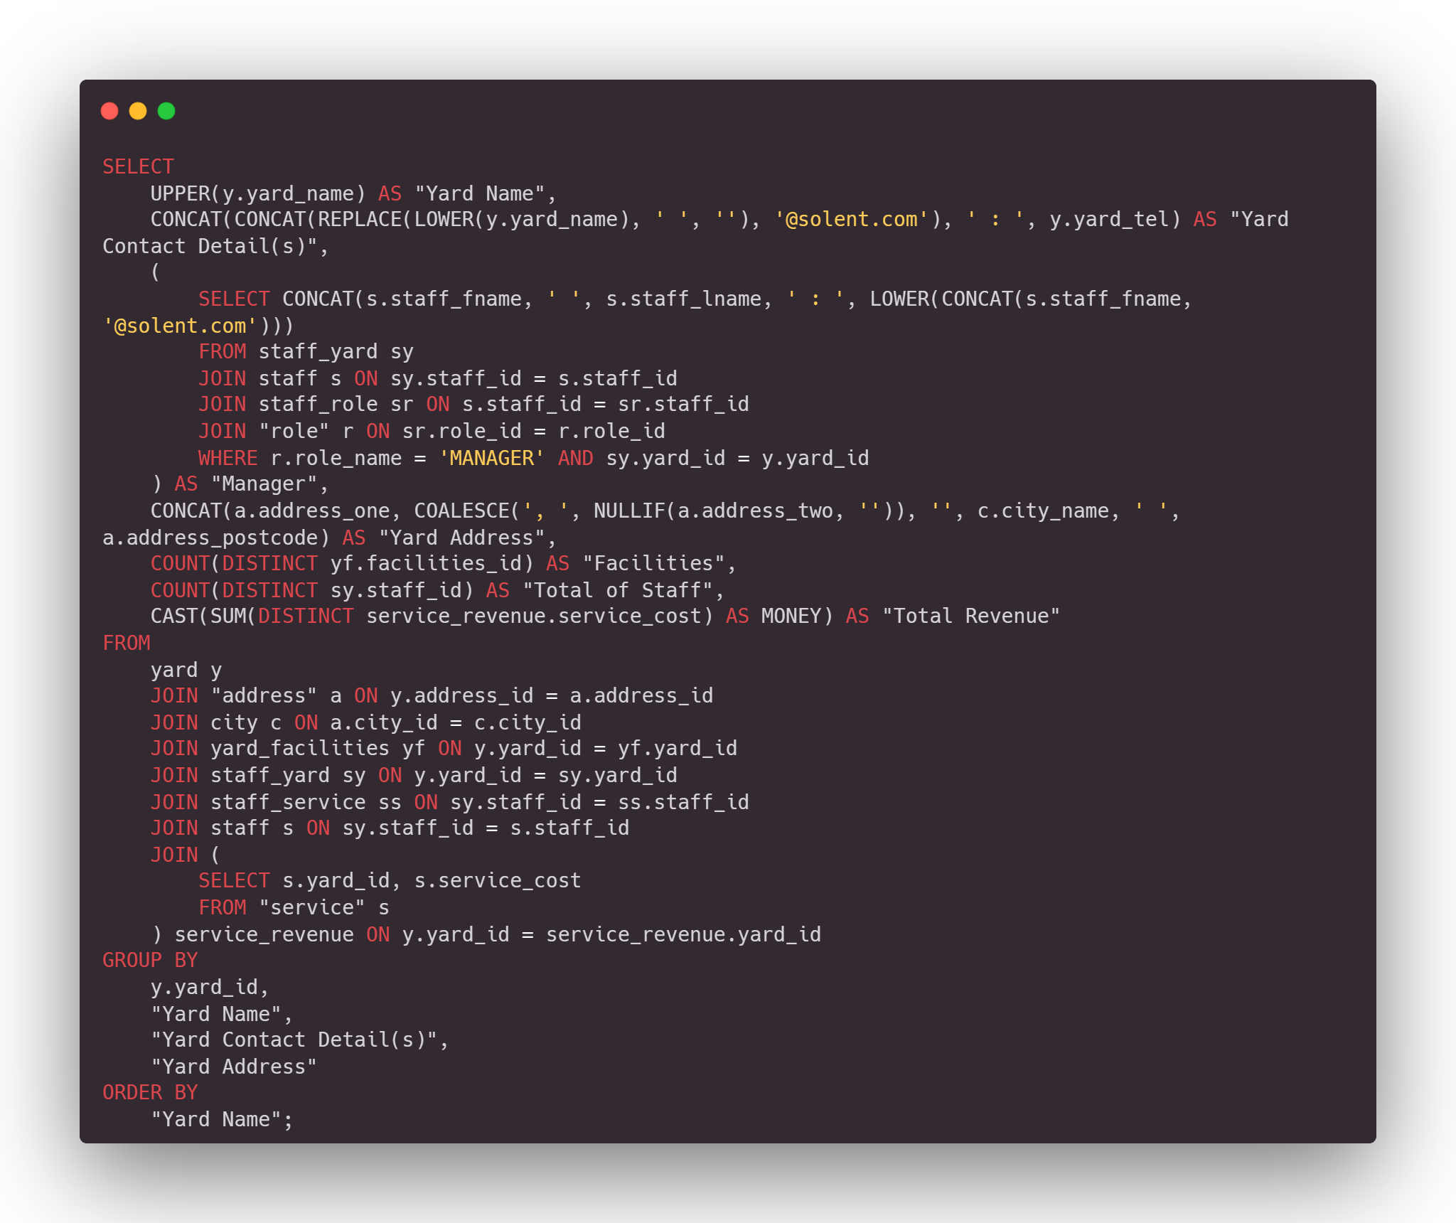

## Query Three

This query is used to see all the staff that have been assigned to a service/repair, however, this query could also be extended to see the service within each yard by staff, by selecting the ‘yard_id’.

This is especially great for seeing if a service requires more staff.

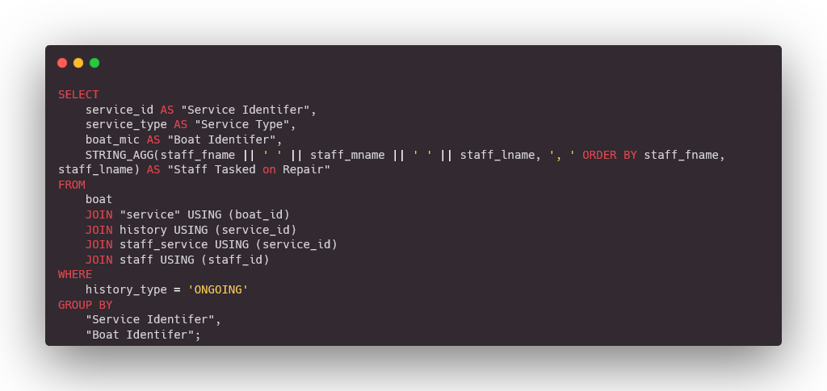

## Query Four

This query is used to see the customers registered within the database and the city they live in, this is then used to find the average cost of customers from these cities, which can be used for expansion purposes for solent boats.

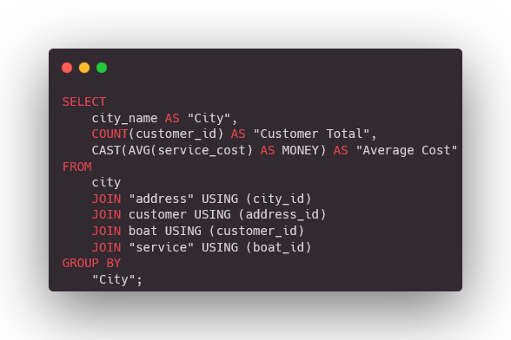

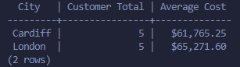

## Query Five

This query is used to see the staff responsibilities and the yard they are assigned to, this is essentially a more in-depth view of each yard from query two, like query two an administrator can move staff to another yard for shortages, etc.

